**BASE URL:** http://localhost:4000

**CUSTOMER**

**Daftar user: /createCustomer**

Method: post

body: form-data

username

email

password

confirmPassword

role

photo

name

nomorWA

address

city_id

city_province_id

contoh:

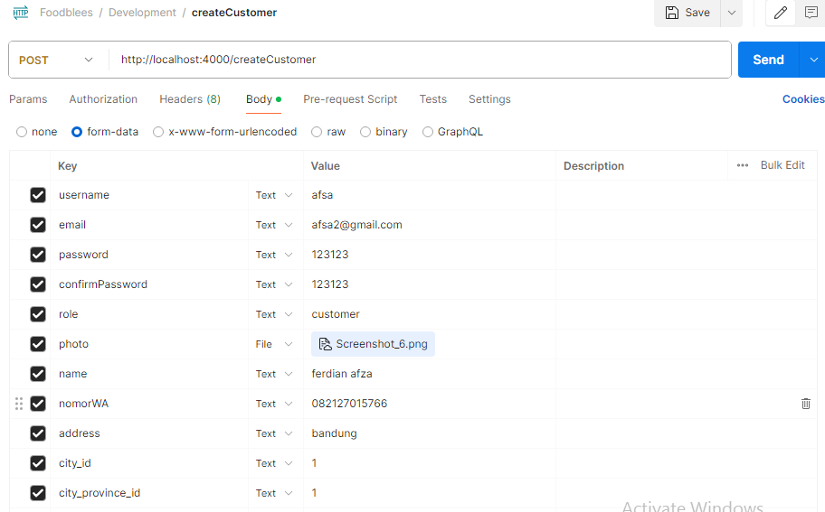

Respon:

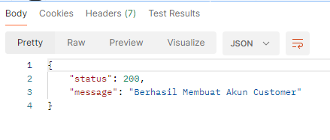

**update customer: /** **updateCustomer**

Method: PUT

headers.Authorization (di isi token jwt)

body: form-data

user_id

id_cust

username

email

password

name

nomorWA

address

city_id

city_province_id

photo

contoh:

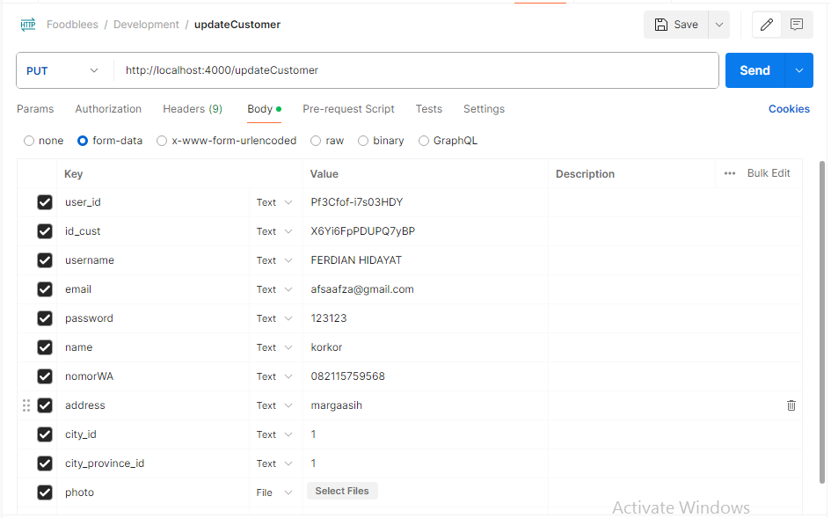

Respone:

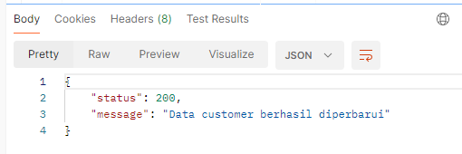

**login user: /** **login**

Method: post

body: x-www-form-urlencoded

email

password

contoh:

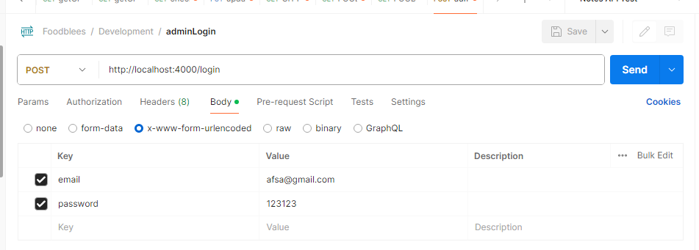

respon:

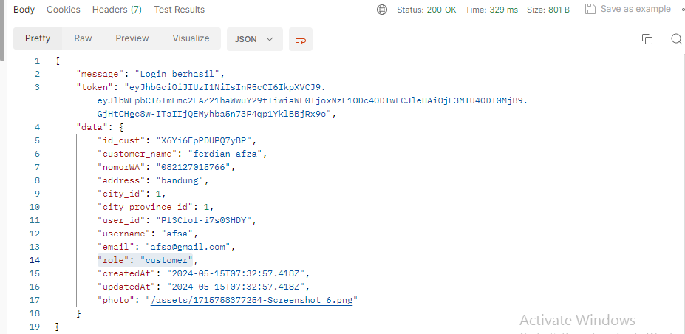

**Detail user: /user/:id**

Method: get

body: none

params

id

contoh:

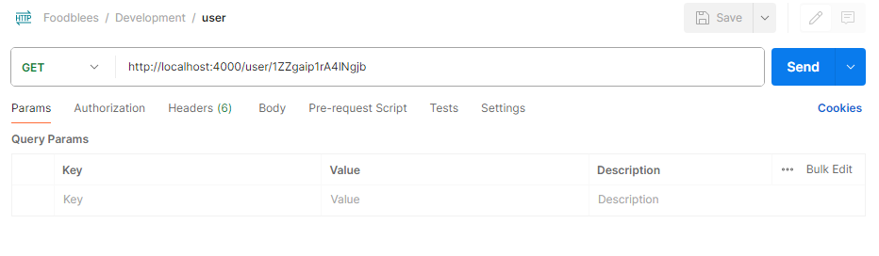

Respone:

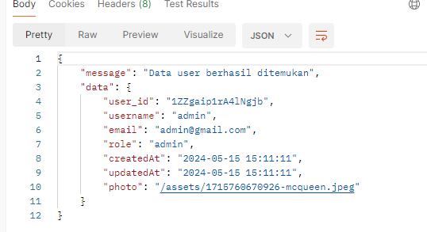

**Admin**

**Daftar admin: /createAdmin**

Method: post

body: form-data

username

email

password

confirmPassword

role

photo

contoh:

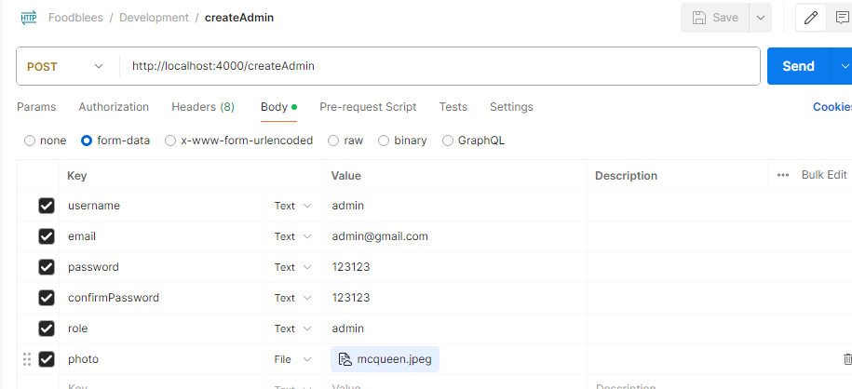

Respon:

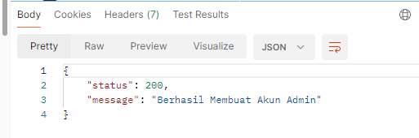

**Ambil semua data seller: /getAllCustomers**

Method: GET

Body: none

Contoh:

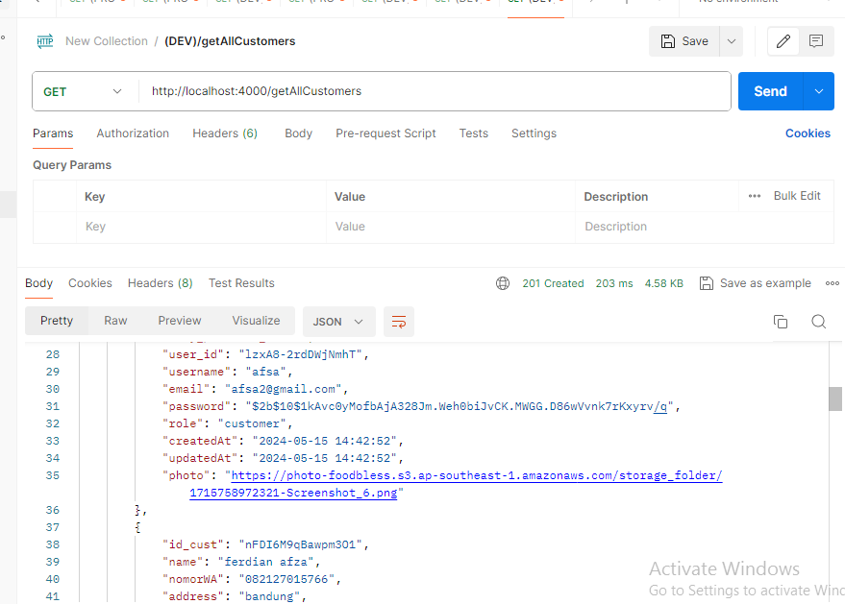

**Mengambil data cutsomer: /** **getAllUserCustomers**

Method: GET

body: form-data

user_id

contoh:

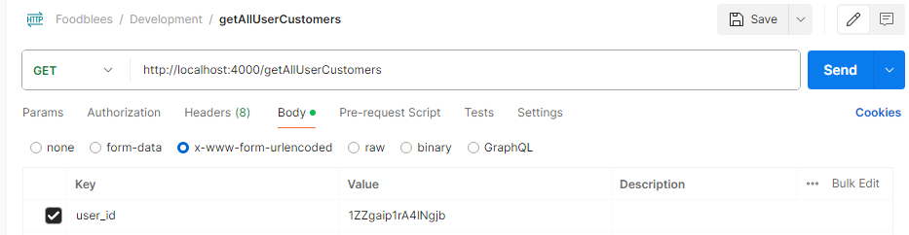

Respon:

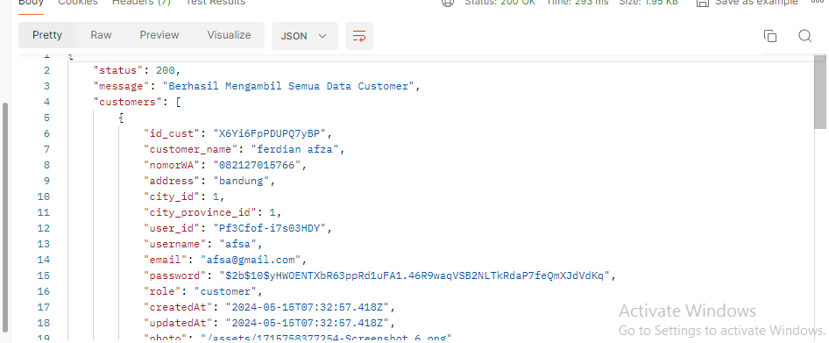

**Mengambil data seller: /** **getAllUserSellers**

Method: GET

body: form-data

user_id

contoh:

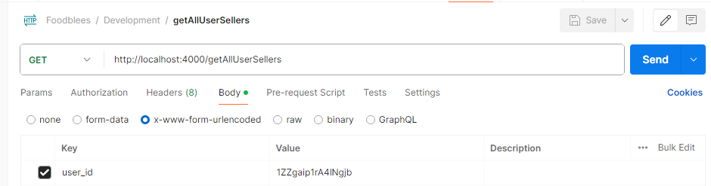

Respon:

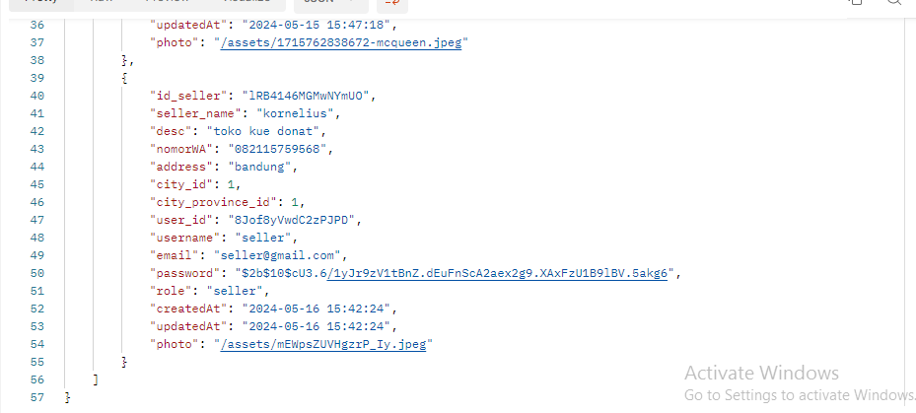

**Seller**

**Daftar seller: /** **createSeller**

Method: post

body: form-data

username

email

password

confirmPassword

role

photo

name

desc

nomorWA

address

city_id

city_province_id

contoh:

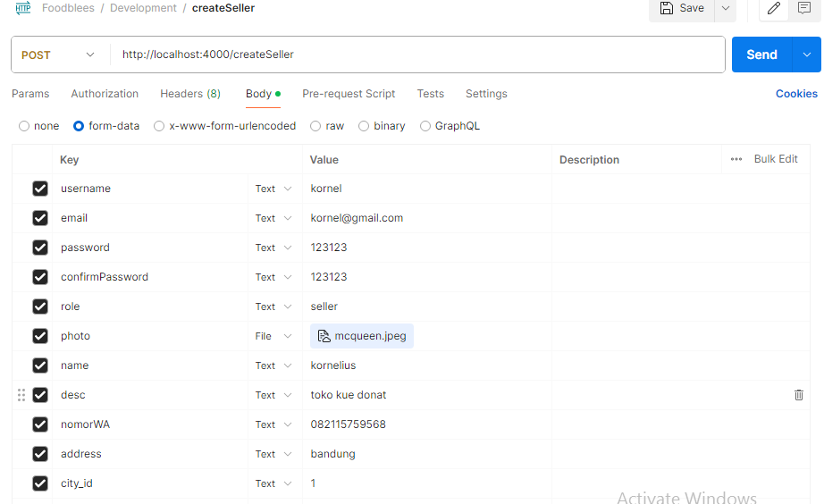

Respone:

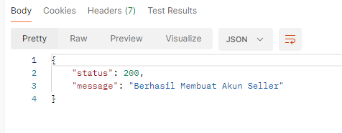

**update seller: /** **updateSeller**

Method: PUT

headers.Authorization (di isi token jwt)

body: form-data

user_id

id_seller

username

email

password

name

desc

nomorWA

address

city_id

city_province_id

photo

contoh:

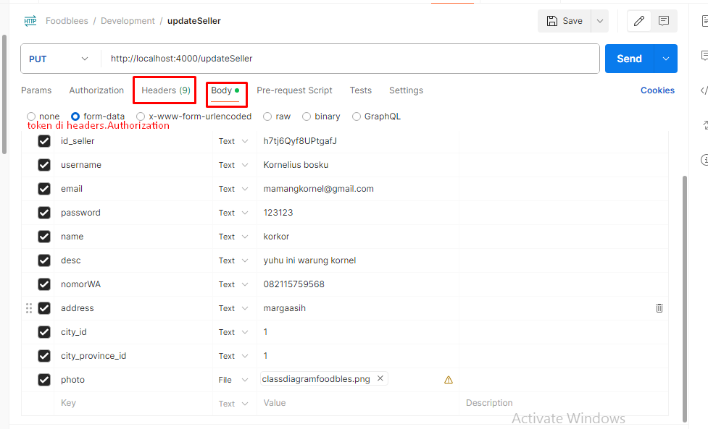

Respone:

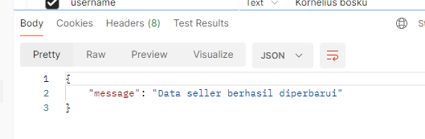

**Detail seller :/seller/${id_seller}**

Method: GET

Body : none

Contoh:

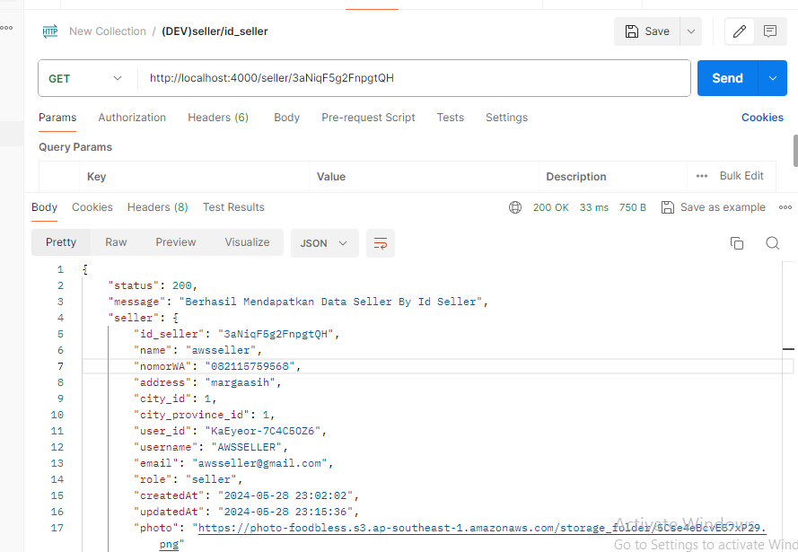

**Ambil semua data seller: /getAllSellers**

Method: GET

Body: none

Contoh:

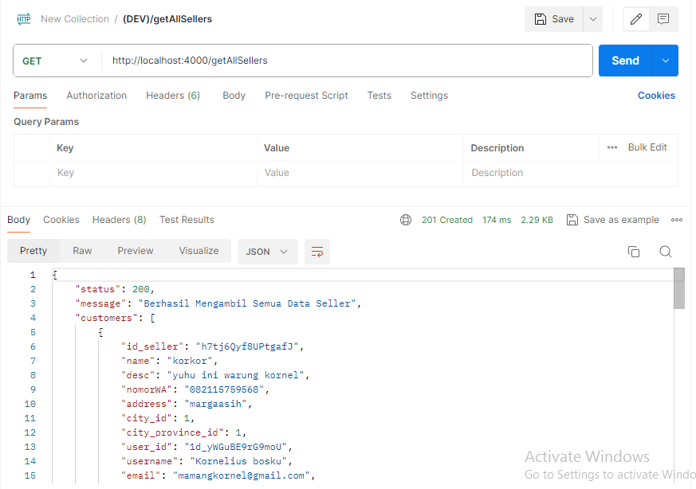

**City**

**Semua Kota: /** **cityAll**

Method: Get

No parameter

Contoh:

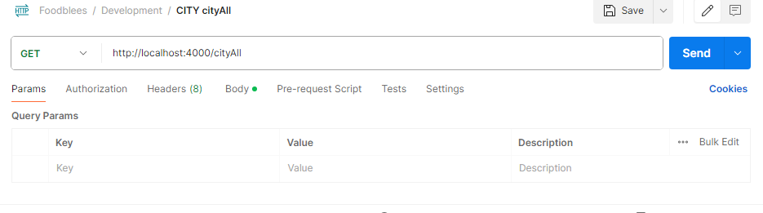

Respone:

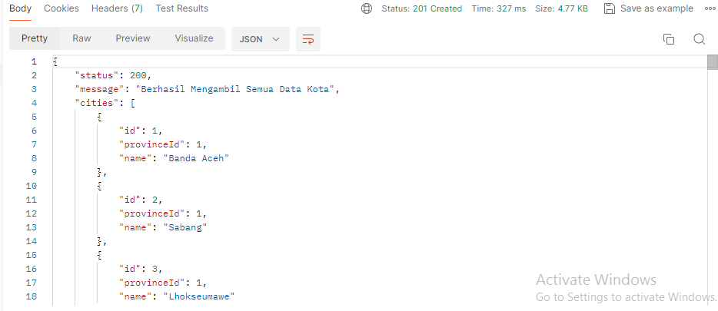

**Kota Berdasarkan Provinsi: /cityByProvinceId**

Method: GET

params: Query params

provinceId

contoh:

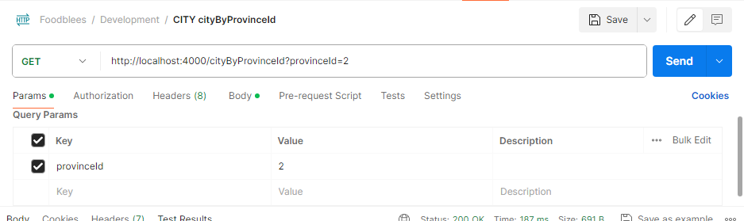

Respon:

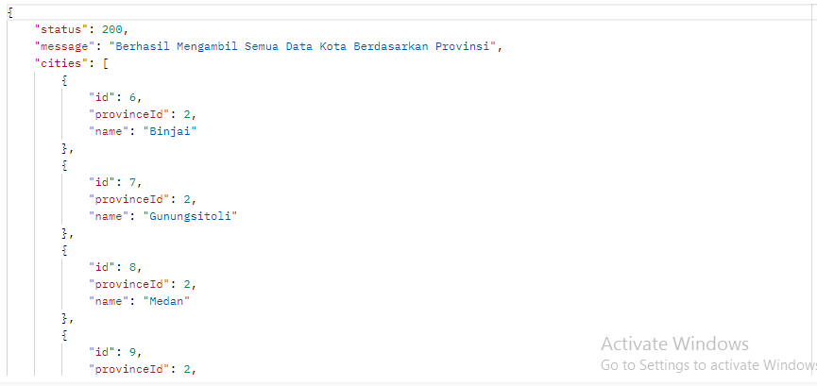

**Kota Berdasarkan id: /** **cityById**

Method: GET

params: Query params

id

contoh:

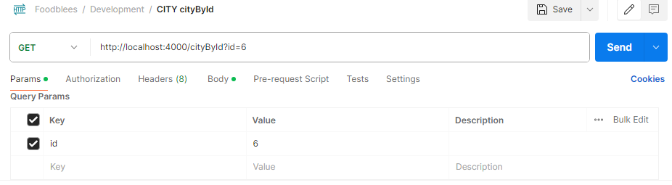

Respon

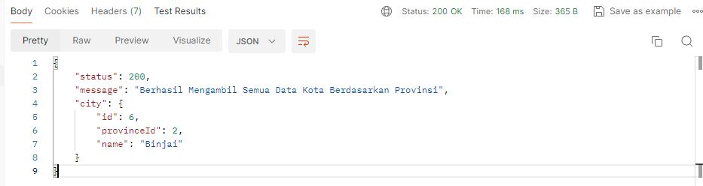

**Province**

**Semua provinsi: /** **provinceAll**

Method: Get

No parameter

Contoh:

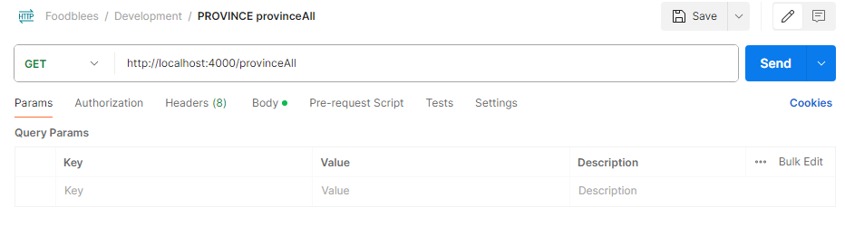

Respone:

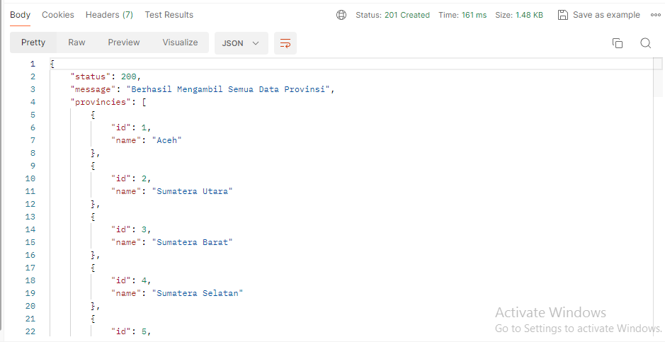

**Provinsi berdasarkan Id: /** **provinceById**

Method: get

params: Query params

id

contoh:

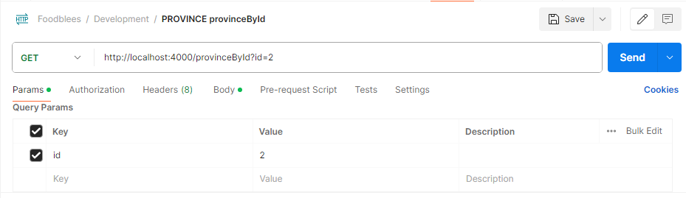

Respon:

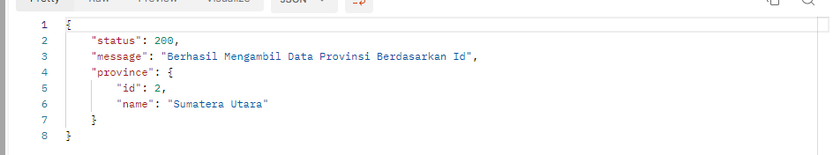

**Food**

**Semua data Food: /** **foods**

Method: GET

No Parameter

Contoh:

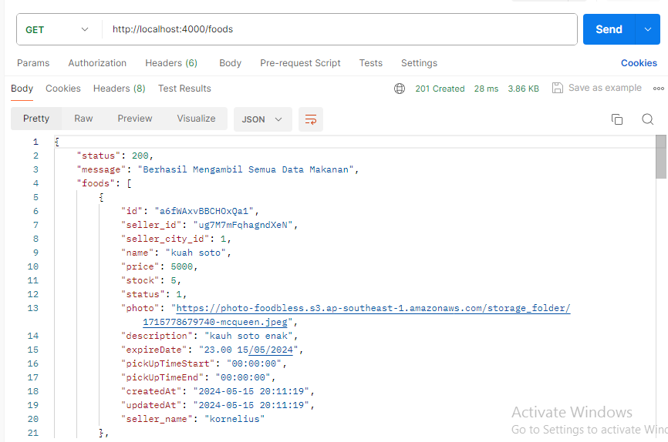

**data Food berdasarkan id: /** **food/{id}**

Method: GET

body: none

id disimpan di param /{} setelah /food misal /food/id1

contoh:

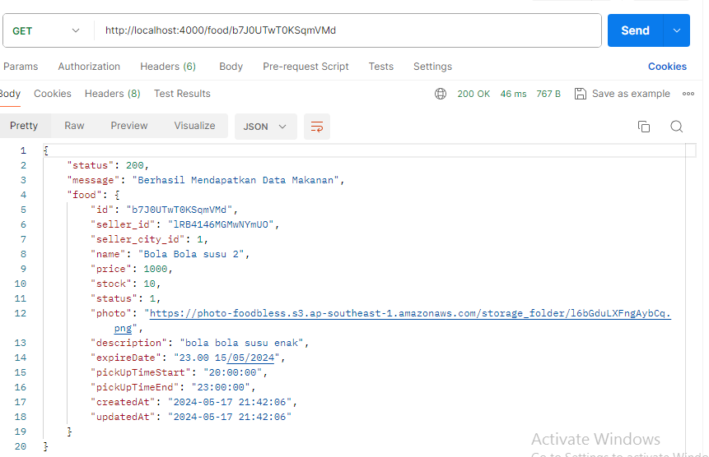

**data Food berdasarkan id: /** **getFoodBySellerId/{id seller}**

Method: GET

body: none

contoh: 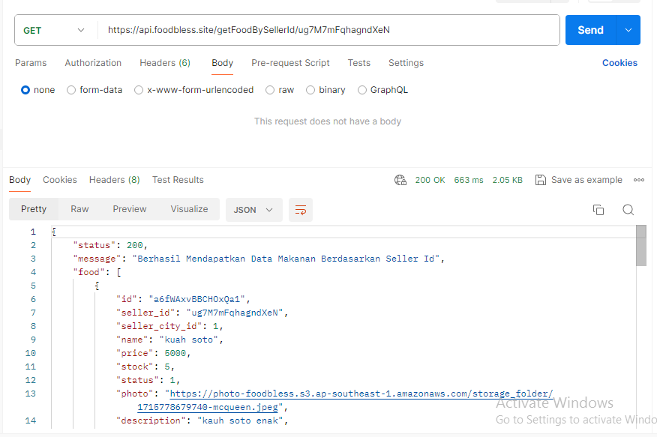

**Buat data food: /** **createFood**

Method: POST

Headers: Authorization: di isi token yang didapat saat seller login

Body: form-data

sellerId

seller_city_id

name

price

stock

description

expireDate

photo

pickUpTimeStart

pickUpTimeEnd

contoh:

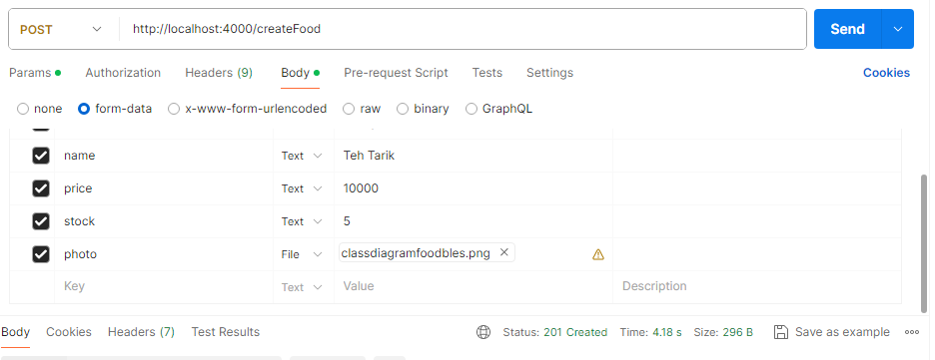

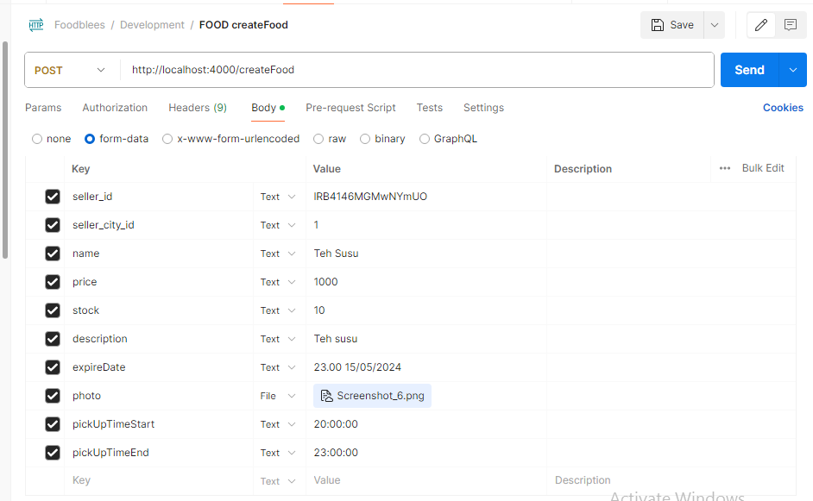

Respone:

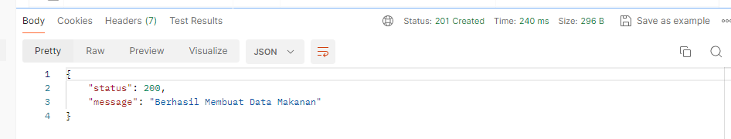

**Update data food: /updateFood**

Method: PUT

Headers: Authorization: di isi token yang didapat saat seller login

Body: form-data

Id (id dari food nya)

sellerId (id dari seller bisa didapat saat setelah seller logii)

name (name dari food nya)

price

stock

status

description

expireDate

photo

pickUpTimeStart

pickUpTimeEnd

contoh:

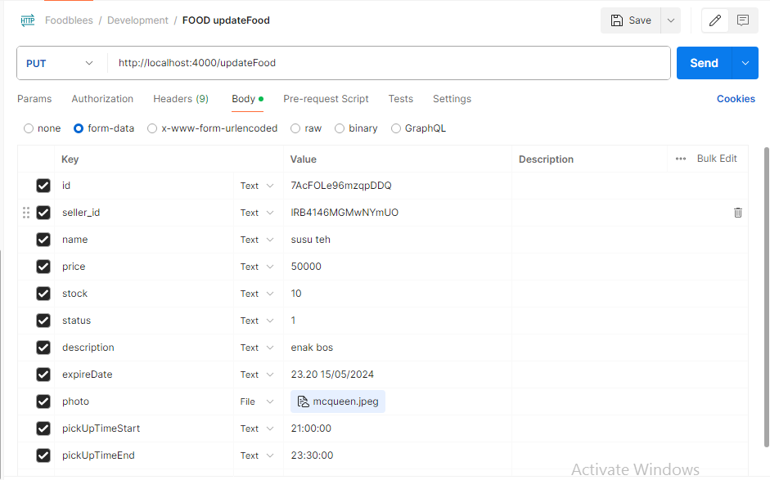

Respon:

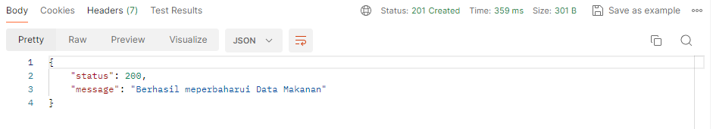

**Hapus data food: /deleteFood**

Method: DELETE

Headers: Authorization: di isi token yang didapat saat seller login

Body: x-www-form-urlencoded

id

sellerId

contoh:

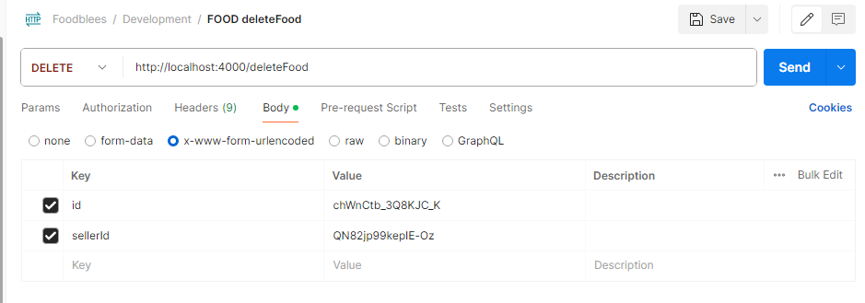

Respone:

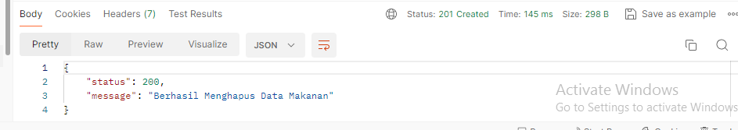

**Order**

**Semua data Order: /** **getAllOrders**

Method: GET

No Parameter

Contoh:

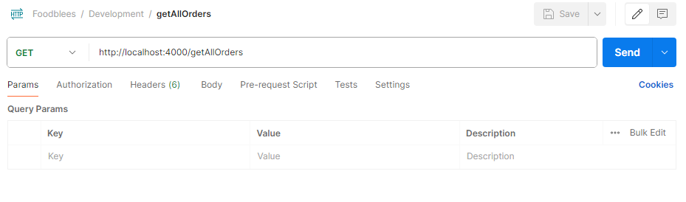

Respone:

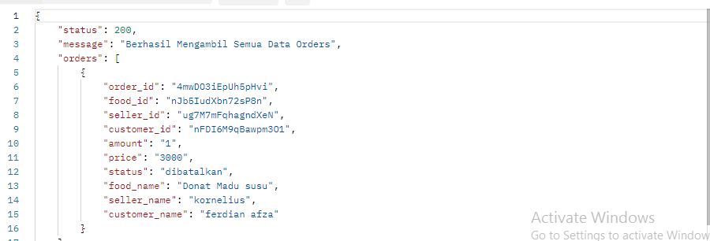

**Semua data Order bySellerId: /** **getOrdersBySellerId**

Method: GET

Body: x-www-form-urlencoded

seller_id

contoh:

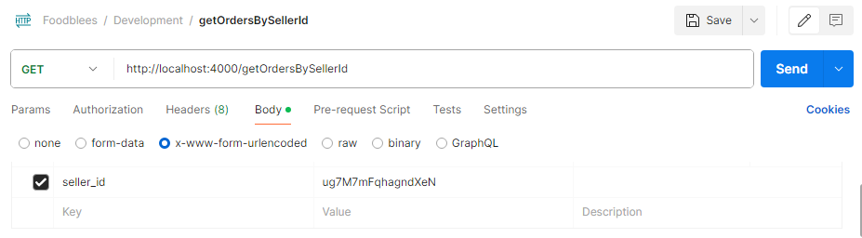

Respon:

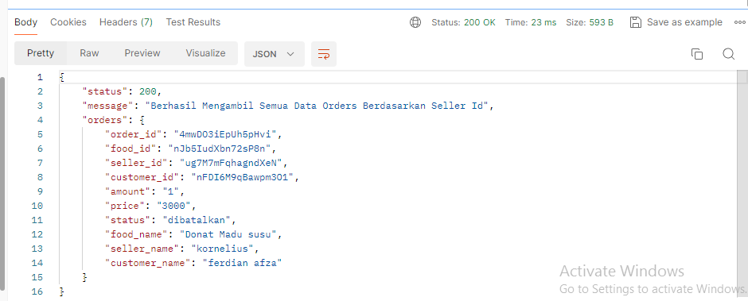

**Semua data Order byCustomerId: /** **getOrdersByCustomerId**

Method: GET

Body: x-www-form-urlencoded

customer_id

contoh:

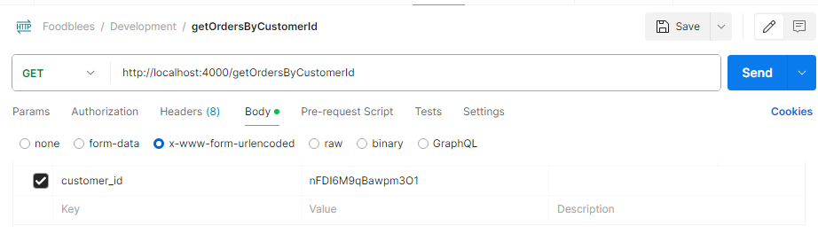

Respon:

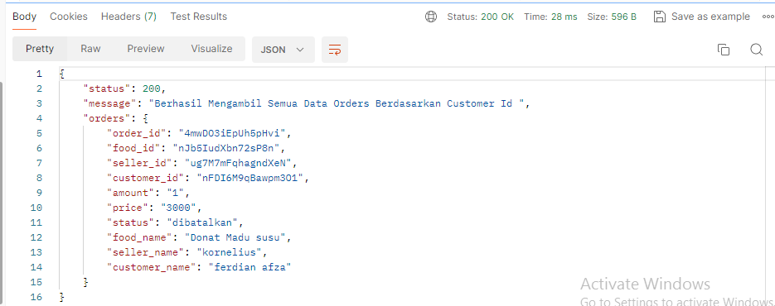

**Semua data Order byFoodId: /** **getOrdersByFoodId**

Method: GET

Body: x-www-form-urlencoded

food_id

contoh:

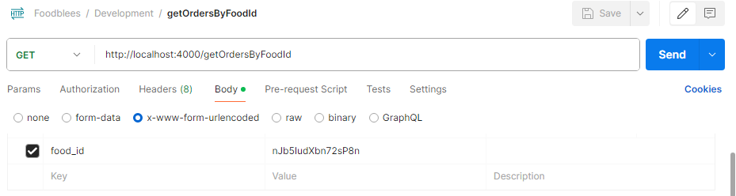

Respon:

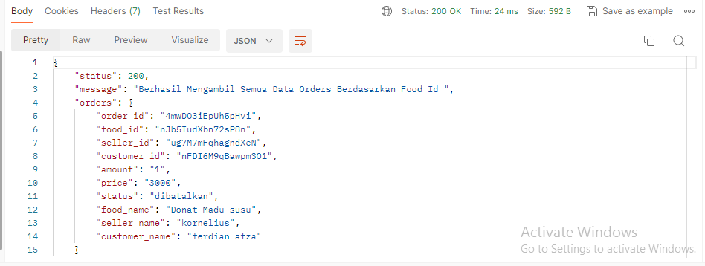

**Semua data Order byOrderId: /** **getOrdersByOrderId**

Method: GET

Body: x-www-form-urlencoded

order_id

contoh:

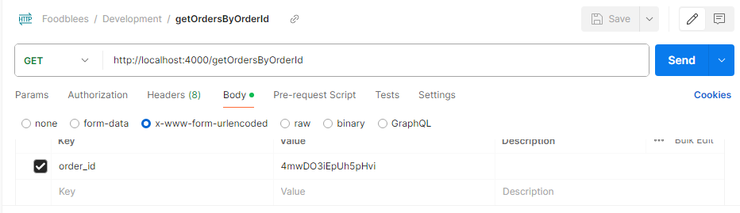

Respon:

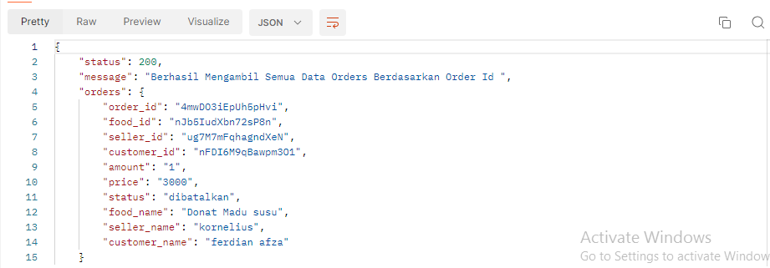

**Cek order baru yang masuk: /** **checkNewOrder**

Method: GET

Body: x-www-form-urlencoded

seller_id

contoh:

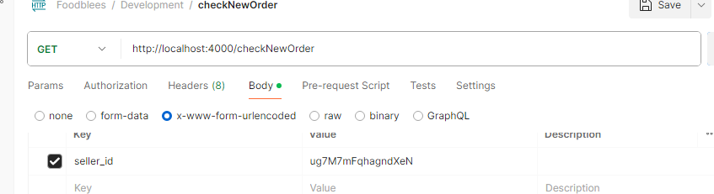

Respon:

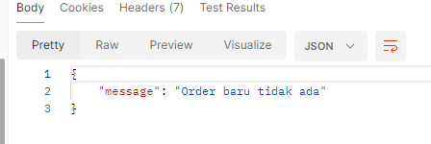

**Update status order menajdi diproses: /** **updateOrderToDiproses**

Method: PUT

Body: x-www-form-urlencoded

seller_id

order_id

contoh:

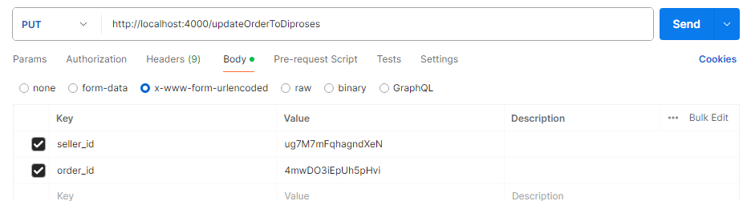

Respon:

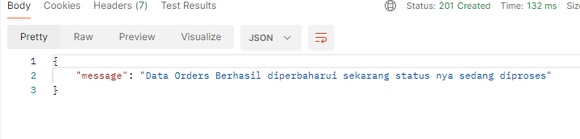

**Update status order menajdi selsai: /** **updateOrderToSelesai**

Method: PUT

Body: x-www-form-urlencoded

seller_id

order_id

contoh:

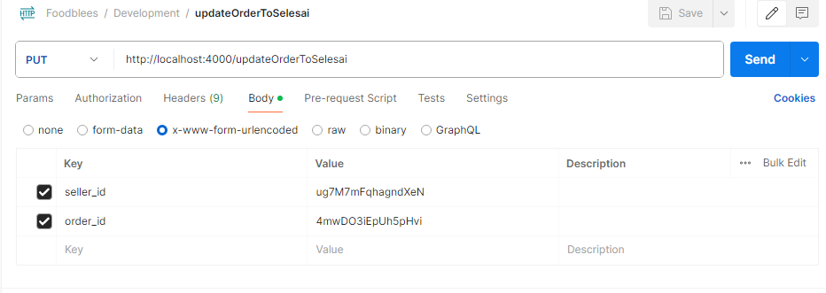

Respon:

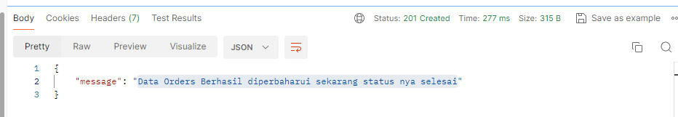

**Update status order menjadi dibatalkan: /** **updateOrderToDibatalkan**

Method: PUT

Body: x-www-form-urlencoded

seller_id

order_id

contoh:

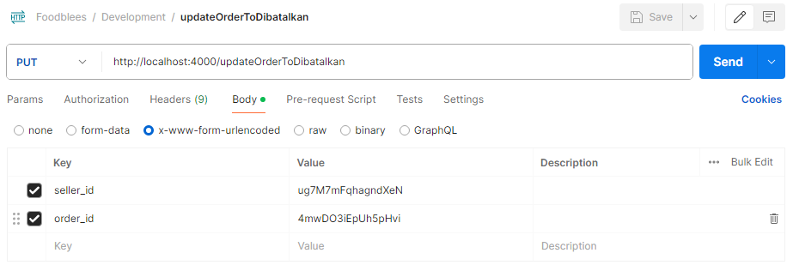

Respon:

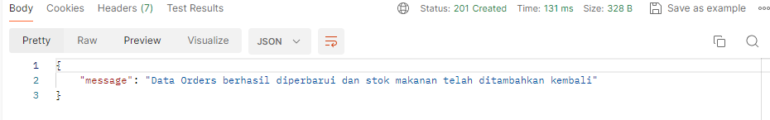

**Comment**

**Membuat comment: /createComment**

Method: POST

body: x-www-form-urlencoded

id_seller

id_cust

description

contoh:

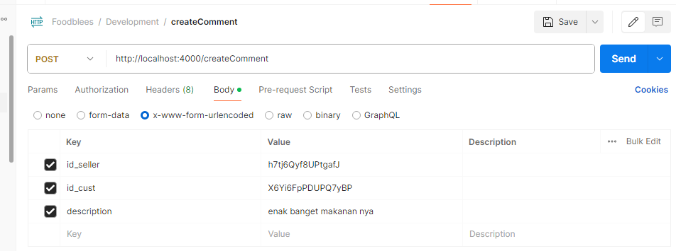

Respone:

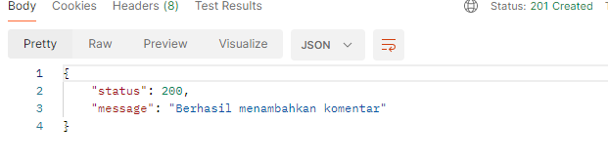

**Ambil semua comment: /getCommentAll**

Method: get

body: none

contoh:

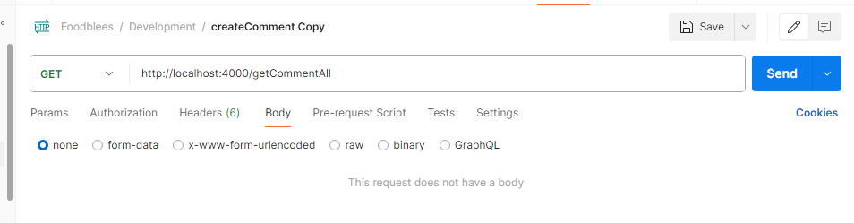

Respon:

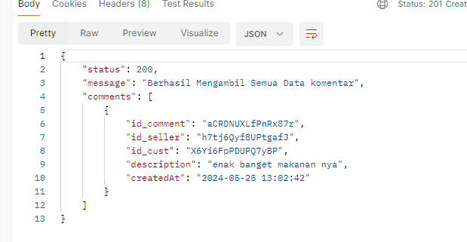

**Ambil comment berdasarkan id_seller: /getCommentByIdSeller**

Method: GET

body: x-www-form-urlencoded

id_seller

contoh:

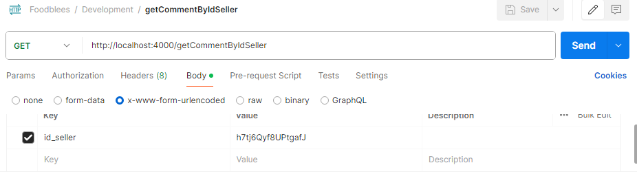

Respone:

