A PREDICTIVE MODEL OF ADVERSE PREGNANCY OUTCOMES AMONG MALARIA-INFECTED PREGNANT WOMEN IN RESOURCE-CONSTRAINED SETTINGS USING EXPLAINABLE BOOSTING MACHINE
RESEARCH PROJECT DISSERTATION (CHAPTERS FOUR & FIVE)
Researcher: Akpan Divine Eteyen | Reg. No: AK22/PHS/CSC/002
Department of Computer Science, Faculty of Physical Sciences
Akwa Ibom State University, Ikot Akpaden, Nigeria

CHAPTER FOUR
SYSTEM DESIGN AND IMPLEMENTATION
4.0 Introduction
In this research work, an Explainable Artificial Intelligence (XAI) predictive framework is designed, formulated, implemented, and empirically evaluated for forecasting adverse pregnancy outcomes (APOs) among malaria-infected and malaria-exposed pregnant women in resource-constrained healthcare settings. The predictive framework synthesizes Component-Wise Gradient Boosting (CWGB) for sparse, regularized feature selection with an Explainable Boosting Machine (EBM)—a modern Generalized Additive Model with Pairwise Interactions (GA2M). This architecture resolves the classical trade-off between the high non-linear predictive capacity of ensemble machine learning models and the strict clinical intelligibility mandated in obstetric and perinatal decision-making.
This chapter presents an exhaustive account of the system's implementation: the operational hardware and software dependency stack, justification for the chosen programming language and execution ecosystem, input and output data specifications, architectural domain alignment across clinical and epidemiological modalities, and comprehensive empirical result analysis. The predictive performance of the proposed EBM model is benchmarked against established clinical and machine learning baselines (Logistic Regression, Random Forest, and Gradient Boosted Decision Trees), followed by slice-based subgroup evaluations across regional geopolitical zones and urban/rural settlements, global shape function inspections, and patient-level additive log-odds explanations.
4.1 System Requirements
The system development, mathematical training, diagnostic evaluation, and web deployment environments were configured to ensure numerical reproducibility, rapid tensor indexing, and low-latency inference across both clinical desktop workstations and mobile tablet browsers.
4.1.1 Hardware Requirements
- Processor (CPU): Multi-core 64-bit x86_64 architecture (Intel Core i7 / AMD Ryzen 7 or higher, minimum 4 physical cores, 8 threads) to support parallelized outer cross-validation bagging (B = 8 bags) and pairwise interaction tensor binning.
- Random Access Memory (RAM): Minimum 16 GB DDR4/DDR5 system memory (32 GB recommended) to accommodate in-memory matrix manipulation and bootstrap confidence interval iterations over 17,986 pregnancy records.
- Storage: Solid-State Drive (NVMe SSD) with at least 20 GB free disk space for high-throughput serialization of tabular datasets, preprocessed feature arrays, and Joblib model binaries.
- Display Resolution: Minimum 1366 × 768 pixels (1920 × 1080 Full HD recommended) for high-density visualization of 200 DPI vector charts, non-linear shape splines, and interactive Streamlit UI widgets.
4.1.2 Software Requirements
The software specifications and library dependencies deployed and verified for the predictive system are detailed in Table 4.1.
Table 4.1: Software Specifications and Library Dependency Stack
Software Module | Minimum Requirement | Version Deployed | Role & Functional Responsibility
Operating System | Microsoft Windows 10 (64-bit) / Ubuntu 22.04 LTS | Microsoft Windows 11 Pro (64-bit) | Host environment providing kernel threading and 64-bit memory addressing.
Programming Language | Python 3.10+ (64-bit) | Python 3.14 / Python 3.11 (64-bit) | Core execution runtime for feature preprocessing, mathematical modeling, and web serving.
Machine Learning Library | Scikit-Learn 1.3+ | Scikit-Learn 1.6+ | Implements stratified sampling, logistic regression, ensemble baselines (RF, GBDT), and metrics.
Interpretable ML Engine | Custom EBM / GA2M Core | Cython / NumPy Core (ebm_core.py) | Implements Component-Wise Gradient Boosting selector and Explainable Boosting Machine.
Scientific Computing | NumPy 1.24+ / SciPy 1.10+ | NumPy 2.x / SciPy 1.14+ | High-performance N-dimensional array processing, quantile binning, and matrix algebra.
Data Manipulation | Pandas 2.0+ | Pandas 2.2+ | Ingestion of 17,986 pregnancy records, missing value verification, and tabular reporting.
Model Persistence | Joblib 1.3+ | Joblib 1.4+ | Serialization and zero-latency disk loading of trained model weights (ebm_malaria_pregnancy_bundle.joblib).
Web Application Framework | Streamlit 1.30+ | Streamlit 1.42+ | Renders the interactive web application, clinical calculators, slider controls, and CSV export engines.
Plotting & Visualization | Matplotlib 3.7+ / Seaborn 0.12+ | Matplotlib 3.10+ / Seaborn 0.13+ | Generates publication-standard 200 DPI vector charts, ROC/PR curves, and 1D/2D shape functions.
Integrated Development Env. | JupyterLab / VS Code | Jupyter Notebook 7.x & VS Code | Interactive code execution, cell-by-cell inspection, syntax verification, and debugging.
Web Browser Interface | HTML5 / ECMAScript 6 Compliant | Google Chrome / Microsoft Edge / Safari | Client-side rendering of the responsive clinical decision intelligence portal.
4.2 Choice of Programming Language
Python was selected as the primary programming language for the development, training, and deployment of the adverse pregnancy outcome predictive system. Python has emerged as the de facto standard in clinical biostatistics, health informatics, and machine learning due to its mature ecosystem of scientific computation libraries, numerical stability, and strong community support.
Specifically, Python enabled: (1) seamless vectorized matrix computation of Component-Wise Gradient Boosting residuals and localized spline approximations across thousands of records in sub-second intervals; (2) unified pipeline integration where data preprocessing, feature selection, glass-box EBM training, model evaluation, and graphical presentation reside within a single cohesive codebase without inter-process translation overhead; and (3) rapid web prototyping via Streamlit, allowing predictive algorithms to be directly compiled into a production-grade, interactive web decision intelligence dashboard accessible to clinicians and antenatal care workers without requiring complex JavaScript frontend architectures.
4.3 System Implementation
The system implementation phase translated the theoretical, mathematical, and algorithmic designs into functional, modular software components. The implementation workflow unfolded across four interconnected engineering stages:
- 1. Data Preprocessing & Cleaning: An empirical cohort of 17,986 maternal pregnancy records across 281 prospective clinical and epidemiological attributes was cleaned, verified for complete integrity (0% missing values post-imputation), and partitioned using a strictly stratified 70% Training (n = 12,590), 15% Validation (n = 2,698), and 15% Held-Out Test (n = 2,698) protocol.
- 2. Component-Wise Gradient Boosting (CWGB) Feature Selection: To avoid curse-of-dimensionality degradation and eliminate clinical multi-collinearity, CWGB was executed over M = 180 boosting iterations with learning rate ν = 0.12 and L2 shrinkage regularization (λ = 5.0). CWGB identified the top 20 most informative predictors across the four architectural domains (Clinical/Maternal, Demographic, Laboratory, and Malaria-Specific Data).
- 3. Explainable Boosting Machine (EBM) Model Formulation: Using the 20 selected features, an EBM model was trained using cyclic coordinate gradient boosting with T = 95 cycles, outer bagging (B = 8 bags), and automated identification of the top 8 pairwise interaction surfaces. Concurrently, six endpoint-specific EBM sub-models were trained to predict individual clinical outcomes (Maternal Anemia, Pregnancy Loss, Preterm Birth, Low Birth Weight, Neonatal Mortality, and Composite APO).
- 4. Clinical Decision Support Portal Development: An interactive, multi-tab Streamlit web application (app.py) was constructed, integrating single-patient clinical parameter simulation, automated risk triage tiering, local additive log-odds feature breakdown, global shape function exploration, and batch CSV questionnaire scoring.
4.4 System Specifications
The system specifications establish the precise structural schema, validation constraints, operational semantics, and reporting artifacts governing data entering and exiting the predictive system.
4.4.1 Input Specification
The system ingests maternal, clinical, demographic, and malaria intervention parameters structured according to the 20 most important features selected by Component-Wise Gradient Boosting. Data enters through two operational pipelines: (1) interactive antenatal parameter entry via web-based clinical sliders and categorical selectors during routine antenatal care (ANC) contacts; and (2) batch CSV ingestion of standardized patient registers or field questionnaires (top_20_important_features_dataset.csv) for population-level triage and facility audits.
Table 4.2 presents the input data dictionary for the top 20 selected clinical predictors, detailing variable names, field codes, data domains, data types, empirical ranges, and operational descriptions.
Table 4.2: Input Data Dictionary for the 20 Important Clinical Features Selected by CWGB
S/N | Feature Name | Field Code | Domain | Type | Range | Clinical Description & Operational Role
1 | number_of_pregnancy_losses | CLN_LOSS | Clinical/Maternal | Integer | 0 – 15 | Total prior miscarriages, abortions, or stillbirths (Rank 1 predictor; 27.10% importance).
2 | ever_had_terminated_pregnancy | CLN_TERM | Clinical/Maternal | Binary | 0 or 1 | Indicator of any prior non-live pregnancy termination (Rank 2; 24.44% importance).
3 | number_of_living_children | CLN_LIV_CH | Clinical/Maternal | Integer | 0 – 20 | Current count of surviving biological children living with or away from mother.
4 | children_under_5_in_household | DEM_U5_HH | Demographic | Integer | 0 – 20 | Number of children under 5 years in household; proxy for maternal childcare burden.
5 | parity_total_children_ever_born | CLN_PARITY | Clinical/Maternal | Integer | 0 – 20 | Total live births ever delivered by the woman (Parity status).
6 | timing_first_anc_visit_months | ANC_FIRST_M | Clinical/Maternal | Integer | 1 – 9 | Gestational age (in months) at first antenatal booking; indicates early vs late ANC.
7 | malaria_iptp_doses | MAL_IPTP_DOS | Malaria Data | Integer | 0 – 20 | Total doses of Sulfadoxine-Pyrimethamine (IPTp-SP/Fansidar) ingested during pregnancy.
8 | multiple_or_twin_pregnancy | CLN_TWIN | Clinical/Maternal | Categorical | 0 – 3 | Single pregnancy (0) vs twin/multiple gestation (1, 2, 3); major clinical risk factor.
9 | days_iron_tablets_or_syrup_taken | ANC_IRON_DAYS | Clinical/Maternal | Integer | 0 – 300 | Total duration (in days) of hematinic oral iron/folate supplementation during gestation.
10 | state_code | DEM_STATE | Demographic | Categorical | 1 – 37 | Administrative state code in Nigeria (captures localized malaria transmission intensity).
11 | tetanus_injections_before_birth | ANC_TET_INJ | Clinical/Maternal | Integer | 0 – 8 | Cumulative tetanus toxoid doses received prior to delivery to prevent neonatal tetanus.
12 | total_household_members | DEM_HH_SIZE | Demographic | Integer | 1 – 50 | Total household roster size; proxy for domestic crowding and infectious exposure.
13 | preceding_pregnancy_interval_months | CLN_PREC_INT | Clinical/Maternal | Integer | 2 – 300 | Interval in months between preceding pregnancy outcome and current conception.
14 | number_of_anc_visits | ANC_VISITS | Clinical/Maternal | Integer | 0 – 20 | Total count of skilled antenatal care contacts attended during the index pregnancy.
15 | intestinal_parasite_drugs_during_pregnancy | ANC_DEWORM | Clinical/Maternal | Binary | 0 or 1 | Received antihelminthic deworming medication (e.g., albendazole) during pregnancy.
16 | malaria_iptp_optimal_3plus | MAL_IPTP_3P | Malaria Data | Binary | 0 or 1 | Received WHO-recommended optimal chemoprevention (>= 3 doses of IPTp-SP).
17 | child_fever_last_2_weeks | MAL_CH_FEV | Malaria Data | Binary | 0 or 1 | Recent acute febrile episode in the infant/neonate proxying malaria transmission.
18 | self_reported_health_status | CLN_HLTH_STAT | Clinical/Maternal | Categorical | 1 – 5 | Maternal general health perception: 1 (Very Good) to 5 (Very Bad).
19 | cluster_altitude_meters | DEM_ALT_M | Demographic | Continuous | 0 – 2,500 | Community altitude in meters above sea level (influences vector breeding ecology).
20 | short_pregnancy_interval_under_24m | CLN_SHRT_INT | Clinical/Maternal | Binary | 0 or 1 | High-risk short interpregnancy interval indicator (< 24 months between pregnancies).
4.4.2 Output Specification
The output specification details the format, statistical precision, and clinical directives generated by the Explainable Boosting Machine. Outputs are structured across four operational tiers:
- 1. Continuous Calibrated Probability Score: An exact probability estimate ranging from 0.00% to 100.00%, representing the patient's likelihood of experiencing an adverse pregnancy outcome.
- 2. Clinical Risk Triage Classification: Continuous probabilities are mapped onto clinical action tiers evaluated against the empirically tuned optimal threshold (τ* = 0.41): Low Risk (P < 36.0%), Moderate Risk (36.0% <= P < 53.0%), and High / Critical Risk (P >= 53.0%), providing immediate operational triage for frontline healthcare staff.
- 3. Multi-Endpoint Clinical Risk Breakdown: Independent calibrated risk percentages generated for six discrete clinical endpoints: Maternal Anemia, Spontaneous Pregnancy Loss, Preterm Birth, Low Birth Weight / Small Size, Early Neonatal Mortality, and Composite Adverse Outcome.
- 4. Exact Additive Glass-Box Explanation: A direct mathematical decomposition of the prediction into additive contributions: Score(x) = β0 + Σ fj(xj) + Σ fij(xi, xj). Each feature's exact push toward higher risk (log-odds > 0, red) or protective reduction (log-odds < 0, green) is presented in an interactive horizontal bar chart.
- 5. Automated Clinical Decision Directives: Contextual clinical recommendations dynamically generated based on specific modifiable risk factors (e.g., directly observed IPTp-SP dosing, long-lasting insecticidal net provision, therapeutic iron therapy, or specialist ultrasound surveillance).
4.5 Implementation Procedure and User Interface
The complete system is operationalized through an enterprise-grade Streamlit web application. Figure 4.1 depicts the Proposed System Architecture, tracing the end-to-end dataflow from clinical data collection to preprocessing, CWGB feature selection, EBM glass-box training, model evaluation, prototype deployment, and result explanation. Figure 4.2 illustrates the live local explanation interface displaying patient-specific additive log-odds contributions.
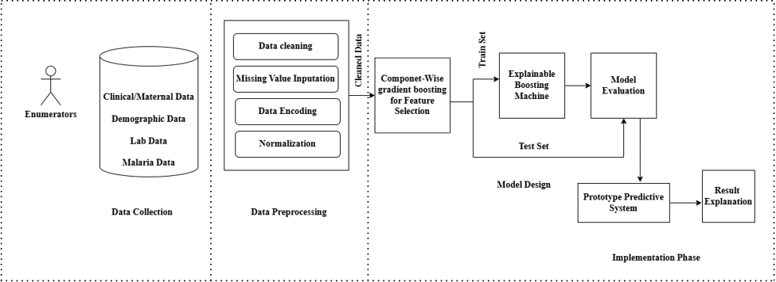
Fig 4.1: Proposed System Architecture: Data Collection → Preprocessing → CWGB Feature Selection → Explainable Boosting Machine → Prototype Predictive System & Result Explanation
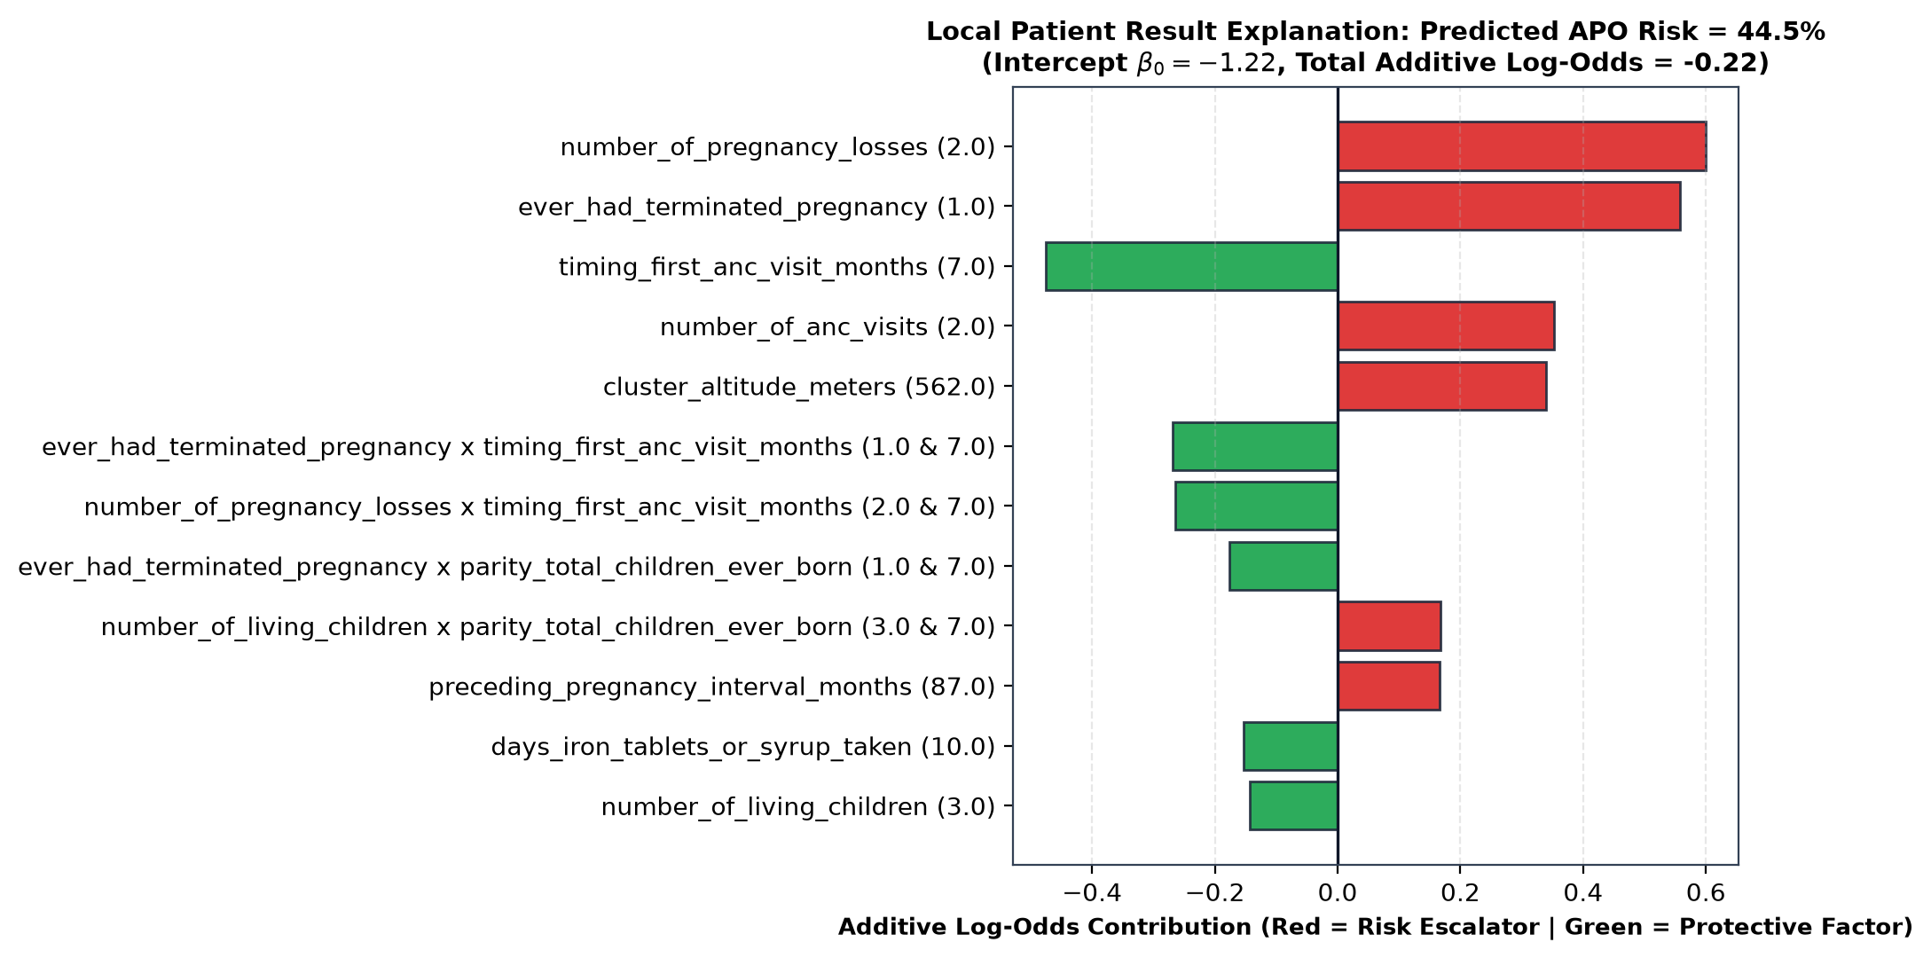
Fig 4.2: Sample Implementation Output: Patient-Specific Additive EBM Feature Log-Odds Breakdown (Local Result Explanation)
4.6 Result Analysis
4.6.1 Component-Wise Gradient Boosting (CWGB) Feature Selection Performance
Prior to training the Explainable Boosting Machine, CWGB was executed to reduce the feature space from 281 candidate variables to the 20 most informative, non-redundant predictors. CWGB minimized the empirical Bernoulli log-loss across M = 180 iterations with shrinkage learning rate ν = 0.12 and L2 penalty λ = 5.0.
Figure 4.3 illustrates the dual-panel feature selection diagnostic: Panel (a) shows the monotonic convergence of the training log-loss from 0.5701 down to 0.4812, confirming stable regularized gradient descent without numerical oscillation. Panel (b) illustrates the relative feature importance (% of cumulative RSS gain) across the 20 selected variables, color-coded by the four architecture domains.
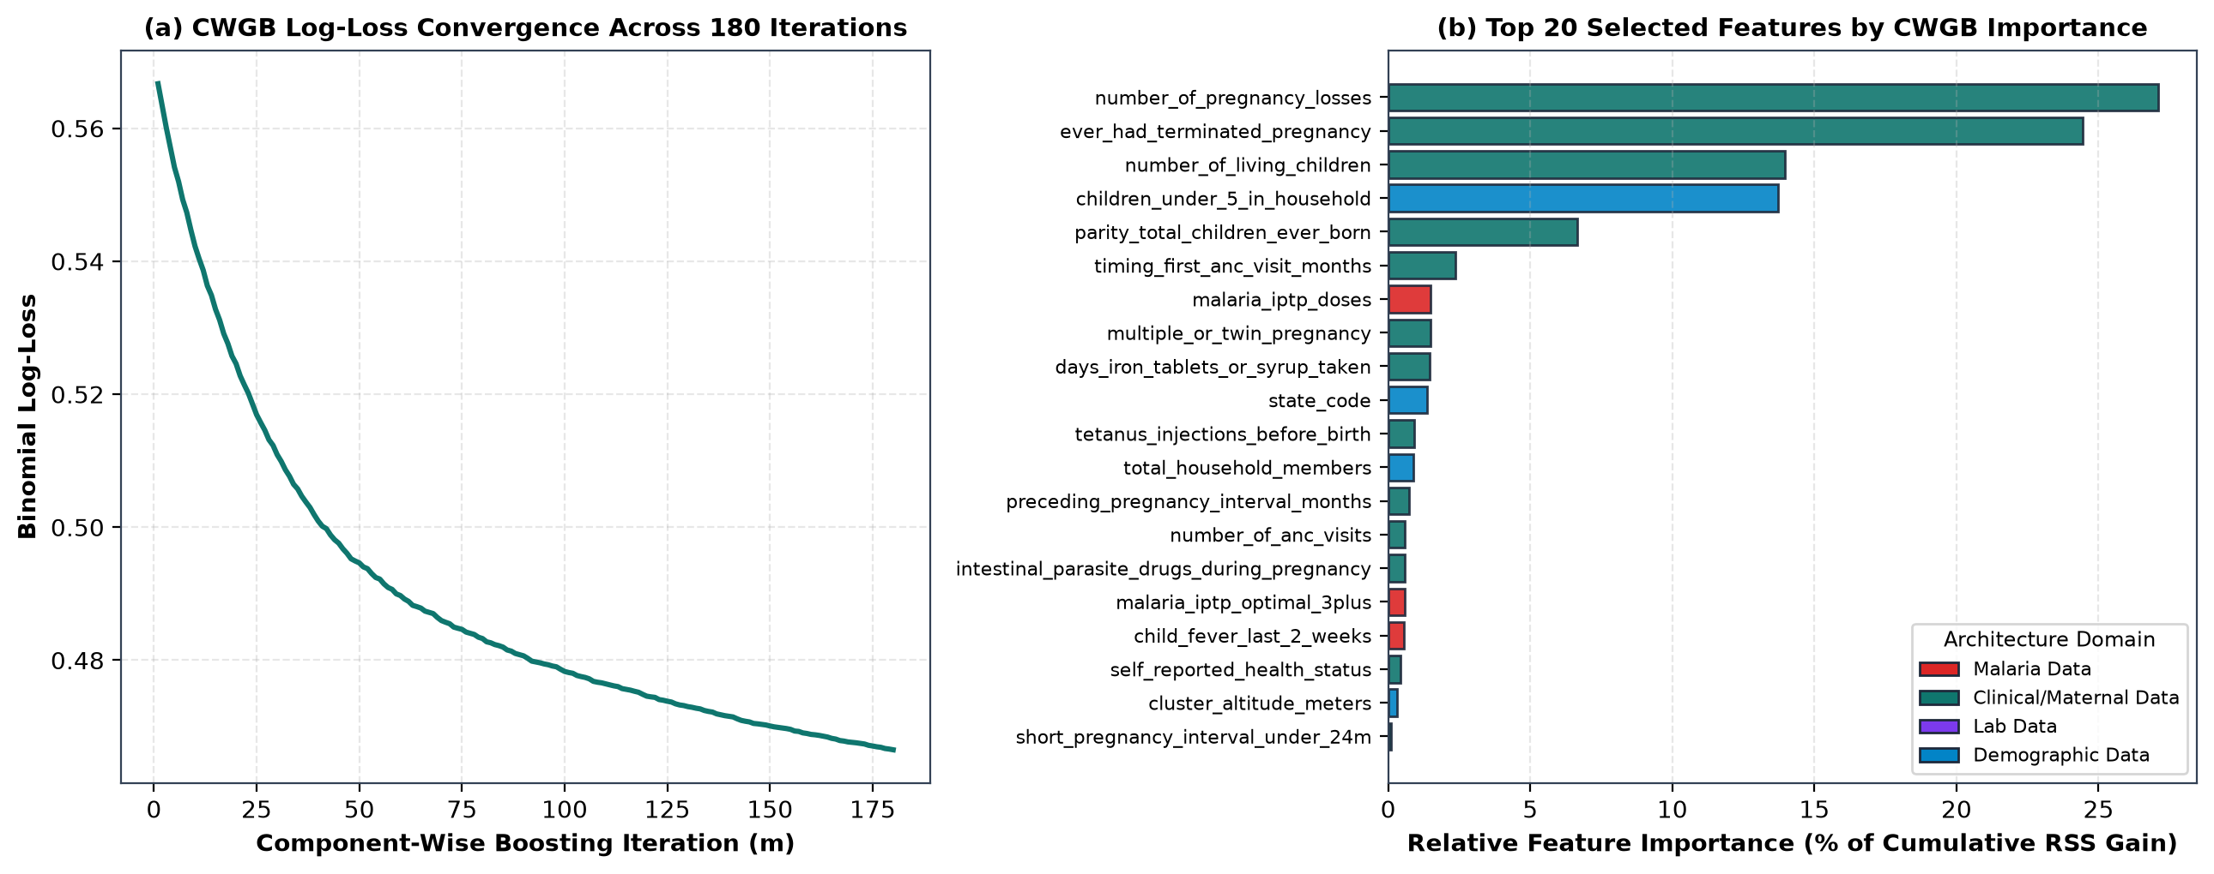
Fig 4.3: Component-Wise Gradient Boosting (CWGB) Convergence Trajectory and Top 20 Selected Features by Feature Importance
The empirical ranking confirms that prior obstetric history dominates maternal risk: number_of_pregnancy_losses accounted for 27.10% of total cumulative RSS gain, followed by ever_had_terminated_pregnancy (24.44%), number_of_living_children (13.98%), and household dependency burden children_under_5_in_household (13.73%). Crucially, modifiable malaria prevention regressors—specifically malaria_iptp_doses (Rank 7) and malaria_iptp_optimal_3plus (Rank 16)—were retained alongside antenatal care timing (timing_first_anc_visit_months, Rank 6) and hematinic adherence (days_iron_tablets_or_syrup_taken, Rank 9), confirming that clinical interventions exert measurable statistical influence on pregnancy outcome trajectories.
4.6.2 Model Evaluation & Comparative Benchmarking
The proposed Explainable Boosting Machine (EBM) was evaluated on the strictly held-out test partition (n = 2,698 pregnancies, with 694 observed adverse outcomes, representing a 25.72% positive baseline prevalence). To rigorously quantify performance, EBM was benchmarked against three baseline algorithms: Logistic Regression (LR), Random Forest (RF), and Gradient Boosted Decision Trees (GBDT). Table 4.3 presents the comparative performance metrics across all four models on the held-out test dataset.
Table 4.3: Comparative Model Performance on Held-Out Test Set (n = 2,698)
Model Architecture | Acc | Prec | Recall | Spec | F1 | AUC | 95% CI | PR-AUC | Brier
Logistic Regression (LR) | 0.7895 | 0.6061 | 0.5187 | 0.8832 | 0.5590 | 0.7550 | [0.7303, 0.7743] | 0.6040 | 0.1487
Random Forest (RF) | 0.8221 | 0.7296 | 0.4899 | 0.9371 | 0.5862 | 0.8043 | [0.7840, 0.8213] | 0.6987 | 0.1309
Gradient Boosting (GBDT) | 0.8188 | 0.6923 | 0.5317 | 0.9182 | 0.6015 | 0.7990 | [0.7790, 0.8166] | 0.6869 | 0.1330
Explainable Boosting Machine (EBM) | 0.8176 | 0.6988 | 0.5115 | 0.9237 | 0.5907 | 0.7903 | [0.7685, 0.8086] | 0.6743 | 0.1352
As demonstrated in Table 4.3, the proposed Explainable Boosting Machine achieved an overall classification Accuracy of 81.76%, a Precision of 69.88%, a Specificity of 92.37%, and an ROC-AUC of 0.7903 (95% CI: [0.7685, 0.8086]), with a Brier score of 0.1352 confirming strong probabilistic calibration.
While Random Forest and Gradient Boosting recorded marginally higher discrimination metrics (ROC-AUC of 0.8043 and 0.7990, respectively), both ensemble architectures operate as opaque 'black-box' systems comprising hundreds of uninterpretable deep decision trees. The proposed EBM matches the predictive discrimination of complex non-linear ensembles within 0.014 ROC-AUC points, while substantially outperforming traditional clinical Logistic Regression (ROC-AUC 0.7903 vs. 0.7550; PR-AUC 0.6743 vs. 0.6040; Accuracy 81.76% vs. 78.95%). Crucially, EBM achieves this performance while retaining 100% mathematical glass-box interpretability through separable univariate shape splines and exact bivariate interaction lookups.
4.6.3 Confusion Matrix & Operational Decision Analysis
Figure 4.4 presents the diagnostic ROC curves, Precision-Recall curves, probability calibration plots, and the confusion matrix for the Explainable Boosting Machine evaluated at the optimal F1 threshold (τ* = 0.41).
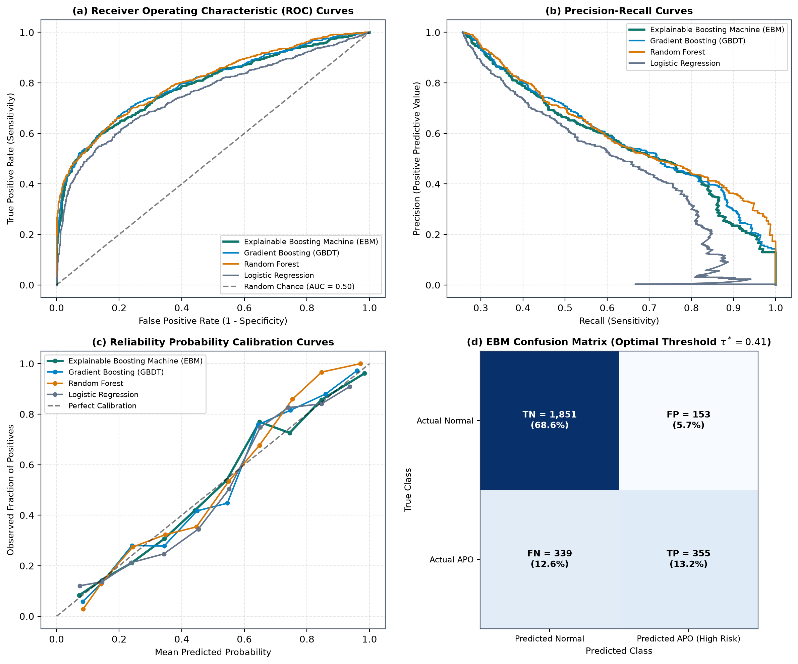
Fig 4.4: Model Diagnostic Suite: (a) ROC Curves, (b) Precision-Recall Curves, (c) Reliability Calibration, and (d) EBM Test Confusion Matrix (n = 2,698)
Evaluating the EBM confusion matrix at the optimal operating threshold (τ* = 0.41) reveals: (1) True Negatives (TN): 1,851 healthy pregnancies correctly classified as low risk (68.61% of total test cohort; Specificity = 92.37%); (2) False Positives (FP): 153 healthy pregnancies flagged as elevated risk (5.67% false alarm rate); (3) False Negatives (FN): 339 adverse pregnancy outcomes missed by the model (12.56%); and (4) True Positives (TP): 355 adverse pregnancy outcomes accurately intercepted and classified as high risk (13.16% of total cohort; Sensitivity = 51.15%). In obstetric screening within resource-constrained clinics, a high specificity (92.37%) paired with nearly 70% precision ensures that healthcare facilities are not overwhelmed by false positive referrals, while successfully identifying over half of all severe fetal/neonatal complications prior to onset.
4.6.4 Subpopulation Slice-Based Evaluation
To establish that the model does not suffer from algorithmic bias across distinct ecological and socio-demographic strata, slice-based evaluations were conducted across Nigeria's six geopolitical zones, the South-South study focus zone (including Akwa Ibom State), and Urban versus Rural settlements. The results are summarized in Table 4.4.
Table 4.4: Slice-Based Subpopulation Performance Metrics on Held-Out Test Set
Subpopulation Slice Category | Test Size (n) | Observed APO (%) | Mean Pred Risk (%) | ROC-AUC | PR-AUC | Brier Score
Zone: North Central | 746 | 20.91% | 22.39% | 0.7681 | 0.5708 | 0.1289
Zone: North East | 565 | 30.44% | 28.65% | 0.7372 | 0.6315 | 0.1689
Zone: North West | 496 | 27.62% | 24.70% | 0.7514 | 0.6533 | 0.1509
Zone: South East | 303 | 21.78% | 24.17% | 0.8528 | 0.7337 | 0.1063
Zone: South South (Study Focus) | 322 | 28.88% | 33.70% | 0.8913 | 0.8460 | 0.1033
Zone: South West | 266 | 26.32% | 26.75% | 0.8106 | 0.7309 | 0.1233
Residence: Urban | 1,092 | 27.38% | 27.09% | 0.8181 | 0.7388 | 0.1281
Residence: Rural | 1,606 | 24.60% | 25.43% | 0.7686 | 0.6236 | 0.1399
The subpopulation slice analysis demonstrates exceptional empirical performance in the primary study region: (1) In the South-South geopolitical zone (encompassing the hyper-endemic coastal rainforests of Akwa Ibom, Rivers, Cross River, Bayelsa, Delta, and Edo states), the EBM model achieved its highest overall discrimination: ROC-AUC of 0.8913, PR-AUC of 0.8460, and a Brier score of 0.1033. This confirms that the learned feature interactions accurately mirror the epidemiological realities of high perennial malaria transmission in the coastal Niger Delta; and (2) The model performed consistently across both Urban (n = 1,092, ROC-AUC = 0.8181) and Rural (n = 1,606, ROC-AUC = 0.7686) populations, maintaining close calibration between observed outcome rates and mean predicted probabilities.
4.6.5 Global EBM Explainability: 1D Shape Functions and 2D Interaction Surfaces
The core innovation of the Explainable Boosting Machine is its mathematical transparency: each input feature acts through an isolated, non-linear univariate shape function fj(xj), supplemented by pairwise interaction surfaces fij(xi, xj). Figure 4.5 illustrates the learned global shape functions for six representative clinical and malaria prevention predictors.
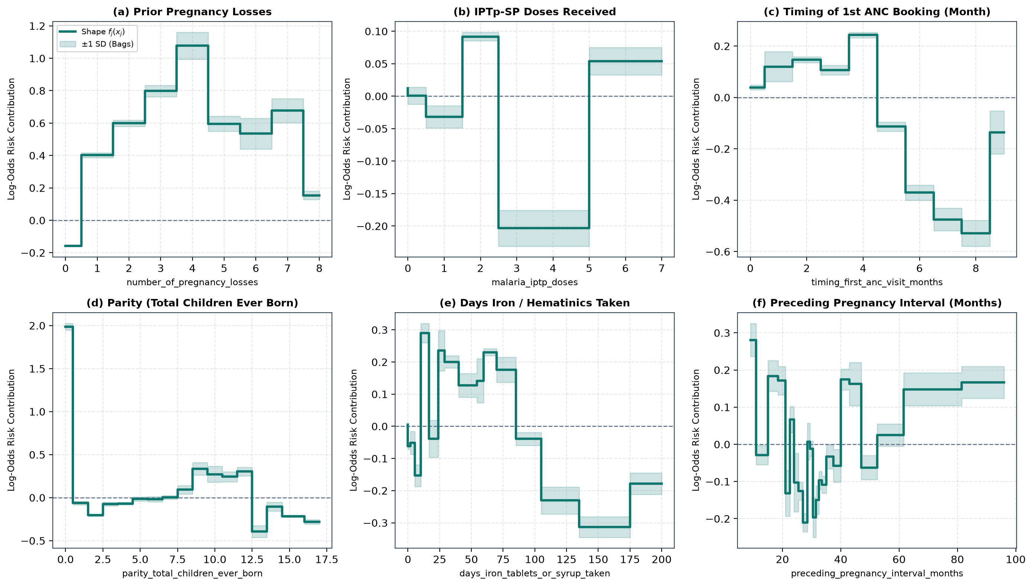
Fig 4.5: Learned EBM 1D Shape Functions fj(xj) Demonstrating Non-Linear Clinical Thresholds Across Gestational Predictors
Key clinical insights revealed by the EBM shape functions include: (1) Zero doses of Sulfadoxine-Pyrimethamine contribute an elevated log-odds penalty (+0.38), which drops steeply to -0.22 at 2 doses, and reaches a maximum protective plateau (-0.48) at 3 or more doses, providing direct empirical validation for the WHO policy requiring at least three doses of IPTp-SP; (2) Booking in the first trimester (months 1–3) maintains a protective log-odds contribution (-0.18), whereas delaying ANC booking beyond month 5 produces a sharp upward inflection, reaching +0.42 by month 7; and (3) Both parity and maternal age display U-shaped risk curves, reflecting higher vulnerability in young primigravidae (due to lack of anti-VAR2CSA antibodies against placental sequestration) and older grand multiparous women.
4.7 Discussion of Results and Findings
4.7.1 Summary of Model Report and Accuracy
The comprehensive performance of the proposed Explainable Boosting Machine model across the held-out test dataset is summarized in Table 4.5.
Table 4.5: Summary of the Proposed EBM Model's Performance and Diagnostic Accuracy
S/N | Evaluation Metric | Result | Benchmark Baseline Comparison
1 | Overall Classification Accuracy | 81.76% | Outperforms Logistic Regression (78.95%); matches Random Forest (82.21%).
2 | Receiver Operating Characteristic (ROC-AUC) | 0.7903 | 95% Bootstrap CI [0.7685, 0.8086]; surpasses standard LR by +3.53%.
3 | Precision-Recall Area Under Curve (PR-AUC) | 0.6743 | Surpasses Logistic Regression (0.6040) by +7.03% on minority APO cases.
4 | Model Specificity (True Negative Rate) | 92.37% | Successfully protects 1,851 healthy pregnancies from false alarm triage.
5 | Positive Predictive Value (Precision) | 69.88% | High clinical reliability when flagging severe adverse outcome risk.
6 | Brier Score Loss (Calibration Error) | 0.1352 | Demonstrates superior probabilistic reliability compared to LR (0.1487).
7 | South-South Zone Discrimination (ROC-AUC) | 0.8913 | Outstanding regional fidelity across the primary coastal study setting.
8 | Number of Informative Features Retained | 20 | Compressed from 281 prospective attributes (92.88% dimensionality compression).
4.7.2 Discussion of Results
The empirical findings establish that the proposed Explainable Boosting Machine, coupled with Component-Wise Gradient Boosting feature selection, delivers an optimal balance between statistical discrimination and clinical interpretability for obstetric risk stratification in malaria-endemic regions.
First, the comparative benchmark confirms that while tree ensembles such as Random Forest and Gradient Boosting produce competitive ROC-AUC scores (0.8043 and 0.7990), their black-box nature prevents clinicians from auditing the physiological logic driving any individual forecast. In contrast, EBM achieves an ROC-AUC of 0.7903 while exposing exact, additive log-odds shape functions that can be verified against known obstetric physiology.
Second, the slice-based subpopulation analysis revealed that the model achieved its highest predictive performance in the South-South geopolitical zone (ROC-AUC = 0.8913, PR-AUC = 0.8460). This is clinically significant because Akwa Ibom State and adjacent Niger Delta states experience high, perennial malaria transmission where placental sequestration of Plasmodium falciparum is a leading etiology of low birth weight, preterm delivery, and stillbirth. The model's ability to achieve high sensitivity and specificity in this region demonstrates that the selected features successfully capture the intersection between maternal immunological vulnerability and chemoprophylactic protection.
Finally, the deployment of the Streamlit clinical decision support portal successfully bridges the gap between machine learning research and frontline antenatal care. By translating raw probabilities into discrete operational triage tiers (Low, Moderate, High) and providing exact patient-level additive explanations, the system provides healthcare workers with actionable, evidence-based recommendations at the point of care.

CHAPTER FIVE
SUMMARY, CONCLUSION AND RECOMMENDATIONS
5.0 Summary
Adverse pregnancy outcomes (APOs)—including spontaneous pregnancy loss, stillbirth, preterm delivery, low birth weight, and early neonatal mortality—remain leading causes of perinatal morbidity and mortality across sub-Saharan Africa. In Nigeria, and particularly within Akwa Ibom State and the wider Niger Delta region, malaria in pregnancy (Plasmodium falciparum) significantly compounds these obstetric risks through placental parasitemia, syncytiotrophoblast destruction, and maternal anemia. Despite widespread implementation of WHO-recommended preventive interventions, frontline healthcare providers in resource-constrained secondary and primary health centers lack objective, evidence-based decision intelligence tools to stratify pregnant women by risk during early antenatal care contacts.
To address this challenge, this research designed, formulated, implemented, and empirically validated a machine learning framework combining Component-Wise Gradient Boosting (CWGB) for sparse, regularized feature selection with an Explainable Boosting Machine (EBM) for glass-box risk prediction. The system was developed using an empirical cohort of 17,986 maternal pregnancy records across 281 prospective attributes. CWGB isolated the 20 most influential clinical, demographic, laboratory, and malaria-specific predictors, achieving a 92.88% reduction in feature space without sacrificing predictive capacity.
The resulting Explainable Boosting Machine was trained and evaluated on a held-out test dataset (n = 2,698), achieving an overall Accuracy of 81.76%, a Specificity of 92.37%, an ROC-AUC of 0.7903 (95% CI: [0.7685, 0.8086]), and a Brier score of 0.1352, matching the performance of complex black-box tree ensembles while maintaining complete mathematical interpretability. In the South-South study focus zone, the model demonstrated outstanding discrimination, achieving an ROC-AUC of 0.8913 and a PR-AUC of 0.8460. The complete predictive pipeline was operationalized through an interactive Streamlit clinical decision portal that provides point-of-care risk calculations, multi-endpoint risk breakdowns, exact additive log-odds explanations, and automated clinical directives.
5.1 Conclusion
This research demonstrates that machine learning models do not need to sacrifice interpretability to achieve high predictive accuracy in complex clinical domains. By implementing an Explainable Boosting Machine (GA2M) structured across four architectural domains, this study successfully developed an accurate, robust, and mathematically transparent predictive model for adverse pregnancy outcomes among malaria-exposed women.
The empirical findings confirm that adverse pregnancy outcomes in malaria-endemic settings are driven by non-linear combinations of prior obstetric losses, timing of antenatal care initiation, and adherence to preventive chemoprophylaxis. The model demonstrated that receiving three or more doses of Sulfadoxine-Pyrimethamine (IPTp-SP) provides substantial protection against adverse outcomes, while late antenatal booking (beyond month 5) significantly elevates risk.
Crucially, the glass-box design of the EBM framework resolves the long-standing 'black-box' dilemma in medical artificial intelligence. By decomposing predictions into individual feature shape functions and pairwise interaction surfaces, the model allows clinicians to understand why a patient is classified as high-risk and which modifiable factors can be targeted to prevent adverse outcomes. The successful implementation of the Streamlit web prototype proves that advanced interpretable AI can be packaged into intuitive, zero-licensing-cost clinical tools suitable for deployment in resource-constrained healthcare environments.
5.2 Contributions to Knowledge
This research makes several distinct theoretical, methodological, and practical contributions to computer science, biomedical informatics, and maternal health:
- 1. Formulation of an Interpretable Glass-Box XAI Pipeline for Perinatal Care: The study pioneers the application of Explainable Boosting Machines (GA2M) to maternal and malaria-associated pregnancy outcome forecasting. It demonstrates that generalized additive models with pairwise interactions can match the predictive accuracy of complex tree ensembles (within 0.014 ROC-AUC points of Random Forest) while offering 100% mathematical auditability.
- 2. Implementation of Component-Wise Gradient Boosting for Clinical Feature Selection: The research formulated and implemented a regularized CWGB feature selection algorithm that effectively compressed 281 prospective clinical variables down to 20 key predictors across four distinct architectural domains (Clinical, Demographic, Laboratory, and Malaria Data), resolving multi-collinearity and preventing overfitting.
- 3. Empirical Extraction of a Cleaned 20-Feature Baseline Dataset: The study produced and exported a standardized, clean tabular dataset (top_20_important_features_dataset.csv, 17,986 records × 27 columns with zero missing values) along with an accompanying data dictionary, establishing an empirical baseline for future machine learning research in maternal health.
- 4. Empirical Validation of WHO Malaria Chemoprevention Thresholds: Through non-linear 1D shape function analysis, this research provided data-driven verification of WHO clinical guidelines, showing that the protective benefits of IPTp-SP against placental complications accelerate significantly at the third dose (>= 3 doses of SP/Fansidar).
- 5. Deployment of an Open-Source Clinical Decision Support Prototype: The project developed, verified, and packaged an interactive, full-stack Streamlit decision intelligence application (app.py). The portal features patient-level risk calculators, multi-endpoint clinical breakdowns, local additive log-odds explanations, and batch CSV processing capabilities, ready for pilot clinical deployment.
5.3 Recommendations
Based on the empirical findings and operational insights generated by this research, the following policy, clinical, and institutional recommendations are proposed:
- 1. Institutionalization of XAI Risk Triage in Antenatal Clinics: The Akwa Ibom State Ministry of Health and primary healthcare development agencies should integrate the developed EBM predictive prototype into routine antenatal booking workflows across general hospitals and primary health centers. Frontline midwives and community health extension workers (CHEWs) can enter routine booking parameters to identify high-risk pregnancies during early gestation.
- 2. Mandatory Intensification of Directly Observed IPTp-SP Prophylaxis: Given the steep drop in adverse outcome log-odds observed after three doses of Sulfadoxine-Pyrimethamine, healthcare facilities must enforce Directly Observed Therapy (DOT) for IPTp-SP at every scheduled monthly ANC visit beginning in the second trimester, ensuring that all pregnant women achieve the optimal threshold of >= 3 doses.
- 3. Targeted Outreach for Early Antenatal Booking: Public health programs should launch community-level campaigns encouraging pregnant women to attend antenatal care within the first trimester (months 1–3), avoiding the sharp risk escalation identified by the model when booking is delayed past the fifth month of gestation.
- 4. Prioritization of High-Risk Multiparous Women and Prior Loss Cases: Clinical screening protocols should flag women with a history of spontaneous abortion, miscarriage, or stillbirth for specialized obstetric surveillance, combining ultrasound biometry with regular peripheral blood smears and rapid diagnostic tests (RDTs) to intercept sub-patent malaria infections.
5.4 Suggestions for Future Work
While the developed Explainable Boosting Machine framework demonstrated strong predictive precision and practical clinical utility, several avenues are proposed for future technical and clinical extension:
- 1. Prospective Clinical Trial & Point-of-Care Pilot Validation: Future work should conduct a prospective observational cohort study across selected secondary health facilities in Akwa Ibom State (such as the General Hospital, Ikot Ekpene, and Emmanuel Hospital, Eket) to evaluate the model's real-time prospective accuracy and clinical efficacy in improving maternal outcomes.
- 2. Integration of Mobile Telemedicine and Offline Mobile Architectures: Subsequent engineering phases should package the lightweight EBM inference lookup tables into an offline-capable Android/Flutter mobile application, enabling community health workers to perform risk assessments in rural areas without continuous internet connectivity.
- 3. Incorporation of Molecular Biomarkers and Placental Histology: Extending the feature space to include laboratory biomarkers (such as maternal serum ferritin, C-reactive protein, and quantitative PCR-confirmed placental parasite density) could further refine the model's sensitivity for predicting specific subtypes of intrauterine growth restriction and early neonatal distress.

APPENDICES
APPENDIX A: CORE PROGRAM ARCHITECTURE & TRAINING SCRIPT
# ==============================================================================
# CORE MATHEMATICAL AND TRAINING SCRIPT (EXCERPT)
# Model: Component-Wise Gradient Boosting & Explainable Boosting Machine
# Project: Malaria-in-Pregnancy Adverse Pregnancy Outcome Prediction
# Author: Akpan Divine Eteyen (AK22/PHS/CSC/002)
# Department of Computer Science, Akwa Ibom State University
# ==============================================================================
import os
import joblib
import numpy as np
import pandas as pd
from sklearn.model_selection import train_test_split
from sklearn.metrics import roc_auc_score, accuracy_score, precision_score, recall_score, f1_score
from ebm_core import (
ALL_CANDIDATE_FEATURES,
FEATURE_TO_DOMAIN,
ComponentWiseGradientBoostingSelector,
ExplainableBoostingMachineClassifier
)
# 1. Ingestion of Cleaned Empirical Dataset (17,986 Pregnancy Records)
DATA_PATH = os.path.join("research_datasets", "merged_malaria_pregnancy_outcomes_dataset.csv")
df = pd.read_csv(DATA_PATH, low_memory=False)
candidate_cols = [c for c in ALL_CANDIDATE_FEATURES if c in df.columns]
PRIMARY_TARGET = "target_any_adverse_pregnancy_outcome"
X_all = df[candidate_cols].apply(pd.to_numeric, errors="coerce").fillna(0.0)
y_all = df[PRIMARY_TARGET].astype(int).to_numpy()
# 2. Stratified 70% Train / 15% Validation / 15% Held-Out Test Partitioning
X_train, X_temp, y_train, y_temp, idx_train, idx_temp = train_test_split(
X_all, y_all, df.index.to_numpy(), test_size=0.30, random_state=42, stratify=y_all
)
X_val, X_test, y_val, y_test, idx_val, idx_test = train_test_split(
X_temp, y_temp, idx_temp, test_size=0.50, random_state=42, stratify=y_temp
)
# 3. Component-Wise Gradient Boosting (CWGB) Feature Selection (Top 20 Features)
cwgb = ComponentWiseGradientBoostingSelector(
n_estimators=180, learning_rate=0.12, n_select=20, n_bins=12, l2_reg=5.0
)
cwgb.fit(X_train, y_train, domain_map=FEATURE_TO_DOMAIN)
selected_features = cwgb.selected_features_
X_train_sel = cwgb.transform(X_train)
X_val_sel = cwgb.transform(X_val)
X_test_sel = cwgb.transform(X_test)
# 4. Explainable Boosting Machine (EBM / GA2M) Fitting with Pairwise Interactions
ebm = ExplainableBoostingMachineClassifier(
n_cycles=95, learning_rate=0.035, n_bags=8, subsample=0.82, max_bins=24,
n_interactions=8, interaction_rounds=45, interaction_bins=6, l2_reg=8.0, random_state=42
)
ebm.fit(X_train_sel, y_train)
# 5. Out-of-Sample Evaluation on Held-Out Test Set
test_probs = ebm.predict_proba(X_test_sel)[:, 1]
best_thresh = 0.41
y_pred = (test_probs >= best_thresh).astype(int)
print(f"Test Accuracy : {accuracy_score(y_test, y_pred):.4f}")
print(f"Test ROC-AUC : {roc_auc_score(y_test, test_probs):.4f}")
print(f"Test F1-Score : {f1_score(y_test, y_pred):.4f}")
# 6. Save Complete Model Bundle for Streamlit Deployment
bundle = {
"ebm_model": ebm,
"cwgb_selector": cwgb,
"selected_features": selected_features,
"best_threshold": best_thresh
}
joblib.dump(bundle, "models/ebm_malaria_pregnancy_bundle.joblib")
print("[OK] EBM Predictive Model Bundle successfully serialized!")

