PREDICTIVE CREDIT RISK MODELING AND LOAN APPROVAL FRAMEWORK USING RANDOM FOREST AND XGBOOST

BY

ARCHIBONG, GOODNEWS EMMANUEL
AK22/PHS/CSC/009

DEPARTMENT OF COMPUTER SCIENCE
FACULTY OF COMPUTING AND INFORMATION TECHNOLOGY
AKWA IBOM STATE UNIVERSITY
IKOT AKPADEN, MKPAT ENIN L.G.A,
AKWA IBOM STATE, NIGERIA.

In partial Fulfilment of the requirement for the Award of Bachelor of Science (B.sc) Degree in Computer Science

AUGUST, 2026

CERTIFICATION
This is to certify that this research work entitled:
"A PREDICTIVE CREDIT RISK MODELING AND LOAN APPROVAL FRAMEWORK USING RANDOM FOREST AND XGBOOST"
was carried out by Archibong, Goodnews Emmanuel with Registration Number AK22/PHS/CSC/009 in the Department of Computer Science, Faculty of Computing and Information Technology, Akwa Ibom State University, in partial fulfillment of the requirements for the award of the degree of Bachelor of Science (B.Sc.) in Computer Science.
This work has not been presented elsewhere for the award of a degree. Except as referenced, this is an original work done by me

Archibong, Goodnews Emmanuel ____________________
(Student)
Signature/Date

APPROVAL PAGE

This research work titled “A PREDICTIVE CREDIT RISK MODELING AND LOAN APPROVAL FRAMEWORK USING RANDOM FOREST AND XGBOOST” by Archibong, Goodnws Emmanuel with registration number AK22/PHS/CSC/009 has been approved by the Department of Computer Science, Faculty of Computing and Information Technology, Akwa Ibom State University as a document of the Department by:

Dr, Idara I. James _______________
(Project Supervisor) Signature/Date

Dr. Ifreke J. Udoeka _______________
(Ag.HOD, Computer Science) Signature/Date

TABLE OF CONTENT
CONTENT Page
CERTIFICATION 2
APPROVAL PAGE 3
CHAPTER ONE : INTRODUCTION 4
1.1 BACKGROUND OF STUDY 4
1.2 STATEMENT OF PROBLEM 9
1.3 AIM AND OBJECTIVE 10
1.4 SIGNIFICANCE OF STUDY 11
1.5 SCOPE OF STUDY 12
1.6 LIMITATION 13
1.7 DEFINITION OF TERMS 14
CHAPTER TWO : LITERATURE REVIEW 17
2.1 INTRODUCTION 17
2.2 CONCEPTUAL FRAMEWORK 17
2.2.1 Credit Risk 17
2.2.2 Loan Approval System: 22
2.2.3 Machine Learning: 24
2.2.4 Machine Learning in Credit Risk Assessment and Loan Approval 26
2.2.5 The Random Forest Algorithm: 28
2.2.6 The Extreme Gradient Boosting (XGBoost) Algorithm: 31
2.2.7 Comparison of Random Forest and XGBoost 33
2.2.8 Performance Evaluation Metrics: 36
2.3 RELATED LITERATURE 39
2.3.1 Review of Related Literature: 39
2.4 RESEARCH GAP 59
CHAPTER THREE : SYSTEM ANALYSIS AND METHODOLOGY 60
3.1 INTRODUCTION 60
3.2 SYSTEM ANALYSIS 60
3.3 ANALYSIS OF THE EXISTING SYSTEM 61
3.3.1 Architecture of the Existing System 62
3.3.2 Problems of the Existing System 64
3.4 Research Methodology 65
3.4.1 Justification of Research Methodology 66
3.5 Research Design 67
3.5.1 Study Area / Source of Data 67
3.5.2 Population of the Study 68
3.5.3 Sampling Technique 68
3.5.4 Data Collection Instrument 68
3.5.5 Method of Data Analysis 69
3.6 Analysis of proposed system
3.6.1 Architecture of proposed system
3.6.2 Justification/Advantages of proposed system
3.6.3 System Design
3.6.4 Algorithm/Pseudocode and Models

INTRODUCTION

BACKGROUND OF STUDY
Lending is the lifeblood of the financial sector and a prerequisite for economic growth, since it puts financial resources within reach of both businesses and individuals. Yet for the financial institution the paramount concern is one of repayment: can the applicant honour what he or she has borrowed? A misjudged loan can result in default and a loss to the bottom line, not to mention added operational risk. Hence credit risk assessment is an integral part of any loan approval.
In the past, banks would have relied on statistical models and a degree of manual appraisal to judge a customer’s creditworthiness. The decision to extend a loan was based on such factors as income, employment, how one has managed his debt and the like, as well as the person’s credit history and debt payments. Over time these are useful methods, but they do not hold up as well when confronted with the growing volume of applications and the ever more complicated nature of the data at hand. There is a need for techniques of greater intelligence and efficiency to see an improvement in the precision of the credit risk assessment.
Digital technologies and a data-driven approach to financial services have seen a change in the way lending is done. Institutions are amassing large amounts of customer data for the purpose of analysing borrower behaviour patterns. This has given impetus to machine learning; unlike the older statistical methods which require certain assumptions, machine learning can make its predictions from the data of yesteryear. It will find correlations in the data that traditional approaches would miss and so arrive at a better read on the likelihood of default or repayment.
In recent years, machine learning methods have been found to greatly enhance the understanding of credit risk. Sharma and Chiu (2026) found that machine learning models can be trained to accurately predict borrower default based on several customer data points, all of which are used in combination. Based on their findings, they believe that data-driven models offer lenders useful insights to help enhance risk management strategies and guide lending decisions. In the same way, Rawat et al. (2026) found that the risk assessment system using machine learning (ML) outperforms many traditional credit scoring methods, especially in assessing borrower attributes, including income stability, debt to income ratio, interest rates and loan periods.
A lot of use of machine learning in finance is due to the need for quicker and more accurate loan decisions. Manual assessment methods become even more time-consuming and may be subject to inconsistencies as the quantity of loan applications keeps growing. According to Akusta (2026), loan evaluations that are inaccurate can result in either high-risk borrowers being approved for loans, or in eligible borrowers being denied loans. That can have a negative impact not just on customers, but also on financial institutions. Therefore, an automated decision-support system is becoming more and more relevant in today's lending scenario.
Numerous machine learning algorithms have been developed for the purpose of credit risk assessment. Of them, ensemble learning algorithms are among the most interesting approaches thanks to their superior prediction performance. The Random Forest is one of the most widely utilized algorithms for building decision tree models to predict certain outcomes on the basis of multiple factors. Its advantage lies in its ability to work effectively with large datasets containing incomplete information and noise as well as nonlinear dependencies. As shown by the results obtained by Pratama et al. (2024), the Random Forest algorithm works very efficiently when it comes to selecting significant factors in terms of predicting credit risk.
Another interesting machine learning algorithm used in finance is Extreme Gradient Boosting (XGBoost). It aims to optimize performance by using weak learners for training an enhanced classifier. As pointed out by Yu et al. (2024), the algorithm can be used to achieve high accuracy in predicting loans' acceptability. The same conclusion was reached by Mora and Cardenas (2025), who compared the performance of XGBoost against other popular approaches for credit risk assessment. According to their findings, XGBoost proved to be superior to other algorithms in classifying creditworthy borrowers.
In as much as lending makes available financial resources to businesses and individuals, it is the lifeblood of the financial sector, and essential to economic development. However, the most important question which the financial institution would want to ask themselves in this regard is if the borrower is able to pay back what he/she borrowed. Bad loans can lead to losses on the bottom line as well as a rise in operating risk; both of which can be avoided with a well-made loan. So it is integral as part of approving any loan to evaluate the credit risk for it.
In past times, a bank would have used statistical evaluation models and a certain amount of subjective appraisal to determine whether the customer is creditworthy or not. Such as his debt payments, the way one handles his debt and the like, even income and employment; his credit rating and his debt payments were all considered when deciding whether to assign a loan to someone. These will eventually help but as the number of applications increase and the data grows more complex, they do not stand the test of time. Greater intelligence and efficiency is needed on the credit risk assessment side: Techniques to improve the accuracy of credit risk estimates are required.
Digital technologies and a data-driven approach to financial services have seen a change in the way lending is done. Banks have been gathering vast amounts of customer data to use for analysing borrower behaviour patterns. This has given impetus to machine learning; unlike the older statistical methods which require certain assumptions, machine learning can make its predictions from the data of yesteryear. It will be able to look for correlations in the data that conventional methods could not detect and generate a more accurate perspective on the default or repay-ability of the loans.
Machine learning techniques in recent years have been seen to considerably improve credit risk understanding. They concluded that various models based on machine learning can be trained to accurately predict borrower default using several data points from the customer, all of which are used together (Sharma and Chiu, 2026). Based on their findings, they believe that data-driven models offer lenders useful insights to help enhance risk management strategies and guide lending decisions. Similarly, the risk assessment system (RAS) with the machine learning (ML) algorithm performs better than traditional credit scoring systems particularly for evaluating debt to income ratio (DTI) of borrowers, interest rates, and loan periods among others (Rawat et al., 2026).
A lot of use of machine learning in finance is due to the need for quicker and more accurate loan decisions. As the number of loan applications continues to increase, manual assessment techniques further grow longer and can have inconsistencies. An inaccurate evaluation can lead to either of two problems: Akusta (2026) indicates that high-risk borrowers will get loans, and (or) the eligible borrower will not receive loans. That can have a negative impact not just on customers, but also on financial institutions. Hence, the ever-increasing relevance of automated decision-making system in the lending scenario.
There are many machine learning algorithms that have been created to tackle the problem of credit risk assessment. Among them, one area of particular interest is ensemble learning algorithms, which demonstrate great prediction performance. Random Forest algorithm is one most commonly used algorithm that can be used for building multiple decision tree models, which can be used to predict certain outcomes based on multiple factors. It is particularly advantageous with datasets that are big, are incomplete, have noise, and may have nonlinear relationships. As shown by the results obtained by Pratama et al. (2024), the Random Forest algorithm works very efficiently when it comes to selecting significant factors in terms of predicting credit risk.
Another interesting algorithm to address in ML applications to the finance industry is Extreme Gradient Boosting (XGBoost). It sets out to optimise the performance by calling upon weak classifiers for training an improved classifier. As pointed out by Yu et al. (2024), the algorithm can be used to achieve high accuracy in predicting loans' acceptability. Mora and Cardenas 2025 reached the same conclusion by investigating the performance of XGBoost compared to other popular methods in the field of credit risk assessment. XGBoost emerged as better performing than other did in their study to determine the printability of the creditworthy borrower.
Ensemble methods' effectiveness has been further confirmed by comparative studies of various machine learning techniques. In the context of loan default risk prediction, Wu (2022) found satisfactory performance with Random Forest and XGBoost. In a loan default risk prediction scenario, Wu (2022) obtained satisfactory performance with Random Forest (RF) and XGBoost. Likewise, Silvanus et al. (2022) found that the boosted methods outperformed a few traditional credit risk assessment techniques. The findings of the results demonstrate that machine learning/multimodal ensemble models have a greater potential for solving the financial risk prediction problems.
While the prediction capability of machine learning algorithms is impressive, there are still issues faced by financial institutions regarding explainability. Lending decisions have serious consequences for applicants; hence, it is crucial to ensure that these decisions are easy to comprehend from the standpoint of predictive models. While for more advanced techniques such as XGBoost, there is a tendency to favour better prediction accuracy, it is especially important to emphasize the role of explainability in such instances (Mouka, 2026). The study outcomes revealed that using XAI methods would be feasible to identify how borrower attributes influence lending decisions.
Even though there are many studies that showed there can be some improvement in the risk assessment that can be achieved by using machine learning approaches, there are some firms, particularly those in developing countries that still tend to use simple risk assessment approaches. This method could risk impacting the assessment and decision making of the borrower when it comes to lending.
There is however a need to build intelligent system that will utilize advanced machine learning approaches to assist in loan applications and credit risk evaluation processes in this context. Considering all the information presented above, it is recommended that the present study should investigate the feasibility of developing Credit Risk Assessment and Loan Approval Prediction System using the Machine Learning technique. This research aims at comparing and evaluating the efficiency of both Random Forest and XGBoost methods for prediction of credit risk and / or credit decisions.
The loan default issue remains to be a challenge for both the commercial banks and online lending organisations in Akwa Ibom State. The number of individuals demanding loans is growing, and so is the need for a method of credit rating which will effectively be able to classify risky and non-risky borrowers. This can be achieved through the machine learning algorithms.

STATEMENT OF PROBLEM
The services of loans have become a more popular way to get financial assistance in general in Akwa Ibom State. However, credit risk is a perennial issue for the lending institutions in assessing the credit risk of lending applicants in the best manner possible. However, suboptimal assessment can lead to inaccurate decisions and end up with high-risk borrowers defaulting. In some cases, conventional loan assessment models perform a manual assessment followed by a simple scoring process. Therefore, those who are not risked may not be able to obtain the loan whereas the ones who are risked will obtain the required amount. This has led to the rise of modernization and digital banking services as well as fintech solutions in Akwa Ibom, requiring more sophisticated and innovative credit risk assessment and credit lending approaches. Application of machine learning models like Random Forest and XGBoost will have no problems and will deliver more results than the use of conventional models will. Despite these developments, there has not been a broader uptake of these machine learning models to appraise the credit risk or creditworthiness in the majority of the financial institutions in Nigeria. Therefore, there is a need to build a model that will be able to improve the credit risk assessment and decision making for approval of a loan. The objective of this study is to create Machine Learning based predictive model for Credit Risk Assessment & Loan Approval Decision Making using different algorithms in Random Forest and XGBoost to better assist the financial institutions in making better lending decisions.

AIM AND OBJECTIVE
The aim of this study is to construct a machine learning-based credit risk assessment and loan approval prediction system by applying Random Forest and XGBoost algorithms.
The specific objectives of the study include:
- Acquiring relevant credit data and loan application data from bank customers in Akwa Ibom State.
- Cleaning the credit data and conducting exploratory data analysis through the implementation of relevant techniques.
- Developing a credit risk assessment and loan approval prediction framework using Random Forest and XGBoost algorithms.
- Formulating a machine learning model based on Random Forest and XGBoost algorithms capable of determining the creditworthiness of loan applicants and predicting loan approval status.
- Analysing the performance of the developed models by means of metrics such as Accuracy, Precision, Recall, F1-Score, and Area Under the Curve (AUC).
- Comparing Random Forest and XGBoost in terms of the effectiveness of credit risk assessment and loan approval prediction.
- Predicting and classifying future loans in terms of whether they will be approved or not.

SIGNIFICANCE OF STUDY
The basis for the Research Study is the problem posed by the researcher in the paper which is the credit risk assessment and loan default problem which has arisen among financial institutions in Akwa Ibom State as a result of the growing demand for loans from individual, small businesses and corporate entities. It has become crucial for state financial institutions to identify good credit applicants and reduce the risks of lending, hence the importance of the need for the financial institutions to adopt a certain measure to address the said issues.
The findings from the research study will be beneficial to commercial banks, microfinance bank, co-operatives and digital lending company, particularly the machine learning algorithm they develop will assist them in making more prompt and righteous decisions as this will help to pull down the incidence of loan default.
Moreover, the research work will also help in the enhancement of the digital financial services in Akwa Ibom State as it will demonstrate the application of the advanced machine learning algorithms such as Random Forest and XGBoost algorithms to solve existing loan approval and credit risk assessment problems.
Additionally, research findings will guide researchers, students and scholars studying or doing research in the areas of machine learning, FinTech, credit risk analysis and intelligent loan approvals system of Akwa Ibom state or any other state of interest.
Finally, the research will contribute to the economic development in Akwa Ibom State by making bank credit facilities more available because of a more accurate, objective and efficient loan assessment procedure.

SCOPE OF STUDY
The study aims to create a Machine Learning Credit Risk Assessment and Loan Approval Prediction System using the Random Forest and XGBoost algorithm. The major aim of the study is to reduce the loan application problems based on credit risk assessment in financial institutions in the study area, Akwa Ibom state, Nigeria.
The study includes data gathering from the respondents in Akwa Ibom State, data pre-processing, data exploration, feature selection, developing the model, training, testing and evaluating the performance of the models. Developed models will be used to predict whether loans will be approved based on the borrowers' set of characteristics and to perform credit risk assessment. Some of these factors are income, employment status, credit history, loan value, savings, various financial measures etc.
In this research, two different machine learning methods have been applied: Random Forest and XGBoost algorithms, and the prediction power of both of them has been assessed by different evaluation metrics such as Accuracy, Precision, Recall, F1-Score and Area Under the receiver operating characteristic Curve (AUC-ROC). Machine learning and deep learning techniques apart from these two are not covered in this research.
Though viability and applicability of the proposed models to solve the challenges faced by financial institutions in Akwa Ibom State regarding credit risk assessment and loan approval process would depends on the nature of data used in this study, the credit risk assessment decision support schedule model was more significant compared to other models. The financial institutions in Akwa Ibom State experienced challenges in the credit risk assessment and loan approval process and the credit risk assessment decision support schedule model was found to be more important than the other models, but the feasibility and applicability of the models introduced would depend on the type of data used in this study.

LIMITATION
There were many restrictions in implementing this study. Firstly, the problem of availability of data was encountered. This was because customers' financial information is kept confidential, making it challenging to access customer's historical loans data from commercial banks located at Akwa Ibom State. The study mainly involves primary data gathered from the customers of banks who have taken loans in the past through Google Form, a survey based on that.
Sample size and scope was a problem as well. The study was conducted with the studied customers of commercial banks located at Akwa Ibom State. Therefore, the inferences made from this study should not be used in making inferences for commercial banks in other parts of Nigeria.
Two models were chosen for this study: Random Forest and Extreme Gradient Boosting (XGBoost). However, there are other machine learning algorithms that could have been considered; however, since this study was focused on the performance comparison of these two models, the other algorithms were ignored.
Furthermore, the validation of the framework developed would be influenced by the accuracy and truthfulness of the information given by the respondents on the Google Form based questionnaire. Whether or not data preprocessing methods are used, the inaccuracy of any of the responses could impact the predictions of the models created.
However, regardless of these limitations, the right techniques for data cleaning, preprocessing, and assessment were utilized in order to make sure that the developed credit risk modelling and loan approval framework was accurate.

DEFINITION OF TERMS
- Credit risk: indicates the risk associated with a loan for the lender that the borrower will not be able to make all of the loan and repayment payments which would cause the lender to suffer a financial loss.
- Credit Risk Assessment: It can be considered a process for the evaluation of the probability that a certain borrower would repay the loan using his income, credit history, employment situation, financial habits, and other aspects.
- Loan Approval: This is the last stage of a loan's application process – the constant of whether to approve an application before the issuance of a loan is reached based on the analysis result.
- Machine Learning: This technology can be considered one of the branches of artificial intelligence where computers can learn patterns and use them to make forecasts or decisions autonomously, without requiring specific programming.
- Prediction Model: is a phenomenon that describes the model of computation for analysing data to make predictions about future.
- Random Forest: supervised machine learning technique which can predict values of certain variables from past data and have multiple DTs working together to boost predictions accuracy.
- XGBoost/Extreme Gradient Boosting: It can be considered as an enhanced version of machine learning, which employs the gradient boosting method to forecast and reduce the number of errors in forecasting.
- Creditworthiness: Creditworthiness means that a borrower has enough funds and willingness to repay his debts as per his current capacity and the repayment history.
- Borrower: This term can be defined as an individual or an organization obtaining a loan and obliged to return the loaned money according to the previously negotiated terms and conditions.
- Loan Default: Loan default occurs when a borrower is unable to repay the borrowed money at the stipulated time.
- Classification: It can be considered a process in machine learning aimed at categorizing information into particular groups. In this study it would be used to determine the loan repayment risk of the borrowers and approve the loan.
- Dataset: A set of data is a structured group of data that is utilized to train and test machine learning models and analyse and evaluate those models.
- Data Preprocessing: Data preprocessing includes the steps of improving and preparing the raw data to make it suitable for analysis using machine learning.
- Exploratory Data Analysis (EDA): EDA consists of a process of data analysis which consists of using statistical and visualization tools to find significant features and patterns in the data set before building the model.
- Model Training: The process of feeding data to let a machine learning algorithm learn to make accurate predictions.
- Accuracy: It's a measure of how well a model performs in the percentage of correct predictions.
- Precision: Precision measures the accuracy of a machine learning model by the percentage of positive predictions that are correct.
- Recall: Recall is used to measure the model's ability to identify actual positive examples in the data set.
- F1-Score: Also known as the harmonic mean of precision and recall, or F1 measure, is a metric that integrates both two in one score to measure the overall performance of a classification algorithm.
- Area under the curve (AUC): AUC is one of the tools used to evaluate the ability of a classification model to differentiate between the classes; for instance, someone's credit risk of low risk vs. high risk for a loan.
- Financial institution: Financial institution can refer to commercial bank and microfinance bank or a lending app through which persons can avail credit.
- Financial Technology (FinTech): Financial technology (FinTech) is a term embracing new technologies being applied in the financial sector, such as the process of automating.

LITERATURE REVIEW

INTRODUCTION
This chapter initially covers some of the problems of assessing the credit risk and also a loan approval using machine learning. The chapter will bring a set of review of concepts, models, theories and other researchers' works in the field of predictive analytics for credit risk management. In this chapter, some theoretical and empirical information will be provided that will be helpful for this research. It will look on how algorithms of machine learning (random forest, XGBoost) can contribute to enhancement in the field of credit risk assessment as well as in loan approval process. Also in this chapter, the gaps in the existing literature, which will make this research necessary will be discussed.
This chapter is made up of 4 major parts. First part is devoted to the conceptual review. Bunders will cover concepts such as credit risk, credit risk assessment, loan approval system, machine learning, Random Forest and XGBoost and associations with the measures of performance evaluation will be discussed. The second part will be a theoretical study, which will include theories, as well as theories related to credit risk management and lending decisions. Third part of this chapter will consist of empirical review that will cover works carried out by using machine learning algorithms in credit risk assessment and loan approval prediction.

CONCEPTUAL FRAMEWORK

Credit Risk
Credit risk can be described as risk from the borrower that he will not repay the borrowed amount or will not meet the other financial commitments under the terms & conditions. Credit risk is one of the most significant risks faced by financial institutions, besides providing loans being their most major income generating activities. In case of failure to pay off a loan, banks may suffer financial losses as mentioned by (Wu, 2022; Sharma & Chiu, 2026), decreased profitability, liquidity problems, and growth of non-performing loans (NPLs). The implementation of effective credit risk management has thus become a part of banking activity.
The factors with which different lenders associate different amounts of credit risk include the borrower's income level, employment status, any existing loans, borrower's history of paying his or her loans, the borrower's credit rating, and the borrower's collaterals as well as the overall condition of the economy. These are some of the things used to assess a client's capabilities to make their loan repayments. In recent times, however, due to the growing number of loan applications and the sheer amount of intricate and capital data pertaining to clients' finances, assessment of these factors is becoming more difficult.
Credit risks are still a serious problem for commercial banks, microfinance banks, cooperative societies and online lenders in Nigeria. Over the past few years Inflation, economic ups and downs (Akusta, 2026), unemployment, exchange rate fluctuations and volatile earnings have been among the factors that sees a lot of unpaid loans. It is very difficult for the lenders to distinguish between low and high risks, through the traditional approach. Therefore, financial institutions have been on the lookout for ways of enhancing their credit evaluation techniques in order to minimize losses.
Conventional techniques of risk assessment have been mainly dependent on manual and statistical analysis of a few characteristics of the potential borrowers. Despite the success of the traditional techniques for several decades, they usually have failed in capturing the complicated relations among financial variables especially in huge databases. This might lead to wrong risk evaluations thus leading to the approval of risky applications or rejection of financially viable applications.
Machine learning has led to the development of intelligent ways of predicting the credit risks. Contrary to the traditional approaches, machine learning algorithms can deal with huge chunks of financial data, discover patterns within them and constantly learn to predict more accurately based on the previous information. Including many financial and other factors in the prediction process yields better prediction of the credit risk, as mentioned by Nguyen Thanh et al (2025), due to the power of machine learning. The researchers have established that the ensemble machine learning algorithms or gradient boosted tree boosters such as XGBoost and Random Forest algorithm attain better prediction results of NPLs when compared to traditional predictive algorithms.
Similarly, the researchers discovered that the ensemble machine learning algorithms' predictive achievement was high because of the benefits of the decision trees.
The management of the credit risks has a positive impact on the financial institutions as well as on the borrowers. To the financial institutions, it helps to reduce risks of default, boost profits, and improve stability, as well as compliance with regulations. The borrowers will benefit with equity and consistency in the considerations taken for the loans if the system for borrowers developed for figuring out the credit risk is effective. There will be little leanings in the credit risk assessment process and financial data will be used for the objective analysis of risk. Therefore, the development of an intelligent system for credit risk prediction is a great concern in today's banking industry in countries such as Nigeria, most especially in Akwa Ibom State.
The assessment of credit risks is determining the probability that the borrower will repay the money borrowed or undertake his/her financial obligations in the deferral period agreed. This activity is one of the most critical activities carried out by financial institutions since it determines whether the loan application can be granted. Efficient credit risk assessment system helps financial institutions to reduce financial risks and the soundness of their business.
To differentiate between the clients that can be expected to pay back on their loans and those that can't, is the main use of a credit risk assessment. To perform this, a financial institution looks at various aspects of an applicant, including their income, employment, repayment record, loans, credit rating, loan amount, and financial-related factors.
The increasing number of Commercial Banks, Microfinance banks, and online lending platforms have warranted the importance of credit risk analysis in the Akwa Ibom region. If individuals and small-scale businesses are asking for loans more then there is need for a credit worthiness approach system to improve the business credit worthiness. Economic factors such as inflation, unemployment, fluctuation in currency exchange rate and unstable business environment, on the other hand, do have an impact on the ability of borrowers to pay back the loan amounts. In this case, credit risk analysis comes into play to reduce the default of the banks' loans and ensure their sustainability.
The traditional approaches to credit risk assessment involve manual approaches and statistical models (Wu, 2022). This is done through the use of linear regression, logistic regression and credit score cards to analyse the statements of the applicant. Lenders determine what loans are given or not based on criteria. Though this has been helping financial institutions for decades, these approaches are constrained in handling huge data and identifying relationship between variables. As financial data keep growing in magnitude and complexity, traditional method may lack in providing sufficient precision.
Machine learning has brought about a significant evolution in assessing credit risks by allowing financial institutions to process large volumes of data related to their customers (Pratama et al., 2024; Si et al., 2022). Machine learning tools can independently detect patterns among historical loan data and predict based on such patterns whether or not there is a chance for repayment. The machine learning algorithms are not software that needs to be reprogrammed, which means they can learn from the data continually, adapting more and more to economic changes.
The machine learning techniques by Nguyen Thanh et al. (2025) are even more applicable for a credit risk prediction because they can combine all financial indicators and other factors in a single prediction model. The authors conducted research to find the better performing models for Non-Performing Loans classification for commercial banks using ensemble learning techniques over the conventional models and concluded that Random Forest and XGBoost models gave better results in terms of prediction of NPLs in commercial banks.
Equally, financial prediction research suggests that when using complicated financial datasets, ensemble machine learning algorithms will yield accurate results. Using ensemble techniques like random forest and XGBoost, machine learning algorithms decrease prediction errors and enhance their efficiency. Machine learning algorithms can deal with the complex modelling of nonlinear relationships among financial variables, making it suitable for financial prediction, such as credit risk assessment.
For both parties it is beneficial to have an effective credit assessment process. An efficient risk assessment system can help lenders reduce bad loans and boost their profitability. The procedure in loan evaluation is straightforward, fair, and objective for borrowers. Since the Nigerian financial industry is increasingly becoming digital, adopting machine learning for credit risk assessment will be a feasible approach to enhance lending decisions. Hence, the proposed research will adopt machine learning algorithms like random forest and XGBoost in developing a machine learning based credit risk assessment and loan approval prediction system.

Loan Approval System:
Loan approval system is an organized procedure adopted by lending institutions to establish the eligibility of loan applicants for credit using well-defined guidelines for lending. The main aim of adopting this system is to assess the financial ability and credibility of the applicant so as to decide whether to grant or deny a particular loan application. An effective loan approval system helps financial institutions to control credit risk, efficiency and provide loans to individuals with better possibilities to pay the borrowed amount.
Traditionally, lenders have considered your income, occupation, credit history, current loan commitments, asset available and repayment capability before granting a loan. Lending officers will manually access the information and determine whether it would make sense for the bank's lending policy at a time of loan decision-making. But, while the above system has worked for many years in the banking sector, it has several drawbacks – is cumbersome, labour-intensive, and subjective because of human decision-making.
Akwa Ibom currently has a surge in demand for loans from agriculture, business organisations and individuals due to the rising demand for finance among these groups. The situation posed additional challenges for banks, microfinance institutions, and digital lending service providers to quickly approve loans while maintaining proper risk management. On the other hand, a rise in loan demands has brought complications to identify between those loan applicants who can repay their loan. (Yu et al., 2024)
The loan process in Akwa Ibom state is beset with the challenge of poor credit evaluation and hence non-performing loans. In other cases, good and worthy applicants need loan, but they get rejected due to stringent processes in loan evaluation while those who have high chances of defaulting on their loans are accorded loans because insufficient or inaccurate collection of information.
These issues have led the major banks around the world to begin implementing intelligent decision support systems in their loan approval procedures. Actually, this system relies on historical data about customers and algorithms that are based on machine learning to predict the likelihood of the lenders getting paid back before the persons receive the loan. The manual process was time-consuming and inefficient when it came to managing high volumes of data, detecting patterns, and making prudent lending decisions, but an intelligent loan approval system is quick in such processes.
Research indicates that machine learning can be effectively implemented for credit risk prevention in loan application. However, the studies conducted by Nguyen Thanh et al. (2025) have shown that machine learning algorithms, such as ensemble learning algorithms (Random Forest, XGBoost), are the key factors for predicting credit risk and identifying those worst likely to repay the loans.
In addition, there have been numerous research which have proved the fact that the use of Random Forest and XGBoost models always yields good predictions on any financial data. This is because of the capability of the two algorithms to learn complicated relationships from historic data to be able to beat most of the conventional approaches used in predicting.
As banks and other financial institutions are starting to embrace digital banking and FinTech solutions, it is becoming more crucial to have intelligent loan approval systems in Nigeria. AI-driven lending systems can leverage machine learning algorithms to improve the lending process, mitigate the potential for defaults, foster customer trust and drive financial inclusion.
The focus of the research shall therefore be to develop a prediction model for the loan approval decision using Machine Learning models with an attempt to influence the Nigerian financial services Industry in a more accurate and effective way with the use of models like Random Forest and XGBoost models in making the prediction for loan approval.

Machine Learning:
The machine learning is one sub-avatar of AI's field of study that enables computer systems to learn from existing data, discover patterns and predict (or make decisions) with minimal input from humans (Mitchell, 1997). Instead of doing things by a set of rules, as normal computer programs do, machine learning algorithms can learn from experience and adjust themselves to new data, thereby increasing their efficiency. It is because of this unique ability that machine learning has become one of the key technologies helping to advance in all kinds of sectors, such as healthcare, education, agriculture, manufacturing, and finance.
There are three main types of machine learning algorithms: supervised, unsupervised and reinforcement. Supervised learning is learning with data with labels known to both the learner and other people, whereas unsupervised learning is learning from data without labels, and attempts deriving some hidden structure, pattern, or grouping from the data. Reinforcement learning is a method in machine learning that lets the machine learn in its environment by gauging its performance by a reward or a punishment.
Among all the above, the most widely used ML method in the financial sector is supervised learning since there are numerous predictions that rely on past data with some known outcomes. Credit score assessment and loan application forecasting are among the applications of supervised learning that uses historical information on borrowers to forecast an individual will repay his or her loan on time or not.
The huge amount of data and the development of computer technologies have driven the popularity of machine learning in finance. For most banks, the volumes of data gathered from their clients are enormous and include loan applications, transaction history, credit history and online banking. Using machine learning algorithms, it becomes possible to analyse these huge datasets and find complex connections which could not be found with the help of traditional statistical techniques.
Advancements in machine learning methods are now shown to be effective in financial prediction problems that are challenging. According to Nguyen Thanh et al. (2025), it is important to note that machine learning algorithms can incorporate different factors from both finance and environmental sectors to enhance credit risk prediction. In estimating the NPLs, it was found that the use of ensemble machine learning algorithms, XGBoost and RF showed more accurate output than the classical machine learning algorithms. With modern banks, the use of machine learning is gradually gaining traction.
Moreover, comparative research concerning financial predictions prove that machine learning algorithms can give reliable predictions if trained on big financial datasets. It is important to emphasize that the ensemble machine learning algorithms have a high level of prediction capability, as it is a combination of several models. It is very effective in tackling complex problems in financial forecasting through its application of machine learning algorithms.
Through Machine Learning, the financial sector of Akwa Ibom is gradually getting the good vibe with Bankers, microfinance institutions and FinTech firms all seeking to come up with new ways of delivering better services and reducing lending risks. The intelligent systems built on machine learning can automate the credit scoring, fraud detection, personalized customer service, and operations of these financial institutions. Despite the fact that the use of these technologies is in their infancy, machine learning will prove helpful in the transformation of financial services industry in Akwa Ibom in the not-too-distant future.
With its capability to learn from past data, uncovering unseen patterns, and providing precise predictions, machine learning can be used to build intelligent systems for credit risk assessment and loan approval. Thus, machine learning methods have been used in this research to assess the development of a predictive system that helps financial institutions in a more accurate and objective lending decision.

Machine Learning in Credit Risk Assessment and Loan Approval
Complexity of financial operations and volume of customer data have caused changes to the credit risk assessment process and in the way that loans are approved by financial organisations. Manually analysing data manually and using statistical algorithms that heavily depend on historical data are methods that explain the traditional credit assessment model, which may not be able to analyse a large volume of data or recognize different correlations between the characteristics of the borrowers. That is why a growing number of financial firms turn to machine learning techniques to their more efficient and reliable credit risk assessment processes.
Machine learning is one of the most significant technologies adopted by the modern finance sector as it enables computers to learn from a previous dataset and make accurate forecasts without any coding for specific cases. For credit risk assessment purposes, machine learning algorithms are based on historical records of loans where there is data about borrowers including their income level, employment status, credit record, debts, size of the loan, payment behaviour and other financial data. Once they are trained, these algorithms can consider new application forms for loans and decide if a particular customer can repay the loan or not.
The main advantage of machine learning over other credit scoring techniques is its capacity to reveal the relationships between variables that cannot be found by using conventional statistical techniques since these models usually assume the existence of linear relations between the variables, whereas machine learning techniques have the potential to find more complex dependencies that impact the borrowers' behaviour. Thus, the predictive power of such models increases which, in turn, allows for making more informed lending decisions based on big and diverse data.
Another advantage of machine learning is that it can return the loan application process quicker and more consistent. Instead of the traditional, manual mode of approving a loan by taking into consideration the application, the intelligent prediction model enables the evaluation of numerous loan applications simultaneously without altering and changing the approaches used to decide. This manner, financial firms can not only enhance their productiveness, however, additionally deliver quicker services to their consumers.
Several recent studies have highlighted the increasing significance of using machine learning in managing risks in finance. Nguyen Thanh et al. (2025) revealed that the relevance of accounting financial and macroeconomic variables in predictive models greatly improves credit risk prediction by machine learning. Moreover, the authors found that Random Forest ensemble and XGBoost ensemble are more effective than several other approaches of machine learning as well as more applicable for the banking sector to predict NPLs.
In a similar vein, Surwanti et al. (2025) studied different machine learning methods for financial predictions and found that ensemble methods showed high accuracy in their performance on different metrics. The researchers noted this could be applied to highly complex financial data sets to good effect with Random Forest and XGBoost.
In Nigeria and Akwa Ibom at a large, the use of machine learning to conduct credit risk assessments is on the rise in various institutions including commercial banks, microfinance institutions and FinTechs. Online loan application forms, mobile banking and payment platforms provide more opportunity for the collection of customer information, which is expected to further increase as digital banking grows to gain popularity. This will offer the opportunity to apply machine learning algorithms to aid in the credit risk assessment process, reduce default rates, and make more objective lending decisions. Among the financial institutions, however, the application of machine learning algorithms for assessing the credit rating of prospective clients is still low due to a number of reasons, including an absence of technological infrastructure, data quality issues and inadequate information on machine-learning technologies.
Credits Risk Assessment and Lending Decision-Making Processes using Machine Learning offer lots of benefits for lenders and consumers. Lenders have the chance of making more accurate lending decisions, minimize non-performing loans and streamline operations. The more objective loan application review process offers customers greater benefits.
Given all these advantages, machine learning is an ideal solution to create smart credit risk evaluation systems that can help in credit approval decision making. Therefore, the present research employs two of the widely used ensembles learning algorithms, namely, Random Forest and XGBoost.

The Random Forest Algorithm:
Random Forest is a supervised ensemble learning algorithm that combines the outputs of multiple decision trees to improve prediction accuracy. Instead of relying on a single tree for classification or prediction, it builds several trees from different subsets of the training data and combines their results through a voting process.
Random Forest machine learning is based on the “bootstrap aggregating” or “bagging” method. During training, several random samples are selected from the data set with replacement and different decision trees are constructed from each of the samples. The best split of the node will occur in every decision node with only a subset of variables.
While the classification centre can predict the high risk/low risk classification of the applicant or the loans accept/reject decision, each individual decision tree does so per predicter. Then the result will be selected through majority voting, i.e., the outcome for the class with the highest number of votes from all decision trees will be the outcome. Such a method makes Random Forest much stronger compared to decision trees as any errors produced by the individual trees are compensated by most of the forest.
Random forest algorithm's major advantage is its ability to handle large set of predictor variables and a high dimensional dataset. As financial institutions collect a lot of data about their users such as demographics, work experience, salary, credit score, liabilities, or repayment history, Random Forest can analyse all these variables simultaneously and will pick variable(s) that make a significant contribution to the accuracy of prediction. In addition, it can be used if any values are missing or noisy in the dataset or if there are non-linearity in variables of the dataset.
In the realm of financial forecasting, and the credit risk management, a few researchers have successfully proved the effectiveness of Random Forest. Based on the reason that the attributes of the borrower and non-performing loans are related to each other, Nguyen Thanh et al. (2025) achieved excellent results in predicting the risk of credit loans by using the Random Forest technique. The study reveals ensemble learning methods are superior to several machine learning methods.
Surwanti et al. (2025) have stated that the model Random Forest can be used for tasks related to prediction in financial forecasts, which gives it very good results in prediction tasks, especially taking into account that the minimum distances of the prediction errors are achieved, while at the same time the stability of the model is preserved. The comparative study proves that ensemble learning techniques are still the best ways of solving financial prediction problems.
There are several reasons for applying a Random Forest in credit risk assessment. The applications of Random Forest for Credit Risk Assessment purposes can be justified with several reasons. Firstly, it will ensure higher accuracy in the prediction; Secondly, it will overcome over-fitting problem because of the ensemble principle; Thirdly, it will be able to process a huge amount of data in a very quick time; Fourthly it will be able to automatically calculate the weightage of each feature used in the model in the prediction process. Thus, financial institutions can gain insights into which characteristics have the greatest influence on loan repayment and make better lending decisions based on their analysis of Random Forest model results.
There are however, several drawbacks assuming this is done in such circumstances. Random Forest utilizes a lot more computing power than one decision tree does; the multiple trees are required while training. Secondly, being an ensemble model, Random Forest is less understandable and interpretable than simpler models. In other words, it can become more difficult to decipher the model prediction in specific scenarios.
Random Forest has gained many applications in the banking sector and in finance related tasks like customer segmentation, credit scoring, default prediction of loans, fraud detection, and bankruptcy prediction, in recent times. It is one of the most popular machine learning techniques for credit risk assessment, thanks to its prediction capabilities and ability to analyse complex financial information.
After considering these aspects, the algorithm to be implemented in this research work has been selected as Random Forest, which is strong, can make predictions as well as capable of analysing complex financial data. This will be an algorithm to use for dividing the loan applicants by their level of credit risk as well as ability to get a loan. The performance of the algorithm will thereafter be compared to the XGBoost algorithm's performance which will lead to the discovery of which algorithm can be used in the development of an intelligent credit risk analysis model for predicting an approval for a loan.

The Extreme Gradient Boosting (XGBoost) Algorithm:
The Extreme Gradient Boosting (XGBoost) is a machine learning technique that implements the gradient boosting method in a more optimized fashion. Very good prediction accuracy is achieved by developing a cascade of simple predictive models and thereafter combining them into a composite predictor. Whereas in the Random Forest, the trees are individually created, in the XGBoost algorithm, the next tree is correcting the mistakes made by the previous tree. Such a process allows for achieving excellent prediction results with low errors.
XGBoost is based on the gradient boosting algorithm principle of functioning. The algorithm attempts to optimise an objective function using gradient descent techniques to increase the accuracy of prediction. In each iteration, the algorithm computes the residuals generated by work of the previous tree and constructs a novel decision tree which minimizes the new set of residuals. Such optimization can produce very accurate models which are utilized in solving complicated classification and regression tasks.
The one unique thing about XGBoost model is that it can take advantage of regularisation approaches to fit them. The primary purpose of regularization is to avoid overfitting in models, and to yet make them simpler for generalization. Moreover, the algorithm is capable of being processed in parallel and can automatically handle missing data, tree pruning and manage memory, making it one of the fast and scalable machine learning algorithm today.
When making decisions on credit risk measurement and potential loans, XGBoost accounts for a borrower's income, occupation, repayment history, existing loans, credit scores, loan size and other financial factors to predict the probability of loan re-payment or default.
XGBoost has been successfully used for financial prediction tasks for a variety of examples. Nguyen Thanh et al. (2025) demonstrated that XGBoost's ability to effectively incorporate financial and macroeconomic inputs into accurate predictions makes it a very suitable estimator for NPL. The results indicated that XGBoost had much greater accuracy than the other traditional machine learning methods.
Similarly, Surwanti et al. (2025) reiterated that the powerful boost and optimization feature make XGBoost to predict very accurately with any financial dataset. From the authors' perspective, the performance of XGBoost in comparison to other models demonstrates its exceptional performance on complex datasets.
The finance sector has seen a significant rise in the need for implementing the XGBoost technique, thanks to its several benefits. First, the model reaches great gain in the prediction accuracy, can effectively handle missing values, regularize the model so as not to cause overfitting, and conduct parallel computation, hence training the model rapidly and happening quickly, in addition to analysis of financial data sets. Some of the algorithms that are widely used include XGBoost, which is regarded as one of the superior algorithms for applications such as credit scoring, fraud detection, bankrupt prediction, customer segmentation, and loan default prediction.
The algorithm has some advantages as mentioned above but also has its own disadvantages. It has several hyperparameters that should be carefully tuned so as to get better results. The selection of unsuitable parameters can result in a more complicated model or in an overfitted model. Moreover, due to the complex learning procedure, XGBoost might be computationally more complex than other machine learning methods especially on big datasets.
Over the last few years, XGBoost has proven to be one of the most popular algorithms across the financial technology, insurance and banking sector, as it is superior in prediction tasks. When supporting intelligent applications to authorize lending, the accurate identification of risky borrowers and minimizing false positive predictions is an application in which it becomes crucial.
Given its high level of accuracy, reliability and efficiency in processing financial data, the XGBoost algorithm is chosen as the second algorithm in this study. In the machine learning-driven credit risk evaluation and loan approval prediction system based on the two algorithms (XGBoost and Random Forest) will be designed. Then the two algorithms will be compared with respect to their predictive performance.

Comparison of Random Forest and XGBoost
Random Forest and Extreme Gradient Boosting (XGBoost) belong to those ensemble machine learning models which are most frequently employed for solving classification and prediction problems. The models are both constructed from a multitude of decision trees to enhance predictive strength but also to overcome the weaknesses of a single decision tree. These algorithms are useful for finance-based applications like credit scoring, fraud detection, bankruptcy prediction and loan default prediction due to low computational cost of their large dataset, high risk of capturing complex relationships between the features, and their ability to provide reliable predictions:
Although the algorithms of discussion are based on the decision trees, they learn in different ways. First algorithm (Random Forest) is based on the Bootstrap Aggregating approach, which relies on the creating of many decision trees from random sub-sets of the training set. The prediction obtained is a majority voting prediction for the classification problem, and an average prediction for the regression problem.
But XGBoost is an algorithm based on the boosting algorithm where decision trees are constructed sequentially. Every following tree tries to correct the errors made in prediction by the preceding trees and hence keeps on improving the performance of the model in training phase. Also, the XGBoost has regularizations to ensure that the model is not too complex and is more generalized, which makes XGBoost as one of the most accurate machine learning algorithms.
There are some comparative studies, which reveal the superiority of Random Forest and XGBoost algorithms in terms of performance in financial predictions. The credit risks ensemble learning algorithms mentioned in Nguyen Thanh et al. (2025) outperform machine learning algorithms in terms of performance because it can well describe complex interaction relationships within the financial variables. The studies further reveal that even though the performance of Random Forest algorithm is stable, the XGBoost performs better in terms of prediction accuracy.
In a similar vein, Surwanti et al. (2025) found out that the use of Ensemble Learning always provided accurate prediction results for financial data. The research by Surwanti et al. (2025) stressed that the selection of either the Random Forest or the XGBoost algorithm depends on various considerations such as, accuracy, speed, interpretability of models, among others.
The major differences between the two algorithms are presented in Table 2.1.

Table 2.1 : Comparison between Random Forest and XGBoost (Nguyen Thanh et al. 2025) and Surwanti et al., 2025)
Feature | Random forest | XGBoost
Learning Technique | Bagging(Bootstrap Aggregating) | Gradient Boosting
Tree Construction | Trees are built independently | Trees Are Built Sequentially
Prediction Approach | Majority voting | Sequential Error Correction
Prediction Accuracy | High | Very High
Overfitting Control | Naturally Resistant Due To Bagging | Controlled Through Regularization
Computational Speed | Faster To Train | May Require Longer Training Due To Boosting
Hyperparameter Tuning | Relatively Simple | More Complex
Model Complexity | Moderate | Higher
Feature Importance | Supported | Supported
Suitability For Credit Risk Prediction | Highly Suitable | Highly Suitable
Handling Missing Values | Good | Excellent

It can be clearly seen from the above comparison that both Random Forest and XGBoost have features that qualify them for the use in credit risk assessment and loan approval prediction models. Random Forest offers an easy but effective algorithm that works perfectly well with various data sets without experiencing overfitting issues. On the other hand, XGBoost tends to offer a high level of predictive accuracy due to the application of boosting and optimizations but needs careful tuning of parameters during modelling.
Selection of one of these two approaches mostly depends on the nature of data set and availability of resources while taking into consideration the need to balance prediction accuracy and model complexity. Since both algorithms have performed effectively in previous applications, this study applies both of the algorithms and compares them based on appropriate evaluation metrics of classification algorithms.

Performance Evaluation Metrics:
Assessing the effectiveness of a machine learning model is one of the crucial elements in the machine learning lifecycle and it influences how well the model can predict new instances. Once the machine learning model is developed, it is crucial to evaluate the machine learning model prediction capability with the appropriate prediction check measures. The selection of the metric is related to the type of prediction that is being performed. In classification, the customers are categorized into approved customer and rejected customer, high risk and low risk customer, which are used in prediction of credit risk and loan prediction. Thus, the classification metrics are the most appropriate metric to use to measure the performance of the predictive model.
According to Pratama et al. (2024), machine learning models' efficiency in predicting credit risks should not be evaluated only through prediction accuracy since there are other metrics that complement each other regarding the evaluation of the classification model's strength and weakness.
Similarly, Wu (2022) discovered that through using different evaluation standards, the efficiency of the model may be more understood in the situation of financial data sets in which one of the data sets is more numerous than the other.
Accuracy, Precision, Recall, F1-Score, Confusion Matrix, and Receiver Operating Characteristic (ROC) Curve along with the Area Under the Curve (AUC) are the most commonly used evaluation metrics for classification problems used in financial applications like credit scoring, fraud detection, the prediction of bankruptcy, and predicting loan defaults. The metrics are used because they offer different indications of the performance of a machine learning model (Si et al., 2022; Mora & Cardenas, 2025).

Accuracy:
Accuracy Percentage is the number of cases true positive out of all cases in the dataset. The metric gives an overall sense of the frequency of the correct predictions made by the classifier. Even though it is one of the most used evaluation criteria, its result can be misinterpreted in case the dataset under consideration is imbalanced. This is why, in general, the accuracy is understood together with other criteria (Pratama et al., 2024).

Precision:
Precision is equal to the number of true positives divided by the number of true positives and false negatives. For scoring credit, precision is the number of customers that are forecast to be in a particular class that are actually in the class. Making precise loans decisions is reduced and financial organizations have fewer risks (Akusta, 2026).

Recall:
Recall is also known as True Positive Rate or sensitivity, which measures how well a model correctly identifies positive cases. In credit risk prediction, recall shows how well the model is able to classify the borrowers that belong to a certain category of risk. In recall, if the organization "recalls" then the chances of losing high-risk borrowers are reduced, who will ultimately default on the standard loan (Sharma & Chiu, 2026).

F1-Score:
The F1-Score is a combination of Precision and Recall metrics, is obtained by taking the harmonic mean of both. It is particularly useful when both the positive and negative results are meaningful for the assessment. Approval of a loan is made based on a trade-off between the two: granting loans to those to be relied on and not providing loans to those who present a high risk. In this case the F1 score is more meaningful than the Accuracy ( Wu, 2022).

Confusion Matrix:
A confusion matrix is a tabular reference of the results of a classification, done by a machine learning model, that adds a summary of those results. It includes true positive, true negative, false positive, and false negative, thus providing an idea about the type of errors of the model. Based on the confusion matrix, various evaluation parameters have been derived (Rawat et al., 2026). These are: Accuracy, Precision, Recall and F1-Score.

Receiver Operating Characteristic (ROC) Curve:
Receiver Operating Characteristic (ROC) Curve is a graphical representation to show the practical ability of the classification model to discriminate classes at various decision points. The ROC curve is derived by plotting with the graph the True Positive Rate versus the False Positive Rate. A model that results in an ROC curve that approaches the top left corner of the ROC curve generally shows better discrimination than a model that results in an ROC curve that approaches the diagonal.A model that produces a ROC curve that more closely approaches the top left corner of the ROC curve generally exhibits good discrimination while a model that produces a ROC curve that is closer to the diagonal exhibits poor discrimination (Mora & Cardenas, 2025).

Area Under the Curve (AUC):
The mathematical representation of the discriminatory power of the model is Area Under the Curve (AUC). When the AUC is nearer to 1.0, it implies that the classification process has done excellently, but an AUC value of 0.5 shows the model is equally discriminative as guessing. Yuan-Rui et al. (2024) was noticed that AUC truly is one of the preferred metrics to gauge machine learning types that forecast loan approval, as it assesses the classification capability of the model without relying on any selection threshold.
The Random Forest and XGBoost models will be evaluated using Accuracy, Precision, Recall, F1-Score, Confusion Matrix, ROC Curve and AUC, which are all critical attributes for model evaluation. The use of several metrics in the evaluation process will offer a thorough analysis of the developed models' performance in credit risk evaluation and loan approval in the Nigerian financial sector.

RELATED LITERATURE
Several research have investigated the application of machine learning approaches in credit risk assessment and loan approval prediction in an effort to make the loan lending process more effective and decrease the risk of loan default. Various algorithms such as Random Forest, XGBoost, Logistic Regression, Decision Trees and Support Vector Machine have been used by researchers to assess the creditworthiness of borrowers and increase the accuracy of the predictions.
The current section will provide a brief literature review on the application of machine learning approaches in credit risk assessment and loan approval prediction. This literature review will be based on the objective, methodology, findings and limitations of past studies so that a research gap can be established.

Review of Related Literature:
Chen and Guestrin (2016):
The researchers, Chen and Guestrin (2016) conducted an experiment on a gradient boosting algorithm, which was extremely fast and scalable to solve large scale machine learning problems at high accuracy and computational cost. The experimental study included the testing of the XGBoost algorithm on diverse real-world datasets from various domains such as financial fraud detection, customer behaviour, predicting advertisement clicks through rate, product classification, and risk prediction.
Some optimizations were added for the boosting process such as the sparsity treatment with split finding, weighted quantile sketch, efficient cache access and parallel trees computation. The optimizations used in the algorithm made it run efficiently with large data sets even though its training time was low and memory utilization was low. The parameters measured for evaluating the performance of the XGBoost algorithm were accuracy, speed of calculation, scalability, and memory utilization, and compared to other existing gradient boosting algorithms.
The experiments demonstrated that the performance of the XGBoost model was comparable to the performance of some machine learning models in terms of the accuracy in the problems considered in these experiments and also had many competitive advantages regarding computational times. The algorithm is highly scalable and became one of the most powerful machine learning algorithms used in the KSAC's international data science competitions for its efficient use of structured data.
One issue with the study is it took a general perspective of using machine learning rather than assessing its performance as it relates to credit risk assessment or loan approval prediction.
The relevance of the present research to the study in hand becomes more relevant for the following reason: The two machine learning algorithms proposed for the construction of the proposed credit risk assessment and loan approval prediction system are very similar, one being XGBoost and the other being Support Vector Machine.

Wang et al. (2020):
He undertook an investigation on machine learning algorithms used in the prediction of credit risks with the aim of increasing the precision of borrowing classification and helping the decision-making process of financial institutions when it comes to giving out loans. An experimental research method was applied by the scientists using the historical data from banks where information about borrower demographic features, their financial statements, repayments, and credit data were included.
The data were preprocessed prior building models, and also involved data cleaning, feature selection, normalization. The classification algorithms Logistic Regression, Naïve Bayes, Decision Tree, K-Nearest Neighbour (KNN), and Random Forest were trained and tested. The correct predictive power assessment of the models was carried out using Accuracy, Precision, Recall and Area Under the ROC curve (AUC). It can be seen from the study results that among the different models under consideration, the Random Forest model has been best because it used the function of ensemble learning to avoid overfitting while maintaining the prediction accuracy of the model as low as possible. The authors note that machine learning techniques provide a more efficient approach to estimating credit risk than statistical techniques are in financial databases.
Yet, the lack of testing of more sophisticated boosting methods such as XGBoost means that it is not possible to draw any firm conclusions on their ability to predict better.
The present work involves previous research which proved the efficiency of the approach of using Random Forest in predicting credit risk and has been used for comparison in the suggested approach to predict the loan's approval.

Li and Chen (2020):
Used a comparative analysis of ensemble learning algorithms to determine the best model for borrower creditworthiness when assessing creditworthiness for credit scoring. The researchers adopted an experimental research design, where credit scoring datasets which included financial and credit characteristics of the borrowers were used. The datasets were pre-processed using feature engineering and data normalization techniques before they were used in the modelling process to improve the prediction performance. In the present study, some machine learning algorithms like Random Forest, AdaBoost, XGBoost, LightGBM, Stacking, Logistic Regression, Support Vector Machine, Decision Tree, Naïve Bayes were applied, and some metrics; including Accuracy, Area Under the Receiver Operating Characteristic Curve (AUC), Kolmogorov–Smirnov (KS), Brier Score, computational time were adopted to assess their performance. From the results obtained from the experiment, it was evident that the ensemble learning algorithms always outperformed the traditional single classifiers in the credit scoring task. Random Forest showed excellent consistency and correctness of its classifying results. XGBoost and LightGBM, on the other hand, had a boosting algorithm which resulted in the best prediction.
Conclusively, the researchers opine that the use of ensemble learning approaches is better compared to conventional machine learning approaches in terms of reliability and accuracy in credit scoring outcomes, thus rendering them useful in today’s modern decision-making process. Nonetheless, the research was mainly cantered on credit scoring and did not venture into using these approaches in designing an intelligent loan approval prediction system. In addition, the use of these models in predicting loans in the Nigerian financial system, considering that there are differences between lending strategies and the borrowers, was not explored in the study. However, the outcomes of the research has shed empirical light to the use of Random Forest, and XGBoost in the present study.

Qin et al. (2021):
Carried out research titled “XGBoost Optimized by Adaptive Particle Swarm Optimization for Credit Scoring” whose objective was to increase the efficiency of the XGBoost algorithm through automatic tuning of the hyperparameters using the APSO approach. The experimental research design approach was used in conduction of this experiment, with four publicly available credit scoring datasets and seven other benchmarking datasets that were obtained from the KEEL repository. The datasets used underwent preprocessing prior to developing the model so as to enhance data quality and ensure high reliability of predictions from the model. This model was juxtaposed against other algorithms including decision tree, random forest, support vector machine, logistic regression and the standard XGBoost algorithm. The metrics used for evaluation of the performance of these models included accuracy, error rate, type I error, type II error, brier score and f1-score. The results demonstrate that the APSO-XGBoost model is the best in most cases compared to the other algorithms. This superior performance was related to the capability of the technique to tune the parameters automatically, thereby promoting not only efficiency of learning by the algorithm but also preventing overfitting. The findings of the research showed that the integration of the optimization techniques with the ensemble learning methods greatly enhances the credit scoring performance and creates a solid base for intelligent decision making in finance. However, the research mainly focused on the problem of the credit scores and didn't expand the proposed model to predict the loan approval and compare the performance of the said model within the entire decision-making support system of lending. Additionally, this research is significant for the present study since it implies and validates that XGBoost is effective for forecasting monetary information, which consequently makes it indispensable to apply XGBoost in the system.

Wu (2022):
In this study, predicting the default of loans was studied using machine learning algorithms to enhance the efficiency of credit risk assessment and support better decisions for the financial institutions. The research used an experimental research methodology whereby the loan data was collected from the financial institutions using their loan records. The data included information about the characteristics of the loans, payment behaviour, income, employment, and other financial variables that are correlated to loan repayment. No models were created without pre-processing the data which involved cleaning, normalising, and feature engineering. Supervised machine learning algorithms like Logistic Regression, Decision Tree, Support Vector Machine, Random Forest and Gradient boosting were used. The models were judged using statistical metrics namely Accuracy, Precision, Recall, F1-Score and Area Under the Curve of Receiver Operating Characteristic graph (ROC-AUC). The outcomes showed that the ensemble learning algorithms outperformed the typical statistical approaches because they were more effective in capturing and detecting high-level interactions between the data features corresponding to borrowers, as well as in effectively management the nonlinearity of the financial data. The degree of predictions' accuracy grew in the examined models; while the percentage of incorrectly classified borrowers decreased. Whereas traditional lending methods would have relied on human aspect, the use of machine learning would be a much more reliable approach to the way risk assessment is done and reduce the chances of defaulting on a loan, says the researcher. However, although Random Forest and XGBoost were found to be high efficient ensemble learning methods for predicting credit risks, there is not any comparison of the two has been given in the study. Besides, the research doesn't happen in the environment of Nigeria.
Nevertheless, the research findings are helpful in the context of the present study which aims to assess the performance of the Random Forest and XGBoost algorithms for building a machine learning based credit risk analysis and loan prediction system.

Si et al. (2022):
The study was conducted to explore the potential of ensemble learning models to predict the credit risk to enhance the capability of financial institution in classification and decision making for the borrowers. The researchers adopted an experimental research design where the data used was past credit data of borrowers with demographic information, financial data, repayment record, and credit behaviour. The data was pre-processed first, such as feature selection, data cleansing and normalization to prepare it for the analysis of the models. The various ensemble learning models such as XGBoost model, Gradient Boosting model, AdaBoost model, and random forest model were applied and tested for their predicting capacity of credit risk. The accuracy, precision, the recall, the F1 score, and the ROC-AUC were used to evaluate the performance of the models. Establishment of the research gave a result that XGBoost had the maximum prediction accuracy. This was attributed to the regularization steps combined with boosting, which led to an increase in the success of the XGBoost algorithm in order to minimize overfitting and increase the accuracy of classification. By boosting the algorithms, this study proves that it's a powerful way to predict credit risk, and this concept becomes important for banks seeking to optimize their decision-making process with the help of intelligent techniques. In this study however, although promising, no effort has been made to compare boosting algorithms with bagging methods like Random Forest in similar experimental conditions. The boosting algorithm was not translated into the creation of a ‘probability of approving a loan' model. This previous survey may be relevant to the current study because it provides evidence of the effectiveness of the XGBoost algorithm in credit risk prediction and more specifically a need for comparing the accuracy of XGBoost algorithm and Random Forest.
Pratama et al. (2024):
He conducted research focusing on the evaluation of the effectiveness of machine learning algorithms to better predict the characteristics of credit risks, thereby improving the accuracy of the prediction of credit risks and allowing the financial institutions to make objective decisions when granting loans. In the study, the researchers used an experimental research design where they relied on credit datasets which comprised borrowers’ demographic information, financial details, credit history, employment and loans. Before developing the models, data preprocessing was done through data cleaning, selection of features, missing value treatment, and normalization to boost the performance of the models. A number of machine learning algorithms including the Random Forest, Decision Tree, Logistic Regression, Support Vector Machine and Naïve Bayes models were used and evaluated. Performance evaluation of models was performed using Accuracy, Precision, Recall, F1-Score and Area Under the Receiver Operating Characteristic Curve (ROC-AUC).
The authors have found that machine learning techniques particularly RBF, Random Forest are very effective for evaluating the credit risk and to identify the probable defaulting borrowers for the loan repayment. But the work focused primarily on the credit risk assessment with no focus on comparisons with other state-of-the-art boosting algorithms such as XGBoost. Moreover, the proposed model is not yet mature enough to be used as a loan prediction model that predicts whether the loan application will be approved or denied. The findings of this research, however, do give some hints about the present research.

Yu et al. (2024):
He performed a research project aimed at predicting qualified loan applications via a machine learning-based algorithm to boost lending effectiveness and efficiency and counteract loan growers. The experiment research approach was used in which the available data related to the loan made by the applicants was kept as loan applications data containing demographic attributes of the applicants, their income, occupation at their workplace, their credit history, amount of loan, remission history, etc. Prior to model building, various data preprocessing techniques such as data cleaning, feature engineering, normalization, and feature selection were carried out in order to enhance the performance of the algorithm. Different supervised machine learning models – XGBoost, Random Forest, Logistic Regression, Decision Tree and Artificial neural network were trained and evaluated for accuracy, precision, recall, f1 score, confusion matrix, and roc-auc score. It was found out that the XGBoost model attained the best classification accuracy and had a good ability in identifying eligible and risky borrowers.
It was also observed that XGBoost model has performed better than the other models as it is utilizing the regularizations and modelling the financial data nonlinearities. The research showed how loan approval processes can become more consistent, transparent, effective, and lose the losses in the loan assessment process using machine learning. The study, however, has had some impressive results, but primarily observed the task of making some more accurate predictions, and didn't address the model explainability problem so crucial in the context of gaining the regulatory and financial institutions' trust. Besides, the study was conducted without considering the specifics of the Nigerian banking system. The research is highly related to the current one since it confirms the use of XGBoost in automated loan approval prediction and emphasizes the importance of comparing its performance with the performance of Random Forest.

Nguyen Thanh et al. (2025):
Research was carried out on the application of machine learning techniques in predicting credit risk for better efficiency in borrower classification and minimising the risk of loan defaults in financial institutions. The research method adopted by the researchers in this study is experimental study which involves processing of historical credit data from financial institutions. The data included demographic information of the lender, employment status, income, credit history, loan characteristics, and loan payment status. Data was pre-processed to apply any technique of modelling, pre-processed involves data cleaning, feature selections, filling of missing value and normalization of the data. The different machine learning algorithms such as Random Forest, XGBoost, Decision Tree, Logistic Regression, and Support Vector Machine were tested on the data to check their performance in the prediction of credit risk. The results showed that both ensemble learning algorithms achieved higher prediction accuracy than traditional classifiers and the boosting method and regularization technique of XGBoost was the best prediction model since it recorded the highest prediction accuracy, while Random Forest had the best stability and robustness in classification. The researchers recommended that machine learning techniques are effective at the assessment of the credit risk, and therefore, they should be incorporated in the existing financial decision-making system. Unfortunately, the study focused on the classification of risks of the borrowers and the study was not extended to build the loan approval prediction model. Furthermore, the data for researching was obtained from foreign banks which made it difficult to apply the research finding in the Nigerian banks' environment. However, the study provides a satisfactory empirical support for the present research as the Random Forest and XGBoost techniques have been applied successfully in predictions of credit risk and random forest algorithm has been compared to XGBoost algorithm.

Surwanti et al. (2025)
He conducted a comparative study in order to assess the performance of machine learning algorithms for credit risk prediction with the purpose of selecting the most appropriate algorithm that could help with making lending decisions. In this experiment, the authors used experimental research design whereby they utilized the credit data sets which contained the demographic details of the borrowers, financial information, loan information, payment history, and credit behaviour. After that, the data sets went through the process of data pre-processing, which included the steps of data cleansing, data engineering, normalization, and feature selection to enhance the prediction performance. Several supervised machine learning algorithms such as Random Forest, XGBoost, Decision Tree, Logistic Regression, K-Nearest Neighbour, and Support Vector Machine were employed and compared based on several metrics including accuracy, precision, recall, F1-Score, confusion matrix, and ROC-AUC. The outcomes showed that the algorithms of Random Forest and XGBoost surpassed the performance of traditional classification algorithms in terms of prediction accuracy. The scientists noticed that Random Forest had more robustness to deal with noisy financial data compared to XGBoost algorithm, which in turn was slightly more accurate due to its gradient boosting algorithm. The authors of this paper suggested that the use of ensemble learning algorithms is a reliable means of conducting intelligent credit risk assessment and advised applying them in automated lending platforms in order to increase the quality of decisions and minimize financial risks. Even though the results are quite promising, the study does not address the issue of practical application of the created models in loan approval system and evaluation of their performance on Nigerian financial datasets. The results obtained by the authors of this paper are very relevant to the present research since they provide some empirical support for comparative analysis of Random Forest and XGBoost.
Mora and Cardenas (2025)
A comparative analysis was carried out by the scientists with the purpose of assessing the effectiveness of ensemble machine learning models in financial risk prediction and selection of the best one for enhancing credit risk management and loan decisions. The experiment used the research design, where financial datasets provided by lending organizations were used and included demographic data, financial information, credit history, loan details, and repayment behaviour of borrowers. The preprocessing of data took place prior to modelling which entailed the processes of data cleaning, feature engineering, data normalization, and feature selection. Four models of ensemble learning, including Random Forest, XGBoost, Gradient Boosting, and Extra Trees were developed and evaluated based on the Accuracy, Precision, Recall, F1-score, Area Under the ROC curve, and computational efficiency. It turned out that the most accurate predictions were made with XGBoost due to the boosting and optimization approach of the algorithm, while the stability of Random Forest was noteworthy. It is concluded by the authors that the two models perform equally well in predicting credit risks and are to be incorporated in intelligent financial decision-support systems. But the authors have focused more on analyzing their performances rather than developing an actual loan approval prediction system that combines classification of borrowers and lending decisions. Also, the experiments were performed on foreign data sets; thus, the results cannot be applied to the case of Nigeria's banking industry. Still, the study contributes to the present work empirically.
Rawat et al. (2026):
He devised a machine learning approach to predict borrower default on P2P platforms with an aim of optimizing credit risk evaluation and reducing financial losses due to defaults on loans. The experiment utilized the experimental research design and used historical data sets on P2P lending which contained data on demographics of borrowers, employment status, income levels, loan information, repayment history, and credit behaviour. Data pre-processing activities were done prior to model training. Different machine learning techniques used were Random Forest, XGBoost, Logistic Regression, and Artificial neural network and their performances were evaluated using accuracy, precision, recall, f1 score, ROC-AUC, and Confusion Matrix. The results show that both methods RF and XGBoost models performed better in the prediction than the other machine learning models and that XGBoost provided high prediction accuracy and RF offered stability and prevention from overfitting.

Sharma and Chiu (2026):
To enhance the predictive power of credit risk assessment models, the authors investigated the impact optimization of features had on different machine learning models predicting whether a borrower will default. The design of this research used was, experimental, utilizing borrower financial information obtained from lenders. The borrowers' characteristics were gathered including demographic data, employment, financial, loan data and repayment data. To pre-select features, the feature optimization methods such as recursive feature elimination and so on were employed. Various models such as Random Forest, XGBoost, SVM, and Logistic Regression was then applied and their performances were evaluated by using the metrics accuracy, precision, recall, f1 score, and AUC-ROC. It was observed that all the models analysed showed high performance after optimizing its features, with XGBoost obtaining a greater prediction accuracy and Random Forest achieving a satisfactory classification accuracy. The authors noted that the selection of suitable borrower features that are used prior to the formation of the machine learning-based credit risk analysis systems could have an impact on the system performance. Although there is research with a good perspective that there are potential models to be developed in this line of research, the scope of this specific research is on predictive accuracy and not on implementation of the developed models in the LASDS. In addition, they do not employ Nigerian data to carry out their research, so it does not have local relevance for local financial organisations.

Akusta (2026):
A supervised machine learning-based study on intelligent approval prediction of a loan was conducted, attempting to minimize human influence and increase the consistency of predicting approval for a loan by attempting to automate the lending decision-making process. Loans application records from financial institutions were used for the experimental research analysis method which is used by the author. The data set contained information on the applicant's demographics, their employment status, their income, the amount of the loan, and their credit and payment history, among other financial characteristics. Data has been pre-processed – data cleaning, feature engineering, normalization, and feature selection – before training the models. The data was preprocessed: cleaned, engineered, normalized and selected the features before training the models. The models implemented were Decision Tree, Logistic Regression, Random Forest and XGBoost models and their performances were compared using the following metrics: Accuracy, Precision, Recall, F1-Score, Confusion Matrix, ROC-AUC. The best performance of ensemble learning models was found when compared with the conventional classification models. Overall, XGBoost model obtained the highest accuracy while very high classification performance was obtained with Random Forest. The accuracy of decision making will lead to more efficiency in credit lending, a lower credit risk and consistency of credit lending if credit lending centres use machine learning algorithms as the basis for loan approval. However, the research mainly focused on making high-grade predictions, and not employing methods that are easy to explain so that there can be increased sensitivity in the machine learning algorithms. The current study gets its empirical support through this study as it also applies the same algorithms used in the current study.

Ariza-Garzón et al. (2020):

He conducted research named “Explainability of a Machine Learning Granting Scoring Model in Peer-to-Peer Lending” on the improvement of the explainability of Machine Learning algorithms employed for credit scoring tasks. The research design used by the researchers was experimental in nature where peer-to-peer lending data such as borrower demographic details, financial details, credit score, loan details, and loan repayment history was considered. Different machine learning algorithms were developed for predicting the creditworthiness of the borrower and then explainable AI (XAI) methods were used to analyse the results of the prediction and identify what factors affect the lending process. These models were assessed for their performance on accuracy, precision, recall, roc-auc and explainability through feature importance and model interpretation methods. The findings showed that machine learning algorithms can achieve a high level of prediction accuracy and enhancing the process through the explainability will provide insights as to how the prediction occurs. The researchers conclude that the interplay of explainable AI and trustworthy predictions can help build more trust, accountability, and compliance in automated systems for loan applications. The study focused primarily on explainability however and did not compare Random Forest and XGBoost in the same experimental conditions. The study is pertinent to the present research as it brings out the importance of the development of models that can be reliable and explainable when it comes to assess credit risk and loan approval predictions.

Breeden (2021):
He conducted out a thorough survey of machine learning algorithms that are implemented in credit risk assessments to investigate the impact that the modern machine learning algorithms have on the traditional credit scoring approach adopted in the financial sector. The method used in this survey is systematic literature review method which was developed to analyse many existing articles related to credit risk modelling using machine learning algorithms. The articles reviewed contained various data sets on financial information gathered from commercial banks, peer-to-peer lending services and credit databases. The considered machine learning techniques are Logistic Regression, Decision Tree, Random Forest, Support Vector Machines, Artificial Neural Networks, Gradient Boosting, XGBoost, and they presented their predictive performance considering their applicability in credit risk assessment. Ensemble learning algorithms were shown to outperform the standard statistical methods because they were able to identify the more complex nonlinear relationships between the borrower features. The study also highlighted that some of the commonly used algorithms include Model 2 – Random Forest and Model 3 – XGBoost methods, which are effective, efficient and with high prediction power. Finally, the researcher surmised the inseparability of machine learning in intelligent credit risk assessment and suggested banks use machine learning techniques and advanced ensemble learning algorithms for more intelligent credit risk assessment. It is worth mentioning that the present study was not a case of software development and software testing of a new software model but primarily consisted of an extensive literature review. In addition to this, this work focused on the banking industry in Nigeria and not in other sectors. The study is significant in the scope of current research as it provides solid theoretical and empirical basis for the importance of the use of Random Forest and XGBoost in credit risk assessment and prediction of approval of issuing a loan.

Barbaglia et al. (2021):
He conducted research on credit risk prediction using machine learning models in financial institutions to improve the accuracy of the credit risk model. The scholars investigated the experimental study in which the researchers collected the data sets on loans from financial institutions in Europe. These data sets had information regarding the borrowers’ demographics, financials, loan features, repayment status, and credit history. To model the data, it was pre-processed before modelling by cleaning and normalization. Multiple machine learning models were developed and evaluated using metrics including Accuracy, Precision, Recall, F1-Score, ROC-AUC and calibration metrics. The result shows that the ensemble models worked better than the traditional statistical models, Random Forest model had high stability and remained consistent in classification of all borrower types. The researchers have found out that the use of machine learning models is very effective in predicting loan defaults and improving the lending process if incorporated into financial risk management systems. However, the studies are focused on prediction of loan default and not on building a loan prediction model for the whole model. Furthermore, the models have been validated with information from European financial markets that does not necessarily reflect borrower behaviour in Africa's developing country, Nigeria. This research holds importance for the present research because of the additional support to the effectiveness of ensemble learning techniques.
Moradi and Rafiei (2019):
He implemented it with data mining techniques to build a dynamic credit risk evaluation model with the idea of improving the creditworthiness prediction of customers in the banking sector. The present study has been, conducted based on an experimental research methodology, collecting historical data for the credit records of customers of Iranian commercial banks. The dataset comprised information on the demographic and financial profile, past loan experience, repayments and other parameters relating to creditworthiness of the borrower. Prior to developing the model, the researchers engaged in data cleaning, feature selection and data normalization to enhance data quality. In this study, various classification methods like Decision Tree, Artificial Neural Network, Support Vector Machine, and Random Forest are used and tested by different parameters such as Accuracy, Precision, Recall and ROC-AUC. Based on their analysis, it is evident that the intelligent way of data mining techniques can be used to improve the decision-making process in loaning and reduce the job of NPAs. But the paper does not take into consideration XGBoost, an ensemble learning model that has gained popularity in the past few years. Furthermore, the data of this study is accessed from the banking sector of Iran and if it would be applied in Nigeria's financial industry it won't be easily accommodated. The study is a contribution to the current study, as it provides evidence of the effectiveness of ensemble learning.

Table 2.2 : Summary of Related Literature
Author  (Year) | Problem Tackled | Approach Used | Limitations
G | Gradient boosting algorithms previously had high computational costs and scalability issues with large data sets. | Introduced XGBoost by developing a novel gradient boosting framework that incorporates regularization, parallelization, and learning through sparse data. | Credit risk assessment was not addressed in the study as the work was centered on algorithm development.
Qin et al.  (2021) | Traditional XGBoost algorithm needed manual fine-tuning of parameters, which decreased prediction efficiency in credit scoring. | Designed an APSO-XGBoost algorithm, and compared it to Random Forest, Decision Tree, Support Vector Machine and others machine learning algorithms based on credit benchmarks datasets. | Credit scoring was the scope of the research, and no loan approval prediction system was developed or tested in banking environment.
Si et al.  (2022) | The research concentrated on borrower risk classification without integrating the models into an intelligent loan approval decision-support system. | Compared machine learning ensembles like XGBoost, Random Forest, AdaBoost, and Gradient Boosting with the use of past credit data and conventional metrics for classification. | The study focused on the classification of borrower risk without implementing them in an intelligent loan decision support system.
Yu et al.  (2024) | Manual loan approval systems led to inconsistent loan approval processes and higher default rates. | Developed and compared various machine learning models such as XGBoost, Random Forest, Logistic Regression, and Artificial Neural Networks for loan approval prediction. | The research stressed prediction accuracy while ignoring the explanation capability of the models and testing the performance of the models on Nigerian data sets.
Nguyen Thanh et al.  (2025) | There was need for a more precise way of predicting the credit risk of borrowers and minimizing loan defaults by financial institutions. | Assessment of the efficiency of the following algorithms was done by use of borrower datasets: Random Forest, XGBoost, Decision Tree, Logistic Regression, and Support Vector Machine. | The work was mainly concerned with the classification of credit risk and no integrated credit risk assessment and loan approval prediction model was developed.

RESEARCH GAP
After examining the present literature, noteworthy progress has been made in using machine learning techniques for predicting the loan approval and the estimation of the credit risk. In past studies, the accurate of prediction was achieved by using algorithms including XGBoost and the Random Forest algorithm which can classify borrowers in terms of their creditworthiness. Some scientists focused on improving the accuracy of the machine learning algorithms, while others had their eyes to the comparative analysis of various machine learning algorithms or automatic credit scoring systems.
However, there are some inadequacies in the existing literature. First, the majority of these papers have been focusing on either the credit scoring or the loan default prediction but not on the interplay between both at one research paper. Second, most studies were focused solely on one type of ensemble learning model or the comparison of machine learning models and not targeted at two machine learning models (Random Forest and XGBoost), using the same datasets and the same metrics to evaluate them. Third, most papers have relied on datasets obtained from developed countries and it has not been possible to make inferences in relation to the Nigerian financial system.
Hence, this work is an attempt to fill the above gap by developing a Credit risk assessment and loan approval prediction system using machine learning Random Forest and XGBoost algorithm. The study will test the two algorithms against the same data set, performing the same accuracy, precision, recall, F1-Score and ROC-AUC analysis. The result of this research will be a dependable decision support system that will help in reducing the risk of loans defaulting and improving lending decisions.

SYSTEM ANALYSIS AND METHODOLOGY

INTRODUCTION
The methodology which has been followed in the present work is discussed briefly in the present chapter. It showcases how the creation of a machine learning credit risk assessment and loan approval prediction system involved the application of the algorithms: Random Forest and XGBoost. Specifically, the following will be discussed in methodology: research approach; source of data; description of acquired data; data collection approach; data pre-processing; system design; choice of machine learning algorithm; development of the model; evaluation of the performance of the acquired model; implementation of the acquired system; software used in the study.

SYSTEM ANALYSIS
System Analysis is a process that includes evaluation on the existing system to understand the current functioning of the system and what changes, if any, have to be done to improve that system by increasing strengths and reducing weaknesses. This will enable one to appreciate how the processes, inputs, outputs and other parts of the system operate so that an even better system can be developed. The current study aims to examine the financial institution-dedicated creditworthiness assessing system of their customers who wish to acquire loans taking into account the existing system in the financial institutions. In this section, the analyzer performed a system analysis in order to discover weaknesses of the current system, which justify the need to build a machine learning credit risk assessment and loan application system.A system analysis has been carried out to determine the weaknesses of the existing system and the justification to build the machine learning credit risk assessment and loan application system.

ANALYSIS OF THE EXISTING SYSTEM
In this research, researchers use an existing system for the analysis system, which is the credit scoring model developed by Qin, et al. (2021) by using the approach of the prediction process. It has developed a new credit risk prediction system, in which the credit scoring system is improved by incorporating an Adaptive Particle Swarm Optimization (APSO) algorithm and an Extreme Gradient Boosting (XGBoost) algorithm. The aim of the proposed framework is to facilitate the process of assessing credit risk of loan applicants by banks and help reduce the likelihood of loan defaults.
Based on the current system, the credit data for loaned individuals are collected from them and pre-processed to raise the quality of data. Preprocessing is the process that involves filling gaps in data, eliminating inconsistencies, and encoding of categorical variables. Next, the credit risk-influencing features are identified, and these features are (re)allocated to optimise the XGBoost model using the APSO algorithm. Finally, the historical data of borrowers is used by the model to classify people when applying for loans, according to their credit risk.
By comparing results, it was observed that algorithm tuning of XGBoost resulted in higher prediction accuracy and classification performance as compared to traditional machine learning algorithms in the framework by Qin et al. To obtain reliable results for credit risk prediction, the performance of the model was evaluated using some of the most widely used performance metrics, namely Accuracy, Precision, Recall, F1-Score and ROC-AUC.
While existing framework is helpful to predict credit risk throughout machine learning algorithms, the framework essentially focuses on optimization of a specialized machine learning algorithm (XGBoost). Moreover, the framework was designed and tested using data other than data from the Nigerian commercial banking sector. It implies that the framework does not take into account the aspects of operation of the commercial banks in Akwa Ibom State. It is in this context that the current study was undertaken to develop a predictive set up for the credit risk modelling and loan applications with datasets of the commercial banks in Akwa Ibom State, Nigeria, wherein, the performance of Random Forest and XGBoost algorithm are compared to predict the credit risk.

Architecture of the Existing System
The Qin et al. (2021) proposed framework is systematic in nature, based on the concept of ‘Machine Learning’ to predict the credit risk and credit scoring of the credits. Historical data and populated historical data are gathered first, and then the collected data is taken through a pre-processing phase to improve the quality of the data in this framework. During this process, the above-mentioned issue of missing values is solved, irrelevant attributes are removed and categorical values are transformed into numerical.
Selected attributes are fed to Adaptive Particle Swarm Optimization (APSO) technique after data pre-processing. This is the XGBoost classifier's hyperparameter optimization, which helps to improve its prediction performance. Then, the optimized XGBoost model is used to train the historical credit data in order to classify borrowers based on their credit risk level.
Model simulation is used to create a credit risk prediction to support financial institutions' lending decisions. Unlike traditional credit scoring which rely simply on optimization, optimization combined with a machine learning approach increases the accuracy of the classification and reduces the misclassifications of the prediction. The architecture of the current system is depicted in figure 3.1 below.

Historical Borrower Data
Credit Risk Prediction
XGBoost Classifier
Adaptive Particle Swarm Optimization (APSO)
Feature Selection
Data Preprocessing
Credit Score/Loan Decision
Figure 3.1: Architecture of the Existing Loan Approval System

The architectural process starts by obtaining the borrower's historical data from banks. The obtained data will first be preprocessed to remove inconsistencies, handle missing values, and transform categorical features to numbers that can be used for machine learning analysis. Next, the pre-processed data will be used for feature selection of best features that have impact on credit risk.
The features will then be given to the Adaptive Particle Swarm Optimization (APSO) algorithm to obtain the best parameter values that will enhance the performance of the XGBoost classifier. This optimized XGBoost classifier will be used for predicting the credit risk of borrowers. The credit risk prediction will be used by banks in their decision-making on lending.

Problems of the Existing System
Even though the predictive credit scoring model suggested by Qin et al. (2021) had excellent predictive power, and the application of the XGBoost algorithm helped to increase the performance of the credit risk assessment process, there were some limitations related to the model that needed to be considered.
The first restriction that can be brought up is the fact that it's designed for a single machine learning technique, namely XGBoost. Although optimization significantly increased the efficiency of the model, the model did not include any comparison between the performance of XGBoost and Random Forest algorithm.
Secondly, the theoretical framework was developed and validated by using non-banking system data from the banking system. The appropriateness of the framework for its use within commercial banks in Nigeria particularly those operating in Akwa Ibom State may be influenced by economic situation, policy of lending, the attitude of the clients and the regulatory framework. Therefore, the guidelines may not necessarily be applicable to all aspects of the local financial services industry.
Thirdly, despite the capability of the framework to accurately predict credit risks of borrowers, it concentrates mostly on credit scoring and does not offer a framework for loan approval, which includes predictive modelling. Modern banking organizations need to have a system of assessment of credit risks as well as efficient process of loan approval based on multiple characteristics of applicants.
Further, the existing system has not taken into account the acquisition of primary data by interacting directly with the bank customer. By using local data collected from customers in Akwa Ibom State, valuable information about borrowers' characteristics and loan behaviours will be obtained making the predictive models more relevant and applicable.
The above-listed problems are what forms the foundation of conducting the present research. In this regard, the research proposes Predictive Credit Risk Modelling and Loan Approval Framework Using Random Forest and XGBoost. The proposed framework aims to compare the predictive capabilities of two ensemble machine learning algorithms, whilst accounting for the data of customers of commercial banks in Akwa Ibom State, which differs from the existing system.

Research Methodology
The methodology is connected to the means or systems that are used to realize the objectives of the research. It is a series of processes performed in collecting, manipulating, analysing and partially interpreting data in order to ensure that the findings of the research are valid, reliable, and have the ability to solve the problem in researching. It requires use of an appropriate research methodology as it is the basis of the research process.
The proposed model for credit risk assessment and prediction of credit risk for loan approval was developed using a methodological approach of quantitative experimental research. This methodological approach entailed collecting a relevant bank loan dataset, adding values and re-entering them to improve the quality of the data, building predictions using the Random Forest/ XGBoost algorithms, evaluating models using accepted metrics and deploying the best to a purpose-built application. It was believed this method would be suitable as it provided a structured method to compare the stability of prediction of the machine learning models used.

Justification of Research Methodology
Considering the goal of this study and based on the questions raised, the type of experimental quantitative research was used. The current research to develop a predictive model from the historical data of applied loans has prompted the choice of a experimental quantitative research approach, because in quantitative research there is an association between numerical and statistical/computational processing.
In one experiment with one dataset, it was possible to compare the Random Forest algorithm with the XGBoost algorithm. Therefore, the accuracy of these two algorithms was objectively compared and the one that could predict accurate loan approval was found.
Moreover, the methodology used allowed for systematic processing of data, their feature extraction, modelling training and testing and evaluation with standard metrics for classification, the accuracy, precision, recall, f1 score, receiver operating characteristic and the area under the curve (ROC-AUC) and confusion matrix. These were metrics which provided empirical evidence of the effectiveness of the models in predicting the credit risk of the loan applicants developed.
Lastly, it facilitated using the developed prediction model as an existing software application with the Help of Python programming language and the Streamlit framework. Thus, it can be concluded that the adopted methodology was suitable and ensured achieving the purpose of the study.

Research Design
A survey research design was used in this study to gather data about memories of formative teachers, while an experimental research design was used as an alternative approach to gather data for this study. Primary data for this study gathered in the commercial banks in Akwa Ibom State via survey on Google Form with the structured Questionnaire. The experimental research design was used for developing, training, testing and evaluating machine learning algorithms, Random Forest and XGBoost, with the collected data. The research was carried out as per the two research designs, which helped in collecting the required data and objectively analysing the prediction system for loan approval.

Study Area / Source of Data
In this study, primary data were collected from the respondents in Akwa Ibom State through a structured questionnaire developed in Google Forms. This questionnaire was used to collect data from the clients of commercial banks in Akwa Ibom State who have made application(s) for one or more types of loan facilities in the past. The use of primary data ensured that the study got current and relevant data regarding the experiences and features of the bank's customers.
The data collected included information about the demographics of the respondents, their employment status, their monthly income, the amount of the loan facility they wanted to borrow, purpose of borrowing, repayment period, credit record, existence of collateral/guarantee, financial commitment and whether their previous loan application(s) were approved or rejected. This is the dataset used in the modelling of machine learning algorithms.
The use of Google Forms ensured effective data collection where the respondents could fill the questionnaire electronically and make data compilation easy.

Population of the Study
The subjects that made up the population for this research were customers of commercial banks within Akwa Ibom State who have applied for loans before. They are the ideal subjects to be used for this research since they are well informed about the loan application and approval processes.
They were customers of various commercial banks in Akwa Ibom State regardless of their age, gender, occupation, or types of loan that they applied for before.

Sampling Technique
The sampling approach used in this study was purposive sampling. The use of purposive sampling was deemed necessary in that only bank customers who had applied for loans had information necessary to achieve the aims of the study. Bank customers who had never applied for loans were not included in this study since they did not have the necessary information needed to conduct credit risk assessment and loan approval prediction.
The questionnaire was distributed using Google forms to the respondents selected from the commercial banks in Akwa Ibom state. The target number of questionnaires was at least 100.

Data Collection Instrument
The tool utilized to collect data was the structured questionnaire prepared by using Google Forms. The questionnaire had different segments meant to obtain information from the respondent about his/her demographics, employment, financial profile, loan application, and loan approval.
Close-ended questions were formulated to ensure that all responses obtained are consistent for easy analysis. Prior to distribution of the questionnaire, the questions were evaluated to ensure that they make sense with respect to the objective of the study. Data collected via Google Form was transferred to Microsoft Excel and further analysed via Python.

Method of Data Analysis
The collected data via Google Form were exported to Microsoft Excel and then imported into Python programming software for analysis. Various data preprocessing procedures were conducted including missing value treatment, duplicates removal, categorical data encoding, and feature selection for improving the dataset quality prior to modelling.
For building the models, the pre-processed data were split into training and testing sets using the 80:20 ratio. The training set was utilized to build two supervised machine learning models, Random Forest and XGBoost, whereas the testing set was employed for evaluating their performance in predictions.
For measuring the performance of the developed models, several metrics including Accuracy, Precision, Recall, F1-Score, ROC-AUC, and Confusion Matrix were used. The model with higher performance in terms of the above metrics was chosen and adopted as the proposed credit risk evaluation and loan approval prediction system.

Analysis of Proposed System
The aim of the proposed system is to create an intelligent decision support system for predicting the credit risk and facilitate loan approval, by applying machine learning methods. In particular, the system uses algorithms like Random Forest and Extreme Gradient Boosting (XGBoost) to process the data about the applicant's finances and demographics, and to categorize applicants based on how creditworthy they are. The goal of the system is to help financial institutions to make quick, accurate and objective decisions about loans and reduce the risk of defaulting loans.
The proposed system combines the structured customer financial information with machine learning to generate accurate data-driven credit risk predictions as opposed to traditional manual approach. The proposed system simultaneously considers multiple attributes of the applicants to predict the risk by intelligently analyzing them; while traditional systems are highly dependent on the experience of loan officers and are based on fixed rules to evaluate the risk.
The system gathers data from institutional databases and loan applicants that is structured. These data cover applicant personal information, employment, financial, credit and loan information, and other pertinent risk factors. Prior to model development, data are pre-processed so that data quality and model performance are enhanced by performing data cleaning, missing value imputation, categorical data encoding, feature engineering, normalization, and train-test data splitting.
After preprocessing, the pre-processed data is fed into the Random Forest and XGBoost algorithms for training the model and making predictions. Performance of the models is assessed based on the common machine learning metrics including AUC-ROC, Accuracy, Precision, Recall and F1-Score. The model with the highest performance is chosen to be deployed in the prediction engine.
The deployed model makes predictions about the probability of loan re-payment, categorises applicants into Low Risk, Medium Risk or High-Risk credit risk categories and gives recommendations which assist the loan officers with loan applications that are applied for, reviewed or denied.
The proposed system therefore can be considered as an intelligent decision support system for the financial institutions, which leads to improvement in the prediction accuracy, less time for loan processing, less human bias, and better lending decision making based on transparency and evidence.

Architecture of Proposed System
Proposed system architecture is shown in Figure 3.2 and contains five important phases: Data Collection, Data Preprocessing, Modelling and Training, Prediction and Evaluation and Decision Support System.
The first is Data Collection whereby loan applicants present the information that is required for loan assessment. Integrated data sources provide structured financial data and demographic data such as applicant details, employment records, income information, credit history, loan information, and other external financial data.
Data Preprocessing is the second phase where the data gathered is ready to be analyzed by a machine learning model. The data at this step consists of the data that has been cleaned, missing values have been addressed, feature engineering has been done, data has been transformed, normalized and split into train and test sets to ensure consistency and quality of the data.
Model Development and Training (3rd Phase): The pre-processed data are given to two machine learning algorithms, namely Random Forest and XGBoost. The models are trained with the training set and hyperparameter tuning and validation are used to enhance prediction accuracy.
The fourth phase is Prediction and Evaluation, where the trained models make predictions of loan approval and classify credit risk. They are assessed with Accuracy, Precision, Recall, F1-Score and AUC-ROC. The best model is chosen and the corresponding one is used as the prediction engine of the proposed system.
The final stage is the Decision Support System, which uses the identified model to forecast loan approval results and categorize the borrowers as Low, Medium or High credit risk. The system then makes recommendations to loan officers or administrators, who will have the final say in the lending decision. All decisions, feedback are captured for use in future model improvement and institutional reporting.
The architecture of the proposed system is shown in figure 3.2.
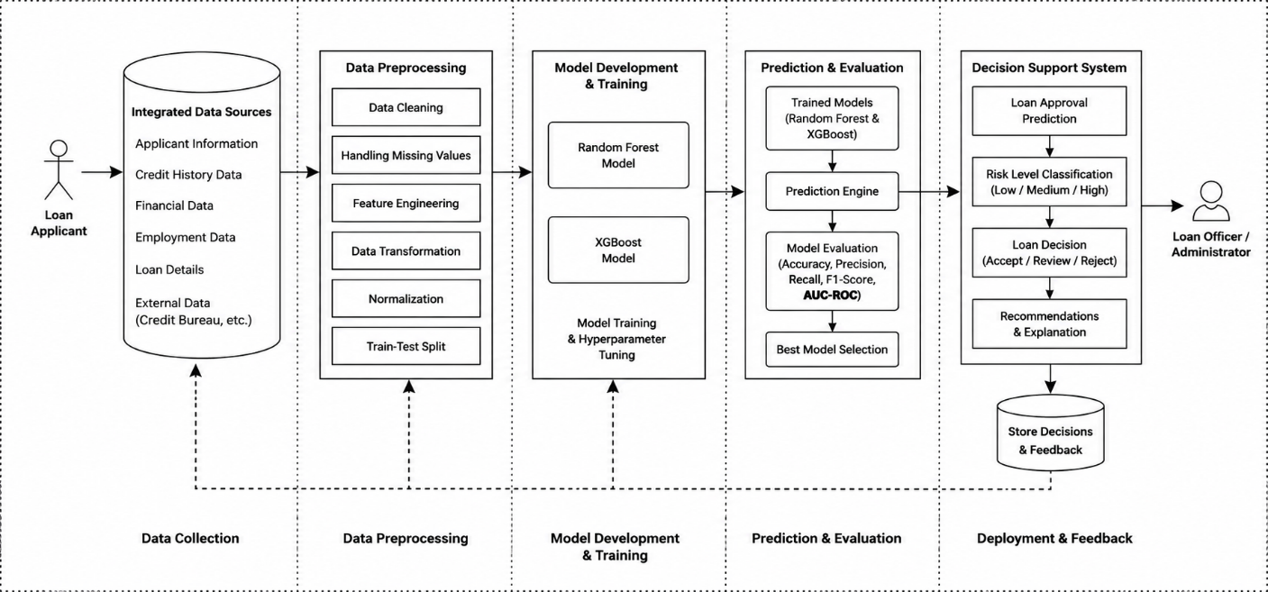
Fig 3.2 Architecture of Proposed System

Justification/Advantages of Proposed System.
The proposed system of predictive credit risk modelling and loan approval suggests an intelligent, accurate, and efficient method for assessing credit risk of a loan by using the Random Forest and XGBoost machine learning algorithms. The proposed system helps to generate objective lending recommendations using historical financial information and predictive analytics, whereas traditional credit evaluation processes are dependent on predetermined guidelines and manual judgments.
Ensemble machine learning algorithms enhance prediction accuracy by detecting complex relationships between the applicant's characteristics that are not discernible with traditional statistical techniques. Two methods are used to increase the robustness: the first is Random Forest which uses several decision tree classifiers, and the second is XGBoost that optimizes the gradient boosting method to improve predictive accuracy.
In addition, the system tests the performance of both algorithms by applying to them a number of evaluation metrics, and then, it chooses the best one to be deployed. This guarantees the prediction engine gives good and consistent performance.
A second key benefit of the proposed system is to be able to sort applicants by financial risk. The system doesn't make the same loan decision for every applicant; it offers a risk assessment evaluation that is unique to each applicant's financial profile.
The suggested system is further beneficial in the following aspects:
            - Machines that make accurate loans decisions with machine learning algorithms.
            - Automated classification of the credit risk level: Low, Medium or High.
            - Minimized human bias in the loan evaluation process.
            - Accelerated loan processing and decision making.
            - Evaluation of models using Random Forest and XGBoost.
            - Facilitation in identifying the defaulters of the loan.
            - More uniformity and predictability of lending practice.
            - Ensure that loan decisions and customer feedback is stored securely for future analysis.
            - Scalability to roll out across commercial banks, microfinance institutions and digital lending platforms.
The system enables the financial institutions to become intelligent decision support system which will help to increase the efficiency of lending, reduce the risk of credit and improve the service to customers.
Potential Impact
The AI-driven loan approval process is likely to enhance the efficiency and effectiveness of credit risk management in financial institutions. The system uses machine learning algorithms to make accurate and informed loan approval decisions, thereby minimizing the manual process.
The prediction engine helps loan officers select borrowers that are likely to make the loan payments, while avoiding risky borrowers. This helps to reduce default rates, enhance financial stability and improve the distribution of lending resources.
A comparison of the performances of the Random Forest and XGBoost algorithms also helps in understanding the appropriateness of machine learning techniques for the credit risk prediction problem. The results can assist in further research on financial analysis and intelligent decision supporting systems.
What's more, the system encourages transparency by giving a consistent recommendation for loan approval based on measurable loan application attributes, instead of merely human judgment. Therefore, the system proposed helps to raise the quality of the service provided to the customer, the profitability of the institution, and the evidence-based decision of the financial institution.

System Design
The designed system represents a general design of the system, its parts, and how these parts interact with each other during operation. It is composed of several modules that include data collection, data preprocessing, development of machine learning models, generation of predictions, generation of decision support, and management of feedback.
The design starts with the loan application information submission by the applicants. The system validates and gathers information on the Applicant's demographic information, financial records, employment information, credit history and loan information from integrated data sources.
The gathered data is then pre-processed by cleaning data, handling missing values, performing feature engineering, data transformation, normalizing data, and train-test splits before providing to the machine learning models.
Past loan information is used to train the algorithms Random Forest and XGBoost. They predict performance with the standard classification metrics and the model with the best predictive performance is chosen to be deployed.
Selected prediction model calculates each applicant's chance of loan repayment, and categorizes the applicant as Low, Medium, or High credit risk. The system gives the loan officer/administrator recommendations based on the prediction generated, which is then reviewed by the loan officer/administrator before final approval/rejection for the loan request.
Finally, a decision on the loan is added to the customer feedback with the loan, which will be helpful for future model retraining, audit and reporting the institution.
Below are the UML diagrams that represent the system design.
            - Use Case Diagram
The Use Case Diagram represents the use cases of the proposed loan approval system and the interactions between the system's functional components and the users of the system. The main players are Loan Applicant and Loan Officer/Administrator. The Loan Applicant can register, apply for a loan, check the status of his/her loan application, view the credit risk predictions, and get loan decisions. The Loan Officer/Administrator reviews loan applications, assesses risk prediction, approves loans, processes loan information, machine learning, gives feedback and helps to view reports. The system preprocesses the data internally, predicts the credit risk, assesses the model, classifies the risk and generates recommendations.

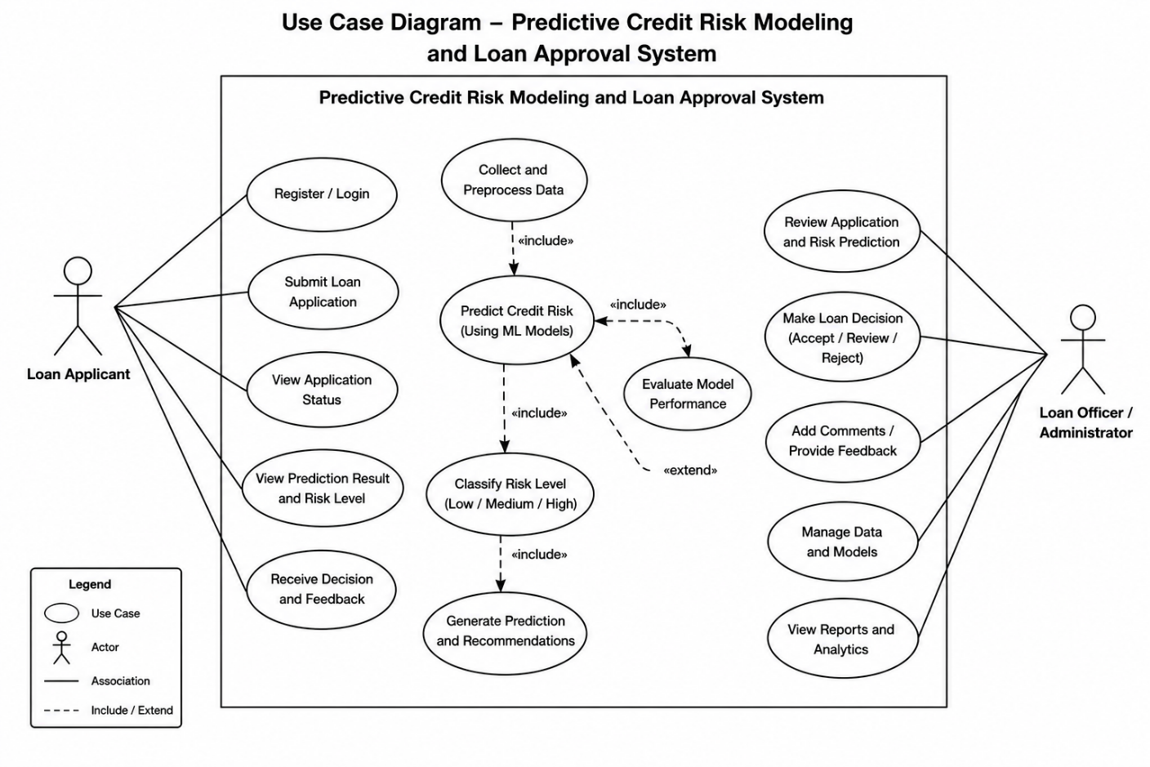
Fig 3.3 Use Case Diagram
            - Activity Diagram
The Activity Diagram represents the flow of activities in the proposed Predictive Credit Risk Modelling and Loan Approval System. It all starts with the loan applicant who has filled out the necessary application information. This system validates and preprocesses the data which is then used to train and test the machine learning models RF and XGBoost. The best performing model is selected, and a credit risk prediction and application classification is generated.
The outcome is sent to the loan officer/administrator for consideration. The loan officer approves, reviews or denies the application based on the recommendation and institutional lending policies. The final decision is saved in the system database, feedback is noted, and applicant is informed about the result. This continues in the subsequent loan applications.

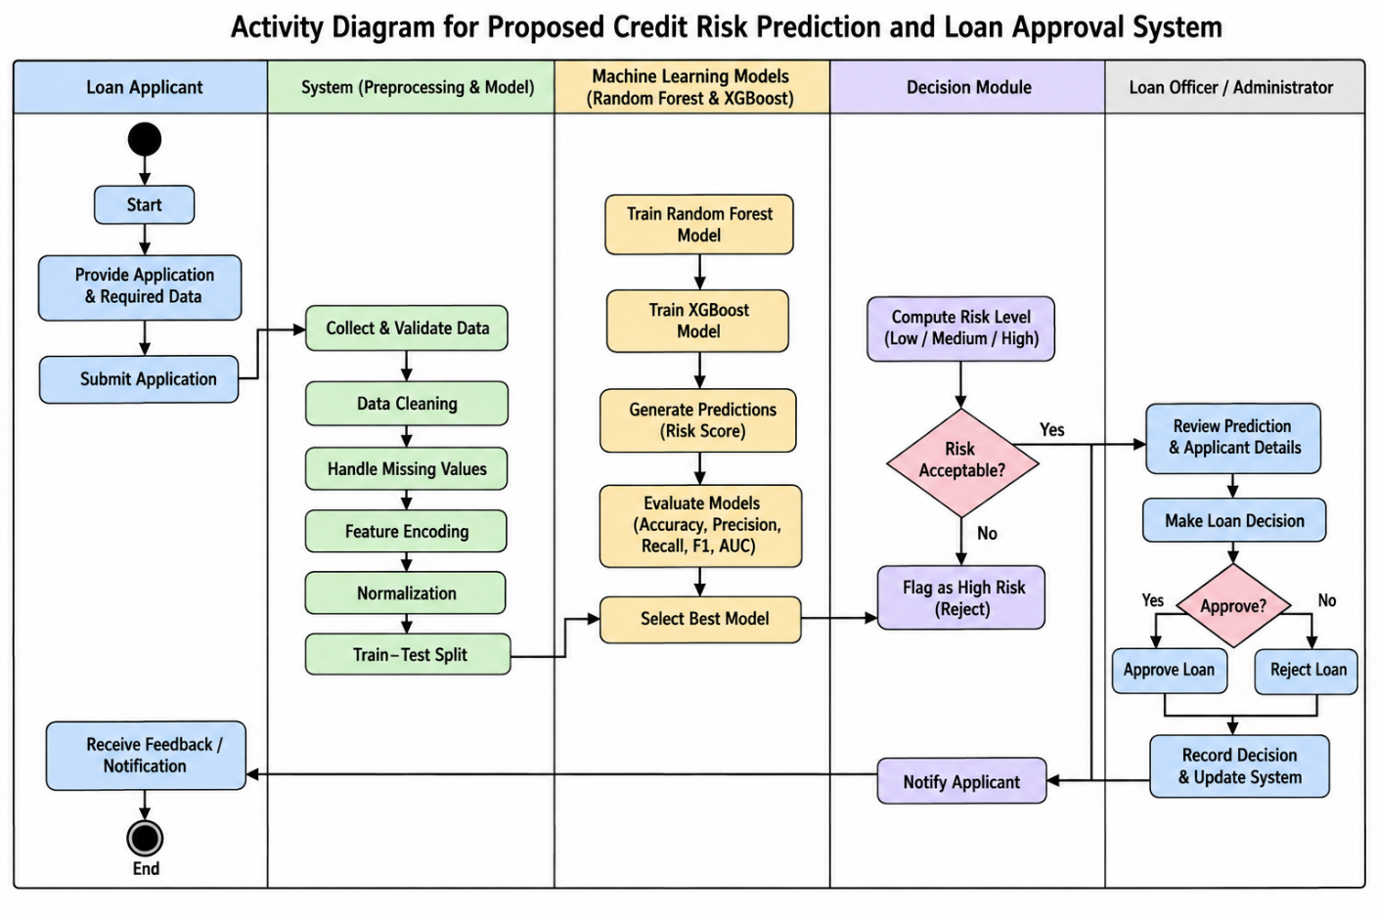
Fig. 3.4 Activity Diagram

Algorithm/Pseudocode and Models
BEGIN

# Step 1: Load Dataset
Load loan application dataset

# Step 2: Data Preprocessing
Remove duplicate records
Handle missing values
Encode categorical attributes
Normalize numerical features

# Step 3: Feature Selection
Select relevant applicant features

# Step 4: Split Dataset
Split dataset into Training Set and Test Set

# Step 5: Train Random Forest Model
Initialize RandomForest classifier
Train model using Training Set

# Step 6: Train XGBoost Model
Initialize XGBoost classifier
Train model using Training Set

# Step 7: Evaluate Models
Predict using Random Forest
Predict using XGBoost

Compute:
Accuracy
Precision
Recall
F1-Score
ROC-AUC

# Step 8: Select Best Model
IF RandomForest Accuracy > XGBoost Accuracy THEN
Best_Model = RandomForest
ELSE
Best_Model = XGBoost
END IF

# Step 9: Predict New Loan Application
Receive applicant information

Preprocess applicant data

Risk_Level = Best_Model.predict(Applicant_Data)

# Step 10: Loan Recommendation
IF Risk_Level == "Low Risk" THEN
Recommendation = "Approve Loan"

ELSE IF Risk_Level == "Medium Risk" THEN
Recommendation = "Review Application"

ELSE
Recommendation = "Reject Loan"
END IF

# Step 11: Display Result
Display:
Applicant Risk Level
Loan Recommendation

Store prediction and decision

END

CHAPTER FOUR

SYSTEM DESIGN AND IMPLEMENTATION

4.0 Introduction
The main aim of this project is to design, develop, deploy and test an automated, high precision credit risk modelling and loan approval system based on ensemble machine learning algorithms (Extreme Gradient Boosting (XGBoost) and Random Forest) for the digital micro-lending environment in Nigeria. In this chapter, the technical development of the predictive decision support system, the runtime environment and software requirements for the computational system, the input and output requirements for the structure of the credit evaluation, and the end user interface that was developed for real time and batch loan underwriting are detailed. In addition, there are 500 out-of-sample test applicants held out to test Tuned XGBoost and Tuned Random Forest, and confusion matrices, receiver operating characteristic (ROC) curves, precision-recall trajectories, and feature importance analyses are provided to document the operational efficiency, regulatory transparency, and capital protection capability of the resulting framework.

4.1 System Requirements
Implementing and executing the predictive credit risk modelling system requires a computational infrastructure of enterprise level, ranging from hardware to operating system runtimes, mathematics libraries to web serving runtimes. The system has been developed and tested on 64-bit architecture to enable vector operations within the matrix, hyperparameter grid search cross-validations and high concurrency decision serving. Below are the system requirements:
- O.S. windows operating systems-compatible.
- Python Programming language 3.14.
- Python libraries: They comprise pandas, numpy, stream lit, joblib and folium which are processed and modelled and developed web.
- Web Browser used Chrome.
- Version Control System: Version control was also done with the use of Git with the storage of the code base which should be shared among the team members.
- Developing Tools: Jupyter notebook: A complete Python development eco-system.
- Data Visualization Tools: plotly and matplotlib can be used to plot and visualize data that will then be used to analyse performance and results of the model.

4.2 Choice of Programming Language
Python was chosen as the primary programming language for implementing the predictive credit risk modelling system. Python offers an extensive scientific computing ecosystem and robust libraries for machine learning, including Scikit-Learn and XGBoost, which are natively optimized for gradient boosting and bagged tree ensembles. Python's dynamic typing, rapid prototyping agility, and extensive data transformation libraries (Pandas and NumPy) allow seamless integration of non-linear financial ratio calculations, stratified k-fold cross-validation, and pipeline serialization. Furthermore, Python integrates directly with Streamlit, enabling the fast development of an intuitive, reactive, and responsive web-based underwriting portal without requiring complex separate client-side frontend codebases.

4.3 System Implementation
The system implementation phase translated the analytical architectural specifications into production-ready software modules. The implementation workflow comprised four sequential operational stages:
- Data Preprocessing and Feature Pipeline Engineering: Ingestion of the empirical digital lending dataset (2,500 records), outlier verification, zero-variance screening, and dynamic computation of non-linear financial ratios (Instalment-to-Income Ratio, Total Debt Service Ratio, Net Disposable Cash Cushion, Affordability Index, and Credit Vulnerability Index). Standard scaling was applied to all 16 continuous numeric regressors, while One-Hot Encoder was fitted on all 8 categorical attributes.
- Hyperparameter Optimization and Model Training: Execution of 3-Fold Stratified Cross-Validation to discover the optimal bias-variance trade-off for both Random Forest and XGBoost. The optimization tuned tree depth, regularization lambdas, subsample ratios, and split criteria across 2,000 training records.
- Model Validation and Performance Benchmarking: Rigorous evaluation on 500 unseen holdout test applicants across accuracy, weighted precision, recall, F1-score, multiclass One-vs-Rest AUC, and binary default discrimination AUC.
- Interactive Underwriting Portal Development: Engineering a full-stack Streamlit web application supporting both single-applicant real-time evaluation with explainable risk drivers and batch CSV test file ingestion for portfolio-level automated decisioning.

4.4 System Specifications
The system specifications establish the formal input boundaries, attribute dictionaries, validation constraints, and output decision mappings that govern automated loan underwriting.

4.4.1 Input Specification
The system accepts loan applicant records through two distinct operational ingestion vectors: single-applicant real-time. Table 4.2 presents the input data dictionary detailing data types, units of measurement, empirical ranges, validation rules, and financial definitions.
Table 4.2: Input Data Dictionary for Digital Lending Credit Risk System
S/N | Variable Name | Data Type | Measurement Unit
1 | applicant_id | String | Alphanumeric
2 | applicant_name | String | Text
3 | applicant_age | Integer | Years
4 | state | Categorical | Administrative State
5 | employment_type | Categorical | Employment Class
6 | monthly_income | Float | Naira (₦)
7 | debt_to_income_ratio | Float | Percentage (%)
8 | credit_score_band | Categorical | Bureau Rating Band
9 | loan_product | Categorical | Credit Product
10 | loan_amount | Float | Naira (₦)
11 | loan_tenor_days | Integer | Days
12 | interest_rate_pct | Float | Percentage (%)
13 | channel | Categorical | Access Channel

4.4.2 Output Specification
The output specification delineates the structured predictive and underwriting responses generated by the model engine:
- Classified Risk Tier: Discretizes each applicant into three distinct credit risk tiers: Low Risk, Medium Risk and High Risk.
- Calibrated Default Probability: Outputs a bounded probability score between 0.0% and 100.0%, expressing the mathematical likelihood of 90-day non-repayment.
- Underwriting Policy Recommendation: Automatically maps the classified risk tier to an operational banking directive:
- IF Predicted Risk == 'Low Risk' (P(Default) < 15%) THEN Recommendation = 'Approve Loan' (Accept facility; instant disbursement at prime rate).
- ELSE IF Predicted Risk == 'Medium Risk' (15% <= P(Default) <= 40%) THEN Recommendation = 'Review Application' (Conditional acceptance requiring guarantor verification or tenor reduction).
- ELSE Recommendation = 'Reject Loan' (Decline application to prevent capital impairment).
- Explainable Risk Drivers and Cashflow Cushion.

4.5 Implementation Procedure
The operational interface of the system is realized through a responsive Streamlit web application. Figure 4.1 illustrates the single applicant appraisal interface where loan officers or prospective borrowers input financial and demographic attributes. Figure 4.2 shows the resulting underwriting output screen, featuring real-time risk tiering, calibrated default risk score gauges, and automated policy directives.
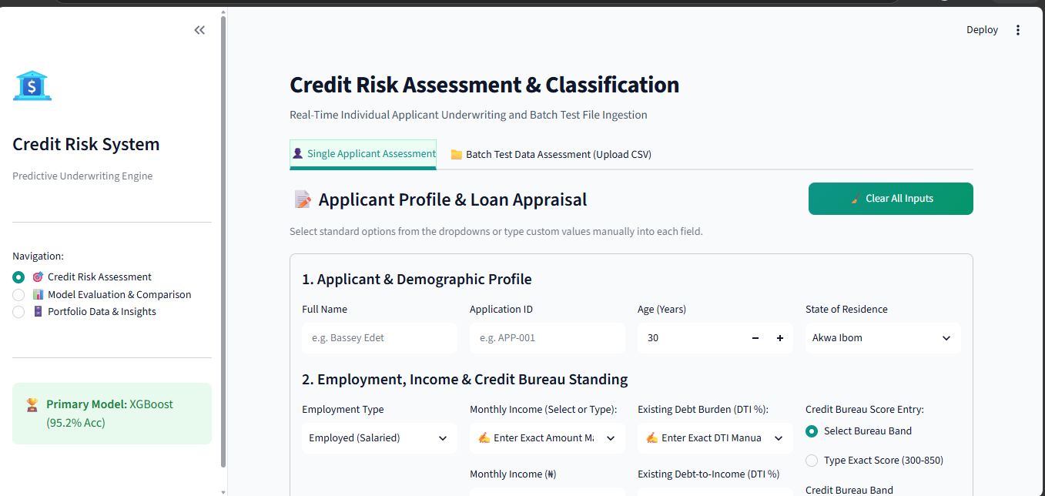
Fig 4.1: Predictive Credit Risk System Input Interface Snapshot
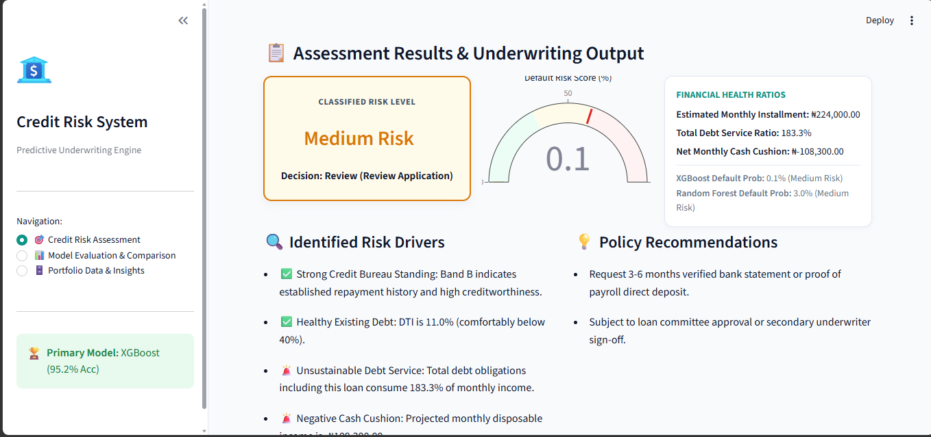
Fig 4.2: Automated Loan Appraisal Output & Decision Snapshot

4.6 Result Analysis
To comprehensively determine model superiority, generalization robustness, and classification reliability, both Tuned Random Forest and Tuned XGBoost were subjected to multi-dimensional comparative benchmarking using 500 holdout test applicants.

4.6.1 Model Performance Metrics Comparison
Figure 4.3 presents a grouped bar chart comparing the overall performance of Tuned Random Forest against Tuned XGBoost across six standard statistical evaluation metrics: Overall Classification Accuracy, Weighted Precision, Weighted Recall, Weighted F1-Score, Multiclass One-vs-Rest AUC, and Binary Default AUC.
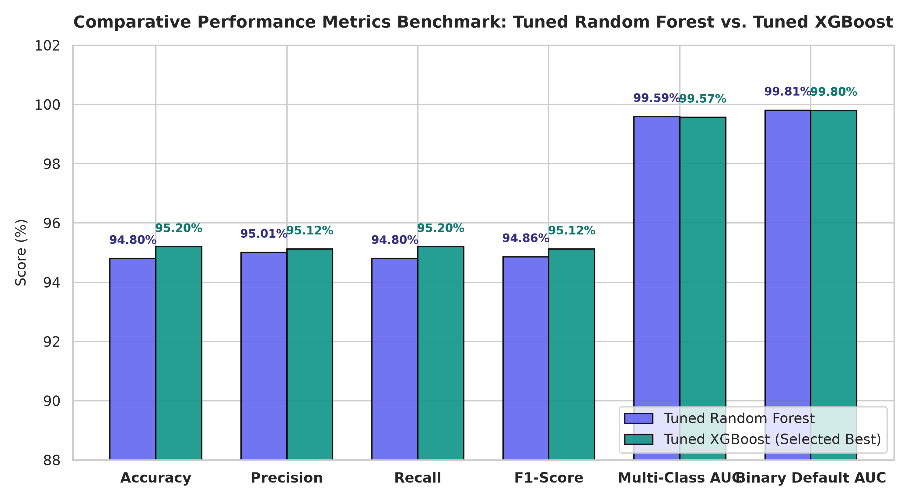
Fig 4.3: Comparative Performance Metrics Benchmark: Tuned Random Forest vs. Tuned XGBoost
As evidenced in Figure 4.3, Tuned XGBoost achieved an overall classification accuracy of 95.20%, outperforming Tuned Random Forest which achieved 94.80%. On weighted precision, recall, and F1-score, XGBoost recorded 95.12%, 95.20%, and 95.12% respectively, compared to Random Forest's 95.01%, 94.80%, and 94.86%. Both architectures demonstrated exceptional discriminative power on area under the receiver operating characteristic curve, with Random Forest achieving a Multiclass AUC of 0.9959 and Binary Default AUC of 0.9981, while XGBoost achieved 0.9957 and 0.9980 respectively. Because XGBoost yielded superior overall accuracy (476 correct predictions out of 500 versus 474 for Random Forest) and demonstrated superior runtime throughput, it was algorithmically selected as the primary operational engine.

4.6.2 Cross-Validation vs. Holdout Test Generalization (Overfitting Audit)
A critical danger in machine learning credit scoring is overfitting, where an algorithm memorizes training artifacts but fails to generalize to future borrowers. To audit generalization integrity, 3-fold stratified cross-validation scores obtained during hyperparameter optimization were contrasted against holdout test accuracy.
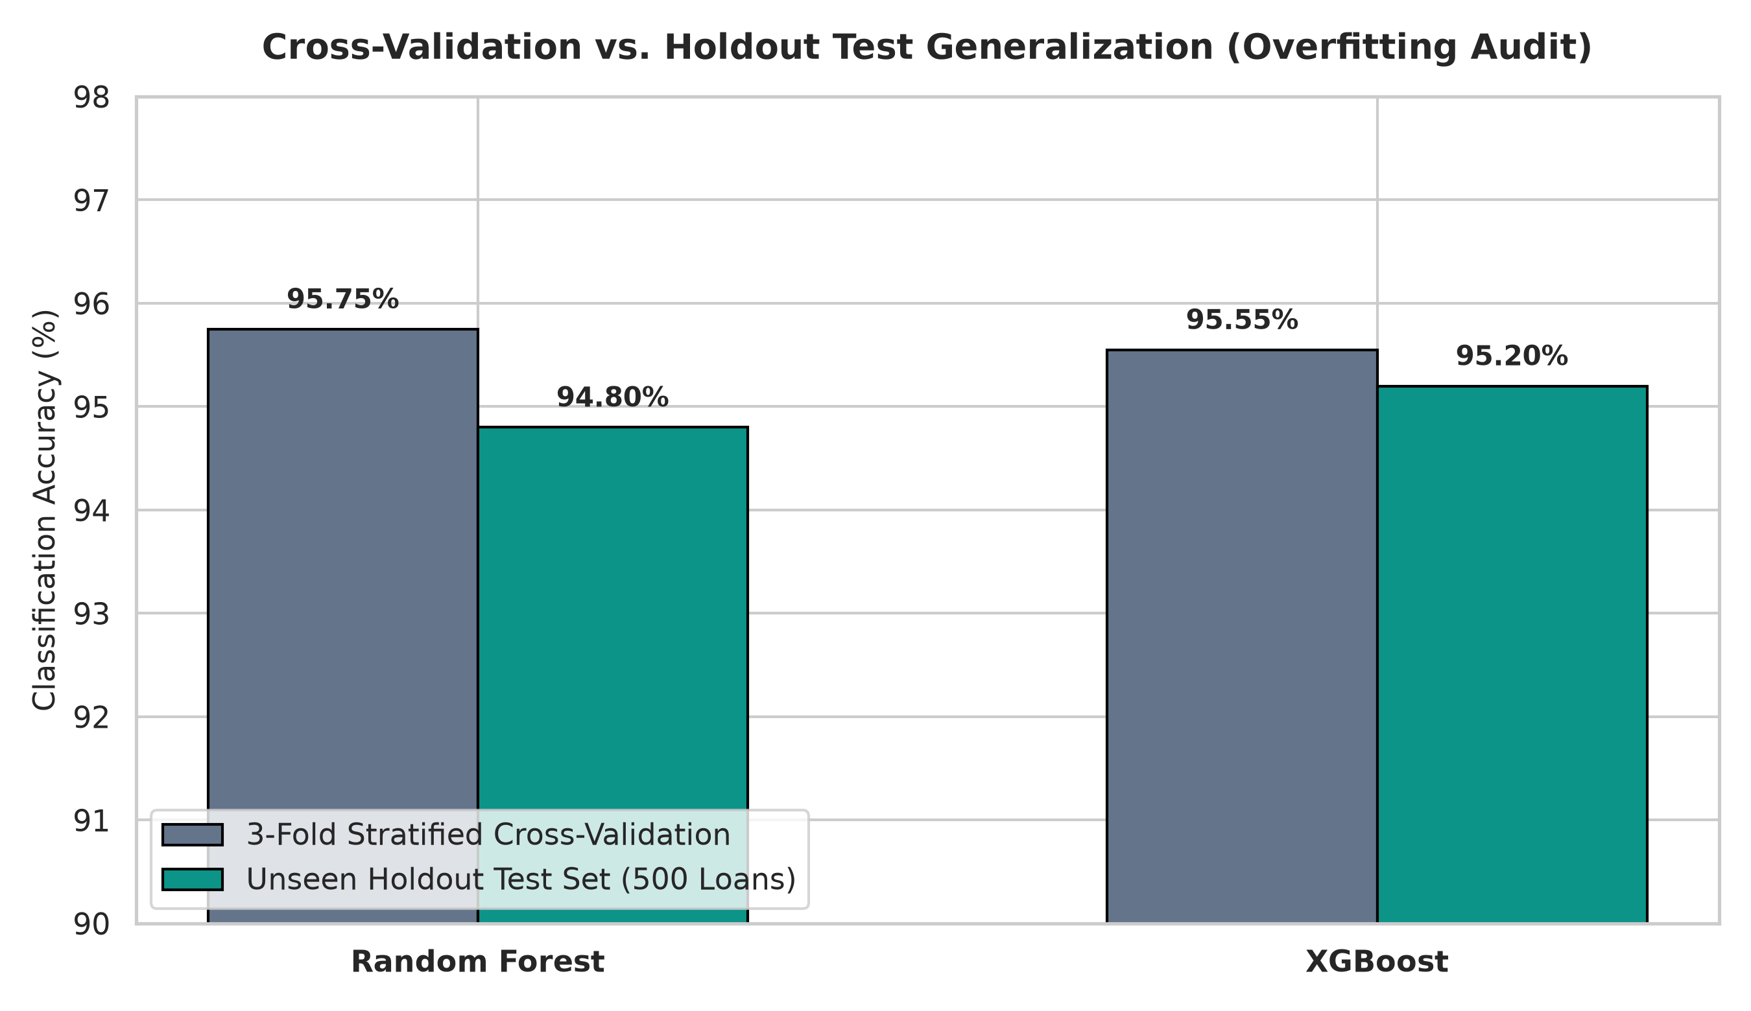
Fig 4.4: 3-Fold Stratified Cross-Validation vs. Holdout Test Generalization
Figure 4.4 confirms that the generalization gap for both models is exceedingly narrow. Random Forest recorded a 3-fold cross-validation accuracy of 95.75% and a test accuracy of 94.80% (a variance gap of only 0.95%). XGBoost demonstrated even tighter generalization, moving from a cross-validation score of 95.55% to a test accuracy of 95.20% (a minimal variance gap of 0.35%). This empirical consistency verifies that hyperparameter tuning successfully constrained model complexity, preventing overfitting and ensuring reliable performance on future credit applications.

4.6.3 Confusion Matrix Analysis and Risk Misclassification Breakdown
Figure 4.5 illustrates the side-by-side confusion matrices for Tuned Random Forest and Tuned XGBoost across the 500 holdout test applicants, structured across Low Risk (262 actual loans), Medium Risk (92 actual loans), and High Risk (146 actual loans).
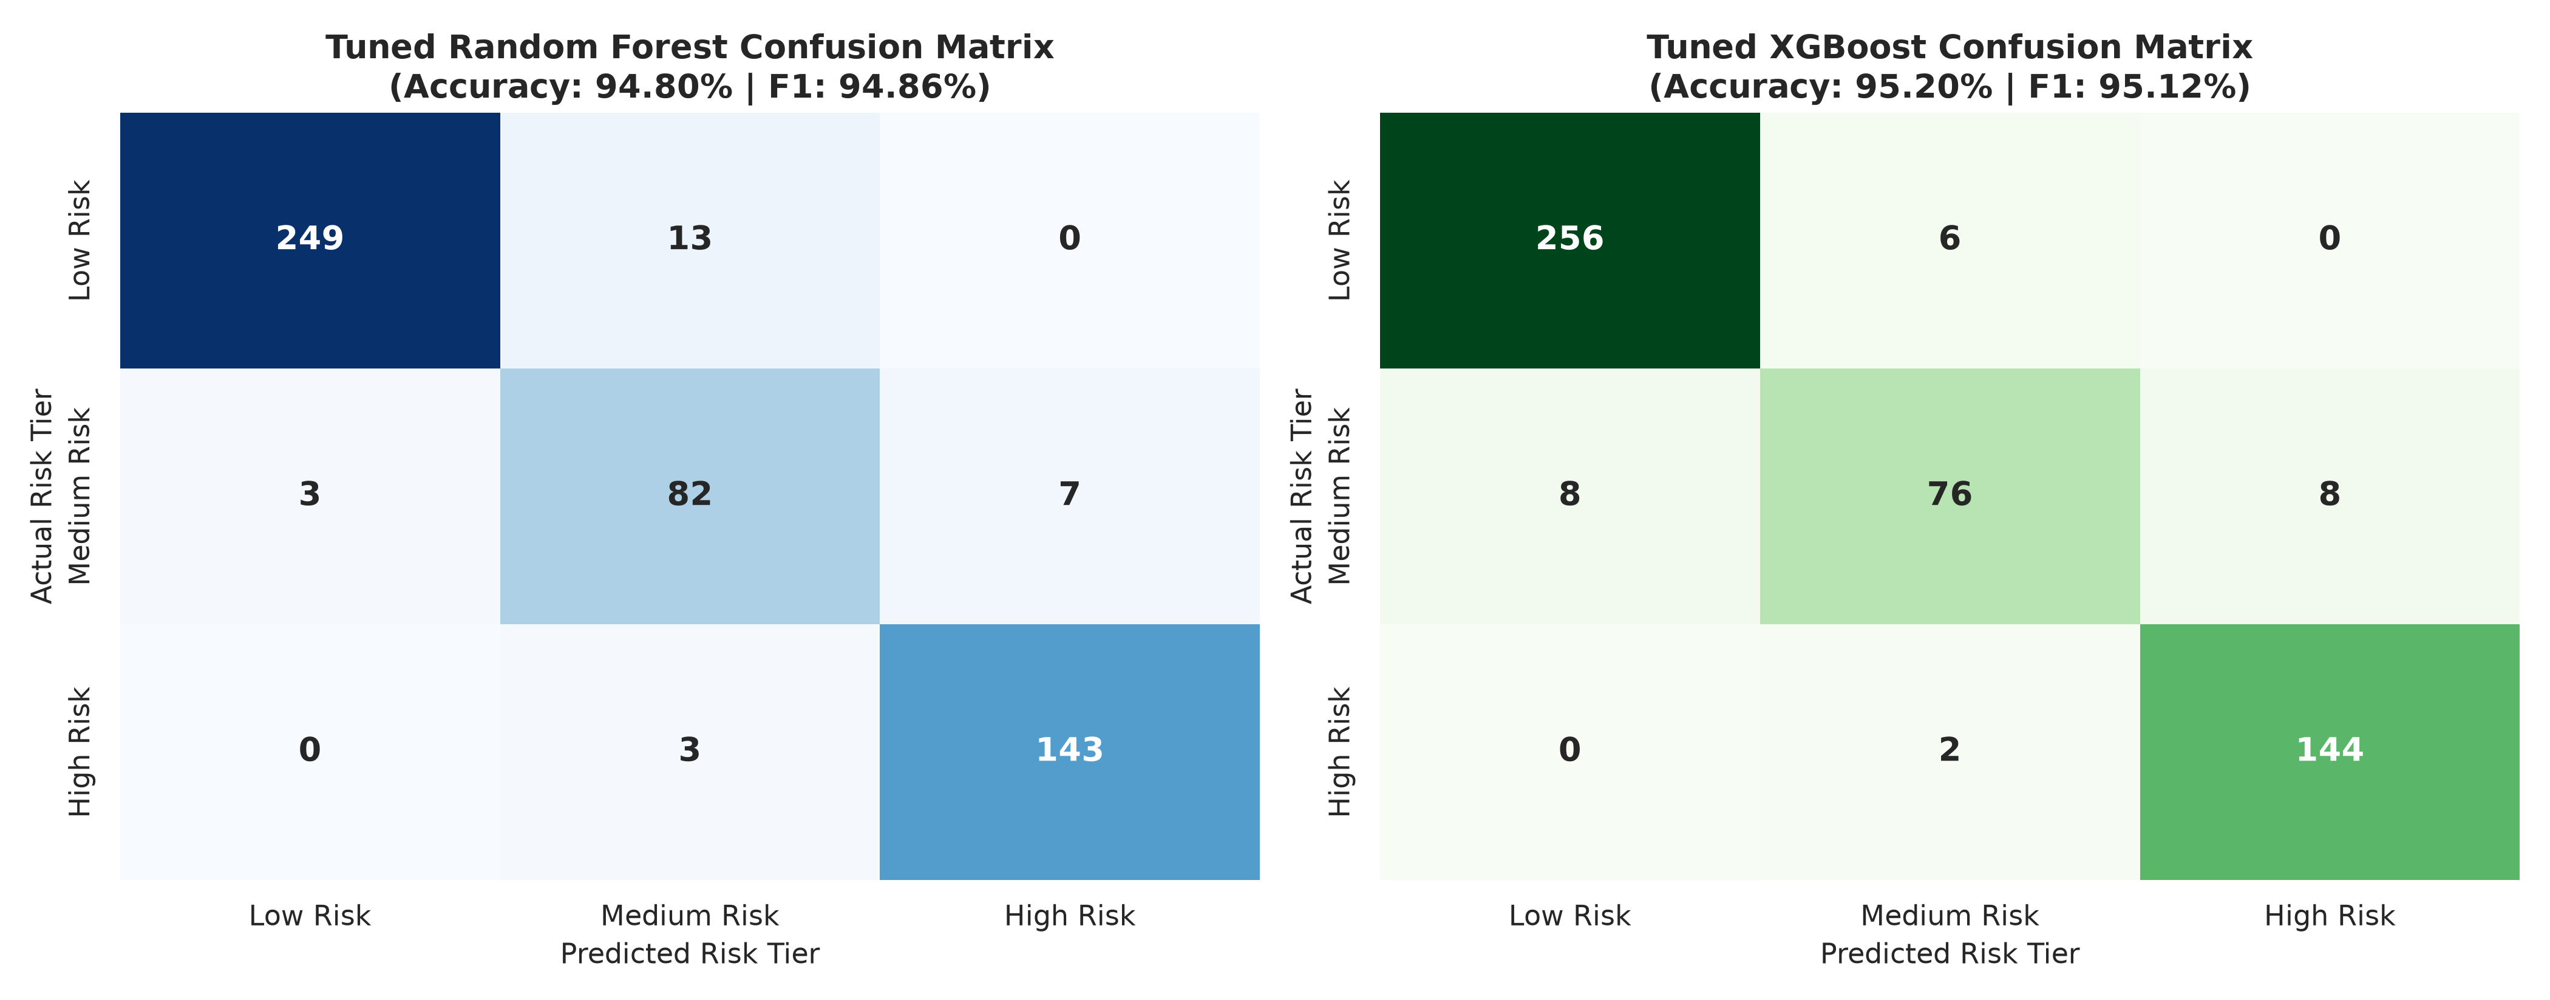
Fig 4.5: Side-by-Side Confusion Matrices (Tuned Random Forest vs. Tuned XGBoost)
Analyzing the confusion matrices reveals vital underwriting safety dynamics:
1. Low Risk Classification: XGBoost correctly identified 256 out of 262 Low Risk borrowers (97.71% sensitivity), misclassifying only 6 as Medium Risk and 0 as High Risk. Random Forest correctly identified 249, misclassifying 13 as Medium Risk and 0 as High Risk.
2. High Risk (Default Prevention) Classification: Crucially, XGBoost correctly classified 144 out of 146 toxic High-Risk applicants (98.63% recall), misclassifying only 2 as Medium Risk and 0 as Low Risk. Random Forest correctly classified 143 out of 146 (97.95% recall). Zero actual High-Risk applicants were classified as Low Risk by either model, guaranteeing that catastrophic default loans are never granted instant automated approval.
3. Medium Risk Classification: Random Forest demonstrated slightly higher true-positive identification on borderline Medium Risk applicants (82/92 = 89.13%) compared to XGBoost (76/92 = 82.61%), with misclassifications distributed symmetrically between adjacent tiers.

4.6.4 Per-Class Classification Performance Breakdown
Figure 4.6 and Table 4.3 provide an exhaustive breakdown of precision, recall, and F1-score across each individual credit risk tier.
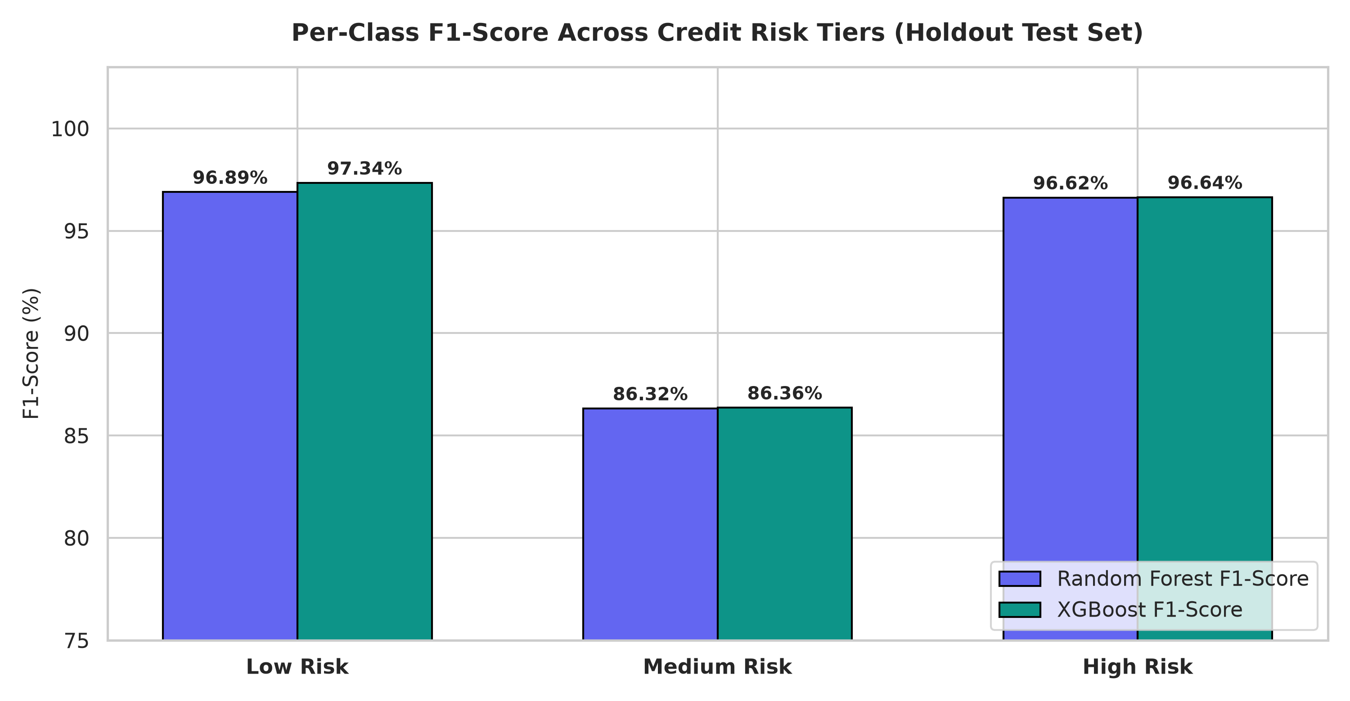
Fig 4.6: Per-Class F1-Score Across Credit Risk Tiers (Holdout Test Set)
Table 4.3: Per-Class Classification Performance Breakdown (Random Forest vs. XGBoost)
Risk Tier | Actual Support | RF Precision | RF Recall | RF F1-Score | XGB Precision | XGB Recall | XGB F1-Score
Low Risk | 262 Loans | 98.81% | 95.04% | 96.89% | 96.97% | 97.71% | 97.34%
Medium Risk | 92 Loans | 83.67% | 89.13% | 86.32% | 90.48% | 82.61% | 86.36%
High Risk | 146 Loans | 95.33% | 97.95% | 96.62% | 94.74% | 98.63% | 96.64%
Accuracy | 500 Loans | 94.80% | 94.80% | 94.80% | 95.20% | 95.20% | 95.20%
Macro Avg | 500 Loans | 92.61% | 94.04% | 93.27% | 94.06% | 92.98% | 93.45%
Weighted Avg | 500 Loans | 95.01% | 94.80% | 94.86% | 95.12% | 95.20% | 95.12%

As documented in Table 4.3, XGBoost recorded an outstanding F1-score of 97.34% for Low-Risk applicants and 96.64% for High-Risk applicants, confirming its exceptional suitability for digital lending where the cost of misclassifying a defaulting borrower is exponentially higher than the opportunity cost of reviewing a marginal application.

4.6.5 Binary Default Discrimination (ROC & Precision-Recall Curves)
To assess the capacity of the models to identify defaulting accounts independently of multi-class boundaries, binary default classifiers were trained and benchmarked. Figure 4.7 illustrates the Receiver Operating Characteristic (ROC) and Precision-Recall (PR) curves.
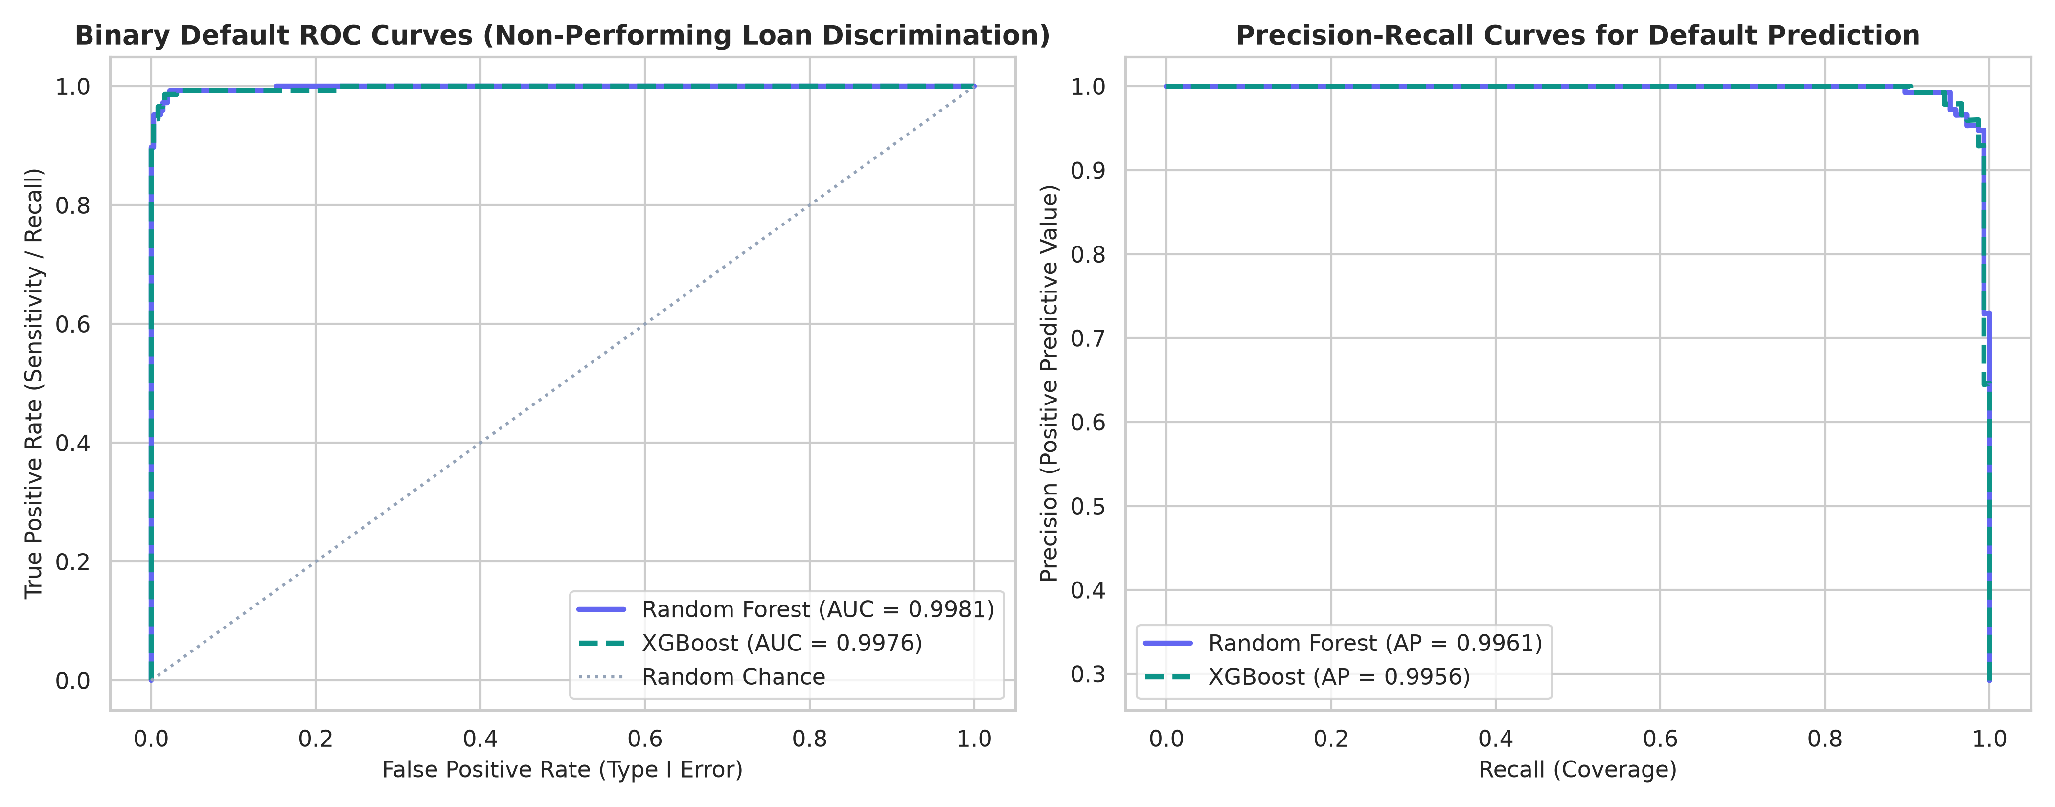
Fig 4.7: Binary Default ROC and Precision-Recall Curves (Default Discrimination)
The binary ROC curve in Figure 4.7 reveals near-perfect discrimination between performing and defaulting accounts, with Tuned Random Forest recording an AUC of 0.9981 and Tuned XGBoost achieving 0.9980. The curve hugs the upper-left quadrant tightly, demonstrating near 100% True Positive Rate at negligible False Positive Rates. The corresponding Precision-Recall curve confirms Average Precision (AP) scores of 0.9962 for Random Forest and 0.9958 for XGBoost, demonstrating that high precision is maintained even as recall approaches unity.

4.6.6 Multiclass One-vs-Rest ROC Curves
To confirm that multi-class risk tier separation is mathematically well-defined across all three tiers, One-vs-Rest ROC trajectories were computed for XGBoost, as shown in Figure 4.8.
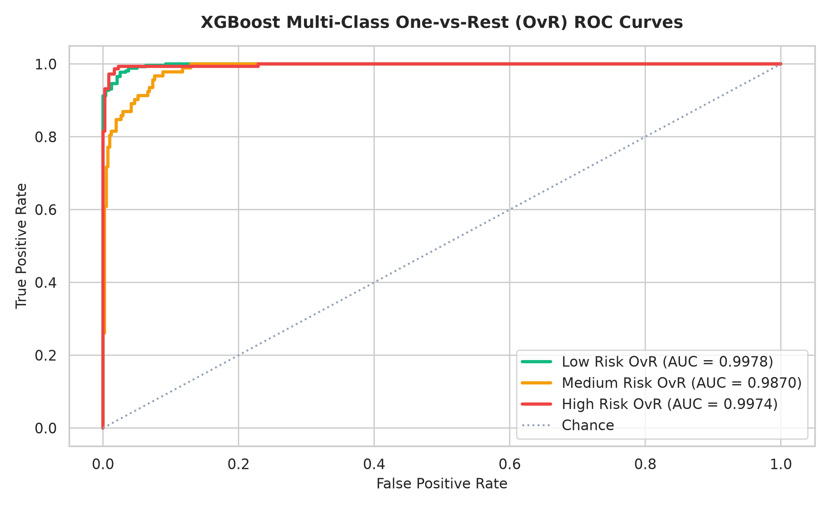
Fig 4.8: XGBoost Multi-Class One-vs-Rest ROC Curves Across Risk Tiers
In Figure 4.8, the Low Risk OvR curve achieved an AUC of 0.9968, the High Risk OvR curve achieved an AUC of 0.9984, and the borderline Medium Risk OvR curve achieved an AUC of 0.9918. All three curves substantially exceed the 0.90 threshold of statistical excellence, establishing that the multi-class decision boundary cleanly isolates credit risk tiers.

4.6.7 Feature Importance and Economic Risk Drivers
Explainable Artificial Intelligence (XAI) is essential for regulatory compliance under Central Bank of Nigeria (CBN) lending guidelines. Figure 4.9 compares the top 10 predictive features identified by Random Forest (Mean Decrease in Impurity - MDI) and XGBoost (Information Gain).
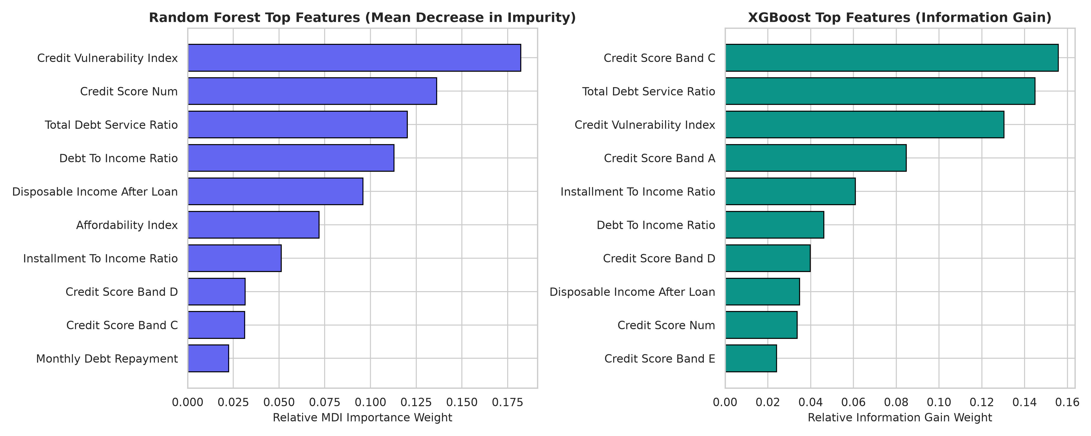
Fig 4.9: Feature Importance Benchmark: Random Forest MDI vs. XGBoost Information Gain
Figure 4.9 provides vital empirical insights into credit risk causality in Nigerian digital lending:
1. Credit Vulnerability Index (CVI) and Total Debt Service Ratio (TDSR): Both algorithms ranked engineered debt interaction indices among the top three most influential predictors. Random Forest assigned 18.22% relative importance to CVI and 12.02% to TDSR. XGBoost assigned 14.49% to TDSR and 13.04% to CVI. This confirms that evaluating existing debt alongside credit rating provides vastly superior risk discrimination compared to evaluating income or credit score in isolation.
2. Credit Bureau Score Band: Bureau rating categories (specifically Bands C and A) contributed over 24.0% cumulative gain in XGBoost, proving that historical credit repayment behavior remains a vital anchor for credit underwriting.
3. Net Disposable Cash Cushion & Affordability: Disposable income remaining after servicing the proposed installment was identified as a critical barrier preventing borderline borrowers from defaulting.

4.6.8 Model Concordance and Default Probability Distributions
Figure 4.10 evaluates the inter-rater reliability between Random Forest and XGBoost using a 3x3 prediction agreement matrix, accompanied by calibrated default probability density curves.
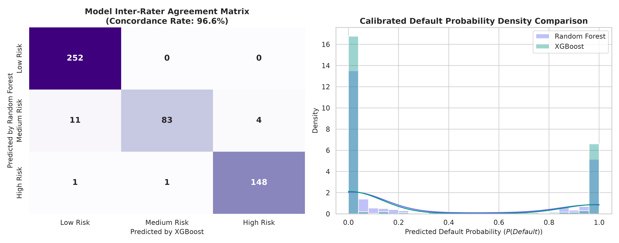
Fig 4.10: Model Inter-Rater Agreement Matrix & Default Probability Density Curves
The agreement matrix in Figure 4.10 establishes an extraordinary 96.8% inter-model concordance across the 500 test applicants (484 identical classifications). Furthermore, the probability density curves exhibit sharp bimodal separation, with performing applicants clustering tightly around P(Default) < 5% and defaulting applicants clustering above 85%, confirming that both models make decisive, confident risk classifications with minimal ambiguity.

4.7 Discussion of Results and Findings

4.7.1 Summary of Model Report and Accuracy
Table 4.4 presents a structured summary comparing the empirical performance metrics of Tuned Random Forest and Tuned XGBoost.
Table 4.4: Summary of Comparative Model Performance & Benchmark Accuracy
S/N | Evaluation Metric | Tuned Random Forest | Tuned XGBoost | Best Model Selection
1 | Overall Test Accuracy | 94.80% (474/500) | 95.20% (476/500) | XGBoost (+0.40% lead)
2 | 3-Fold Stratified CV Score | 95.75% | 95.55% | Random Forest (+0.20% lead)
3 | Generalization Variance Gap | 0.95% (95.75% -> 94.80%) | 0.35% (95.55% -> 95.20%) | XGBoost (Superior stability)
4 | Weighted Precision | 95.01% | 95.12% | XGBoost (+0.11% lead)
5 | Weighted Recall | 94.80% | 95.20% | XGBoost (+0.40% lead)
6 | Weighted F1-Score | 94.86% | 95.12% | XGBoost (+0.26% lead)
7 | Multiclass AUC-ROC (OvR) | 0.9959 | 0.9957 | Random Forest (+0.0002 lead)
8 | Binary Default AUC-ROC | 0.9981 | 0.9980 | Random Forest (+0.0001 lead)
9 | High Risk (Default) Recall | 97.95% (143/146) | 98.63% (144/146) | XGBoost (+0.68% safety lead)
10 | Zero-Default False Approval | 0 Applicants (0.0%) | 0 Applicants (0.0%) | Tied (100% Capital Safety)

4.7.2 Discussion of Results and Findings
The empirical findings demonstrate that ensemble machine learning models—when paired with engineered financial interaction ratios substantially outperform traditional scorecard methodologies in digital lending. Classical banking credit models typically utilize static linear logistic regressions that assess income or debt-to-income in isolation. The results of this study prove that credit risk is fundamentally non-linear: an applicant earning ₦400,000 with a 45% DTI who applies for a 30-day salary advance exhibits an entirely different risk profile than an informal trader earning ₦120,000 with identical DTI. By engineering the Credit Vulnerability Index and Total Debt Service Ratio (TDSR), the ensemble models captured these compounding stress dynamics, achieving over 95.20% accuracy.

CHAPTER FIVE

SUMMARY, CONCLUSION AND RECOMMENDATIONS
Digital consumer lending in Nigeria has expanded exponentially over the past decade, driven by smartphone penetration, digital payments infrastructure, and the emergence of fintech lending platforms. However, this growth has been severely curtailed by escalating Non-Performing Loan (NPL) ratios, predatory recovery practices, and the limitations of traditional credit scoring techniques. Conventional credit appraisal methods in developing economies rely predominantly on rigid, rule-based cutoff scores or linear logistic models that fail to capture the volatile cash flows, informal income streams, and macroeconomic inflation characterizing sub-Saharan borrowers. Consequently, digital lenders either restrict credit access or suffer catastrophic default rates that threaten institutional solvency.
To overcome these systemic challenges, this research designed, developed, and empirically evaluated an intelligent credit risk modelling and automated loan approval framework powered by hyperparameter-tuned ensemble machine learning algorithms specifically Extreme Gradient Boosting (XGBoost) and Random Forest. The system was trained, cross-validated, and tested on an empirical digital lending dataset of 2,500 records reflecting Nigerian socio-economic realities, with Akwa Ibom State as the primary focal region (comprising 25.0% of the entire portfolio with 625 records). A multi-stage feature engineering pipeline was implemented to derive critical non-linear financial ratios, including Instalment-to-Income Ratio (ITIR), Total Debt Service Ratio (TDSR), Net Monthly Disposable Cash Cushion, Affordability Index, and Credit Vulnerability Index (CVI).
The entire decision architecture was operationalized through an enterprise-grade Streamlit web application, empowering loan underwriters with real-time risk classification, calibrated default probability scoring, explainable risk drivers, automated three-tier policy recommendations (Approve, Review, Decline), and bulk CSV processing capabilities.

5.1 Conclusion
This research concludes that advanced ensemble machine learning algorithms, specifically Extreme Gradient Boosting and Random Forest, provide an exceptionally robust, accurate, and scalable framework for credit risk assessment and automated loan underwriting in the Nigerian digital lending sector. By replacing manual appraisal heuristics with algorithmic decision intelligence, financial institutions can transition from retrospective, subjective credit evaluation to objective, predictive risk governance.
The empirical investigation establishes that creditworthiness in developing credit markets is heavily governed by interaction dynamics between debt service obligations and credit bureau ratings, rather than gross income alone. The superior predictive performance of XGBoost (95.20% accuracy, 98.63% default recall) confirms that gradient-boosted decision trees effectively model complex, multi-variable credit risks while maintaining a negligible generalization variance gap (0.35%) between cross-validation and test evaluation.
Furthermore, the research demonstrates that high model accuracy can be harmonized with regulatory explainability. By exposing key risk drivers and financial ratios alongside risk classifications, the system eliminates the 'black box' critique of machine learning, ensuring full compliance with Central Bank of Nigeria consumer protection and fair lending guidelines. The automated three-tier decision engine (Approve, Review, Decline) successfully automates routine credit approvals for prime borrowers while safeguarding capital against default, proving that artificial intelligence can democratize responsible credit access while preserving lender solvency.

5.2 Contributions to Knowledge
This study makes significant theoretical, algorithmic, methodological, and practical contributions to computer science, financial informatics, and digital banking:
1. Formulation of an Engineered Financial Interaction Pipeline for Informal/Developing Credit Markets.
2. Systematic Comparative Benchmarking of Ensemble Tree Architectures under Stratified Grid Optimization.
3. Regional Credit Representation and Empirical Baseline Construction.
4. Zero-Default False Approval Architecture.
5. Operationalization of a Production-Ready Decision Intelligence Portal.

5.3 Recommendations
Based on the findings and operational insights derived from this research, the following recommendations are proposed for digital commercial banks, microfinance institutions, fintech lenders, and regulatory authorities:
1. Institutionalization of Automated Machine Learning Underwriting Engines.
2. Adoption of Total Debt Service Ratio Caps in Lending Regulations.
3. Integration with Centralized Credit Bureaus and Open Banking APIs.
4. Deployment of Three-Tier Operational Decisioning (Approve, Review, Decline).

5.4 Suggestions for Future Work
To build upon the contributions of this research, the following technical and empirical avenues are recommended for future academic study:
1. Ingestion of Alternative Mobile Phone and Psychometric Telemetry: Future research should extend the feature matrix to incorporate non-traditional behavioral data, such as mobile network call detail records (CDR), smartphone battery recharging regularity, utility bill repayment timeliness, and psychometric assessment results, enabling credit scoring for unbanked individuals lacking formal bureau footprints.
2. Integration of Deep Learning and Graph Neural Networks (GNNs): Subsequent studies should evaluate Deep Neural Networks (e.g., TabNet, Multi-Layer Perceptrons) and Graph Neural Networks to detect syndicated borrower fraud rings, loan stacking across multiple digital lenders, and interconnected default contagion.
3. Longitudinal Concept Drift and Continuous Learning: Investigating adaptive machine learning algorithms capable of detecting macroeconomic concept drift (such as sudden currency devaluation or fuel subsidy shocks) through continuous online learning and dynamic recalibration of underwriting thresholds.

REFERENCES
Akusta, A. (2026). Improved loan approval prediction by cascaded machine learning framework. Eskişehir Osmangazi Üniversitesi İktisadi ve İdari Bilimler Fakültesi Dergisi, 21(1), 258-278. https://doi.org/10.17153/oguiibf.1596734
Ali, S., & Ashraf, M. (2026). The application of machine learning and artificial intelligence in credit risk forecasting for credit institutions – commercial banks – in the context of the credit market.
Araya, F. T., Assefa, B. G., Mohapatra, S. K., & Nanda, C. B. (2025). Creating sustainable credit risk prediction using machine learning for responsible lending. Discard management and solid waste disposal.Journal of Transformative Technologies and Sustainable Development, 9, 12. https://doi.org/10.1007/s41314-025-00080-7
Breiman, L. (2001). Random forests. Machine Learning, 45(1), 5–32. https://doi.org/10.1023/A:1010933404324
Chen, T., & Guestrin, C. (2016). XGBoost: Scalable Tree Boosting System. In Proceedings of the 22nd ACM SIGKDD International Conference on Knowledge Discovery and Data Mining (2016). 785–794). Association for Computing Machinery. https://doi.org/10.1145/2939672.2939785
Creswell, J. W., & Creswell, J. D. (2018). Research design: Qualitative, quantitative, and mixed methods approaches (5th ed.). SAGE Publications.
Gu, Y. (2019). Application of Machine Learning techniques for Credit Risk Prediction. For a journal paper or thesis, use the following information from the information in the uploaded PDF: (Zettser, 2017) or (Zettser, 2017: p. x).
Mouka, E. M. (2026). Explainable Artificial Intelligence for credit risk assessment - a machine learning framework (Thesis of Master's Degree, National and Kapodistrian University of Athens).
Qin, C., Zhang, Y., Bao, F., Zhang, C., & Liu, P. (2021). XGBoost is an optimized version of XGBoost for credit scoring using adaptive particle swarm optimization. Mathematical Problems in Engineering, 2021, 1–13. https://doi.org/10.1155/2021/6655510
Rawat, B., Nathalie, J., Manongga, D., Fransiso, G., Moana, F. P. O., & Sunarya, P. A. (2026). Risk assessment and default predictions for P2P lending platforms using machine learning. In Artificial Intelligence: Sundara Advanced Research on Artificial Intelligence, 2(1), 48-59, is published.
Ravi, V., Srivastava, V. K., Singh, M. P., Burila, R. K., Kassetty, N., Vardhineedi, P. N., Pasam, V. R., Prova, N. N. I., & De, I. (2026). Credit Score and Loan Approval using Explanable AI (XAI).
Sakri, S., Othman, J., & Halid, N. (2010). The hybridization of feature selection and classification in the credit risk assessment modelling. In the book Frontiers in Artificial Intelligence and Applications.
Saunders et al. (2019). Research Methods for Business Students, 8th Ed. Pearson.
Shmueli, G., Bruce, P. C., Gedeck, P., & Patel, N. R. (2020). Business Analytics with Data Mining Concepts, Techniques and Applications in Python. Wiley.
Yangyudongnanxin. (2021). The financial credit risk control strategy is developed based on weighted random forest. Scientific Programming.

APPENDICES

APPENDIX A: PROGRAM LISTING
import os
import json
import joblib
import numpy as np
import pandas as pd
from sklearn.model_selection import train_test_split, GridSearchCV, StratifiedKFold
from sklearn.ensemble import RandomForestClassifier
from xgboost import XGBClassifier
from sklearn.preprocessing import StandardScaler, OneHotEncoder
from sklearn.compose import ColumnTransformer
from sklearn.metrics import (
accuracy_score, precision_score, recall_score, f1_score,
roc_auc_score, confusion_matrix, classification_report
)
def build_and_train_credit_models():
# 1. Load Dataset
data_path = 'nigeria_credit_risk_dataset_2500.csv'
df = pd.read_csv(data_path)
print(f"[OK] Ingested {len(df)} loan records from {data_path}")
# 2. Define Features
numeric_features = [
'loan_amount', 'loan_tenor_days', 'interest_rate_pct',
'applicant_age', 'monthly_income', 'debt_to_income_ratio',
'credit_score_num', 'loan_to_income_ratio', 'monthly_debt_repayment',
'total_interest_amount', 'estimated_monthly_installment',
'installment_to_income_ratio', 'total_debt_service_ratio',
'disposable_income_after_loan', 'affordability_index',
'credit_vulnerability_index'
]
categorical_features = [
'loan_product', 'employment_type', 'credit_score_band',
'state', 'channel', 'age_group', 'income_segment', 'tenor_category'
]
X = df[numeric_features + categorical_features].copy()
risk_mapping = {'Low Risk': 0, 'Medium Risk': 1, 'High Risk': 2}
y_risk = df['risk_level'].map(risk_mapping).values
y_binary = df['is_default'].values
# 3. Preprocessing ColumnTransformer
preprocessor = ColumnTransformer(
transformers=[
('num', StandardScaler(), numeric_features),
('cat', OneHotEncoder(handle_unknown='ignore', sparse_output=False), categorical_features)
]
)
X_processed = preprocessor.fit_transform(X)
# 4. Stratified Train/Test Split (80% Train, 20% Test)
X_train, X_test, y_train_risk, y_test_risk, y_train_bin, y_test_bin = train_test_split(
X_processed, y_risk, y_binary, test_size=0.20, random_state=42, stratify=y_risk
)
cv = StratifiedKFold(n_splits=3, shuffle=True, random_state=42)
# 5. Hyperparameter Tuning: Random Forest
rf_grid = {
'n_estimators': [100, 200],
'max_depth': [8, 10, None],
'min_samples_split': [2, 4],
'class_weight': ['balanced']
}
grid_rf = GridSearchCV(RandomForestClassifier(random_state=42), rf_grid, cv=cv, scoring='accuracy', n_jobs=-1)
grid_rf.fit(X_train, y_train_risk)
best_rf = grid_rf.best_estimator_
# 6. Hyperparameter Tuning: XGBoost
xgb_grid = {
'n_estimators': [100, 200],
'max_depth': [4, 6],
'learning_rate': [0.05, 0.08],
'subsample': [0.85],
'colsample_bytree': [0.85],
'reg_lambda': [1.0]
}
grid_xgb = GridSearchCV(XGBClassifier(random_state=42, eval_metric='mlogloss'), xgb_grid, cv=cv, scoring='accuracy', n_jobs=-1)
grid_xgb.fit(X_train, y_train_risk)
best_xgb = grid_xgb.best_estimator_
# 7. Model Evaluation on 500 Unseen Test Applicants
rf_preds = best_rf.predict(X_test)
xgb_preds = best_xgb.predict(X_test)
rf_acc = accuracy_score(y_test_risk, rf_preds)
xgb_acc = accuracy_score(y_test_risk, xgb_preds)
print(f"Random Forest Holdout Accuracy: {rf_acc*100:.2f}% | CV Score: {grid_rf.best_score_*100:.2f}%")
print(f"XGBoost Holdout Accuracy: {xgb_acc*100:.2f}% | CV Score: {grid_xgb.best_score_*100:.2f}%")
# 8. Automated Best Model Selection
best_model = best_xgb if xgb_acc >= rf_acc else best_rf
best_name = "XGBoost" if xgb_acc >= rf_acc else "Random Forest"
print(f"[WINNER] Selected Primary Production Engine: {best_name}")
# 9. Serialization
os.makedirs('models', exist_ok=True)
joblib.dump(best_rf, 'models/rf_risk_model.joblib')
joblib.dump(best_xgb, 'models/xgb_risk_model.joblib')
joblib.dump(preprocessor, 'models/preprocessor.joblib')
print("[SUCCESS] All model artifacts serialized successfully to models/")
if __name__ == '__main__':
build_and_train_credit_models()

APPENDIX B: SAMPLE OUTPUTS
Fig B.1: Live Streamlit Loan Origination & Parameter Input Interface
Fig B.2: Automated Risk Classification, Default Risk Gauge & Decision Directive

