INF1103 – WEEK 8 LAB SUBMISSION
Name – ONG MING SHUN
Student ID – 2601464
Date – 11/11/2026
GitHub Repository: https://github.com/FoolishAmbition/inf1103-labs
Screenshot #1 (complete test discovery)
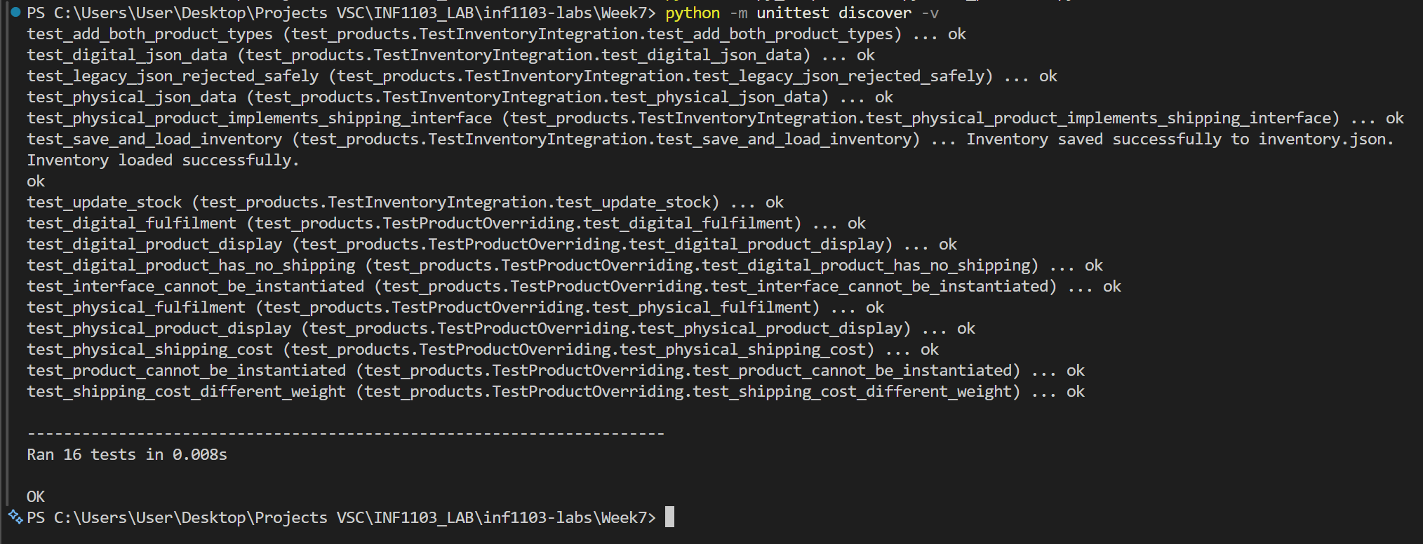 Screenshot #2 (running menu and displayed physical/digital products)
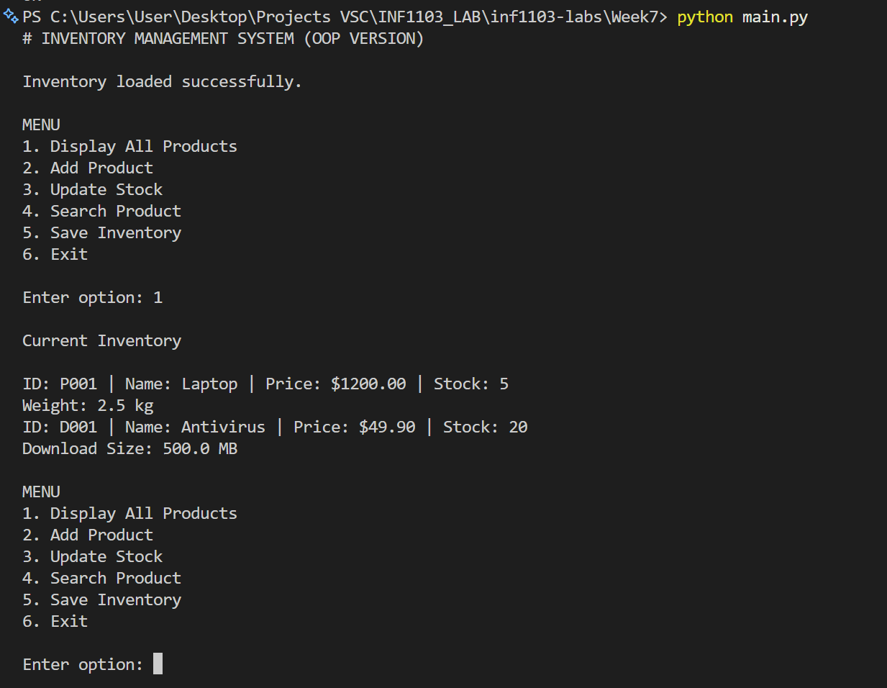
Screenshot #3 (saved JSON showing the type identifiers and subclass-specific fields)
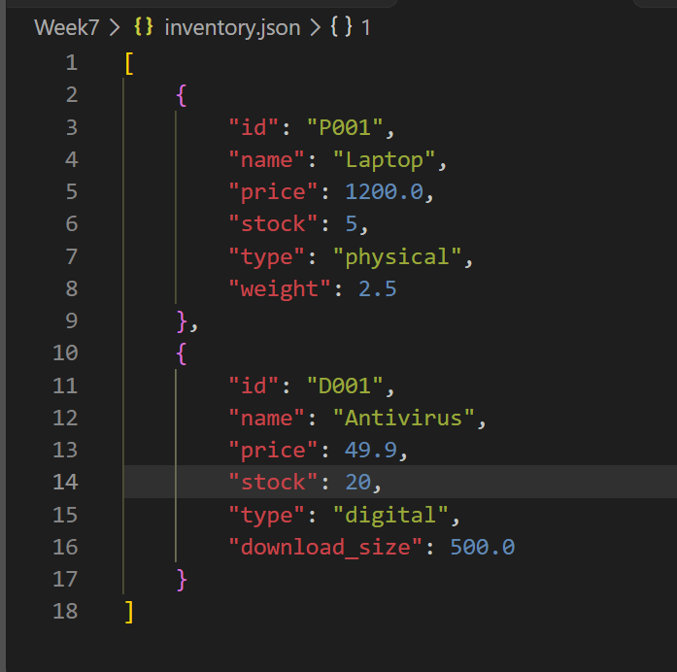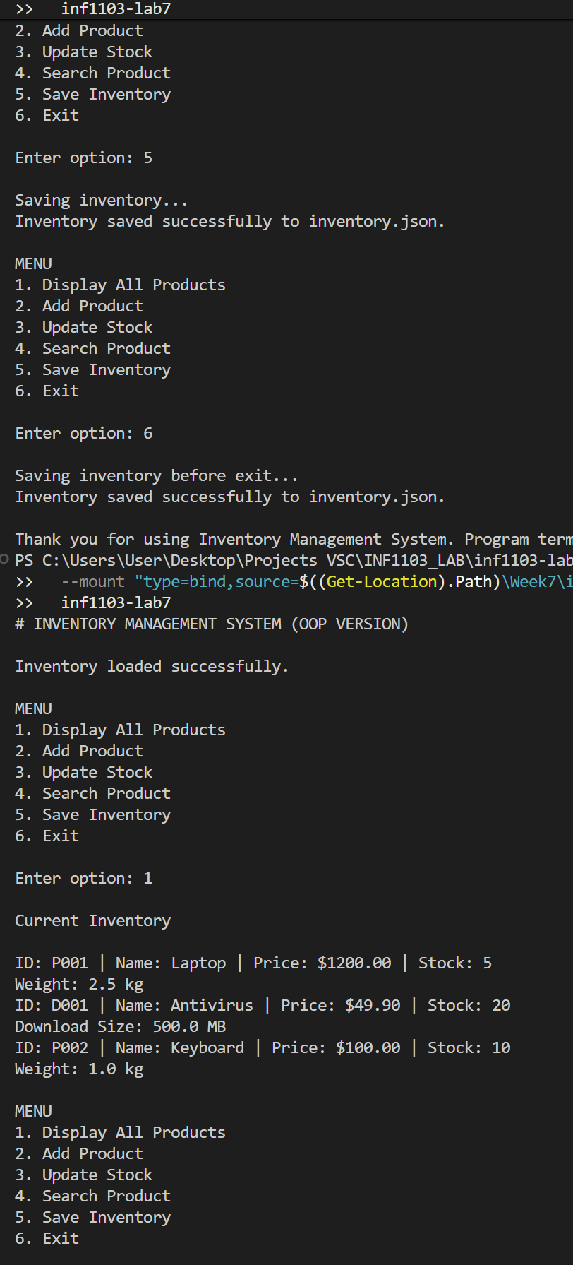
Screenshot #4 (clean Git status after the final commit)


