INF1103 – WEEK 4 LAB SUBMISSION
Name – ONG MING SHUN
Student ID – 2601464
Date – 01/11/2026
GitHub Repository: https://github.com/FoolishAmbition/inf1103-labs
Screenshot #1 (Git Logs)
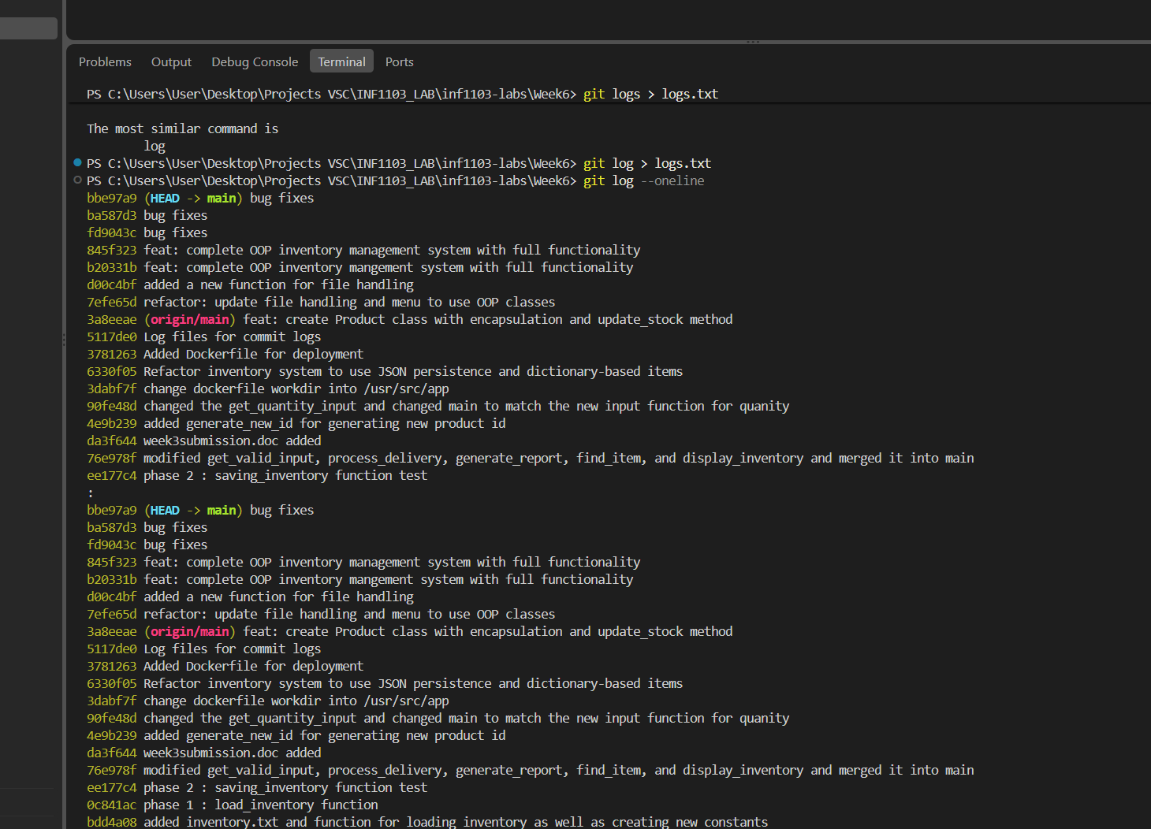
Screenshot #2 (Docker Build).
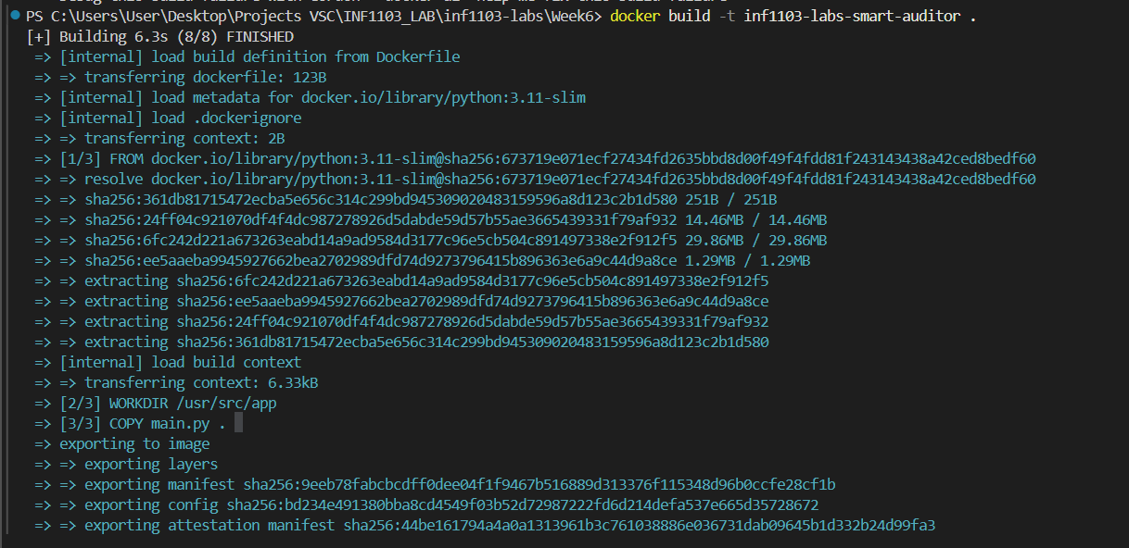
Screenshot #3 (docker images).
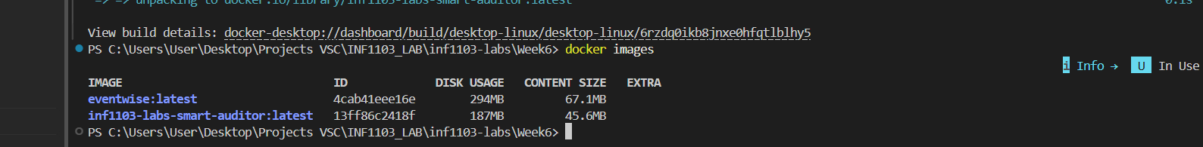
Screenshot #4 (Docker Run)
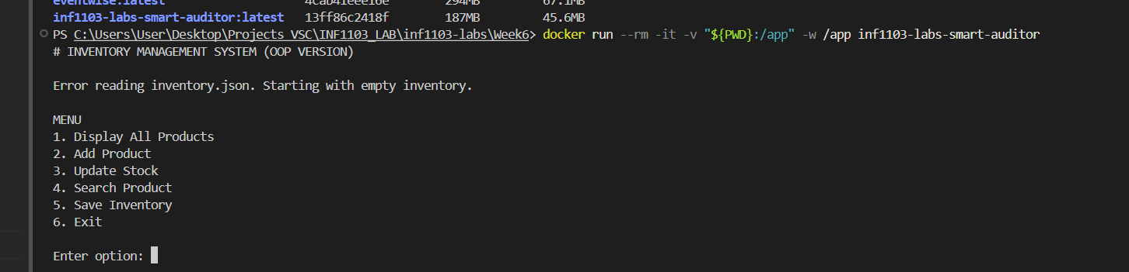
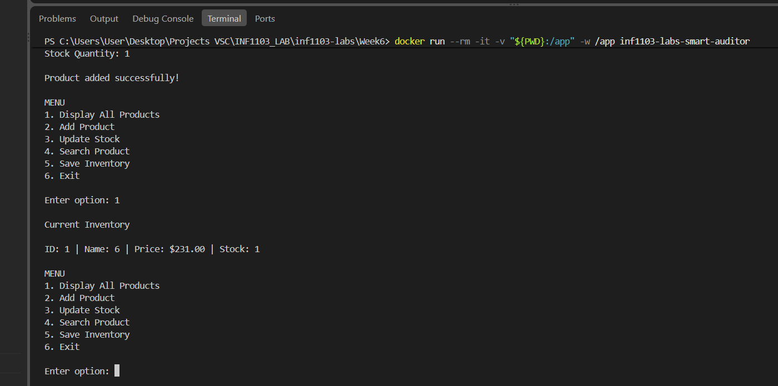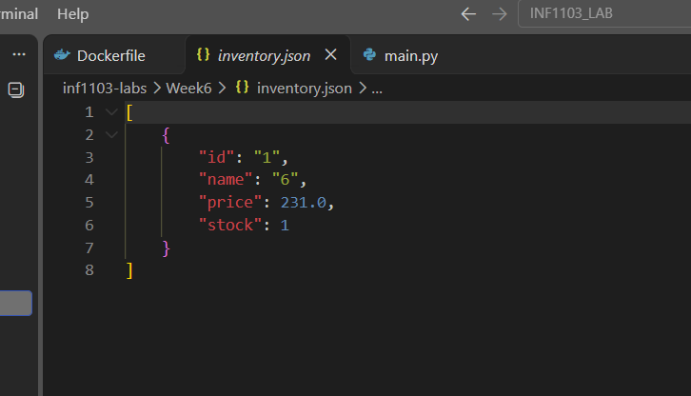
Screenshot #5 (UML_DIAGRAM)


