INF1103 – WEEK 3 LAB SUBMISSION
Name – ONG MING SHUN
Student ID – 2601464
Date – 21/9/2026
GitHub Repository: https://github.com/FoolishAmbition/inf1103-labs
Screenshot #1 (Git Logs)
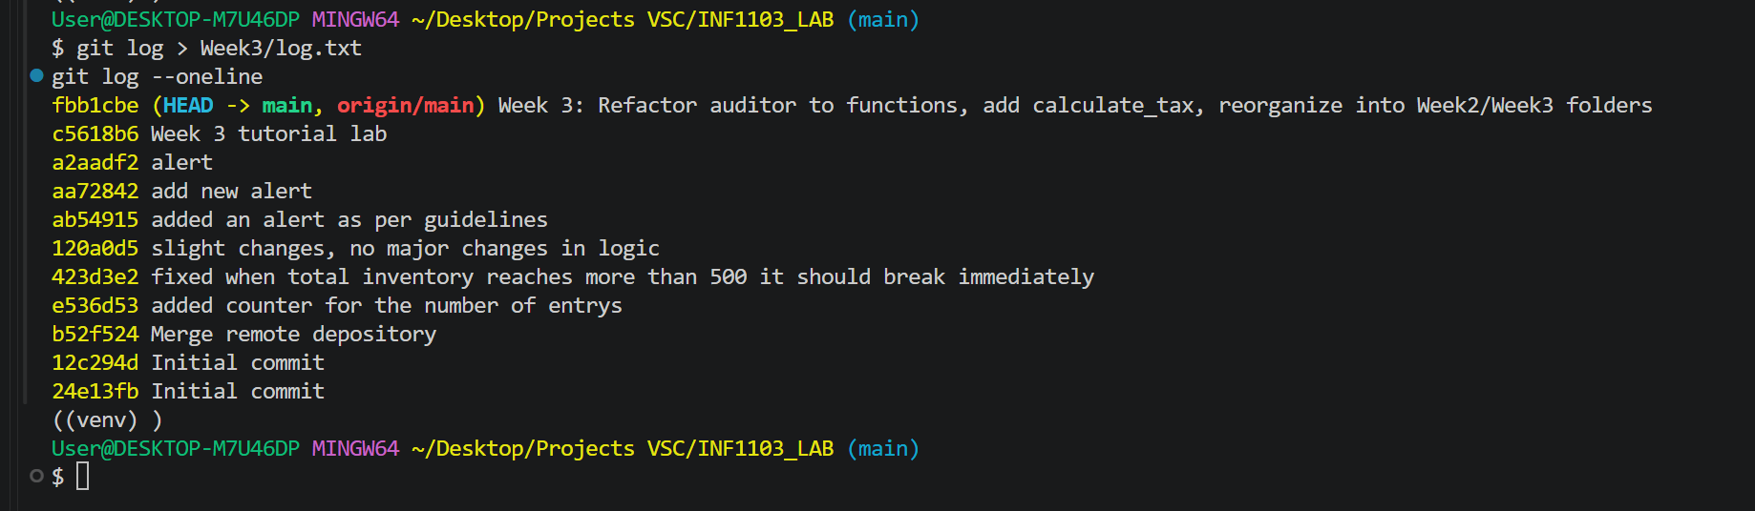
Screenshot #2 (Docker Build).
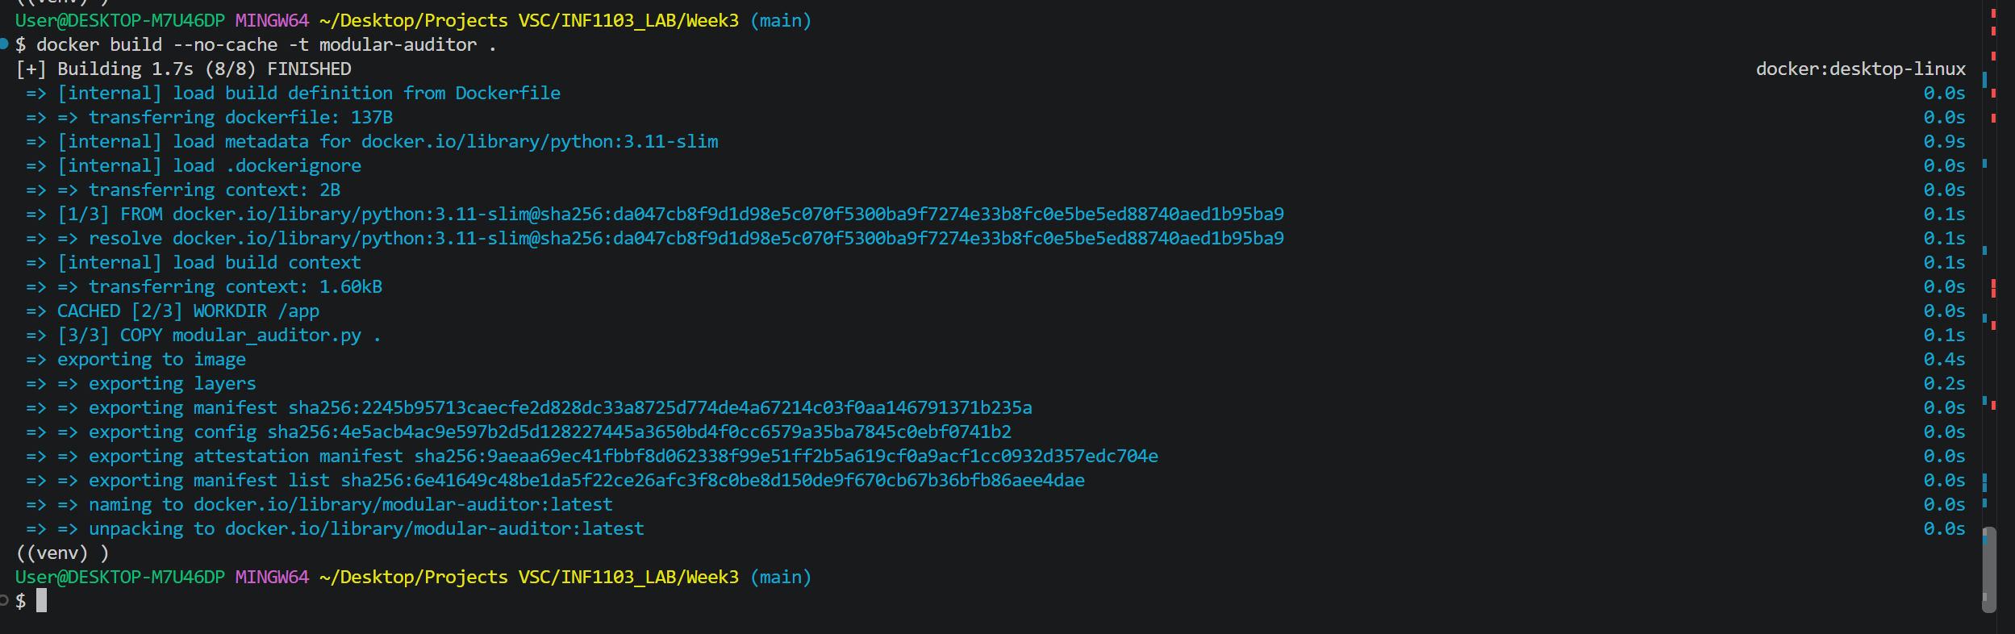
Screenshot #3 (docker images).
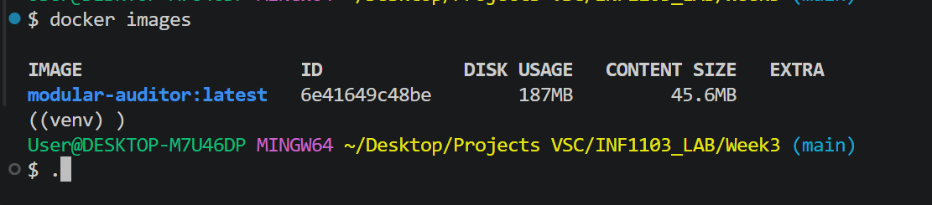
Screenshot #4 (Docker Run)
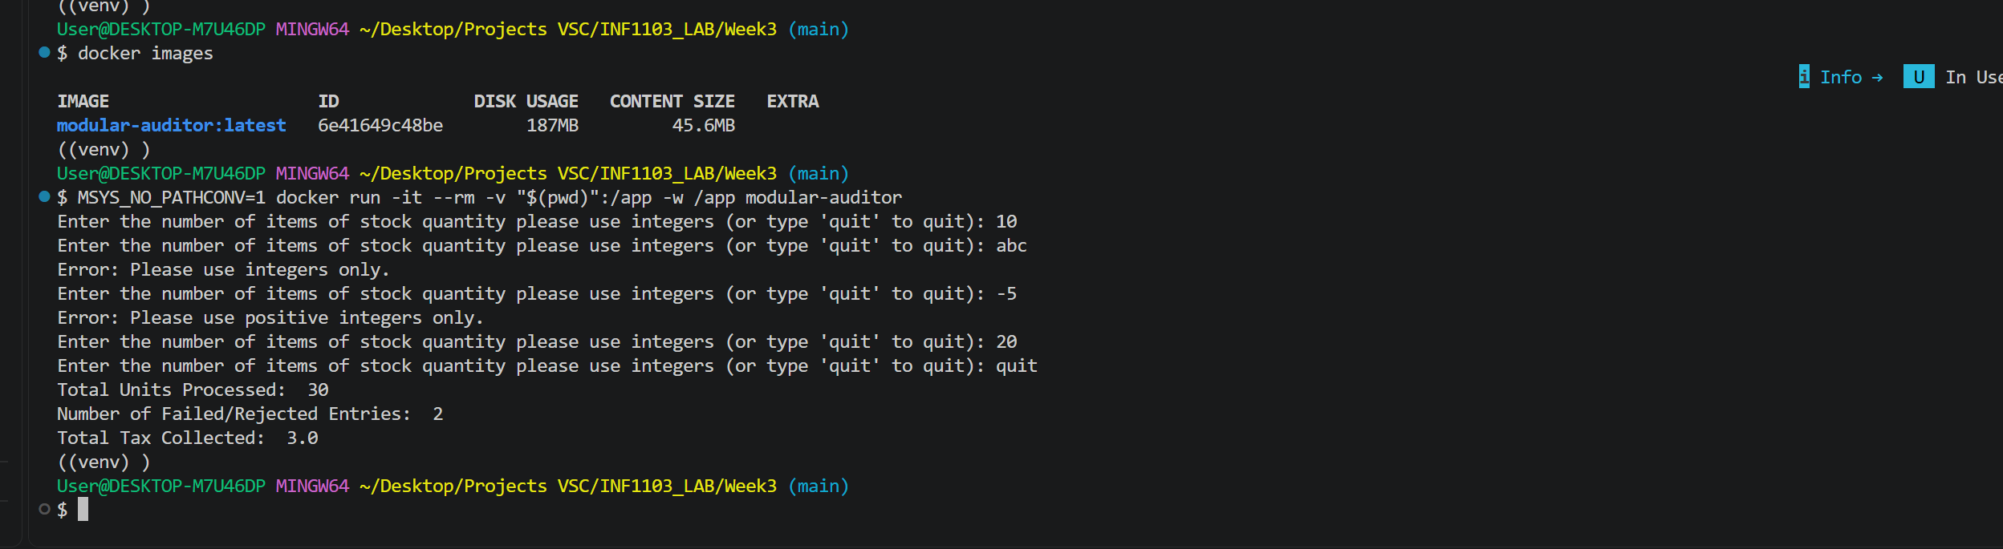
Q: Why is it better to have a calculate_tax function that simply returns a value, rather than having it print the tax amount directly inside the function?
It is a function that returns a value which is reusable in any context, meaning that it can be printed, written to a file, summed into a running total, or tested automatically. A function that simply prints is locked to the screen. This is important because keeping calculation logic separate from presentation logic makes code easier to test, reuse, and maintain.

