**JAVA Arrays- Level 1 - 10 Practice Problems**

Soham Roy,

RA2411033010148,

Z2 Section,

CSE w/s SWE

**1.** Write a program to take user input for the age of all 10 students in a class and check whether the student can vote depending on his/her age is greater or equal to 18.

**Hint =>**

1. Define an array of 10 integer elements and take user input for the student's age.
2. Loop through the array using the length property and for the element of the array check If the age is a negative number print an invalid age and if 18 or above, print The student with the age ___ can vote. Otherwise, print The student with the age ___ cannot vote.

**Program:**

/**A program to take user input for the age of all 10 students in a class and check whether the student can vote depending on his/her age is greater or equal to 18*/

package step_program;

import java.util.*; //Importing java.util.* for Scanner class

public class VoteArray

{

public static void main(String args[])

{

int arr[] = new int[10]; //Initializing the array to store the ages of the 10 students

System.***out***.println("Enter the ages of the 10 students:");

Scanner sc=new Scanner(System.***in***); //Initializing Scanner class

for(int i = 0; i < arr.length; i++) //For Loop

{

arr[i] = sc.nextInt(); //Inputting 10 elements of the array one by one from the user

} //End For Loop

for(int i = 0; i < arr.length; i++) //For Loop

{

if(arr[i] < 0) //Checking if age is negative

System.***out***.println("Invalid Age"); //Displaying Final Output

else if(arr[i] < 18) //Checking if age is less than 18

System.***out***.println("The student with the age "+ arr[i] +" cannot vote."); //Displaying Final Output

else

System.***out***.println("The student with the age "+ arr[i] +" can vote."); //Displaying Final Output

} //End For Loop

} //End Method

} //End Class

**Output:**

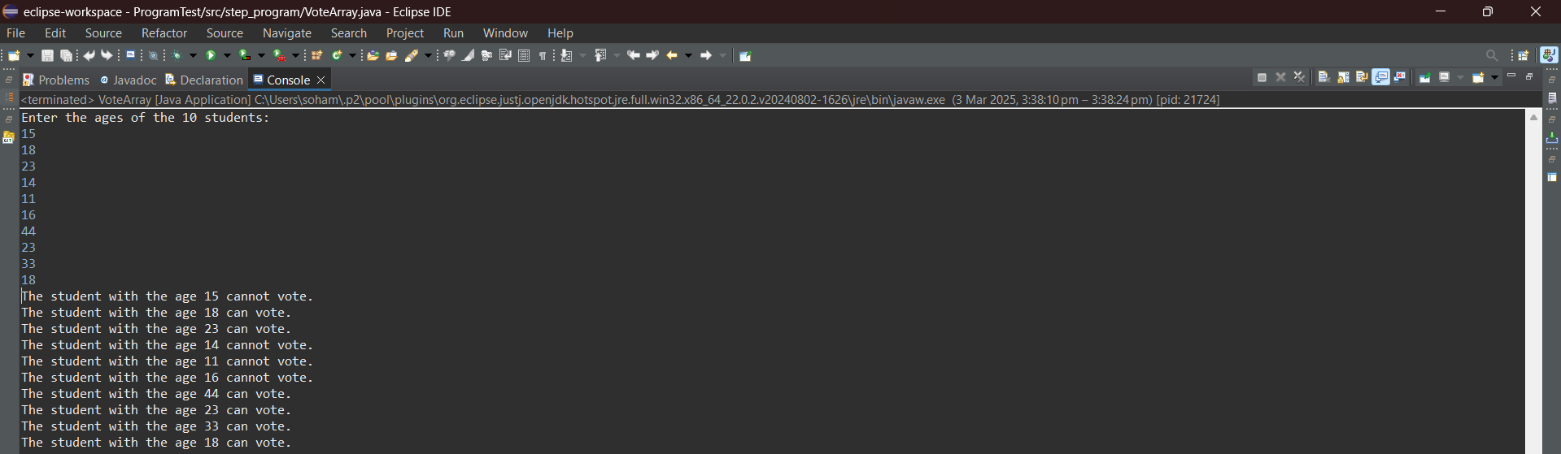

**2.** Write a program to take user input for 5 numbers and check whether a number is positive,  negative, or zero. Further for positive numbers check if the number is even or odd. Finally compare the first and last elements of the array and display if they equal, greater or less

Hint =>

1. Define an integer array of 5 elements and get user input to store in the array.
2. Loop through the array using the length If the number is positive, check for even or odd numbers and print accordingly
3. If the number is negative, print negative. Else if the number is zero, print zero.
4. Finally compare the first and last element of the array and display if they equal, greater or less

**Program:**

/**A program to take user input for 5 numbers and check whether a number is positive, negative, or zero and for positive numbers check if the number is even or odd and finally compare the first and last elements of the array and display if they equal, greater or less*/

package step_program;

import java.util.*; //Importing java.util.* for Scanner class

public class PosNegZerOddEvArray

{

public static void main(String args[])

{

int arr[] = new int[5]; //Initializing the array

Scanner sc=new Scanner(System.***in***); //Initializing Scanner object

System.***out***.println("Enter the 5 numbers of the array:");

for(int i = 0; i < 5; i++) //For Loop

{

arr[i] = sc.nextInt(); //Inputting the elements of the array from the user

} //End For Loop

for(int i = 0; i < 5; i++) //For Loop

{

System.***out***.print(arr[i] + " is ");

if(arr[i] == 0) //Checking if the number is zero

System.***out***.println("Zero"); //Displaying Final Output

else if(arr[i] < 0) //Checking if the number is negative

System.***out***.println("Negative"); //Displaying Final Output

else //Concluding that the number is positive

{

System.***out***.print("Postive and "); //Displaying Final Output

if(arr[i] % 2 == 0) //Checking if the number is even

System.***out***.println("Even"); //Displaying Final Output

else //Concluding that the number is odd

System.***out***.println("Odd"); //Displaying Final Output

} //End Else Block

} //End For Loop

if(arr[0] > arr[4]) //Comparing the first element of the array with the last element of the array

System.***out***.println("The first element of the array is greater than the last element of the array"); //Displaying Final Output

else if(arr[0] < arr[4])

System.***out***.println("The first element of the array is smaller than the last element of the array"); //Displaying Final Output

else

System.***out***.println("The first element of the array is equal to the last element of the array"); //Displaying Final Output

} //End Method

} //End Class

**Output:**

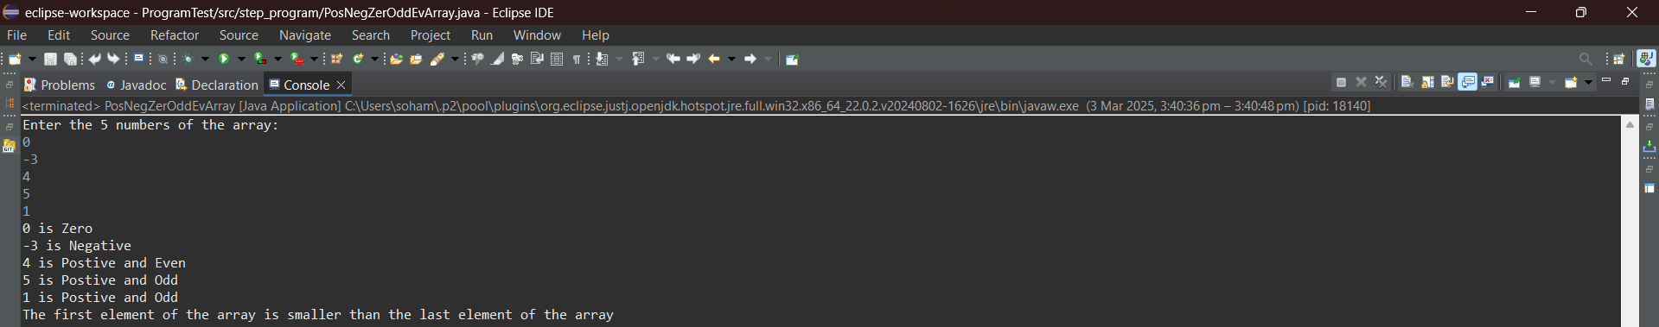

**3.** Create a program to print a multiplication table of a number.

Hint =>

1. Get an integer input and store it in the number variable. Also, define a integer array to store the results of multiplication from 1 to 10
2. Run a loop from 1 to 10 and store the results in the multiplication table array
3. Finally, display the result from the array in the format number * i = ___

**Program:**

/**A program to print a multiplication table of a number using integer array*/

package step_program;

import java.util.*; //Importing java.util.* for Scanner class

public class MultiplicationTableArray

{

public static void main(String args[])

{

int number; //Initializing number variable

int arr[] = new int[10]; //Initializing integer array for storing the multiplication values

Scanner sc=new Scanner(System.***in***);

System.***out***.println("Enter the number to find the multiplication table of:");

number = sc.nextInt(); //Inputting the number from the user

for(int i = 1; i <= 10; i++) //For Loop

arr[i-1] = i * number; //Calculating the multiples and storing them in the array

System.***out***.println("The multiplication table of "+ number +":");

for(int i = 1; i <= 10; i++) //For Loop

System.***out***.println(number +" * "+ i +" = "+ arr[i-1]); //Displaying Final Output

} //End Method

} //End Class

**Output:**

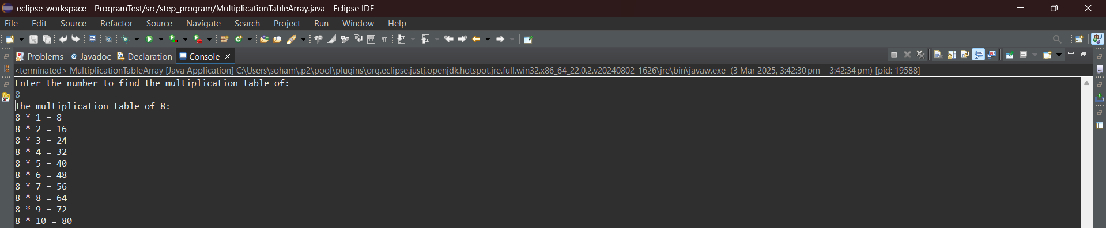

**4.** Write a program to store multiple values in an array up to a maximum of 10 or until the user enters a 0 or a negative number. Show all the numbers as well as the sum of all numbers

Hint =>

1. Create a variable to store an array of 10 elements of type double as well as a variable to store the total of type double initializes to 0.0. Also, the index variable is initialized to 0 for the array
2. Use infinite while loop as in *while (true)*
3. Take the user entry and check if the user entered 0 or a negative number to break the loop
4. Also, *break* from the loop if the index has a value of 10 as the array size is limited to 10.
5. If the user entered a number other than 0 or a negative number inside the while loop then assign the number to the array element and increment the index value
6. Take another *for* loop to get the values of each element and add it to the total
7. Finally display the total value

**Program:**

/**A program to store multiple values in an array up to a maximum of 10 or until the user enters a 0 or a negative number and show all the numbers as well as the sum of all numbers*/

package step_program;

import java.util.*; //Importing java.util.* for Scanner class

public class Array10Numbers

{

public static void main(String args[])

{

double arr[]=new double[10]; //Initializing the array to store the numbers

double total = 0.0, input; //Initializing variables

int k = 0; //Initializing loop control variable

System.***out***.println("Enter the elements of the array. Enter 0 or negative number to stop.");

Scanner sc=new Scanner(System.***in***); //Initializing Scanner object

while(true) //Infinite Loop

{

if(k > 9) //Checking if index is out of bounds

break; //Ending Loop

input = sc.nextDouble(); //Inputting the element of the array from the user

if(input < 0 || input == 0) //Checking if the element is zero or negative

break; //Ending Loop

else

arr[k] = input; //Storing input element inside array

total+= arr[k]; //Adding input element to the total sum

k++; //Incrementing loop control variable

} //End While Loop

System.***out***.println("Sum of the elements of the array = " + total); //Displaying Final Output

for(int i = 0; i < 10; i++) //For Loop

System.***out***.print(arr[i] + " "); //Displaying Final Output

} //End Method

} //End Class

**Output:**

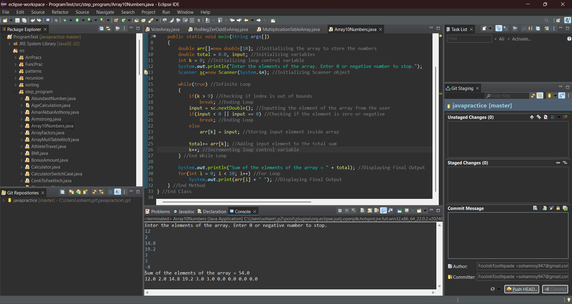

**5.** Create a program to find the multiplication table of a number entered by the user from 6 to 9 and display the result

Hint =>

1. Take integer input and store it in the variable number as well as define an integer array to store the multiplication result in the variable multiplicationResult
2. Using a for loop, find the multiplication table of numbers from 6 to 9 and save the result in the array
3. Finally, display the result from the array in the format number * i = ___

**Program:**

/**A program to find the multiplication table of a number entered by the user from 6 to 9 and display the result*/

package step_program;

import java.util.*; //Importing java.util.* for Scanner class

public class ArrayMultTable6to9

{

public static void main(String args[])

{

int number; //Initializing number variable

int arr[] = new int[4]; //Initializing integer array for storing the multiplication values

Scanner sc=new Scanner(System.***in***);

System.***out***.println("Enter the number to find the multiplication table of:");

number = sc.nextInt(); //Inputting the number from the user

for(int i = 6; i <= 9; i++) //For Loop

arr[i-6] = i * number; //Calculating the multiples and storing them in the array

System.***out***.println("The multiplication table of "+ number +":");

for(int i = 6; i <= 9; i++) //For Loop

System.***out***.println(number +" * "+ i +" = "+ arr[i-6]); //Displaying Final Output

} //End Method

} //End Class

**Output:**

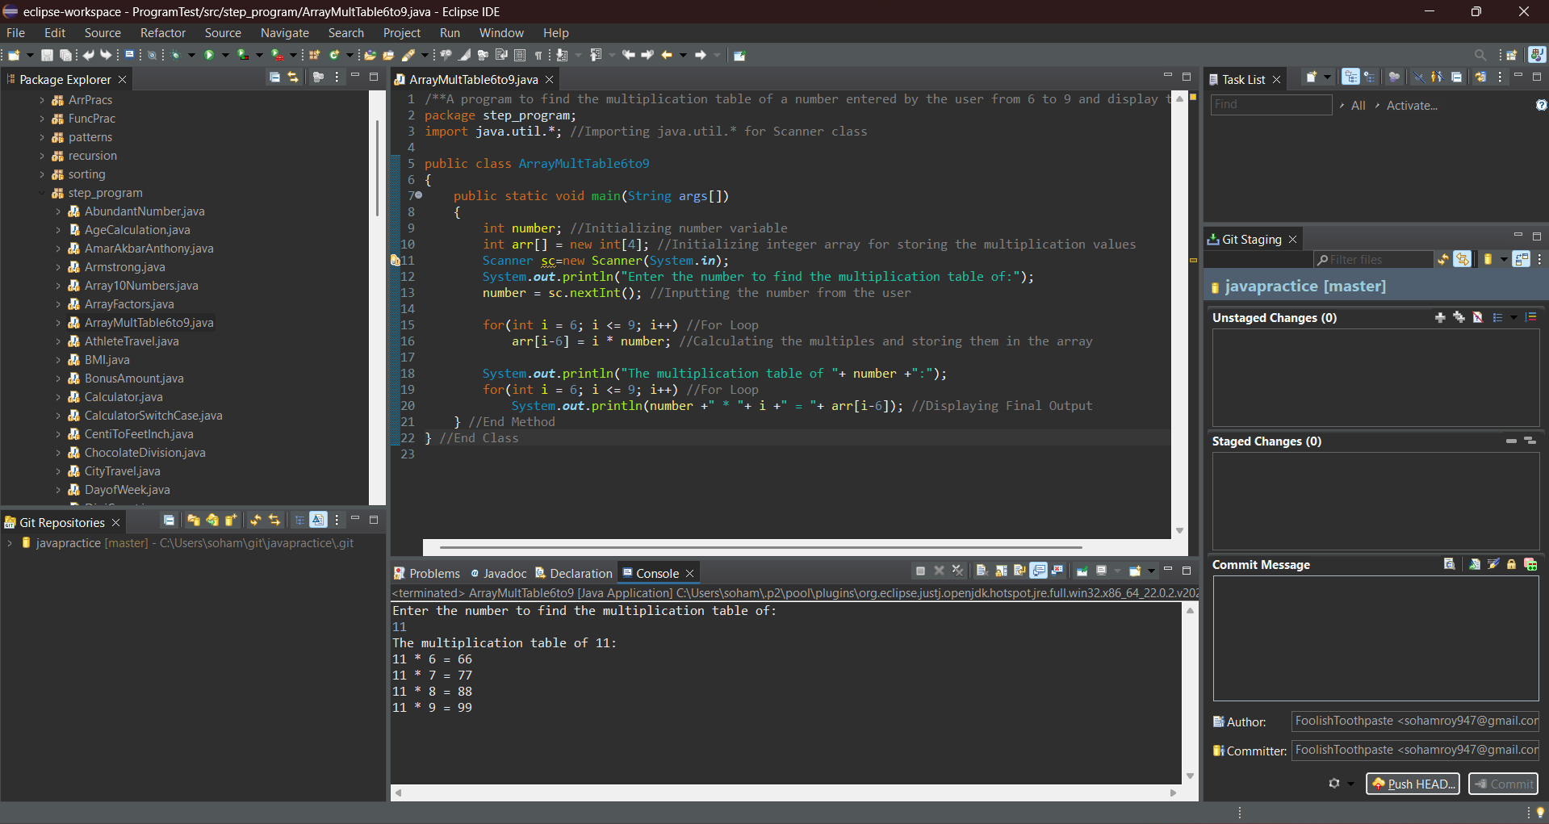

**6.** Create a program to find the mean height of players present in a football team.

Hint =>

1. The formula to calculate the mean is: mean = sum of all elements / number of elements
2. Create a double array named heights of size 11 and get input values from the user.
3. Find the sum of all the elements present in the array.
4. Divide the sum by 11 to find the mean height and print the mean height of the football team

**Program:**

/**A program to find the mean height of players present in a football team*/

package step_program;

import java.util.*; //Importing java.util.* for Scanner class

public class FootballTeamHeightMean

{

public static void main(String args[])

{

double height[] = new double[11]; //Initializing the array to store the height values

double sum = 0, mean; //Initializing variables

Scanner sc=new Scanner(System.***in***); //Initializing Scanner object

System.***out***.println("Enter the heights of the players:");

for(int i = 0; i < height.length; i++) //For Loop

height[i] = sc.nextDouble(); //Inputting the height values of the football players from the user

for(int i = 0; i < height.length; i++) //For Loop

sum+= height[i]; //Calculating the sum of the elements in the array

mean = sum / 11; //Calculating the mean of the height values of the football players

System.***out***.println("The mean of the heights of the football players = "+ mean); //Displaying Final Output

} //End Method

} //End Class

**Output:**

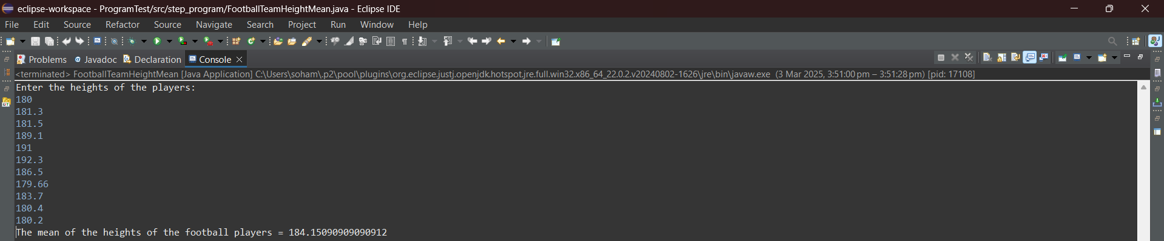

**7.** Create a program to save odd and even numbers into odd and even arrays between 1 to the number entered by the user. Finally, print the odd and even numbers array

Hint =>

1. Get an integer input from the user, assign it to a variable *number,* and check for Natural Number. If not a natural number then print an error and exit the program
2. Create an integer array for even and odd numbers with size = number / 2 + 1
3. Create index variables for odd and even numbers and initialize them to zero
4. Using a for loop, iterate from 1 to the number, and in each iteration of the loop, save the odd or even number into the corresponding array
5. Finally, print the odd and even numbers array using the odd and even index

**Program:**

/**A program to save odd and even numbers into odd and even arrays between 1 to the number entered by the user and print the odd and even numbers array*/

package step_program;

import java.util.*; //Importing java.util.* for Scanner class

public class EvenOddArrays

{

public static void main(String args[])

{

int number; //Initializing the number variable

System.***out***.println("Enter the number to store and print to: ");

Scanner sc=new Scanner(System.***in***); //Initializing Scanner object

number = sc.nextInt(); //Inputting the number from the user

if(number > 0) //Checking if the number is a natural number

{

int even[] = new int[(number / 2) + 1]; //Initializing the array to store the even numbers

int odd[] = new int[(number / 2) + 1]; //Initializing the array to store the odd numbers

int m = 0, n = 0; //Initializing the index variables

for(int i = 1; i <= number; i++) //For Loop

{

if(i % 2 == 0) //Checking if the number is even

{

even[m] = i; //Inserting the number to the even array

m++; //Incrementing the index tracker of the even array by 1

} //End If Block

else //If the number is odd

{

odd[n] = i; //Inserting the number to the odd array

n++; //Incrementing the index tracker of the odd array by 1

} //End Else Block

} //End For Loop

System.***out***.println("Even Array:"); //Displaying Final Output

for(int i = 0; i < m; i++) //For Loop

System.***out***.print(even[i] + " "); //Displaying Final Output

System.***out***.println("\nOdd Array:"); //Displaying Final Output

for(int i = 0; i < n; i++) //For Loop

System.***out***.print(odd[i] + " "); //Displaying Final Output

}

else //If number is non natural

System.***out***.println(number + " is not a natural number."); //Displaying Final Output

} //End Method

} //End Class

**Output:**

I/P:

-3

O/P:

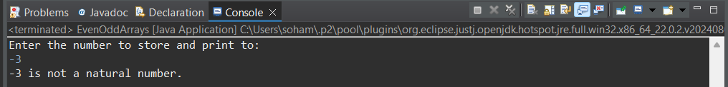

I/P:

20

O/P:

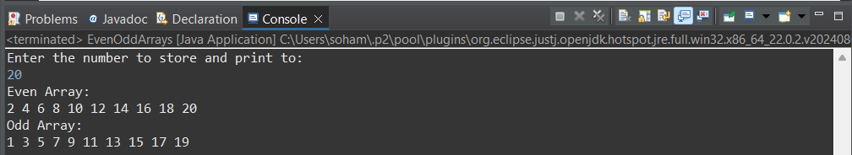

**8.** Create a program to find the factors of a number taken as user input, store the factors in an array, and display the factors

Hint =>

1. Take the input for a number
2. Find the factors of the number and save them in an array. For this create integer variable maxFactor and initialize to 10, factors array of size maxFactor and index variable to reflect the index of the array.
3. To find factors loop through the numbers from 1 to the number, find the factors, and add them to the array element by incrementing the index. If the index is equal to maxIndex, then need factors array to store more elements
4. To store more elements, reset the maxIndex to twice its size, use the temp array to store the elements from the factors array, and eventually assign the factors array to the temp array
5. Finally, Display the factors of the number

**Program:**

/**A program to find the factors of a number taken as user input and store the factors in an array, and display the factors*/

package step_program;

import java.util.*; //Importing java.util.*

public class ArrayFactors

{

public static void main(String args[])

{

int number, maxFactor = 10, index = 0; //Initializing variables

int factors[] = new int[maxFactor]; //Initializing

Scanner sc=new Scanner(System.***in***); //Initializing Scanner object

System.***out***.println("Enter the value of the number whose factors you want to find:");

number = sc.nextInt(); //Inputting the number from the user

for(int i = 1; i < number; i++) //For Loop

{

if(index >= maxFactor) //Checking if the index becomes larger than the size of the factors array

{

maxFactor*= 2; //Doubling the size of the array

int temp[] = new int[maxFactor]; //Creating a temporary array of double size

System.*arraycopy*(factors, 0, temp, 0, index); //Copying elements from factors array to temporary array

factors = temp; //Assigning factors array to refer to temporary array

} //End If Block

if(number % i == 0) //Checking if i is a factor of the number

{

factors[index] = i; //Inserting i to the factors array

index++; //Incrementing the index of the factors array by 1

} //End If Block

} //End For Loop

System.***out***.println("Factors of " + number +":");

for(int i = 0; i < index; i++) //For Loop

System.***out***.print(factors[i] + " "); //Displaying Final Output

} //End Method

} //End Class

**Output:**

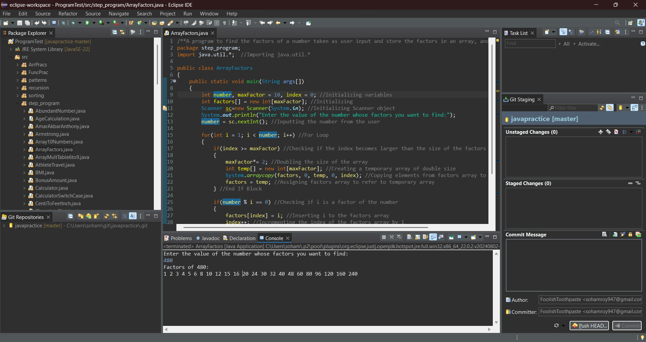

**9.** Working with Multi-Dimensional Arrays. Write a Java program to create a 2D Array and Copy the 2D Array into a single dimension array

Hint =>

1. Take user input for rows and columns, create a 2D array (Matrix), and take the user input
2. Copy the elements of the matrix to a 1D array. For this create a 1D array of size rows*columns as in int[] array = new int[rows * columns];
3. Define the index variable and Loop through the 2D array. Copy every element of the 2D array into the 1D array and increment the index
4. Note: For looping through the 2D array, you will need Nested for loop, Outer for loop for rows, and the inner for loops to access each element

**Program:**

/**A Java program to create a 2D Array and Copy the 2D Array into a single dimension array*/

package step_program;

import java.util.*; //Importing java.util.* for Scanner class

public class TwoDToOneDArr

{

public static void main(String args[])

{

int rows, columns, index = 0; //Initializing variables

Scanner sc=new Scanner(System.***in***); //Initializing Scanner object

System.***out***.println("Enter the rows and columns of the 2D Array:");

rows = sc.nextInt(); //Inputting the number of rows in the 2D Array from the user

columns = sc.nextInt(); //Inputting the number of columns in the 2D Array from the user

int array2D[][] = new int[rows][columns]; //Initializing the 2D array

int array[] = new int[rows * columns]; //Initializing the 1D array

System.***out***.println("Enter the elements of the 2D Array:");

for(int i = 0; i < rows; i++) //For Loop 1

for(int j = 0; j < columns; j++) //For Loop 2

array2D[i][j] = sc.nextInt(); //Inputting the elements of the 2D array

for(int i = 0; i < rows; i++) //For Loop 1

for(int j = 0; j < columns; j++) //For Loop 2

{

array[index] = array2D[i][j]; //Inserting the elements of the 2D array into the 1D array

index++; //Incrementing the index of the 1D array by 1

} //End Loop 2

System.***out***.println("2D Array:");

for(int i = 0; i < rows; i++) //For Loop 1

{

for(int j = 0; j < columns; j++) //For Loop 2

System.***out***.print(array2D[i][j] + " "); //Displaying Final Output

System.***out***.println(); //Moving cursor to next line to print next row

} //End Loop 1

System.***out***.println("\n1D Array:");

for(int i = 0; i < index; i++) //For Loop

System.***out***.print(array[i] + " "); //Displaying Final Output

} //End Method

} //End Class

**Output:**

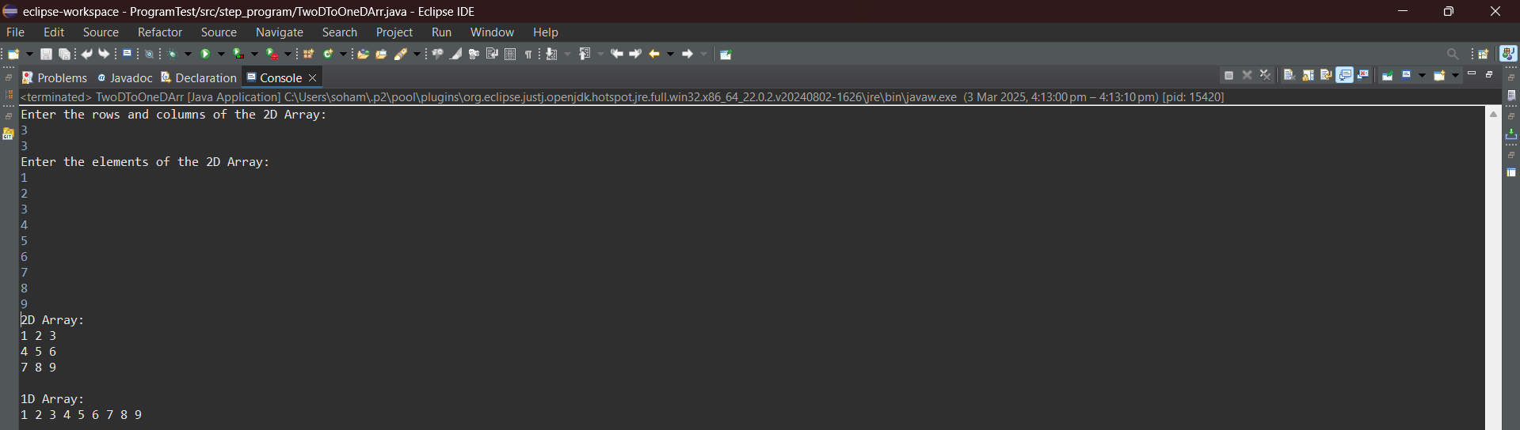

**10.** Write a program FizzBuzz, take a number as user input and if it is a positive integer loop from 0 to the number and save the number, but for multiples of 3 save "Fizz" instead of the number, for multiples of 5 save "Buzz", and for multiples of both save "FizzBuzz". Finally, print the array results for each index position in the format Position 1 = 1, …, Position 3 = Fizz,...

Hint =>

1. Create a String Array to save the results and
2. Finally, loop again to show the results of the array based on the index position

**Program:**

/**A program FizzBuzz that take a number as user input and if it is a positive integer loops from 0 to the number and saves the number, but for multiples of 3 saves "Fizz" instead of the number, for multiples of 5 saves "Buzz", and for multiples of both saves "FizzBuzz" and finally, prints the array results for each index position in the format Position 1 = 1, …, Position 3 = Fizz,...*/

package step_program;

import java.util.*; //Importing java.util.* for Scanner class

public class FizzBuzzArray

{

public static void main(String args[])

{

int number, j; //Initializing variables

Scanner sc=new Scanner(System.***in***); //Initializing Scanner object

System.***out***.println("Enter the number:");

number = sc.nextInt(); //Inputting the number from the user

if(number > 0) //Checking if the number is a positive number

{

String arr[] = new String[number]; //Initializing the array to store the elements

for(int i = 0; i < number; i++) //For Loop

{

j = i+1; //j will be element stored at index i

if( j % 5 == 0 && j % 3 == 0) //Checking if the element is divisible by both 5 and 3

arr[i] = "FizzBuzz"; //Storing "FizzBuzz" in the array

else if(j % 3 == 0) //Checking if the element is divisible by 3 and not 5

arr[i] = "Fizz"; //Storing "Fizz" in the array

else if(j % 5 == 0) //Checking if the element is divisible by 5 and not 3

arr[i] = "Buzz"; //Storing "Buzz" in the array

else //The number is divisible by neither 3 nor 5

arr[i] = ""+j; //Storing the number in the array

} //End For Loop

for(int i = 0; i < number; i++) //For Loop

System.***out***.println("Position " + (i+1) + " = " + arr[i]); //Displaying Final Output

}

else //The number is not a positive number

System.***out***.println("Invalid Input"); //Displaying Final Output

} //End Method

} //End Class

**Output:**

I/P:

-3

O/P:

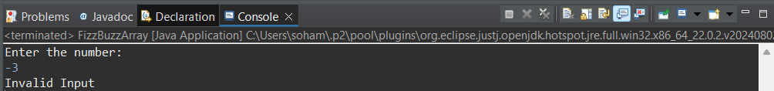

I/P:

15

O/P:

