**JAVA Arrays- Level 2 - 10 Practice Problems**

Soham Roy,

RA2411033010148,

Z2 Section,

CSE w/s SWE

**1.** Create a program to find the bonus of 10 employees based on their years of service and the total bonus amount the company Zara has to pay, along with the old and new salary.

**Hint =>**

1. Zara decides to give a bonus of 5% to employees whose year of service is more than 5 years or 2% if less than 5 years
2. Define a double array to save salary and years of service for each of the 10 employees
3. Also define a double array to save the new salary and the bonus amount as well as variables to save the total bonus, total old salary, and new salary
4. Define a loop to take input from the user. If salary or year of service is an invalid number then ask the use to enter again. Note in this case you will have to decrement the index counter
5. Define another loop to calculate the bonus of 10 employees based on their years of service. Save the bonus in the array, compute the new salary, and save in the array. Also, the total bonus and total old and new salary can be calculated in the loop
6. Print the total bonus payout as well as the total old and new salary of all the employees

**Program:**

/**A program to find the bonus of 10 employees based on their years of service and the total bonus amount the company Zara has to pay, along with the old and new salary*/

package step_program;

import java.util.*; //Importing java.util.* for Scanner class

public class BonusAmountArray

{

public static void main(String args[])

{

double salary[] = new double[10]; //Initializing the array to store the old salaries of the 10 employees

double years[] = new double[10]; //Initializing the array to store the years of service of the 10 employees

double newSalary[] = new double[10]; //Initializing the array to store the new salaries of the 10 employees

double bonusAmount[] = new double[10]; //Initializing the array to store the bonus amounts of the 10 employees

double totalBonus = 0.0, totalOldSalary = 0.0, totalNewSalary = 0.0, salaryInp, yearsInp; //Initializing the variables

Scanner sc=new Scanner(System.***in***); //Initializing Scanner object

System.***out***.println("Enter old salary and years of service for each employee:");

for(int i = 0; i < 10; i++) //For Loop

{

System.***out***.println("Employee "+ (i+1) + ":"); //Numbering each employee's input

salaryInp = sc.nextDouble(); //Inputting the old salary of the employee from the user

yearsInp = sc.nextDouble(); //Inputting the years of service of the employee from the user

if(salaryInp <= 0 || yearsInp <= 0) //Checking if the old salary and years of service is valid

{

System.***out***.println("Invalid Input, try again."); //If invalid, asking user to input the details again

i--; //Decrementing the index to iterate the loop again

} //End If Block

else //If input details are valid

{

salary[i] = salaryInp; //Storing input old salary value in the array

years[i] = yearsInp; //Storing input years of service in the array

totalOldSalary+= salary[i]; //Calculating the total old salary of the employees

} //End Else Block

} //End For Loop

for(int i = 0; i < 10; i++) //For Loop

{

if(years[i] >= 5) //If years of service of the employee is greater than or equal to 5

bonusAmount[i] = salary[i] * 0.05; //Calculating the bonus amount of the employee

else //If years of service of employee is lesser than 5

bonusAmount[i] = salary[i] * 0.02; //Calculating the bonus amount of the employee

newSalary[i] = salary[i] + bonusAmount[i]; //Calculating the new salary of the employee

totalBonus+= bonusAmount[i]; //Calculating the total bonus amount of the employees

totalNewSalary+= newSalary[i]; //Calculating the total new salary of the employees

} //End For Loop

//Displaying Final Output

System.***out***.println("Total Bonus Payout = " + totalBonus); //Displaying Final Output

System.***out***.println("Total Old Salary = " + totalOldSalary);

System.***out***.println("Total New Salary = " + totalNewSalary);

} //End Method

} //End Class

**Output:**

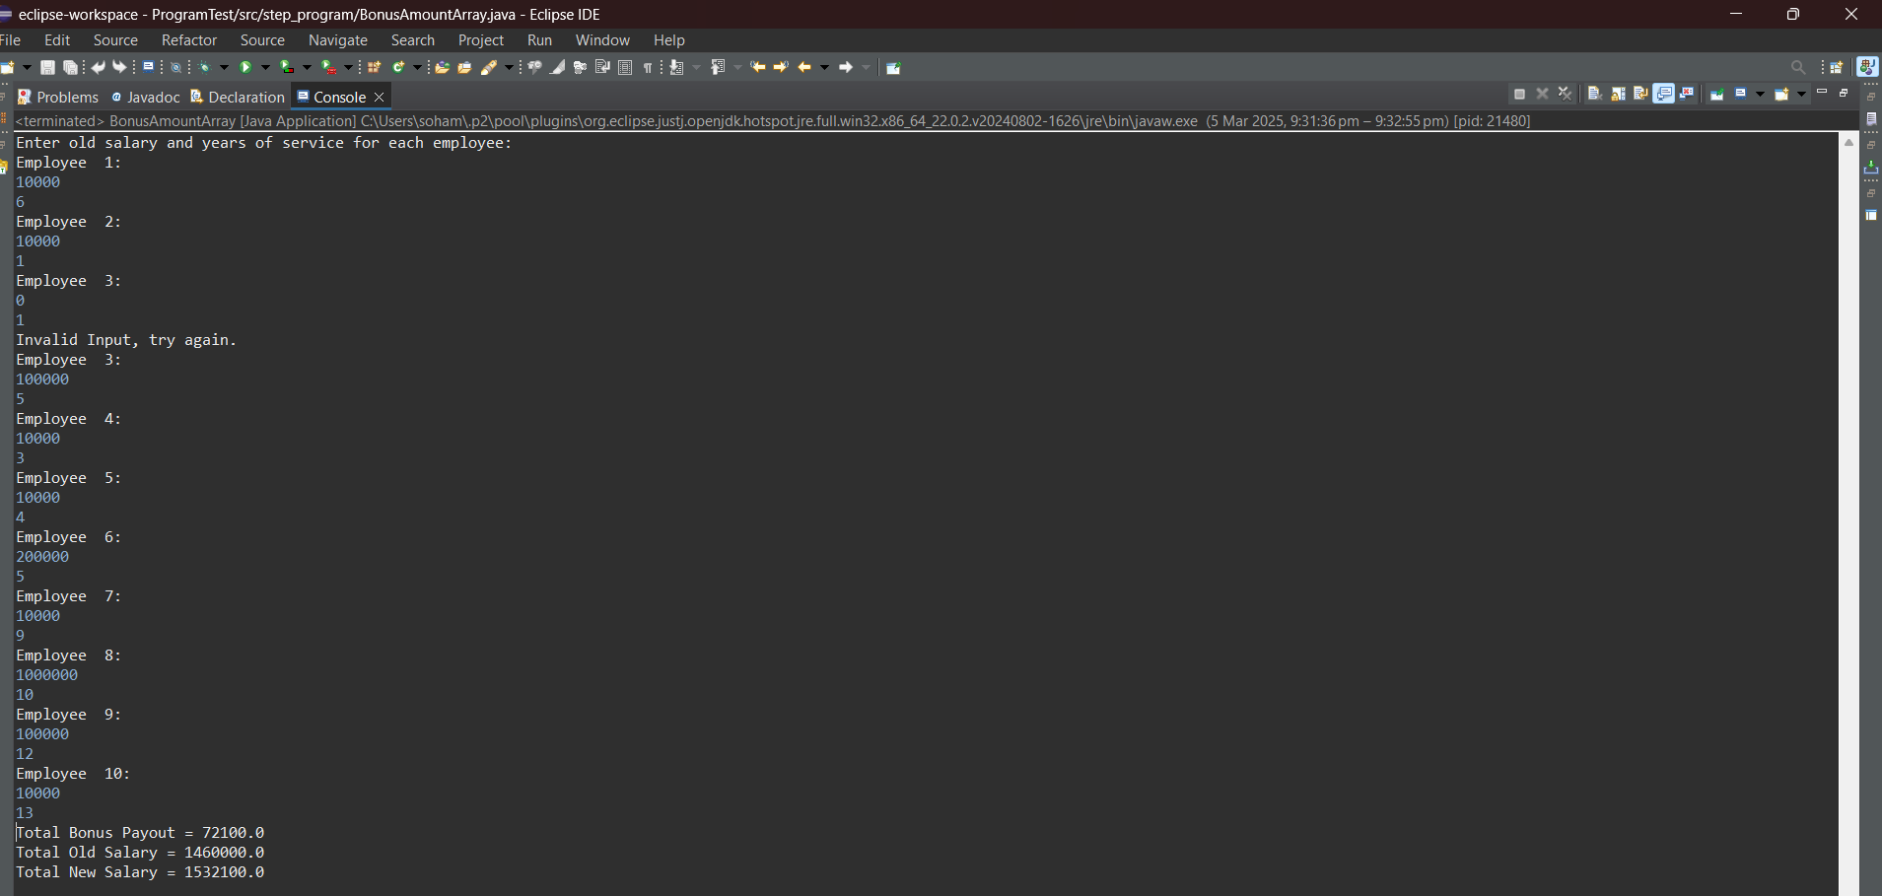

**2.** Create a program to find the youngest friends among 3 Amar, Akbar, and Anthony based on their ages and the tallest among the friends based on their heights

Hint =>

1. Take user input for age and height for the 3 friends and store it in two arrays each to store the values for age and height of the 3 friends
2. Loop through the array and find the youngest of the 3 friends and the tallest of the 3 friends
3. Finally display the youngest and tallest of the 3 friends

**Program:**

/**A program to find the youngest friends among 3 Amar, Akbar, and Anthony based on their ages and the tallest among the friends based on their heights*/

package step_program;

import java.util.*; //Importing java.util.* for Scanner class

public class AmarAkbarAnthony

{

public static void main(String args[])

{

int ageAmar, ageAkbar, ageAnthony; //Initializing the age variables

double hAmar, hAkbar, hAnthony; //Initializing the height variables

Scanner sc=new Scanner(System.***in***); //Initializing the Scanner object

System.***out***.println("Enter the ages of Amar, Akbar and Anthony:");

ageAmar = sc.nextInt(); //Inputting the age of Amar from the user

ageAkbar = sc.nextInt(); //Inputting the age of Akbar from the user

ageAnthony = sc.nextInt(); //Inputting the age of Anthony from the user

System.***out***.println("Enter the heights of Amar, Akbar and Anthony:");

hAmar = sc.nextDouble(); //Inputting the height of Amar from the user

hAkbar = sc.nextDouble(); //Inputting the height of Akbar from the user

hAnthony = sc.nextDouble(); //Inputting the height of Anthony from the user

if(ageAmar > ageAkbar) //Checking for the youngest friend among the three

{

if(ageAkbar > ageAnthony)

System.***out***.println("Anthony is the youngest"); //Displaying Final Output

else

System.***out***.println("Akbar is the youngest"); //Displaying Final Output

} //End If Block

else if(ageAmar > ageAnthony)

System.***out***.println("Anthony is the youngest"); //Displaying Final Output

else

System.***out***.println("Amar is the youngest"); //Displaying Final Output

if(hAmar > hAkbar) //Checking for the tallest friend among the three

{

if(hAmar > hAnthony)

System.***out***.println("Amar is the tallest"); //Displaying Final Output

else

System.***out***.println("Anthony is the tallest"); //Displaying Final Output

} //End If Block

else if(hAkbar > hAnthony)

System.***out***.println("Akbar is the tallest"); //Displaying Final Output

else

System.***out***.println("Anthony is the tallest"); //Displaying Final Output

} //End Method

} //End Class

**Output:**

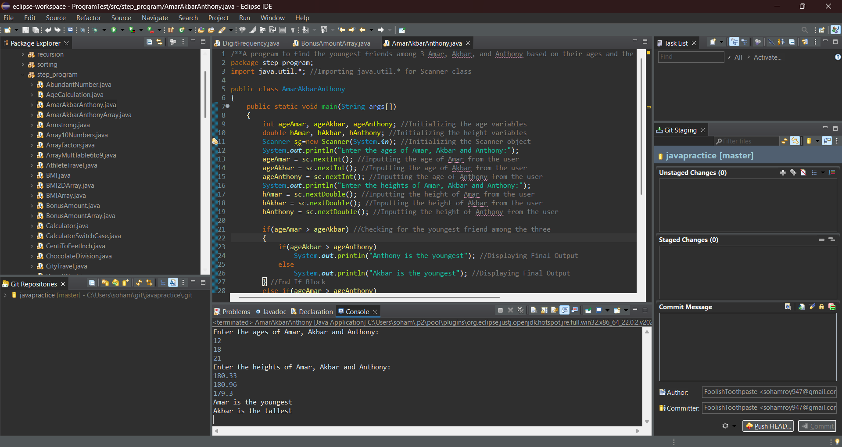

**3.** Create a program to store the digits of the number in an array and find the largest and second largest element of the array.

Hint =>

1. Create a number variable and Take user input.
2. Define an array to store the digits. Set the size of the array to maxDigit variable initially set to 10
3. Create an integer variable index with the value 0 to reflect the array index.
4. Use a loop to iterate until the number is not equal to 0.
5. Remove the last digit from the number in each iteration and add it to the array.
6. Increment the index by 1 in each iteration and if the index count equals maxDigit then break out of the loop and the remaining digits are not added to the array
7. Define variable to store largest and second largest digit and initialize it to zero
8. Loop through the array and use conditional statements to find the largest and second largest number in the array
9. Finally display the largest  and second-largest number

**Program:**

/**A program to store the digits of the number in an array and find the largest and second largest element of the array*/

package step_program;

import java.util.*; //Importing java.util.* for Scanner class

public class LargestSecondLargest

{

public static void main(String args[])

{

int maxDigit = 10, index = 0, largest = 0, secondLargest = 0; //Initializing variables

long number;

int digits[] = new int[maxDigit]; //Initializing the array for storing digits of the number

Scanner sc=new Scanner(System.***in***); //Initializing Scanner object

System.***out***.println("Enter a number. Make sure it has less than 11 digits:");

number = sc.nextLong(); //Inputting the number from the user

while(number > 0) //While Loop

{

digits[index] = (int) (number % 10); //Extracting the last digit of the number and storing them in the array

index++; //Incrementing index variable by 1

if(index >= maxDigit) //Checking number of digits has exceeded the limit

break; //Breaking out of loop

number/= 10; //Removing the last digit from the number

} //End WHile Loop

for(int i = 0; i < 10; i++) //For Loop

{

//Conditional statements to find the largest and second largest digits

if(digits[i] > secondLargest)

{

if(digits[i] > largest)

{

secondLargest = largest;

largest = digits[i];

} //End If Block

else if(digits[i] != largest)

secondLargest = digits[i];

} //End If Block

} //End For Loop

System.***out***.println("Largest Number = " + largest); //Displaying Final Output

System.***out***.println("Second Largest Number = " + secondLargest); //Displaying Final Output

} //End Method

} //End Class

**Output:**

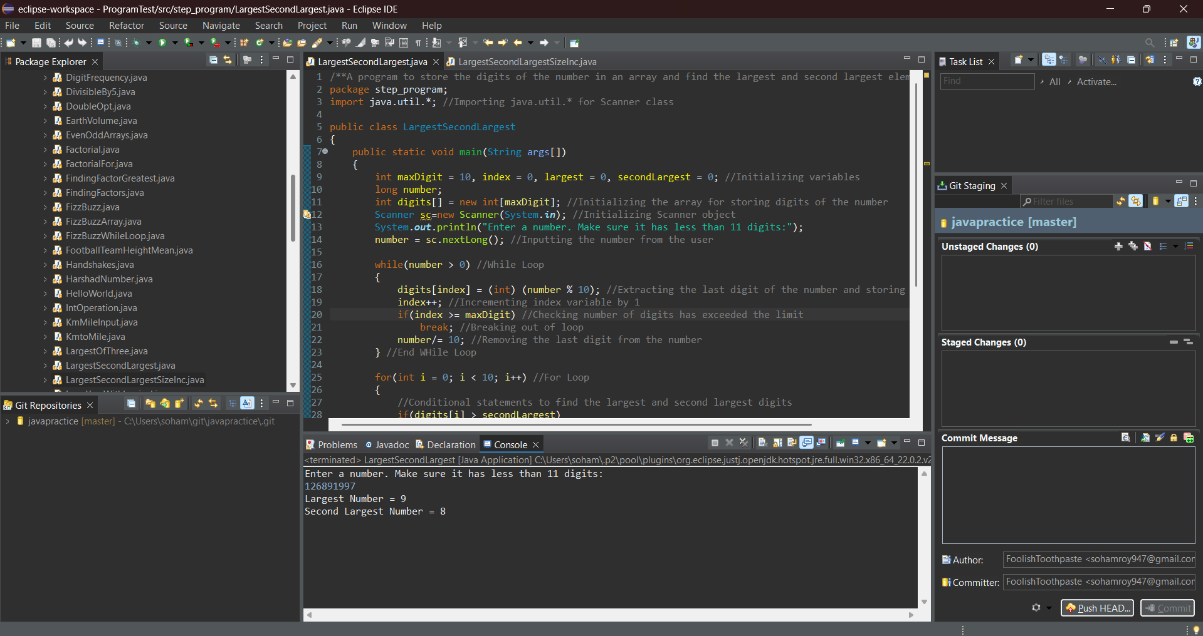

**4.** Rework the program 2, especially the Hint f where if index equals maxDigit, we break from the loop. Here we want to modify to Increase the size of the array i,e maxDigit by 10 if the index is equal to maxDigit. This is done to consider all digits to find the largest and second-largest number

Hint =>

1. In Hint f inside the loop if the index is equal to maxDigit, increase maxDigit and make digits array to store more elements.
2. To do this, we need to create a new temp array of size maxDigit, copy from the current digits array the digits into the temp array, and assign the current digits array to the temp array
3. Now the digits array will be able to store all digits of the number in the array and then find the largest and second largest number

**Program:**

/**A program to store the digits of the number in an array and find the largest and second largest element of the array, increase size of array to fit all digits*/

package step_program;

import java.util.*; //Importing java.util.* for Scanner class

public class LargestSecondLargestSizeInc

{

public static void main(String args[])

{

int maxDigit = 10, index = 0, largest = 0, secondLargest = 0; //Initializing variables

long number;

int digits[] = new int[maxDigit]; //Initializing the array for storing digits of the number

Scanner sc=new Scanner(System.***in***); //Initializing Scanner object

System.***out***.println("Enter a number:");

number = sc.nextLong(); //Inputting the number from the user

while(number > 0) //While Loop

{

index++; //Incrementing index variable by 1

if(index >= maxDigit) //Checking number of digits has exceeded the limit

{

maxDigit*= 2; //Doubling the size of the array

int temp[] = new int[maxDigit]; //Creating a temporary array of double size

System.*arraycopy*(digits, 0, temp, 0, index); //Copying elements from digits array to temporary array

digits = temp; //Assigning digits array to refer to temporary array

}

digits[index] = (int) (number % 10); //Extracting the last digit of the number and storing them in the array

number/= 10; //Removing the last digit from the number

} //End WHile Loop

for(int i = 0; i < maxDigit; i++) //For Loop

{

//Conditional statements to find the largest and second largest digits

if(digits[i] > secondLargest)

{

if(digits[i] > largest)

{

secondLargest = largest;

largest = digits[i];

} //End If Block

else if(digits[i] != largest)

secondLargest = digits[i];

} //End If Block

} //End For Loop

System.***out***.println("Largest Number = " + largest); //Displaying Final Output

System.***out***.println("Second Largest Number = " + secondLargest); //Displaying Final Output

} //End Method

} //End Class

**Output:**

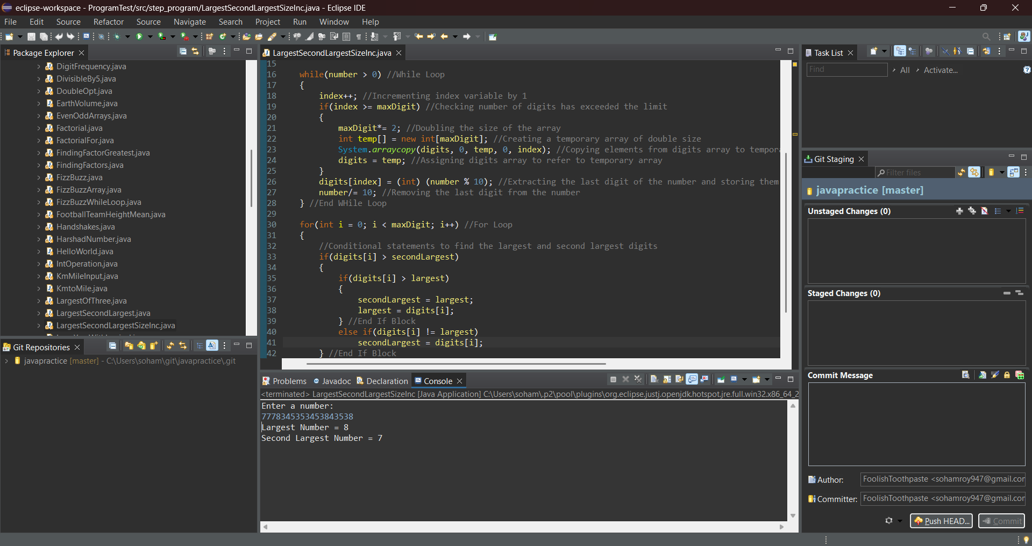

**5.** Create a program to take a number as input and reverse the number. To do this, store the digits of the number in an array and display the array in reverse order

Hint =>

1. Take user input for a number.
2. Find the count of digits in the number.
3. Find the digits in the number and save them in an array
4. Create an array to store the elements of the digits array in reverse order
5. Finally, display the elements of the array in reverse order

**Program:**

/**A program to take a number as input and reverse the number*/

package step_program;

import java.util.*; //Importing java.util.*

public class ReverseDigitArray

{

public static void main(String args[])

{

int number, numbert, count = 0; //Initializing variables

Scanner sc=new Scanner(System.***in***); //Initializing Scanner object

System.***out***.println("Enter the number:");

number = sc.nextInt(); //Inputting the number from the user

numbert = number; //Storing the number in a temporary variable

while(numbert > 0) //While Loop

{ //Counting the digits in the input number

count++; //Incrementing digit counter

numbert/= 10; //Removing the last digit from the temporary number variable

} //End While Loop

int arr[] = new int[count]; //Initializing the array to store the reverse of the number

int rarr[] = new int[count]; //Initializing the array to store the reverse of the reverse of the number

for(int i = 0; i < count; i++) //For Loop

{

arr[i] = number % 10; //Storing the digits of the number in the array in reverse order

number/= 10; //Removing the last digit from the number

} //End For Loop

for(int i = count-1, j = 0; i >= 0; i--, j++) //For Loop

{

rarr[j] = arr[i]; //Reversing the reversed array arr[] and storing it in rarr[] {As said in hint (d)}

} //End For Loop

System.***out***.println("The number in reverse:");

for(int i = 0; i < count; i++) //For Loop

System.***out***.print(arr[i]); //Displaying Final Output

} //End Method

} //End Class

**Output:**

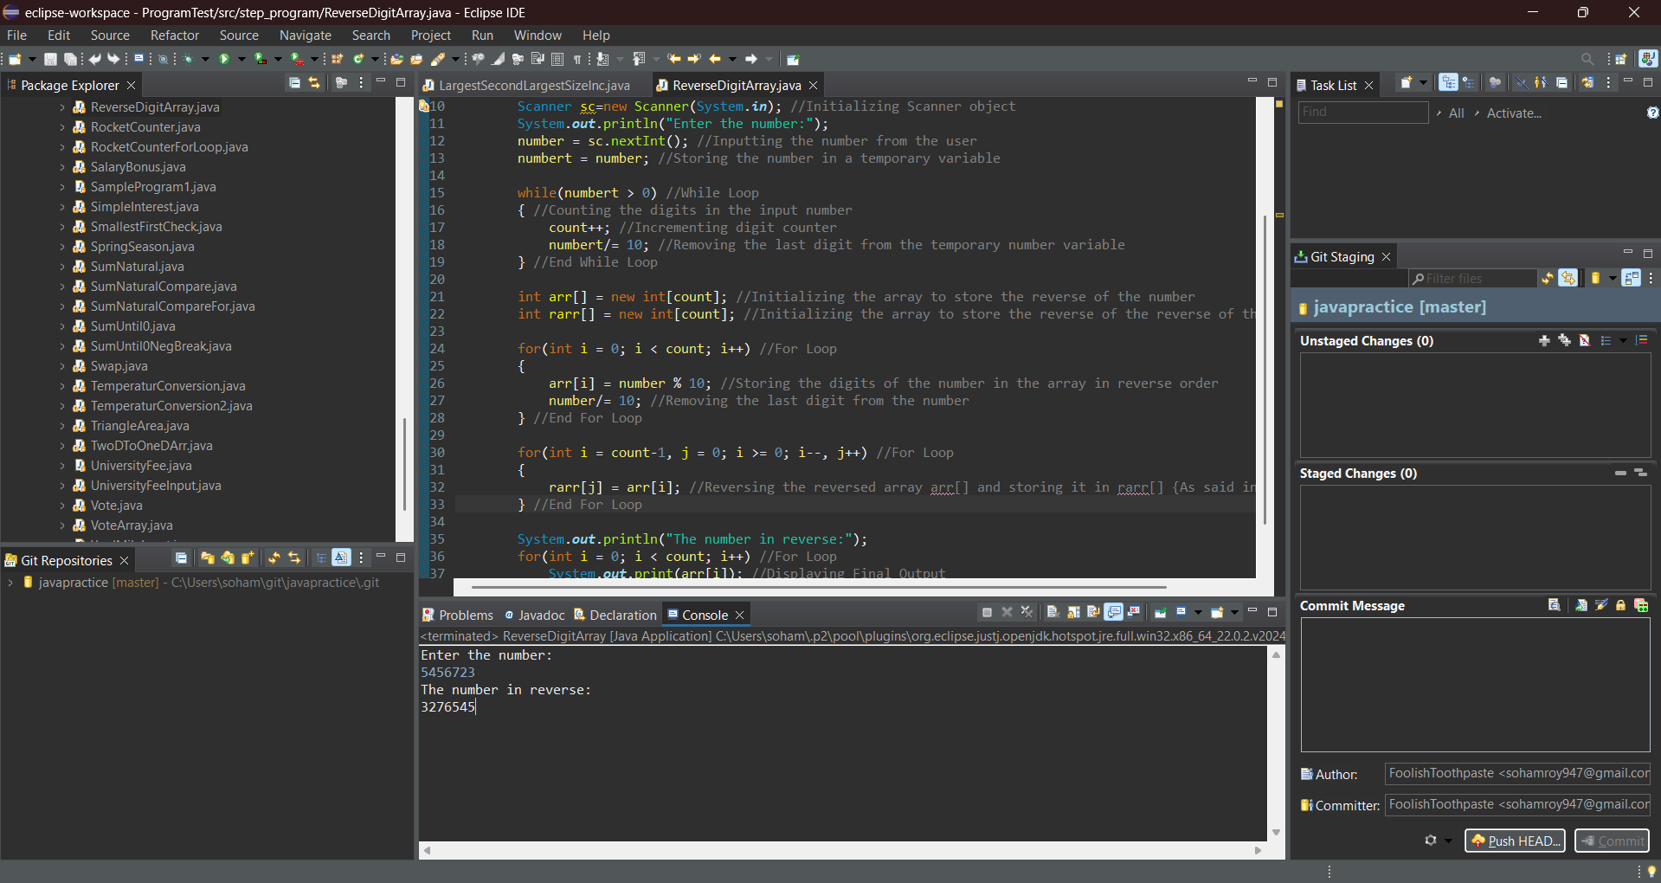

**6.** An organization took up an exercise to find the Body Mass Index (BMI) of all the persons in the team. For this create a program to find the BMI and display the height, weight, BMI and status of each individual

Hint =>

1. Take input for a number of persons
2. Create arrays to store the weight, height, BMI, and weight status of the persons
3. Take input for the weight and height of the persons
4. Calculate the BMI of all the persons and store them in an array and also find the weight status of the persons
5. Display the height, weight, BMI, and weight status of each person
6. Use the table to determine the weight status of the person

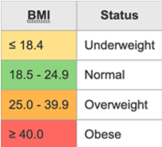

**Program:**

/**A program to calculate BMI and Weight Status of several persons*/

package step_program;

import java.util.*; //Importing java.util.* for Scanner class

public class BMIArray

{

public static void main(String args[])

{

int persons; //Initializing the number of persons variable

Scanner sc=new Scanner(System.***in***); //Initializing Scanner object

System.***out***.println("Enter the number of persons:");

persons = sc.nextInt(); //Inputting the number of persons from the user

double weight[] = new double[persons]; //Initializing the array to store the weights of the persons

double height[] = new double[persons]; //Initializing the array to store the heights of the persons

double BMI[] = new double[persons]; //Initializing the array to store the BMI values of the persons

String weightStatus[] = new String[persons]; //Initializing the array to store the weight statuses of the persons

System.***out***.println("Enter the weight and height of the "+ persons +" persons:");

for(int i = 0; i < persons; i++) //For Loop

{

System.***out***.println("Person "+ (i+1));

weight[i] = sc.nextDouble(); //Inputting the weight of the person from the user

height[i] = sc.nextDouble(); //Inputting the height of the person from the user

BMI[i] = weight[i] / (height[i] * height[i]); //Calculating the BMI of the person

if(BMI[i] >= 40) //Checking the weight status of the person using BMI value

weightStatus[i] = "Obese";

else if(BMI[i] >= 25.0)

weightStatus[i] = "Overweight";

else if(BMI[i] >= 18.5)

weightStatus[i] = "Normal";

else

weightStatus[i] = "Underweight";

} //End For Loop

for(int i = 0; i < persons; i++) //For Loop

{

//Displaying Final Output

System.***out***.println("Details of Person "+ (i + 1) +":");

System.***out***.println("Weight = " + weight[i]);

System.***out***.println("Height = " + height[i]);

System.***out***.println("BMI = " + BMI[i]);

System.***out***.println("Weight status : " + weightStatus[i]);

System.***out***.println();

} //End For Loop

} //End Method

} //End Class

**Output:**

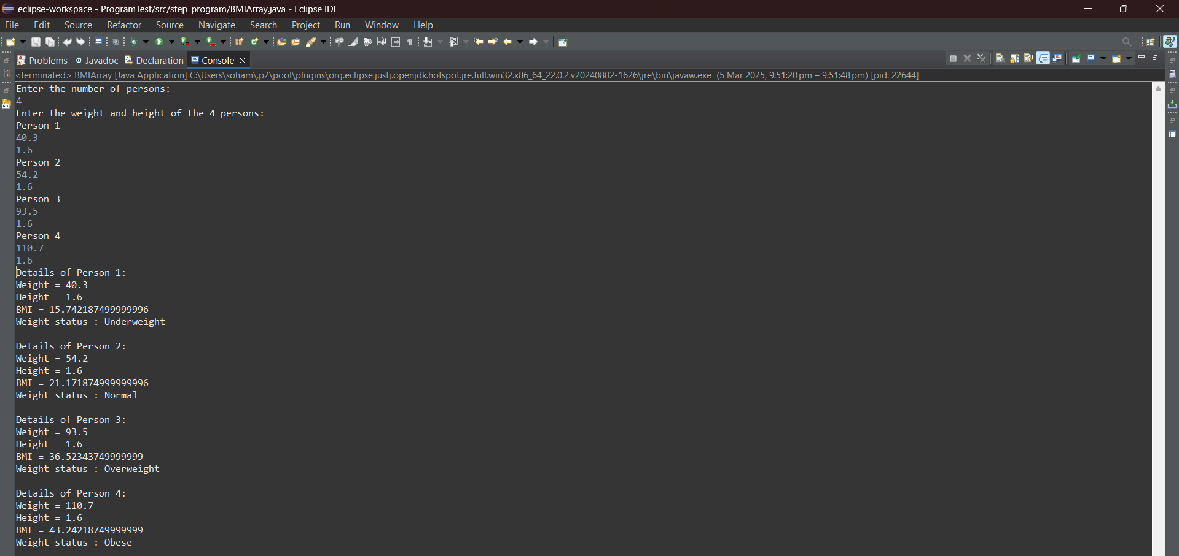

**7.** Rewrite the above program using multi-dimensional array to store height, weight, and BMI in 2D array for all the persons

Hint =>

1. Take input for a number of persons
2. Create a multi-dimensional array to store weight, height and BMI. Also create an to store the weight status of the persons

       double[][] personData = new double[number][3];

       String[] weightStatus = new String[number];

1. Take input for weight and height of the persons and for negative values, ask the user to enter positive values
2. Calculate BMI of all the persons and store them in the personData array and also find the weight status and put them in the weightStatus array
3. Display the height, weight, BMI and status of each person

**Program:**

/**A program to calculate BMI and Weight Status of several persons using 2D Array*/

package step_program;

import java.util.*; //Importing java.util.* for Scanner class

public class BMI2DArray

{

public static void main(String args[])

{

int number; //Initializing the number of persons variable

Scanner sc=new Scanner(System.***in***); //Initializing Scanner object

System.***out***.println("Enter the number of persons:");

number = sc.nextInt(); //Inputting the number of persons from the user

double[][] personData = new double[number][3]; //Initializing the array to store the weights, heights and BMI values of the persons

String weightStatus[] = new String[number]; //Initializing the array to store the weight statuses of the persons

System.***out***.println("Enter the weight and height of the "+ number +" persons:");

for(int i = 0; i < number; i++) //For Loop

{

System.***out***.println("Person "+ (i+1));

personData[i][0] = sc.nextDouble(); //Inputting the weight of the person from the user

personData[i][1] = sc.nextDouble(); //Inputting the height of the person from the user

personData[i][2] = personData[i][0] / (personData[i][1] * personData[i][1]); //Calculating the BMI of the person

if(personData[i][2] >= 40) //Checking the weight status of the person using BMI value

weightStatus[i] = "Obese";

else if(personData[i][2] >= 25.0)

weightStatus[i] = "Overweight";

else if(personData[i][2] >= 18.5)

weightStatus[i] = "Normal";

else

weightStatus[i] = "Underweight";

} //End For Loop

for(int i = 0; i < number; i++) //For Loop

{

//Displaying Final Output

System.***out***.println("Details of Person "+ (i + 1) +":");

System.***out***.println("Weight = " + personData[i][0]);

System.***out***.println("Height = " + personData[i][1]);

System.***out***.println("BMI = " + personData[i][2]);

System.***out***.println("Weight status : " + weightStatus[i]);

System.***out***.println();

} //End For Loop

} //End Method

} //End Class

**Output:**

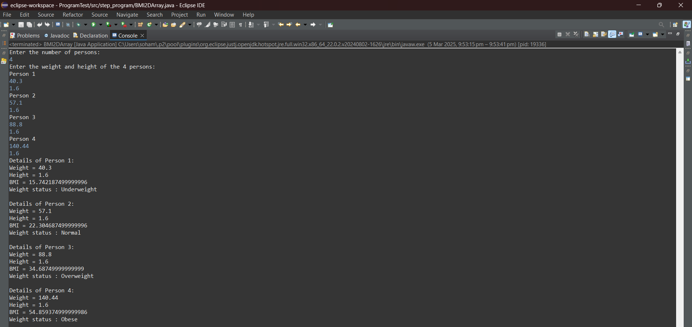

**8.** Create a program to take input marks of students in 3 subjects physics, chemistry, and maths. Compute the percentage and then calculate the grade  as per the following guidelines

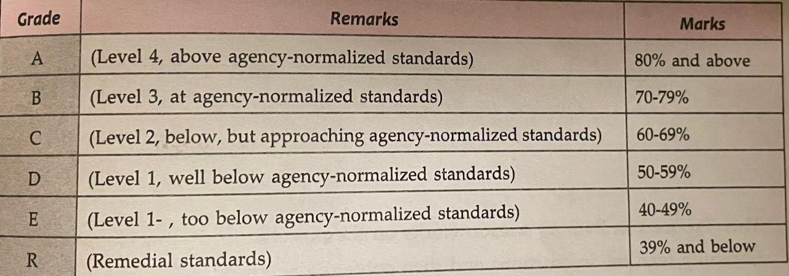

**Hint =>**

1. Take input for the number of students
2. Create arrays to store marks, percentages, and grades of the students
3. Take input for marks of students in physics, chemistry, and maths. If the marks are negative, ask the user to enter positive values and decrement the index
4. Calculate the percentage and grade of the students based on the percentage
5. Display the marks, percentages, and grades of each student

**Program:**

/**A program to input marks and 3 subjects physics, chemistry and maths and compute the percentage and calculate the grade of several students*/

package step_program;

import java.util.*; //Importing java.util.* for Scanner class

public class MarksGradeArray

{

public static void main(String args[])

{

int number; //Initializing the number variable

Scanner sc=new Scanner(System.***in***); //Initializing Scanner object

System.***out***.println("Enter the number of Students:");

number = sc.nextInt(); //Inputting the number of student from the user

int physics[] = new int[number]; //Initializing the array to store the physics marks of the students

int chemistry[] = new int[number]; //Initializing the array to store the chemistry marks of the students

int maths[] = new int[number]; //Initializing the array to store the maths marks of the students

double percentage[] = new double[number]; //Initializing the array to store the percentage marks of the students

String grade[] = new String[number]; //Initializing the array to store the grade of the students

System.***out***.println("Enter the marks of the "+ number +" students in Phyics, Chemistry and Maths:");

for(int i = 0; i < number; i++) //For Loop

{

System.***out***.println("Student " + (i + 1));

physics[i] = sc.nextInt(); //Inputting the physics marks of the student

chemistry[i] = sc.nextInt(); //Inputting the chemistry marks of the student

maths[i] = sc.nextInt(); //Inputting the maths marks of the student

percentage[i] = (physics[i] + chemistry[i] + maths[i]) / 3.0; //Calculating the percentage of marks of the student

if(percentage[i] >= 80) //Checking which Grade the student will get and storing relevant Grade in grade array

grade[i] = "Grade A : Level 4, above agency-normalized standards";

else if(percentage[i] >= 70)

grade[i] = "Grade B : Level 3, at agency-normalized standards";

else if(percentage[i] >= 60)

grade[i] = "Grade C : Level 2, below, but approaching agency-normalized standards";

else if(percentage[i] >= 50)

grade[i] = "Grade D : Level 1, well below agency-normalized standards";

else if(percentage[i] >= 40)

grade[i] = "Grade E : Level 1-, too below agency-normalized standards";

else //Below 40, end of if else ladder

grade[i] = "Grade R : Remedial status";

} //For Loop End

for(int i = 0; i < number; i++) //For Loop

{

//Displaying Final Output

System.***out***.println("Student " + (i + 1));

System.***out***.println("Marks in Physics = " + physics[i]);

System.***out***.println("Marks in Chemistry = " + chemistry[i]);

System.***out***.println("Marks in Maths = " + maths[i]);

System.***out***.println("Percentage = " + percentage[i] + "%");

System.***out***.println("Grades : " + grade[i]);

System.***out***.println();

} //End For Loop

} //End Method

} //End Class

**Output:**

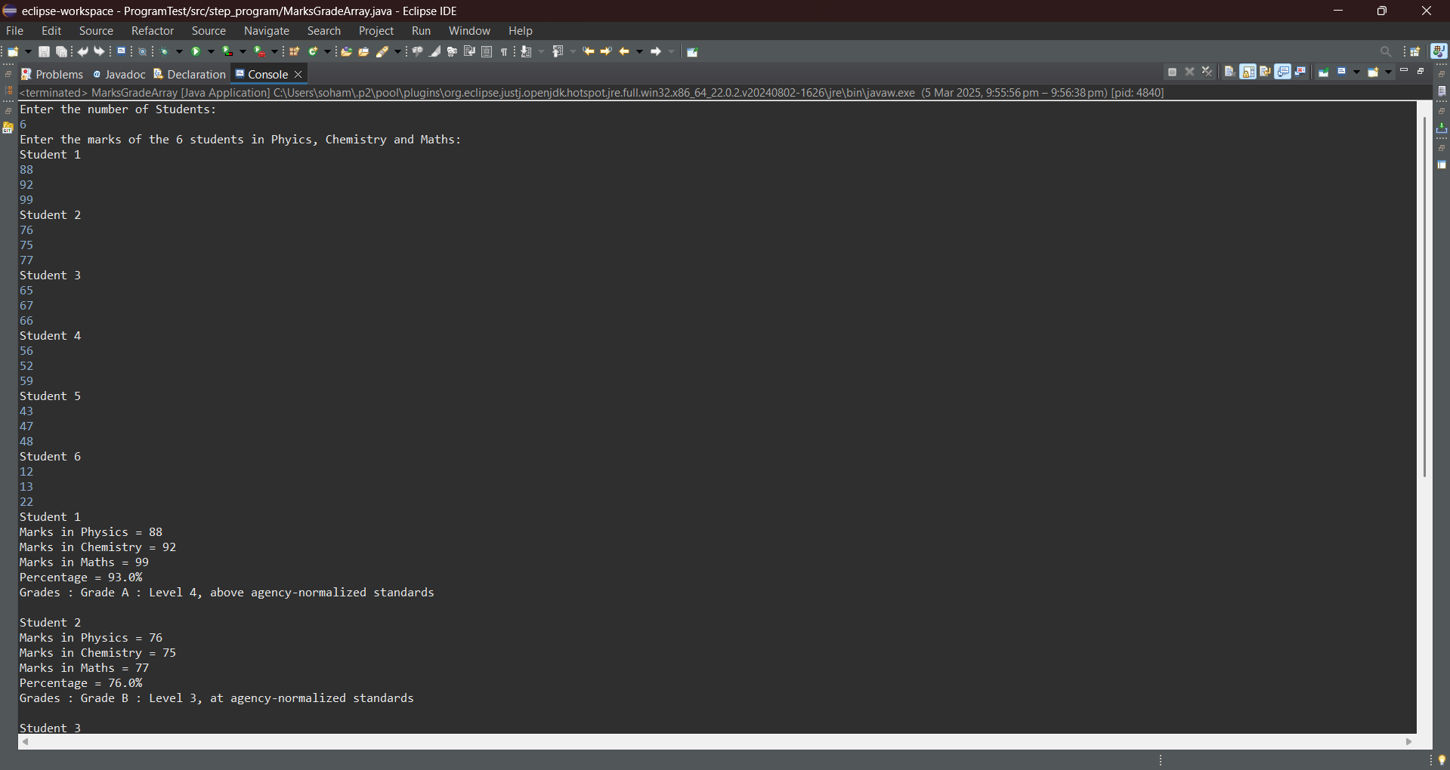

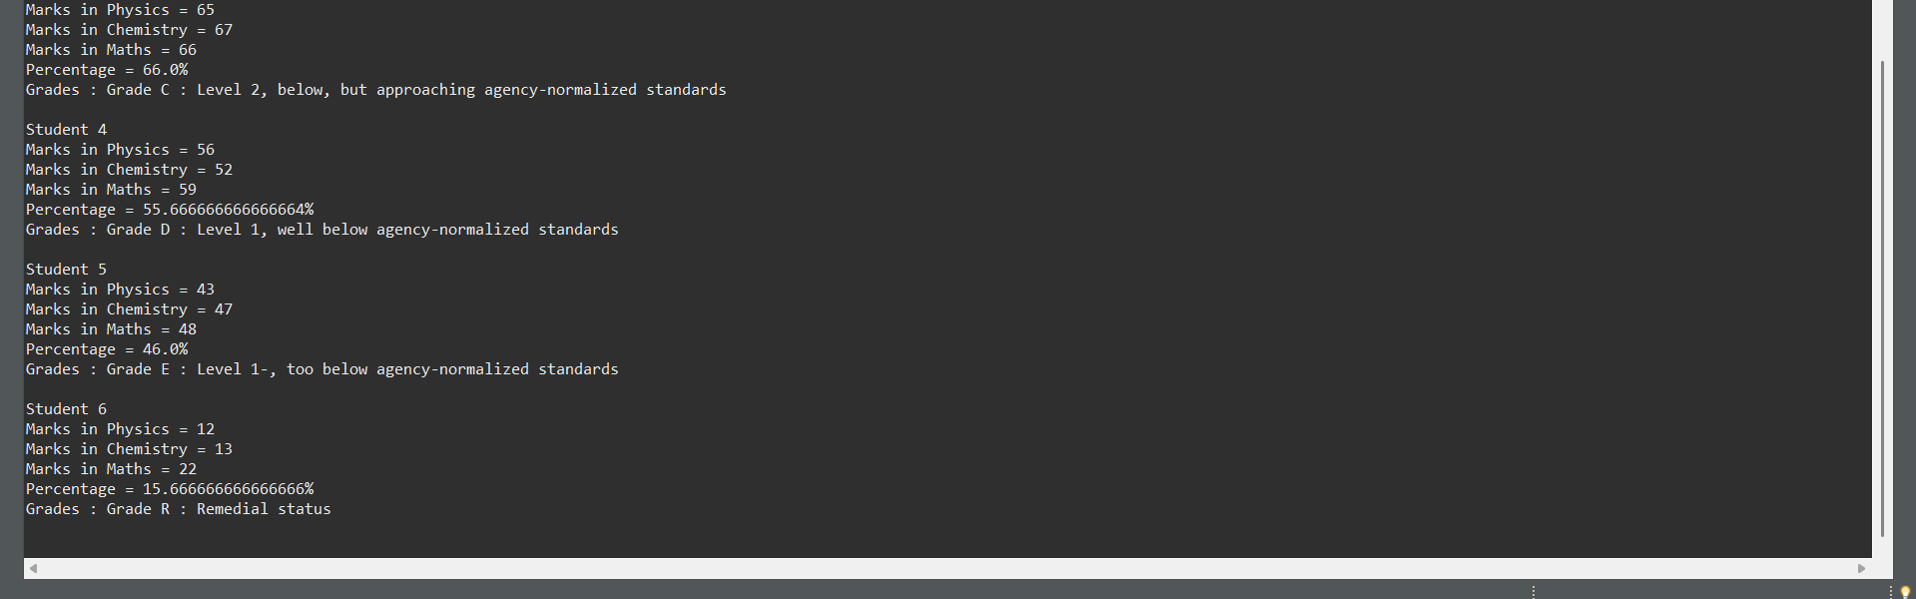

**9.** Rewrite the above program to store the marks of the students in physics, chemistry, and maths in a 2D array and then compute the percentage and grade

Hint =>

1. All the steps are the same as the problem 8 except the marks are stored in a 2D array
2. Use the 2D array to calculate the percentages, and grades of the students

**Program:**

/**A program to input marks and 3 subjects physics, chemistry and maths and compute the percentage and calculate the grade of several students using 2D Array*/

package step_program;

import java.util.*; //Importing java.util.* for Scanner class

public class MarksGrade2DArray

{

public static void main(String args[])

{

int number; //Initializing the number variable

Scanner sc=new Scanner(System.***in***); //Initializing Scanner object

System.***out***.println("Enter the number of Students:");

number = sc.nextInt(); //Inputting the number of student from the user

int marks[][] = new int[number][3]; //Initializing a 2D Array to store the marks of the students in Physics, Chemistry and Maths

double percentage[] = new double[number]; //Initializing the array to store the percentage marks of the students

String grade[] = new String[number]; //Initializing the array to store the grade of the students

System.***out***.println("Enter the marks of the "+ number +" students in Phyics, Chemistry and Maths:");

for(int i = 0; i < number; i++) //For Loop

{

System.***out***.println("Student " + (i + 1));

marks[i][0] = sc.nextInt(); //Inputting the physics marks of the student

marks[i][1] = sc.nextInt(); //Inputting the chemistry marks of the student

marks[i][2] = sc.nextInt(); //Inputting the maths marks of the student

percentage[i] = (marks[i][0] + marks[i][1] + marks[i][2]) / 3.0; //Calculating the percentage of marks of the student

if(percentage[i] >= 80) //Checking which Grade the student will get and storing relevant Grade in grade array

grade[i] = "Grade A : Level 4, above agency-normalized standards";

else if(percentage[i] >= 70)

grade[i] = "Grade B : Level 3, at agency-normalized standards";

else if(percentage[i] >= 60)

grade[i] = "Grade C : Level 2, below, but approaching agency-normalized standards";

else if(percentage[i] >= 50)

grade[i] = "Grade D : Level 1, well below agency-normalized standards";

else if(percentage[i] >= 40)

grade[i] = "Grade E : Level 1-, too below agency-normalized standards";

else //Below 40, end of if else ladder

grade[i] = "Grade R : Remedial status";

} //For Loop End

for(int i = 0; i < number; i++) //For Loop

{

//Displaying Final Output

System.***out***.println("Student " + (i + 1));

System.***out***.println("Marks in Physics = " + marks[i][0]);

System.***out***.println("Marks in Chemistry = " + marks[i][1]);

System.***out***.println("Marks in Maths = " + marks[i][2]);

System.***out***.println("Percentage = " + percentage[i] + "%");

System.***out***.println("Grades : " + grade[i]);

System.***out***.println();

} //End For Loop

} //End Method

} //End Class

**Output:**

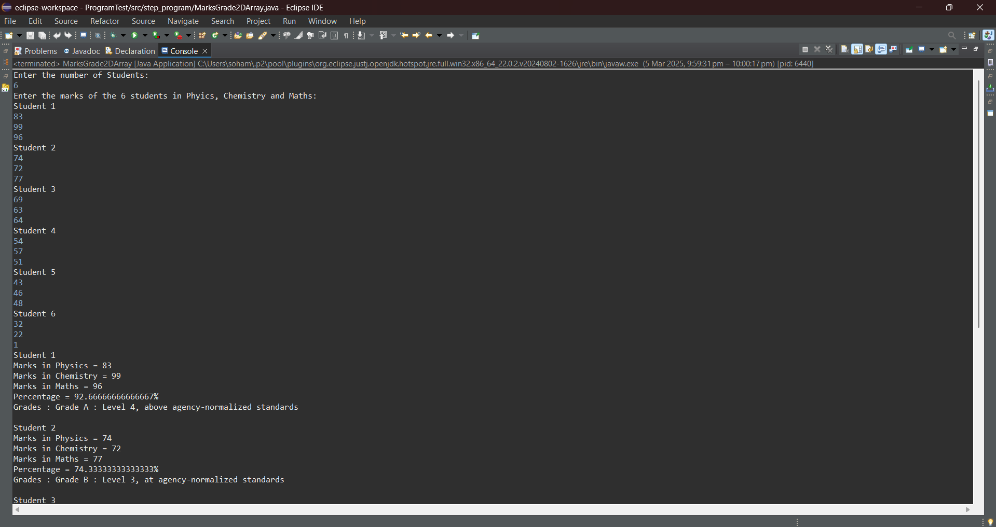

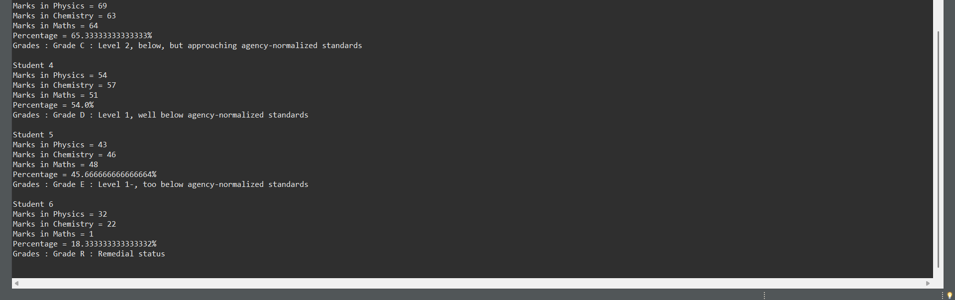

**10.** Create a program to take a number as input find the frequency of each digit in the number using an array and display the frequency of each digit

Hint =>

1. Take the input for a number
2. Find the count of digits in the number
3. Find the digits in the number and save them in an array
4. Find the frequency of each digit in the number. For this define a frequency array of size 10, Loop through the digits array, and increase the frequency of each digit
5. Display the frequency of each digit in the number

**Program:**

/**A program to take a number as input find the frequency of each digit in the number*/

package step_program;

import java.util.*; //Importing java.util.* for Scanner class

public class DigitFrequency

{

public static void main(String args[])

{

int number, numbert, count = 0; //Initializing variables

int frequency[] = new int[10]; //Initializing the array to store the frequencies of the digits

Scanner sc=new Scanner(System.***in***); //Initializing Scanner object

System.***out***.println("Enter the number:");

number = sc.nextInt(); //Inputting the number from the user

numbert = number; //Storing the number in a temporary number variable

while(numbert > 0) //While Loop

{

count++; //Counting the total number of digits in the number

numbert/= 10; //Removing the last digit from the temporary number variable

} //End While Loop

int digits[] = new int[count]; //Initializing the array to store the digits of the number

for(int i = 0; i < count; i++) //For Loop

{

digits[i] = number % 10; //Extracting the last digit from the number variable to store in the array

number/= 10; //Removing the last digit from the number variable

} //End For Loop

for(int i = 0; i < 10; i++) //For Loop 1

for(int j = 0; j < count; j++) //For Loop 2

if(i == digits[j]) //Checking if the digit in the digits array matches the index of frequency array

frequency[i]++; //Incrementing frequency of ith decimal digit

for(int i = 0; i < 10; i++) //For Loop

if(frequency[i] > 0) //Checking if the decimal digit is available in the number

System.***out***.println("Frequency of "+ i +" = "+ frequency[i]); //Displaying Final Output

} //End Method

} //End Class

**Output:**

