**Conditional Statements - Level 1 - 15 Practice Problems**

Soham Roy,

RA2411033010148,

Z2 Section,

CSE w/s SWE

**1.** Write a program to check if a number is divisible by 5

I/P => number

O/P => Is the number ___ divisible by 5? ___

**Program:**

/**A program to check if a number is divisible by 5*/

package step_program;

import java.util.*; //Importing java.util.* for Scanner class

public class DivisibleBy5

{

public static void main(String args[])

{

int number; //Initializing variables

String answer;

Scanner sc=new Scanner(System.*in*); //Initializing Scanner object

System.*out*.println("Enter the number:");

number = sc.nextInt(); //Inputting the number from the user

if(number % 5 == 0) //Checking if the remainder after dividing by 5 is zero, i.e., divisibility by 5

answer = "Yes"; //If divisible by 5

else

answer = "No"; //If not divisible by 5

//Displaying final output

System.*out*.println("Is the number "+ number +" divisible by 5? "+ answer);

} //End method

} //End class

**Output:**

I/P: 123

O/P: 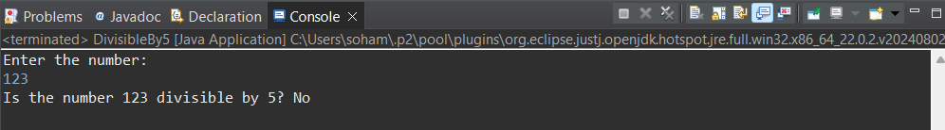

I/P: 125

O/P:

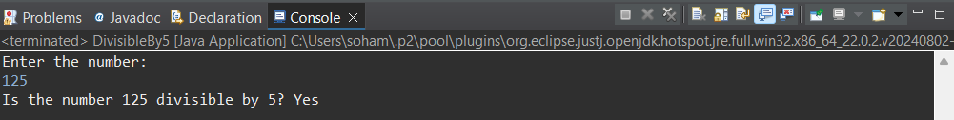

**2.** Write a program to check if the first is the smallest of the 3 numbers.

I/P => number1, number2, number3

O/P => Is the first number the smallest? ____

**Program:**

/**A program to check if the first is the smallest of the 3 numbers*/

package step_program;

import java.util.*; //Importing java.util.* for Scanner class

public class SmallestFirstCheck

{

public static void main(String args[])

{

int number1, number2, number3; //Initializing variables

String answer = "No"; //Default value

Scanner sc=new Scanner(System.*in*); //Initializing Scanner object

System.*out*.println("Enter the three numbers:");

number1 = sc.nextInt(); //Inputting the first number from the user

number2 = sc.nextInt(); //Inputting the second number from the user

number3 = sc.nextInt(); //Inputting the third number from the user

if(number1 < number2 && number1 < number3) //Checking if the first number is the smallest

answer = "Yes"; //If condition matched

//Displaying Final Output

System.*out*.println("Is the first number the smallest? "+ answer);

} //End Method

} //End Class

**Output:**

I/P:

12

153

11

O/P:

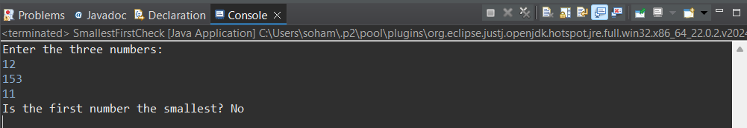

I/P:

11

12

153

O/P:

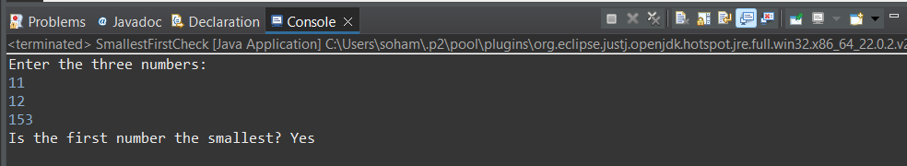

**3.** Write a program to check if the first, second, or third number is the largest of the three.

I/P => number1, number2, number3

O/P =>

Is the first number the largest? ____

Is the second number the largest? ___

Is the third number the largest? __

**Program:**

/**A program to check if the first, second, or third number is the largest of the three*/

package step_program;

import java.util.*; //Importing java.util.* for Scanner class

public class LargestOfThree

{

public static void main(String args[])

{

int number1, number2, number3; //Initializing variables

String answer1 = "No"; //Default values

String answer2 = "No";

String answer3 = "No";

Scanner sc=new Scanner(System.***in***); //Initializing Scanner object

System.***out***.println("Enter the three numbers:");

number1 = sc.nextInt(); //Inputting the first number from the user

number2 = sc.nextInt(); //Inputting the second number from the user

number3 = sc.nextInt(); //Inputting the third number from the user

if(number1 > number2 && number1 > number3) //Checking if the first number is the largest

answer1 = "Yes";

else if(number2 > number3) //Checking if the second number is the largest

answer2 = "Yes";

else if(number3 > number2) //Checking if the third number is the largest, if condition to make sure all numbers aren't equal

answer3 = "Yes";

//Displaying Final Output

System.***out***.println("Is the first number the largest? "+ answer1 +"\nIs the second number the largest? "+ answer2 +"\nIs the third number the largest? "+ answer3);

} //End method

} //End class

**Output:**

I/P:

11

4

9

O/P:

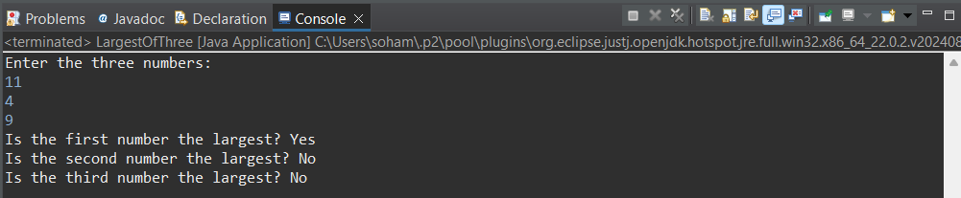

I/P:

4

11

9

O/P:

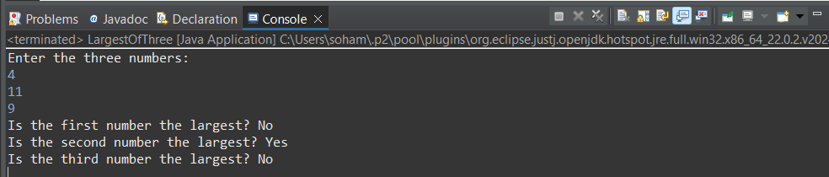

I/P:

4

9

11

O/P:

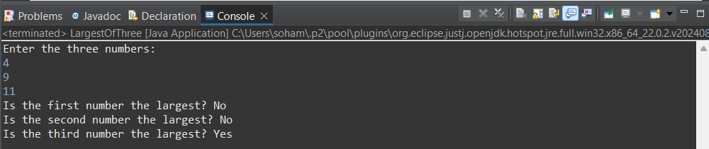

I/P:

11

11

11

O/P:

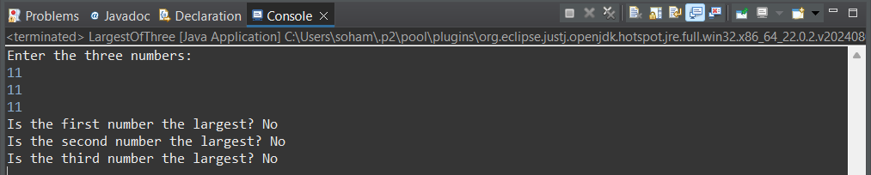

**4.** Write a program to check for the natural number and write the sum of n natural numbers

Hint =>

1. A Natural Number is a positive integer (1,2,3, etc) sometimes with the inclusion of 0
2. A sum of n natural numbers is n * (n+1) / 2

I/P => number

O/P => If the number is a positive integer then the output is

The sum of ___ natural numbers is ___

Otherwise

The number ___ is not a natural number

**Program:**

/**A program to check for the natural number and write the sum of n natural numbers*/

package step_program;

import java.util.*; //Importing java.util.* for Scanner class

public class SumNatural

{

public static void main(String args[])

{

int number, sum; //Initializing variables

Scanner sc=new Scanner(System.*in*); //Initializing Scanner object

System.*out*.println("Enter the number of natural numbers:");

number = sc.nextInt(); //Inputting the number of terms from the user

if(number<=0) //Checking if the number of terms is a natural number

System.*out*.println("The number "+ number +" is not a natural number"); //Displaying Final Output

else

{

sum = (number * (number+1)) / 2; //Calculating the sum of n natural numbers

System.*out*.println("The sum of "+ number +" natural numbers is "+ sum); //Displaying Final Output

} //End else block

} //End method

} //End class

**Output:**

I/P:

-3

O/P:

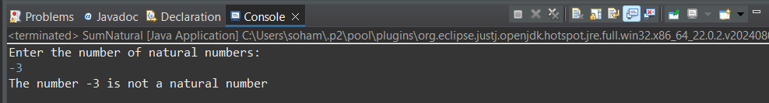

I/P:

5

O/P:

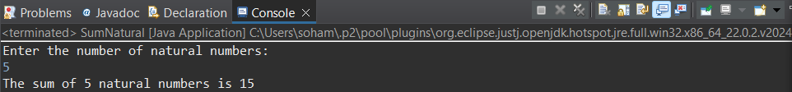

**5.** Write a program to check whether a person can vote, depending on whether his/her age is greater than or equal to 18.

Hint =>

1. Get integer input from the user and store it in the age variable.
2. If the person is 18 or older, print "The person can vote." Otherwise, print "The person cannot vote."

I/P => age

O/P => If the person's age is greater or equal to 18 then the output is

The person's age is ___ and can vote.

Otherwise

The person's age is ___ and cannot vote.

**Program:**

/**A program to check whether a person can vote, depending on whether his/her age is greater than or equal to 18*/

package step_program;

import java.util.*; //Importing java.util.* for Scanner class

public class Vote

{

public static void main(String args[])

{

int age; //Initializing variables

Scanner sc=new Scanner(System.***in***); //Initializing Scanner object

System.***out***.println("Enter the age of the person:");

age = sc.nextInt(); //Inputting age of the person from the user

if(age>=18) //Checking if the age of the person is above or equal to 18

System.***out***.println("The person's age is "+ age +" and can vote."); //Displaying Final Output

else //If age of the person is below 18

System.***out***.println("The person's age is "+ age +" and cannot vote."); //Displaying Final Output

} //End method

} //End class

**Output:**

I/P:

12

O/P:

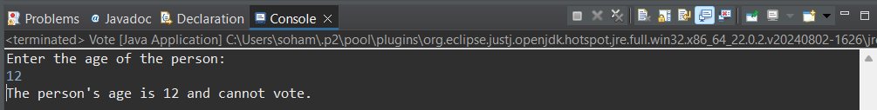

I/P:

23

O/P:

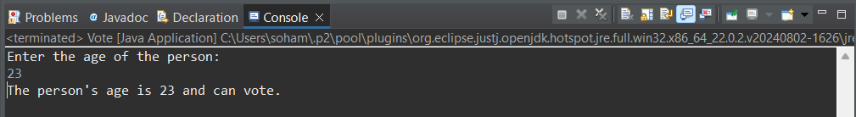

**6**. Write a program to check whether a number is positive, negative, or zero.

Hint =>

1. Get integer input from the user and store it in the number variable.
2. If the number is positive, print positive.
3. If the number is negative, print negative.
4. If the number is zero, print zero.

**Program:**

/**A program to check whether a number is positive, negative, or zero*/

package step_program;

import java.util.*; //Importing java.util.* for Scanner class

public class PosNegZer

{

public static void main(String args[])

{

int n; //Initializing variable

Scanner sc=new Scanner(System.***in***); //Initializing Scanner object

System.***out***.println("Enter the number:");

n = sc.nextInt(); //Inputting the number from the user

if(n > 0) //Checking if the number is positive

System.***out***.println("Positive"); //Displaying Final Output

else if(n < 0) //Checking if the number is negative

System.***out***.println("Negative"); //Displaying Final Output

else //Concluding that the number is zero

System.***out***.println("Zero"); //Displaying Final Output

} //End method

} //End class

**Output:**

I/P:

25

O/P:

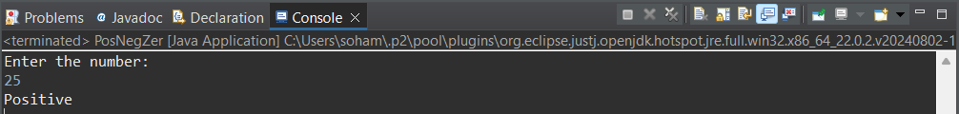

I/P:

-25

O/P:

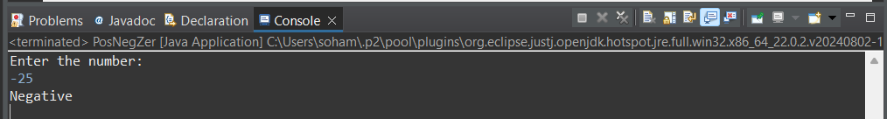

I/P:

0

O/P:

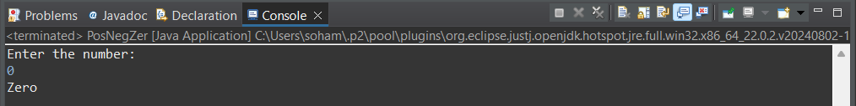

**7.** Write a program SpringSeason that takes two int values month and day from the command line and prints “Its a Spring Season” otherwise prints “Not a Spring Season”.

Hint =>

1. Spring Season is from March 20 to June 20

**Program:**

/**A program SpringSeason that takes two int values month and day from the command line and prints “Its a Spring Season” otherwise prints “Not a Spring Season”*/

package step_program;

import java.util.*; //Importing java.util.* for Scanner class

public class SpringSeason

{

public static void main(String args[])

{

int month, day; //Initializing variables

Scanner sc=new Scanner(System.***in***); //Initializing Scanner object

System.***out***.println("Enter the month number and day number:");

month = sc.nextInt(); //Inputting the month number from the user

day = sc.nextInt(); //Inputting the day number from the user

if((month == 3 && day >= 20 && day <= 31) || (month == 4 && day >= 1 && day <= 20)) //Checking the conditions

System.***out***.println("Its a Spring Season"); //Displaying Final Output

else //If condition not matched

System.***out***.println("Not a Spring Season"); //Displaying Final Output

} //End method

} //End class

**Output:**

I/P:

5

27

O/P:

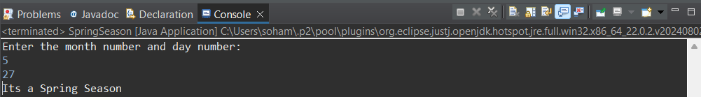

I/P:

12

9

O/P:

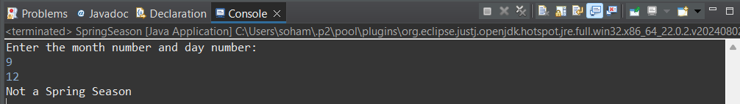

**8.** Write a program to count down the number from the user input value to 1 using a *while* loop for a rocket launch

Hint =>

1. Create a variable counter to take user inputted value for the countdown.
2. Use the *while* loop to check if the counter is 1
3. Inside a *while* loop, print the value of the counter and decrement the counter.

**Program:**

/**A program to count down the number from the user input value to 1 using a while loop for a rocket launch*/

package step_program;

import java.util.*; //Importing java.util.* for Scanner class

public class RocketCounter

{

public static void main(String args[])

{

int counter; //Initializing counter variable

Scanner sc=new Scanner(System.*in*); //Initializing Scanner object

System.*out*.println("Enter the number to count down from:");

counter = sc.nextInt(); //Inputting the number to start the count down from the user

System.*out*.println(); //Skipping a line for clean output

while(counter>0) //While Loop

{

System.*out*.println(counter); //Printing the count down numbers

counter--; //Decrementing counter variable

} //End While Loop

} //End Method

} //End Class

**Output:**

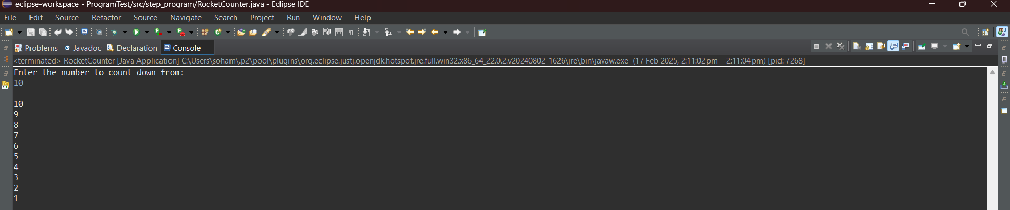

**9.** Rewrite program 8 to do the countdown using the *for-*loop.

**Program:**

/**A program to count down the number from the user input value to 1 using a for loop for a rocket launch*/

package step_program;

import java.util.*; //Importing java.util.* for Scanner class

public class RocketCounterForLoop

{

public static void main(String args[])

{

int counter; //Initializing counter variable

Scanner sc=new Scanner(System.*in*); //Initializing Scanner object

System.*out*.println("Enter the number to count down from:");

counter = sc.nextInt(); //Inputting the number to start the count down from the user

System.*out*.println(); //Skipping a line for clean output

for(int i = counter; i > 0; i--) //For Loop

{

System.*out*.println(i); //Printing the count down numbers

} //End For Loop

} //End Method

} //End Class

**Output:**

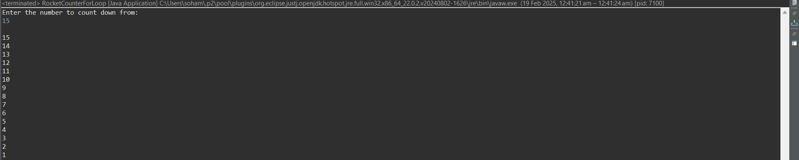

**10.** Write a program to find the sum of numbers until the user enters 0

Hint =>

1. Create a variable total of type double initialize to 0.0. Also, create a variable to store the double value the user enters
2. Use the *while* loop to check if the user entered is 0
3. If the user entered value is not 0 then inside the while block add user entered value to the total and ask the user to input again
4. The loop will continue till the user enters zero and outside the loop display the total value

**Program:**

/**A program to find the sum of numbers until the user enters 0*/

package step_program;

import java.util.*; //Importing java.util.* for Scanner class

public class SumUntil0

{

public static void main(String args[])

{

double i = 1.0, sum = 0.0; //Initializing variables

Scanner sc=new Scanner(System.*in*); //Initializing Scanner object

System.*out*.println("Start entering numbers to add, enter 0 to stop adding and print the result:");

while(i != 0.0) //While Loop

{

i = sc.nextDouble(); //Inputting the numbers to be added to the sum from the user

sum+= i; //Adding inputted numbers to sum

} //While Loop End

System.*out*.println("\nSum = "+ sum); //Displaying Final Output

} //End Method

} //End Class

**Output:**

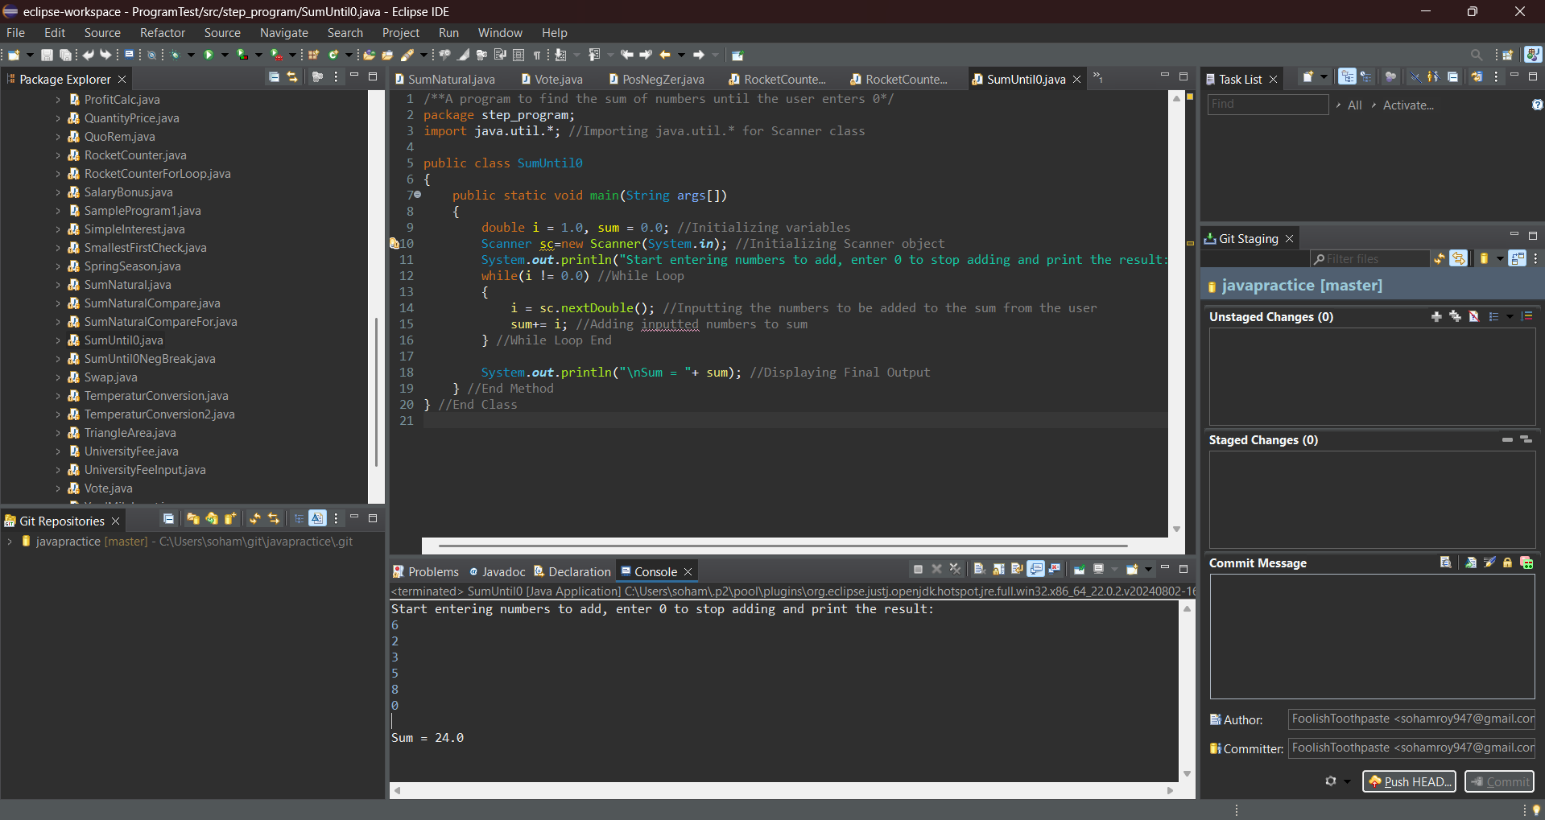

**11.** Rewrite the program 10 to find the sum until the user enters 0 or a negative number using *while* loop and break statement

Hint =>

1. Use infinite while loop as in while (true)
2. Take the user entry and check if the user entered 0 or a negative number to break the loop using break;

**Program:**

/**A program to find the sum of numbers until the user enters 0 or a negative number using while loop and break statement*/

package step_program;

import java.util.*; //Importing java.util.* for Scanner class

public class SumUntil0NegBreak

{

public static void main(String args[])

{

double i = 1.0, sum = 0.0; //Initializing variables

Scanner sc=new Scanner(System.*in*); //Initializing Scanner object

System.*out*.println("Start entering numbers to add, enter 0 to stop adding and print the result:");

while(true) //While Loop

{

i = sc.nextDouble(); //Inputting the numbers to be added to the sum from the user

if(i > 0) //Checking if the input number is positive

sum+= i; //Adding input numbers to sum

else //If input number is negative

break; //Loop Break

} //While Loop End

System.*out*.println("\nSum = "+ sum); //Displaying Final Output

} //End Method

} //End Class

**Output:**

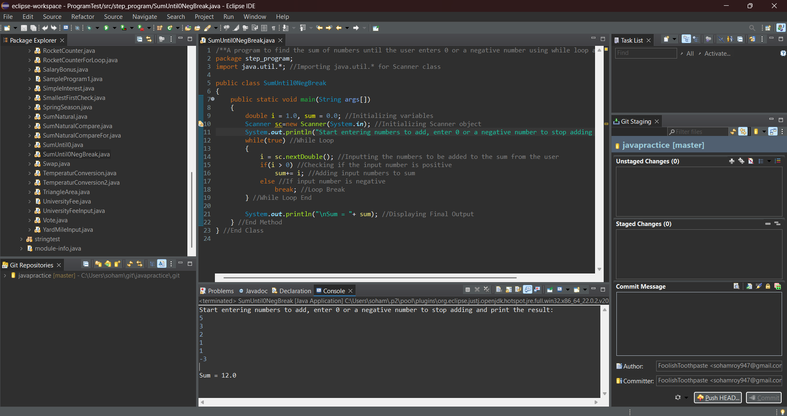

**12.** Write a program to find the sum of n natural numbers using *while* loop compare the result with the formulae n*(n+1)/2 and show the result from both computations was correct.

Hint =>

1. Take the user input number and check whether it's a Natural number
2. If it's a natural number Compute using formulae as well as compute using *while* loop
3. Compare the two results and print the result

**Program:**

/**A program to find the sum of n natural numbers using while loop compare the result with the formulae n*(n+1)/2 and show the result from both computations was correct.*/

package step_program;

import java.util.*; //Importing java.util.* for Scanner class

public class SumNaturalCompare

{

public static void main(String args[])

{

int number, sum1, sum2 = 0, i = 1; //Initializing variables

Scanner sc=new Scanner(System.*in*); //Initializing Scanner object

System.*out*.println("Enter the number of natural numbers:");

number = sc.nextInt(); //Inputting the number of terms from the user

if(number<=0) //Checking if the number of terms is a natural number

System.*out*.println("The number "+ number +" is not a natural number"); //Displaying Final Output

else

{

sum1 = (number * (number+1)) / 2; //Calculating the sum of n natural numbers using formulae

while(i <= number) //While Loop

{

sum2+= i; //Calculating the sum of n natural numbers using loop

i++; //Incrementing the while counter

} //End While Loop

if(sum1 == sum2) //Comparing results of the two methods

{

//Displaying Final Output

System.*out*.println("Results matched");

System.*out*.println("Sum = "+ sum1);

} //End Else Block

}

} //End Method

} //End Class

**Output:**

I/P:

-3

O/P:

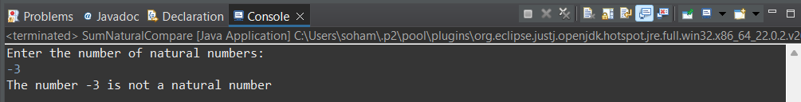

I/P:

5

O/P:

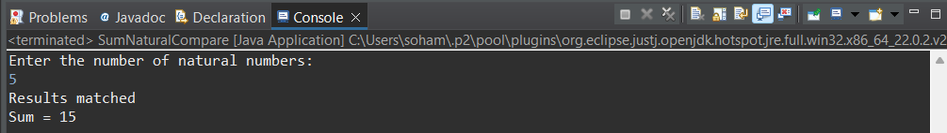

**13**. Rewrite the program number 12 with the *for* loop instead of a while loop to find the sum of n Natural Numbers.

Hint =>

1. Take the user input number and check whether it's a Natural number
2. If it's a natural number Compute using formulae as well as compute using *for* loop
3. Compare the two results and print the result

**Program:**

/**A program to find the sum of n natural numbers using for loop compare the result with the formulae n*(n+1)/2 and show the result from both computations was correct.*/

package step_program;

import java.util.*; //Importing java.util.* for Scanner class

public class SumNaturalCompareFor

{

public static void main(String args[])

{

int number, sum1, sum2 = 0; //Initializing variables

Scanner sc=new Scanner(System.*in*); //Initializing Scanner object

System.*out*.println("Enter the number of natural numbers:");

number = sc.nextInt(); //Inputting the number of terms from the user

if(number<=0) //Checking if the number of terms is a natural number

System.*out*.println("The number "+ number +" is not a natural number"); //Displaying Final Output

else

{

sum1 = (number * (number+1)) / 2; //Calculating the sum of n natural numbers using formulae

for(int i = 1; i <= number; i++) //For Loop

{

sum2+= i; //Calculating the sum of n natural numbers using loop

} //End For Loop

if(sum1 == sum2) //Comparing results of the two methods

{

//Displaying Final Output

System.*out*.println("Results matched");

System.*out*.println("Sum = "+ sum1);

} //End If Block

} //End Else Block

} //End Method

} //End Class

**Output:**

I/P:

-12

O/P:

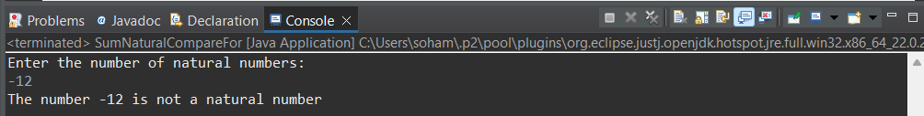

I/P:

6

O/P:

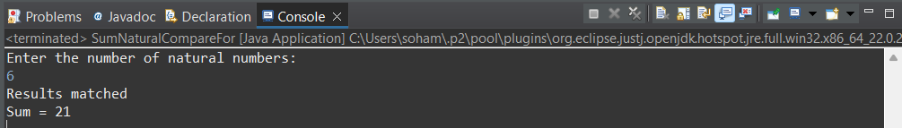

**14.** Write a Program to find the factorial of an integer entered by the user.

Hint =>

1. For example, the factorial of 4 is 1 * 2 * 3 * 4 which is 24.
2. Take an integer input from the user and assign it to the variable. Check the user has entered a positive integer.
3. Using a *while* loop, compute the factorial.
4. Print the factorial at the end.

**Program:**

/**A Program to find the factorial of an integer entered by the user.*/

package step_program;

import java.util.*; //Import java.util.* for Scanner class

public class Factorial

{

public static void main(String args[])

{

int n, i=1, fact = 1; //Initializing variables

Scanner sc=new Scanner(System.*in*); //Initializing Scanner object

System.*out*.println("Enter the number to find the factorial of:");

n = sc.nextInt(); //Inputting the number from the user

if(n<=0) //Checking if the number is positive

System.*out*.println(n + " is not a positive number."); //Displaying Final Output

else

{

while(i <= n) //While Loop

{

fact*= i; //Multiplying the numbers to find the factorial

i++; //Incrementing while counter

} //End While Loop

System.*out*.println("Factorial = "+ fact); //Displaying Final Output

} //End Else Block

} //End Method

} //End Class

**Output:**

I/P:

-8

O/P:

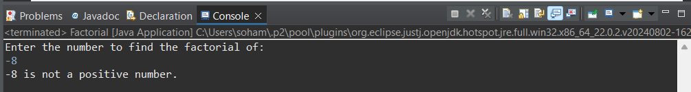

I/P:

6

O/P:

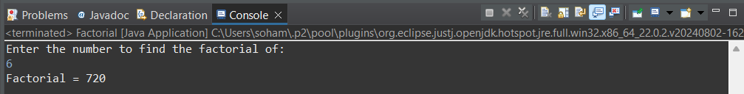

**15.** Rewrite program 14 using for loop

Hint =>

1. Take the integer input, check for natural number and determine the factorial using for loop and finally print the result.

**Program:**

/**A Program to find the factorial of an integer entered by the user using for loop.*/

package step_program;

import java.util.*; //Import java.util.* for Scanner class

public class FactorialFor

{

public static void main(String args[])

{

int n, fact = 1; //Initializing variables

Scanner sc=new Scanner(System.*in*); //Initializing Scanner object

System.*out*.println("Enter the number to find the factorial of:");

n = sc.nextInt(); //Inputting the number from the user

if(n<=0) //Checking if the number is a natural number

System.*out*.println("The number "+ n +" is not a natural number"); //Displaying Final Output

else

{

for(int i = 1; i <= n; i++) //For Loop

{

fact*= i; //Multiplying the numbers to find the factorial

} //End For Loop

System.*out*.println("Factorial = "+ fact); //Displaying Final Output

} //End Else Block

} //End Method

} //End Class

**Output:**

I/P:

0

O/P:

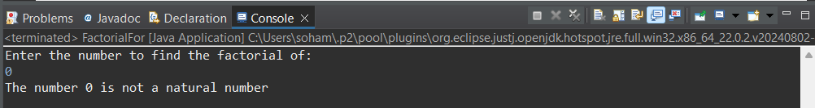

I/P:

5

O/P:

