**Conditional Statements - Level 2 - 10 Practice Problems**

Soham Roy,

RA2411033010148,

Z2 Section,

CSE w/s SWE

**1.** Create a program to print odd and even numbers between 1 to the number entered by the user.

Hint =>

1. Get an integer input from the user, assign to a variable number and check for Natural Number
2. Using a for loop, iterate from 1 to the number
3. In each iteration of the loop, print the number is odd or even number

**Program:**

/**A program to print odd and even numbers between 1 to the number entered by the user*/

package step_program;

import java.util.*; //Importing java.util.* for Scanner class

public class OddEvenPrint

{

public static void main(String args[])

{

int number; //Initializing the variable to store the number

Scanner sc=new Scanner(System.***in***); //Initializing Scanner object

System.***out***.println("Enter the number:");

number = sc.nextInt(); //Inputting the number from the user

if(number<1) //Checking if the number is a natural number

System.***out***.println("The number "+ number +" is not a natural number."); //Displaying Final Output

else

{

for(int i = 1; i <= number; i++) //For Loop iterating from 1 to the number

{

if(i % 2 == 0) //Checking if the number is even

System.***out***.println("The number "+ i +" is an even number"); //Displaying Final Output

else //If the number is odd

System.***out***.println("The number "+ i +" is an odd number"); //Displaying Final Output

} //End For Loop

} //End Else Block

} //End Method

} //End Class

**Output:**

I/P:

-2

O/P:

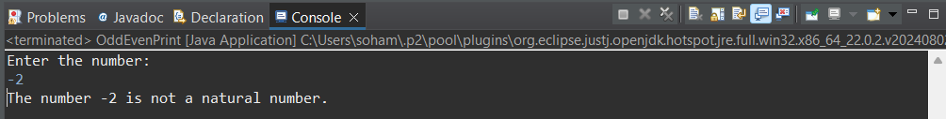

I/P:

7

O/P:

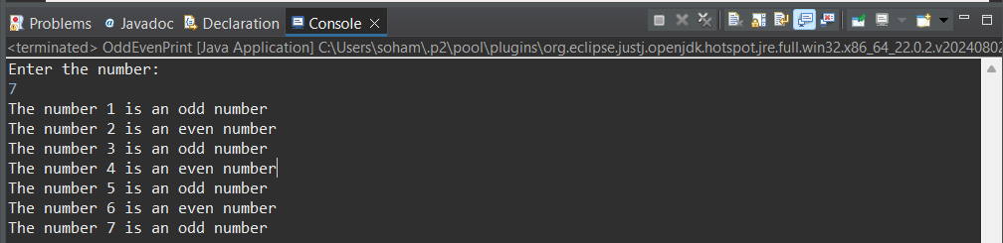

**2.** Create a program to find the bonus of employees based on their years of service.

Hint =>

1. Zara decided to give a bonus of 5% to employees whose year of service is more than 5 years.
2. Take salary and year of service in the year as input.
3. Print the bonus amount.

**Program:**

/**A program to find the bonus of employees based on their years of service*/

package step_program;

import java.util.*; //Importing java.util.* for Scanner class

public class BonusAmount

{

public static void main(String args[])

{

double salary, bonusP = 0.05, bonus = 0; //Initializing variables

int year;

Scanner sc=new Scanner(System.*in*); //Initializing Scanner object

System.*out*.println("Enter the year(s) of service and salary:");

year = sc.nextInt(); //Inputting year of service of the employee from the user

salary = sc.nextDouble(); //Inputting salary of employee from the user

if(year > 5) //Checking if the year of service is more than 5

bonus = salary * bonusP; //Calculating bonus amount

System.*out*.println("The bonus amount = "+ bonus); //Displaying Final Output

} //End Method

} //End Class

**Output:**

I/P:

3

20000

O/P:

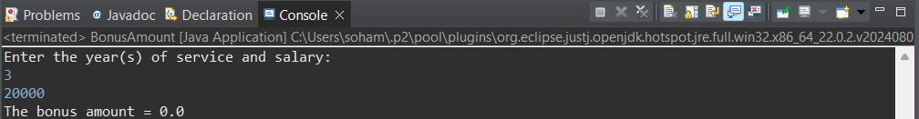

I/P:

8

10000

O/P:

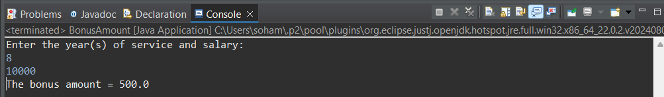

**3.** Create a program to find the multiplication table of a number entered by the user from 6 to 9.

Hint =>

1. Take integer input and store it in the variable number
2. Using a for loop, find the multiplication table of number from 6 to 9 and print it in the format number * i = ___

**Program:**

/**A program to find the multiplication table of a number entered by the user from 6 to 9*/

package step_program;

import java.util.*; //Importing java.util.* for Scanner class

public class MultTable69

{

public static void main(String args[])

{

int number, prod; //Initializing variables

Scanner sc=new Scanner(System.***in***); //Initializing Scanner object

System.***out***.println("Enter the number:");

number = sc.nextInt(); //Inputting the number from the user

for(int i = 6; i <= 9; i++) //For Loop (note that i starts from 6)

{

prod = number * i; //Multiplying the number with loop variable to find product

System.***out***.println(number + " * " + i + " = " + prod); //Displaying final output

} //End For Loop

} //End Method

} //End Class

**Output:**

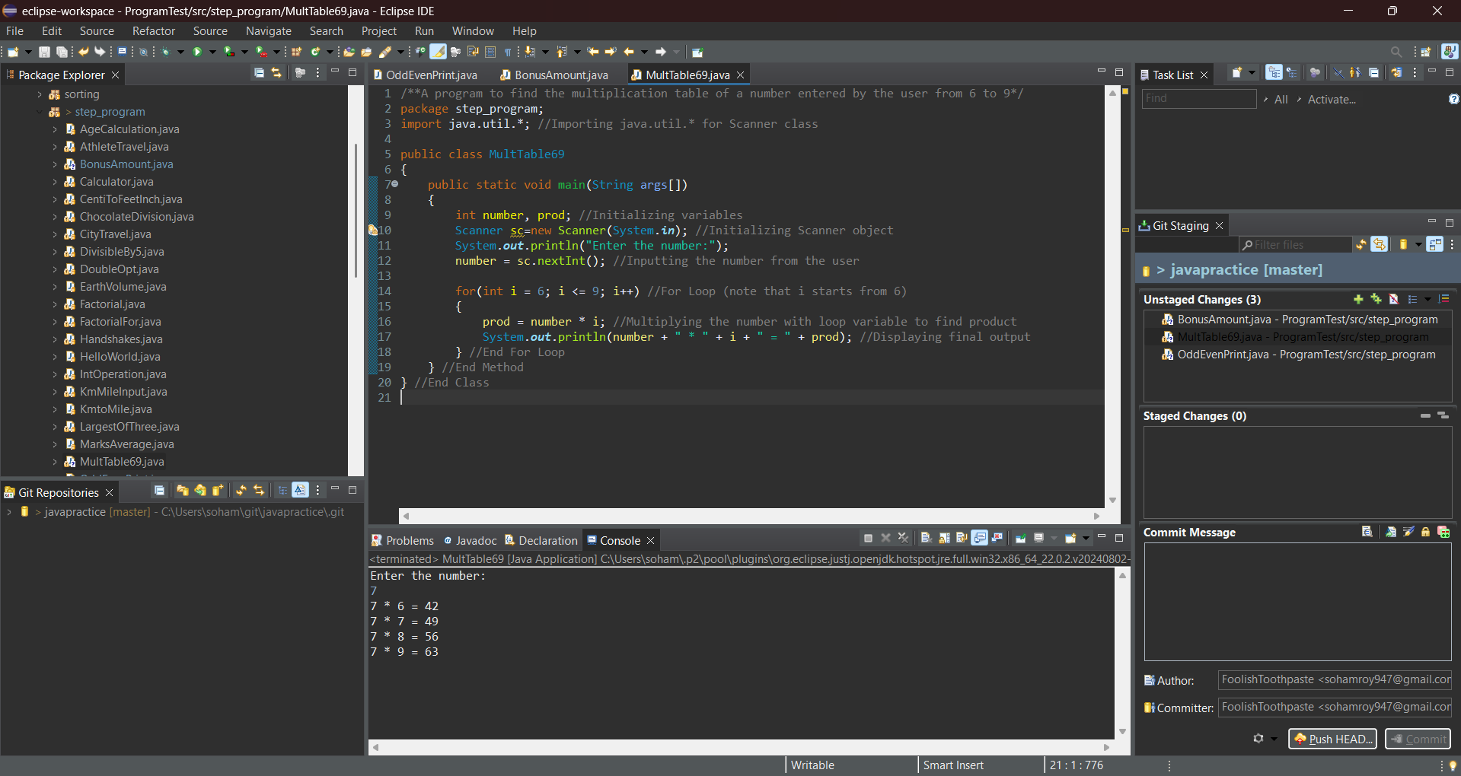

**4.** Write a program FizzBuzz, take a number as user input, and if it is a positive integer loop from 0 to the number and print the number, but for multiples of 3 print "Fizz" instead of the number, for multiples of 5 print "Buzz", and for multiples of both print "FizzBuzz".

Hint =>

1. Write the program and use *for* loop

**Program:**

/**A program that takes a number as user input, and if it is a positive integer loops from 0 to the number and prints the number,

* but for multiples of 3 prints "Fizz" instead of the number, for multiples of 5 prints "Buzz",

* and for multiples of both prints "FizzBuzz"*/

package step_program;

import java.util.*; //Importing java.util.* for Scanner class

public class FizzBuzz

{

public static void main(String args[])

{

int n; //Initializing variables

String f = "Fizz", b = "Buzz";

Scanner sc=new Scanner(System.***in***); //Initializing Scanner object

System.***out***.println("Enter the number:");

n = sc.nextInt(); //Inputting the number from the user

if(n <= 0) //Checking if the number is a positive number or not

System.***out***.println(n + "is not a positive number."); //Displaying Final Output

else

{

for(int i = 1; i <= n; i++) //For Loop

{

if(i % 3 == 0) //Checking if the loop variable is a multiple of 3

System.***out***.print(f); //Printing Fizz

if(i % 5 == 0) //Checking if the loop variable is a multiple of 5

System.***out***.print(b); //Printing Buzz

if(i % 5 != 0 && i % 3 != 0) //Checking if the loop variable is a multiple of neither 3 nor 5

System.***out***.print(i); //Printing the loop variable

System.***out***.println(); //Moving to next line

} //End For Loop

} //End Else Block

} //End Method

} //End Class

**Output:**

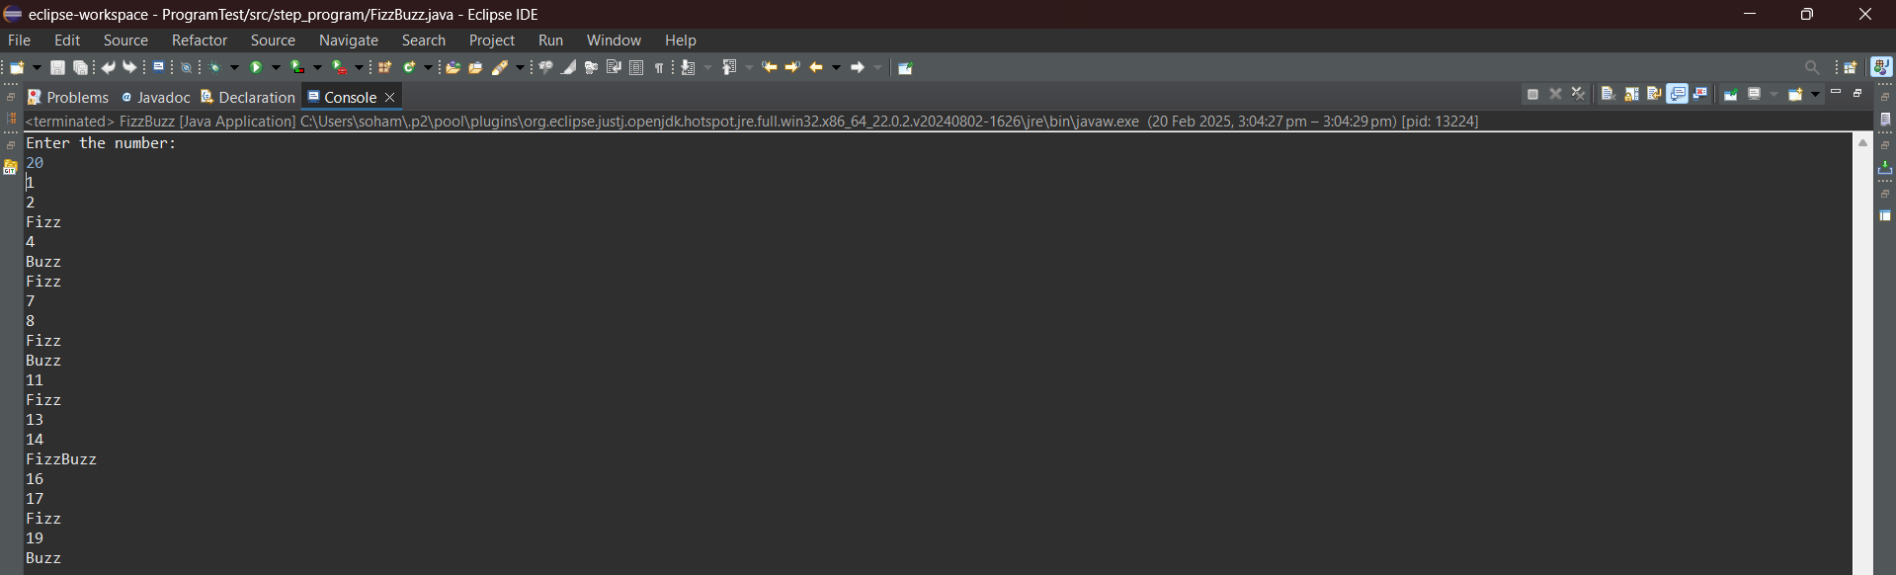

**5. Rewrite the program 5 FizzBuzz using while loop.**

**Program:**

/**A program that takes a number as user input, and if it is a positive integer loops from 0 to the number and prints the number,

* but for multiples of 3 prints "Fizz" instead of the number, for multiples of 5 prints "Buzz",

* and for multiples of both prints "FizzBuzz"*/

package step_program;

import java.util.*; //Importing java.util.* for Scanner class

public class FizzBuzzWhileLoop

{

public static void main(String args[])

{

int n, i = 1; //Initializing variables

String f = "Fizz", b = "Buzz";

Scanner sc=new Scanner(System.***in***); //Initializing Scanner object

System.***out***.println("Enter the number:");

n = sc.nextInt(); //Inputting the number from the user

if(n <= 0) //Checking if the number is a positive number or not

System.***out***.println(n + "is not a positive number."); //Displaying Final Output

else

{

while(i<=n) //While Loop

{

if(i % 3 == 0) //Checking if the loop variable is a multiple of 3

System.***out***.print(f); //Printing Fizz

if(i % 5 == 0) //Checking if the loop variable is a multiple of 5

System.***out***.print(b); //Printing Buzz

if(i % 5 != 0 && i % 3 != 0) //Checking if the loop variable is a multiple of neither 3 nor 5

System.***out***.print(i); //Printing the loop variable

System.***out***.println(); //Moving to next line

i++; //Incrementing loop variable

} //End While Loop

} //End Else Block

} //End Method

} //End Class

**Output:**

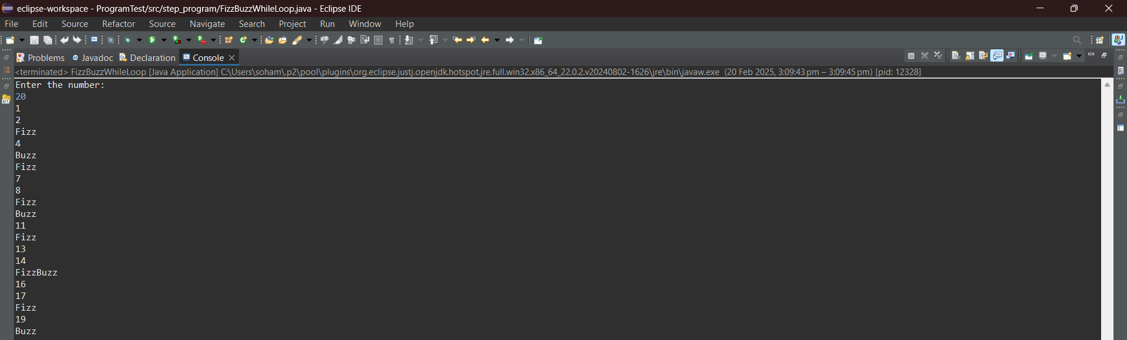

**6.** Create a program to find the youngest friends among 3 Amar, Akbar, and Anthony based on their ages and the tallest among the friends based on their heights

Hint =>

1. Take user input for the age and height of the 3 friends and store it in a variable
2. Find the smallest of the 3 ages to find the youngest friend and display it
3. Find the largest of the 3 heights to find the tallest friend and display it

**Program:**

/**A program to find the youngest friends among 3 Amar, Akbar, and Anthony based on their ages and the tallest among the friends based on their heights*/

package step_program;

import java.util.*; //Importing java.util.* for Scanner class

public class AmarAkbarAnthony

{

public static void main(String args[])

{

int ageAmar, ageAkbar, ageAnthony; //Initializing the age variables

double hAmar, hAkbar, hAnthony; //Initializing the height variables

Scanner sc=new Scanner(System.*in*); //Initializing the Scanner object

System.*out*.println("Enter the ages of Amar, Akbar and Anthony:");

ageAmar = sc.nextInt(); //Inputting the age of Amar from the user

ageAkbar = sc.nextInt(); //Inputting the age of Akbar from the user

ageAnthony = sc.nextInt(); //Inputting the age of Anthony from the user

System.*out*.println("Enter the heights of Amar, Akbar and Anthony:");

hAmar = sc.nextDouble(); //Inputting the height of Amar from the user

hAkbar = sc.nextDouble(); //Inputting the height of Akbar from the user

hAnthony = sc.nextDouble(); //Inputting the height of Anthony from the user

if(ageAmar > ageAkbar) //Checking for the youngest friend among the three

{

if(ageAkbar > ageAnthony)

System.*out*.println("Anthony is the youngest"); //Displaying Final Output

else

System.*out*.println("Akbar is the youngest"); //Displaying Final Output

} //End If Block

else if(ageAmar > ageAnthony)

System.*out*.println("Anthony is the youngest"); //Displaying Final Output

else

System.*out*.println("Amar is the youngest"); //Displaying Final Output

if(hAmar > hAkbar) //Checking for the tallest friend among the three

{

if(hAmar > hAnthony)

System.*out*.println("Amar is the tallest"); //Displaying Final Output

else

System.*out*.println("Anthony is the tallest"); //Displaying Final Output

} //End If Block

else if(hAkbar > hAnthony)

System.*out*.println("Akbar is the tallest"); //Displaying Final Output

else

System.*out*.println("Anthony is the tallest"); //Displaying Final Output

} //End Method

} //End Class

**Output:**

I/P:

12

15

23

180.66

180.23

180.45

O/P:

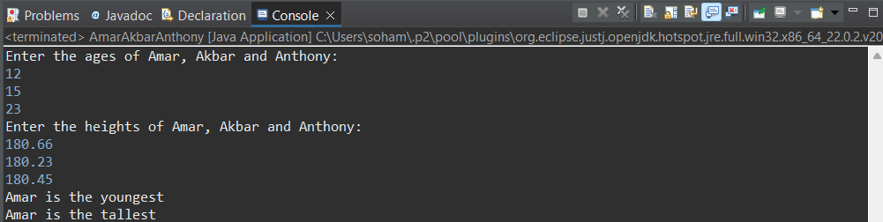

I/P:

23

12

15

180.45

180.66

180.23

O/P:

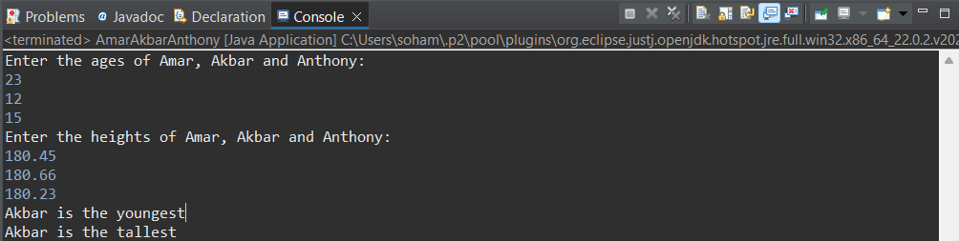

I/P:

15

23

12

180.23

180.45

180.66

O/P:

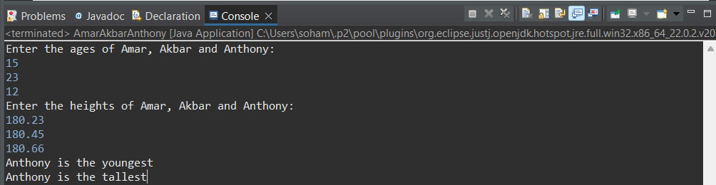

**7.** Create a program to find the factors of a number taken as user input.

Hint =>

1. Get input value for a variable named number.
2. Run a *for* loop from i = 1 to i < number. In each iteration of the loop, check if the number is perfectly divisible by i. If true, print the value of i.

**Program:**

/**A program to find the factors of a number taken as user input*/

package step_program;

import java.util.*; //Importing java.util.* for Scanner class

public class FindingFactors

{

public static void main(String args[])

{

int number; //Initializing the number variable

Scanner sc=new Scanner(System.***in***); //Initializing the Scanner object

System.***out***.println("Enter the number:");

number = sc.nextInt(); //Inputting the number from the user

System.***out***.println("The factors of "+ number +" are:");

for(int i = 1; i < number; i++) //For loop

{

if(number % i == 0) //Checking if the loop variable is a factor of the number

System.***out***.println(i); //Printing Factors

} //End For Loop

} //End Method

} //End Class

**Output:**

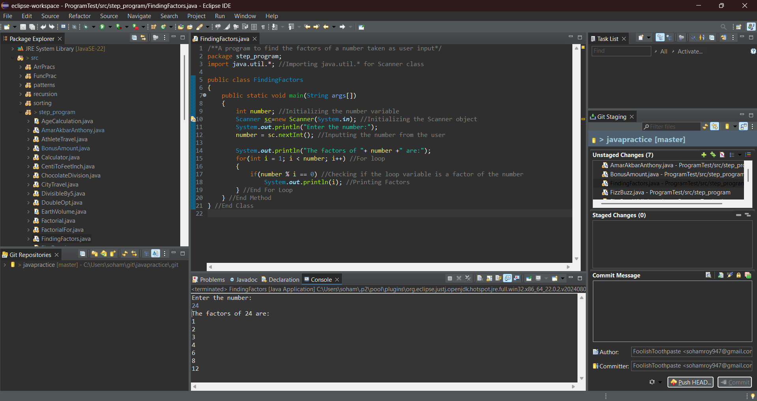

**8.** Create a program to print the greatest factor of a number beside itself using a loop.

Hint =>

1. Get an integer input and assign it to the number variable. As well as define a greatestFactor variable and assign it to 1
2. Create a *for* loop that runs from last but one till 1 as in i = number - 1 to i = 1.
3. Inside the loop, check if the number is perfectly divisible by i then assign i to greatestFactor variable and break the loop.
4. Display the greatestFactor variable outside the loop

**Program:**

/**A program to find the factors of a number taken as user input*/

package step_program;

import java.util.*; //Importing java.util.* for Scanner class

public class FindingFactorGreatest

{

public static void main(String args[])

{

int number, greatestFactor = 1; //Initializing variables

Scanner sc=new Scanner(System.***in***); //Initializing the Scanner object

System.***out***.println("Enter the number:");

number = sc.nextInt(); //Inputting the number from the user

for(int i = 1; i < number; i++) //For loop

{

if(number % i == 0) //Checking if the loop variable is a factor of the number

greatestFactor = i; //Storing chronological greatest factor

} //End For Loop

System.***out***.println("Greatest Factor of "+ number +" = "+ greatestFactor); //Displaying Final Output

} //End Method

} //End Class

**Output:**

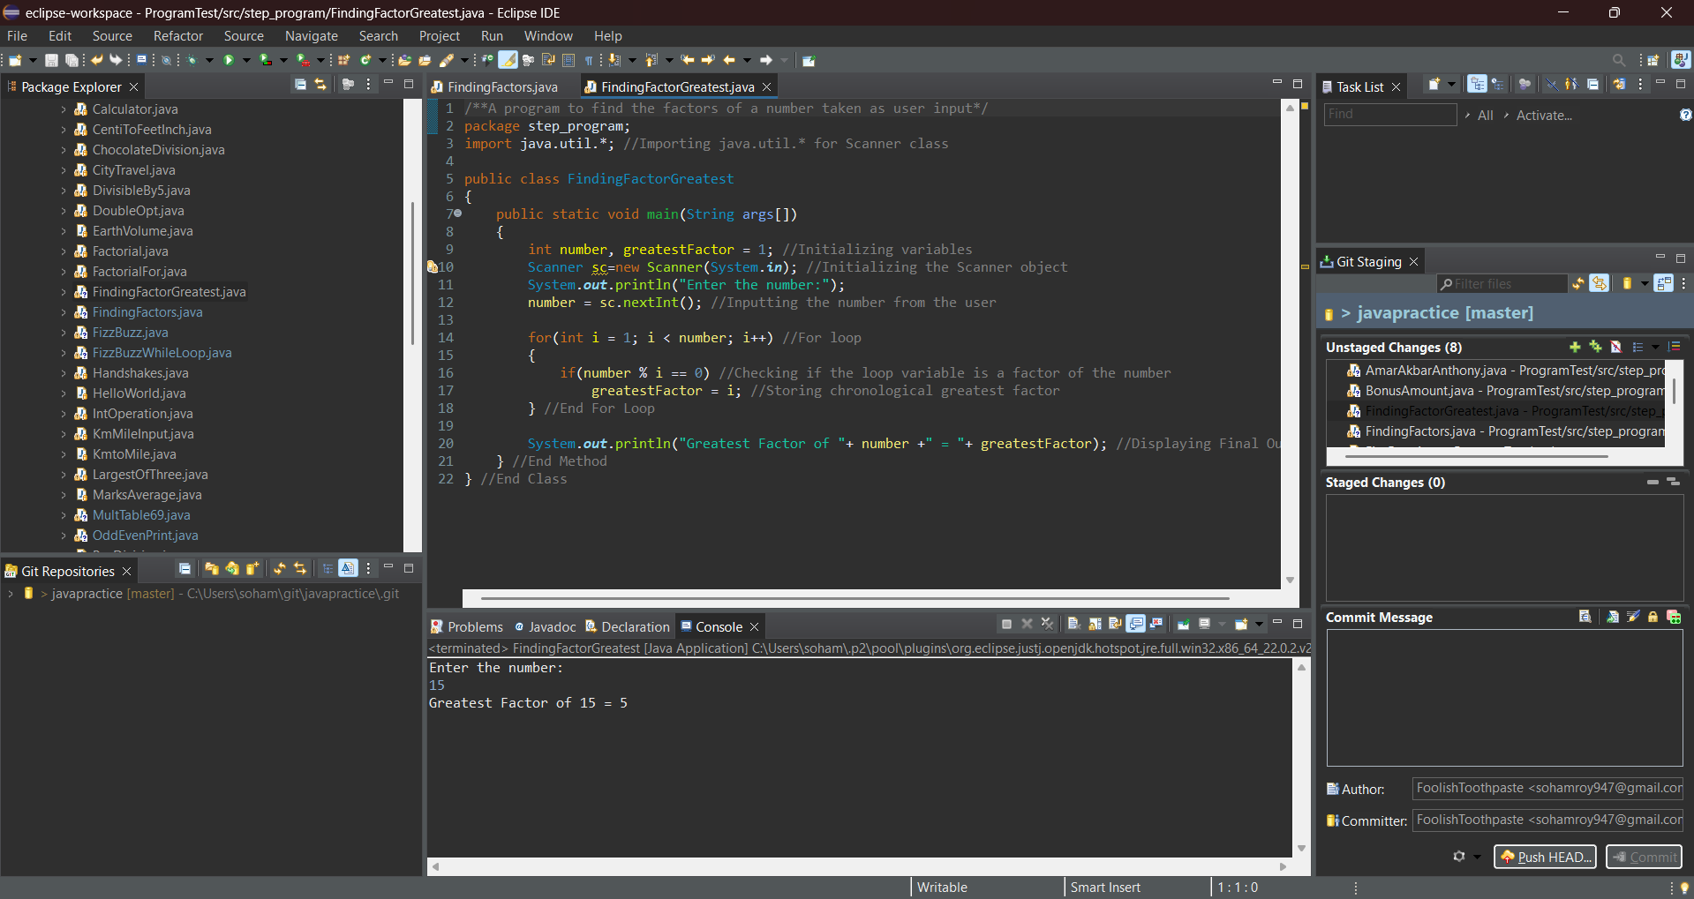

**9.** Create a program to find the power of a number.

Hint =>

1. Get integer input for two variables named number and power.
2. Create a result variable with an initial value of 1.
3. Run a for loop from i = 1 to i <= power.
4. In each iteration of the loop, multiply the result with the number and assign the value to the result.
5. Finally, print the result

**Program:**

/**A program to find the power of a number using loop*/

package step_program;

import java.util.*; //Importing java.util.* for Scanner class

public class PowerForLoop

{

public static void main(String args[])

{

int number, power, result = 1; //Initializing variables

Scanner sc=new Scanner(System.***in***); //Initializing Scanner object

System.***out***.println("Enter the number and the power to be raised to:");

number = sc.nextInt(); //Inputting the number from the user

power = sc.nextInt(); //Inputting the power the number will be raised to from the user

for(int i = 1; i <= power; i++) //For Loop iterating the number of times as the power

{

result*= number; //Multiplying the number continually with result

} //End For Loop

System.***out***.println(number + " raised to the power " + power + " = " + result); //Displaying Final Output

} //End Method

} //End Class

**Output:**

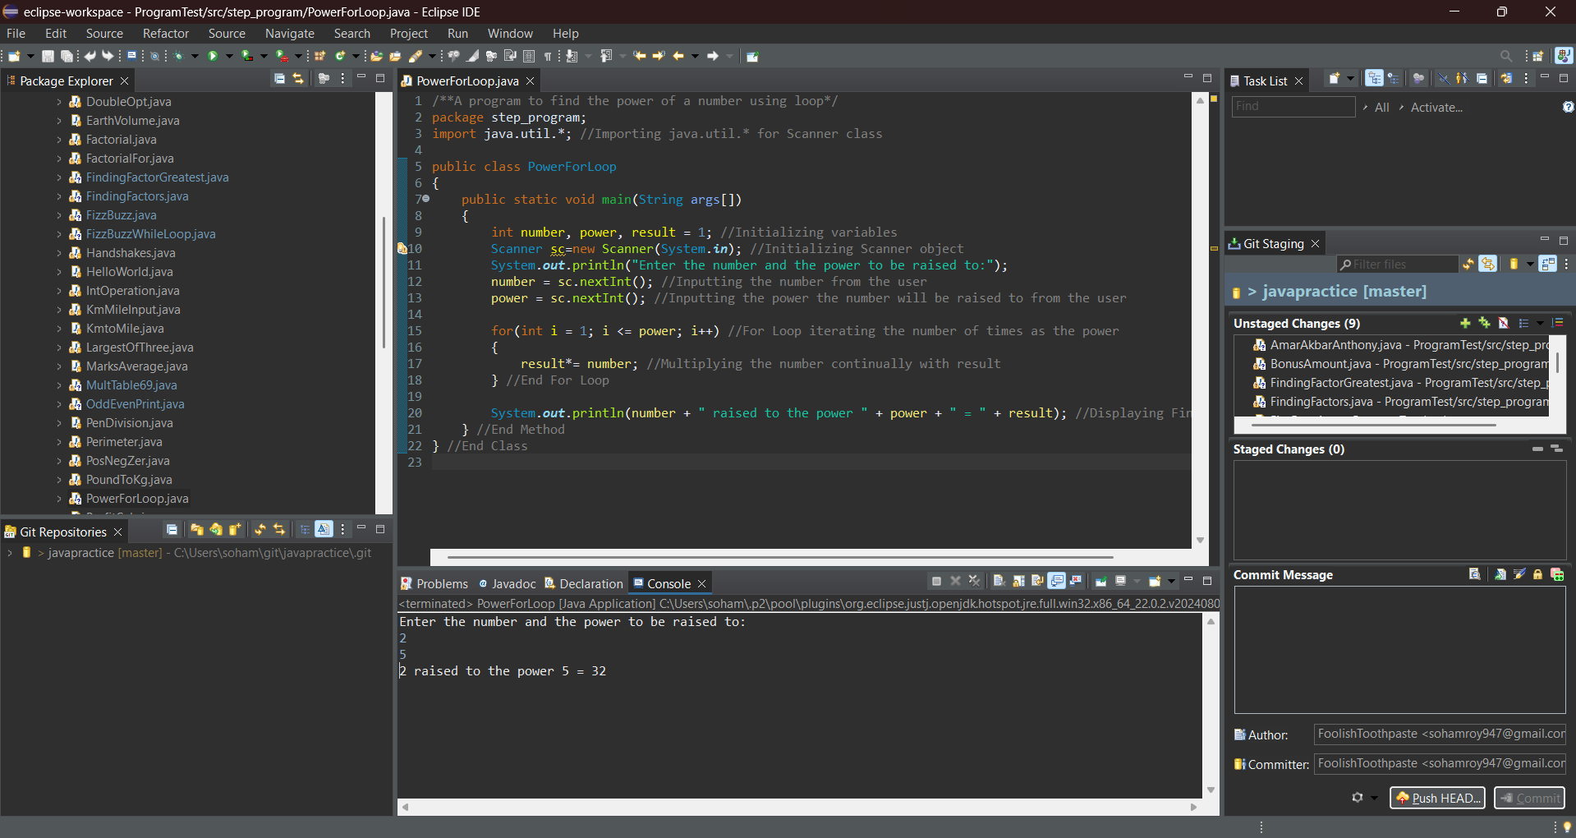

**10**. Create a program to find all the multiple of a number taken as user input below 100.

Hint =>

1. Get input value for a variable named number.
2. Run a *for* loop backwards: from i = 100 to i = 1.
3. Inside the loop, check if i perfectly divides number.
4. If true, print the number and *continue* the loop.

**Program:**

/**A program to find all the multiple of a number taken as user input below 100*/

package step_program;

import java.util.*; //Importing java.util.*

public class MultiplesBelow100

{

public static void main(String args[])

{

int number; //Initializing the number variable

Scanner sc=new Scanner(System.***in***); //Initializing Scanner object

System.***out***.println("Enter the number:");

number = sc.nextInt(); //Inputting the number from the user

for(int i = 100; i >= 1; i--) //For Loop Backwards from 100 to 1

{

if(i % number == 0) //Checking if i is a multiple of number

System.***out***.println(i); //Printing the multiple

} //End For Loop

} //End Method

} //End Class

**Output:**

