**Week 1 - Level 1 - 10 Practice Problems**

Soham Roy,

RA2411033010148,

Z2 Section,

CSE w/s SWE

**1.** Write a program to find the age of Harry if the birth year is 2000. Assume the Current Year is 2024

I/P => NONE

O/P => Harry's age in 2024 is ______.

**Program:**

/**A program to find the age of Harry if the birth year is 2000. Assume the Current Year is 2024*/

package step_program;

public class AgeCalculation

{

public static void main(String args[])

{

int currentyear = 2024; //Initializing current year

int birthyear = 2000; //Initializing birth year

int age = currentyear - birthyear; //Calculating age

System.***out***.println("Harry's age in " + currentyear + " is " + age); //Displaying Final Output

} //End method

} //End class

**Output:**

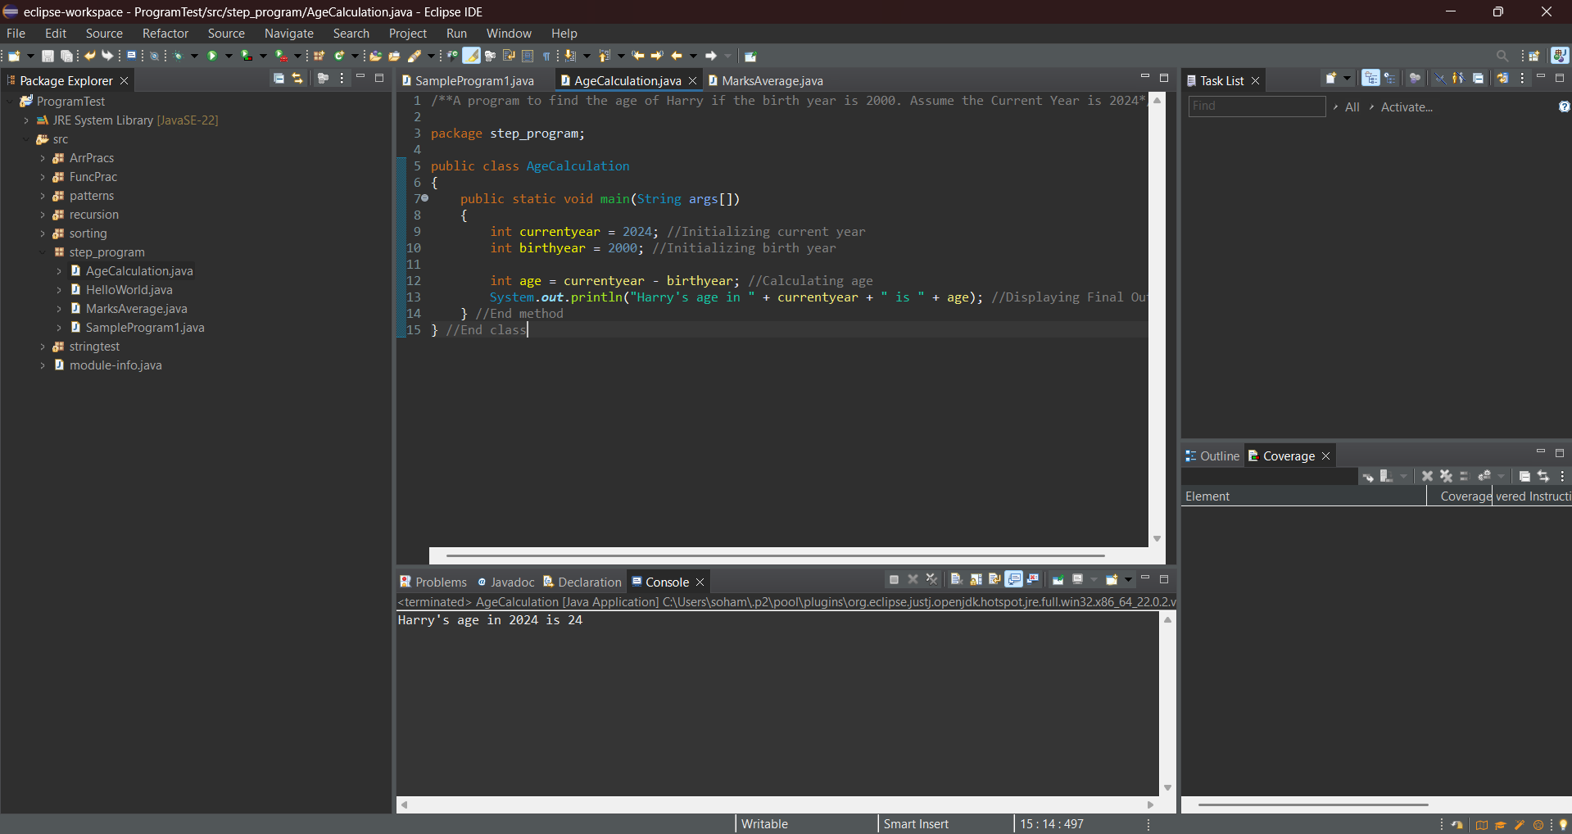

**2.** Sam’s mark in Maths is 94, Physics is 95 and Chemistry is 96 out of 100. Find the average percent mark in PCM

I/P => NONE

O/P => Sam’s average mark in PCM is ___

**Program:**

/**Sam’s mark in Maths is 94, Physics is 95 and Chemistry is 96 out of 100. A program to find the average percent mark in PCM*/

package step_program;

public class MarksAverage

{

public static void main(String args[])

{

int maths = 94; //Storing Sam's Maths marks

int physics = 95; //Storing Sam's Physics marks

int chemistry = 96; //Storing Sam's Chemistry marks

int sum = maths + physics + chemistry; //Calculating Sum of the three marks

double average = sum / 3.0; //Calculating Average of the three marks

System.***out***.println("Sam’s average mark in PCM is " + average); //Displaying Average of the three marks

} //End method

} //End class

**Output:**

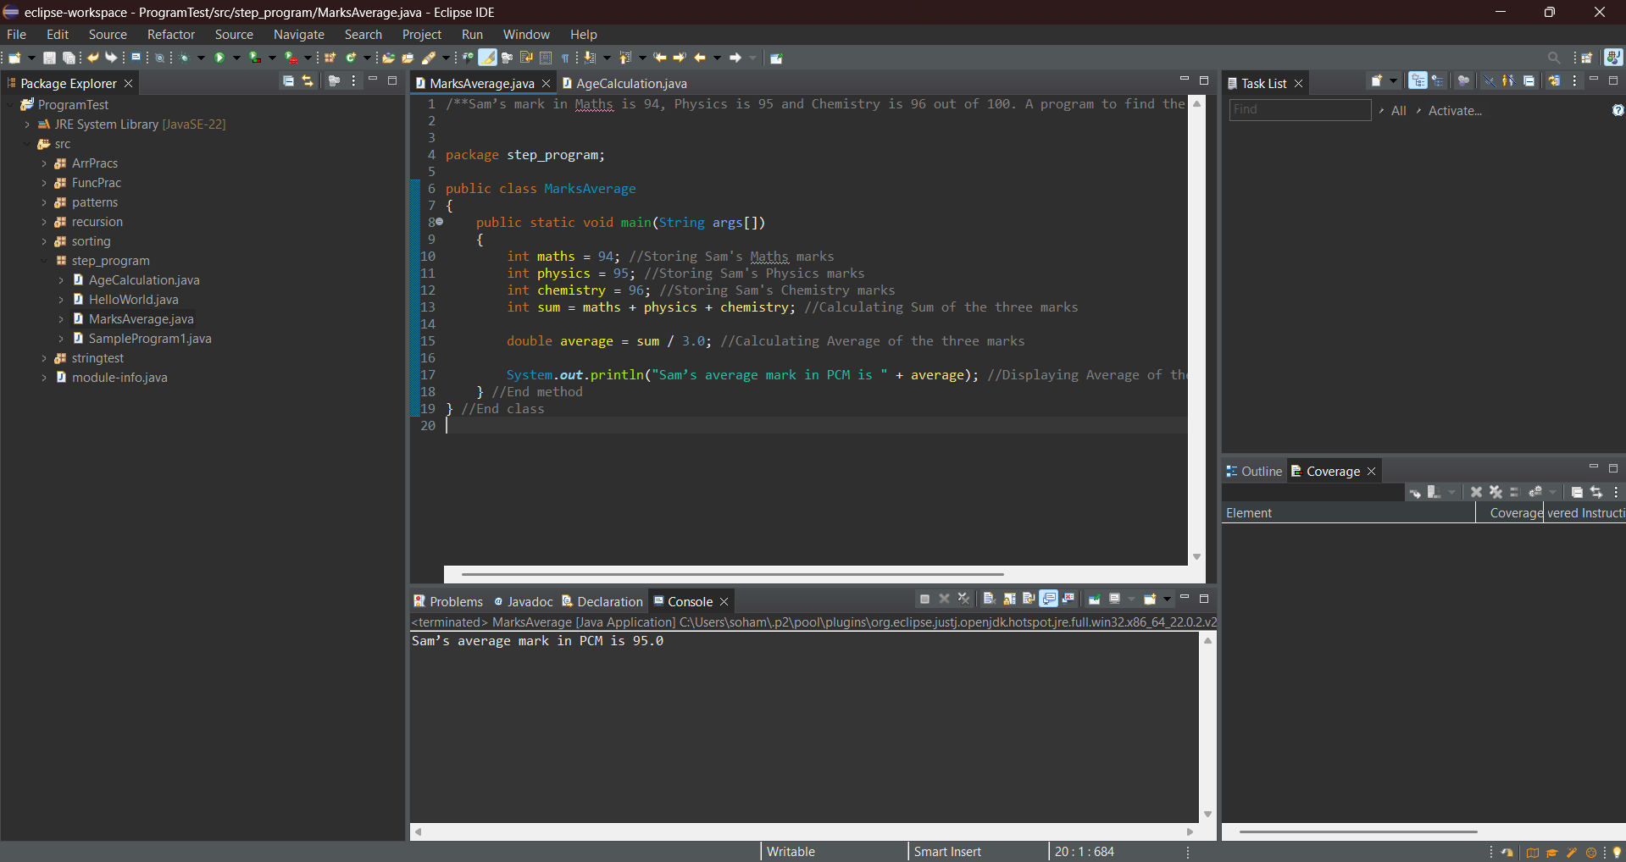

**3.** Create a program to convert the distance of 10.8 kilometers to miles.

Hint: 1 km = 1.6 miles

I/P => NONE

O/P => The distance  ___ km in miles is ___

**Program:**

/**A program to convert the distance of 10.8 kilometers to miles.*/

package step_program;

public class KmtoMile

{

public static void main(String args[])

{

double kilometer = 10.8; //Storing kilometer value

double rate = 1.6; //Storing conversion rate

double mile = kilometer * rate; //Converting kilometers to miles

System.***out***.println("The distance " + kilometer + " km in miles is " + mile); //Displaying final output

}

}

**Output:**

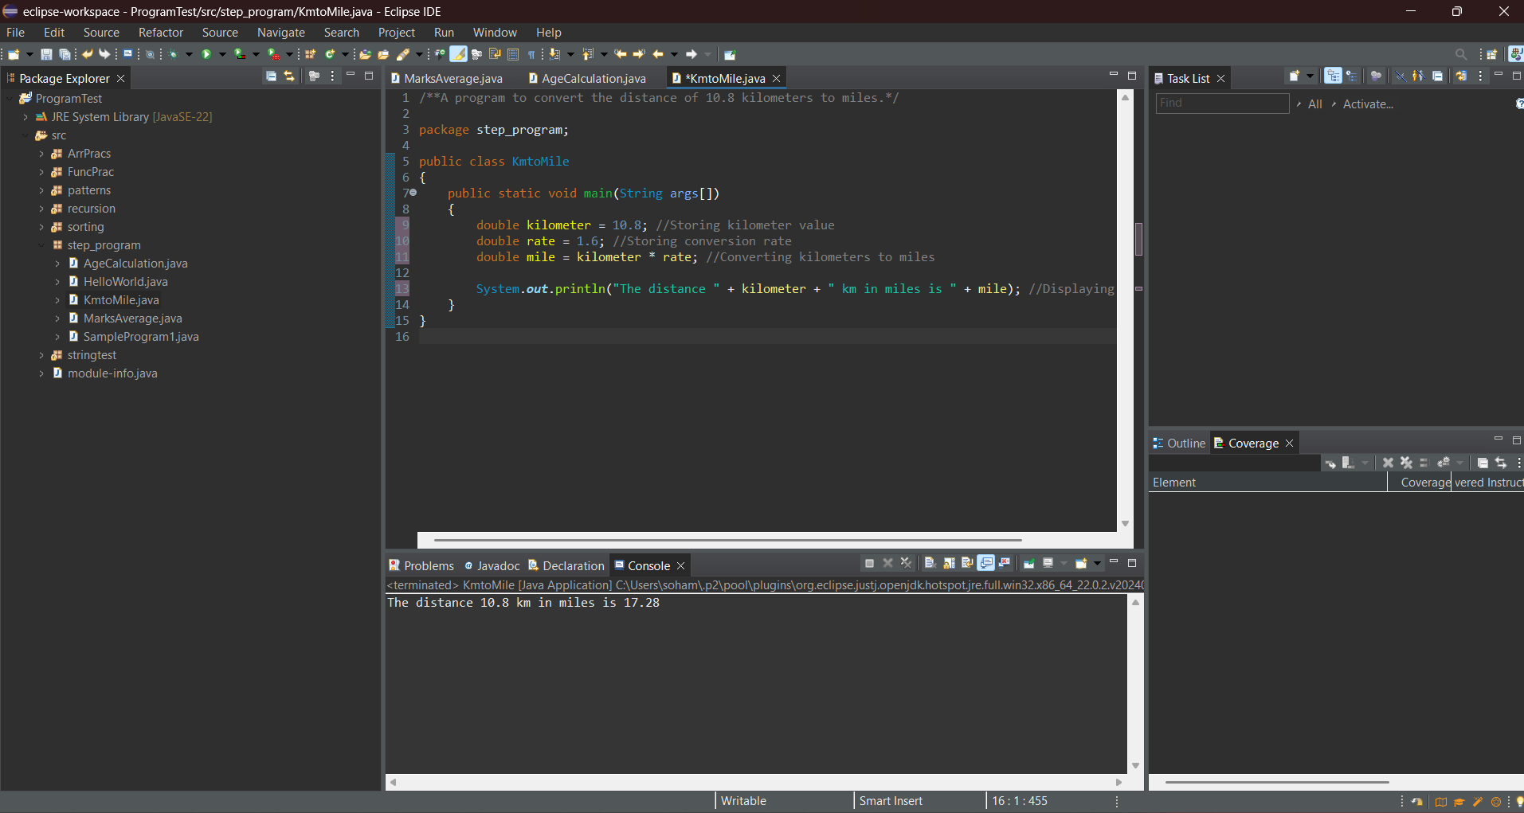

**4.** Create a program to calculate the profit and loss in number and percentage based on the cost price of INR 129 and the selling price of INR 191.

Hint =>

1. Use a single print statement to display multiline text and variables.
2. Profit = selling price - cost price
3. Profit Percentage = profit / cost price * 100

I/P => NONE

O/P =>

The Cost Price is INR ___ and Selling Price is INR ___

The Profit is INR ___ and the Profit Percentage is ___

**Program:**

/**A program to calculate the profit and loss in number and percentage based on the cost price of INR 129 and the selling price of INR 191.

*/

package step_program;

public class ProfitCalc

{

public static void main(String args[])

{

int cp = 129; //Storing Cost Price

int sp = 191; //Storing Selling Price

int profit = sp - cp; //Calculating Profit

double profitp = ( (double) profit / cp) * 100; //Calculating Profit Percentage, double type conversion to ensure decimal division

//Displaying final output, \n escape sequence used to ensure multi-line output

System.*out*.println("The Cost Price is INR " + cp + " and Selling Price is INR "+ sp + "\nThe Profit is INR "+ profit +" and the Profit Percentage is " + profitp);

} //End method

} //End class

**Output:**

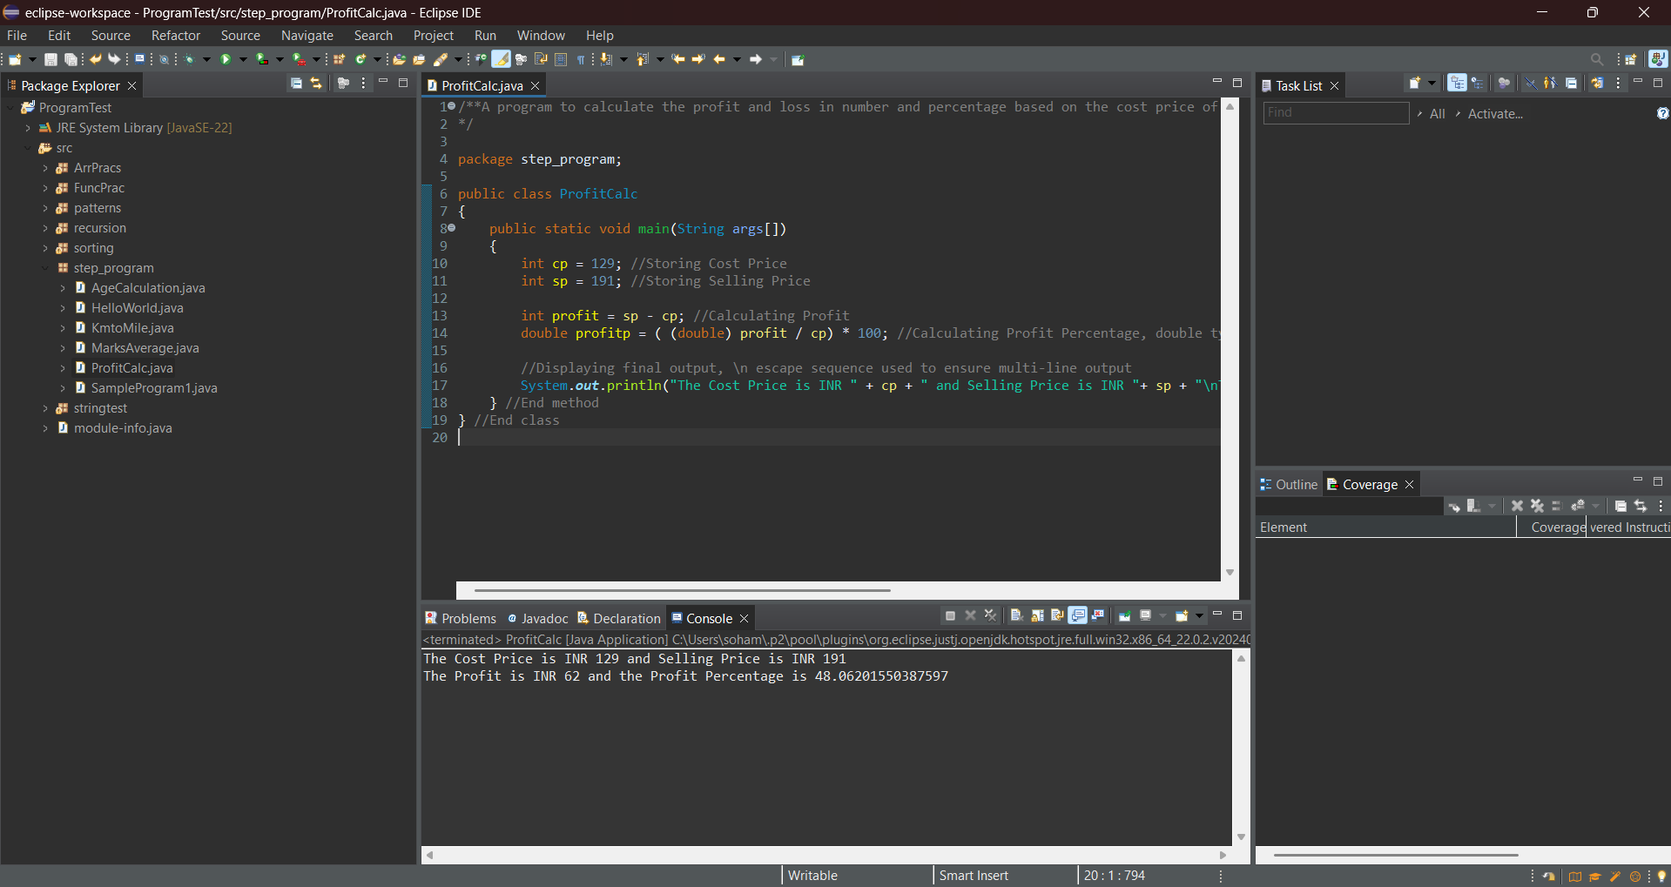

**5.** Suppose you have to divide 14 pens among 3 students equally. Write a program to find how many pens each student will get if the pens must be divided equally. Also, find the remaining non-distributed pens.

Hint =>

1. Use Modulus Operator (%) to find the reminder.
2. Use Division Operator to find the Quantity of pens

I/P => NONE

O/P => The Pen Per Student is ___ and the remaining pen not distributed is ___

**Program:**

/**Suppose you have to divide 14 pens among 3 students equally. A program to find how many pens each student will get if the pens must be divided equally and finding the remaining non-distributed pens.*/

package step_program;

public class PenDivision

{

public static void main(String args[])

{

int npen = 14; //Storing total number of pens

int nstudent = 3; //Storing total number of students

int npeneach = npen / nstudent; //Calculating number of pens each student gets (integer division)

int rem = npen % nstudent; //Calculating remaining pens

//Displaying final output

System.*out*.println("The Pen Per Student is " + npeneach + " and the remaining pen not distributed is " + rem);

} //End method

} //End class

**Output:** 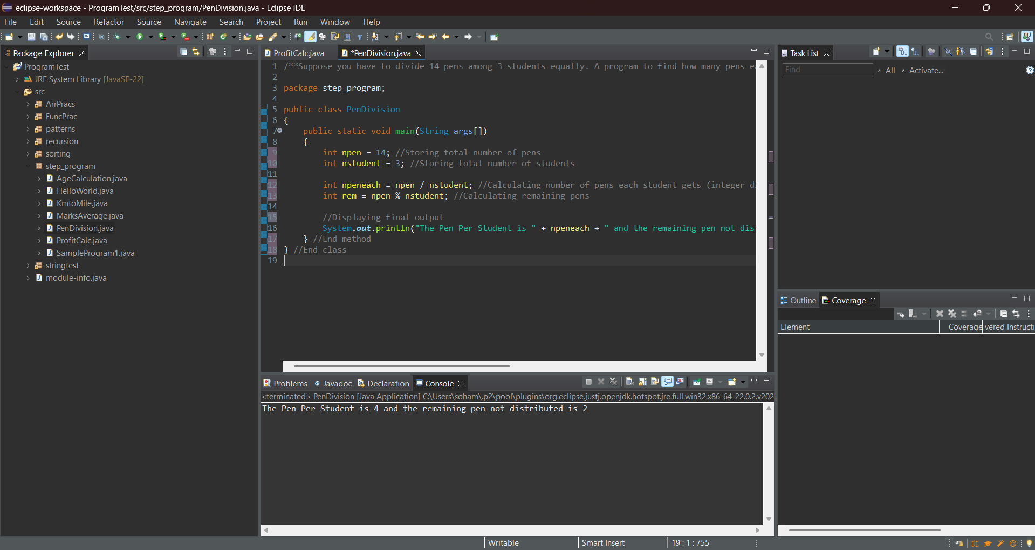

1. The University is charging the student a fee of INR 125000 for the course. The University is willing to offer a discount of 10%. Write a program to find the discounted amount and discounted price the student will pay for the course.

Hint =>

1. Create a variable named fee and assign 125000 to it.
2. Create another variable discountPercent and assign 10 to it.
3. Compute discount and assign it to the discount variable.
4. Compute and print the fee you have to pay by subtracting the discount from the fee.

O/P => The discount amount is INR ___ and final discounted fee is INR ___

**Program:**

/**The University is charging the student a fee of INR 125000 for the course. The University is willing to offer a discount of 10%. A program to find the discounted amount and discounted price the student will pay for the course.*/

package step_program;

public class UniversityFee

{

public static void main(String args[])

{

int fee = 125000; //Storing University Fee

int discountPercent = 10; //Storing Fee Discount Percentage

double discount = (discountPercent / 100.0) * fee; //Calculating Discount

double finalfee = fee - discount; //Calculating Final University Fee

//Displaying Final Output

System.*out*.println("The discount amount is INR " + discount + " and final discounted fee is INR " + finalfee);

} //End Method

} //End Class

**Output:**

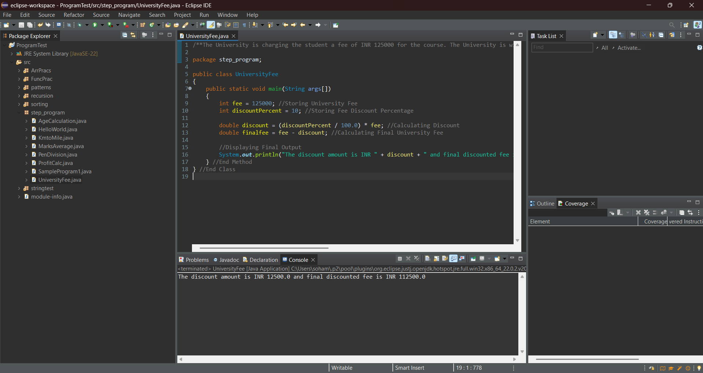

**7.** Write a Program to compute the volume of Earth in km^3 and miles^3

Hint => Volume of a Sphere is (4/3) * pi * r^3 and radius of earth is 6378 km

O/P => The volume of earth in cubic kilometers is ____ and cubic miles is ____

**Program:**

/**A program to compute the volume of Earth in km^3 and miles^3*/

package step_program;

public class EarthVolume

{

private static final double *PI* = 3.1416; //Declaring Pi as a constant

public static void main(String args[])

{

int radius = 6378; //Storing radius of Earth

double vkm = (4.0/3) * *PI* * Math.*pow*(radius,3); //Calculating volume of Earth in kms

double vmile = vkm / 1.6; //Calculating volume of Earth in miles

//Displaying final output

System.*out*.println("The volume of earth in cubic kilometers is " + vkm + " and cubic miles is " + vmile);

} //End method

} //End class

**Output:**

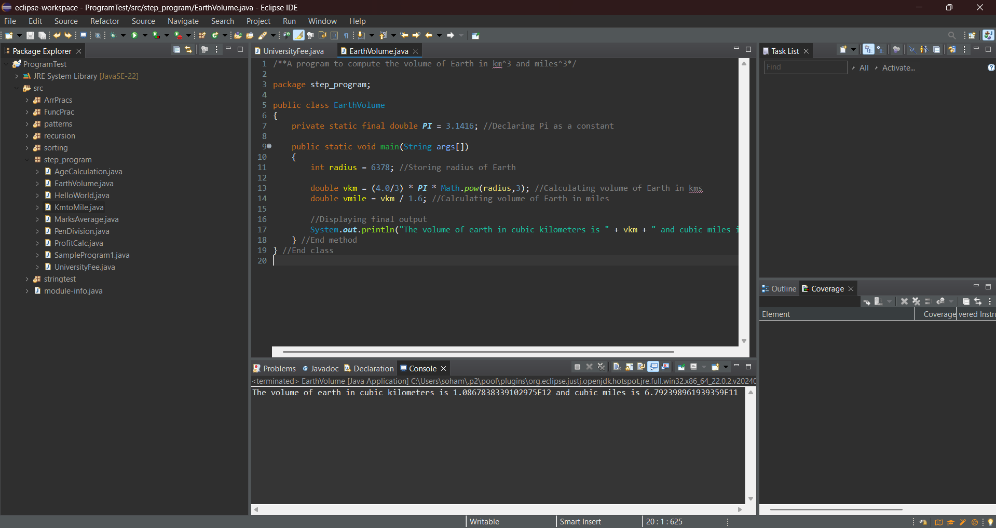

**8.** Create a program to convert distance in kilometers to miles.

Hint =>

1. Create a variable km and assign type as double as in double km;
2. Create Scanner Object to take user input from Standard Input that is the Keyboard as in Scanner input = new Scanner(System.in);
3. Use Scanner Object to take user input for km as in km = input.nextInt();
4. Use 1 mile = 1.6 km formulae to calculate miles and show the output

I/P => km

O/P => The total miles is ___ mile for the given ___ km

**Program:**

/**A program to convert distance in kilometers to miles with kilometers input by user.*/

package step_program;

import java.util.*; //importing java.util.* for Scanner class

public class KmMileInput

{

public static void main(String args[])

{

double km; //Initializing variable to store distance in kilometers

Scanner input = new Scanner(System.***in***); //Initializing Scanner object

System.***out***.println("Enter the distance in kilometers: ");

km = input.nextInt(); //Inputting the distance in kilometers from the user

double miles = km / 1.6; //Converting distance from kilometers to miles

//Displaying final output

System.***out***.println("The total miles is "+ miles +" mile for the given "+ km +" km");

} //End method

} //End class

**Output:**

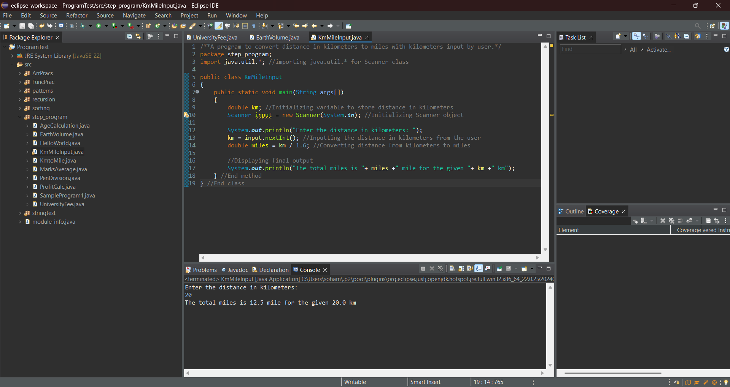

**9.** Write a new program similar to the program # 6 but take user input for Student Fee and University Discount

Hint =>

1. Create a variable named fee and take user input for fee.
2. Create another variable discountPercent and take user input.
3. Compute the discount and assign it to the discount variable.
4. Compute and print the fee you have to pay by subtracting the discount from the fee.

I/P => fee, discountPrecent

O/P => The discount amount is INR ___ and final discounted fee is INR ___

**Program:**

/**A program similar to the program UniversityFee but taking user input for Student Fee and University Discount*/

package step_program;

import java.util.*; //importing java.util.* for Scanner class

public class UniversityFeeInput

{

public static void main(String args[])

{

int fee, discountPercent; //Initializing University Fee and Fee Discount Percentage

Scanner sc=new Scanner(System.*in*); //Initializing Scanner object

System.*out*.println("Enter the fee and discount percentage: ");

fee=sc.nextInt(); //Inputting University Fee from user

discountPercent = sc.nextInt(); //Inputting Discount Percent from user

double discount = (discountPercent / 100.0) * fee; //Calculating Discount

double finalfee = fee - discount; //Calculating Final University Fee

//Displaying Final Output

System.*out*.println("The discount amount is INR " + discount + " and final discounted fee is INR " + finalfee);

} //End method

} //End class

**Output:**

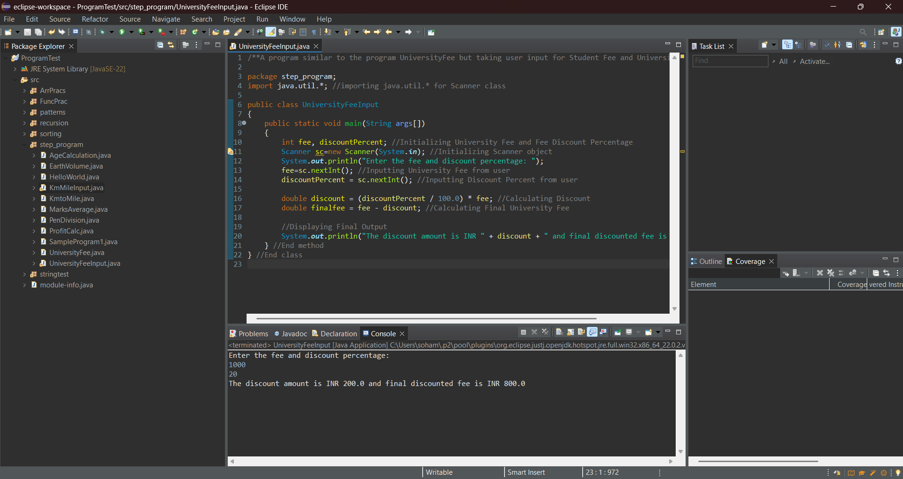

**10.** Write a program that takes your height in centimeters and converts it into feet and inches

Hint => 1 foot = 12 inches and 1 inch = 2.54 cm

I/P => height

O/P => Your Height in cm is ___ while in feet is ___ and inches is ___

**Program:**

/**A program that takes your height in centimeters and converts it into feet and inches*/

package step_program;

import java.util.*; //importing java.util.* for Scanner class

public class CentiToFeetInch

{

public static void main(String args[])

{

double hcm; //Initializing variable to store height in centimeters

Scanner sc=new Scanner(System.*in*); //Initializing Scanner object

System.*out*.println("Enter your height in centimeters: ");

hcm=sc.nextDouble(); //Inputting height in centimeters from the user

double hinch = hcm / 2.54; //Converting height in centimeters to inches

double hfeet = hinch / 12; //Converting height in centimeters to feet

//Displaying final output

System.*out*.println("Your Height in cm is "+ hcm +" while in feet is "+ hfeet +" and inches is "+ hinch);

} //End method

} //End class

**Output:**

