**Week 2 - Level 2 - 8 Practice Problems**

Soham Roy,

RA2411033010148,

Z2 Section,

CSE w/s SWE

**1.** Write a program to create a basic calculator that can perform addition, subtraction, multiplication, and division. The program should ask for two numbers (floating point) and perform all the operations

Hint =>

1. Create a variable number1 and number 2 and take user inputs.
2. Perform Arithmetic Operations of addition, subtraction, multiplication and division and assign the result to a variable and finally print the result

I/P => number1, number2

O/P => The addition, subtraction, multiplication and division value of 2 numbers ___ and ___ is ___, ____, ____, and ___

**Program:**

/**A program to create a basic calculator that can perform addition, subtraction, multiplication, and division*/

package step_program;

import java.util.*; //Importing util package for Scanner class

public class Calculator

{

public static void main(String args[])

{

float number1, number2, sum, diff, prod, divi; //Initializing all the variables

Scanner sc=new Scanner(System.*in*); //Initializing Scanner object

System.*out*.println("Enter two numbers to perform operations on: ");

number1 = sc.nextFloat(); //Inputting the first number from the user

number2 = sc.nextFloat(); //Inputting the second number from the user

sum = number1 + number2; //Calculating sum of the two numbers

diff = number1 - number2; //Calculating difference of the two numbers

prod = number1 * number2; //Calculating product of the two numbers

divi = number1 / number2; //Calculating division of the two numbers

//Displaying final output

System.*out*.println("The addition, subtraction, multiplication and division value of 2 numbers "+ number1 + " and "+ number2 +" is "+ sum +", "+ diff +", "+ prod +", and "+ divi);

} //End method

} //End class

**Output:**

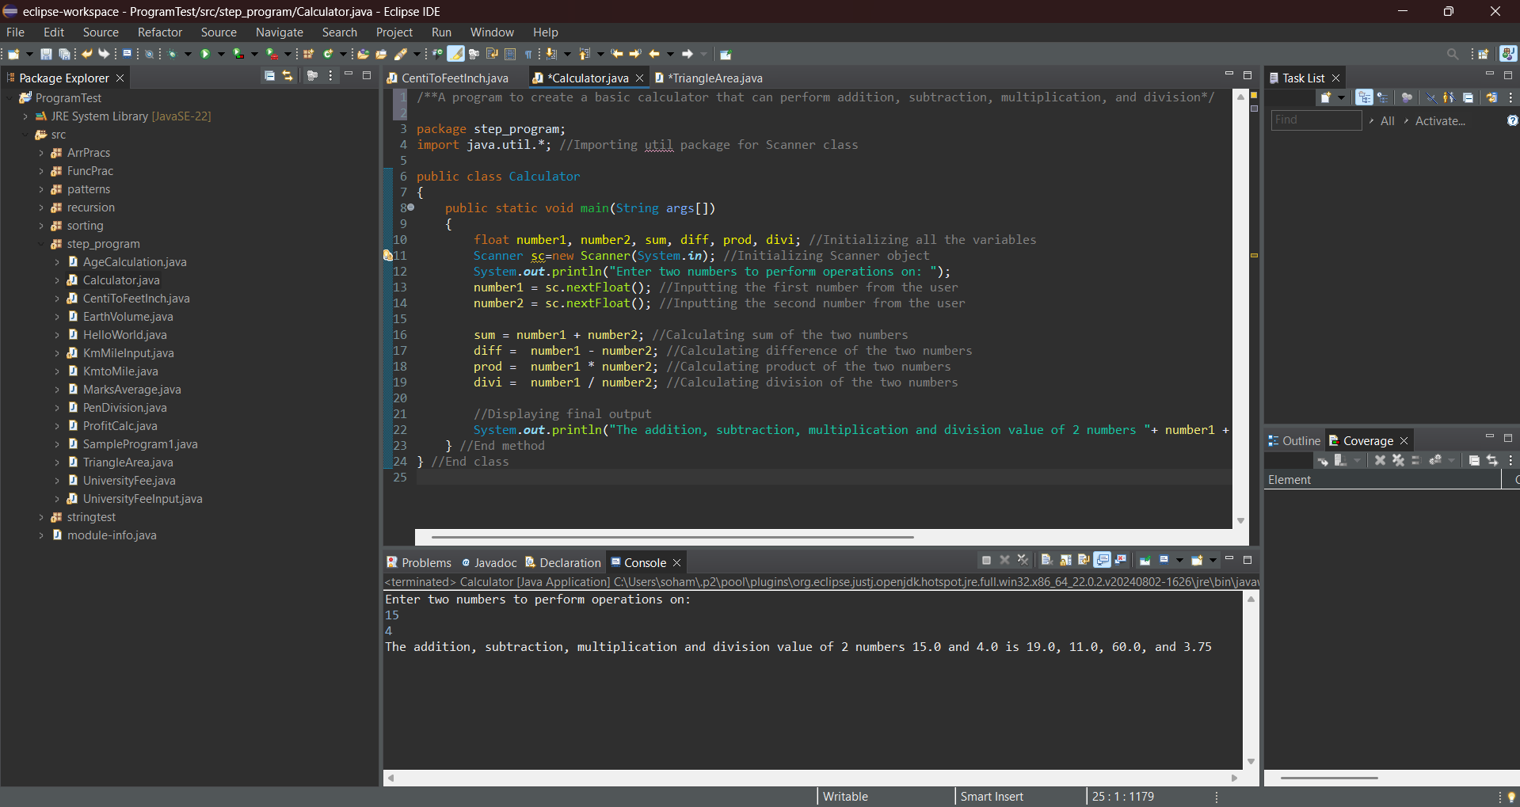

**2.** Write a program that takes the base and height to find area of a triangle in square inches and square centimeters

Hint => Area of a Triangle is ½ * base * height

I/P => base, height

O/P => Area of triangle in cm is ___ while in feet is ___ and inches is ___

**Program:**

/**A program that takes the base and height to find area of a triangle in square inches and square centimeters*/

package step_program;

import java.util.*; //Importing java.util.* for Scanner class

public class TriangleArea

{

public static void main(String args[])

{

double base, height, basecm, basefeet, heightcm, heightfeet, area, areacm, areafeet; //Initializing variables

Scanner sc=new Scanner(System.*in*); //Initializing Scanner object

System.*out*.println("Enter the base and the height of the triangle in inches: ");

base = sc.nextDouble(); //Inputting the base of the triangle in inches

height = sc.nextDouble(); //Inputting the height of the triangle in inches

area = 0.5 * base * height; //Calculating the area of the triangle in inches

basecm = base * 2.54; //Calculating the base of the triangle in centimeter

heightcm = height * 2.54; //Calculating the height of the triangle in centimeter

areacm = 0.5 * basecm * heightcm; //Calculating the area of the triangle in centimeter

heightfeet = 0.083 * height; //Calculating the height of the triangle in feet

basefeet = 0.083 * base; //Calculating the base of the triangle in feet

areafeet = 0.5 * heightfeet * basefeet; //Calculating the area of the triangle in feet

//Displaying Final Output

System.*out*.println("Area of triangle in cm is "+ areacm +" while in feet is "+ areafeet +" and inches is "+ area);

} //End method

} //End class

**Output:**

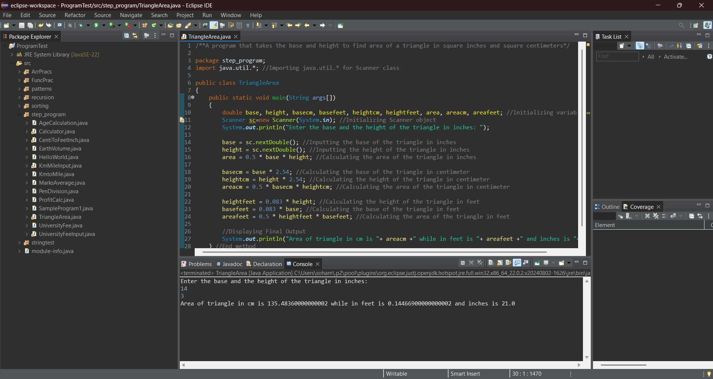

**3.** Write a program to find the side of the square whose perimeter you read from user

Hint => Perimeter of Square is 4 times side

I/P => perimeter

O/P => The length of the side is ___ whose perimeter is ____

**Program:**

/**A program to find the side of the square whose perimeter read from user*/

package step_program;

import java.util.*; //Importing java.util.* for Scanner class

public class Perimeter

{

public static void main(String args[])

{

double perimeter, side; //Initializing variables

Scanner sc=new Scanner(System.***in***); //Initializing Scanner object

System.***out***.println("Enter the perimeter of the square: ");

perimeter = sc.nextDouble(); //Inputting the perimeter of the square from the user

side = perimeter / 4; //Calculating the side of the square from the perimeter

//Displaying final output

System.***out***.println("The length of the side is " + side + " whose perimeter is "+ perimeter);

} //End method

} //End class

**Output:**

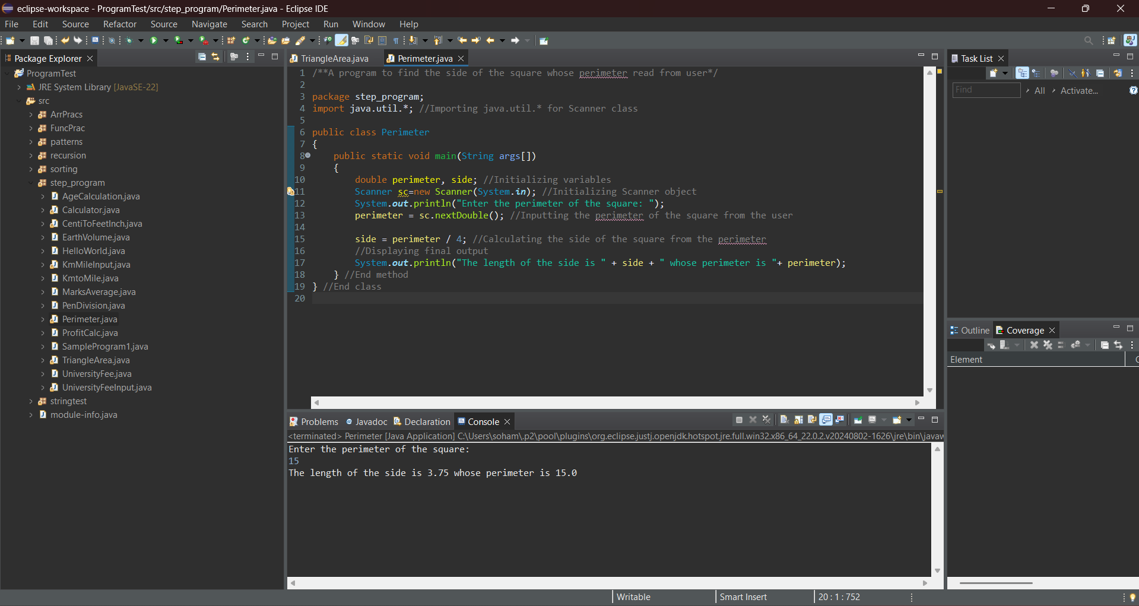

**4.** Write a program the find the distance in yards and miles for the distance provided by user in feets

Hint => 1 mile = 1760 yards and 1 yard is 3 feet

I/P => distanceInFeet

O/P => Your Distance in feet is ___ while in yards is ___ and miles is ___

**Program:**

/**A program that find the distance in yards and miles for the distance provided by user in feet*/

package step_program;

import java.util.*; //Importing java.util.* for Scanner class

public class YardMileInput

{

public static void main(String args[])

{

double distanceInFeet, yard, miles; //Initializing variables

Scanner sc=new Scanner(System.*in*); //Initializing Scanner object

System.*out*.println("Enter the distance in feet:");

distanceInFeet = sc.nextDouble(); //Inputting the distance in feet from the user

yard = distanceInFeet / 3; //Converting distance in feet to yards

miles = yard / 1760; //Converting distance in feet to miles

//Displaying final output

System.*out*.println("Your Distance in feet is "+ distanceInFeet +" while in yards is "+ yard +" and miles is "+ miles);

} //End method

} //End class

**Output:**

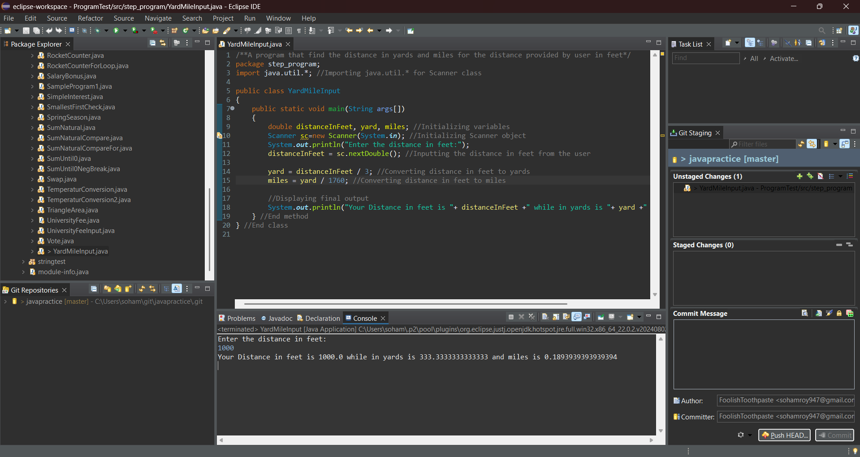

**5.** Write a program to input the unit price of an item and the quantity to be bought. Then, calculate the total price.

Hint => NA

I/P => unitPrice, quantity

O/P => The total purchase price is INR ___ if the quantity ___ and unit price is INR ___

**Program:**

/**A program to input the unit price of an item and the quantity to be bought, then, calculating the total price.*/

package step_program;

import java.util.*; //Importing java.util.* for Scanner class

public class QuantityPrice

{

public static void main(String args[])

{

double unitPrice, totalPrice; //Initializing variables

int quantity;

Scanner sc=new Scanner(System.*in*); //Initializing Scanner object

System.*out*.println("Enter the Unit Price of the item:");

unitPrice = sc.nextDouble(); //Inputting Unit Price of item from the user

System.*out*.println("Enter the Quantity of item to be bought:");

quantity = sc.nextInt(); //Inputting Quantity of Item from the user

totalPrice = quantity * unitPrice; //Calculating Total Price of Item

//Displaying Final Output

System.*out*.println("The total purchase price is INR "+ totalPrice +" if the quantity "+ quantity +" and unit price is INR "+ unitPrice);

} //End method

} //End class

**Output:**

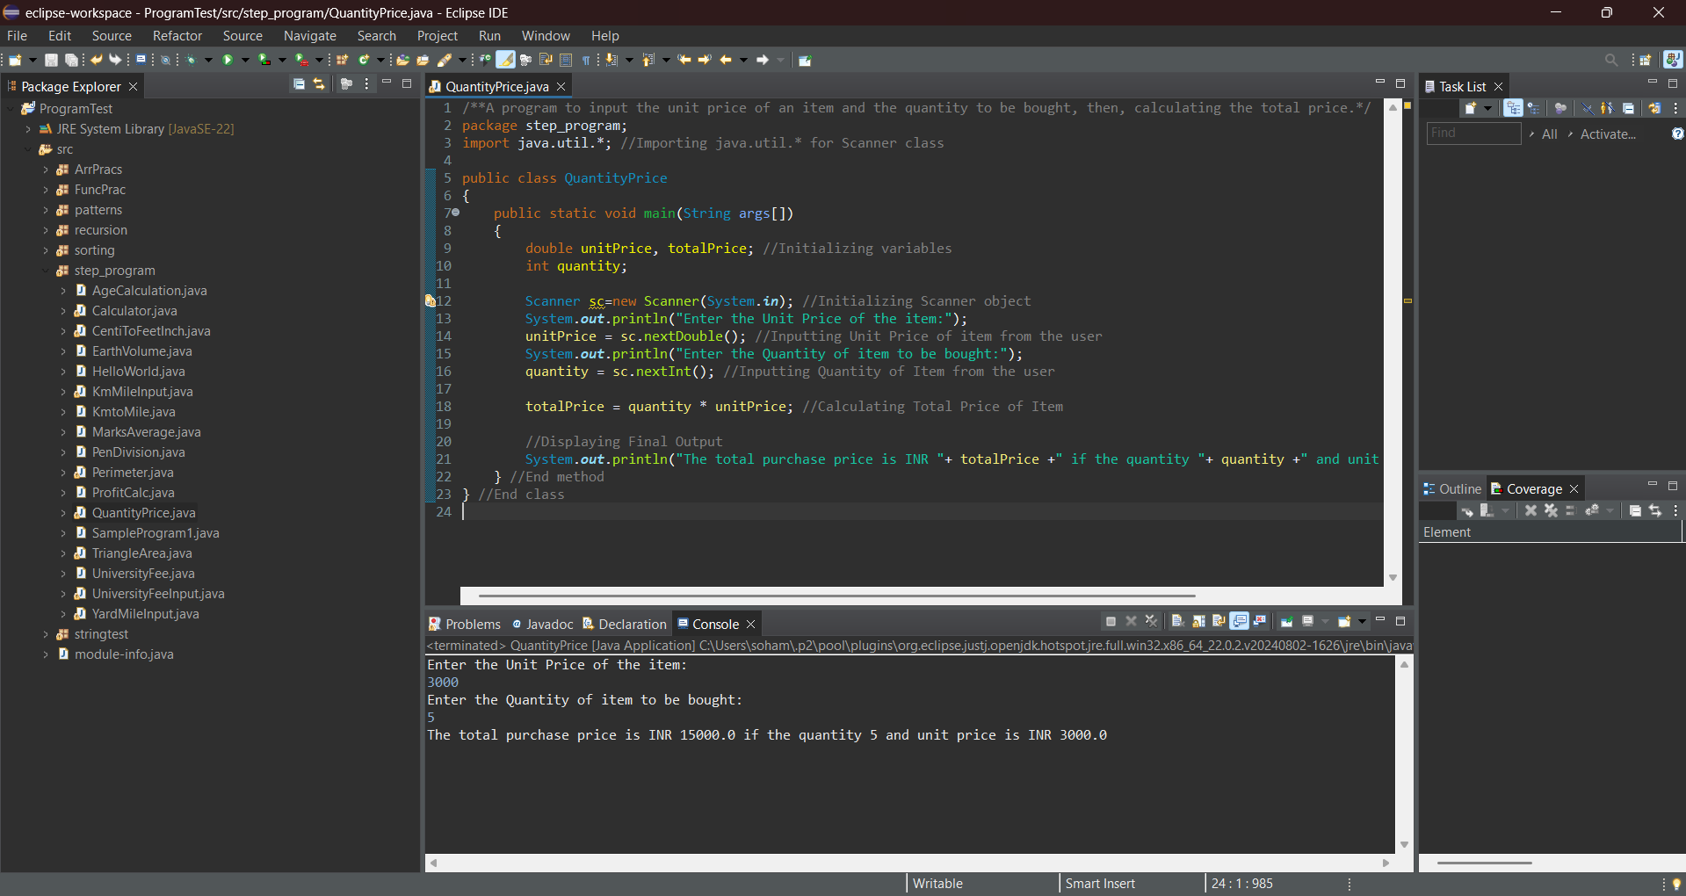

**6.** Write a program to take 2 numbers and print their quotient and reminder

Hint => Use division operator (/) for quotient and moduli operator (%) for reminder

I/P => number1, number2

O/P => The Quotient is ___ and Reminder is ___ of two number ___ and ___

**Program:**

/**A program to take 2 numbers and print their quotient and reminder*/

package step_program;

import java.util.*; //importing java.util.* for Scanner class

public class QuoRem

{

public static void main(String args[])

{

int number1, number2, quo, rem; //Initializing variables

Scanner sc=new Scanner(System.*in*); //Initializing Scanner object

System.*out*.println("Enter the two numbers: ");

number1 = sc.nextInt(); //Inputting the first number from the user

number2 = sc.nextInt(); //Inputting the second number from the user

quo = number1 / number2; //Calculating Quotient of the two numbers

rem = number1 % number2; //Calculating Remainder of the two numbers

//Displaying the Final Output

System.*out*.println("The Quotient is "+ quo +" and Reminder is "+ rem +" of two number "+ number1 +" and "+ number2);

} //End Method

} //End Class

**Output:**

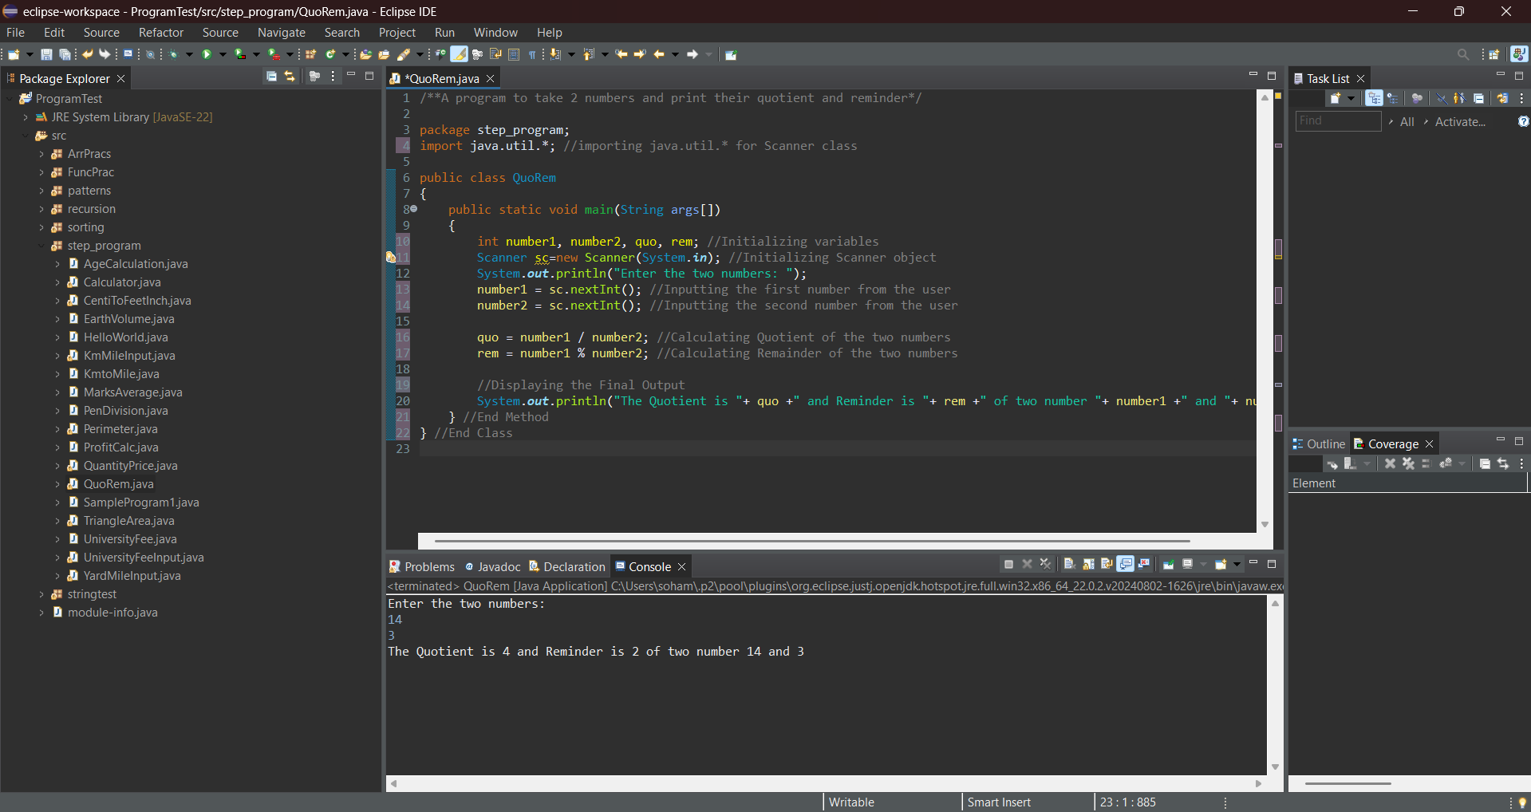

**7.** Write an ***IntOperation*** program by taking a, b, and c as input values and print the following integer operations a + b *c, a * b + c, c + a / b, and a % b + c. Please also understand the precedence of the operators.

Hint =>

1. Create variables a, b, c of int data type.
2. Take user input for a, b, and c.
3. Compute 3 integer operations and assign the result to a variable
4. Finally, print the result and try to understand operator precedence.

I/P => fee, discountPrecent

O/P => The results of Int Operations are —, —, and —

**Program:**

/**An IntOperation program by taking a, b, and c as input values and printing the following integer operations a + b *c, a * b + c, c + a / b, and a % b + c*/

package step_program;

import java.util.*; //Importing java.util.* for Scanner class

public class IntOperation

{

public static void main(String args[])

{

int a, b, c, op1, op2, op3, op4; //Initializing variables

Scanner sc=new Scanner(System.***in***); //Initializing Scanner object

System.***out***.println("Enter the three numbers: ");

a = sc.nextInt(); //Inputting the first number from the user

b = sc.nextInt(); //Inputting the second number from the user

c = sc.nextInt(); //Inputting the third number from the user

op1 = a + b * c; //First operation

op2 = a * b + c; //Second operation

op3 = c + a / b; //Third operation

op4 = a % b + c; //Fourth operation

//Displaying Final Output

System.***out***.println("The results of Int Operations are " + op1 +", "+ op2 +", "+ op3 +" and " + op4);

} //End Method

} //End Class

**Output:**

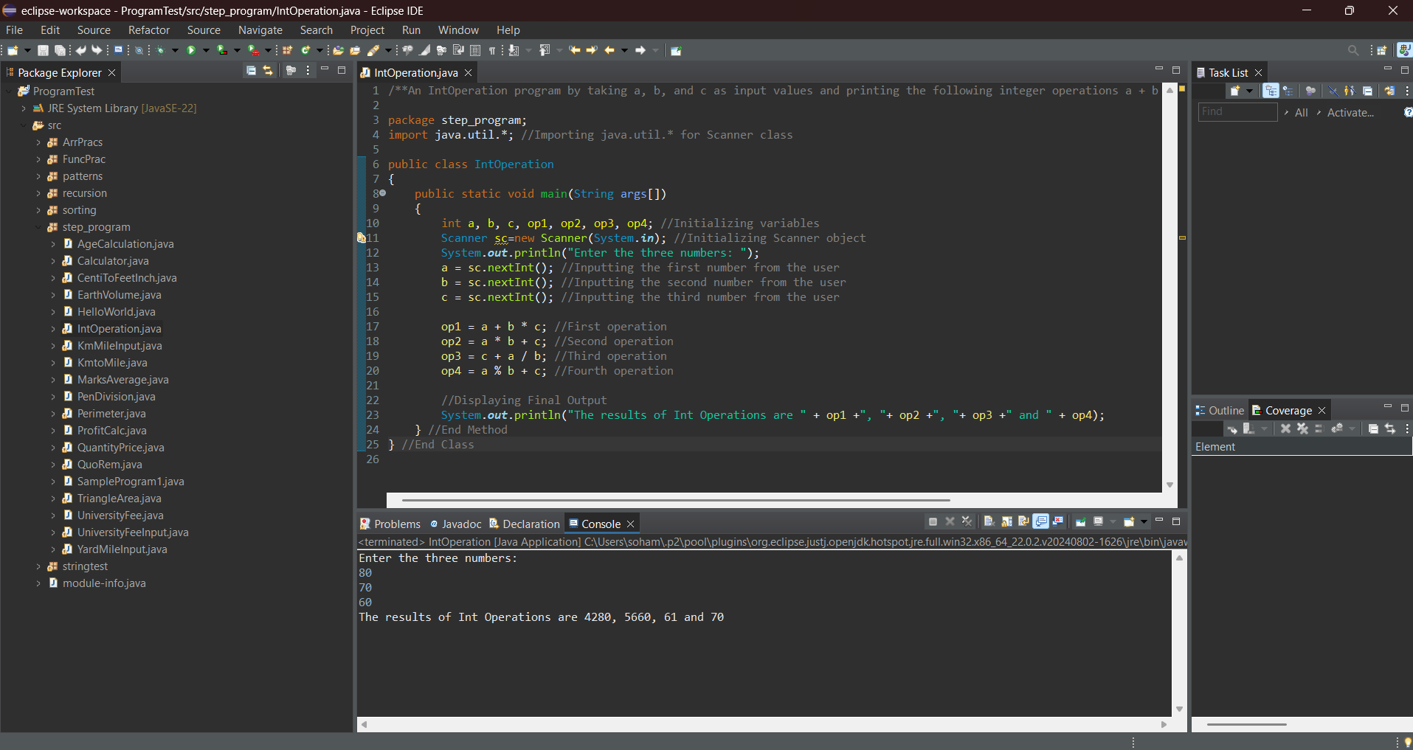

**8.** Similarly, write the *DoubleOpt* program by taking double values and doing the same operations.

**Program:**

/**A DoubleOpt program by taking a, b, and c as input values and printing the following double operations a + b *c, a * b + c, c + a / b, and a % b + c*/

package step_program;

import java.util.*; //Importing java.util.* for Scanner class

public class DoubleOpt

{

public static void main(String args[])

{

double a, b, c, op1, op2, op3, op4; //Initializing variables

Scanner sc=new Scanner(System.***in***); //Initializing Scanner object

System.***out***.println("Enter the three numbers: ");

a = sc.nextDouble(); //Inputting the first number from the user

b = sc.nextDouble(); //Inputting the second number from the user

c = sc.nextDouble(); //Inputting the third number from the user

op1 = a + b * c; //First operation

op2 = a * b + c; //Second operation

op3 = c + a / b; //Third operation

op4 = a % b + c; //Fourth operation

//Displaying Final Output

System.***out***.println("The results of Int Operations are " + op1 +", "+ op2 +", "+ op3 +" and " + op4);

} //End Method

} //End Class

**Output:**

