**Week 2 - Level 3 - 10 Practice Problems**

Soham Roy,

RA2411033010148,

Z2 Section,

CSE w/s SWE

**1.** Write a TemperaturConversion program, given the temperature in Celsius as input outputs the temperature in Fahrenheit

**Hint =>**

1. Create a ***celsius*** variable and take the temperature as user input
2. Use the Formulae Celsius to Fahrenheit:   (°C × 9/5) + 32 = °F and assign to ***farenheitResult***  and print the result

**I/P =>** celcius

**O/P =>**  The ____ celsius is _____ Fahrenheit

**Program:**

/**a TemperaturConversion program, given the temperature in Celsius as input outputs the temperature in Fahrenheit*/

package step_program;

import java.util.*; //Importing java.util.* for Scanner class

public class TemperaturConversion

{

public static void main(String args[])

{

double celcius, farenheitResult; //Initializing variables

Scanner sc=new Scanner(System.***in***); //Initializing Scanner object

System.***out***.println("Enter the temperature in Celcius:");

celcius = sc.nextDouble(); //Inputting the temperature value in Celcius

farenheitResult = (celcius * (9/5.0)) + 32; //Converting the Celcius value to Farenheit

//Displaying Final Output

System.***out***.println("The "+ celcius +" celsius is "+ farenheitResult +" Fahrenheit");

} //End method

} //End class

**Output:**

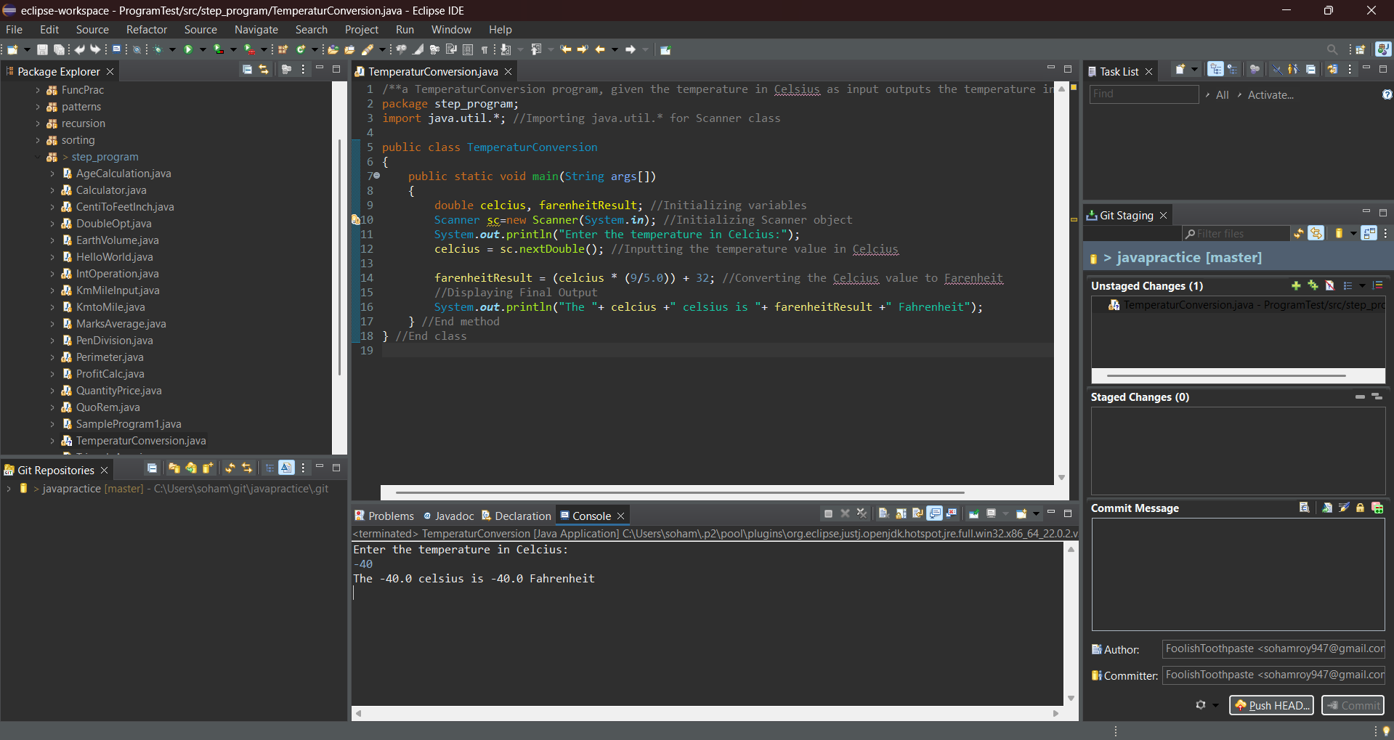

**2.** Write a TemperaturConversion program, given the temperature in Fahrenheit as input outputs the temperature in Celsius

Hint =>

1. Create a *fahrenheit* variable and take the user's input
2. User the formulae to convert Fahrenheit to Celsius:   (°F − 32) x 5/9 = °C and assign the result to *celsiusResult*  and print the result

I/P => fahrenheit

O/P => The ____ fahrenheit is _____ celsius

**Program:**

/**a TemperaturConversion program, given the temperature in Farenheit as input outputs the temperature in Celcius*/

package step_program;

import java.util.*; //Importing java.util.* for Scanner class

public class TemperaturConversion2

{

public static void main(String args[])

{

double farenheit, celciusResult; //Initializing variables

Scanner sc=new Scanner(System.*in*); //Initializing Scanner object

System.*out*.println("Enter the temperature in Farenheit:");

farenheit = sc.nextDouble(); //Inputting the temperature value in Farenheit

celciusResult = (farenheit - 32) * (5/9.0); //Converting the Farenheit value to Celcius

//Displaying Final Output

System.*out*.println("The "+ farenheit +" farenheit is "+ celciusResult +" celcius");

} //End method

} //End class

**Output:**

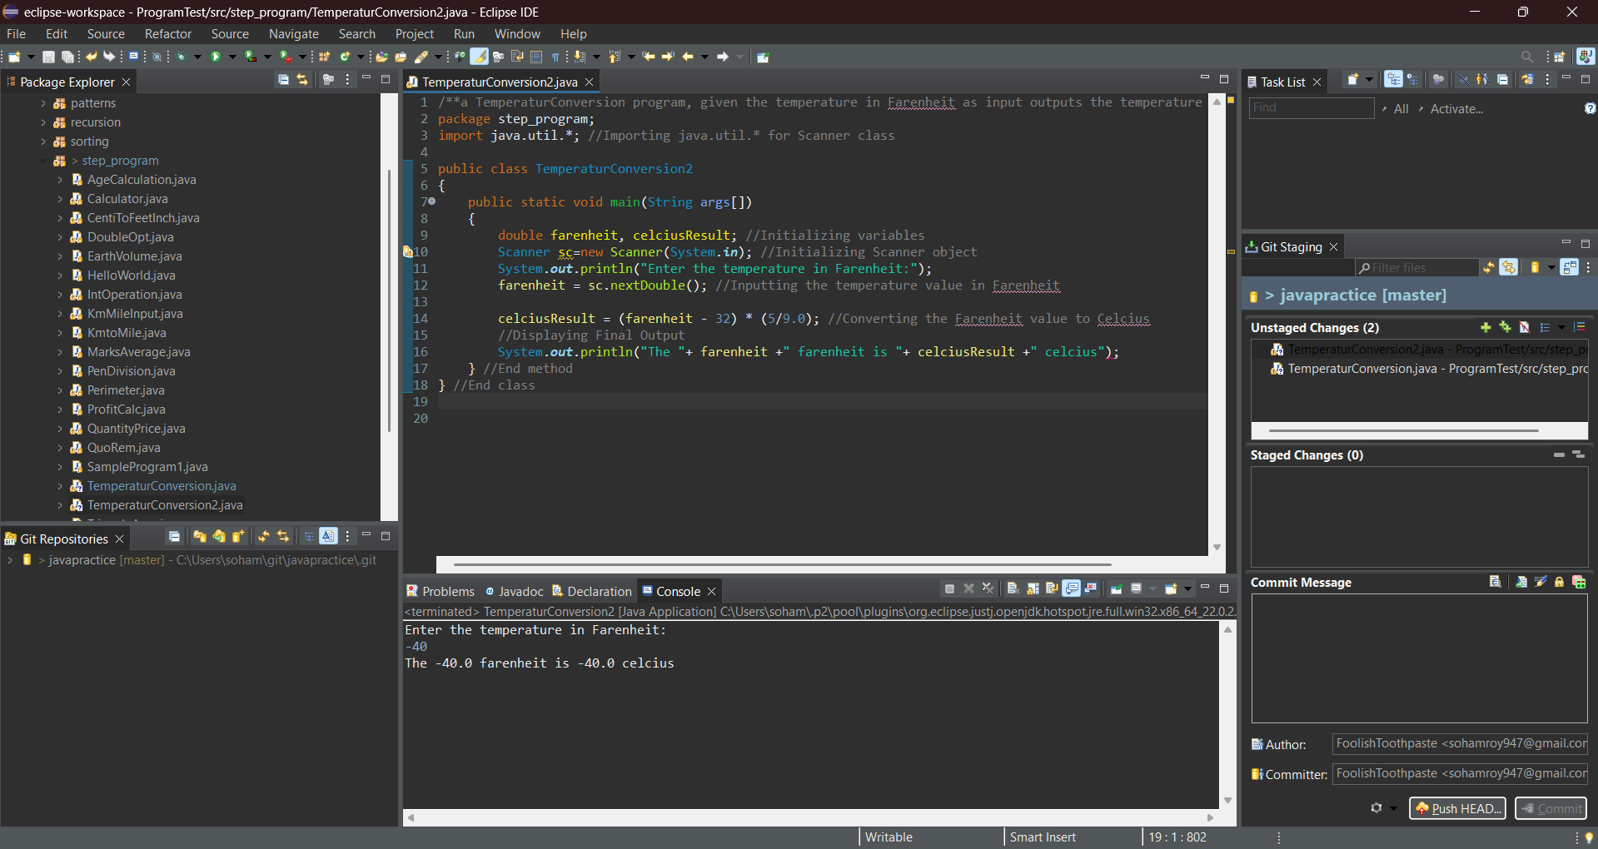

**3.** Create a program to find the total income of a person by taking salary and bonus from user

Hint =>

1. Create a variable named salary and take user input.
2. Create another variable bonus and take user input.
3. Compute income by adding salary and bonus and print the result

I/P => salary, bonus

O/P => The salary is INR ___ and bonus is INR ___. Hence Total Income is INR ___

**Program:**

/**A program to find the total income of a person by taking salary and bonus from user*/

package step_program;

import java.util.*; //Importing java.util.* for Scanner class

public class SalaryBonus

{

public static void main(String args[])

{

double income, bonus, salary; //Initializing variables

Scanner sc=new Scanner(System.*in*); //Initializing Scanner object

System.*out*.println("Enter the income and bonus of the employee:");

income = sc.nextDouble(); //Inputting the income of the employee from the user

bonus = sc.nextDouble(); //Inputting the bonus of the employee from the user

salary = income + bonus; //Calculating the salary of the employee

//Displaying Final Output

System.*out*.println("The salary is INR "+ income +" and bonus is INR "+ bonus +". Hence Total Income is INR "+ salary);

} //End method

} //End class

**Output**

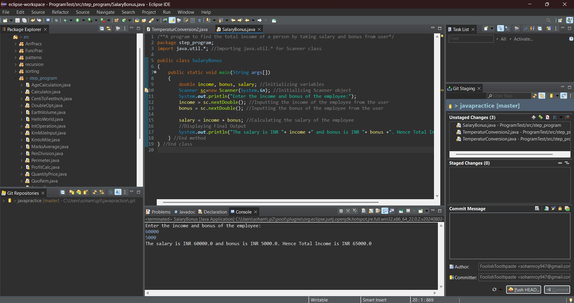

**4.** Create a program to swap two numbers

Hint =>

1. Create a variable number1 and take user input.
2. Create a variable number2 and take user input.
3. Swap number1 and number2  and print the swapped output

I/P => number1, number2

O/P => The swapped numbers are  ___ and ___

**Program:**

/**A program to swap two numbers*/

package step_program;

import java.util.*; //Importing java.util.* for Scanner class

public class Swap

{

public static void main(String args[])

{

int number1, number2, temp; //Initializing the variables

Scanner sc=new Scanner(System.*in*); //Initializing Scanner object

System.*out*.println("Enter the two numbers to be swapped:");

number1 = sc.nextInt(); //Inputting the first number from the user

number2 = sc.nextInt(); //Inputting the second number from the user

temp = number1; //Swapping Algorithm Step 1: Store first number in temporary variable

number1 = number2; //Step 2: Store second number in first number variable

number2 = temp; //Step 3: Store temporary variable (first number value) in second number variable

//Displaying Final Output

System.*out*.println("The swapped numbers are "+ number1 +" and "+ number2);

} //End Method

} //End Class

**Output:**

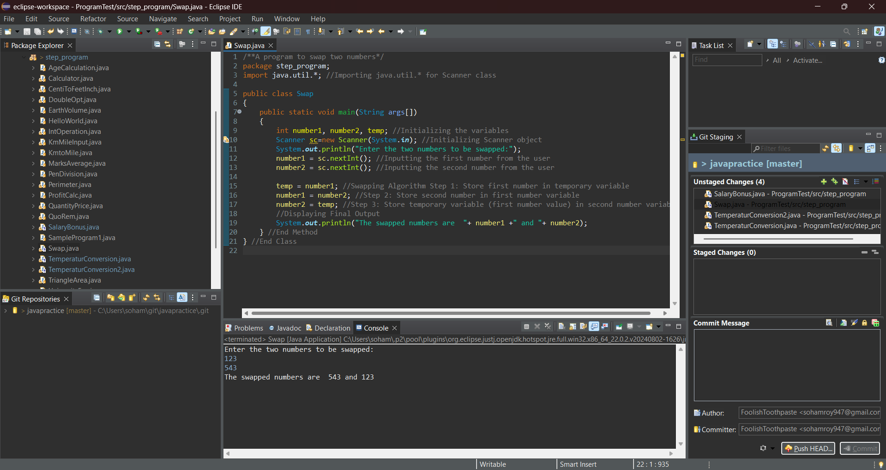

**5.** Rewrite the Sample Program 2 with user inputs

Hint =>

1. Create variables and take user inputs for name, fromCity, viaCity, toCity
2. Create variables and take user inputs for distances fromToVia and viaToFinalCity in Miles
3. Create Variables and take time taken
4. Finally, print the result and try to understand operator precedence.

I/P => fee, discountPrecent

O/P => The results of Int Operations are ___, ___, and ___

**Program:**

/**A program to calculate time and distance covered to travel from a city via another city to final city*/

package step_program;

import java.util.*; //Importing java.util.* for Scanner class

public class CityTravel

{

public static void main(String args[])

{

String name, fromCity, viaCity, toCity; //Initializing the String variables

double fromToVia, viaToFinalCity, totalDistance; //Initializing the distance variables

int timeFromToVia, timeViaToFinalCity, totalTime; //Initializing the time variables

Scanner sc=new Scanner(System.*in*); //Initializing Scanner object

System.*out*.println("Enter: Name of the Passenger, From City, Via City, Final City");

name = sc.nextLine(); //Inputting the name of the Passenger from the user

fromCity = sc.nextLine(); //Inputting the name of the From City from the user

viaCity = sc.nextLine(); //Inputting the name of the Via City from the user

toCity = sc.nextLine(); //Inputting the name of the To (Final) City from the user

System.*out*.println(); //Skipping a line to avoid streamline errors and clean output

System.*out*.println("Enter distance covered to travel from:\na) "+fromCity+" to "+viaCity+"\nb) "+viaCity+" to "+toCity);

fromToVia = sc.nextDouble(); //Inputting the distance covered to travel from From City to Via City from the user

viaToFinalCity = sc.nextDouble(); //Inputting the distance covered to travel from Via City to To (Final) City from the user

System.*out*.println(); //Skipping a line for clean output

System.*out*.println("Enter time taken (in minutes) to travel from:\na) "+fromCity+" to "+viaCity+"\nb) "+viaCity+" to "+toCity);

timeFromToVia = sc.nextInt(); //Inputting the time taken to travel from From City to Via City from the user

timeViaToFinalCity = sc.nextInt(); //Inputting the time taken to travel from Via City to To (Final) City from the user

System.*out*.println(); //Skipping a line for clean output

totalDistance = fromToVia + viaToFinalCity; //Calculating total distance travelled by Passenger

totalTime = timeFromToVia + timeViaToFinalCity; //Calculating total time taken by Passenger

//Displaying Final Output

System.*out*.println("The Total Distance travelled by " + name + " from " + fromCity + " to " + toCity + " via " + viaCity +" is " + totalDistance + " km and " +"the Total Time taken is " + totalTime + " minutes");

} //End method

} //End class

**Output:**

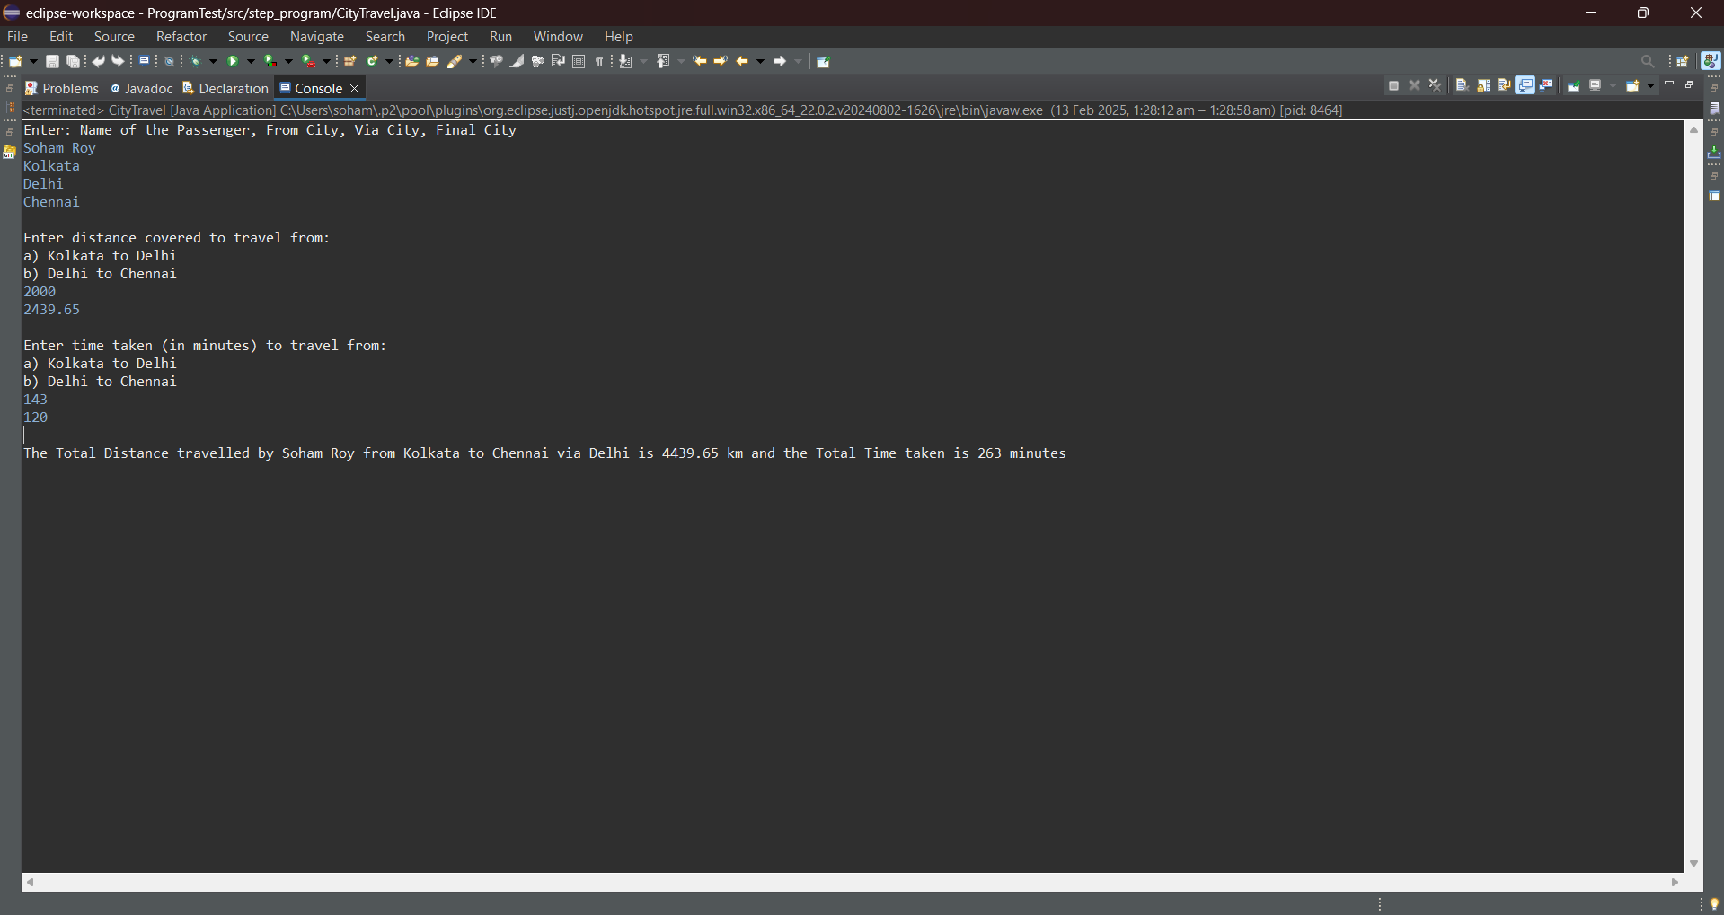

**6.** An athlete runs in a triangular park with sides provided as input by the user in meters. If the athlete wants to complete a 5 km run, then how many rounds must the athlete complete

Hint => The perimeter of a triangle is the addition of all sides and rounds is distance/perimeter

I/P => side1, side2, side3

O/P => The total number of rounds the athlete will run is ___ to complete 5 km

**Program:**

/**A program to calculate the number of rounds an athlete needs to run to complete 5 kilometers in a triangular park the dimensions of which are input by the user*/

package step_program;

import java.util.*; //Importing java.util.* for Scanner class

public class AthleteTravel

{

public static void main(String args[])

{

int distance = 5; //Storing value of distance to be covered by the athlete

double side1, side2, side3, perimeter; //Initializing dimension variables

int round; //Initializing variable to store the number of round(s)

Scanner sc=new Scanner(System.*in*); //Initializing Scanner object

System.*out*.println("Enter the three sides of the triangular park:");

side1 = sc.nextDouble(); //Inputting the first side of the triangular park from the user

side2 = sc.nextDouble(); //Inputting the second side of the triangular park from the user

side3 = sc.nextDouble(); //Inputting the third side of the triangular park from the user

perimeter = side1 + side2 + side3; //Calculating the perimeter of the triangular park

round = distance / (int) perimeter; //Calculating the number of rounds the athlete has to cover

//Displaying Final Output

System.*out*.println("The total number of rounds the athlete will run is "+ round +" to complete 5 km");

} //End method

} //End class

**Output:**

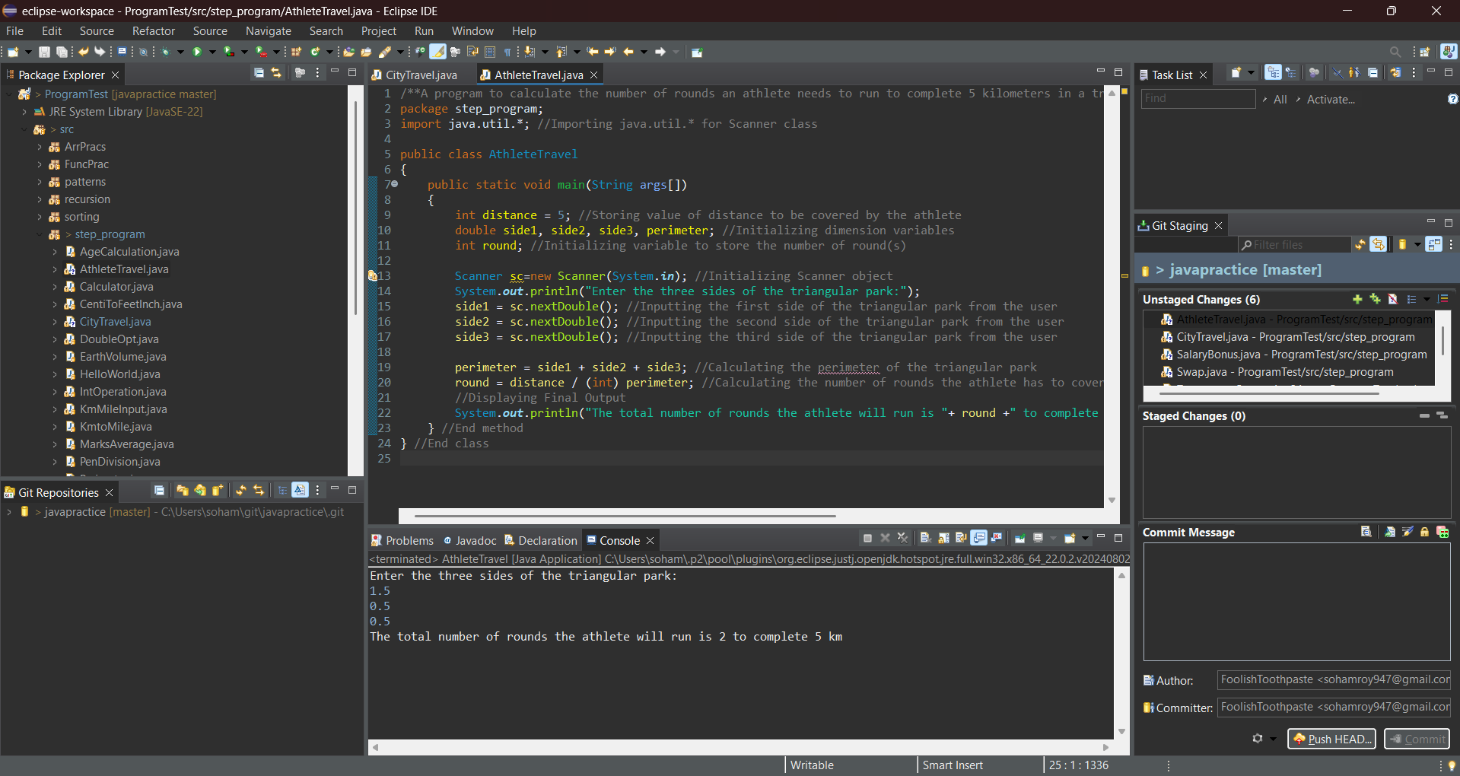

**7**. Create a program to divide N number of chocolates among M children.

Hint =>

1. Get an integer value from user for the numberOfchocolates and numberOfChildren.
2. Find the number of chocolates each child gets and number of remaining chocolates
3. Display the results

I/P => numberOfchocolates, numberOfChildren

O/P => The number of chocolates each child gets is ___ and the number of remaining chocolates are ___

**Program:**

/**A program to divide N number of chocolates among M children.*/

package step_program;

import java.util.*; //Importing java.util.* for Scanner class

public class ChocolateDivision

{

public static void main(String args[])

{

int numberOfchocolates, numberOfChildren, eachChocolate, remChocolate; //Initializing variables

Scanner sc=new Scanner(System.*in*); //Initializing Scanner object

System.*out*.println("Enter the number of chocolates and number of children:");

numberOfchocolates = sc.nextInt(); //Inputting the number of chocolates from the user

numberOfChildren = sc.nextInt(); //Inputting the number of children from the user

eachChocolate = numberOfchocolates / numberOfChildren; //Calculating the number of chocolates each child will get

remChocolate = numberOfchocolates % numberOfChildren; //Calculating the remaining number of chocolates

//Displaying Final Output

System.*out*.println("The number of chocolates each child gets is "+ eachChocolate +" and the number of remaining chocolates are "+ remChocolate);

} //End method

} //End class

**Output:**

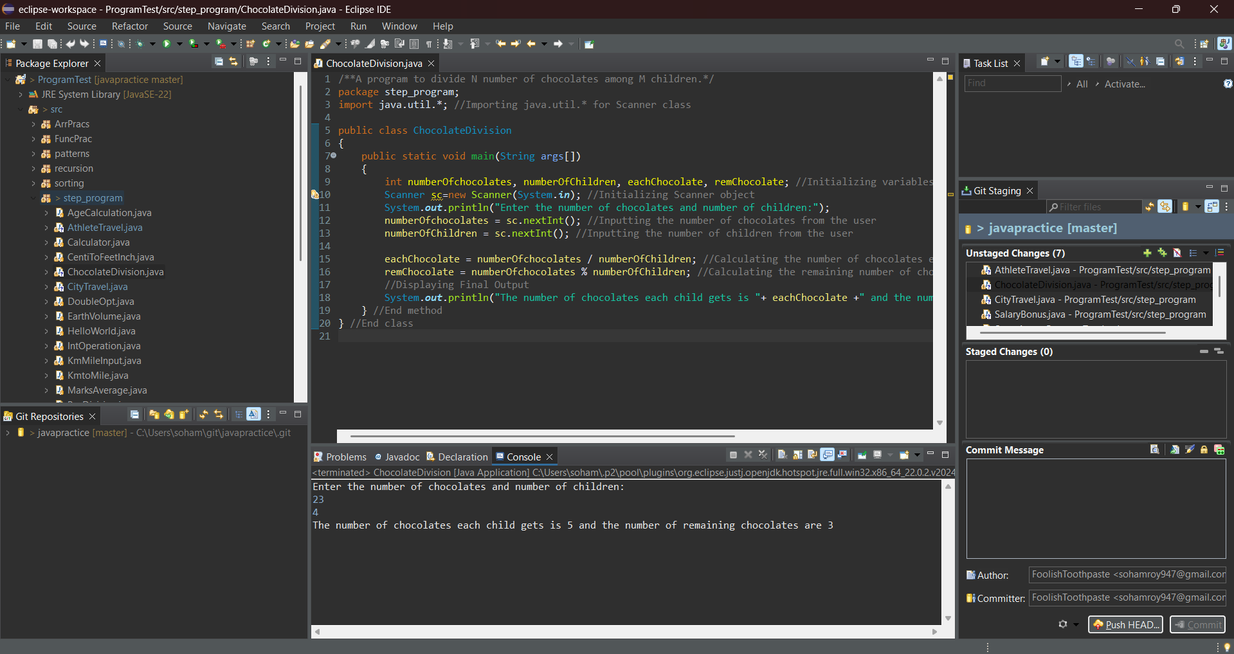

**8.** Write a program to input the Principal, Rate, and Time values and calculate Simple Interest.

Hint => Simple Interest = Principal * Rate * Time / 100

I/P => principal, rate, time

O/P => The Simple Interest is ___ for Principal ___, Rate of Interest ___ and Time ___

**Program:**

/**A program to input the Principal, Rate, and Time values and calculate Simple Interest*/

package step_program;

import java.util.*; //Importing java.util.* for Scanner class

public class SimpleInterest

{

public static void main(String args[])

{

double principal, rate, time, si; //Initializing variables

Scanner sc=new Scanner(System.*in*); //Initializing Scanner object

System.*out*.println("Input the principal, rate and time:");

principal = sc.nextDouble(); //Inputting the principal from the user

rate = sc.nextDouble(); //Inputting the rate of interest from the user

time = sc.nextDouble(); //Inputting the time from the user

si = (principal * rate * time) / 100.0; //Calculating the simple interest

//Displaying Final Output

System.*out*.println("The Simple Interest is "+ si +" for Principal "+ principal +", Rate of Interest "+ rate +" and Time " + time);

}

}

**Output:**

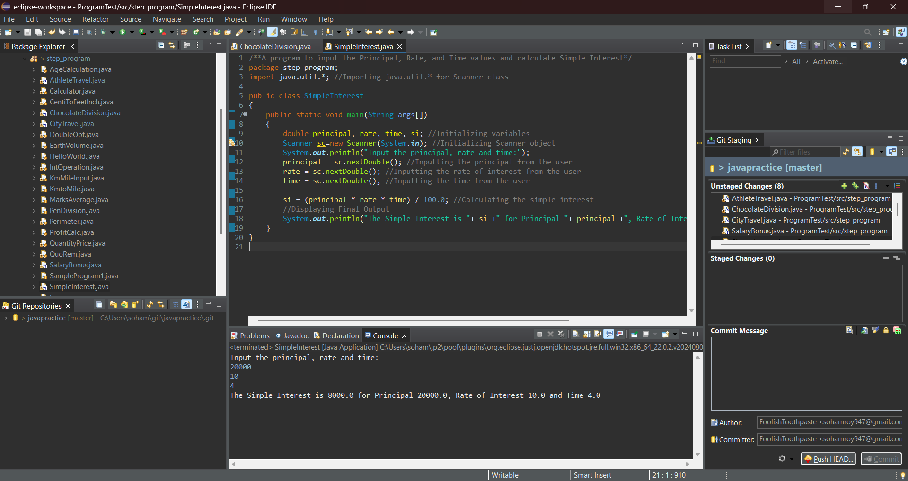

**9.** Create a program to find the maximum number of handshakes among N number of students.

Hint =>

1. Get integer input for numberOfStudents variable.
2. Use the combination = (n * (n - 1)) / 2 formula to calculate the maximum number of possible handshakes.
3. Display the number of possible handshakes.

**Program:**

/**A program to find the maximum number of handshakes among N number of students*/

package step_program;

import java.util.*; //Importing java.util.* for Scanner class

public class Handshakes

{

public static void main(String args[])

{

int numberOfStudents, maxHandshakes; //Initializing variables

Scanner sc=new Scanner(System.*in*); //Initializing Scanner object

System.*out*.println("Enter the number of students:");

numberOfStudents = sc.nextInt(); //Inputting the number of students from the user

maxHandshakes = (numberOfStudents * (numberOfStudents - 1)) / 2; //Calculating the maximum number of handshakes possible

System.*out*.println("Maximum Number of Handshakes = "+ maxHandshakes); //Displaying Final Output

} //End method

} //End class

**Output:**

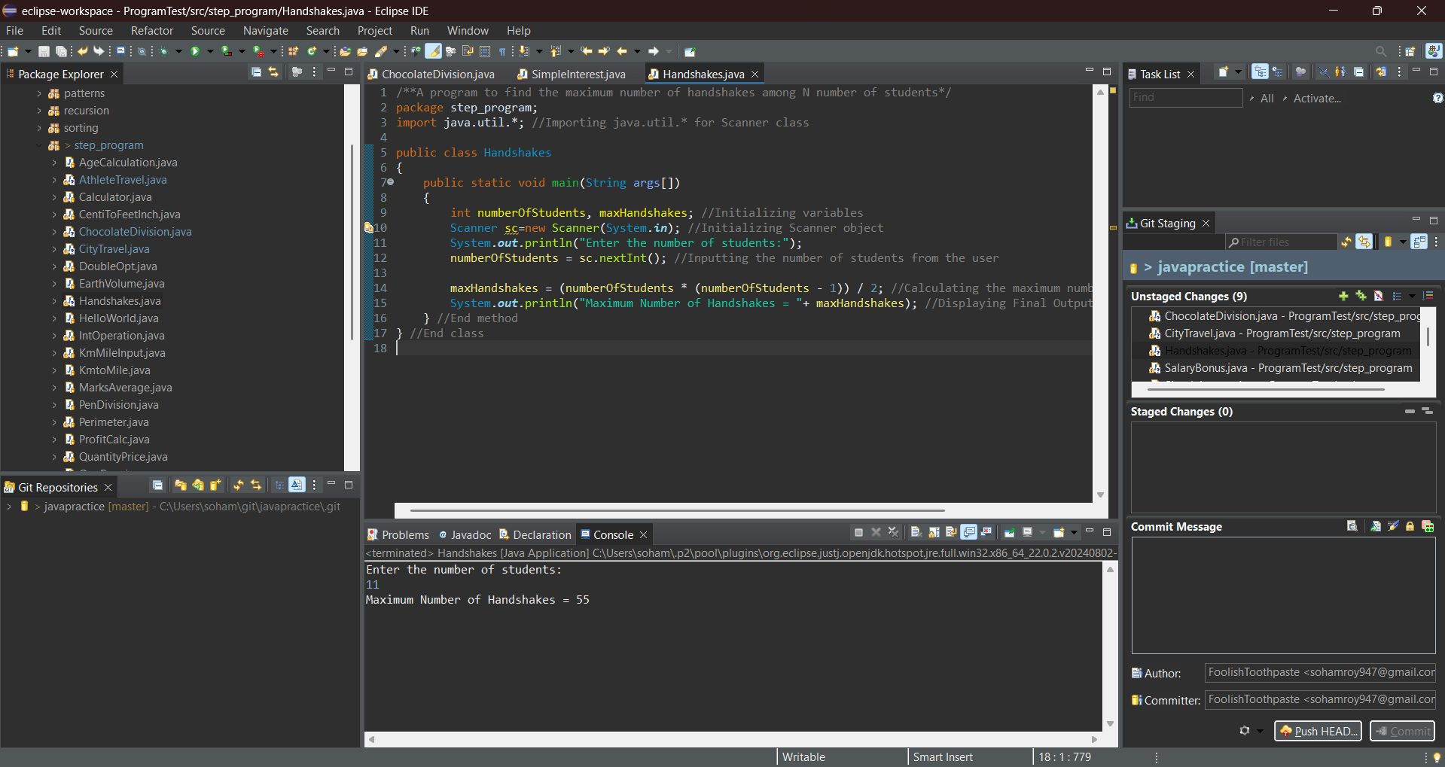

**10.** Create a program to convert weight in pounds to kilograms.

Hint => 1 pound = 2.2 kg

I/P => weight

O/P => The weight of the person in pound is ___ and in kg is ___

**Program:**

/**A program to convert weight in pounds to kilograms*/

package step_program;

import java.util.*; //Importing java.util.*

public class PoundToKg

{

public static void main(String args[])

{

double weight, weightkg; //Initializing variables

Scanner sc=new Scanner(System.*in*); //Initializing Scanner object

System.*out*.println("Enter the weight in pounds:");

weight = sc.nextDouble(); //Inputting the weight in pounds from the user

weightkg = weight * 2.2; //Converting the weight from pounds to kilograms

System.*out*.println("Weight in kilograms = "+ weightkg); //Displaying Final Output

} //End method

} //End class

**Output:**

