Lab Project: WARP Shoe Company

Most Profitable Production Plan

Foong Ann Loo (1004988659)

Preeti Kumari (1005057395)

## 

## Table of Contents

**Abstract** **3**

**Introduction** **3**

**Methodology** **3**

**Results** **4**

**Conclusion** **6**

**Appendices** **7**

## 

## Abstract

Taking in all the conditions provided by WARP management, we were able to identify the most profitable production plan. Our chosen decision variable is xi which is the amount of product i sold. There are five different types of constraints included in the model: maximum average processing duration of each machine, warehouse capacity, availability of raw materials, budget for raw materials, and demand for each product. As a result, our profit function was maximized yielding a result of $2,659,620.20.

## Introduction

WARP Shoe Company is one of the oldest shoe companies in Canada. Over the past three years, WARP management has been consulting with University of Toronto Industrial Engineering students in order to receive help by proposing a production plan. At the beginning of 2006, WARP Shoe Company’s major competitor went bankrupt. In effect, market analysts predicted that the demand will double for February for each type of shoe. Therefore, it is our goal to find a new production plan for the WARP shoe company in order to maximize their profit while still adhering to the constraints that they provided.

## Methodology

We maximized profit by taking first considering the profit made from selling one unit of product. To do so, we subtracted the cost of raw materials and operating costs on each machine per minute from the sale price of each product i, summed it across all products, and then multiplied it all by xi, which is the amount of product i produced. To account for the $10 lost for every product that does not meet the demand, we subtracted the discrepancy between the demand and amount produced for each product summed over all products multiplied by $10 from the total sales. Finally, the workers wages were included in the profit function by subtracting the hourly wage of $25 with the amount of time spent working on each machine for each product summed over all machines and products. As a result, the profit that is projected for the WARP Shoe Company in February 2006 is $2,659,620.20. To see all amounts of product i that need to be produced (total of 557 products), please refer to the attached Project.run file for further details. For the purpose of this report, the following key assumptions were made:

(1) The sales price on the shoes remains the same as in the Product_Master table.

(2) Transportation and machine setup costs, as well as setup times have been ignored.

(3) The manufacturing sequence has been ignored.

(4) The demand for each product in January 2006 is equal to the average demand for that

product from 1997 to 2003.

(5) The demand for February 2006 is twice that for January 2006.

(6) During February 2006, all machines will operate up to 12 hours a day, 28 days a

month which translates to 20160 minutes a month.

(7) The total warehouse capacity has been obtained from the Warehouse_Master table.

(8) The budget for raw materials is $10,000,000.

(9) Not meeting the demand for any type of shoe means loss of new potential customers,

and hence has been evaluated at a cost of $10/pair.

(10) Workers are paid on an hourly basis at the rate of $25/hour. Each machine has to be

operated by one worker.

## Results

In order to create the production plan, we first began with creating the data file named Project.dat. Each table (BOM, RM_Master, Machine_Assign, Machine_Master, Demand_Feb06, Warehouse_Master, and Product_Master) was read from the access file and our primary keys and parameters were clearly defined. Then we created our model file named Project.mod by defining the key parameters used and variables to solve for. It is important to declare the variables to be solved as “integer” as we are trying to solve the integer programme.

We defined both our objective function and constraints for all i in products, k in machines, and m in warehouses. The first constraint “maxDuration” states that all machines will work no more than 20160 minutes. The second constraint “maxCapacity” states that the amount of product i sent to each warehouse must be less than or equal to the total capacity of the warehouse. The third constraint “availRM” states that the total quantity of raw materials used to make the products must be less than or equal to the total amount of raw materials available at hand. The fourth constraint “budgetRM” states that the budget for raw materials must be less than or equal to $10,000,000. The fifth constraint “maxDemand” states that the amount of each product produced must be less than or equal to the demand of each product i.

To calculate the demand for February 2006, we first considered the average demand for a particular product across all years from 1997 to 2003 as an estimate of the demand for January 2006. Since we know that the demand for each product in February 2006 is twice that of January 2006, we utilised SQL queries (Appendix [1], [2], [3]) to calculate the demand.

The model consists of a total of 557 variables which are listed as xi where each variable corresponds to the ith product. There are 5 types of constraints: maximum average processing duration for each of the 72 machines, warehouse capacity, availability of each of the 165 types of raw materials, budget for raw materials and the demand for each of the 557 products. Thus, there are a total of 796 constraints.

*72 + 1 + 165 + 1 + 557 = 796*

The results of the model suggest that there are no binding constraints for the integer programme, where a binding constraint is one where some optimal solution is on the line for the constraint. As such, even the slightest change can alter the optimality or feasibility of a solution. Please refer to the attached Project.run file for the complete solution.

Once the integer programme (IP) had been relaxed into a linear programme (LP), one constraint had been violated after the LP had been rounded. The only constraint that had been violated is the maxDemand implying that there are certain products which exceed the limit of the demand. The LP that is later rounded to its nearest integer solution is shown in Appendix [4]. The profit obtained before rounding the LP solution is $2,706,917.94 whereas the profit obtained after rounding is $2,706,800, which is less than prior to being rounded. Please refer to the attached Project_Q3.run file for the complete solution.

Assuming that additional warehouse space can be bought for $10 per box of shoe, the newly declared decision variable, yi  refers to the amount of additional shoes produced for each product i. This new variable is expected to affect the revenue associated with the sale of each product i, the cost of loss in demand, the maxCapacity, and the maxDemand constraint. Also, it will incur a cost of $10 per extra box of shoes produced, which is included in the objective profit function. Upon solving the new IP, it is discovered that the maximum profit remains the same as the solution to the original IP, which is $2,659,620.20. Therefore, it is not economical to buy any additional warehouse space. Please refer to the attached Project_Q5.run file for the complete solution.

If the machines were only available for 8 hours a day, 28 days a month which translates to 13440 minutes per month, the maximum profit of $2,659,620.20 remains unchanged. Since the solution remains unchanged from when the machines are available for 24 hours a day, 20160 minutes per month, no binding constraint exists still. Since the slack for the maxDuration constraint for each machine is greater than

*20160 mins - 13440 mins = 6720 mins,*

this implies that changing the right hand side of the maxDuration constraint to 13440 minutes will not affect the optimal solution. Please refer to the attached Project_Q6.run file for the complete solution.

Next, the budget for raw materials was changed to $7,000,000 instead of $10,000,000, the solution would still remain the same because the original slack for the raw materials budget was $9,968,160, which is greater than

*$10,000,000-$7,000,000 = $3,000,000.*

The slack for budget constraint for $7,000,000 falls within the range of:

*$9,968,160 ± $3,000,000.*

Thus, changing the right hand side of the budget constraint to $7,000,000 had no impact on the optimal objective function value. Please refer to the attached Project_Q7.run file for the complete solution.

## Conclusion

In conclusion, the maximum profit the WARP Shoe Company will make in February 2006 is projected to be $2,659,620.20, with $9,968,160 remaining in the budget for raw materials compared to the original budget of $10,000,000. In our production plan, we defined variables, constants, objective function, and constraints. By using Gurobi Solver in AMPL, we were able to solve for our decision variables and create a new production plan for WARP Shoe Company to follow in order to generate maximum profit.

## Appendices

[1] SQL Query used to calculate the demand for Jan 2006 which is also average demand for all years starting from 1997 to 2003, and the corresponding table produced.

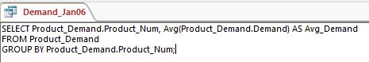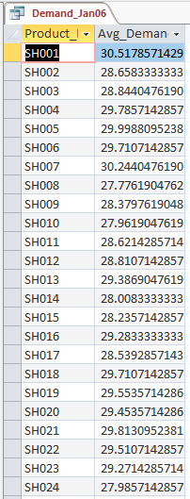

[2] SQL Query used to calculate the demand for Feb 2006 which is twice that of Jan 2006, and the corresponding table produced.

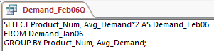

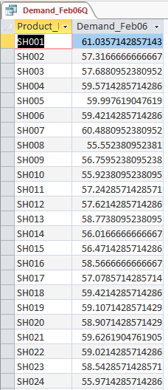

[3] SQL Query to create a new table named Demand_Feb06, which stores the results from the query in [2].

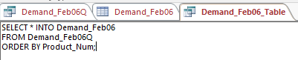

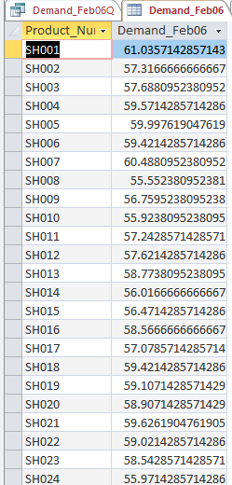

[4] Rounding the solutions after relaxing the LP.

