Employee Sentiment Analysis
- Introduction & Project Overview
This project analyzes an employee email dataset, applying natural language processing (NLP), exploratory data analysis (EDA), rule-based scoring, and model prediction techniques to predict employees who are likely to leave the company.
The project includes six main tasks: (1) Perform sentiment analysis on employee emails (2) Explore sentiment distribution and trends (3) Calculate monthly sentiment scores for each employee (4) Rank employees based on their sentiment performance (5) Identify employees at potential risk of leaving (6) Use models to analyze factors that influence sentiment scores.
All analyses are performed using Python, with key libraries including Pandas, NLTK, Transformers, Scikit-learn and so on.
- Sentiment Labeling Methodology
To classify employee messages into sentiment categories (Positive, Neutral, Negative), the VADER sentiment analysis model from the NLTK library was used. VADER is a lexicon- and rule-based NLP technique designed for short text such as emails and messages, which is suitable for this dataset.
Each message was constructed by combining the email subject and body to ensure sufficient contextual information for sentiment detection. VADER produces a normalized compound sentiment score ranging from −1 to +1. Based on commonly accepted thresholds, sentiment labels were assigned as follows:
Positive: compound score ≥ 0.05
Negative: compound score ≤ −0.05
Neutral: otherwise
To further improve classification quality, a RoBERTa-based sentiment model was applied as a refinement step for messages which are initially classified as negative by VADER. This approach was used because work-related emails containing words such as problems, issues, or requests may be mislabeled as negative even though the general tone is neutral. The RoBERTa output was converted into the same three sentiment categories, and the refined labels were used to update the original VADER classification for those messages. Here is the plot shows the refinement result of 163 negative messages after RoBERTa.
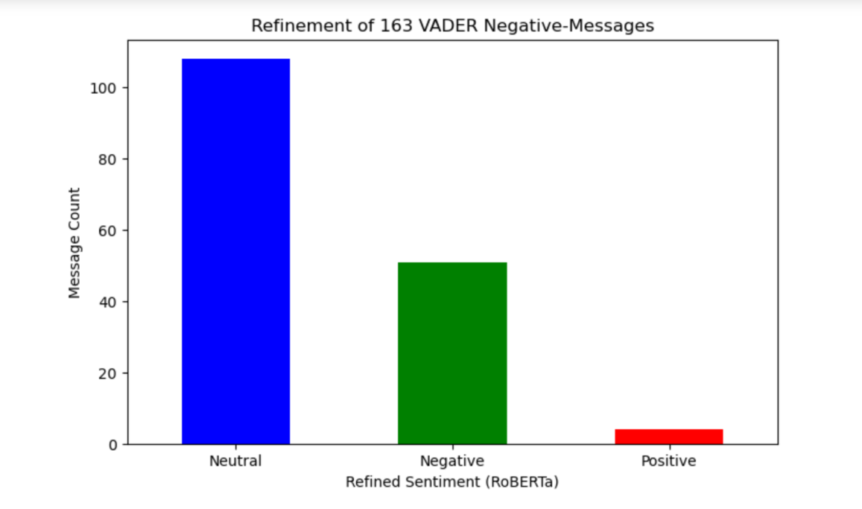
Picture 1. Refinement of 163 VADER Negative-Messages
After this two-step sentiment labeling process, further analysis can be carried out based on the dataset.
- Exploratory Data Analysis
3.1 Dataset Overview
The dataset consists of employee email messages with subject lines, message bodies, sender identifiers, and timestamps. The dataset contains a total of 2191 email records from 10 employees. Initial inspection of the dataset showed no missing values in key fields after preprocessing. All date fields were successfully parsed into datetime format, ensuring data quality for subsequent analysis.
3.2 Sentiment Distribution
Analysis of sentiment labels revealed that positive sentiment dominates employee communication (1578), followed by neutral messages (562), with negative sentiment (51) representing a relatively small proportion of the dataset.
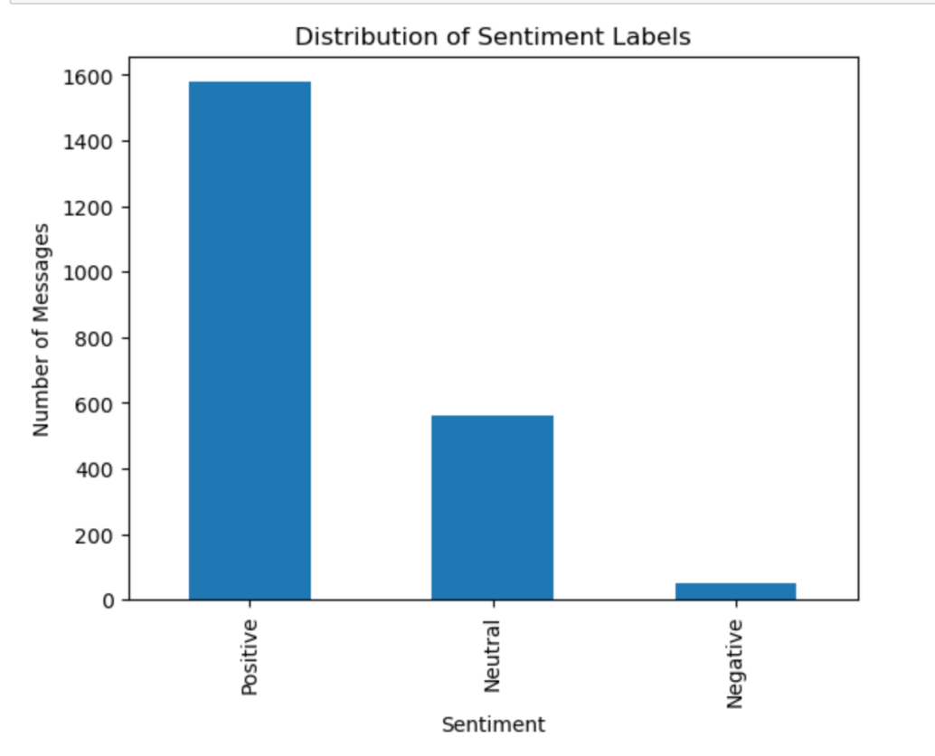
Picture 2. Distribution of Sentiment Labels
3.3 Temporal Sentiment Trends
The monthly sentiment trend shows that positive sentiment consistently dominates employee communication across all months, typically accounting for about two-thirds to three-quarters of total emails. Neutral sentiment is the second largest category and shows moderate month-to-month fluctuations, while negative sentiment remains at a very low level throughout the entire period, generally close to zero.
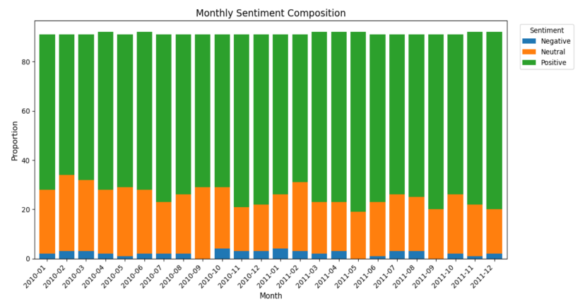
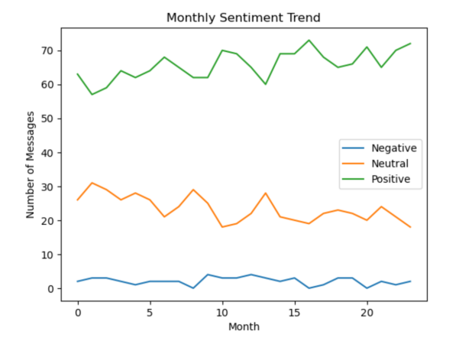
Picture 3. Monthly Sentiment Trend Picture 4. Monthly Sentiment Composition
3.4 Additional Patterns and Insights
(1) Message length and word count are highly correlated at 0.98, meaning they reflect very similar information. Their correlations with sentiment score are much weaker at 0.28 and 0.29, which suggests that longer emails are only slightly associated with more positive sentiment. Overall, text length has limited power in explaining sentiment.
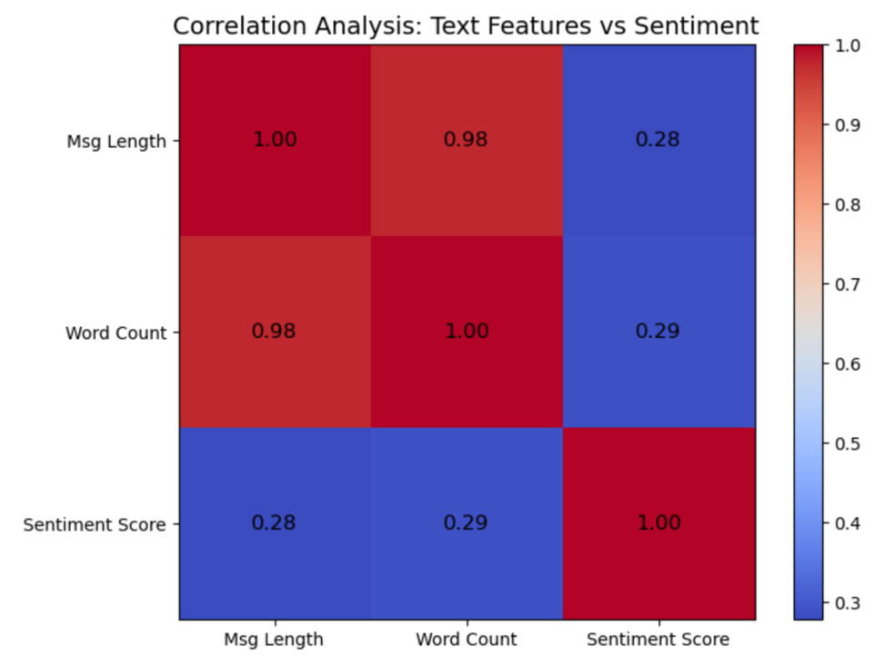
Picture 5. Correlation Analysis

- Employee communication volume varies from person to person. Some employees send far more messages than others (maximum gap is 112), likely due to differences in their job roles, responsibilities, or level of engagement. This variation highlights the importance of conducting emotional analysis at the individual employee level, rather than relying solely on overall trends.
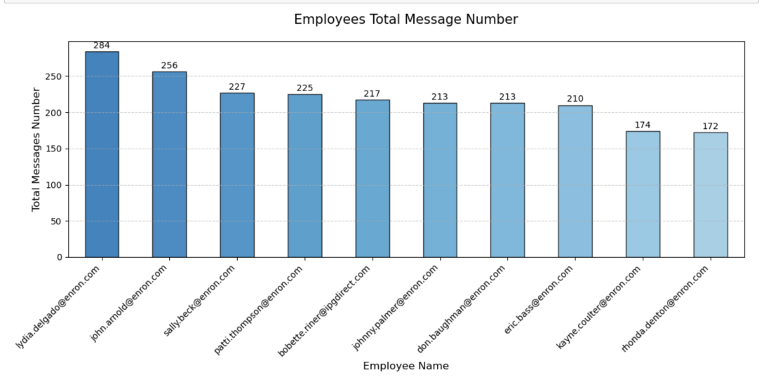
Picture 6. Employees communication volume
- Employee Sentiment Score Calculation
To quantify employee sentiment over time, each message was assigned a numerical score based on its sentiment label: Positive: 1; Neural 0; Negative: -1. Sentiment scores were aggregated on a monthly basis (sum) for each employee by grouping messages by employee identifier and month. Scores will be reset to zero at the beginning of each month to ensure independent monthly evaluations.
I also calculated the average sentiment score of employees each month to observe the company sentiment trend. The result shows that the company’s average sentiment remained consistently positive over time. Although there are some moderate month to month changes, the overall pattern is relatively stable, with no sharp drops or long-term negative periods.
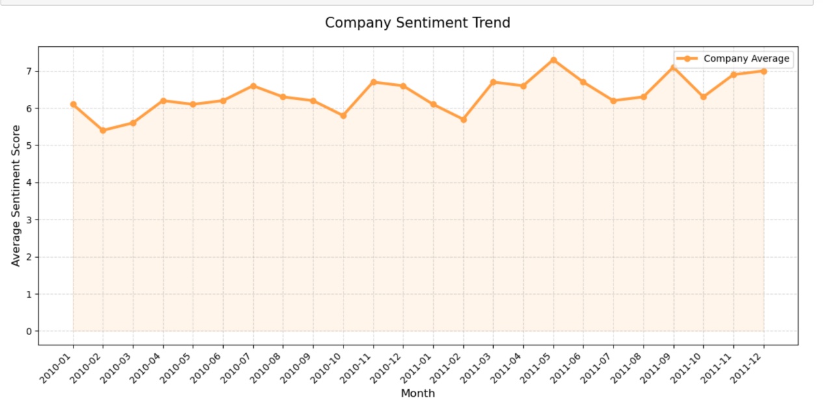
Picture 7. Company Sentiment Trend
To avoid the overall trend masking individual differences, I extracted representative figures from three employees, namely those with the highest monthly average sentiment score, those near the median, and those with the lowest. It shows that the monthly fluctuation of each employee’s score is much larger than the company’s baseline, and the change in their sentiment scores differs.
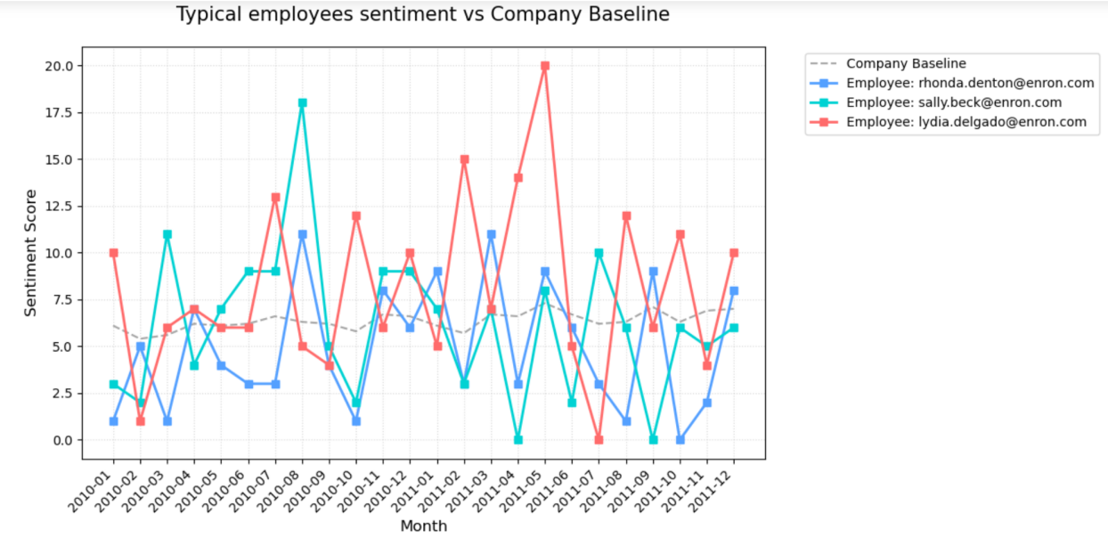
Picture 8. Employees sentiment vs Company baseline
- Employee Ranking Analysis
I ranked employees based on their aggregated scores each month. The three employees with the highest emotional scores are considered the most positive; the three employees with the lowest emotional scores are considered the most negative. In case of ties in emotional scores, employees are sorted alphabetically to ensure consistency and reproducibility of the ranking. I perform the ranking both monthly and throughout 24 months. The former shows in each month, who are the most positive employees and the most negative employees; the later shows the average sentiment score ranking across 24 months. Here is the ranking table of the average scores:
Employee | Average Sentiment Score | Ranking
lydia.delgado@enron.com | 8.125 | 1
john.arnold@enron.com | 7.875 | 2
patti.thompson@enron.com | 6.833 | 3
eric.bass@enron.com | 6.625 | 4
sally.beck@enron.com | 6.167 | 5
bobette.riner@ipgdirect.com | 6.083 | 6
don.baughman@enron.com | 6.042 | 7
johnny.palmer@enron.com | 6 | 8
kayne.coulter@enron.com | 4.958 | 9
rhonda.denton@enron.com | 4.917 | 10
Table 1. Average Sentiment Score Ranking (24 months)
- Flight Risk Identification
Flight risk employees were identified based on the frequency of negative messages within a rolling 30-day window. An employee is flagged as a flight risk if they sent four or more negative messages within any consecutive 30-day period, regardless of calendar month. This rolling-window approach ensures timely detection of sustained dissatisfaction.
However, the result shows that no employee is flagged as flight risk under the predefined rule of four or more negative emails within any rolling 30-day window. To validate this result, I checked the maximum number of negative emails observed within a 30-day window for each employee, and the highest value is only 2. This confirms that the empty result is due to the data itself.
- Predictive Modeling
  - Model Design
A linear regression model was developed to analyze factors influencing monthly employee sentiment scores. The dependent variable was the monthly sentiment score, while the following features were used as independent variables: Message count per month; Average message length; Average word count per message.
The dataset was split into training and testing subsets to evaluate model performance.
  - Model Performance and Interpretation
The linear regression model achieved an R² value of approximately 0.81 and a mean squared error of about 2.54, indicating that communication behavioral characteristics have strong explanatory power for emotional scores.
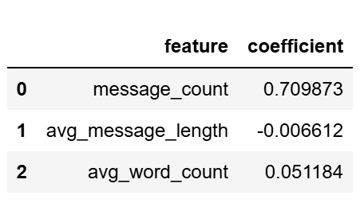
Picture 9. Coefficient Analysis
Message frequency exhibited a strong positive relationship with sentiment score, suggesting that more actively communicating employees tend to express more positive sentiment. Average message length showed a slight negative association, which may reflect problem-focused or issue-driven communication. In addition, the predicted values are generally close to the actual values, which suggests that the model captures the overall pattern of the data reasonably well.
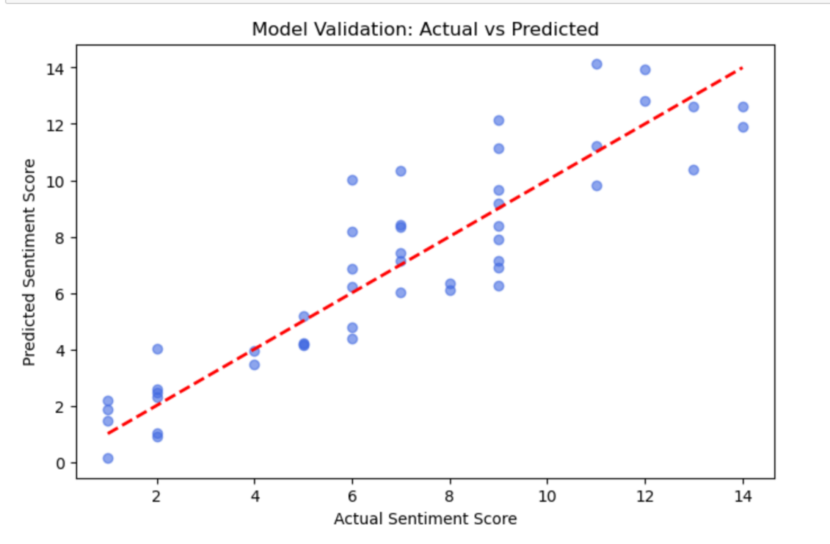
Picture 10. Model prediction vs Actual results
Overall, although emotions are driven by subjective factors, communication patterns can still provide objective and interpretable dimensions for understanding employees’ psychological states.
- Key Insights and Recommendations
8.1 Key insights
(1) Positive sentiment dominates internal communication.
(2) Negative sentiment is limited and generally short-lived.
(3) Message frequency is a strong indicator of employee engagement.
(4) No employees exhibit sustained negative sentiment patterns.
8.2 Recommendations
(1) Focus on monitoring persistent negative emotions, rather than isolated incidents.
(2) Organizations should encourage constructive communication and interaction among employees.
(3) Managers can use emotional trend changes as early warning indicators for employee support or intervention.
- Conclusion
This project analyzes employee email communication from multiple perspectives, including emotional tags, time trends, employee level ratings, rankings, Flight risk detection, and predictive modeling. In order to improve the classification quality, a two-step approach was adopted: VADER generates initial labels, and RoBERTa refines the messages that are first identified as negative. The results indicate that positive emotions dominate the dataset, neutral emotions account for a large proportion, and negative emotions are still relatively limited. The monthly analysis also indicates that over time, the overall emotional tone of the company has remained stable and generally positive.
At the employee level, emotional ratings and rankings reveal differences in communication patterns between individuals, while the rolling 30 day negative information rule helps identify potential flight risk employees. The linear regression model also performed well, with an $R^{2}$of approximately 0.81, indicating that communication behavior variables explained a significant portion of monthly emotional changes. Among the predictive factors, the number of messages has the strongest positive correlation with emotions, while the positive impact of average word count is relatively small, and the negative impact of average message length is relatively small. Overall, the research findings indicate that employee communication data is useful and interpretable.
Finally, no employees were identified as potentially flight prone, therefore the predicted list is empty.

