Currency Converter Documentation

for version: 2022.04.v1

Piotr Czajka

2022

**Table of Contents**

About 2

Supported currencies 2

Future updates 3

Setup 3

Usage 3

Conversion 4

Options 4

Customization 4

Support 5

Author 5

# About

Currency Converter is a web application which can be used to exchange currencies. The application is using European Central Bank exchange rates for calculations. The rates are being updated automatically but it is possible to check for updates manually. The European Central Bank is updating its exchange rates on every working day usually around 16:00 CET.

## Supported currencies

List of 32 supported currencies:

* AUD
* BGN
* BRL
* CAD
* CHF
* CNY
* CZK
* DKK
* EUR
* GBP
* HKD
* HRK
* HUF
* IDR
* ILS
* INR
* ISK
* JPY
* KRW
* MXN
* MYR
* NOK
* NZD
* PHP
* PLN
* RON
* SEK
* SGD
* THB
* TRY
* USD
* ZAR

## Future updates

There are ambitious plans for future updates. Most important for now is to make a table of all the currencies with their exchange rates. I also would like to upgrade currency dropdown lists so they will contain flags and country names. There are also plans to add tooltips, dark theme, more customization options, control panel (which will replace config.php) and more.

# Setup

The setup process is very simple. Follow these steps:

1. After unzipping archive file *CurrencyConverter2022.04.v1.zip* just put everything from there to your web server folder.
2. Go to the right URL in your web browser.

# Usage

The application was designed to be intuitive and clear.

## Conversion

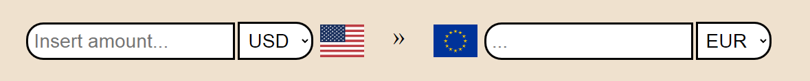

The conversion is occurring automatically right after the user inserts any amount into the input field on the left. During this process, Converter is checking if the local exchange rates are updated. If no, the application will automatically update its own local exchange rates and continue to calculate to output the final result.

## Options



The three buttons below conversion section are: settings, swap and info button.

In the settings window the user can select maximum decimal numbers count and (if enabled) manually update the local exchange rates.

Info button displays some information about the converter, e.g. last updates and version.

## Customization

Path to the configuration document: data/config.php.

The user can customize the converter a bit by making changes in the configuration document. To open the file properly use any text editor like ordinary notepad. The things that can be changed are:

* default currencies (replace currency codes on lines 10 and 11 with any other supported currencies),
* default decimal numbers count (replace a integer on line 12),
* display of manual update button from the settings window (on line 13; replace true with false or the other way around).

Example of a customized config.php:

* before:

define("DEFAULT_BASE_CURRENCY", "**USD**");

define("DEFAULT_TARGET_CURRENCY", "**EUR**");

define("DEFAULT_DECIMAL_NUMBERS", **2**);

define("UPDATE_BTN_DISPLAY", **true**);

* after:

define("DEFAULT_BASE_CURRENCY", "**JPY**");

define("DEFAULT_TARGET_CURRENCY", "**GBP**");

define("DEFAULT_DECIMAL_NUMBERS", **0**);

define("UPDATE_BTN_DISPLAY", **false**);

# Support

For support please contact me via Codester. Preferably in the Support section of the Currency Converter. I will answer as soon as possible.

# Author

My name is Piotr Czajka (nickname Foortec).

GitHub profile: *https://github.com/Foortec*.

Fiverr profile: *www.fiverr.com/foortec*.