

FootlyIQ – User Manual

FootlyIQ Team| User Manual 1.0 | 05.06.2025

# Match feed

For accessing the match feed navigate to the home page of the app accessible at <https://frontend-i3fb.onrender.com> or navigate to the Live matches tab in the right sidebar.

In the top right corner you can choose the date for which you'd like to check the matches. You can also filter the matches shown based on country and/or league, by using filters at the top of the side.

# 

# Right sidebar

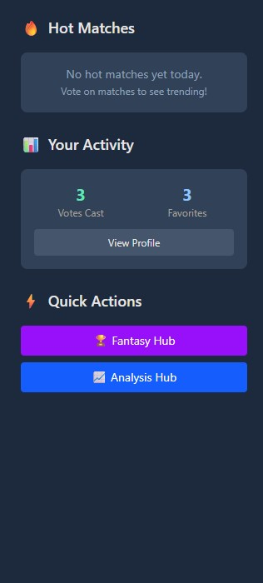

On the right side of the home page you can see a few categories shown. Hot matches will show the most viewed and voted matches for the day. Your activity shows you how many matches you voted for (picked an outcome) and how many teams/matches are saved in your favorites. Quick action can take you to the fantasy hub or the analysis hub if you want to use that instead of the navbar.

# Match view

By clicking on a match of your own choosing you will be taken to the match overview screen where you can see all the data regarding the match, from result, venue, referees, to lineups and statistics. You can toggle between all of these by selecting the desired option under the result display.

There you will be able to see all the data you want from goal scorers, to detailed match stats.

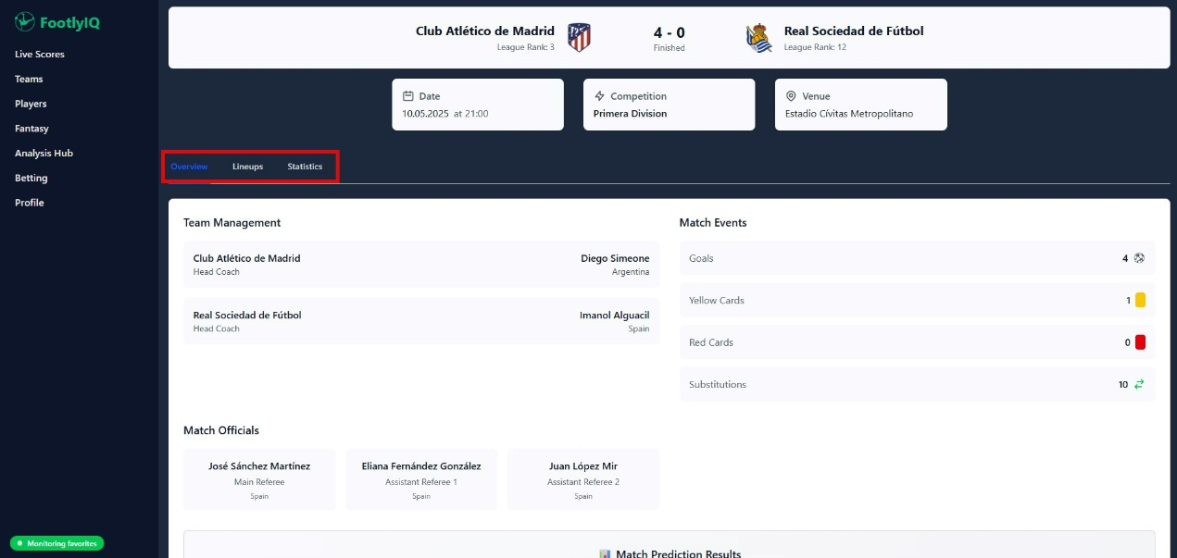

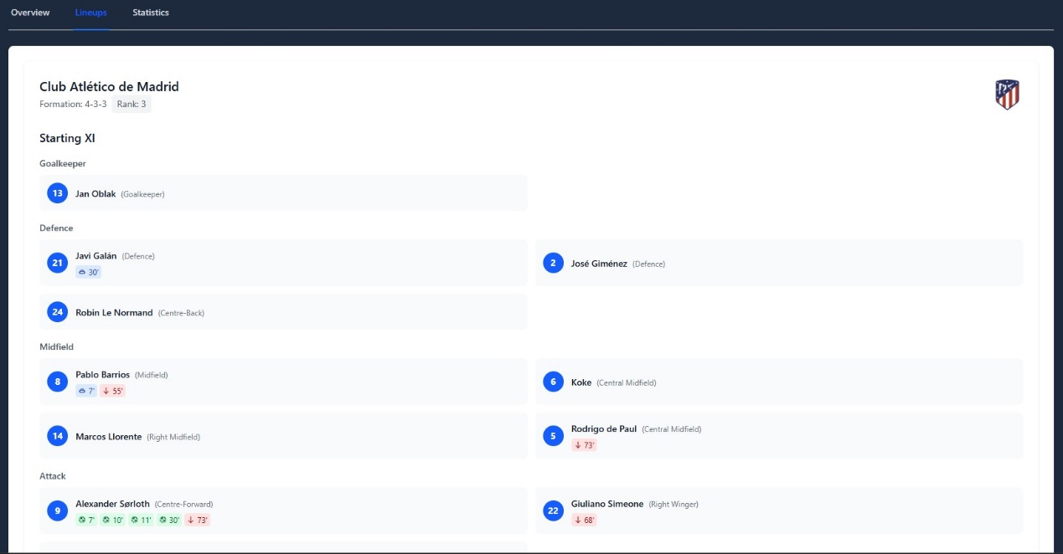

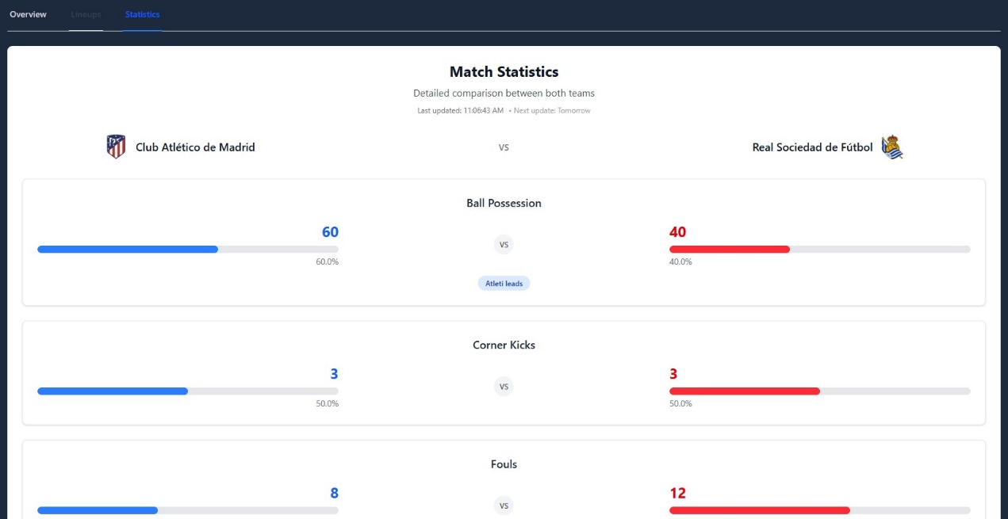

# Voting

Want to share your opinion for an upcoming match? Fin dan upcoming match, scroll to the bottom of the match view and vote fort he outcome you fancy. You can also see how other users have voted.

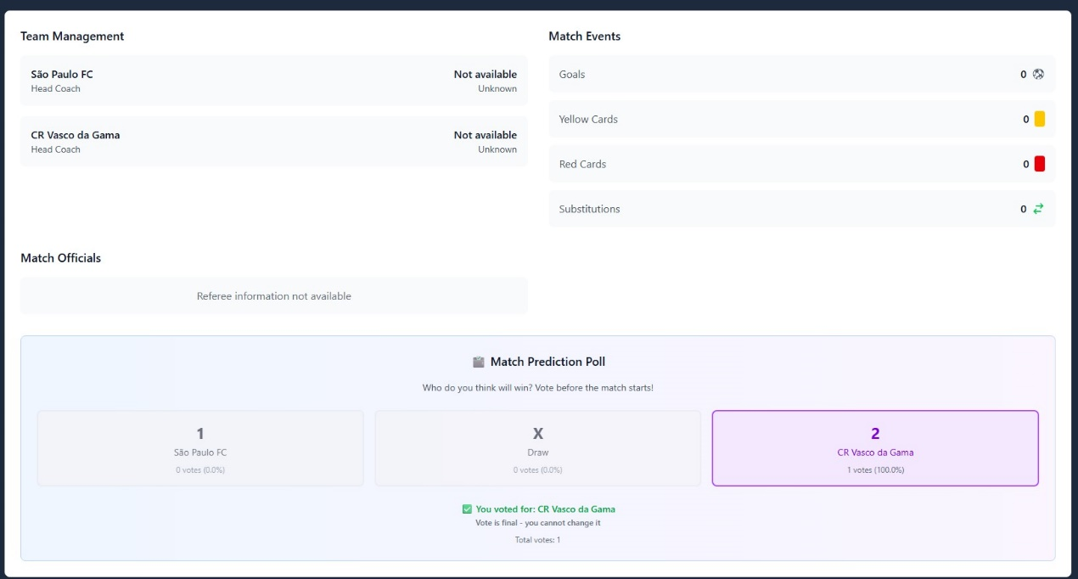

# Team view

Want to know more about the team? Just click on the team name and you will be taken to the Team overview screen. From there on you can see all of the team's matches for that season (you can also filter the matches based on competition) or look into their squad.

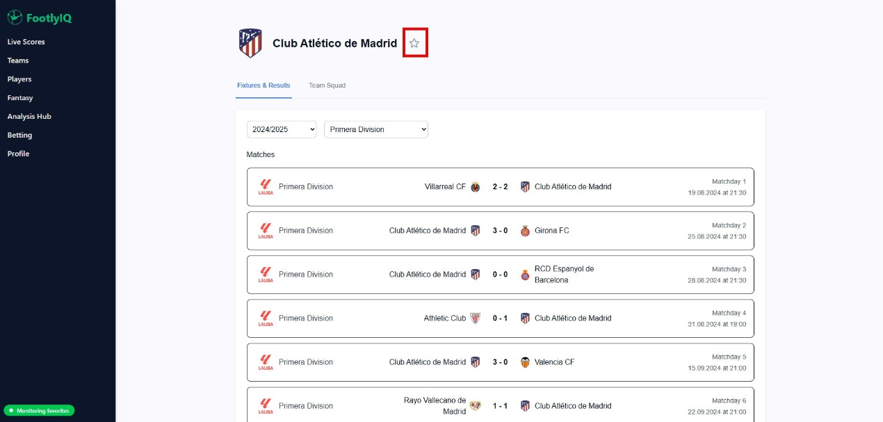

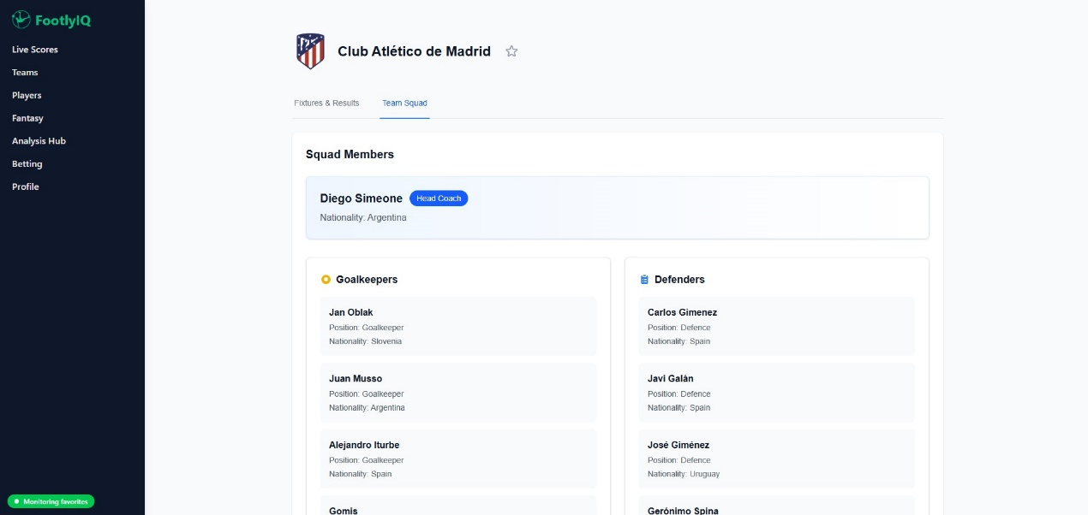

# Player view

Want to know more about the player? Just hover over him and click view profile. There you can see his personal info and check his recent matches.

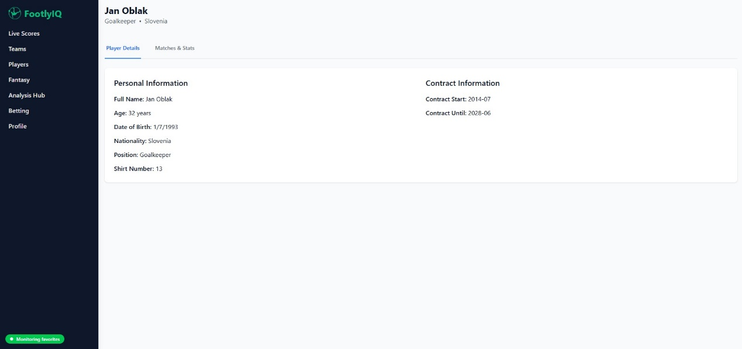

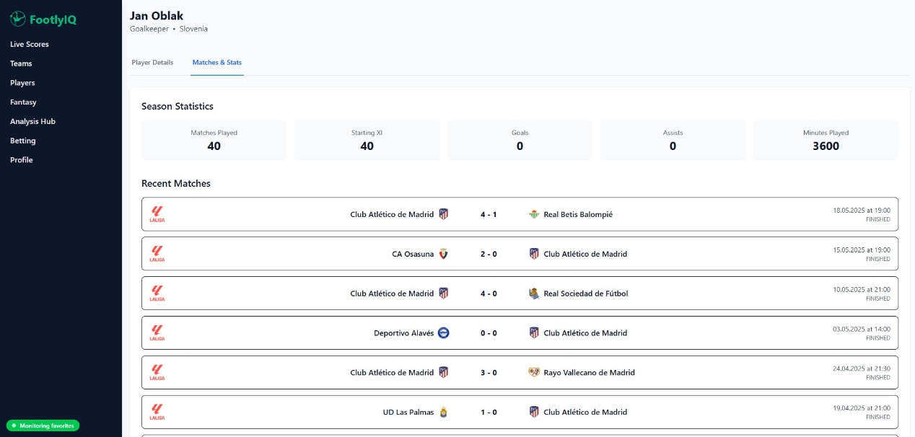

# Profile

You can login via username and password or use google sign in.

Once you are logged in you can use your profile to:

* Add your Premier league fantasy team id
* Get an overview of your favorites

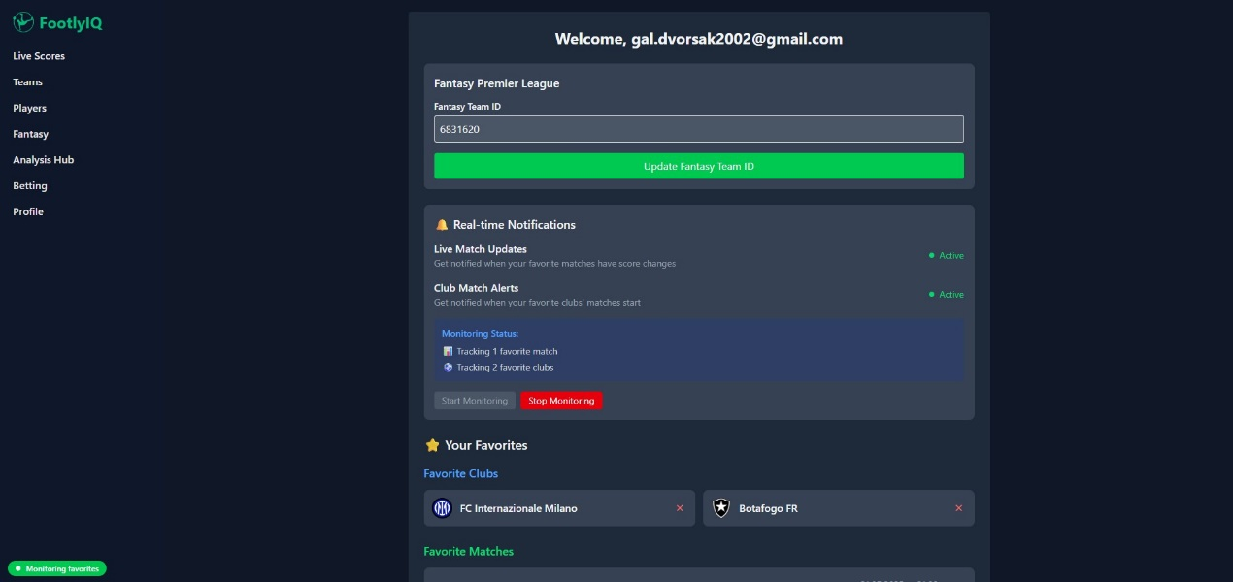

# Favorites

Want to give certain matches and teams extra attention. Simply add them to favorites. For matches you can do that by pressing the little star icon on the right side of the match window. For teams navigate to the team page and click on the little star next to the team name.

Favorites will be shown in your profile. You will receive notifications (game start, goal…) in the app for your favorite teams or matches by default. If you don't want that simply click on »stop monitoring« in your profile. We will not disturb you 😊.

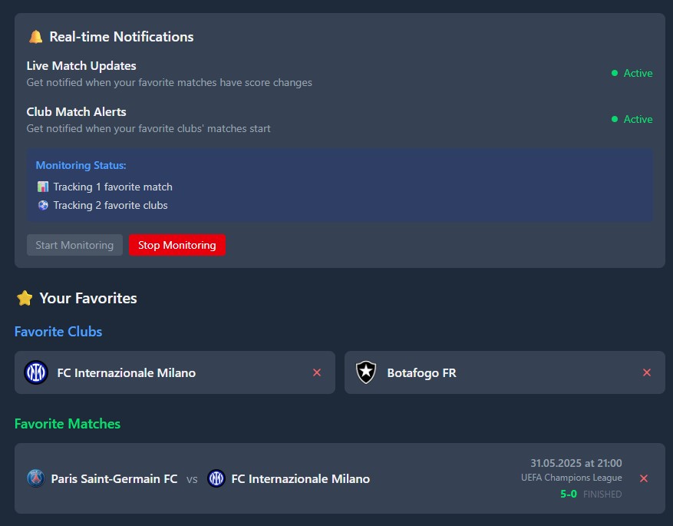

# Searching fot teams and players

Sometimes accessing teams or players through match view can be tedious. Don't worry, we offer search option. Just navigate to the »Teams« or »Players« page with the navbar. In there just type in your desired team/player and check them out.

You can also filter and sort the results by clicking the Filters button.

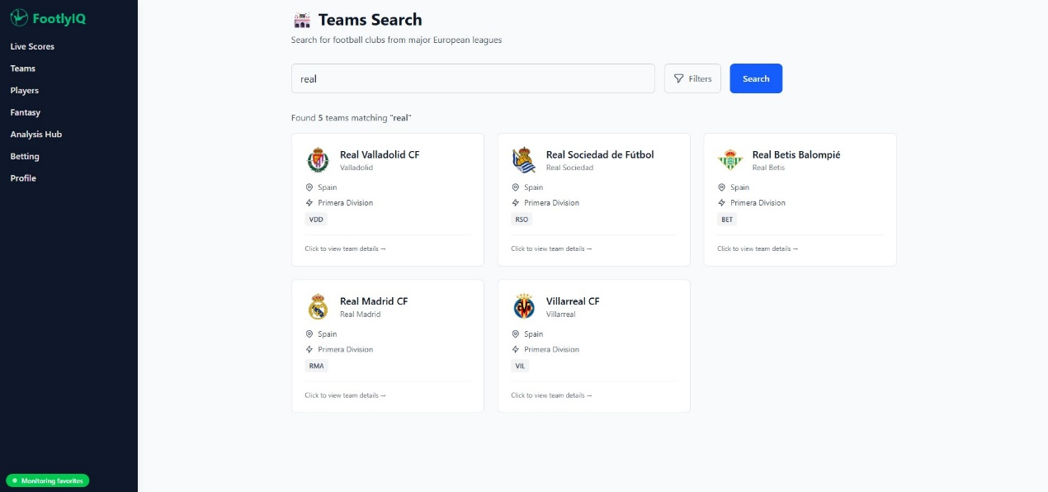

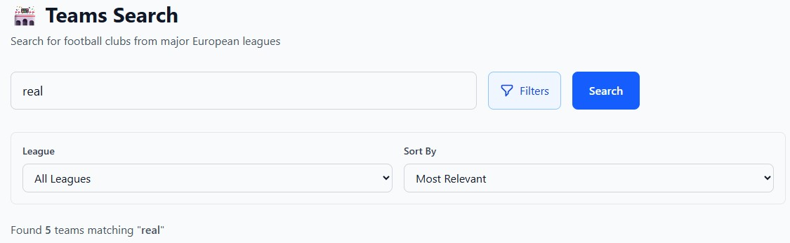

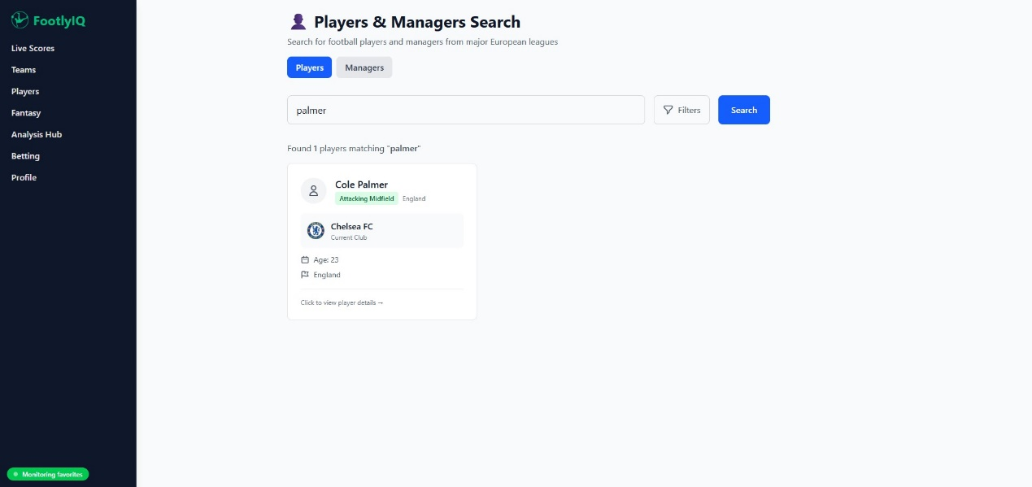

# Betting odds

If you'd like to check the odds for upcoming matches just click on the »Betting« page. Odds are there for informational purposes only, you can not access any third party betting providers from our site.

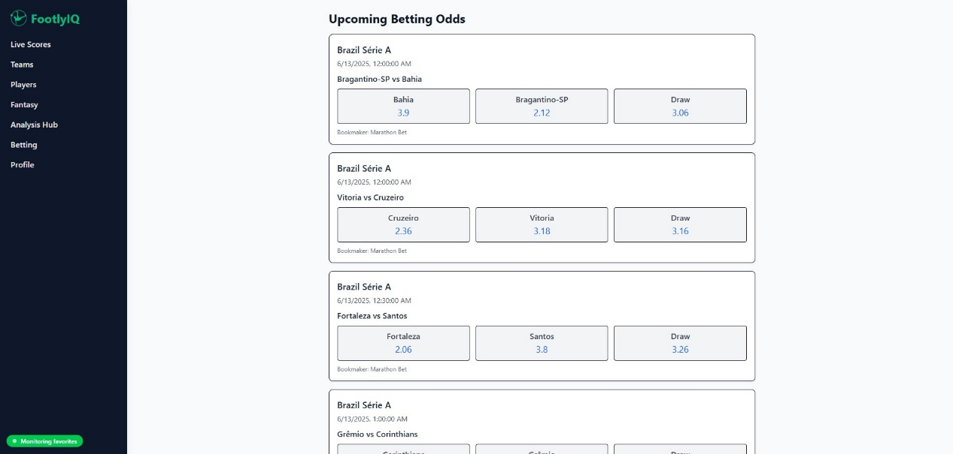

# Analysis hub

Analysis hub is our intelligent solution for more detailed look into team stats and tactics. It is powered on historical premier league data and our machine learning. Therefore it is only accessible to premier league teams.

Users can look into three important parts of play:

* Passing with pass clustering, where users can see most common pass clusters, most common entries in final 3rd, or most common passes based on their desired filters. After every new display, the legend, explaining pass clusters is updated.
* Goals with xG which will give you a look into each team most dangerous zones when it comes to scoring
* Threats and attacking tactics with xT, which can give an insight into the way teams are moving passes, creating chances, and their shooting zones, also with shot probability.

