# Project 2: adventure on company (Racism in work)

## Background:

You are a person that just immigrant to this country, you must find a job that make your life keeps running. One day, you received an interview notice and step into a unknow company. In the first day, you are being asked to deliver a file **(important file that comes from your teams leaders, talks about the future plan for this company)** to the upper level, then you gradually discover that this company is a huge maze and hidden problems.

## Character:

John – User, a teenager that want to do the best in everything.

Tom – Boss of the company, doesn’t care about the other colleague, money first.

Unknow Race workers (about 5 in each Race/Class) – enemy, discriminatory and hostile to other race staff, think about promotion at all costs.

## Program goal:

Find the boss’s office and deliver this file. But the trip is not easy to find the correct path, you will find other race’s worker and they will snatch your file and try to make a fool of you.

## Detail:

NPC talks: You can hear some NPC’s talking about their carrier and promotion needs.

Find the key card: You need something to take the elevator to upper class.

NPC are not friendly to each other: Each class of the enemy can prank each other.

Friendly NPC: You will find someone like you (appear only in that state).

Copy machine: Adding more chance of the enemy attack.

Final ask: You need to find someone to access the boss’s office.

## STATE flow:

Home – Company – Floor one – Office – LEVEL 2 MAZE – ELEVATOR – LEVEL 3 MAZE – FRONT DOOR OF BOSS’S OFFICE – FINAL.

## Color and front:

Background (PNG or color choose (blue: #BBFFFF, green: #54FF9F and Gold: #FFD700)

Text: Front – Arial color white (0)

## MOOD BOARD：

First floor:

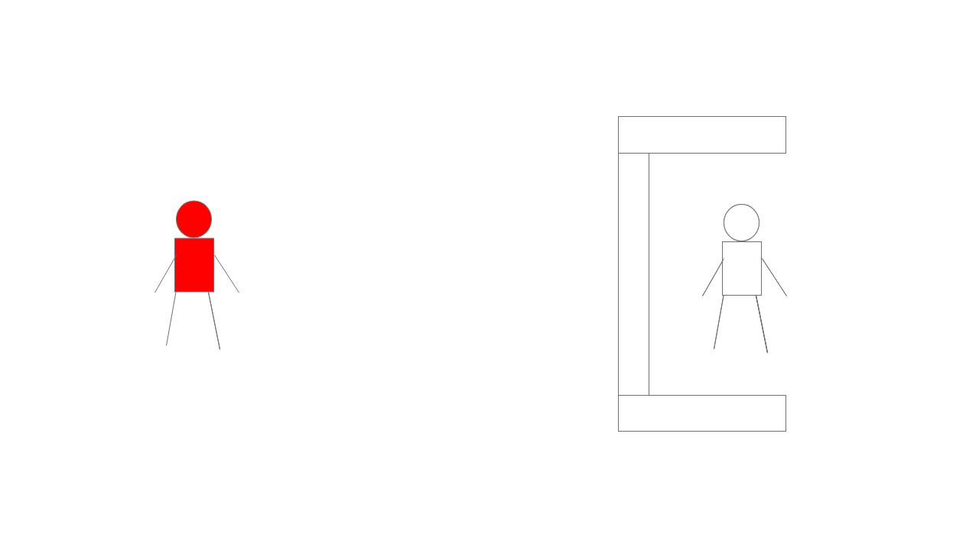

Office

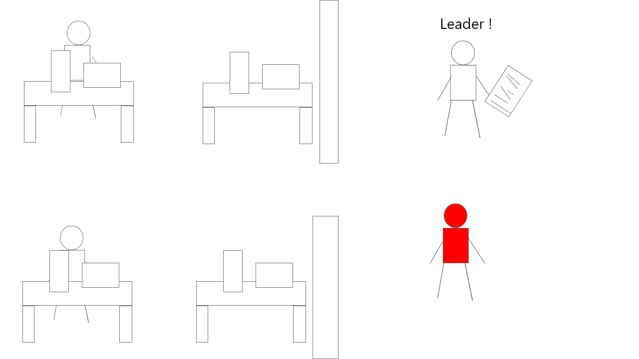

Elevator:

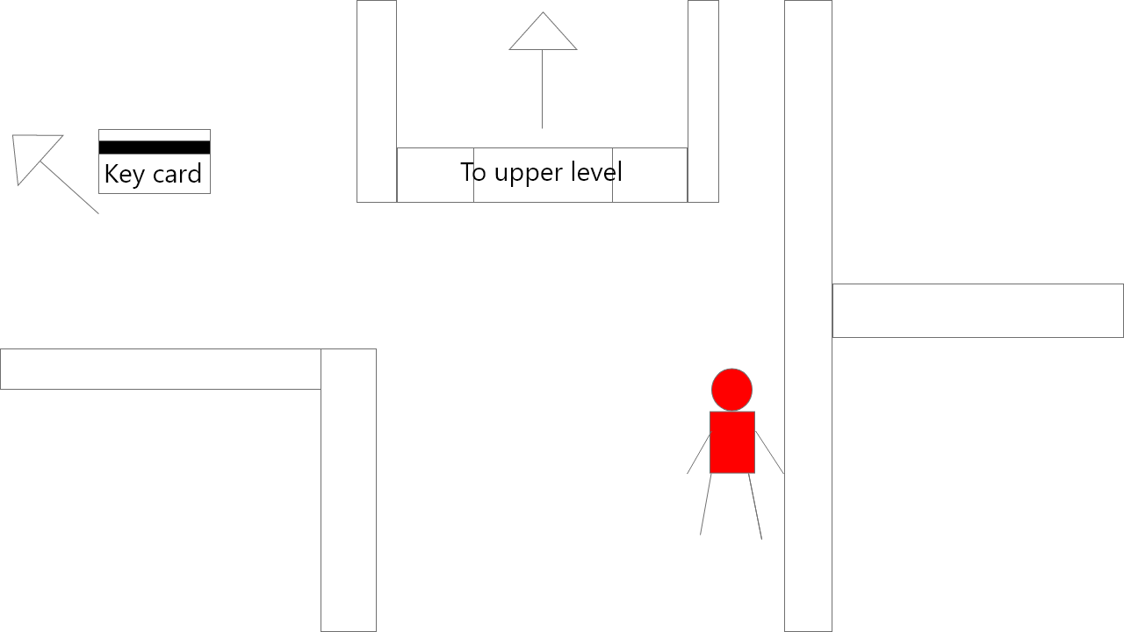

Upper level

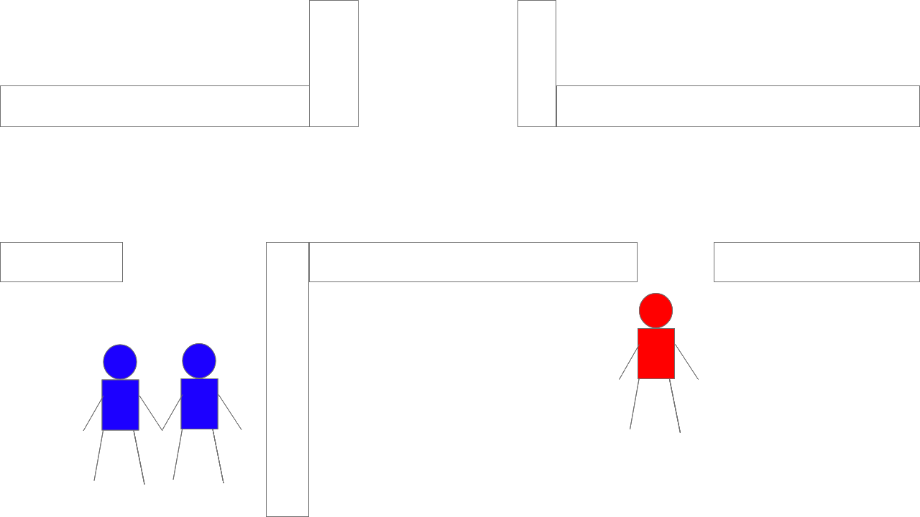

Upper level 2

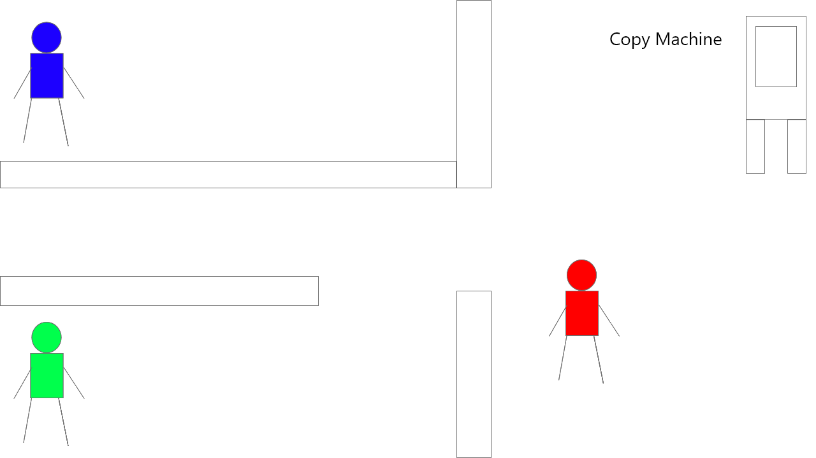

MAZE:

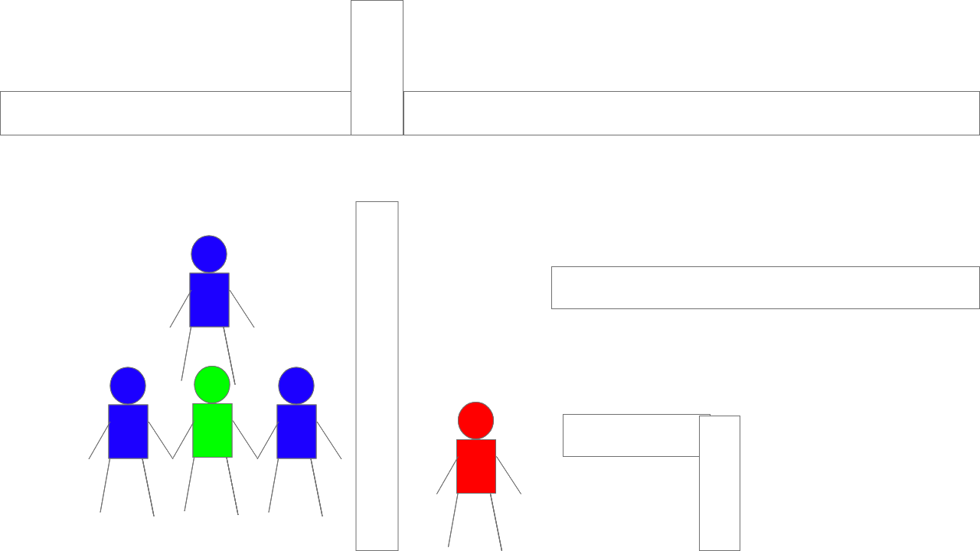

Find office key:

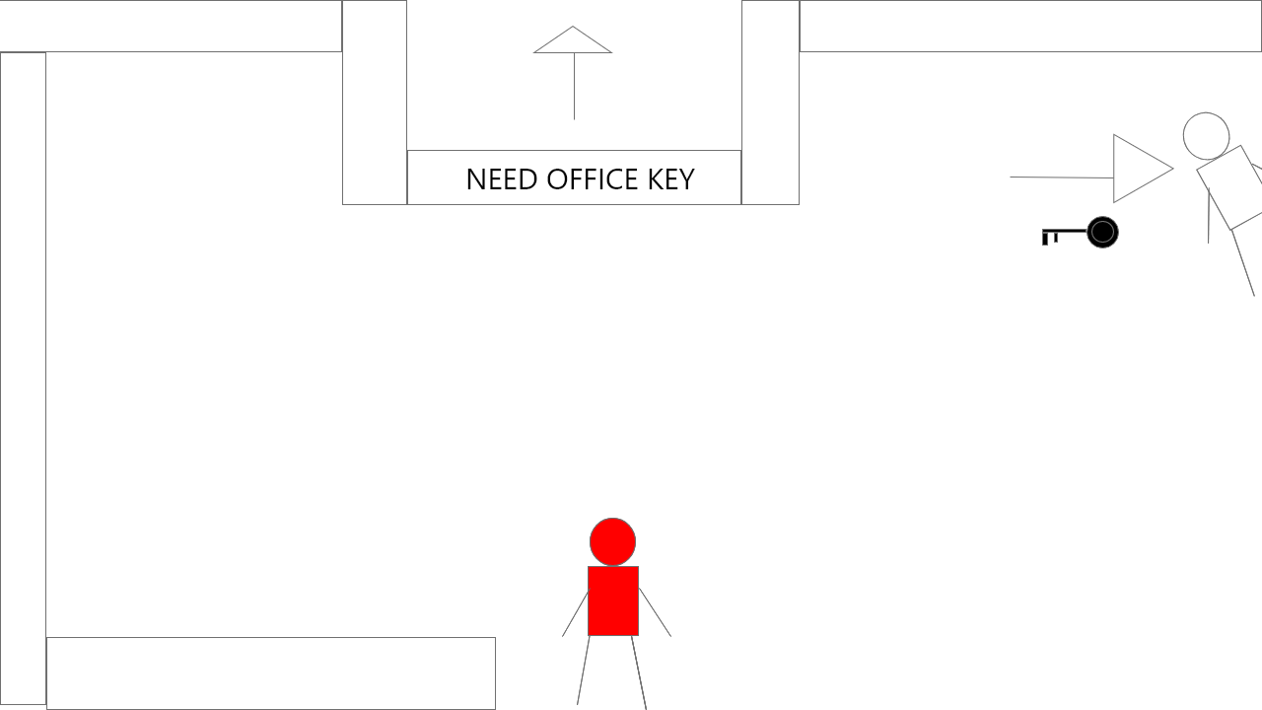

FINAL:

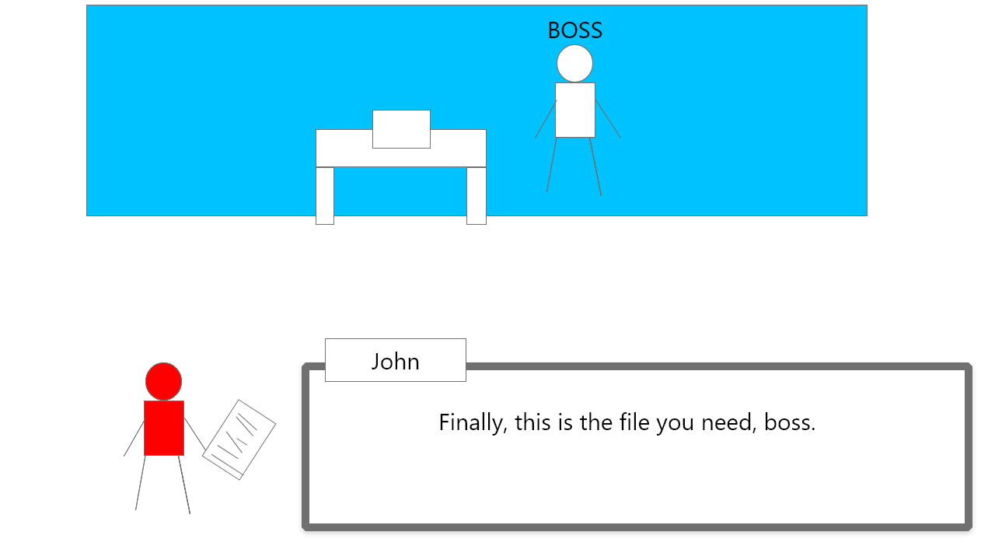

## PNG OF SPRITE:

