**Bootstrap**

**Ans(1):-**

**Media Queries:-**

🡪Media queries in CSS are used to apply different styles based on the characteristics of a user's device, such as screen size, resolution, or orientation.

**Why it is important:-**

🡪They are essential for responsive design because they allow web pages to adapt and provide an optimal viewing experience across various devices, including desktops, tablets, and Smartphone’s.

**Ans(2):-**

**A basic media query that adjusts the font size:-**

@media (max-width: 600px) {

body {

font-size: 14px;

}

}

|  |
| --- |
| **Lab Assignment** |

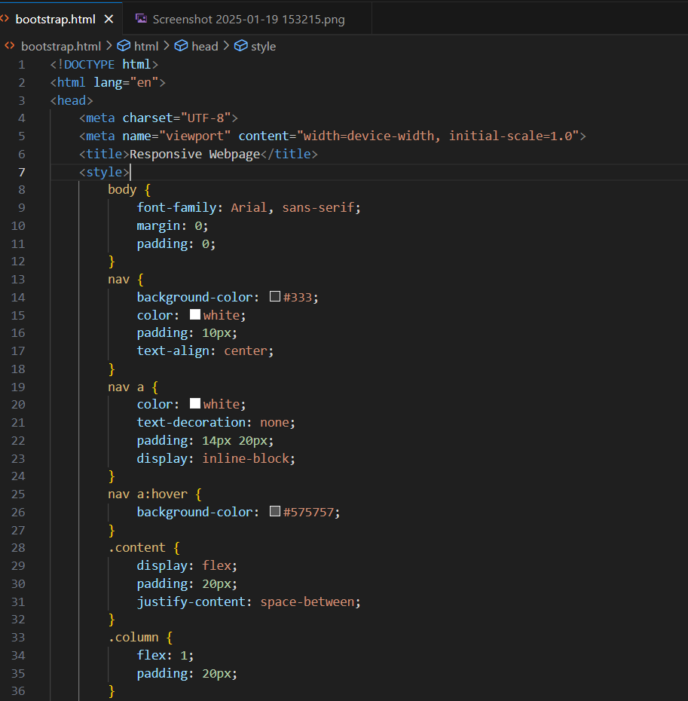

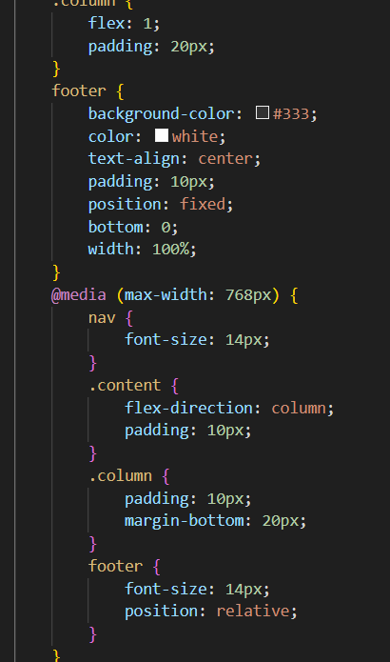

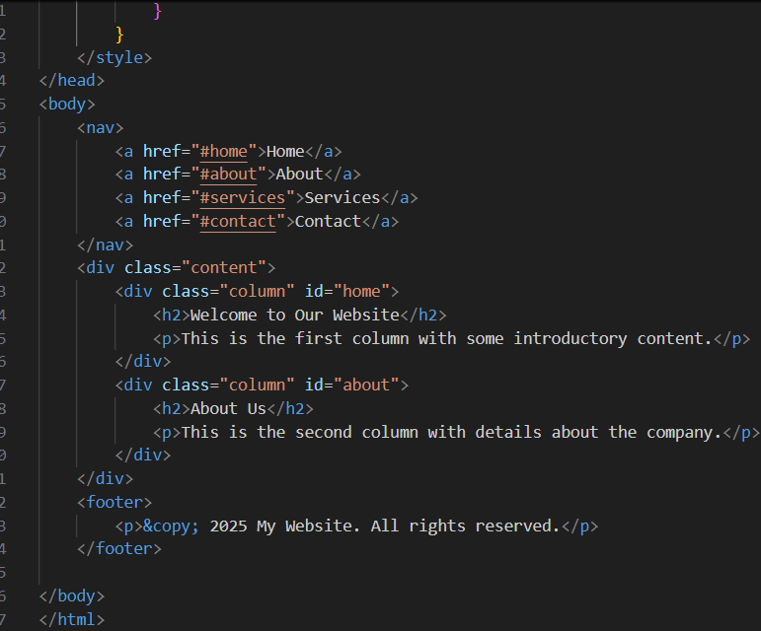

OUTPUT:-

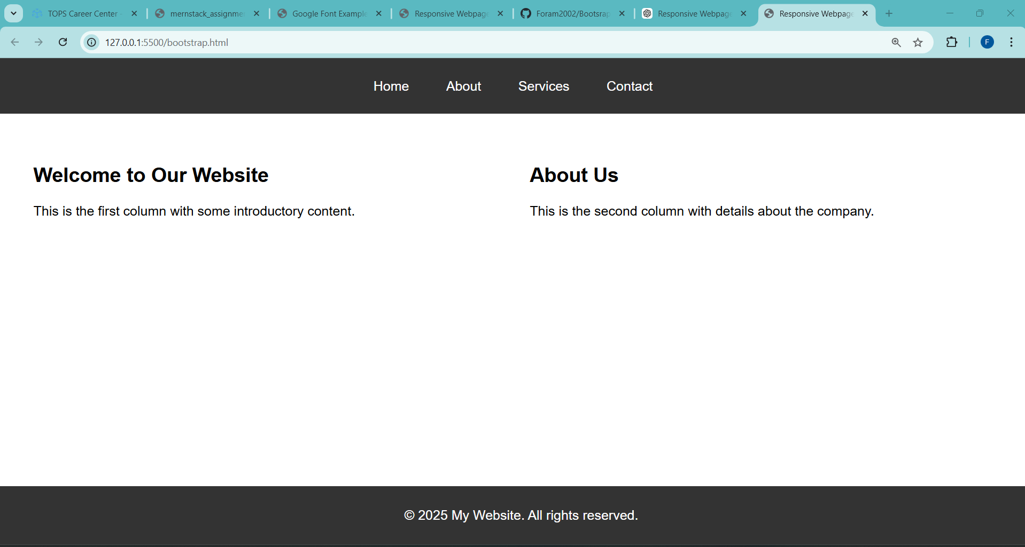

**Ans (3):-**

|  |  |
| --- | --- |
| **Web-Safe Fonts** | **Custom Web Fonts** |
| Fonts that are widely supported across all devices. | Fonts that are not installed on users' devices. |
| Arial, Times New Roman, Verdana. | Google Fonts. |
| Fast loading as they are already installed on most devices. | May slow down page loading as they need to be downloaded. |
| Limited customization options. | Highly customizable with different styles |

**Why Custom Form:-**

**🡪** Web-safe fonts are already installed on most devices.

🡪 They provide consistent rendering across all devices and browsers, avoiding potential issues with font rendering on different platforms.

**Ans (4):-**

**Font-family property:-**

The font-family property in CSS is used to specify the font of the text on a webpage. It allows you to define a list of fonts in order of preference.