.tΩόϟ' Γ3'ίpΑ ι¹Χϟ'

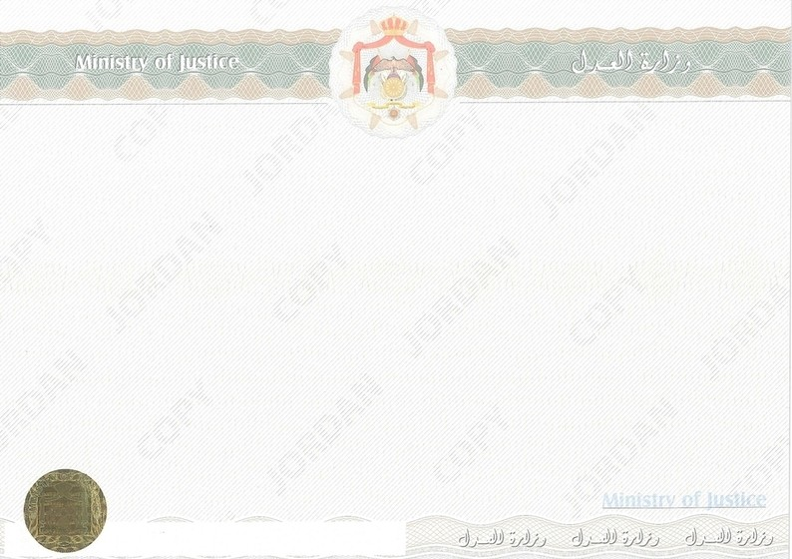

**Δϳa÷¹Ϭ¹' Δϳ:¹uϷ' Δ¹¹aa¹' ϥ¹a> Ώo:Ο çγϗ - ϥ¹a> Δϳ'¹Α Δa¹Σa**

**24723644 : ϲόΟua¹' çϗu¹'**

**31/10/2024 : ¿ ϳu¹;¹'**

**Δϳao¹Σa ç¹> Γ¹¹Ϭ÷**

**ϲΟ¹Λ ϝϳ¹: ua: n'uϓ : ç γϹ'**

**ϲ:¹u' : Δ--ϳγ:Ο¹'**

**2000453705 : ϲ:ρo¹' çϗu¹' Δϳ¹:'¹ n¹ϬΟ : Δϳao¹Σa ç¹> Γ¹¹Ϭ÷ Ώ¹ρ ϥa Δϳ¹ϐ¹'**

**ﮫΑ¹ρ y¹> s¹:Αo Δa¹ό¹' ϕϼ:Ϸ'o ϑu÷¹¹Α Δ¹:a ΔΣ:Ο o΃ Δϳ¹:ΟΑ ço¹Σa uϳ“ ϩϼ>΃ uo¹4a¹'**

**. ϝoaϷ' ΏγΣ Γ¹¹Ϭ÷¹' ϩ4& ϲρ>΃**

**ϥ¹ϳ:Λ¹' ¹¹¹:**

**ϥ¹a> Ώo:Ο çγϗ - ϥ¹a> Δϳ'¹Α Δa¹Σa ϱu'¹' uϳ¹a**

**2024/723644**

[https://ncrc.moj.gov.jo](https://ncrc.moj.gov.jo/Forms/Request/RequestDetails.aspx?DDwCF0Aq46MTN7yn%2bSRUrljStJeN1hT6bEYsQG9oyuqWL0TrmgcBrqvfYLqtcLifsSS0UHSKQ9db0e%2fy2NXU%2fg%3d%3d)

Γ3¹iί ›¹Ο3ϟ' ΓΩ¹Ϭηϟ' ÷¹ϣpϠόϣ ϥϣ äϘΣΗϠϟ *