Finansportalen Insurance calculators - Integration overview 4.0

An overview of the communication involved between the companies and Finansportalen’s insurance calculators.

Contents

Contents 1

Overview 1

Web services 3

Rules for request processing 4

Product landing page 5

Typical integration flow 6

Communication flow 7

FAQ 7

## Overview

The communication between Finansportalen’s insurance calculators and a company is a simple client/server- communication where the company provides web services (further in text as web services) and Finansportalen’s insurance calculators are clients (further in text as client).

Other terms and applications:

* “Datafanger” – application at Finansportalen where the company manually enters insurance terms and conditions for its products
* Product landing page – page at the company’s web site where the user is directed after clicking on the company name in Finansportalen’s result table (Figure 1)

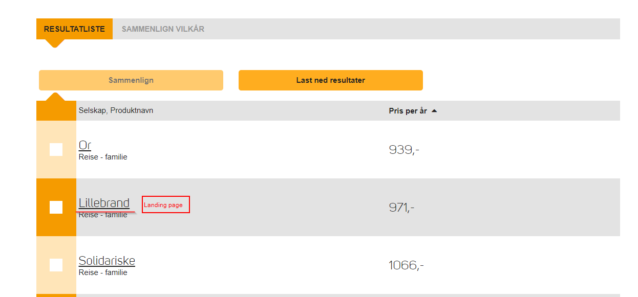

Figure 1

Figure 2 shows the interaction between client, web services, datafanger and product landing pages.



Figure 2

## Web services

The communication between the client and the web services adheres to SOAP protocol version 1.1 and it is secured by two-way SSL. WSDL confirms to WS-I Basic Profile 1.1. The company must use Finansportalen’s client certificate to authenticate and authorize the client, accordingly the client has to trust the company’s certificate.

Finansportalen might issue new versions of the web service. All the company’s web services have to be of the same version – at Finansportalen’s side the version is set per company (not per single web service).

WSDL defines two web service-operations for:

* hentPris (get price)
* ping

Operation «hentPris» is called to retrieve a price. The response can be either a normal response with the price, or one of defined errors: PriceUnavailable, PossibleMisuseDetected, RequestTimedOut, ServiceUnavailable, NotAuthorized and UnknownFailure. These error responses are displayed to user as an error message (see picture Figure 3).

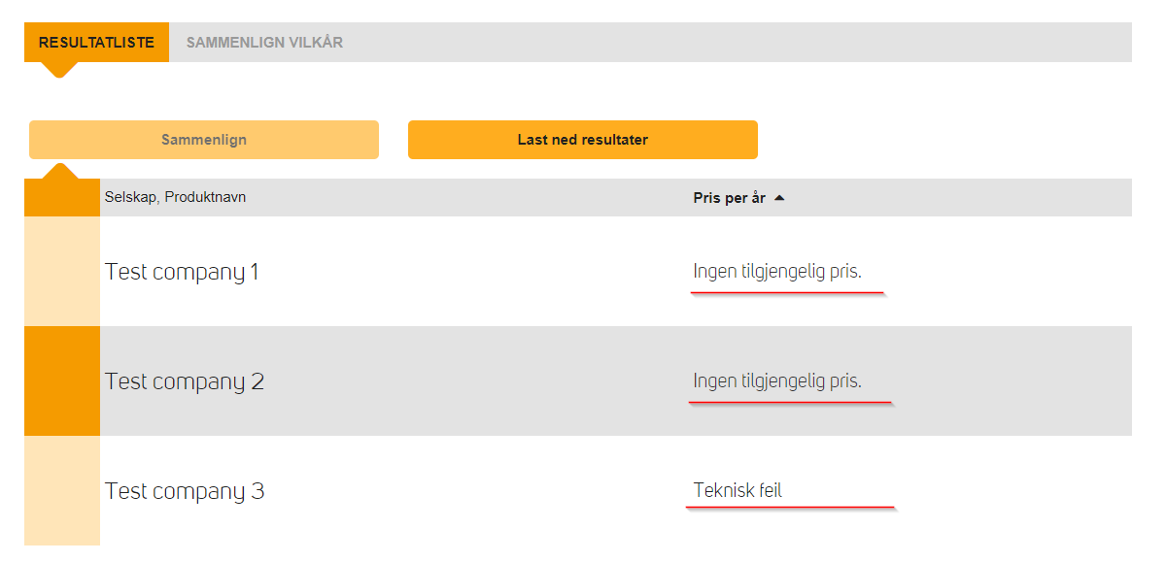

Figure 3

A normal response generally contains these fields:

* pris - price
* produktnavn – product name (NOTE: the product name here has to be same as product name in the “Datafanger” application), the product name is displayed in the calculator’s result table (see image Figure 4)
* presisering – product description is displayed in the calculator’s result table by clicking on product name (see image Figure 5), for formatting can be use subset (lists and headings) of Textile markup
* (http://en.wikipedia.org/wiki/Textile_%28markup_language%29).

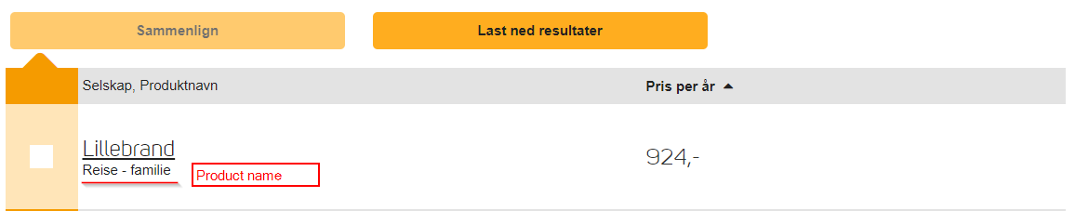

Figure 4

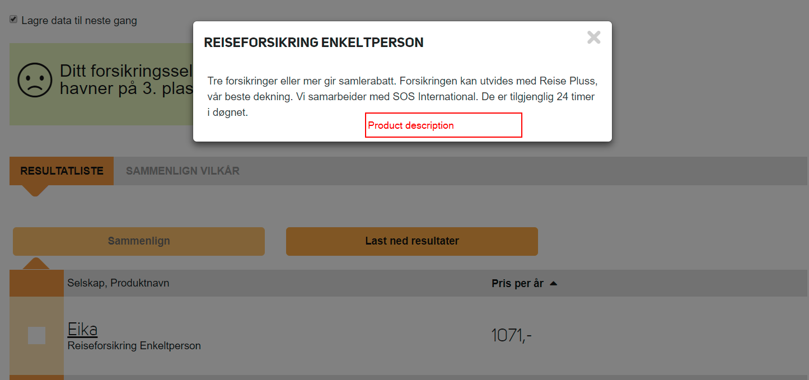

Figure 5

Finansportalen periodically calls a “ping” operation to check whether the company’s web service is available. The response should be either “true” or “false”. A price request will be transmitted via the web service only if the last “ping” operation was “true”. Any other response than “true” is interpreted as “false” (i.e., web service is not available). In the test environment, “ping” is called every 15 minutes. Upon the second failure, a notification is sent to the company via e-mail. In the production environment, a ping request is performed every minute and a notification sent on the 15th.

Diagram Figure 6 describes communication and interaction flow between client, web services and user.

Valid web service requests and responses are found in the file called “request_response_<version>.zip”

## Rules for request processing

When the birth number is not identified, error messages are NOT allowed. The service should give a price as if nothing happened. In this way, Finansportalen can not be used to detect whether a birth number is genuine or not. Fake error messages ("Technical error") etc. are not allowed either, as this is easily comprehended by criminals.  
  
Birth numbers and union membership is considered sensitive in Norway, and should not be stored by the companies.



Figure 6

## Product landing page

A product landing page is the page where the user gets directed after clicking the company’s name in the calculator result table. The landing page must be secure (i.e., HTTPS). A POST (not GET) request is made to the lading page, the POST request contains two parameters “requestData” and “version”:

* requestData – contains user input as a JSON object (field names and values)
* version – the company’s web service version

“requestData” example:

{

"lob": "reise",

"postnr": "8450",

"gatenavn": "ALKEVEIEN",

"gatenr": "2",

"foreningsmedlemskap": null,

"antallskader": 0,

"omfang": "familie",

"eldste": 55,

"gate": "ALKEVEIEN 2",

"klientInfo": {

"forespoerselId": "f8e9fb155a2977aa03998eb900000149f016c490",

"sesjonId": "TYSbm2uaV9J9Uy3Sivbr3g",

"ipAdresse": "127.0.0.1"

},

"foedselsnr": "01115549800"

}

The JSON object “requestData” contains almost the same as the web service request – the differences are described below:

Additional field (which are not in web service request):

* lob – line of business (valid values: bil, bygning, innbo, reise, ulykke, liv, barne)

Fields naming differences:

in the WSDL some fields are underscored (e.g., “foedselsnr**_**forelder”). In the JSON object these underscores are removed and the next letter is a capital letter (e.g. “foedselsnr**F**orelder”).

## Typical integration flow

These are the typical steps for integration with Finansportalen. These steps are the same for the test and the production environments (except step 2.2):

1. The following information and actions are requested from company:
   1. provide web service URLs
   2. provide landing page URLs
   3. provide web service server certificate (required for two way SSL)
   4. company have to update the firewall to allow incoming traffic from 54.76.250.186 and 54.76.248.49 – prod. env. and 54.72.25.12 – test env.
   5. validate “finansportalen” client certificate (required for two way SSL)
   6. provide user (email) who receives automatic status notification about company’s web service status and certificate expiration date, Finansportalen sends an automatic e-mail notification when the company’s web service appears unavailable and another when it is available again also notification about certificate expiration is sent
2. The company receives the allowing information from Finansportalen
   1. Finansportalen’s client certificate
   2. access to the insurance calculator application (applies only to Finansportalen test environment, only in test environment calculators are protected by password, company users can see own prices and fake company prices (Lillebrand, Or and Solidariske))
   3. access to the insurance calculator administration application “ICC” (applies only to Finansportalen test environment, production ICC is meant only for Finansportalen administrators)
   4. access to “Datafanger” application
3. When implementation is ready and company is ready to be put into production env. then company will be requested to:
   1. Provide production URLs and production certificates to support ([youtrack@fportalen.no](mailto:youtrack@fportalen.no)) for price testing
   2. Whitelist Finansportalen test env. IP in their production environment for price checking
   3. Answer comments and fix errors found because of price checking
4. Finansportalen will
   1. Price checking for control of implementation
   2. Provide comments and results of price checking
   3. Declare company ready for production
   4. Edit production ICC, so company available in FP production environment
   5. Roll back Test URLs and certificates in test environment when price check approved

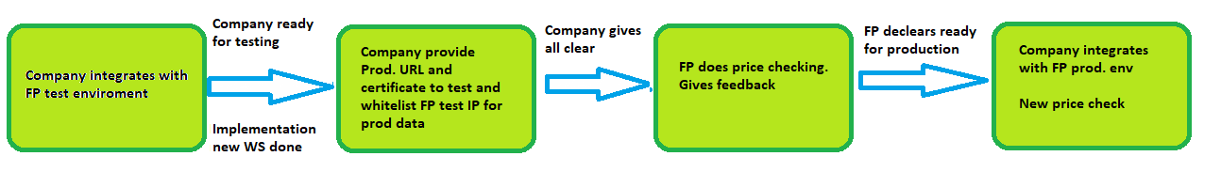

## Communication flow

All technical questions and requests have to be sent to [youtrack@fportalen.no](mailto:youtrack@fportalen.no) . An e-mail to this address will automatically lead to a support issue being registered in Finansportalen’s issue tracking system and the Finansportalen support team will take care of it. Further communication with “finansportalen” support team should be via e-mail, during communication never exclude [youtrack@fportalen.no](mailto:youtrack@fportalen.no) from the recipient list (as CC: [youtrack@fportalen.no](mailto:youtrack@fportalen.no)) and don’t change the email subject. Also please note that support requests are closed if there has been no response from company in 7 days (unless this was otherwise agreed).

## FAQ

**Q:** Terms and conditions are entered in “datafanger” application, but in Finansportalen they are not displayed. Why?

**A:** Ensure that the product name in the web service response is exactly the same as the product name entered into the “Datafanger” application. Capital letters must also be exactly same.

**Q:** How is the communication between the client and the web services secured?

**A:** Two-way SSL

**Q:** What should be returned if we are unable to give a price

**A:** In case you are not able to give a price you have two options:

* return “PriceUnavailable”, ”ServiceUnavailable”, ”PossibleMisuseDetected”, ”RequestTimedOut”, ”NotAuthorized” or “UnknownFailure” fault with your error message
* return price response with zero price and feilmelding = "Your error message"

Note that all such responses on portal will be displayed as “Ingen tilgjengelig pris”.