NOUN ANALYSIS

You are required to develop a C++ Multiple Choice Quiz application to aid students taking the module “Software Design & Quality” understand agile software development methodologies (specifically Kanban & SCRUM) and hence study for their January exams. Users will be presented with a randomly chosen set of 10 questions from a question bank and be presented with a choice of solutions. The user must then choose a correct answer and move to the next question. The application will generate a report of how well the student did after the quiz has completed. The student’s result is saved to their profile. The application can manage many student profiles and can generate an overall class report. The quiz may be administrated by an admin user. An admin user has full access to all student’s attempts, but a student user can only see their own attempts as such Student’s must login to their profile before starting the quiz. Students are allowed have multiple attempts which are all persistently saved against their individual profile. Questions and solutions are saved in an XML file which is read by the quiz application. You will need to research Agile developmental lifecycles to define your questions and you will need to investigate how to parse XML using C++

# Casual description

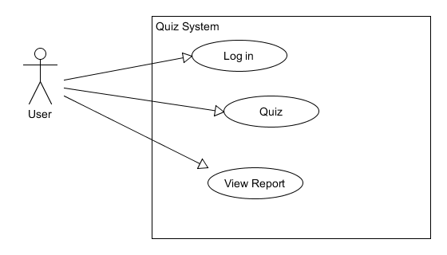

## User use cases description

Use case 1 Log in

1. User logs in
2. Log in details checked
3. If account is non-existent, make the new account
4. Presented with choices of ‘take test’ or ‘view report’ or ‘log out’

Use case 2 Take quiz

1. User is presented with a question and a multiple answer
2. Chosen answer is checked against the correct answer
3. Save/tally the correct answer
4. Repeat step 1 – 4 until for 10 questions
5. Generate the report
6. Save report to the account

Use case 3 View report

1. Retrieve accounts report
2. User is presented with a choice of Log out or Do quiz

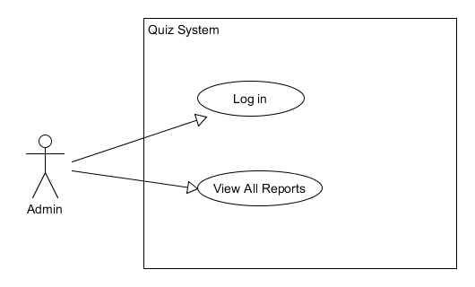

## Admin use cases description

Use case 1 Log in

1. Admin logs in
2. Log in details checked
3. If account non-existent, exit
4. If details correct, allow access
5. User presented with choices of ‘view users report’ or ‘log out’

Use case 2 View report

1. Retrieve reports