**Student ID: 46564602**

**Name: Ford Tang**

**Score: /100**

**CS122A HW4**

Refer to this template to create your document. Please do not submit a hand-­‐written document.

A. **Relational Algebra [70pts]**

1.

(a) σ total_amount > 300 (Orders)

(b)

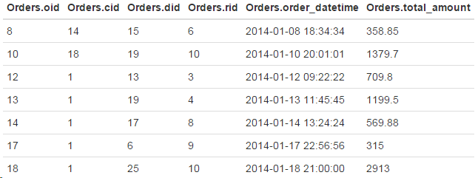

2.

(a) π name (σ rid = 9 (Dishes))

(b)   
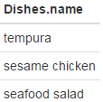

3.

(a) π name, phone_number, address (σ id = 9 (Users) ⨝ σ cid = 9 (Customers))

(b)

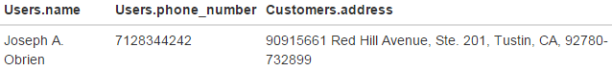

4.

(a) π address (σ name = 'wafu steak' (Orders_Contain_Dishes) ⨝ Orders ⨝ Customers)

(b)

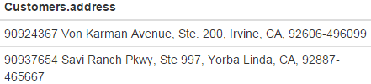

5.

(a) π name, quantity (σ ssn = '179589904' (Drivers) ⨝ Orders ⨝ Orders_Contain_Dishes)

(b)

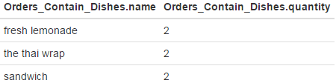

6.

(a) π cid, phone_number ((Customers - π cid, address (Customers ⨝ Orders)) ⨝ ρ cid <- id (Users))

(b)

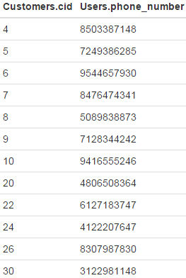

7.

(a) (π cid, rid (Orders)) ÷ (π rid (Restaurants)) ⨝ Customers

(b)

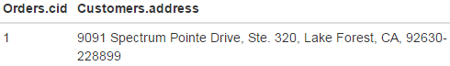

B. **Tuple Relational Calculus [30 pts]**

1. {o | o ∈ Orders ∧ o.total_amount > 300}
2. {t(name) | ∃d ∈ Dishes (t.name = d.name ∧ d.rid = 9)}
3. {t(name, phone_number, address) | ∃u ∈ Users (u.id = 9 ∧  
   t.name = u.name ∧  
   t.phone_number = u.phone_number) ∧  
   ∃c ∈ Customers (c.cid = 9 ∧  
   t.address = c.address)}
4. {t(address) | ∃c ∈ Customers(t.address = c.address ∧  
   ∃o ∈ Orders (o.cid = c.cid ∧  
   ∃ocd ∈ Order_Contain_Dishes (ocd.name = ‘wafu steak’ ∧  
   ocd.oid = o.oid)))}
5. {t(name, quantity) | ∃ocd ∈ Order_Contain_Dishes (t.name = ocd.name ∧  
   t.quantity = ocd.quantity ∧  
   ∃o ∈ Orders (o.oid = ocd.oid ∧  
   ∃d ∈ Drivers (d.did = o.did ∧  
   d.snn = ‘179589904’)))}
6. {t(id, phone_number) | ∃u ∈ Users (t.id = u.id ∧  
   t.phone_number = u.phone_number ∧  
   ¬∃o ∈ Orders (o.cid = u.id))}
7. {t(id, address) | ∃c ∈ Customers (t.id = c.cid ∧  
   t.address = c.address ∧  
   ∃o ∈ Orders (o.cid = c.cid ∧  
   ∀r ∈ Restaurants(r.rid = o.rid)))}