Ford Tang

46564602

CS 178

Homework #2

Problem 1

1. >> data = load('data/curve80.txt');  
   >> x = data(:,1);  
   >> y = data(:,2);  
   >> [Xtr Xte Ytr Yte] = splitData(x,y,.75);
2. >> lr = linearRegress(Xtr, Ytr);  
   >> xs = [0:.05:10]';  
   >> ys = predict(lr,xs);  
   >> plot(Xtr, Ytr,'r.', 'markersize',20);hold on;plot(xs,ys,'k-');hold off;  
   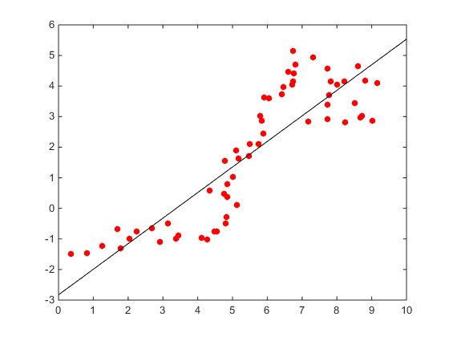  
   mse(lr, Xtr, Ytr) = 1.1277  
   mse(lr, Xte, Yte) = 2.2423
3. degree = [1, 3, 5, 7, 10, 18];  
   >> for i = 1:6,  
   figure(i)  
   XtrP = fpoly(Xtr, degree(i), false);  
   [XtrP, M, S] = rescale(XtrP);  
   lr = linearRegress(XtrP, Ytr);  
   Phi = rescale(fpoly(xs, degree(i), false), M, S);  
   ys = predict(lr, Phi);  
   plot(xs, ys, 'k-', Xtr, Ytr, 'r.', Xte, Yte, 'g.', 'markersize', 20)  
   XteP = rescale(fpoly(Xte, degree(i), false), M, S);  
   error(:,end+1) = [mse(lr, XtrP, Ytr) , mse(lr, XteP, Yte)]';  
   end;  
     
   degree = 1  
   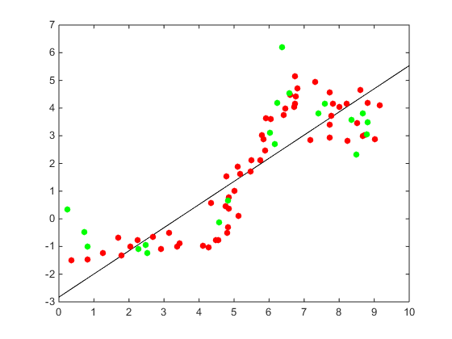  
     
     
     
     
     
     
     
     
     
     
     
     
     
     
     
     
     
     
     
     
     
   degree = 3  
   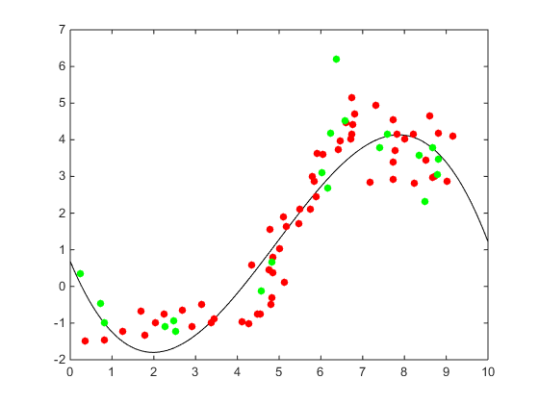  
   degree = 5  
   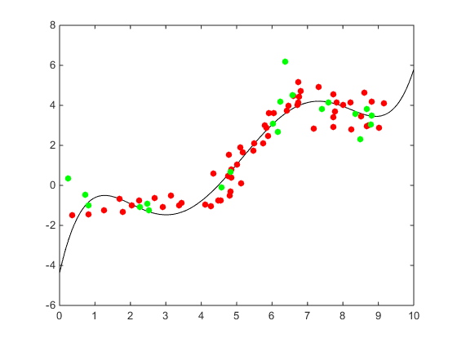  
     
     
     
     
   degree = 7  
   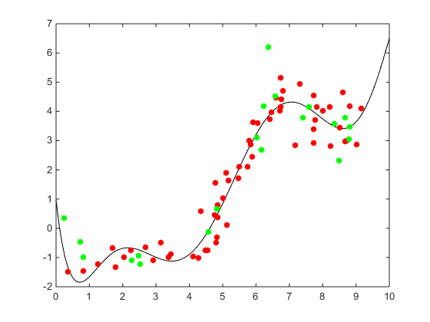  
   degree = 10  
   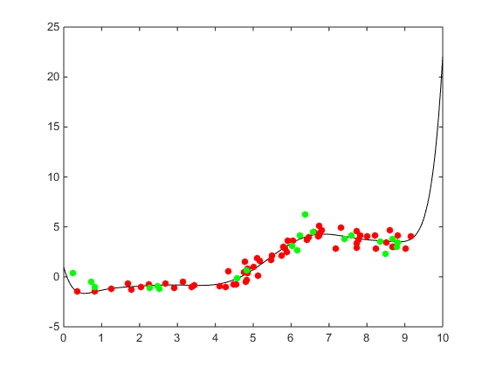  
     
     
     
     
   degree = 18  
   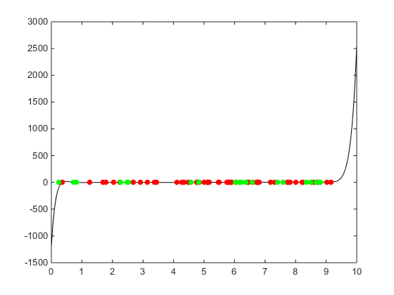  
   semilogy(degree, error(1,:),'-r',degree,error(2,:),'-g');  
   