Ford Tang

46564602

CS 178

Homework #3

Problem 1

1. plot(XA(:,1),XA(:,2),'k.');  
   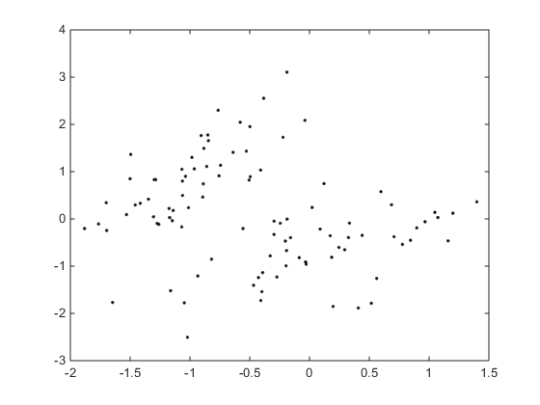  
     
     
     
     
     
     
     
     
     
     
     
     
     
     
     
     
     
     
     
   plot(XB(:,1),XB(:,2),'k.');  
   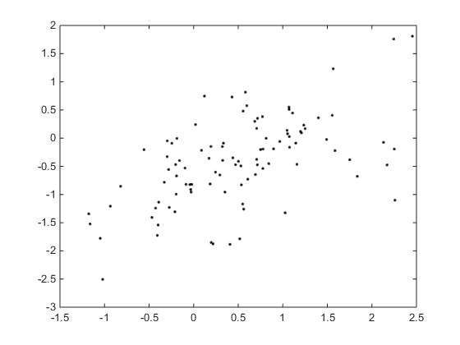  
   XA is clearly seperable, while XB is not.
2. function plot2DLinear(obj, X, Y)  
    [n,d] = size(X);  
    if (d~=2) error('Sorry -- plot2DLogistic only works on 2D data...'); end;  
     
    %%% TODO: Fill in the rest of this function...   
     
    class = unique(Y);  
    X1 = find(  
    X2 = X(:,2);  
    plot(X1(Y == class(1,:)), class(1,:), 'r.');  
    hold on;  
    plot(X1(Y == class(2,:)), class(2,:), 'g.');  
    plot(X2(Y == class(1,:)), class(1,:), 'r.');  
    plot(X2(Y == class(2,:)), class(2,:), 'g.');  
    hold off;  
     
   >> learner=logisticClassify2();  
   >> learner=setClasses(learner, unique(YA));  
   >> wts = [.5 1 -.25];  
   >> learner=setWeights(learner, wts);  
     
     
     
     
     
     
     
     
     
   >> plot2DLinear(learner, XA, YA)  
   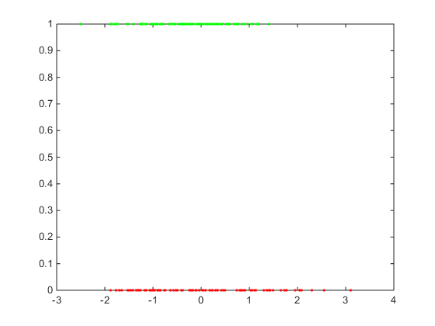  
   >> plot2DLinear(learner, XB, YB)  
   