Ford Tang

46564602

CS 178

Homework 5

* 1. iris = load('data/iris.txt'); X = iris(:,1:2);
  2. z = kmeans(X, 5, ‘farthest’);  
     plotClassify2D([], X, z)  
     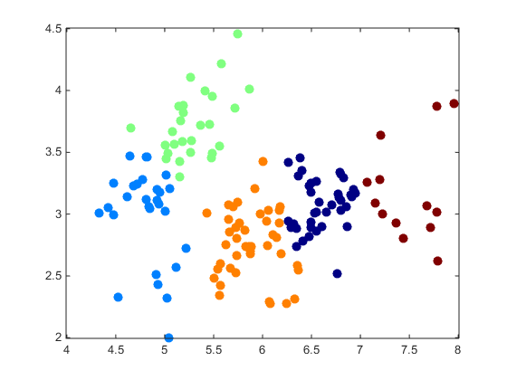  
     z = kmeans(X, 20, ‘k++’);  
     plotClassify2D([], X, z)  
     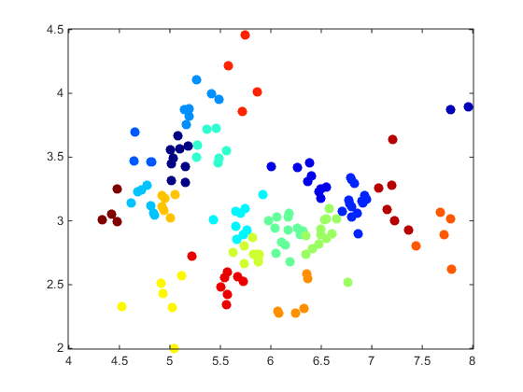
  3. y = linkage(X, 'single');  
     z = agglomCluster(y, 5);  
     plotClassify2D([], X, z);  
     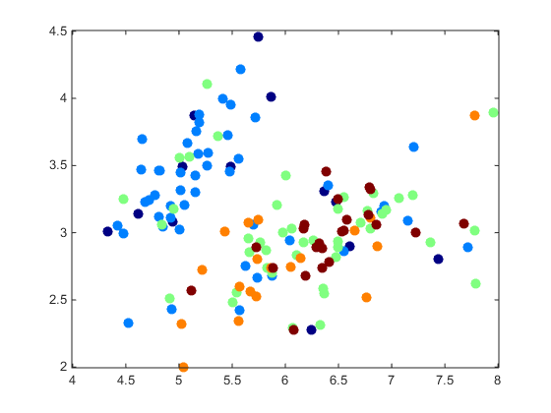  
     z = agglomCluster(y, 20);  
     plotClassify2D([], X, z);  
     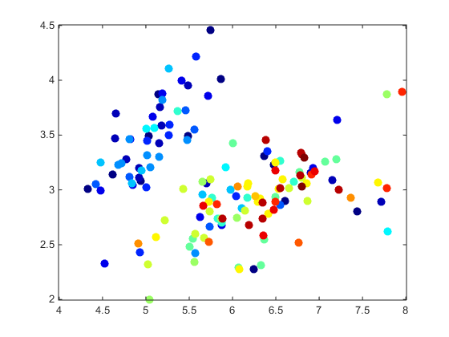  
     y = linkage(X, 'complete');  
     z = agglomCluster(y, 5);  
     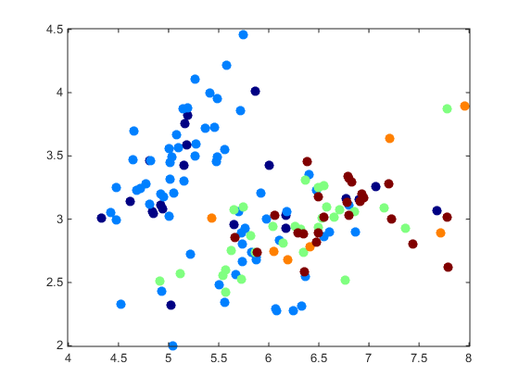  
     z = agglomCluster(y, 20);  
     plotClassify2D([], X, z);  
     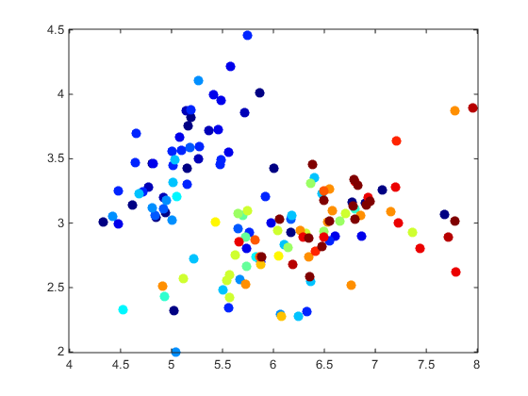
  4. z = emCluster(X, 5, 'farthest');  
     plotClassify2D([], X, z);  
     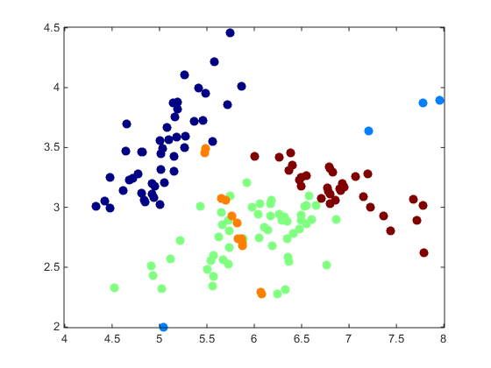  
     z = emCluster(X, 20, 'random');  
     plotClassify2D([], X, z);  
     