# Admin Guide – CATHAI

## Administration Dashboard

Users with admin access can use the ‘Administrator Dashboard’ in the top navigation bar:

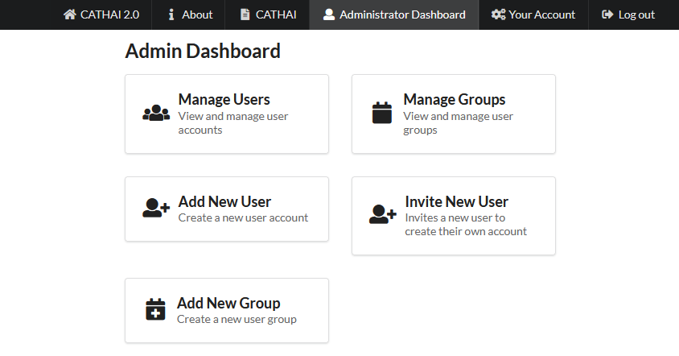

## Manage Users

Selecting ‘Manage Users’ from the admin dashboard will display a list of registered users:

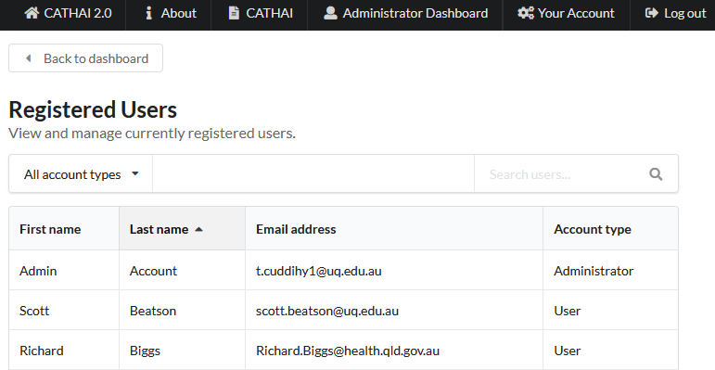

Clicking on a user will bring up their account:

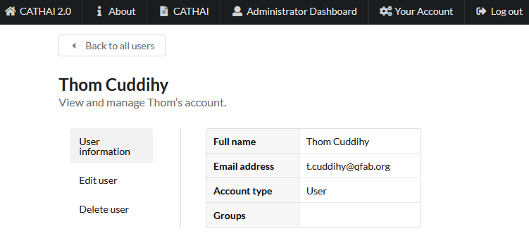

From here, one can edit their details by clicking on the ‘Edit user’ link:

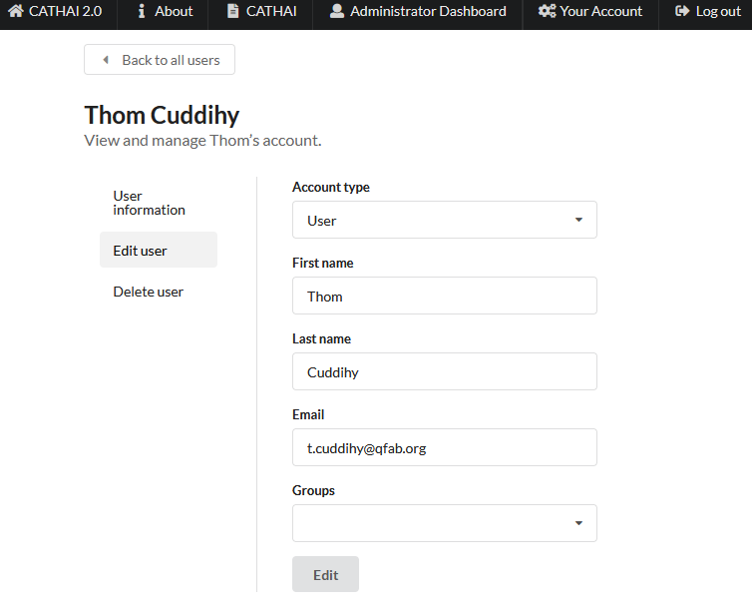

The account may also be deleted using the ‘Delete user’ link:

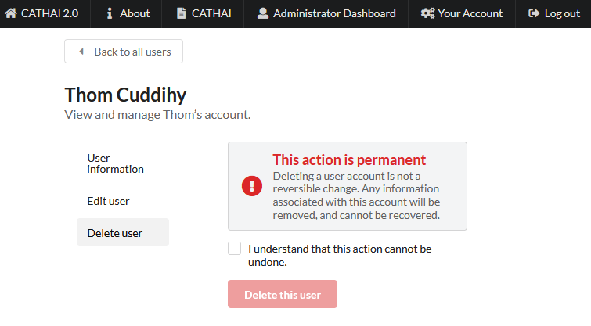

Note that one cannot modify or delete one’s own account. To update profile details, please see the relevant section in the Quick Guide. To delete one’s own account, please contact another administrator.

Also note that admins cannot change or reset users’ passwords. In case of a forgotten or breached password, please see the relevant section in the Quick Guide on how to request a password reset email.

## Add New User

One can manually add a new user by selecting ‘Add New User’ from the admin dashboard, and entering the account details, including the account password:

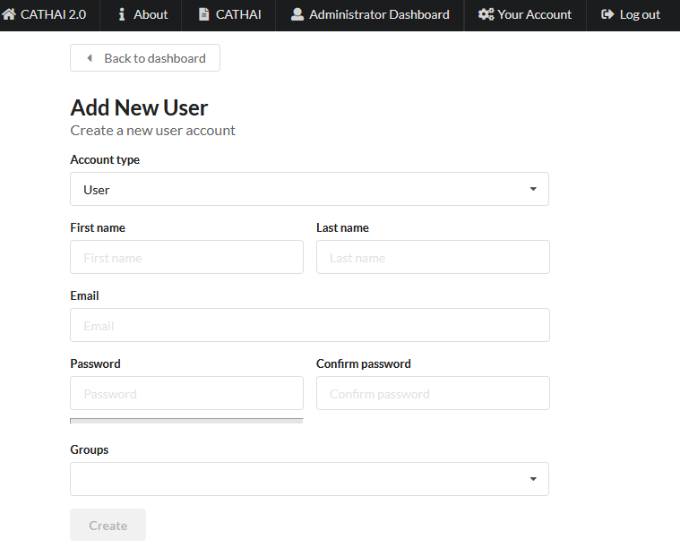

## Invite New User

One can manually invite a new user by selecting ‘Invite New User’ from the admin dashboard, and entering the account details, excluding the account password. This will generate an invite email that will be sent to the nominated email address to allow the user to set their own password:

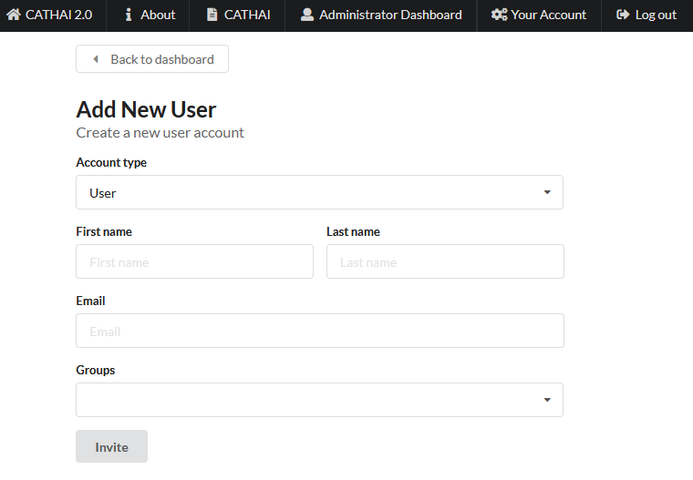

## Groups

Groups can be added and managed as per users using the relevant links in the admin dashboard. Note that this functionality is for planned future updates to CATHAI and is not currently in use and may be subject to change.

## Stack

CATHAI itself is a R Markdown app being served by Shiny Server and reverse proxied through a Flask Python app served by uWSGI and reverse proxied again through NGINX.

## Logging Locations

Shiny server: /var/log/shiny-server

uWSGI: /opt/cathai/cathai.log

NGINX: /var/log/nginx/

## Authentication

User passwords are stored as salted hashes using Werkzeug’s security module which uses the SHA-256 algorithm and 8-character length salt.

## Maintenance

Rotate logs as required.