# User Guide – CATHAI

## Registering

CATHAI is a closed system and requires manual registration. Please contact the following administrators regarding access:

* PLEASE ADD AS APPROPRIATE

## Log In

In a web browser, preferably Firefox or Chrome, navigate to: <https://cathai.fordelab.com/account/login>

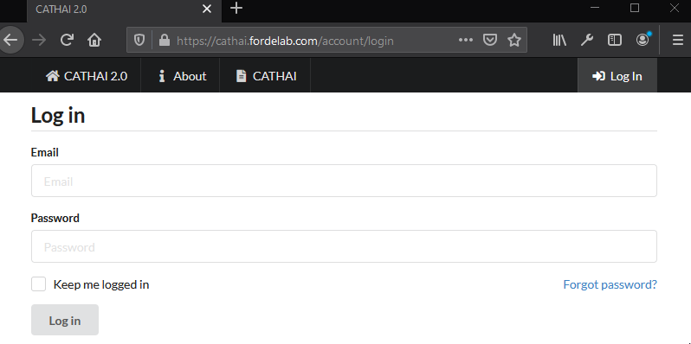

Enter the email address and password set on registration to login. Selecting ‘Keep me logged in’ will keep your session valid for up to 30 days.

## Reset Password

If required, click on “Forgot password?” and enter your registered email address to receive a password reset email:

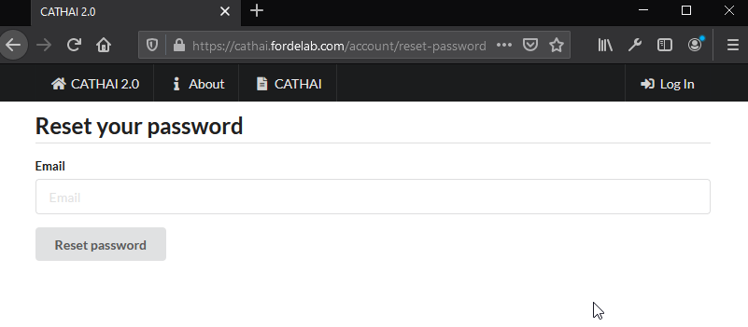

## Profile Management

Once logged in, click on “Your Account” on the top navigation bar to manage your profile:

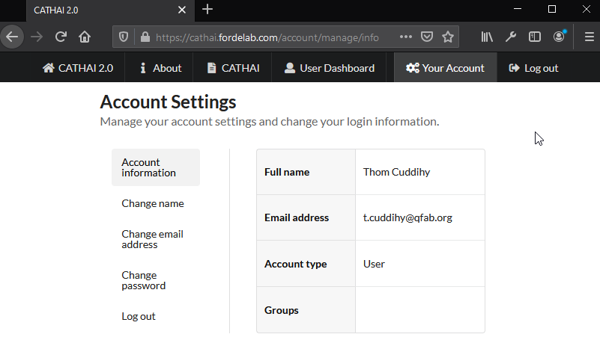

You can modify your name, email address, and password from here.

## Accessing CATHAI

At any time, you can access CATHAI by clicking on the “CATHAI” link in the top navigation bar:



## Overview

The primary screen can be broken down into the following segments:

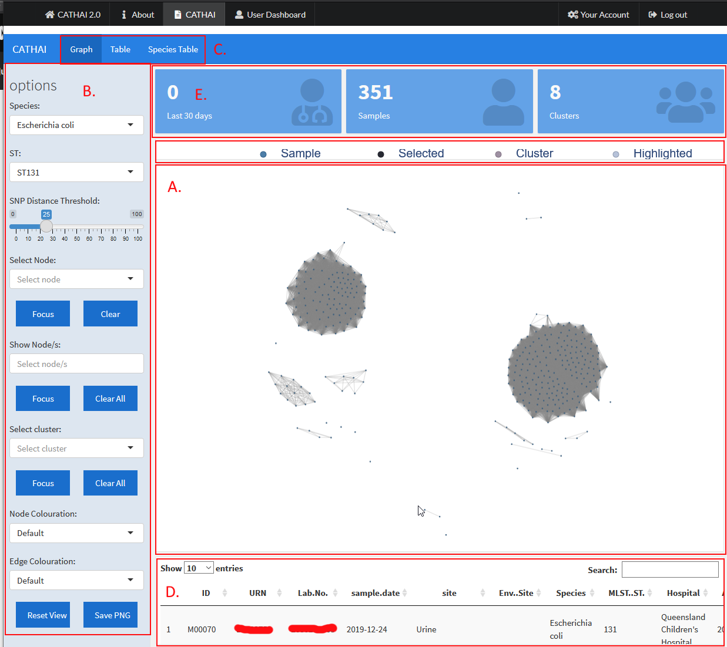

1. Graph view
2. Options panel
3. Page selector
4. Graph page table. A fuller version is available from the page selector (C.)
5. Metric display

## Selecting a species and ST

In the options panel, click on the dropdown for ‘Species’ and select the desired species. By default, CATHAI will select E. coli on load.

Once a species has been selected, the ST dropdown will update with the available types. By default, CATHAI will select ST131 for E. coli and NA for other species.

## Setting the SNP Distance Threshold

In the options panel there is a slider from 0 to 100 SNPs that sets the threshold for connecting samples (graph nodes) with a line (graph edge). This provides a quick visual indication for samples that are genetically similar to each.

By default, this is set at 25 SNPs, however this may not be appropriate depending on the sample counts and size of species genome e.g.

## Selecting and highlighting samples

CATHAI offers two different methods for inspecting individual samples. The first, ‘Select Node’ in the options panel, allows for a single sample to be highlighted in the colour indicated in the graph view legend as ‘Selected’, and will set that sample as the reference for the SNP distance measure on node mouse-over, and in the table view:

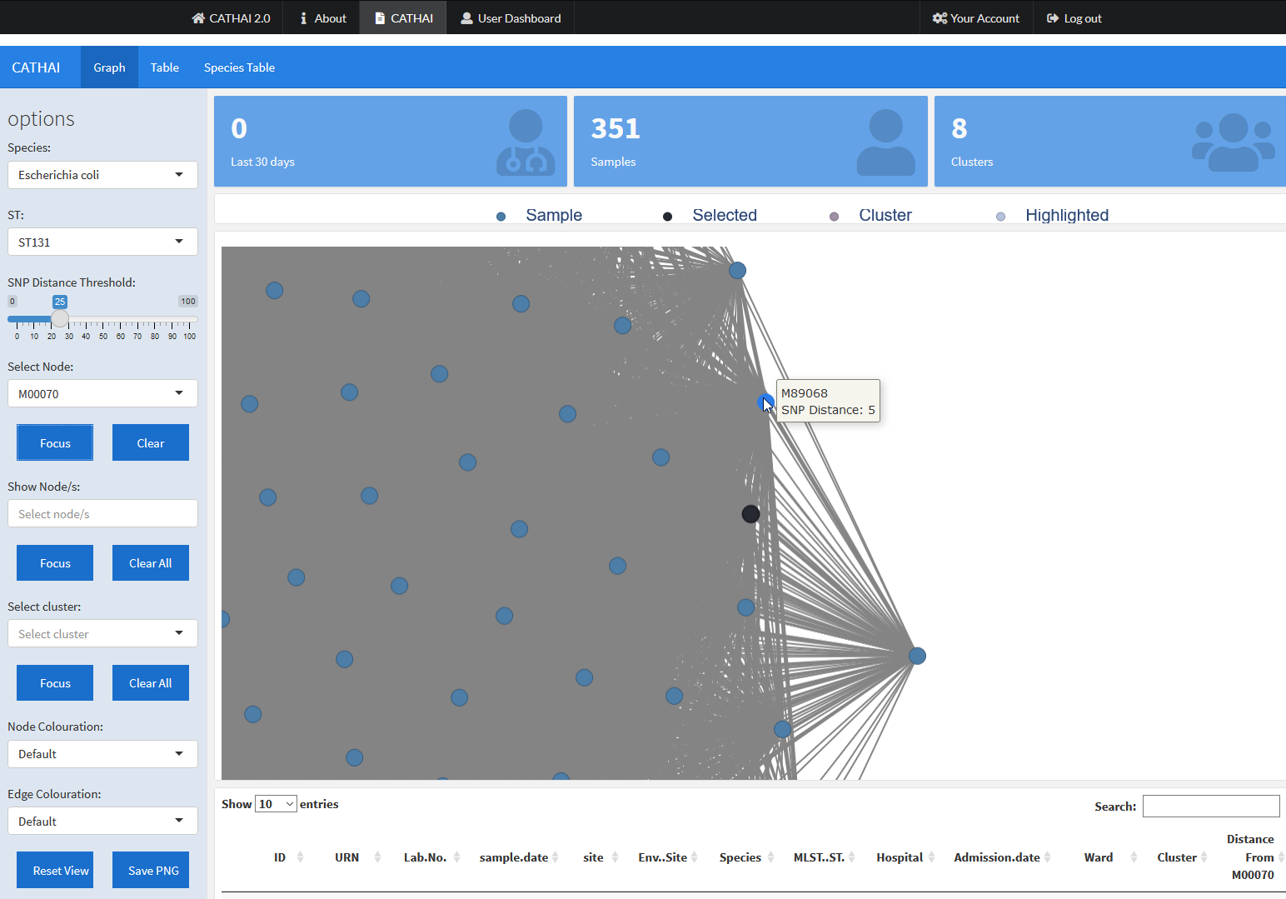

Mouse-over text for samples when a node is selected.

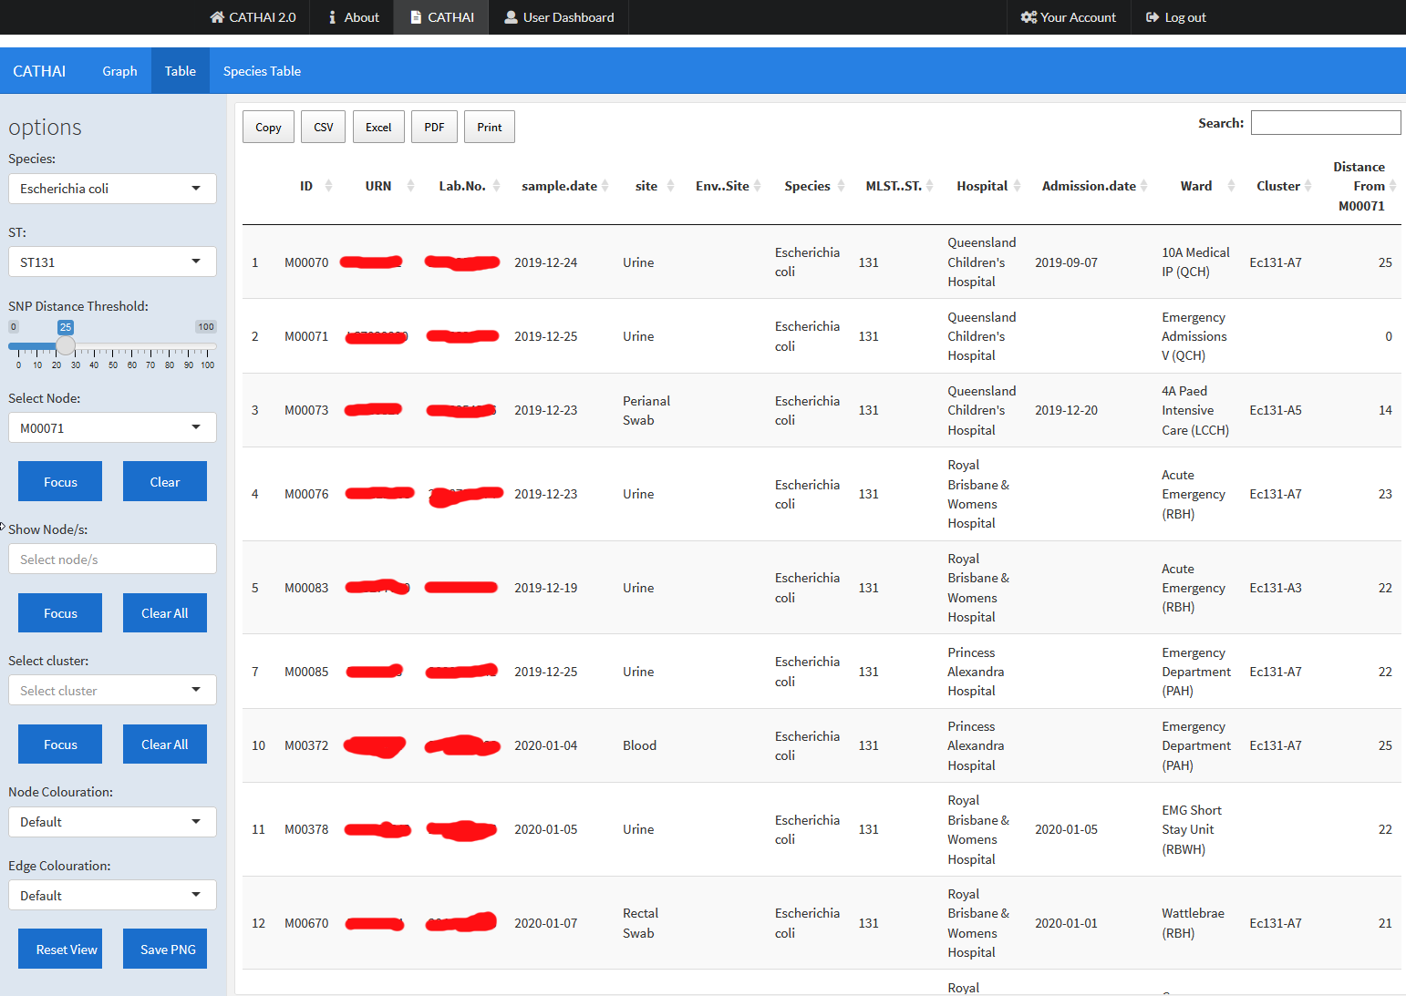

Additional column ‘Distance from …” when a node is selected.

For the options panel, there are also buttons under ‘Select Node’ for ‘Focus’ (zoom in on selected node) and ‘Clear’ (clears the selected node):

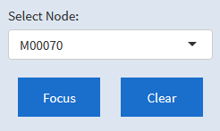

The second method for inspecting individual samples is done under the ‘Show Node/s’ section of the options panel. Clicking on this dropdown will allow the selection of multiple samples:

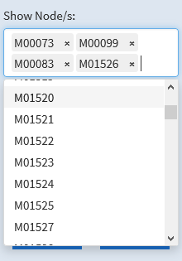

Node selected in this manner will be coloured as per the “Highlighted” colour of the graph view legend. Note that this will not affect any SNP distance metric unlike the ‘Select Node’ option, and is useful to visually differentiate samples. The ‘Focus’ button for ‘Show Node/s’ will adjust the graph view to display all the selected samples at the same time.

## Cluster Inspection

Where clusters have been identified, they will available for selection under the ‘Select cluster’ dropdown in the options panel. A quick way to see the number of clusters for a given species and ST is under the clusters section of the metric display panel.

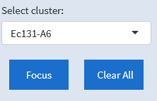

Selecting a cluster in this way will colour the samples in the cluster as per the ‘Cluster’ colour of the graph view legend. Clicking on ‘Focus’ will adjust the graph view to display the cluster:

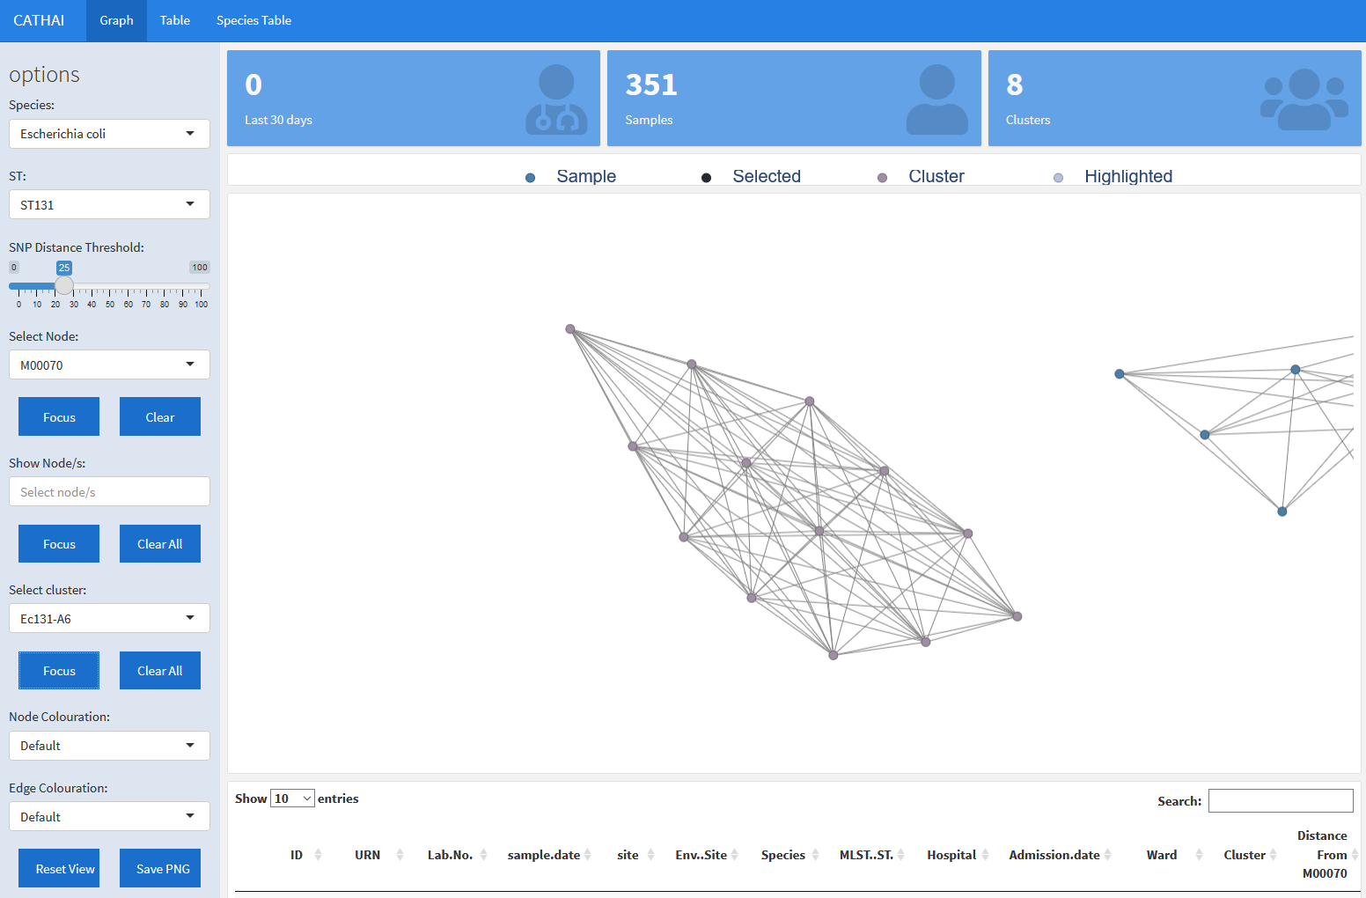

## Node and edge colouration

In addition to the default colouration, CATHAI supports multiple other options. From the relevant dropdowns in the options panel, node may be coloured by SNP distance from the selected node, the sample data, hospital and the site of collection. Edges may be coloured by SNP distance from each other, and the number of days between samples.

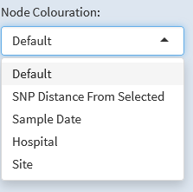 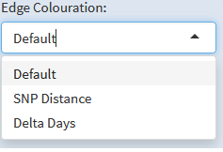

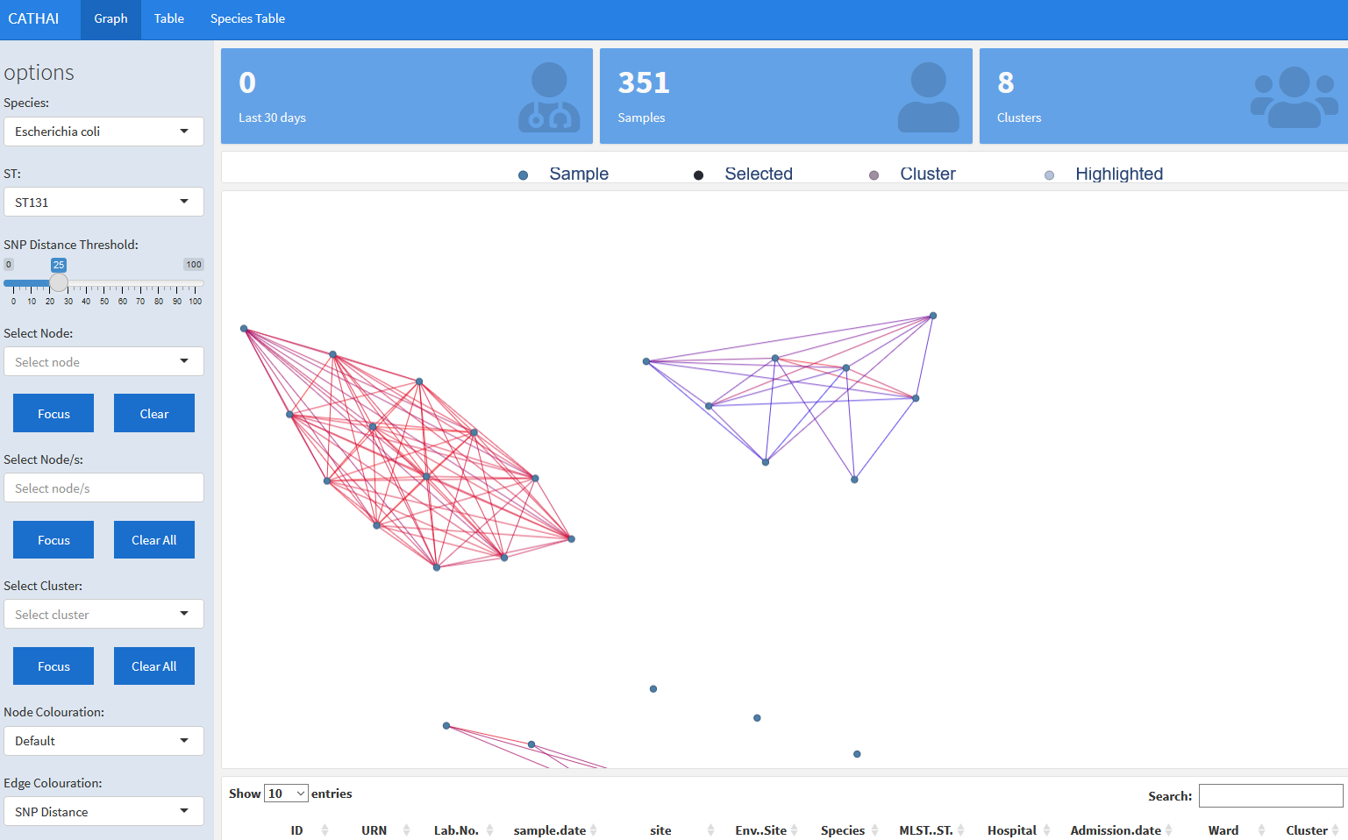

Graph view with edge colouration set to ‘SNP Distance’. This will colour the edges based on the SNP distance to each other, from the SNP Distance Threshold to 0 (blue to red).

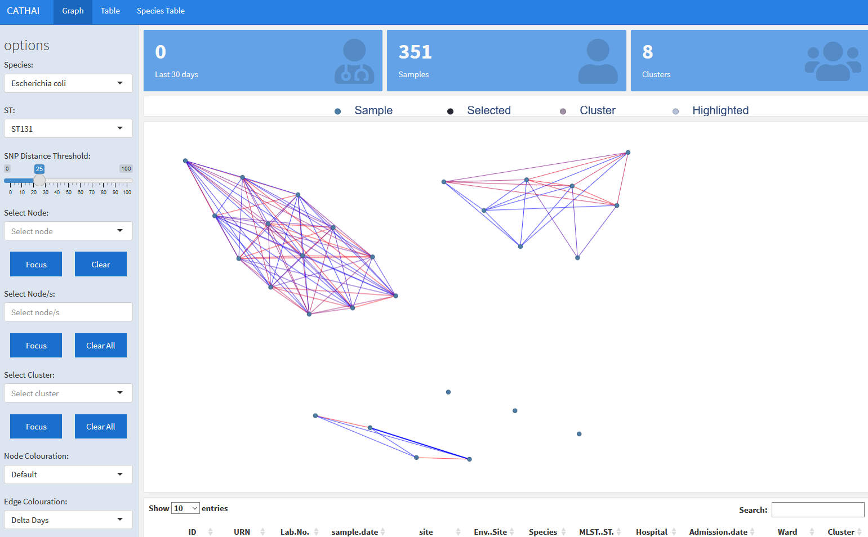

Graph view with edge colouration set to ‘Delta Days’. This will colour the edges based on the number of days between each sample, from the longest span to 0 days (blue to red).

## Table View

Inspection of metadata is possible under the ‘Table’ page. Exports to clipboard, CSV, Excel and PDF are available, as well as a print option and search functionality:

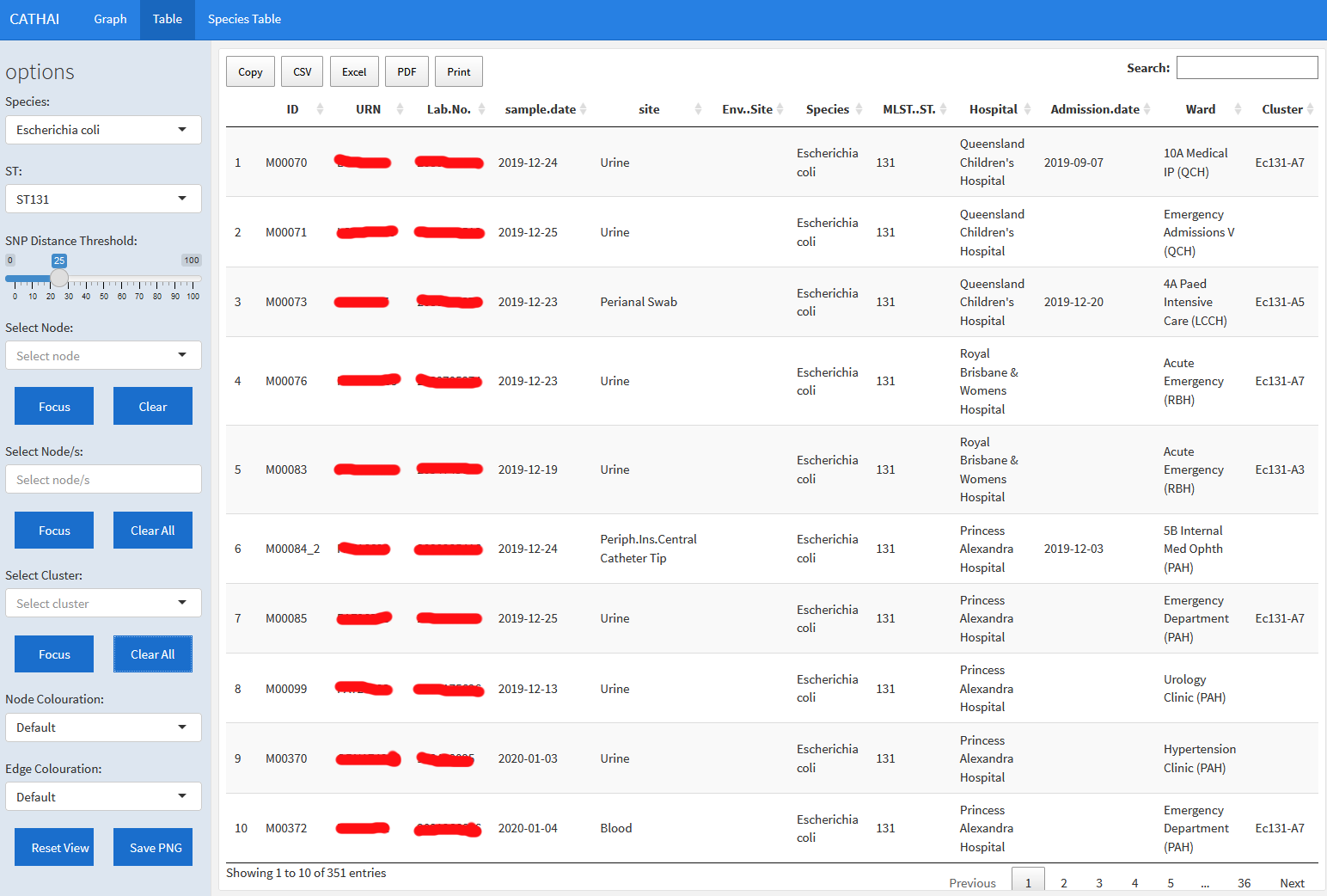

When either ‘Show Node/s’ and/or ‘Select Cluster’ have been selected, they will act to filter the ‘Table’ page listings to those samples only:

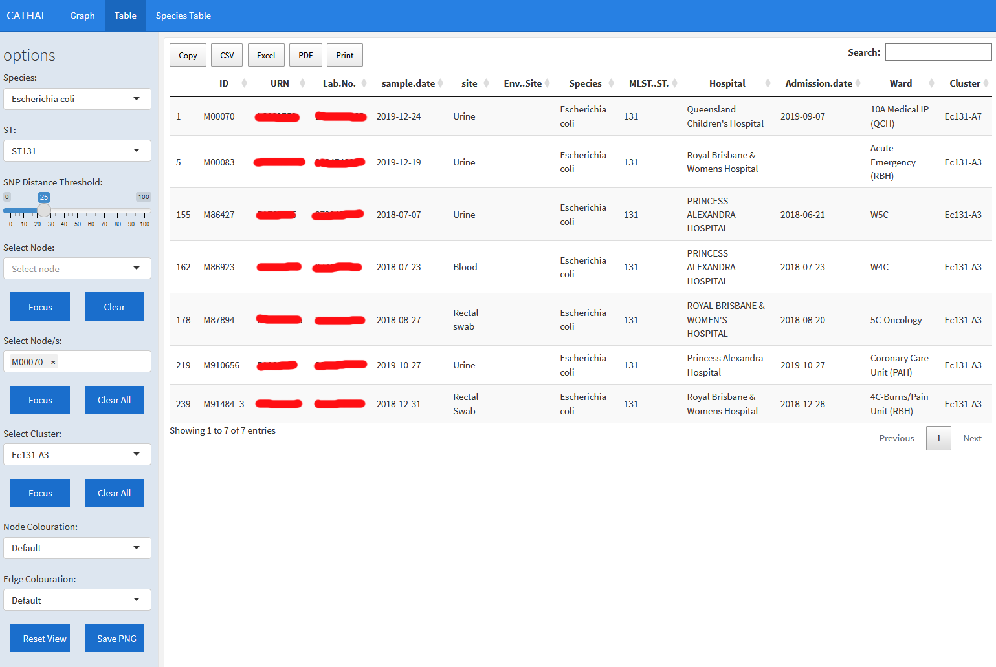

## Species Table View

Where it is useful to consider all samples from a species, the ‘Species Table’ page provides metadata for all samples. The same export and search functionality exist as per the ‘Table’ page, but note that selections for ‘Show Node/s’, ‘Select Node’, and/or ‘Select Cluster’ will not filter the listings:

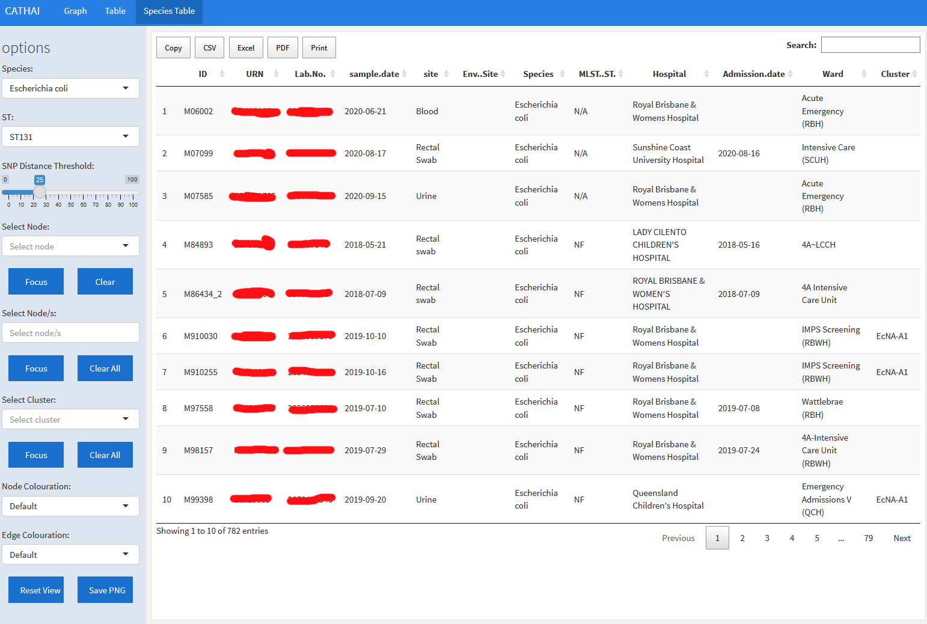

## Additional Features

The bottom of options panel includes two buttons, ‘Reset View’ (to return the graph view display to default) and ‘Save PNG’ (to export a picture of the current graph view).