SONORA: MUSIC PLAYLIST MANAGEMENT SYSTEM

TEOLOGO, IMMACULATE AMMETHIES A
BALDE, CLAYFORD E.
EGONIA, RICHELLE C.
YAP, SHENA MAE M.

  - Problem
Managing songs manually can become difficult when a catalog contains many tracks. Users may need to find a particular song, arrange songs into playlists, decide what should play next, and return to a previously played track. Without organized data structures, these tasks can be harder to manage and may require repeated searching or manual tracking.
Sonora addresses these needs through a single web application. It stores catalog and playlist data in a database and uses suitable data structures for playback navigation, queue management, listening history, and song lookup. The application is also designed to demonstrate the behavior of selected DSA techniques through interactive search, sorting, and live metrics.
1.2 Objectives
General Objectives:
The general objective of SONORA is to design and implement a web-based music playlist management system that demonstrates the practical use of data structures and algorithms.
Specific Objectives:
The project specifically aims to:
- To develop a web-based music playlist management system using Python Flask and SQLite.
- To allow users to register, sign in, browse songs, and manage personal playlists.
- To provide search, sorting, genre filtering, and playback navigation features.
- To implement and demonstrate arrays/lists, a queue, a stack, a doubly linked list, and a binary search tree.
- To apply linear search, binary search, bubble sort, selection sort, and binary-search-tree in-order traversal
- .To provide an administrator interface for publishing, editing, and deleting catalog songs.
- To connect the interface, backend routes, DSA engine, and database in one working application.
1.3 Scope and Limitations
Scope
- Account access: registration and sign-in for database users, session-based authentication, and a separate administrator access path.
- Music catalog: display songs and track play counts; search, sort, and filter the catalog by genre.
- Playlist management: create and delete playlists, view playlist contents, and add or remove songs.
- Playback controls: play, pause, move to the next or previous song, adjust volume, and scrub through the current playback progress.
- Queue and history: add songs to an Up Next queue and review recent listening history.

- Administrator tools: publish, edit, and delete songs, and view summary information such as catalog KPIs and genre distribution.
- DSA demonstration: use search and sorting endpoints and live states inspector to show data-structure behavior and metrics
Limitations
- The current player uses a browser-based Web Audio synthesizer to generate procedural audio based on genre; it does not establish that the app streams licensed commercial recordings from an external music service.
- Search and sorting performance depends on the size and ordering of the catalog and on how the selected method is implemented.
- The binary search algorithm requires sorted data. A binary search tree can become less efficient if it is unbalanced.
- The described administrator account includes a static credential in the project design. Hard-coded credentials are suitable only for a controlled demonstration and should be replaced with secure secret handling before public deployment.
- Actual deployment security, large-scale traffic handling, and commercial music licensing are outside the stated project scope.

1.5 Tools and Technologies
Tool/Technology | Purpose | Use in Sonora
Python | Backend programming language | Implements server routes and DSA classes.
Flask | Web Framework | Handles HTTP routes, sessions, authentication checks, and APIs.
SQLite | Relational Databases | Stores users, songs, playlist, playlist-song links, and listening history.
HTML | Page Structures | Renders authentication, user dashboard, and settings pages.
CSS | Visual design | Creates the neumorphic interface and page-specific layouts.
JavaScript | Frontend behavior | Handles catalog updates, forms, player controls, queue/history views, and API requests.
Web Audio API | Browser audio generation | Generates procedural audio with genre-based tones and waveforms.
Data Structure and Algorithms | Data organization and processing | Supports playback navigation, queue order, history, searching, and sorting.

2. System Design

Sonora uses a three-layer design. The frontend displays the pages and sends requests; the Flask backend validates requests and coordinates application logic; and SQLite stores persistent records. The DSA engine provides reusable structures and algorithms to the backend.

2.1 System Flowchart
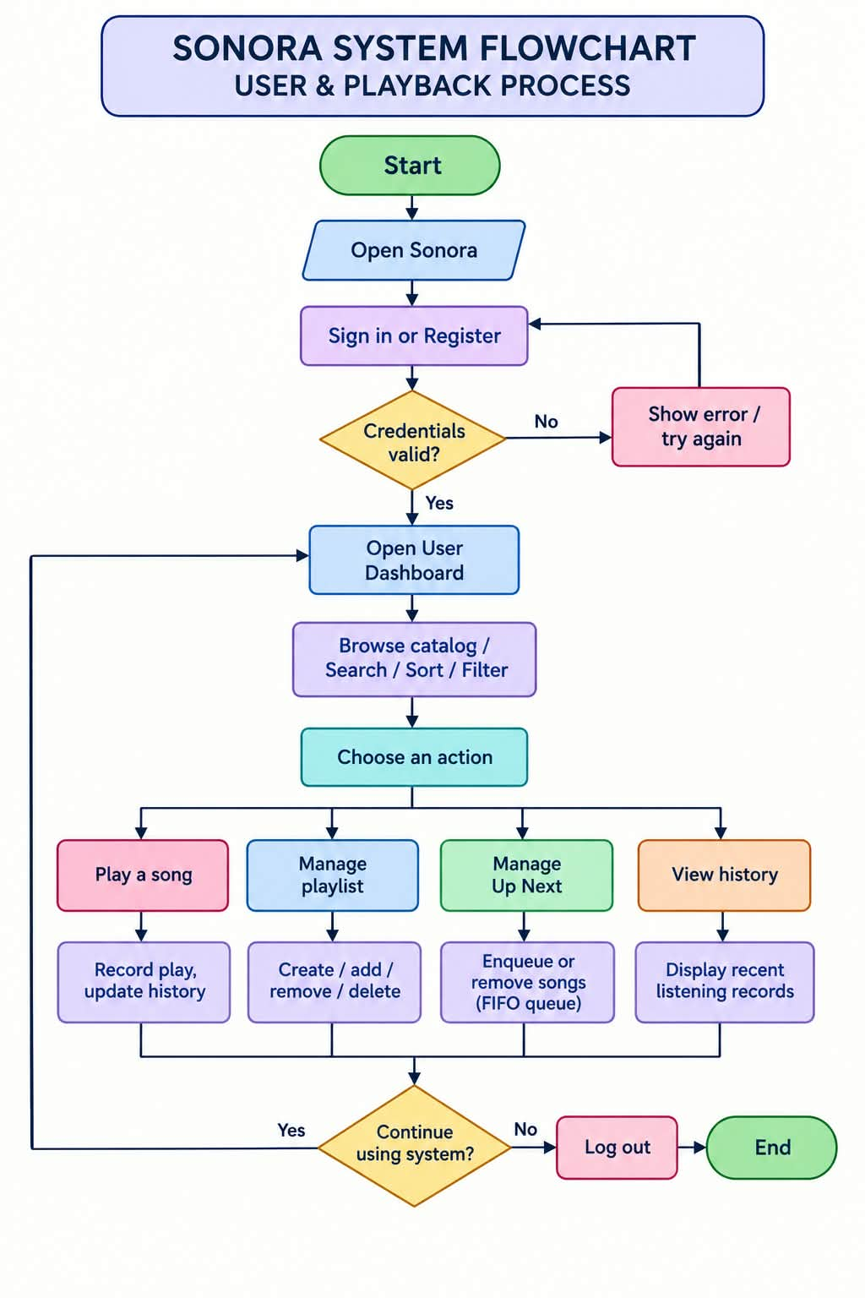
(Sonora System Flowchart- User and Playback Process)

3. Data Structures and Algorithms
The DSA engine is separated into dsa.py. The following structures are assigned specific jobs so that the application can demonstrate how different ways of organizing data affect behavior and efficiency.

Data Structure | Class/Representation | Purpose | Typical Operation
Array/List | Song/ArrayManager | Stores and filters catalog items, extract genres. | Iterate, filter, append
Queue(FIFO) | MusicQueue | Stores songs waiting to play in the order they were added. | Enqueue at rear; dequeue at front
Stack(LIFO) | PlaybackStack | Tracks playback history and supports last-in-first-out undo/pop behavior. | Push and pop
Doubly Link List | DoublyLinkList | Moves between playlist tracks in both directions. | Next and previous node
Binary Search Tree | SongBST | Indexes song titles for ordered lookup and traversal. | Insert,search,in-order traversal

3.1 Algorithms
Linear Search
Linear search checks items one by one until the target is found or the list ends. It works even when the data is not sorted.

LINEAR_SEARCH(items, target)
for each item in items
if item matches target
return item
return NOT_FOUND

Time complexity: O(n) in the worst case, because every item may need to be checked.

Binary Search
Binary search compares the target with the middle item of a sorted list. It discards half of the remaining search range after each comparison.
BINARY_SEARCH(sorted_items, target)
low = 0
high = length(sorted_items) - 1
while low <= high
mid = floor((low + high) / 2)
if sorted_items[mid] equals target
return sorted_items[mid]
else if sorted_items[mid] is less than target
low = mid + 1
else
high = mid - 1
return NOT_FOUND

Time complexity: O(log n) for a sorted array/list. The list must be sorted using the same comparison rule before this algorithm is used.

Bubble Sort
Bubble sort compares adjacent items and swaps them when they are in the wrong order. Repeated passes move larger items toward the end of the list.

BUBBLE_SORT(items)
for i from 0 to length(items) - 1
for j from 0 to length(items) - i - 2
if items[j] should come after items[j + 1]
swap items[j] and items[j + 1]
return items

Time complexity: O(n²) in the average and worst cases. It is simple to demonstrate but is not ideal for very large catalogs.

Selection Sort
Selection sort finds the smallest remaining item and swaps it into the next position in the sorted section.
SELECTION_SORT(items)
for i from 0 to length(items) - 1
smallest = i
for j from i + 1 to length(items) - 1
if items[j] should come before items[smallest]
smallest = j
swap items[i] and items[smallest]
return items

Time complexity: O(n²) in the average and worst cases. It performs a limited number of swaps, but still compares many pairs of items.

BST In-Order Traversal
In-order traversal visits the left subtree, then the current node, then the right subtree. For a binary search tree ordered by title, this produces titles in sorted order.

IN_ORDER(node)
if node is not null
IN_ORDER(node.left)
visit(node.song)
IN_ORDER(node.right)

Time complexity: O(n) to visit every node. The traversal uses O(h) call-stack space, where h is the tree height. A balanced tree has height around log n; an unbalanced tree can have height n.

3.2 Pseudocode
Queue: Add a Song to Up Next
ENQUEUE_SONG(song)
create queue if it does not exist
add song to the rear of the queue
update the Up Next display

Queue: Play the Next Song
PLAY_NEXT()
if Up Next queue is not empty
song = remove the front item from queue
else
song = next song in the doubly linked list

if song exists
set song as current
record song in listening history
start playback
else
show that no next song is available

Stack: Record and Undo Playback History
RECORD_PLAY(song)
push song onto playback history stack
save listening record to database

UNDO_LAST_PLAY()
if playback history stack is not empty
remove the top item from the stack
update the history display
else
report that there is no item to undo

The database is used for persistent records, while the in-memory stack supports LIFO behavior during the active session. Exact synchronization behavior depends on the implementation of the history API.

Playlist: Add a Song
ADD_SONG_TO_PLAYLIST(playlist, song)
verify that the playlist belongs to the current user
verify that the song exists
if the song is not already linked to the playlist
insert playlist-song relationship into database
update the playlist display
otherwise
show an appropriate message

Search and Sort Request
PROCESS_DSA_REQUEST(mode, songs, target_or_order)
receive request from the frontend
validate the selected mode
if mode is linear search
run linear search
else if mode is binary search
sort or confirm sorted data, then run binary search
else if mode is BST search
search the song-title tree
else if mode is bubble sort
run bubble sort
else if mode is selection sort
run selection sort
else if mode is BST traversal
return in-order traversal results
return results and available metrics to the frontend

4. System Implementation
Sonora is a web-based Music Playlist Management System developed using Python Flask, SQLite, HTML, CSS, and JavaScript. The system combines a user interface, a backend server, a database, and a Data Structures and Algorithms (DSA) engine to provide music catalog management, playlist organization, playback controls, and song searching and sorting.
The frontend allows users to interact with the system, while Flask processes their requests and communicates with the SQLite database. The DSA engine manages the organization and processing of song information using different data structures and algorithms.

4.1 System Features

Sign in and registration: Users can access the system through the authentication page. Session-based checks protect routes that require a logged-in user.
User dashboard and catalog: The dashboard displays the song catalog and provides controls for searching, sorting, filtering by genre, and choosing a song.
Playlist management: Users can create and delete playlists and add or remove songs. Playlist relationships are stored in the playlist_songs table.
Up Next queue: The queue follows First In, First Out (FIFO), so the first song added is the first song selected for queue-based playback.
Listening history: The application records played songs and uses a stack to demonstrate Last In, First Out (LIFO) behavior. Persistent listening records are stored in SQLite.
Playback controls: The player supports play/pause, next/previous navigation, progress scrubbing, and volume control. The current audio is generated by a browser-based Web Audio synthesizer.

Search and sorting: The DSA interface can demonstrate linear search, binary search, BST search, bubble sort, selection sort, and BST in-order traversal, with live metrics where implemented.
Administrator dashboard: The administrator can publish new songs and edit or delete existing catalog entries. Summary cards and genre distribution provide a quick catalog overview.
Profile and password settings: Users can update profile information and submit a password update through the settings page.
Live DSA state inspector: The DSA state endpoint exposes information used to inspect current structures and demonstrate how they change as users interact with the system.

4.2 System Screenshots
User Dashboard
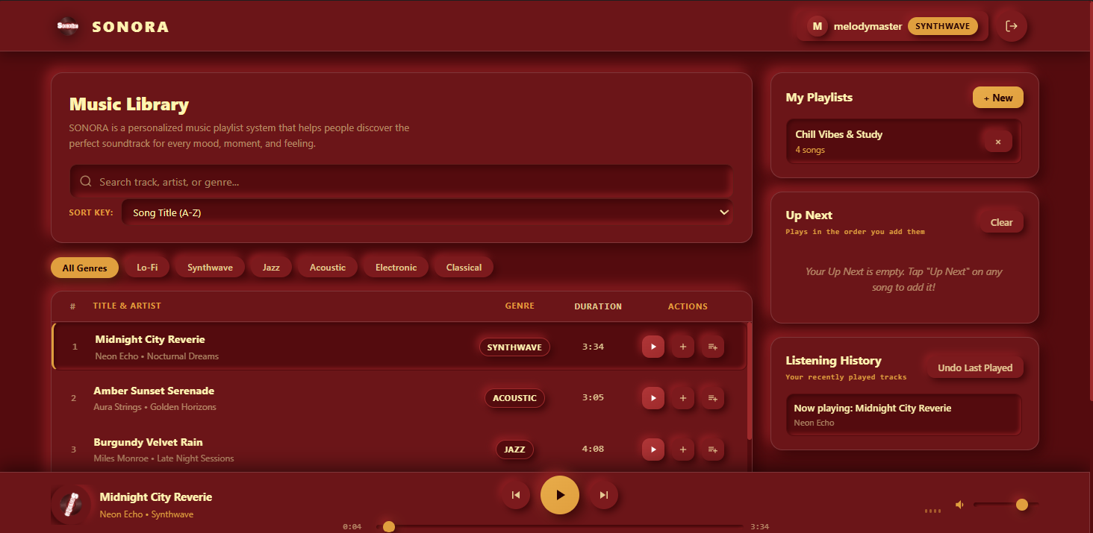

4.3 DSA Implementation
The DSA implementation is centered in dsa.py and is accessed by the Flask backend through API routes. This separation keeps the data-structure logic reusable and avoids placing all DSA operations directly inside the frontend code.

Implementation by component
Component | Where it is used | Expected Behavior
Doubly Linked List | Player next/previous navigation | Each node links to previous and next nodes, allowing movement in either direction.
MusicQueue | Up Next queue API | Enqueue adds the rear; dequeue removes from the front.
PlaybackStack | Listening history/undo | Push adds the latest item to the top; pop removes the latest item.
SongBST | Catalog title index and BST search | Titles are placed according to comparison rules; search follows left or right links.
SongArrayManager | Catalog filtering and genre extraction | Iterates through song records to filter items or collect genre values.
Search algorithms | DSA search endpoint | Returns a matching song or a not found results.
Sorting algorithms | DSA sort endpoint | Returns songs in the selected order for display.
State endpoint | Live inspector | Provides current structure states or summary data to help users observe operations.

Database design
The SQLite database contains the following main tables:
- users — stores user account and profile data.
- songs — stores music catalog details and play-count information.
- playlists — stores playlists and their owner relationship.
- playlist_songs — links playlists and songs in a many-to-many relationship.
- listening_history — stores persistent records of songs played by users.
Database helper functions initialize the schema, seed demonstration records, and perform create, read, update, and delete operations. Foreign-key cascades help remove dependent relationship records when the relevant parent record is deleted, when configured and enforced by SQLite.

API and frontend connection
- /api/songs — provides catalog data; song play tracking updates play counts and history.
- /api/dsa/search — handles the selected search method.
- /api/dsa/sort — handles the selected sorting method.
- /api/dsa/state — returns information for the live DSA inspector.
- /api/queue — supports queue operations such as adding, removing, and retrieving queued songs.
- /api/history — supports listening-history operations.
- /api/playlists — supports playlist creation, viewing, deletion, and song membership changes.
- /api/player/next and /api/player/prev — coordinate playback navigation.
- Administrator routes — publish, edit, and delete catalog songs.
- Settings routes — update profile and password information.

Frontend JavaScript calls these routes and updates the page based on the returned results. For example, user_dashboard.js manages catalog and playlist displays, player.js controls playback, audio_synth.js generates audio, admin_dashboard.js manages catalog administration, settings.js submits settings forms, and auth.js handles authentication form behavior and the logo-based admin gate.

