Enterprise Architecture Design: CognitiveDoc AI
Integration between Microsoft Azure and IBM Cloud
1. High-Level Architecture Overview
CognitiveDoc AI utilizes a Hybrid Multi-Cloud Architecture:
• Azure DevOps (Microsoft) is used for project management, source control, and the automated CI/CD pipeline (DevOps Layer).
• IBM Cloud hosts the serverless runtime (IBM Code Engine) and the core AI services (watsonx.ai and Watson Discovery).
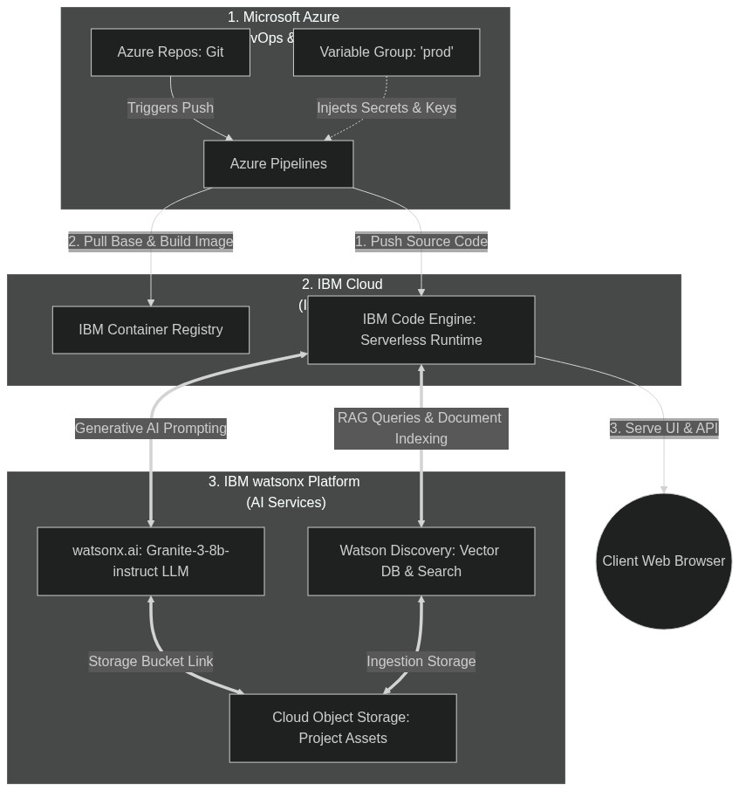
Figure 1.1: Multi-Cloud Integration Architecture Diagram
2. CI/CD Lifecycle (Azure to IBM Cloud)
Code pushed to Azure Repos triggers a pipeline that: installs node packages, verifies boot, logs into IBM Cloud, cleans old container images, and deploys to Code Engine from source.
3. RAG Runtime Data Flow (The AI Integration)
• Upload: PDF uploads are saved locally and pushed to Watson Discovery collection.
• Query: Search inputs query Watson Discovery for relevant text passages. The returned text block is formatted as context and sent to watsonx.ai (Granite-3-8b-instruct) to synthesize the cited answer.
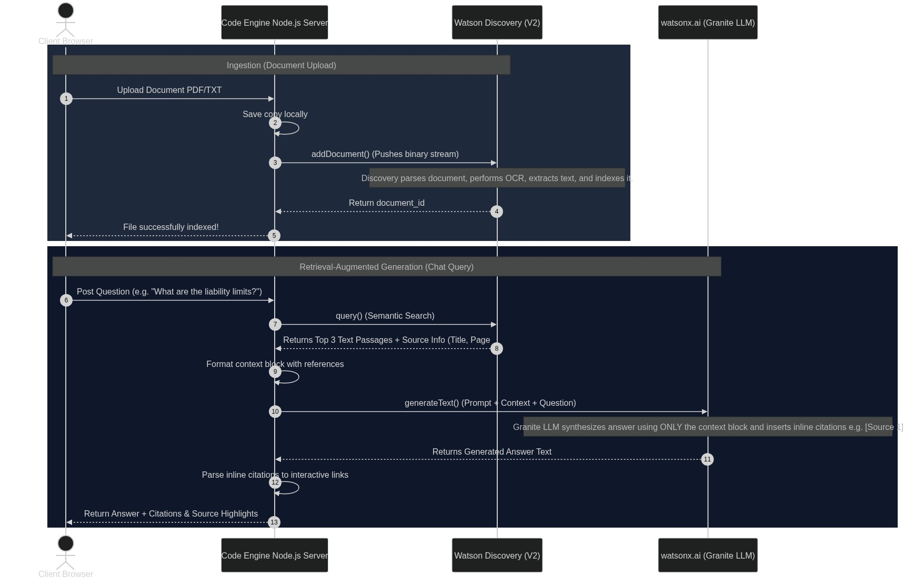
Figure 1.2: RAG Pipeline Runtime Interaction Sequence
4. Resource Directory
Resource | Functionality
Azure Pipelines | Runs CI/CD, runs boot validation, and deploys to Code Engine.
IBM Code Engine | Serverless runtime hosting Node.js server, scaling to zero when idle.
Watson Discovery | Performs semantic search across uploaded PDFs.
watsonx.ai | Large Language Model (Granite) generating cited natural answers.
IBM Cloud Object Storage | Primary storage bucket for Watson Discovery files.

