Remarque Feature Probe
Disposable document for the rebuild inventory. UNIQUE_TOP_ANCHOR

Inline formatting
Plain bold, italic, both, strike, inline_code, highlight, H₂O, x², 🚀 and snake_case.
An inline equation 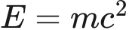 and literal prices $5 and $10.
Inline link and reference link. Other Note

Lists and callouts
- Parent
  - Child
    - Nested ordered child
☐ Unchecked task
☑ Checked task
- Third
- Fourth
Ordinary quote
Continued paragraph.
Custom note title
A note with bold.
Tip
A tip.
Important
Important.
Warning
Warning.
Caution
Caution.
Custom box
A custom callout.

Tables
Left | Center | Right
bold | escaped | pipe | 42
link | code | 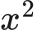

Code and equations
SWIFT
let greeting = "Hello"
// A comment
print(greeting)
TEXT
```nested fence```
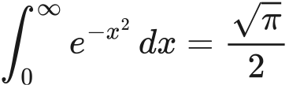

Extended structure
A footnote reference.¹
Term
First definition
Second definition
Expandable section
Hidden Markdown and .

Setext heading
Hard break follows.
Second line.

Diagrams
Flow probe
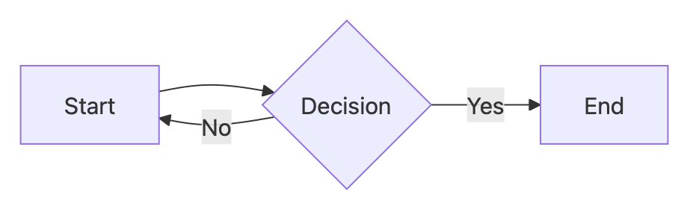
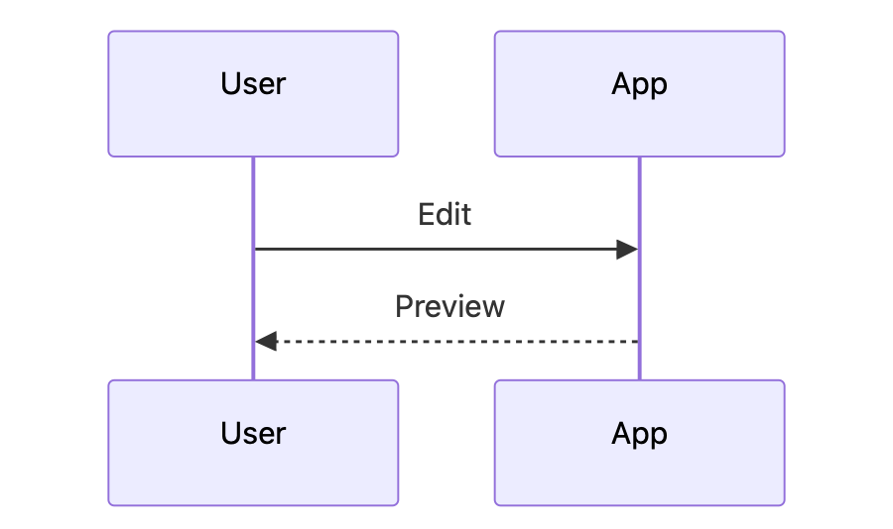
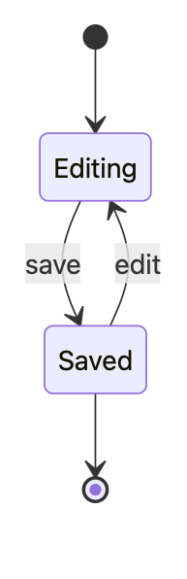
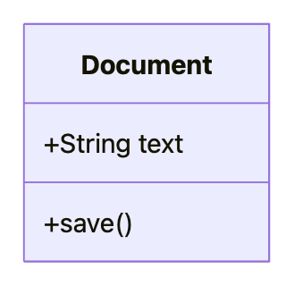
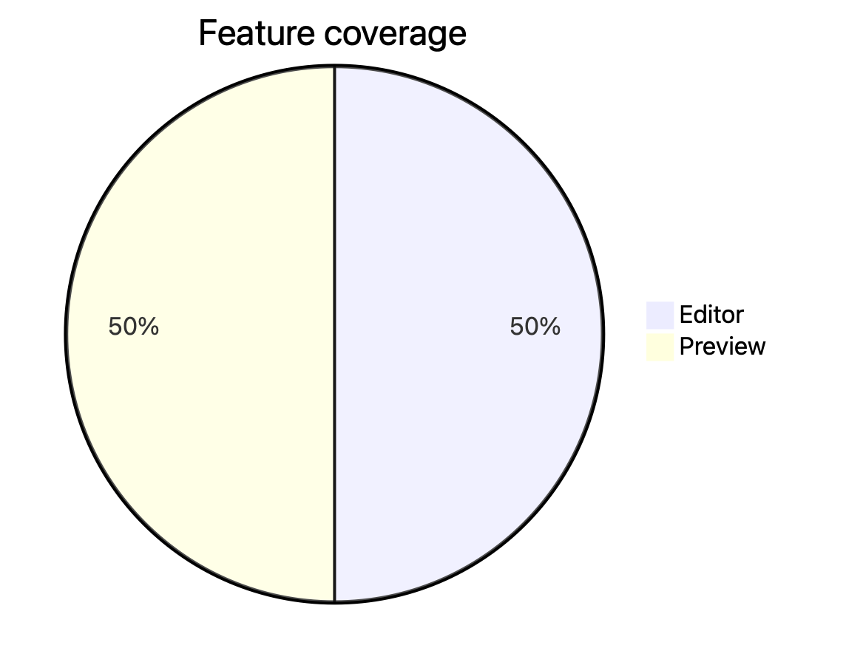

Repeated heading
First duplicate. UNIQUE_MIDDLE_ANCHOR

Repeated heading
Second duplicate. Unicode: café, 日本語, 👩🏽‍💻.

End marker
UNIQUE_BOTTOM_ANCHOR. Selecting this rendered sentence should identify this source paragraph in the rebuilt editor.

1. Footnote content.

