Remarque Feature Probe
Disposable document for the rebuild inventory. UNIQUE_TOP_ANCHOR
Inline formatting
Plain bold, italic, both, strike, inline_code, highlight, H₂O, x², 🚀 and snake_case.
An inline equation 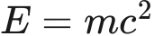 and literal prices $5 and $10.
Inline link and reference link. Other Note
Lists and callouts
• Parent
• Child
1. Nested ordered child
☐ Unchecked task
☑ Checked task
3. Third
4. Fourth
Ordinary quote
Continued paragraph.
Custom note title
A note with bold.
Tip
A tip.
Important
Important.
Warning
Warning.
Caution
Caution.
Custom box
A custom callout.
Tables
Left Center Right
——— ——— ———
bold escaped | pipe 42
link code x^2
Code and equations
let greeting = "Hello"
// A comment
print(greeting)
```nested fence```
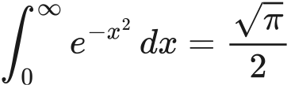
Extended structure
A footnote reference.1
Term
First definition
Second definition
Expandable section
Hidden Markdown and 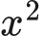.
Setext heading
Hard break follows.
Second line.

Diagrams
Flow probe
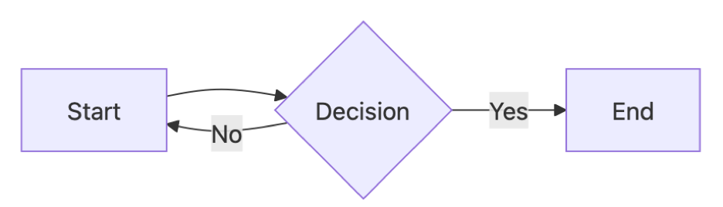
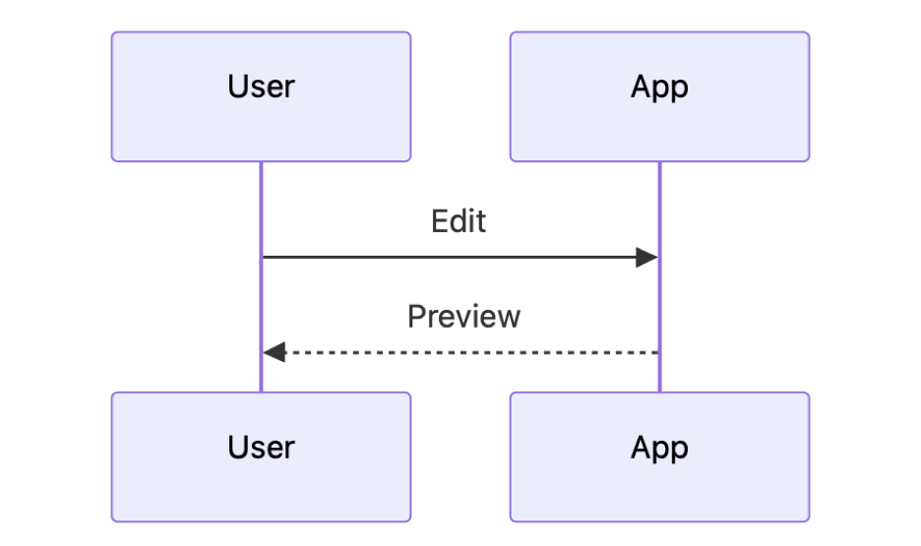
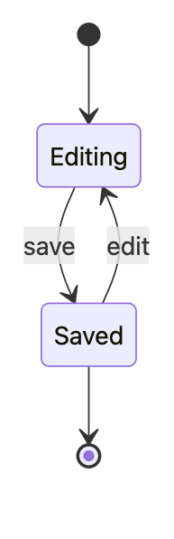
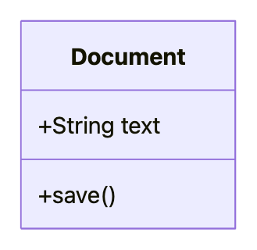
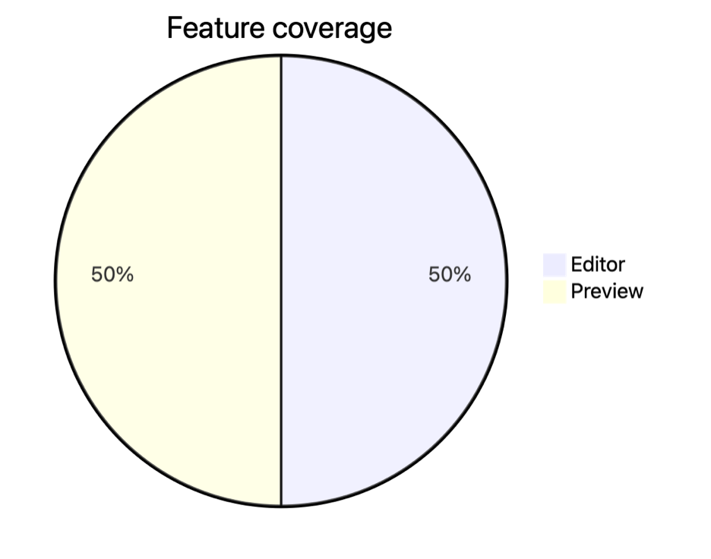
Repeated heading
First duplicate. UNIQUE_MIDDLE_ANCHOR
Repeated heading
Second duplicate. Unicode: café, 日本語, 👩🏽‍💻.
End marker
UNIQUE_BOTTOM_ANCHOR. Selecting this rendered sentence should identify this source paragraph in the rebuilt editor.

1. Footnote content.

