**Documentation Usage**

To begin run the script and the script will output “Enter Folder Location”. Input the first path you would like to browse too.

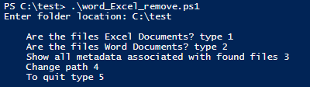

By selecting option 1 it will find all excel files and fully remove personal metadata and represent you with a menu option.

https://lh3.googleusercontent.com/QWuQsvWC-RymyMrY7uHw4pZy-xY3zdGqe9pKikx4AYvXQR7Mg4s7vWHXGvOldNcb2lulBuTF02eKuoWB_yt_uQFTIASV5i8U0_x2U3T3l9Zvh8ilFGbZYgpbYw

By selecting option 2 it will find all Word files and remove personal metadata and represent you with a menu option.

https://lh4.googleusercontent.com/c29vgcs1UGR_Qn1p7wM5qUWAt9iWKv9Gdpbsat6uhvFj6f1EjPTsAC6RNG9FpMMf8Krzu0jc9I4fZ28MXg7N31R-vuhzGQz8IjFFaotqmb-UiNiMLU6FQiMcuA

By selecting option 3 you can see the current metadata on the list of files in the inputted path and represent you with a menu option. 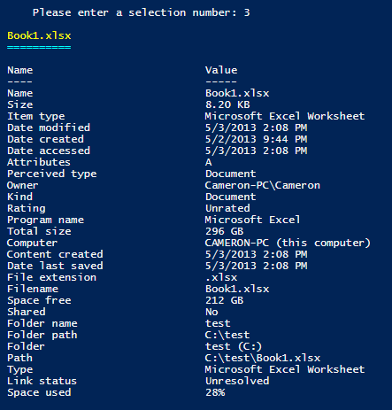

By selecting option 4 you can can re-enter a new path to a new set of files and start the process all over again.

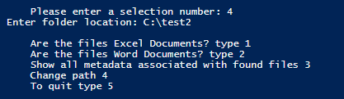

By selecting 5 the script will end to quit.