**mDixon-Based Synthetic CT Generation via Patch Learning**

**ABSTRACT**

We proposed a new method for generating synthetic CT on abdomen from modified Dixon (mDixon) MR data of abdomens to address the challenges of PET/MR attenuation correction (AC). AC is necessary in process of PET/MR but MR data lack photon attenuation, thus multiple methods are proposed to generate synthetic CT. However, these existing methods requires advantaged MR sequences which needs fine acquisition and huge cost consumption. To address this problem, we proposed a new method for generating synthetic CT using Patch Learning (SCG-PL). Global model of SCG-PL is transfer learning and patch model is semi-supervised classification. The advantages of our method can be summarized into two points. (1) Patch learning is a gradual learning process with gradually updating global model on remodeling patch model, so our SCG-PL method is gradually capable of generating synthetic CT. (2). Semi-supervised classification adopted in the process of patch learning, only small amount of labeled data is needed in SCG-PL, which greatly reduced the workload of radiologists. The experimental results indicate that proposed SCG-PL method can effectively generate synthetic CT image from challenging abdomen images using mDixon MR sequence data only.

**Key words**: Synthetic CT generation, mDixon-based MR, Abdomen, attenuation correction (AC), Patch Learning (PL)

**1. INTRODUCTION**

Benefit from the superior soft tissue contrast and high anatomical resolution, Magnetic Resonance Imaging (MRI) scans have been widely applied in radiotherapy [1, 2]. With the evolution of modern medical imaging technologies, PET/MR, combining with advantages of two imaging modalities, can offer further information which cannot be presented in PET/CT and has potential applications. Meanwhile, compared with CT, the characteristic of using no ionizing radiation MRI has an absolute advantage. Yet there are rarely MRI or PET/MR used in radiotherapy procedure individually due to the lack of the geometric integrity and precision in mapping Relative Electron Density (RED) for dose calculations.

Solely using MRI or PET/MR for radiotherapy has become an interesting goal in radioactive medicine. Here, the primary problem to be solved is attenuation correction in radiotherapy. To achieve this goal, multiple methods are proposed. However, the diversity and the real-time movement of human organs and tissues directly cause the failure of methods, such as atlas-based [3, 4] and template-based [5]. Standing out from the proposed methods, the synthetic CT generation method by distinguishing the tissue type of all voxel in MRI images.

At present, the limitations of the development of synthetic CT generation lie primarily in two areas, i.e. target body sections and methods of generation. From the site of body sections, most studies have focused on brain and breast, these body sections have common characteristic of simple organization and less deformation. Abdomen, as the challenging body section, with its complex anatomical structure and along with a large amount of organs deformation caused by massive human respiration is little studied. From the existing methods, some advantage sequences which are technically challenging like Ultrashort Echo Time (UTE) and Zero Echo Time (ZTE) are needed [6, 7].

Focusing on abdomen, on the basis of existing methods, we introduce the ensemble learning thought i.e. patch learning [8] to generate synthetic CT in the case of only using easily obtainable MR sequence. Global model of SCG-PL is transfer learning and patch model is semi-supervised classification. The advantage of our proposed synthetic CT generation on abdomen using patch learning method (SCG-PL for short) lies mainly in the following two points:

1. The combination of transfer learning and semi-supervised classification in patch learning enables the indistinguishable tissue type i.e. bone, to be well differentiated from voxels of Dixon sequence.
2. With the semi-supervised classification adopted in the process of patch learning, only small amount of labeled data is needed in SCG-PL, which greatly reduced the workload of radiologists.

The rest of this manuscript shows you our proposed SCG-PL method in detail. Related work is introduced in Section 2. Specifically, the method is explained in Section 3. Section 4 presents the experimental studies. Conclusion is given in Section 5.

**2.RELATED WORK**

**2.1 Patch Learning**

Patch learning (PL) [8] is a strategy of gradually improving the performance of a machine learning model by iteratively updating the global model by remodeling the patch model. PL consists of the following three steps:

1. Train an initial global model using all training data.
2. Identify L patches from the initial global model, which contribute the most to the learning error, and train a (local) patch model for each patch.
3. Update the global model using training data that do not fall into any patch.

PL zooms into those parts that need more work without discarding the initial entire model, and become an excellent model until appropriate amount of patches remodeled, which is shown as Figure 1.

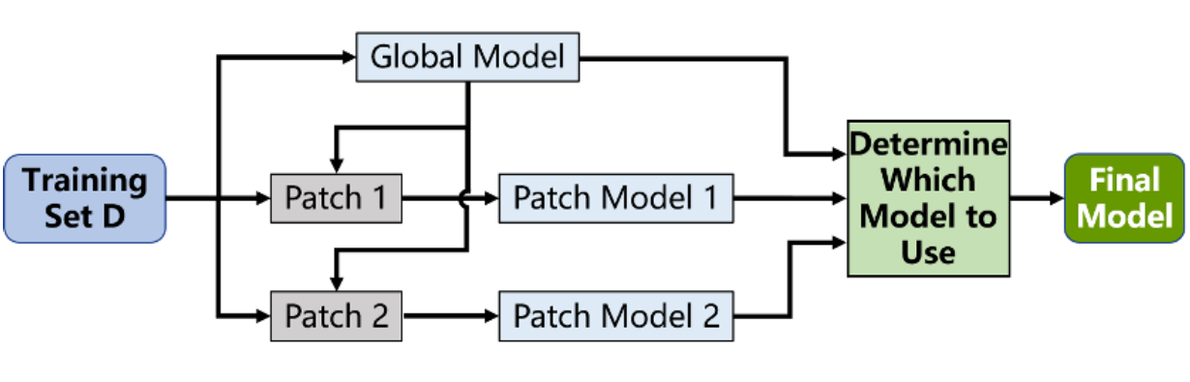

Fig.1. Idea of PL.

**2.2** KL-TFCM

Fuzzy c-means (FCM) is the most widely used and successful technique among the fuzzy cluster algorithm in unsupervised machine learning, which group dataset into N clusters with every sample in the dataset belonging to every cluster to a certain degree. However, the effectiveness of FCM often degrades due to the presence of noise in the dataset. To address this, we integrate transfer learning into FCM and propose the KL-TFCM approach [X]. KL-TFCM includes two data domains, i.e., source domain and target domain. Source domain provides some knowledge like cluster prototypes as the reference in target domain and the data in target domain is partitioned into C clusters.

Letdenote the data set in target domain, where the example number denotes asand the dimension denotes as *d*. denotes themembership matrix in the target domain withindicating the membership degree of belonging to cluster, where the cluster number denotes as. denotes the cluster prototype matrix in the target domain with signifying thecluster prototype(centroid). denotes the employed cluster representatives from the source source domain for the eventual knowledge utilization in the target domain with denoting thecluster representative in the source domain.

The framework of KT-TFCM can be reformulated as

|  |  |
| --- | --- |
|  | (1) |

Where, ,,, andis a regularization coefficient. The update of the cluster centroidand fuzzy membershipcan be deduced using the Lagrange optimization as follows

|  |  |
| --- | --- |
|  | (2) |
|  | (3) |

**2.3 Laplacian Support Vector Machine (LapSVM)**

LapSVM, a semi-supervised classification algorithm based on manifold regularization, mainly research on how to use a small number of labeled samples and a large number of unlabeled samples for training and classification, which is an extension of the traditional SVM. The LapSVM learning model contains the intrinsic geometry information of the sample because of the introduction of sample manifold regularity item.

Assume the sample set S = {xi, i = 1, ⋯, n}, xi represents the i-th sample and n represents the number of samples. Set L = {xi, i = 1, ⋯, m} represents the labeled sample, m represents the number of the labeled sample. Set U = {xi, i = 1, ⋯, u} represents the unlabeled sample, u represents the number of the unlabeled sample. Let yi represent the category of the i-th sample, yi∈{-1,1}. The LapSVM model is defined as follows:



Where, is an n-dimensional column vector on the training data set.  is the Ambient Norm defined in the regenerative nuclear Hilbert space (RKHS), Hk is the RKHS related to the kernel function. Parameter  is weight, which controls the complexity of  in RKHS.  is the intrinsic regular term, which keeps the inner manifold structure of the sample distribution. Parameter  is the weight of the function in the low-dimensional manifold, which controls the complexity of inner geometry function. By calculating the Lagrangian multiplier, the classifier is as follows:

|  |  |
| --- | --- |
|  | (5) |

Where,  is the Lagrangian multiplier and K is the kernel matrix. Solving the Lagrangian multiplier

|  |  |
| --- | --- |
|  | (6) |

Where, I is the identity matrix and L is the Laplacian matrix .  is a diagonal matrix composed of identification samples . is a block matrix formed by labeled samples and unlabeled samples. is the Lagrange multiplier, which is

|  |  |
| --- | --- |
|  | (7) |

**3.THE PROPOSED SCG-PL METHOD**

The proposed SCG -PL method includes data prepare stage, constructing Patch Learning (PL) model and generating synthetic CT image. In data prepare stage, we extract features of four types of MR data to form seven-dimensional MR feature data for each subject and obtain the referenced class prototypes of 4 key tissue types via conventional FCM from prior knowledge of referenced MR data. After data preparing, we construct PL model to obtain multiple 4-class classifiers.

Taking KL-TFCM as global model in PL refers to [X], which indicates that KL-TFCM is an effective method for generating synthetic CT for brain.

Global model is constructed as KL-TFCM and blocks whose error impacts most become candidate patches, which need to be remodeled. Patch model is constructed as LapSVM, which belongs to semi-supervised classification, and then updating the PL model. Finally, we organically combine multiple 4-class classifiers to generate target synthetic CT image. Next, we detail each stages as follows.

**3.1 Data prepare**

Feature extraction is of vital importance in machine learning and pattern recognition. The quality of features has a crucial impact on generalization performance. Considering the unavoidable noise in acquiring MR image, we adopt a principle of convolutional kernel to extract local texture features, which learns from the convolution layer in convolutional neural network (CNN) [10]. We extract local texture features from four types of abdominal MR data, i.e., fat, water, in-phase(IP) and opposed-phase(OP) [11], as the input to our SCG-PL method for each subject. Except for above features, position feature is adopted as well for better distinguish with the consideration of the similarity of signals of air and bone in MR data. The scan voxel size and pixel slices of 3D MR image are 0.98×0.98×5 mm3 and 512×512 pixel slices of Z-axis respectively. Considering isotropism, we design a grid partition strategy of 5×5 voxels assembled. Each voxel position feature is determined by spacing of size 4.9×4.9×5 mm3. Thus position feature (x, y, z) can be expressed as the indexes of grid, 1≤x≤103, and 1≤y≤103. Combining all the features we obtain seven-dimension MR feature data as the input data to our method.

To generate final synthetic CT image from MR image as accurate as possible, we need referenced prior knowledge, i.e., referenced class prototypes of bone, air, fat tissue and soft tissue. Thus, paired CT and MR images are necessary and each pair needed to deformably registered before. The work and data flows of

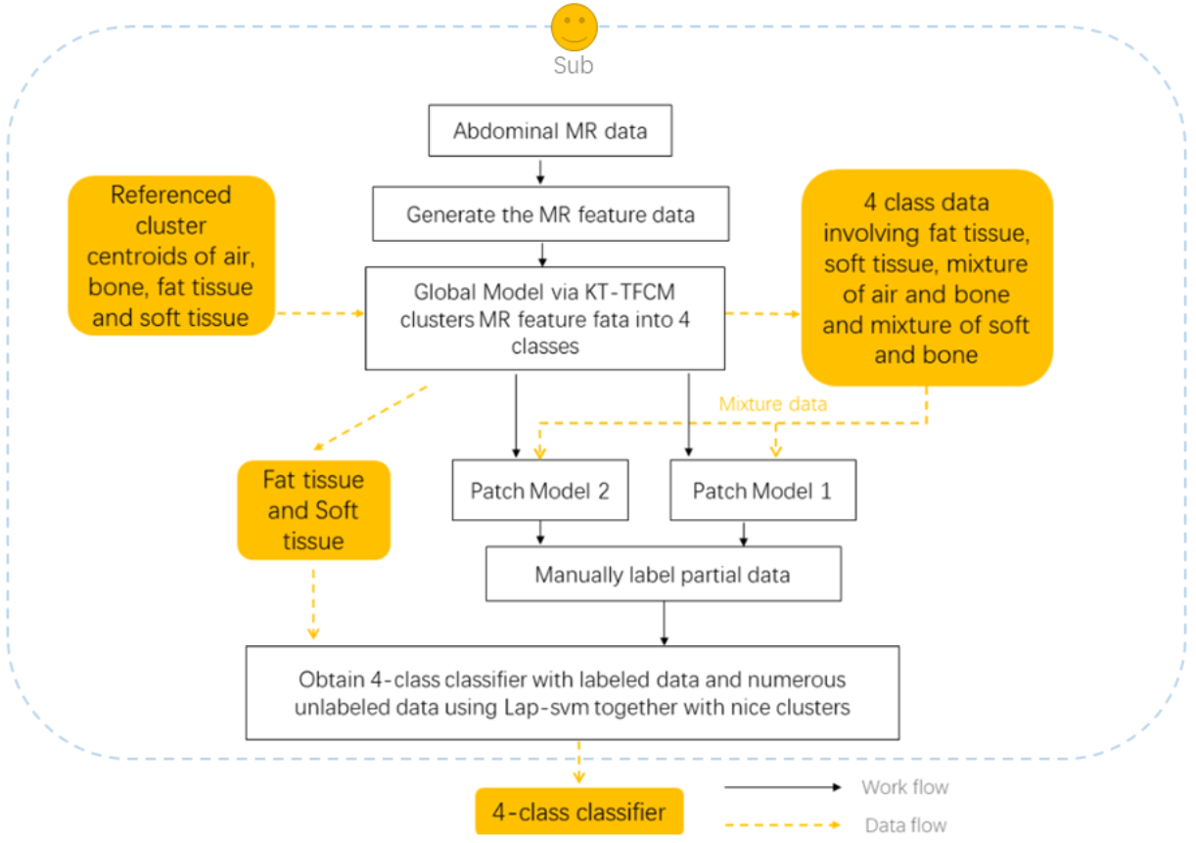

Fig.2. Illustration of the work and data flows for generating 4-class classifier

Phase 2 are shown in Fig. Suppose there are n pairs CT and MR images to be referenced, we take one pair as example for detail. For reference pair 1, bone class centroid can be first determined since we can recognize bone data in MR image with CT data whose Hounsfield Unit (HU) is 300, and takes the average value of bone data as bone class centroid. Then we apply FCM to the leftover data, i.e., data without bone, for clustering and obtain three clusters centroids later. At this point, we obtain four class centroids of pair 1. And n referenced pairs produce n class centroids, class prototypes are the average value of class centroids for every class. Thus we obtain the reference class prototypes of four key tissue types.

**3.2 Constructing PL model to obtain 4-class classifier**

4-class classifier via PL model is necessary for generating synthetic CT, as shown in Figure 2. Global model for constructing a 4-class classifier would naturally be KL-TFCM considering the existing historical referenced cluster centroids. The preliminary result of clustering would roughly be 4 classes, i.e., bone, air, soft tissue and fat tissue, after applying KL-TFCM to MR feature data. Owing to the fact that mDixon sequences are expert in reflecting fat tissue, the gained cluster of fat tissue after transfer clustering is relatively accurate. The leftover three clusters include soft tissue, bone and air. Soft tissue can be subdivided into one tissue approximate to soft bone and other soft tissue, which means soft bone and some soft tissue are mixed and hard to distinguish. In transfer clustering, the cluster of soft tissue not close to soft bone is believable as well. Actually, the signals of air and hard bone are both very low in MR data thus one of the clusters from transfer clustering is the mixture of them.

In order to gain the final 4-class classifier to generate precise synthetic CT image, patch models are reconstructed in these mixture parts.

**TABLE 1. PERFORMANCE COMPARISON OF GENERATING SYNTHETIC CTs AMONG THE PROPOSED SCG-PL AND OTHER METHODS**

|  |  |  |  |  |  |  |  |  |  |  |  |  |  |
| --- | --- | --- | --- | --- | --- | --- | --- | --- | --- | --- | --- | --- | --- |
| Sub | | MAPD | | | | RMSE | | | | R | | | |
| SCG-PL | AW | TFCM | SVM | SCG-PL | AW | TFCM | SVM | SCG-PL | AW | TFCM | SVM |
| 1 | Mean | **93.44** | 150.45 | 159.02 | 106.99 | **155.50** | 233.49 | 232.64 | 196.11 | **0.76** | 0.35 | 0.61 | 0.58 |
| Std. | **0.10** | 0.00 | 0.00 | 0.91 | **0.12** | 0.00 | 0.00 | 0.76 | **0.00** | 0.00 | 0.00 | 0.00 |
| 2 | Mean | **73.47** | 142.80 | 118.63 | 87.09 | **136.97** | 228.49 | 195.38 | 174.73 | **0.78** | 0.25 | 0.64 | 0.60 |
| Std. | **0.05** | 0.00 | 0.00 | 0.12 | **0.07** | 0.00 | 0.00 | 0.05 | **0.00** | 0.00 | 0.00 | 0.00 |
| 3 | Mean | **81.12** | 168.21 | 132.39 | 104.29 | **137.54** | 261.03 | 203.70 | 199.81 | **0.85** | 0.36 | 0.74 | 0.66 |
| Std. | **0.08** | 0.00 | 0.00 | 0.56 | **0.13** | 0.00 | 0.00 | 0.09 | **0.00** | 0.00 | 0.00 | 0.00 |
| 4 | Mean | **61.09** | 129.55 | 109.36 | 71.95 | **116.68** | 200.63 | 183.44 | 148.70 | **0.80** | 0.36 | 0.65 | 0.66 |
| Std. | **0.05** | 0.00 | 0.00 | 0.15 | **0.10** | 0.00 | 0.00 | 0.08 | **0.00** | 0.00 | 0.00 | 0.00 |
| 5 | Mean | **76.11** | 145.55 | 134.63 | 89.11 | **137.97** | 224.10 | 210.92 | 173.06 | **0.78** | 0.38 | 0.64 | 0.62 |
| Std. | **0.09** | 0.00 | 0.00 | 0.44 | **0.15** | 0.00 | 0.00 | 0.19 | **0.00** | 0.00 | 0.00 | 0.00 |
| 6 | Mean | **93.38** | 149.09 | 156.05 | 111.41 | **157.72** | 219.24 | 234.02 | 194.02 | **0.72** | 0.29 | 0.60 | 0.60 |
| Std. | **0.15** | 0.00 | 0.00 | 1.17 | **0.23** | 0.00 | 0.00 | 1.05 | **0.00** | 0.00 | 0.00 | 0.00 |
| 7 | Mean | **89.14** | 154.07 | 145.61 | 104.36 | **153.37** | 235.96 | 218.61 | 189.16 | **0.76** | 0.22 | 0.67 | 0.63 |
| Std. | **0.14** | 0.00 | 0.00 | 1.16 | **0.19** | 0.00 | 0.00 | 0.98 | **0.00** | 0.00 | 0.00 | 0.00 |
| 8 | Mean | **77.69** | 152.41 | 125.44 | 95.92 | **138.86** | 227.09 | 206.17 | 176.67 | **0.77** | 0.34 | 0.60 | 0.64 |
| Std. | **0.10** | 0.00 | 0.00 | 0.83 | **0.17** | 0.00 | 0.00 | 0.60 | **0.00** | 0.00 | 0.00 | 0.00 |
| 9 | Mean | **73.41** | 139.04 | 131.70 | 95.06 | **125.36** | 222.99 | 200.56 | 184.73 | **0.82** | 0.33 | 0.66 | 0.59 |
| Std. | **0.07** | 0.00 | 0.00 | 0.43 | **0.13** | 0.00 | 0.00 | 0.19 | **0.00** | 0.00 | 0.00 | 0.00 |
| 10 | Mean | **86.48** | 153.00 | 164.96 | 112.76 | **148.43** | 225.90 | 238.13 | 197.52 | **0.76** | 0.37 | 0.64 | 0.60 |
| Std. | **0.13** | 0.00 | 0.00 | 1.08 | **0.19** | 0.00 | 0.00 | 0.74 | **0.00** | 0.00 | 0.00 | 0.00 |
| Average | Mean | **80.53** | 148.42 | 137.78 | 97.89 | **140.84** | 227.89 | 212.36 | 183.45 | **0.78** | 0.32 | 0.64 | 0.62 |
| Std. | **10.26** | 10.27 | 18.22 | 12.69 | **13.23** | 15.11 | 18.15 | 15.67 | **0.04** | 0.05 | 0.04 | 0.03 |

Benefiting from the prior knowledge of subject’s CT image, we can acquire labeled examples. However, it is practically infeasible for radiologist to label the whole data manually because of huge time consumption. Thus, semi-supervised classification can be used in patch model and LapSVM is ideal. With numerous unlabeled data and a limit amount of mark data, which is practically feasible for radiologist, it’s capable of obtaining final 4-class classifier.

**3.3 Generating synthetic CT Image Through Multiple 4-Class Classifiers**

We assemble multiple results of 4-class classifiers via the strategy of voting to decide voxel type. Considering numerous data in MR feature data, it’s infeasible to directly take the entire data as input to our method because of huge time consumption. Thus, we propose sampling-KNN mechanism, which involves randomly sampling the MR feature data and using K nearest neighbor (KNN) to restitute the whole prediction results, in our method to accelerate the whole process. Sampling-size denotes as *ss* and the choice of the Kth nearest neighbor denotes as *k*. Considering all patch models, we continue to subdivide the parameters. Therefore, ss1 and k1 is for patch model1 while ss2 and k2 is for patch model2.

Specific CT value are set to 380, -700, 98 and 32 corresponding with bone, air, fat tissue and soft tissue with the referring to [12] to reconstruct a synthetic CT image.

**4. EXPERIMENT RESULTS**

**4.1 Setup**

In this section, we assess the effectiveness of the proposed SCG-PL method for generating synthetic CTs. Thus, ten subjects were recruited using a protocol approved by the University Hospitals Cleveland Medical Center Institutional Review Board.

Moreover, three existing methods are in comparison with our method, i.e., the all-water method (AW) [13], transfer fuzzy C-means clustering (TFCM) and the support machine (SVM). Three metrics, i.e., the mean absolute prediction deviation (MAPD), the root mean square error (RMSE), and R [14, 15], are used to evaluate the effectiveness of our method.

We adopt Leave-one-out strategy to generate ultimate result. That is, we treat one subject as test dataset and the other leftover subjects as train dataset. Each result for generating synthetic CT of one subject are assembled from results of the remainder classifiers, which excludes the classifier of the test one.

Our experimental studies were carried out on a computer with an Intel i5-4570 3.20 GHz CPU, 8 GB of RAM, Microsoft Windows 10 (64 bit), and MATLAB 2017a.

|  |
| --- |
| F:\医学项目\Test_and_Train\论文需要的数据\MAPD.bmp |
| F:\医学项目\Test_and_Train\论文需要的数据\RMSE.bmp |
| F:\医学项目\Test_and_Train\论文需要的数据\R.bmp |

Fig.3. Performance curves of the four methods. The proposed SCG-PL method has a lower mean absolute prediction deviation (MAPD), a lower root mean square error (RMSE), and a higher correlation (R) than the other three methods, including AW, TFCM and the SVM.

**4.2 Results**

We display the experimental results in Table X for each subject. In order to visually and intuitively present our method, the performance curves regarding to MAPD, RMSE and R metrics are shown in Figure 2. As shown in Table 1, and we display the synthetic CT images from Sub8 with four methods above. As the results depict, our proposed method SCG-PL outperforms other existing method both in terms of vadility metrics and effect of the generating synthetic CT image.

4.3 Analysis and discuss

Then we analysis the robustness of SCG-PL. We analyze two types of parameters of our proposed SCG-PL, i.e., *ss* and *k*, denotes as the sampling size and the *Kth* nearest neighbor respectively. Due to the existed patch models, we subdivide *ss* and *k* into *ss1*, *ss2*, *k1* and *k2* for different patch models, i.e., *ss1* and *k1* for patch model1 and *ss2* and *k2* for patch model2. For this end, we first assign suggested value to experimental parameters, then gradually change parameter value within a reasonable range for each subject. The vadility metrics, i.e., MAPD, RMSE and R of experimental parameters of Sub8. We run 20 times of SCG-PL and display the average value as shown in Figure X. As the figure depicts, the fluctuation of the experimental parameters has little effect on the vadility metrics, which indicates the good robustness and stability of our proposed SCG-PL method.

|  |  |  |
| --- | --- | --- |
| F:\医学项目\Test_and_Train\soft_bone\param_control\pic\ss1_MAPD.png | F:\医学项目\Test_and_Train\soft_bone\param_control\pic\ss1_RMSE.png | F:\医学项目\Test_and_Train\soft_bone\param_control\pic\ss1_R.png |
| (a1) | (a2) | (a3) |
| F:\医学项目\Test_and_Train\soft_bone\param_control\pic\k1_MAPD.png | F:\医学项目\Test_and_Train\soft_bone\param_control\pic\k1_RMSE.png | F:\医学项目\Test_and_Train\soft_bone\param_control\pic\k1_R.png |
| (b1) | (b2) | (b3) |
| F:\医学项目\Test_and_Train\soft_bone\param_control\pic\ss2_MAPD.png | F:\医学项目\Test_and_Train\soft_bone\param_control\pic\ss2_RMSE.png | F:\医学项目\Test_and_Train\soft_bone\param_control\pic\ss2_R.png |
| (c1) | (c2) | (c3) |
| F:\医学项目\Test_and_Train\soft_bone\param_control\pic\k2_MAPD.png | F:\医学项目\Test_and_Train\soft_bone\param_control\pic\k2_RMSE.png | F:\医学项目\Test_and_Train\soft_bone\param_control\pic\k2_R.png |
| (d1) | (d2) | (d3) |

Fig.X. Parameter robustness of SCG-PL method. (a1)~(a3) ss1 vs. MAPD, RMSE and R. (b1)~(b3) k1 vs. MAPD, RMSE and R. (c1)~(c3) ss2 vs. MAPD, RMSE, R. (d1)~(d3) k2 vs. MAPD, RMSE, R

|  |
| --- |
|  |
| Measured CT |
|  |
| Synthetic CT generated by AW |
|  |
| Synthetic CT generated by TFCM |
|  |
| Synthetic CT generated by SVM |
|  |
| Synthetic CT generated by SCG-PL |

Fig.4. Synthetic CT images on a representative subject (Sub 8) using four methods.

**5. Conclusion**

We study on the challenging abdominal section in medical image for generating synthetic CT image with mDixon MR image only. Recognizing the similarity between the situation we face and the feature of Patch Learning, we propose the effective SCG-PL method with techniques such as transfer learning for global model and semi-supervised classification for patch model. Patch Learning is a process of gradual improvement with remodeling indistinguishable domains to gradually obtain good performance of classification. This exactly corresponds the complicated situation in part of abdominal section because of deformable tissues and varying air position over time. The proposed method proves preferable generation of synthetic CT image.

**References and Notes**

1. Zaidi, H. and Alavi, 2007. Current trends in PET and combined (PET/CT and PET/MR) systems design. PET Clinics, 2(2), pp.109–123.

2. Zaidi, H., Mawlawi, O. and Orton, C.G., 2007. Simultaneous PET/MR will replace PET/CT as the molecular multimodality imaging platform of choice.Medical Physics, 34(5), pp.1525–1528.

3. Hofmann, M., Steinke, F. and Scheel, V., 2008. MRI-based attenuation correction for PET/MRI: A novel approach combining pattern recognition and atlas registration. Journal of Nuclear Medicine, 49(11), pp.1875–1883.

4. Farjam, R., Tyagi, N. and Deasy, J.O., 2019. Dosimetric evaluation of an atlasbased synthetic CT generation approach for MR-only radiotherapy of pelvis anatomy. Journal of Applied Clinical Medical Physics, 20(1), pp.101–109.

5. Kops, E.R. and Herzog, H., 2008. Template Based Attenuation Correction for PET in MR-PET Scanners. IEEE Nuclear Science Symposium Conference Record, pp.3786–3789.

6. Liu, L., Cao, Y. and Fessler, J.A., 2015. A female pelvic bone shape model for air/bone separation in support of synthetic CT generation for radiation therapy. Physics in Medicine & Biology, 61(1), pp.169–182.

7. Berker, Y., Franke, J. and Salomon, A., 2012. MRI-based attenuation correction for hybrid PET/MRI systems: A 4-class tissue segmentation technique using a combined ultrashort-echo-time/Dixon MRI sequence. Journal of Nuclear Medicine, 53(5), pp.796–804.

8. Dongrui Wu, Jerry M Mendel, 2019. Patch Learning. IEEE Transactions on Fuzzy Systems

, 1906.00158.

9. P. Qian, K. Zhao, Y. Jiang, K.-H. Su, Z. Deng, S. Wang, and R. F. Muzic, Jr., “Knowledge-leveraged transfer fuzzy c-means for texture image segmentation with self-adaptive cluster prototype matching,” Knowledge-Based Systems, vol. 130, pp. 33-50, 2017.

10. Chen, Y., Jiang, H. and Li, C., 2016. Deep feature extraction and classification of hyperspectral images based on convolutional neural networks. IEEE Transactions on Geoscience and Remote Sensing, 54(10), pp.6232–6251.

11. Eggers, H., Brendel, B. and Duijndam, A., 2011. Dual-echo Dixon imaging with flexible choice of echo times. Magnetic Resonance in Medicine, 65(1), pp.96–107.

12. Schneider, W., Bortfeld, T. and Schlegel, W., 2000. Correlation between CT numbers and tissue parameters needed for Monte Carlo simulations of clinical dose distributions. Physics in Medicine & Biology, 45(2), pp.459–478.

13 Andreasen, D., Edmund, J.M. and Zografos, V., 2016. Computed tomography synthesis from magnetic resonance images in the pelvis using multiple random forests and auto-context features. Medical imaging: Image processing. International Society for Optics and Photonics, 9784, p.978417.

14. Sekine, T., ter Voert, E.E.G.W. and Warnock, G., 2016. Clinical evaluation of zero-echo-time attenuation correction for brain 18F-FDG PET/MRI: Comparison with atlas attenuation correction. Journal of Nuclear Medicine, 57(12), pp.1927–1932.

15. Delso, G., Wiesinger, F. and Sacolick, L.I., 2015. Clinical evaluation of zeroecho-time MR imaging for the segmentation of the skull. Journal of Nuclear Medicine, 56(3), pp.417–422.

16. Wen, J., Tian, Y. and Yehang, S., 2018. Improved evidential fuzzy c-means method. Journal of Systems Engineering and Electronics, 29(1), pp.187–195.

17. Tao, X., Wang, R. and Chang, R., 2019. Density-sensitive fuzzy kernel maximum entropy clustering algorithm. Knowledge-Based Systems, 166, pp.42–57.