1. **Problem statement:**

To ask user to input an account information which has already been declared locally inside main function to login in. After the user logins in successfully, the program can provide the options (view balance, withdraw, deposit and quit) which can be selected by users. The program should be able to tell whether the input is correct or not.

**2. Analysis:**

Inputs: an account number and an associated passcode, the number of selected options and the amount of money the user wants to withdraw or deposit.

Outputs: the four options (view balance, withdraw, deposit and quit),the current money in this account, the two options which can let users decide to return or quit after they withdraw or deposit money.

Additional requirements: the program should be able to tell whether the input is correct or not. If the user enters a wrong input, the program can let him enter again.

1. **Design:**

Algorithm (inside the main function)

1. Declare variables and a 2Darray[5][3](which contains the account information) the account number, an associated passcode and the current value are

1, 111, 1000

2, 222, 2000

3, 333, 3000

4, 444, 4000

5, 555, 5000

1. Ask user to login in by a outside function and return the current money if he logins in successfully.
2. Give the current value to function menu for later operations.

Algorithm (outside the main function)

The login function

1. Declare variables
2. Ask user to input the account number and passcode
3. Use do while statement for circulation if the users enter the wrong number
4. Use for statement to decide whether the account number and passcode are correct or not.
5. Return the current value of that correct account to main function.

The menu function

1. Declare variables
2. Display the four options to users
3. Use switch statement for users to select options

The search function

1. Declare variables
2. Display the current value
3. Use switch statement for users to decide either to return menu function or quit.

The withdraw function

1. Declare variables
2. Get the money the users want to withdraw
3. Use if else to decide whether the money is bigger than the current value. The users can not withdraw money if the money is bigger than the current value.
4. Use switch statement for users to decide either to return menu function or quit for both possibilities.

The deposit function

1. Declare variables
2. Get the money the users want to deposit and display the current value
3. Use switch statement for users to decide either to return menu function or quit

The input function

1. Declare variables
2. Use while loop for circulation
3. Use if else statement to decide whether the input is correct. If not, ask the user to enter again. If correct, return the input value and jump out off the loop.

**4. Implementation**: see C code in file 1405347_4-1.c with comments.

**5. Testing:**

The C program was tested by carrying out a set of experiments and the C program output was verified successfully. However, there still exist two limitations. Firstly, the account number and passcode can only be set to an integer, not a string or a mixture of both. Secondly, the account should be set to a float number not just an integer. Therefore, the program is still imperfect and needed to be improved. Some screenshot of testing are shown below. For instance,

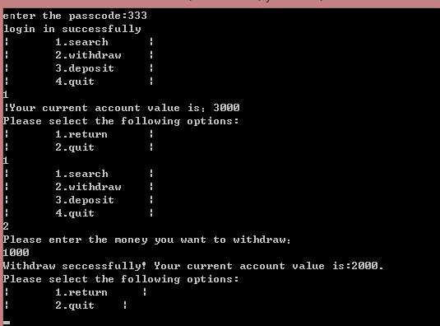

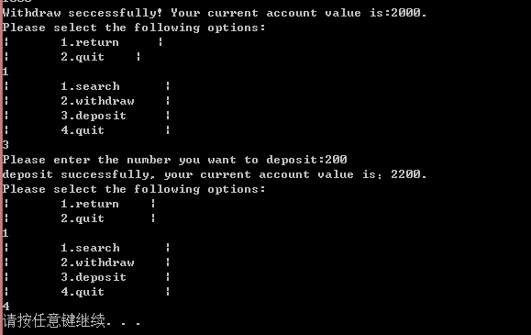

The following screenshot shows what happens if the users enter the wrong input

