1. **Problem statement:**

Generate a 2D array with 8 pairs of random ASCII characters. Display the randomized matrix for a short time and then allow the player to make guesses selecting two same elements and then displaying them. If the player guesses correctly the elements should remain showing, otherwise they should be hidden again. The player should be able to quit the program at any time by pressing q. On successfully finding all 8 pairs, the program should end displaying the number of guesses it took.

**2. Analysis:**

Inputs: the number of rows and columns

Outputs: a 4 x 4 matrix with 8 pairs of random ASCII characters, a 4 x 4 matrix with 16 same characters and the two selected elements.

Additional requirements: the program should be able to tell whether the input is correct or not. If the user enters a wrong input, the program can let him enter again.

1. **Design:**

Algorithm (inside the main function)

1. Declare variables and a 4 x 4 matrix with 8 pairs of random ASCII characters. (Use function srand and random to generate the random numbers and display them as characters.)
2. Use for loop to declare a 4 x 4 matrix with 16 same characters
3. Display the random matrix (use function display) and use function sleep to let the program stop for ten seconds
4. Display the second matrix
5. Ask users to input 2 locations (use function input) with regard to rows and columns
6. Replace the 2 selected elements into the second matrix and display it for 2 seconds (sleep function)
7. Use if else statement to decide whether the guess is correct. if correct, do nothing. If not, let the second matrix return its previous form and display it.
8. Use for loop (use function compare) for circulation till all the pairs are found.
9. Display the total numbers of guesses.

Algorithm (outside the main function)

The display function

1. Use 2 for loops to display the given array by rows and columns

The compare function

1. Use 2 for loops to compare the elements of two given arrays.
2. If all the elements are same, the return value is 16.

The input function

1. Declare variables
2. Use while loop for circulation
3. Use if else statement to decide whether the input is correct. If the input is q, end the program. If not, ask the user to enter again. If correct, return the input value and jump out off the loop.

**4. Implementation**: see C code in file 1405347_4-2.c with comments.

**5. Testing:**

The C program was tested by carrying out a set of experiments and the C program output was verified successfully. However, there still exist two limitations. Firstly, 8 pairs of random characters may not be exactly different. Sometimes there will be 2 same pairs of random characters or even more. Secondly, when the player has already guessed two same elements correctly, if he guesses the next two locations with a precious correct element and another different element, the precious correct element will be hidden. The player has to choose it with the other same element again to turn it over. Therefore, the program is still imperfect and needed to be improved. Some screenshot of testing are shown below. For instance,

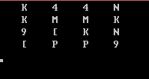

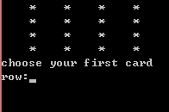

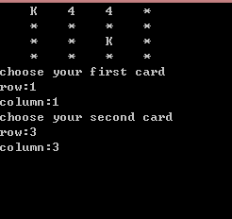

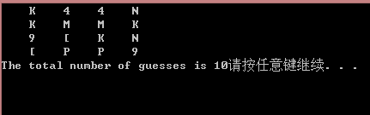

The following screenshot shows what happens if the users enter the wrong input or press q.

