1. **Problem statement:**

To ask user to put his student ID number and name and then display the name and student id number.

1. **Analysis:**

Inputs: a name and a student ID number

Outputs: a name and a student ID number

Additional requirements: To construct stores and displays a third string, consisting of the user’s student ID number followed by a comma, a space and the full name.

1. **Design:**

Method 1

1. Declare five char arrays namely StudentNumber, FirstName, LastName , Str, Comma
2. Ask user to input student number
3. Store the input as variable StudentNumber
4. Ask user to input full name
5. Store the fisrtname as variable FirstName and the lastname as variable LastName, because space is considered the end of input in cin.
6. copy the characters from StudentNumber into Str
7. attach characters from Comma, FirstName, LastName to Str
8. display the char array Str

Method 2

1. declare four string objects StudentNumber, FirstName, LastName , Str
2. ask user to input student number
3. store the input as object StudentNumber
4. ask user to input full name
5. store the fisrtname as object FirstName and the lastname as variable LastName, because space is considered the end of input in cin
6. add all the information to a new string
7. display the string Str

**4. Implementation**: see C++ code in file 1405347_1-11.cpp and 1405347_1-12.cpp with comments.

**5. Testing:**

The C program was tested by carrying out a set of experiments and the C program output was verified successfully. For example

For method 1,

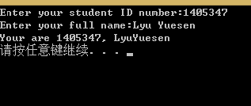

For method 2,

