1. **Problem statement:**

To design a RPG style game based on the code provided from teachers. The provided code contains a container class, a player class, a swordsman and the main function. However, the codes provided are not perfect, students need to first understand the codes and fill the blank or make some changes to the codes to make it work properly. In addition, besides swordsman, students should add another two professions archer and mage to the game by designing two classes. Also, in the main function, the original codes only have enemy with one profession. It should be modified with all three professions which are chosen randomly. The program should also provide functions for restarting and reviving when players are dead. The program should also be able to detect illegal inputs such as characters when users are making choices, and tell them to input again.

1. **Analysis:**

Inputs: a string variable representing the name of characters, integer numbers representing the job selection and command selection and a character variable for reviving and restart selection

Outputs: the profession and level of enemy of type string and integer respectively, the value of attack and experience obtained of type integer, values of character attribute of type integer, and the remaining objects in bag of type integer

Additional requirements: none

**Design:**

Class definition (only mentioned where I have made changes in original codes)

1. In player.cpp, member function isDead was changed. Else statement was added to reset the label of not death to value 0, which was meant to revive players in main function
2. Fill all the blanks to make the program work
3. Add a virtual member function AI in player.h, which is convenient for polymorphism
4. Add archer and mage class following swordsman class
5. In swordsman, archer and mage class, the values of character attributes were changed in a small scale. The attack factor hit was added in the formula which is to calculate the HP decreases

Main function (only mentioned where I have made changes in original codes)

1. Use do while statement and a flag to achieve the goals of restarting the game
2. Generate random seed based on system time and then generate a number no more than 3 to randomly select enemies. In addition, declare a pointer of base class namely enemy. If the number is one, give the address of a swordsman object (do not need an actual name) to enemy and so on.
3. Add if else statement in blank 6 to ask user whether they want to revive. If yes, refill the player and check whether he is dead. If not, exit the game.
4. Add a function to detect illegal inputs such as characters when users are making choices, and tell them to input again.

The CRC cards and hierarchy chart are shown below from figure 1 to figure 4.

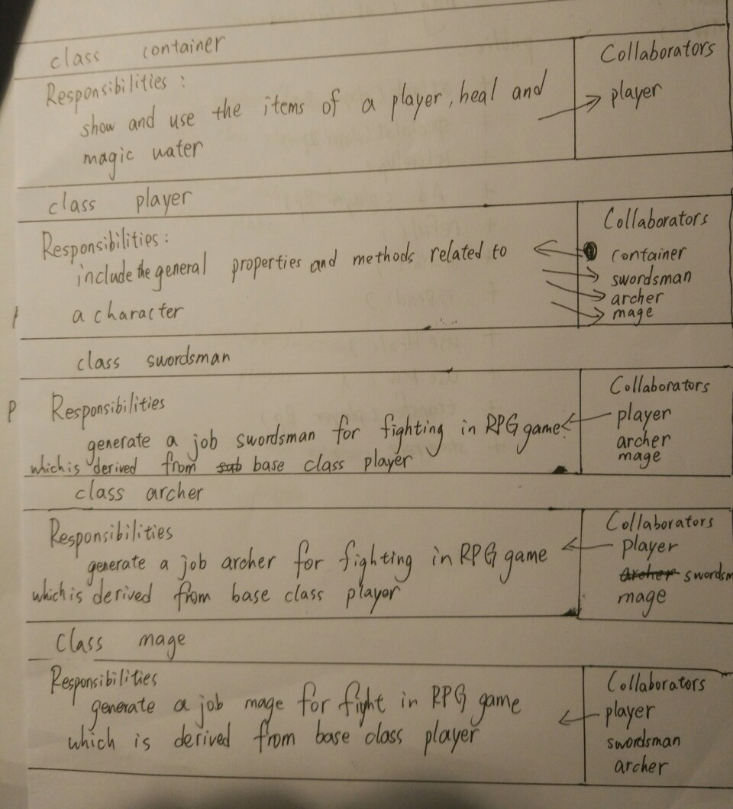

Figure 1

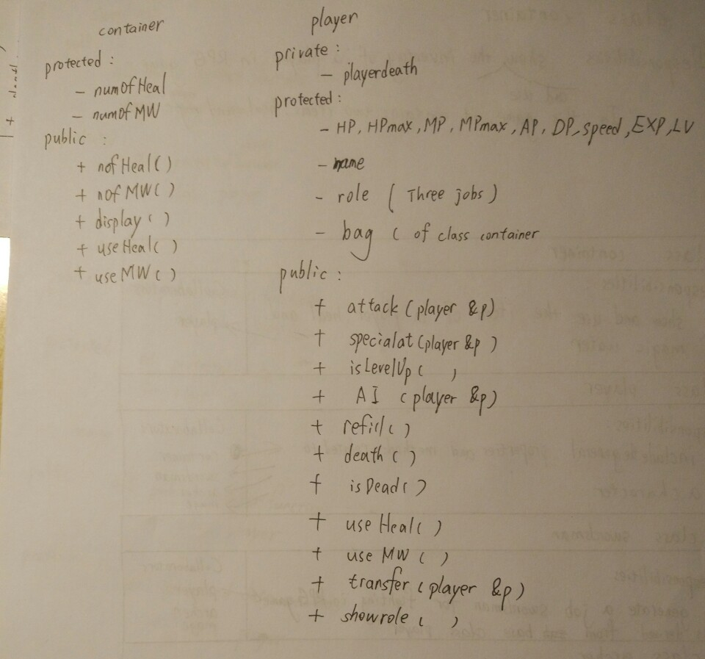

Figure 2

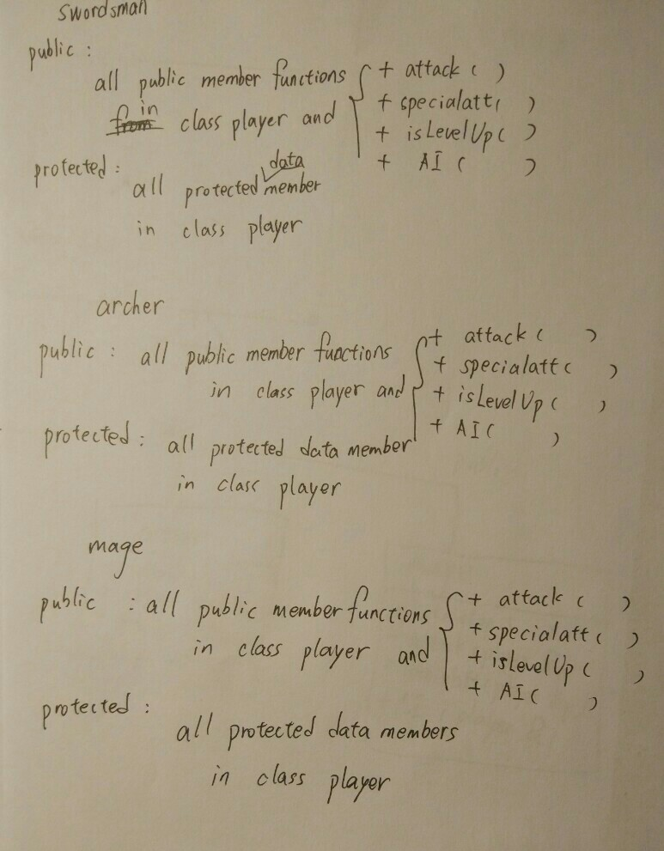

Figure 3

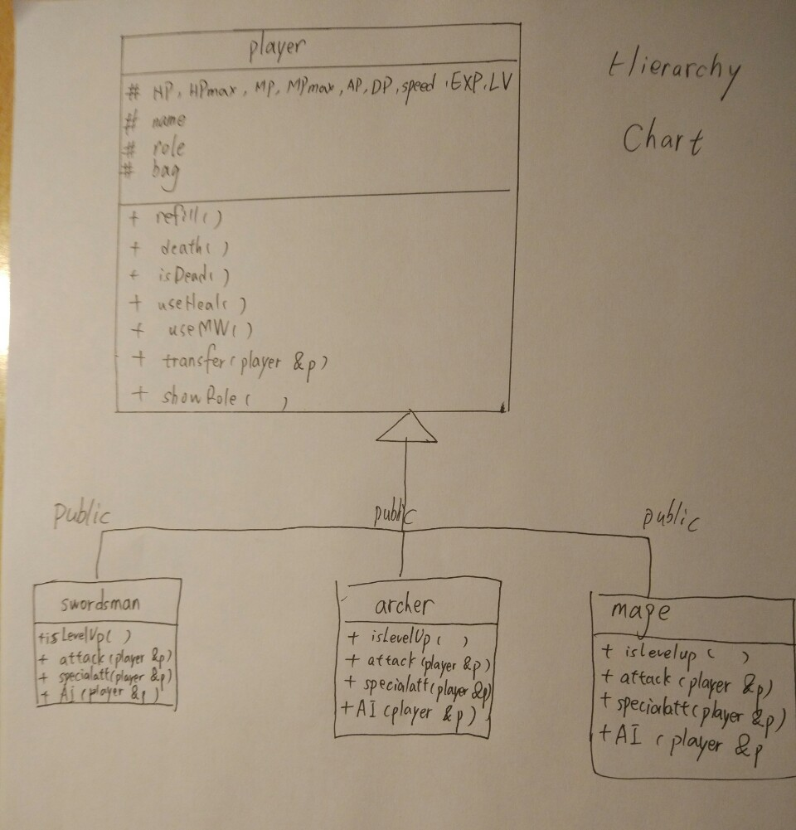

Figure 4

**4. Implementation**: see C++ code in file 1405347_4-2.cpp, 1405347_container.h, 1405347_container.cpp, 1405347_player.h, 1405347_player.cpp, 1405347_swordsman.h, 1405347_swordsman.cpp, 1405347_archer.h, 1405347_archer.cpp, 1405347_mage.h and 1405347_mage.cpp with comments.

**5. Testing:**

The C++ program was tested by carrying out a set of experiments and the C ++program output was verified successfully. For example,

Enter a name called Forset and select profession mage, the enemy is a level 1 archer which is randomly selected.

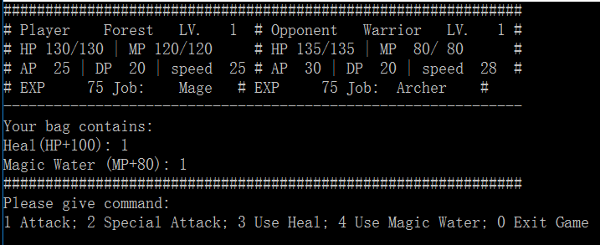

Then give command 2 special attack, Forest obtained 75 experience and level up, the enemy uses bash and decreases Forest 20 HP.

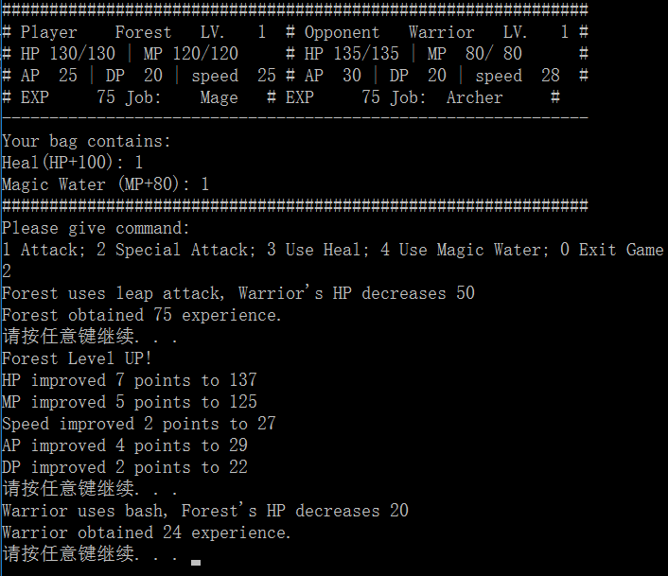

Then press button to continue, the character attributes changed.

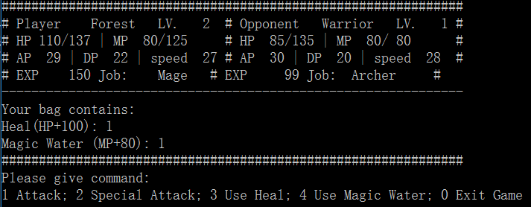

Then give command 1 attack. The enemy gives an critical attack.

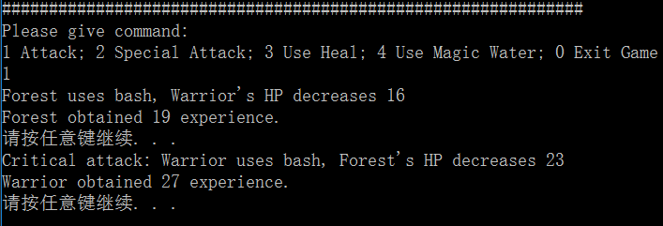

Then give command 3, the HP increased by 100 and the heal decreased by 1

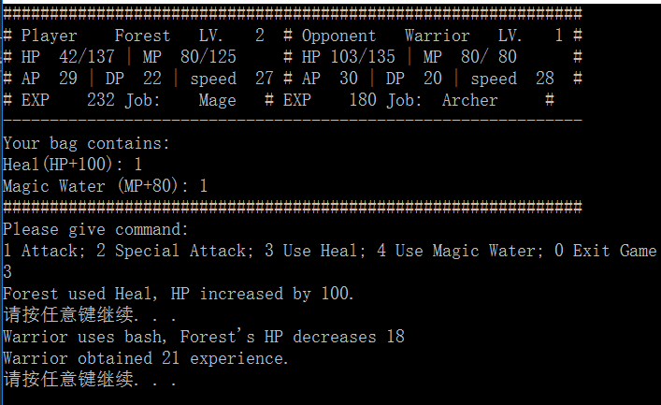

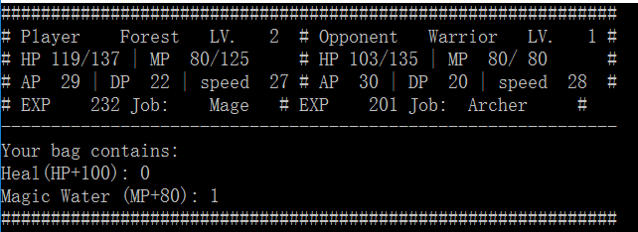

Then give command 3, the MP increased by 100 and the magic water decreased by 1.

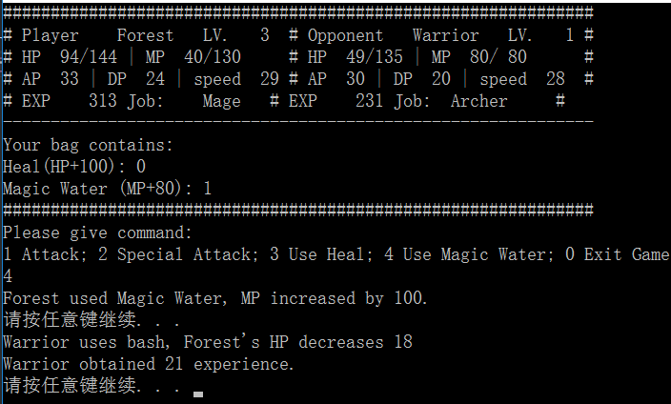

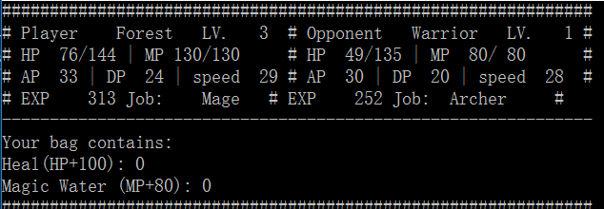

When the enemy is dead, Forest gets his bag and fight with a higher level enemy. In this case, the profession of enemy is a mage of level 3.

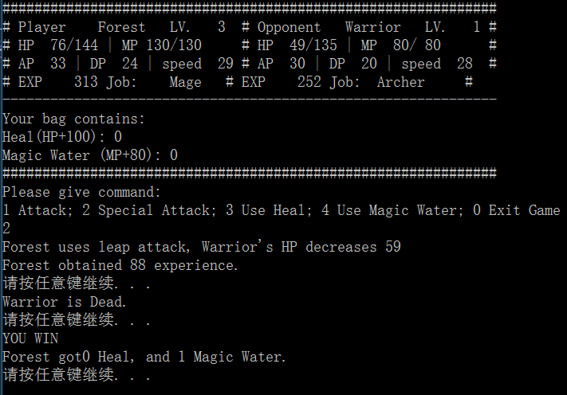

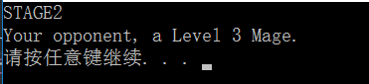

When player do not have enough magic, heal or magic water, the program can tell the user not enough and ask him to give other commands.

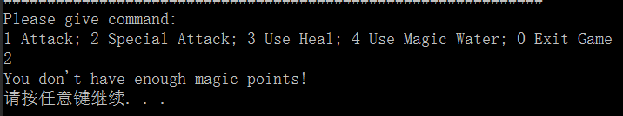

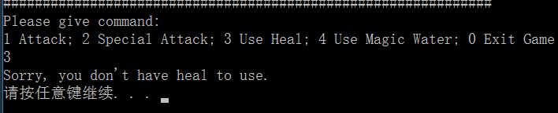

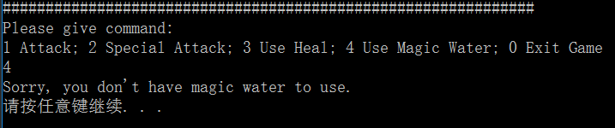

When player is dead, the program will ask whether he wants to revive. If he enters ‘y’, the player will revive with HPmax and MPmax. The bag will remain the same.

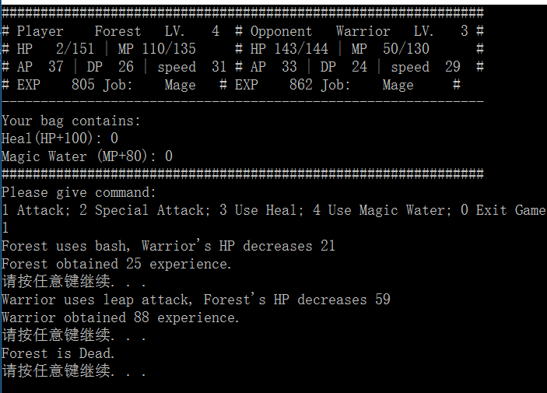

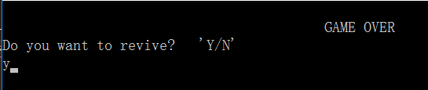

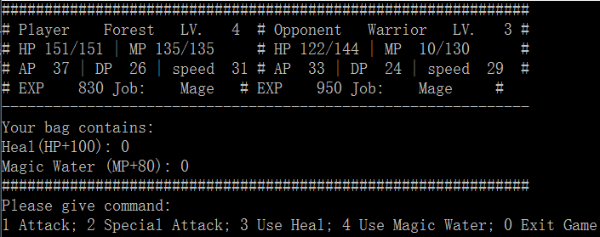

If player gives command 0, the program will ask again and exit.

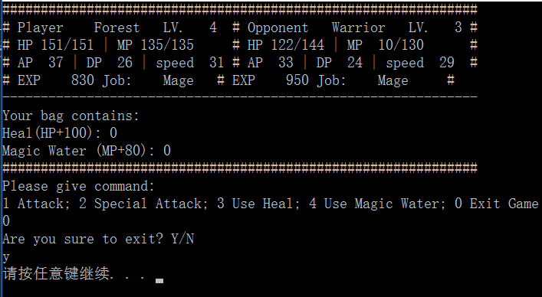

If the player defeated all the enemies, the program will ask him to restart.

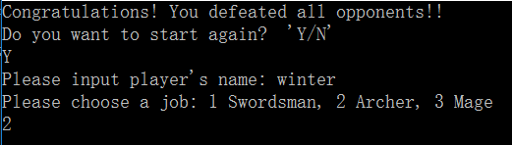

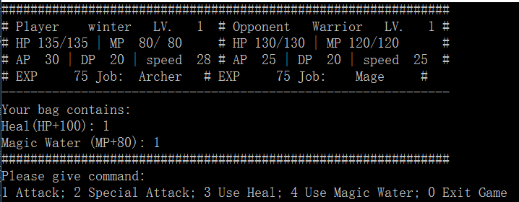

If user enters an illegal input such as a character, the program should detect it and ask user to enter again.

