1. **Problem statement:**

The purpose is to design a program that can fit a curve by using regression analysis. The curve could be either linear or polynomial. The program should first read the points from a file and use these points to conduct regression analysis. The choice of the type of curve is decided by users. Then the program should get the coefficients of the equation according to the tips of question. These coefficients and the modified points should be copied in an output file and show a message to the user when it finishes a fitting process. In addition, the program should detect any illegal inputs and ask him to input again if the user is entering an illegal inputs.

1. **Analysis:**

Inputs: an integer number representing the choice of curve

Outputs: the original content of the input file, the calculated coefficients of the best fit curve, the type of equation derived and the calculated value of y.

Additional requirements: none

1. **Design:**

Main function

1. Declare variables according to the requirements. Four allocated pointers x, y CLy and CSy are declared.
2. Open the file “my_file” and use for loop and the getline function to get each line of my_file.txt file and display the each line.
3. Move the pointer to the beginning
4. Use for loop and eof() function to check whether the pointer read the end of file. Store x and y respectively.
5. Ask the user to choose the type of curve. In the program, if the user wants to choose linear regression, the corresponding set is the integer 1 or polynomial regression corresponds to the integer 2.
6. For each choice, firstly create and open “my_display” file as an output file. Then calculate the coefficients of the equation according to the tips of question.
7. Display the type of equation derived, the coefficients of the equation, x, y, the modified y and the error in screen and in the output file.
8. Indicate that the program has finished the curve fitting process and he could get the information from mt_display.txt.
9. Close the file and delete all the allocated memory of pointers.

CountLines function

1. Declare an input file operator infile, an integer namely n and a string variable called temp.
2. Open the file which is the parameter of the function.
3. If there is nothing in the file ,then return 0 line
4. Else, using while () loop to read each line in the file and add one to n for counting lines.
5. Close the file and return the value of n.

**4. Implementation**: see C++ code in file 1405347_5-1.cpp with comments.

**5. Testing:**

The C++ program was tested by carrying out a set of experiments and the C ++program output was verified successfully. For example,

The first step, the user could view the information of points in the my_file.txt before he chooses the decision.

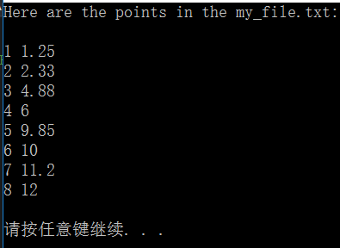

In the my_file.txt, the information of points is

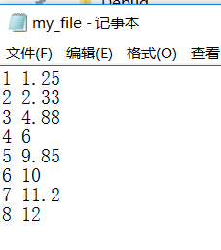

After pressing any button, the user will make a choice between two curves.

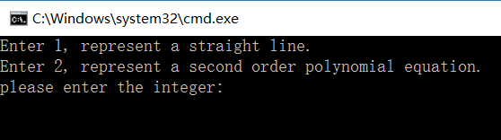

If he chooses 1, the system would show the type of equation derived, the coefficients of the equation, x, y, the modified y and the error on the screen and he can also obtain these date in my_display.txt file.

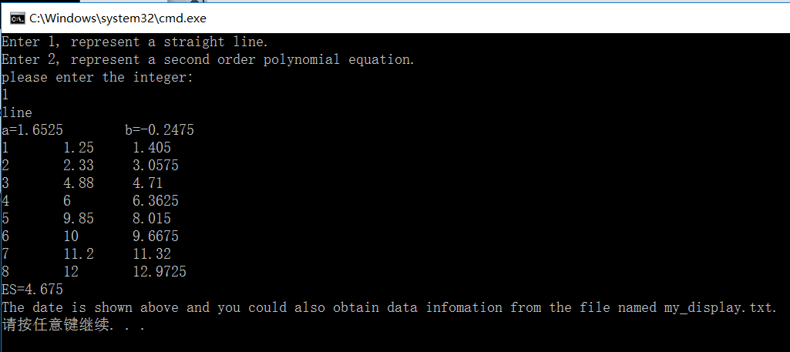

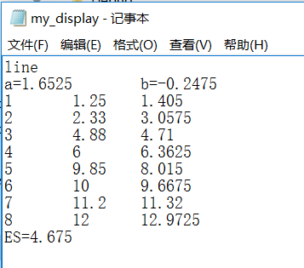

|  |
| --- |
|  |

Figure 1

Figure 1 shows the relationship between original y and x and the calculated y by line regression analysis and x.

If the user entered 2, the system would again show the type of equation derived, the coefficients of the equation, x, y, the modified y and the error on the screen and he can also obtain these date in my_display.txt file.

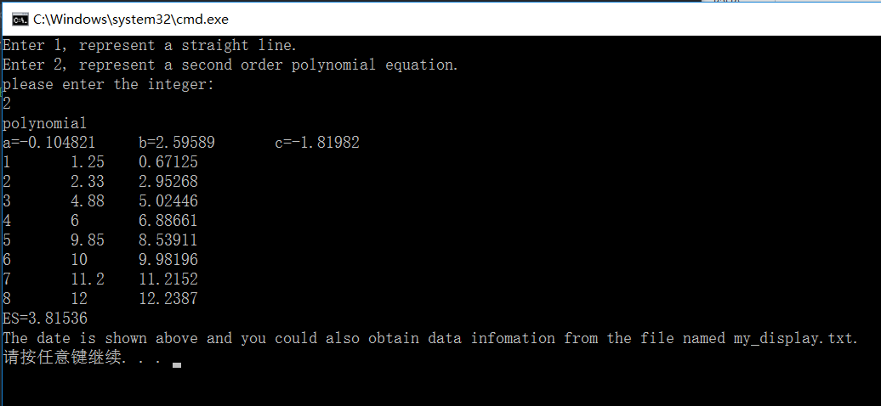

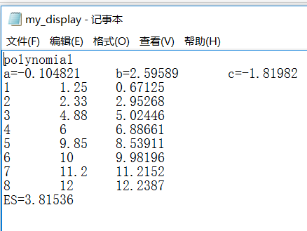

Figure 2

Figure 2 shows the relationship between original x and y and the calculated y by second polynomial regression analysis and x.

If the user enters a number that is neither 1 nor 2, the program will ask him to enter again.

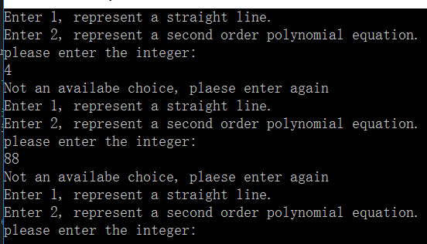

If the user enters a character, the program will also ask him to enter again.

