一、/*通用样式，尚未实现，等message之前的页面重构好才能实现*/

view, scroll-view{

display: flex;

}

input{

min-height: 0;

}

二、/*最外层容器，*/

.cont{

min-height: 1108rpx;

font-family: "微软雅黑";

background: #f0f0f0;

}

三、按钮

1、/*基本按钮*/

<button class="bt-primary">同意</button>

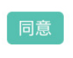

.bt-primary{

margin: 0;

padding: 15;

box-sizing: content-box;

height: 40rpx;

line-height: 40rpx;

text-align: center;

color: #ffffff;

background-color: #56c0b0;

font-size: 10px;

border-radius: 6rpx;

}

2、/*拒绝按钮*/

<button class="bt-reject">忽略</button>

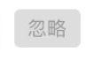

.bt-reject{

margin: 0;

padding: 15;

box-sizing: content-box;

height: 40rpx;

line-height: 40rpx;

text-align: center;

color: #999;

background-color: #ddd;

font-size: 10px;

border-radius: 6rpx;

}

1. /*反色按钮*/

<button class="bt-inverse">忽略</button>



.bt-inverse{

margin: 0;

border: 1rpx solid #56c0b0;

padding: 15;

box-sizing: content-box;

height: 40rpx;

line-height: 40rpx;

text-align: center;

color: #56c0b0;

background-color: #fff;

font-size: 10px;

border-radius: 6rpx;

}

4、/*占满屏幕宽度的按钮*/

<button class="bt-full">申请职位</button>



.bt-full{

display: flex;

align-items: center;

justify-content: center;

background-color: #56c0b0;

color:#ffffff;

font-size: 14px;

border-radius: 6rpx;

}

1. /*带有删除图标的按钮*/

<button class="bt-inverse bt-able-delete">ps

<image src="../../images/icon/cir_del.png"></image>

</button>



.bt-able-delete{

position: relative;

overflow: visible;

}

.bt-able-delete image{

position: absolute;

right: 0;

top:-15rpx;

width: 30rpx;

height: 30rpx;

}

四、/*标题图标*/

<view class="title-icon col2" id="news-information">

<image src="../../images/icon/mess_test.png"></image>

<text>消息通知</text>

</view>

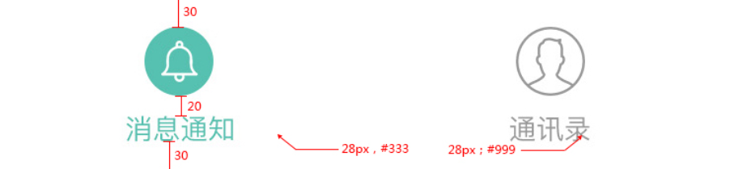

.title-icon{

display: flex;

flex-direction: column;

align-items: center;

justify-content: center;

}

.title-icon image{

width: 80rpx;

height: 80rpx;

padding-bottom: 20rpx;

}

/*如果一行中有两列*/

.col2{

width: 375rpx;

}

五、表单元素

1、

.form-sec{

width: 100%;

background-color: #ffffff;

margin-bottom: 20rpx;

}

.form-group, group{

padding: 30rpx 30rpx 30rpx 0;

border-bottom: 1rpx solid #eeeeee;

margin-left: 30rpx;

}

.form-group-last, group-last{

padding: 30rpx 30rpx 30rpx 0;

margin-left: 30rpx;

}

2、/*表单 下面弹出的选择器元素*/

<view class="form-group">

<picker bindchange="bindPickerChange" value="{{index}}" range="{{array}}">

<view class="picker">

<text class="picker-name">类型</text>

<view class="picker-body">

<text>普通</text>

<image src="../../images/icon/cir_info_right.png"></image>

</view>

</view>

</picker>

</view>

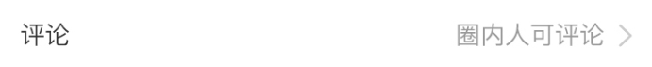

.picker{

display: flex;

align-items: center;

justify-content: space-between;

}

.picker-name{

color: #333;

font-size: 14px;

}

.picker-body{

display: flex;

align-items: center;

}

.picker-body text{

color: #999999;

font-size: 14px;

}

.picker-body image{

padding-left: 20rpx;

width: 30rpx;

height: 30rpx;

}

六、媒体框

1、/*基本媒体框1*/

<view class="media1">

<image src="../../images/test2.jpg"></image>

<view class="media1-body">

<text class="media1-title">上海运营圈</text>

<text class="media1-content">上海/网络运营/运营课程</text>

</view>

</view>

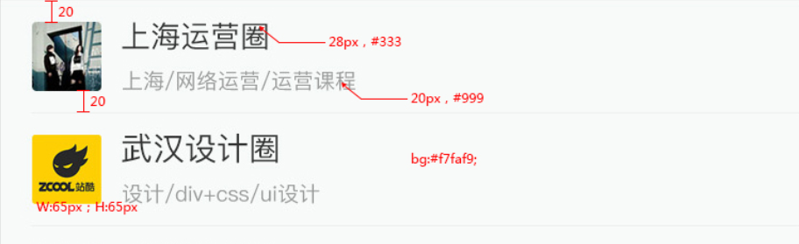

.media1{

display: flex;

align-items: center;

padding: 20rpx 0;

margin-left: 30rpx;

border-bottom: 1rpx solid #eef0ef;

}

.media1 image{

width: 65rpx;

height: 65rpx;

margin-right: 20rpx;

border-radius: 6rpx;

}

.media1-body{

display: flex;

flex-direction: column;

}

.media1-title{

color: #333;

font-size: 28rpx;

}

.media1-content{

color: #999999;

font-size: 20rpx;

}

2、/*媒体框2，对象加入媒体框*/

<view class="media2">

<image src="../../images/test1.jpg"></image>

<view class="media2-body">

<view class="media2-left">

<view class="info">

<text class="name">陈雪</text>

<text class="sex">/女</text>

<text class="edu">/本科</text>

<text class="loc">/武汉</text>

</view>

<text class="message">申请加入圈子</text>

</view>

<view class="media2-right">

<text class="time">14：35</text>

<view class="recieve">

<button class="bt-primary">同意</button>

<button class="bt-primary bt-reject">忽略</button>

</view>

</view>

</view>

</view>

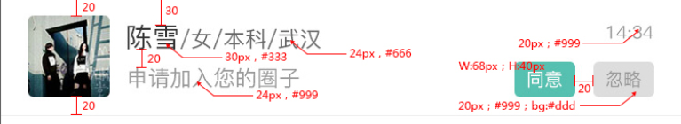

.media2{

display: flex;

align-items: center;

padding: 20rpx 30rpx;

border-bottom: 1rpx solid #eef0ef;

}

.media2 image{

width: 90rpx;

height: 90rpx;

margin-right: 20rpx;

border-radius: 6rpx;

}

.media2-body{

display: flex;

justify-content: space-between;

width: 580rpx;

}

.media2-left{

display: flex;

flex-direction: column;

justify-content: center;

}

.media2-left .name{

color:#333;

font-size: 15px;

}

.media2-left .sex,.media2-left .edu,.media2-left .loc{

color: #666;

font-size: 12px;

}

.media2-left .message{

color: #999;

font-size: 12px

}

.media2-right{

display: flex;

flex-direction: column;

align-items: flex-end;

justify-content: space-between;

}

.media2-right .recieve{

display: flex;

}

.media2-right .recieve button{

width: 68rpx;

margin-left: 20rpx !important;

}

3、/*媒体框3，消息提示媒体框*/

<view class="media3">

<image src="../../images/test4.jpg"></image>

<view class="media3-body">

<view class="media3-left">

<view class="info">

<text class="name">黎明</text>

</view>

<text class="message">哈喽，在不？</text>

</view>

<view class="media3-right">

<text class="time">14：35</text>

<view class="mess-num-circle">

<text>2</text>

</view>

</view>

</view>

</view>

<view class="media3">

<image src="../../images/test5.jpg"></image>

<view class="media3-body">

<view class="media3-left">

<view class="info">

<text class="name">武汉设计圈</text>

</view>

<text class="message">谁做过app?</text>

</view>

<view class="media3-right">

<text class="time">14：35</text>

<view class="mess-num">

<text>14</text>

</view>

</view>

</view>

</view>

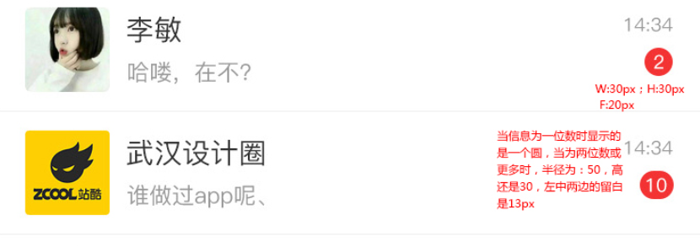

.media3{

display: flex;

align-items: center;

padding: 20rpx 30rpx;

border-bottom: 1rpx solid #eef0ef;

}

.media3 image{

width: 90rpx;

height: 90rpx;

margin-right: 20rpx;

border-radius: 6rpx;

}

.media3-body{

display: flex;

justify-content: space-between;

width: 580rpx;

}

.media3-left{

display: flex;

flex-direction: column;

justify-content: center;

}

.media3-left .name{

color:#333;

font-size: 15px;

}

.media3-left .message{

color: #999;

font-size: 12px

}

.media3-right{

display: flex;

flex-direction: column;

align-items: flex-end;

justify-content: space-between;

}

/*消息数为一位数,盒子为圆*/

.media3-right .mess-num-circle{

width: 30rpx;

height: 30rpx;

line-height: 30rpx;

border-radius: 15rpx;

color:#ffffff;

background-color: #ed322d;

font-size: 10px;

text-align: center;

}

/*消息数为两位数以上*/

.media3-right .mess-num{

height: 30rpx;

padding: 0 13rpx;

line-height: 30rpx;

border-radius: 15rpx;

color:#ffffff;

background-color: #ed322d;

font-size: 10px;

text-align: center;

}

1. /*媒体框4，三列圈子详细媒体框*/

<view class="media4">

<image class="media4-icon" src="../../images/test5.jpg"></image>

<view class="media4-body">

<view class="media4-left">

<text class="media4-title">武汉设计圈</text>

<text class="media4-info">网页设计、设计、div</text>

<view class="media4-footer">

<image src="../../images/icon/cir_adr.png"></image>

<text class="media4-adr">武汉</text>

<image src="../../images/icon/cir_cy.png"></image>

<text class="media4-cy">20</text>

<image src="../../images/icon/cir_zw.png"></image>

<text class="media4-zw">11</text>

</view>

</view>

<view class="media4-right">

<text class="media4-time">2小时以前</text>

<button class="bt-primary media4-join">加入</button>

</view>

</view>

</view>

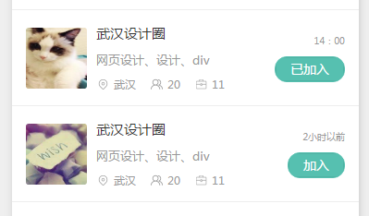

.media4{

padding: 30rpx;

border-bottom: 1rpx solid #eee;

display: flex;

align-items: center;

color:#999;

background-color: #fff;

}

.media4-icon{

width: 132rpx;

height: 132rpx;

margin-right: 20rpx;

border-radius: 6rpx;

}

.media4-body{

display: flex;

align-items: center;

justify-content: space-between;

width: 538rpx;

}

.media4-left{

display: flex;

flex-direction: column;

}

.media4-title{

color: #333;

font-size: 15px;

padding-bottom: 20rpx;

}

.media4-info{

font-size: 13px;

padding-bottom: 20rpx;

}

.media4-footer{

font-size: 12px;

display: flex;

align-items: center;

}

.media4-footer image{

width:30rpx;

height: 30rpx;

padding-right: 8rpx;

}

.media4-footer text{

padding-right: 30rpx

}

.media4-right{

display: flex;

flex-direction: column;

align-items: flex-end;

}

.media4-time{

padding-bottom: 20rpx;

color: #999;

font-size: 10px;

}

.media4-join, .media4-joined{

height: 53rpx;

line-height: 53rpx;

padding: 0 32rpx;

border: 1rpx solid #56c0b0;

border-radius: 26rpx;

color:#fff;

font-size: 14px;

text-align: center;

}

.media4-salary{

color:#56c0b0;

font-size: 15px;

}

七、提示框

1、/*弹出来的提示框，按钮样式,默认隐藏*/

<view id="success" class="tip-button">修改密码成功</view>

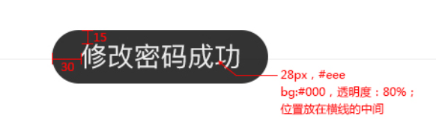

.tip-button{

display: none;

position: absolute;

height: 58rpx;

line-height: 58rpx;

padding: 0 30rpx;

color:#eee;

background-color: #000;

font-size: 14px;

border-radius: 30rpx;

text-align: center;

opacity: 0.8;

}

八、

<view class="hover">

</view>

/*遮罩层*/

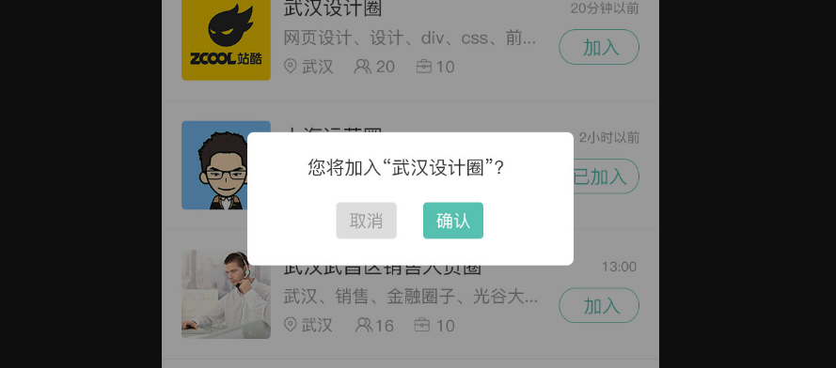

.hover{

position: fixed;

top:0;

left: 0;

width: 750rpx;

height: 1206rpx;

background-color: #000;

opacity: 0.4;

}