**Threat Modeling of Keystone Catalog Service**

**1.1 System Overview**

|  |  |
| --- | --- |
| Application version | Keystone Havana Stable Release |
| Application  Description | The Keystone Catalog Service falls under the Identity service. [**http://api.openstack.org/api-ref-identity.html**](http://api.openstack.org/api-ref-identity.html)  This document is in continuation with the Threat Modeling of Keystone Identity and Assignment Driver. |
| Version | 0.1 |
| Participants |  |
| Additional Info |  |

**1.2 Implementation Overview**

|  |  |
| --- | --- |
| Major Components | Keystone Credential Controller.  Catalog Drivers (example SQL) |
| Dependent components | Keystone Policy Engine |
| Description |  |

**1.3 System Assumptions (External Dependencies)**

|  |  |
| --- | --- |
| **ID** | **Description** |
| 1 | The driver for Keystone Catalog Service used in this document is SQL. |
| 2 | The path for policy.json file is rightly configured in the Keystone configuration file. In addition, it can be enforced. |

**2. Security Objective**

|  |  |
| --- | --- |
| 1. | Provide authentic CRUD operation for Catalog Services. |

**3.1 Data Flow Diagrams**

**Catalog API(s):** [**http://api.openstack.org/api-ref-identity.html**](http://api.openstack.org/api-ref-identity.html)

**I. ENDPOINT OPERATIONS:**

**Context: Endpoint Related Operations**

**API: version 3**

**Controller: Controllers.EndpointV3()**

**1. Create Endpoint:**

**Request Type: POST v3/endpoints**

**Operation: Adds an endpoint.**

**Normal Response Code: 201**

**API REQUEST:**

{

"endpoint":{

"interface":"[admin|public|internal]",

"name":"name",

"region":"--optional--",

"url":"...",

"service_id":"--service-id--"

}

}

**DFD:**

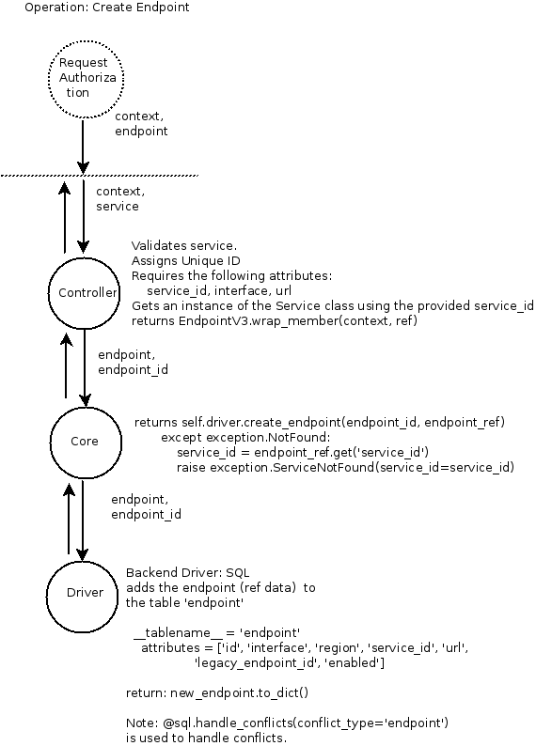

**2. Update Endpoint:**

**Request Type: PATCH v3/endpoints/ {endpoint_id}**

**Operation: Updates a specified endpoint.**

**Normal Response Code: 200**

**DFD:**

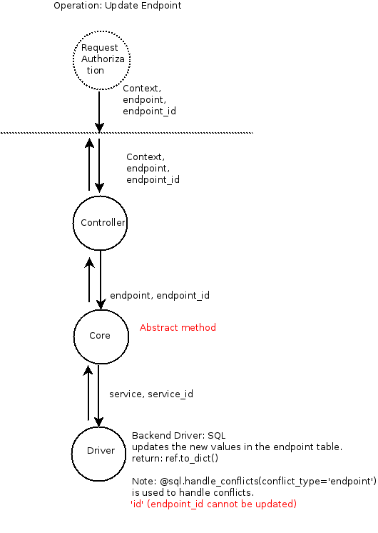

**3. Delete Endpoint:**

**Request Type: DELETE v3/endpoints/ {endpoints_id}**

**Operation: Deletes a specified endpoint.**

**Normal Response Code: 204**

**NOTE: This operation does not require a request body and does not return a response body.**

**DFD:**

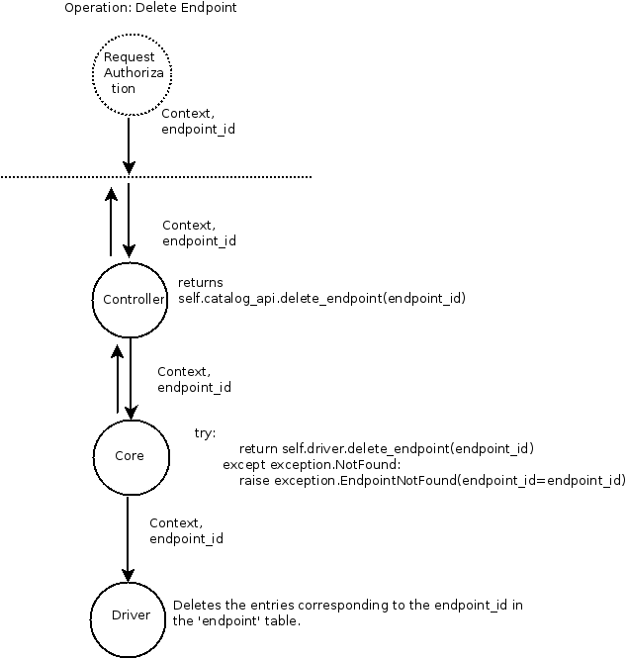

**I. SERVICE OPERATIONS:**

**Context: Service Related Operations**

**API: version 3**

**Controller: Controllers.ServiceV3()**

**1. Create Service**

**Request Type: POST v3/services**

**Operation: Adds a service.**

**Normal Response Code: 201**

**API REQUEST:**

{

"type": "..."

}

**DFD:**

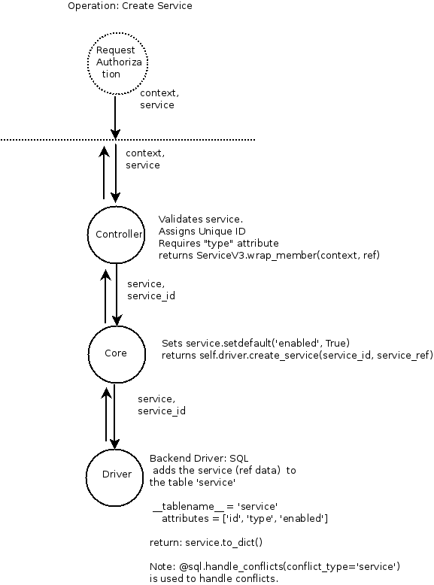

**2. Update Service**

**Request Type: PATCH v3/services/{service_id}**

**Operation: Updates a specified service.**

**Normal Response Code: 200**

**DFD:**

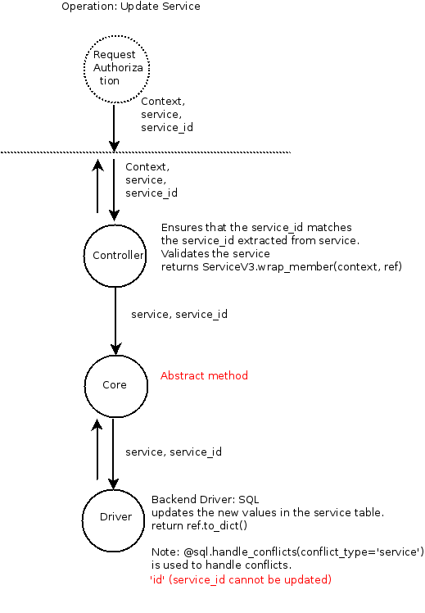

**3. Delete Service**

**Request Type: DELETE v3/services/ {services_id}**

**Operation: Deletes a specified service.**

**Normal Response Code: 204**

**NOTE:**

**1. Deleting a service when endpoints exist should either (1) delete all associated endpoints or (2) fail until endpoints are deleted.**

**2. This operation does not require a request body and does not return a response body.**

**DFD:**

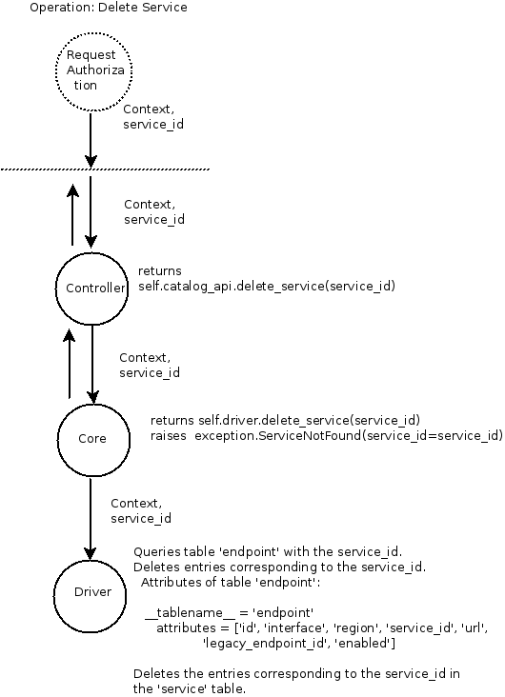

**3.2 Entry points**

|  |  |  |  |
| --- | --- | --- | --- |
| **ID** | **Name** | **Description** | **Accessible To** |
| 1. | Public Port | SSL protected port, used to access the keystone server. External requests come and return through this port. Default 5000. If you plan to use SSL proxy, it could be different. | All, however only authenticated user can get in. |
| 4. | Interface towards persistence layer | Keystone server communicates with database backend. We only consider MySQL server. |  |

**3.3 Assets**

|  |  |  |  |
| --- | --- | --- | --- |
| **ID** | **Name** | **Details** | **Accessible To** |
| 10 | Service | Includes:  Type of service |  |
| 10.1 | Service ID | ID of a specific service. |  |
| 11. | Endpoint | Includes information like:  Interface  Name  Region |  |
| 11.1 | Endpoint ID | ID of a specific endpoint. |  |

**3.4 (Existing Security Controls)**

**Not Done**

**4. ThreatIdentification and Analysis**

**// TODO:**