1. 角色用例图(the Use Case Diagram of Actor)

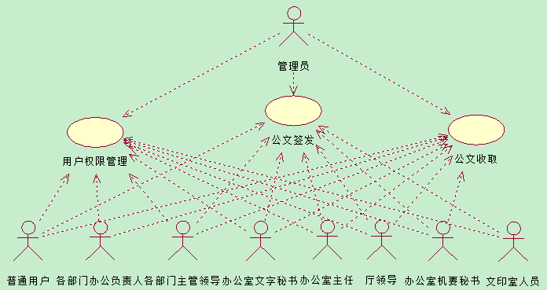

2. 用户权限管理功能用例图(the Use Case Diagram of User Permission Management Function)
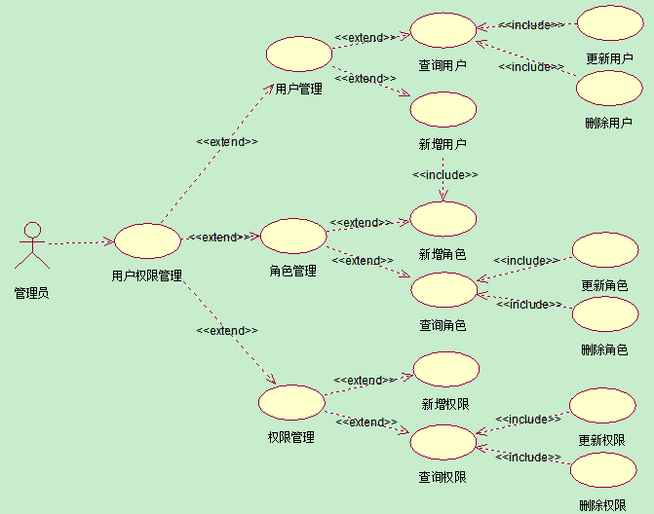

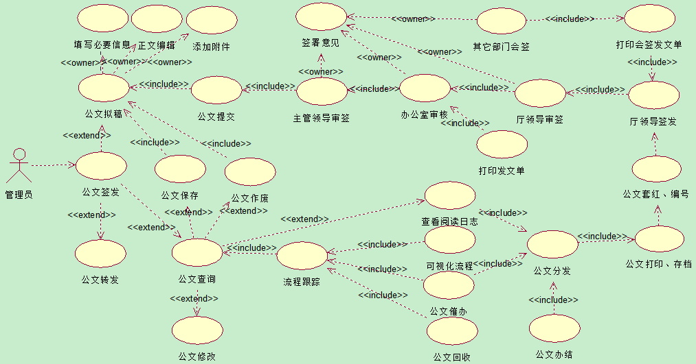
3.1 功能用例图(the Use Case Diagram of Ut Function)

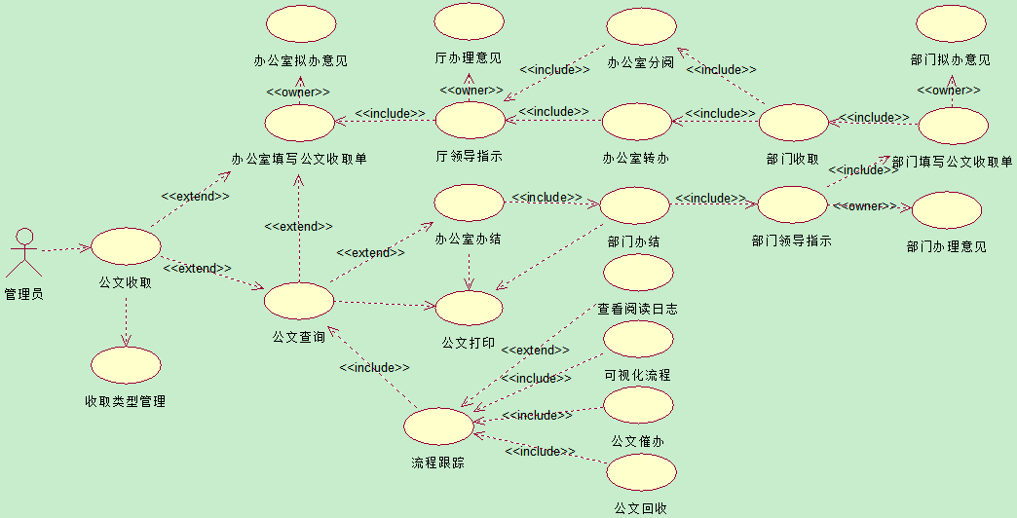
3.2 功能用例图(the Use Case Diagram of Ut Function)

4.1 功能工作流设计图(the Work Flow Design Diagram of Function)

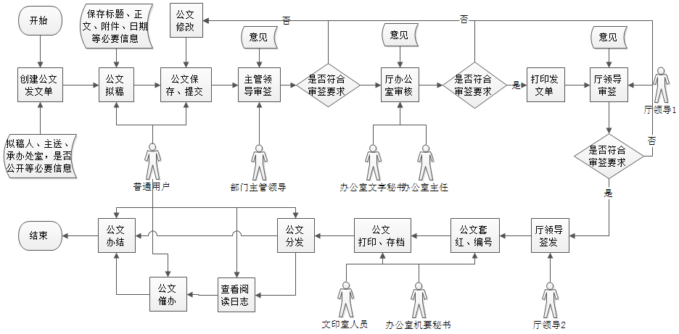

4.2 功能工作流设计图(the Work Flow Design Diagram of Function)

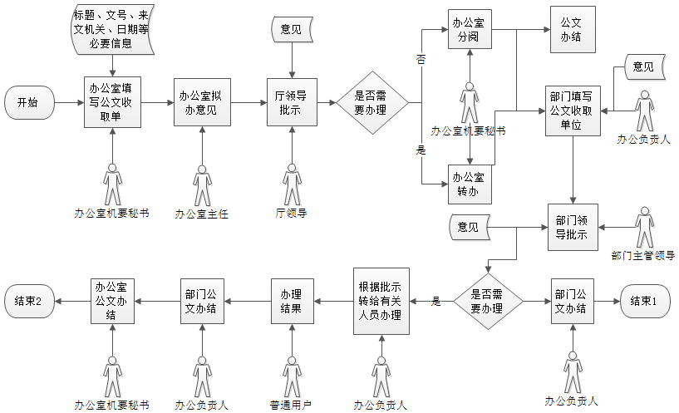

5.1时序图1: (the Sequence Diagram of the Login Verification Function)

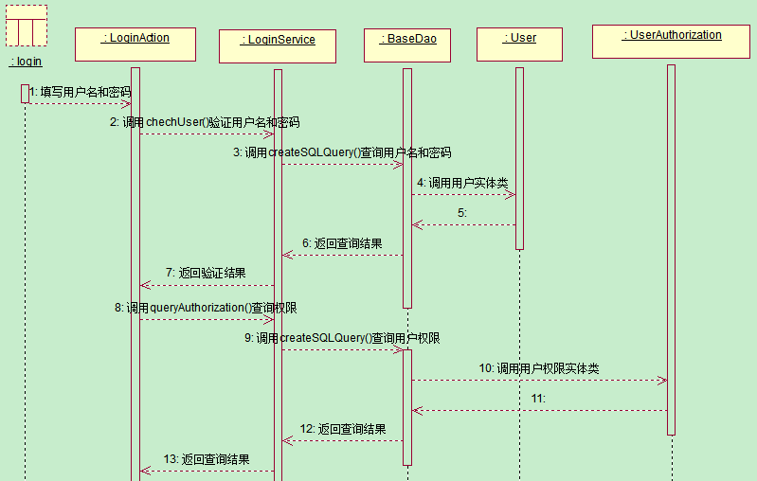

5.2时序图2: (the Sequence Diagram of the Login Verification Function)

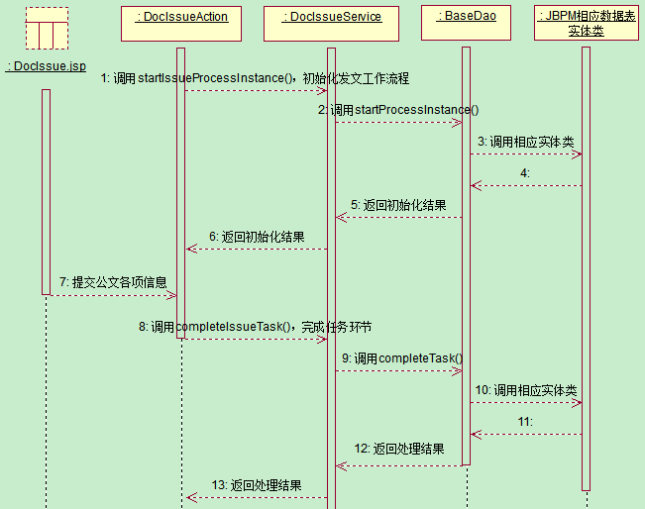

5.3时序图3: (the Sequence Diagram of the Login Verification Function)
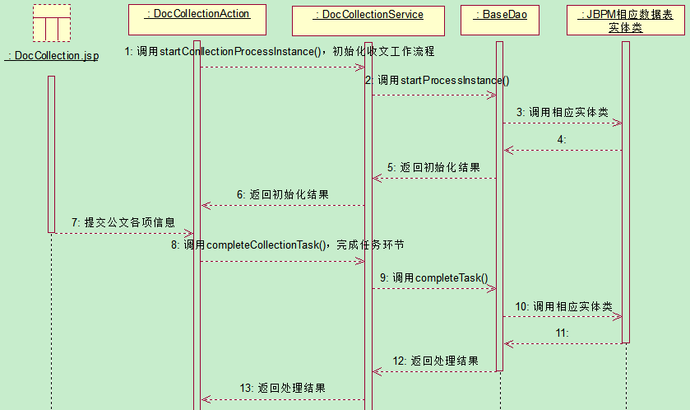

6.1 ER图1：（the Entity Relationship Diagram of Platform）

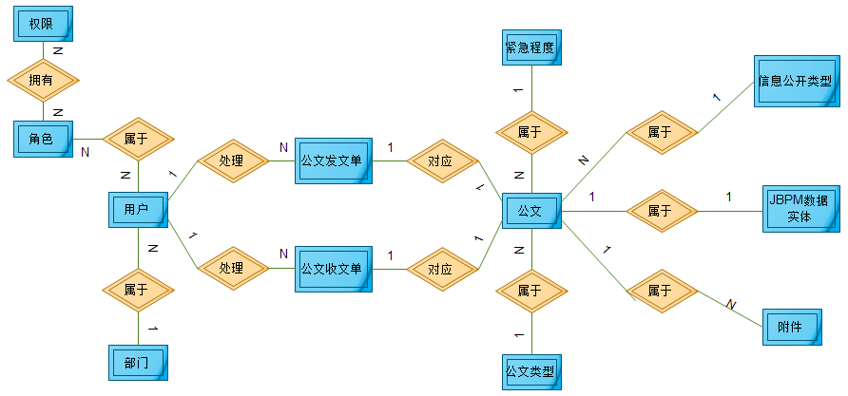

6.2 ER图2：（the Entity Relationship Diagram of Platform）

