CALCULUS DERIVATIVES PROJECT

My project is about the sounds cylindrical objects make when you drop them while spinning them. When you do this, the object rolls its bottom edge along the ground in a circle repeatedly, getting faster and faster until it comes to a stop. This creates a repeating sound that gets faster and faster until the object stops. I recorded this sound, and noted every time it repeats. I did this for the same object on a bunch of different surfaces, and for objects of differing radii. This is what the audio looks like on a spectrogram:
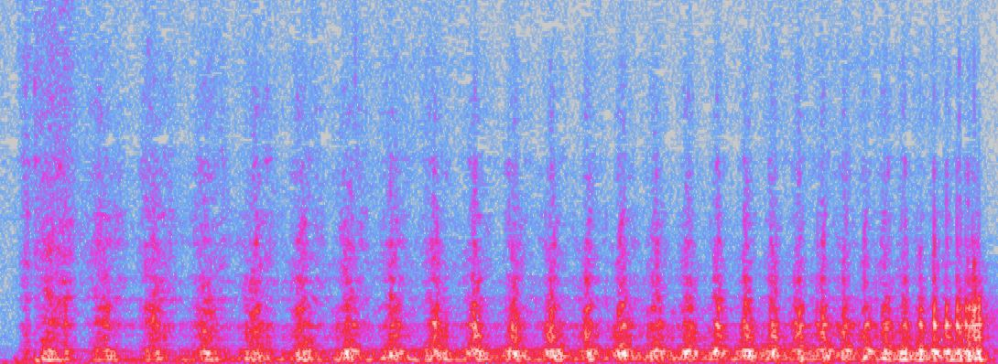
You can clearly see the repeated sound getting faster and faster, before reaching a stop. I manually noted down each peak, and this is what it looks like graphed, whatever the object was it looked generally like this:

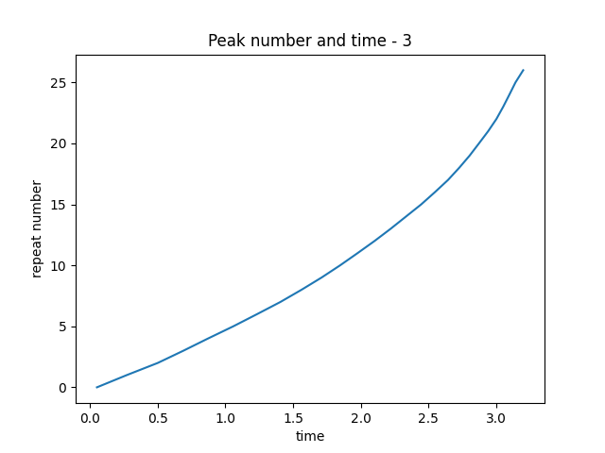
Or, with the axes flipped:
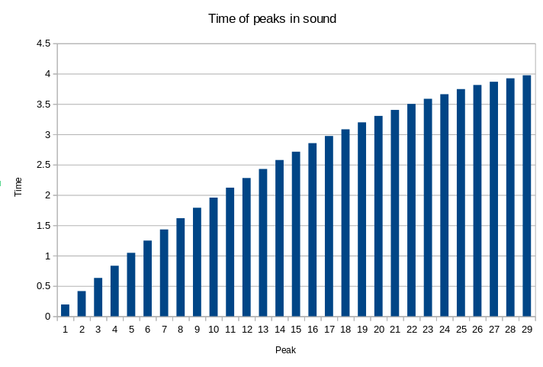
You can see here that as the sound progresses, the peaks become closer together in time. With peak # on the x axis, the slope of the line decreases over time. This is probably quadratic, because when I take the difference in time of adjacent peaks, to find the period of the sound over time, it looks like this:
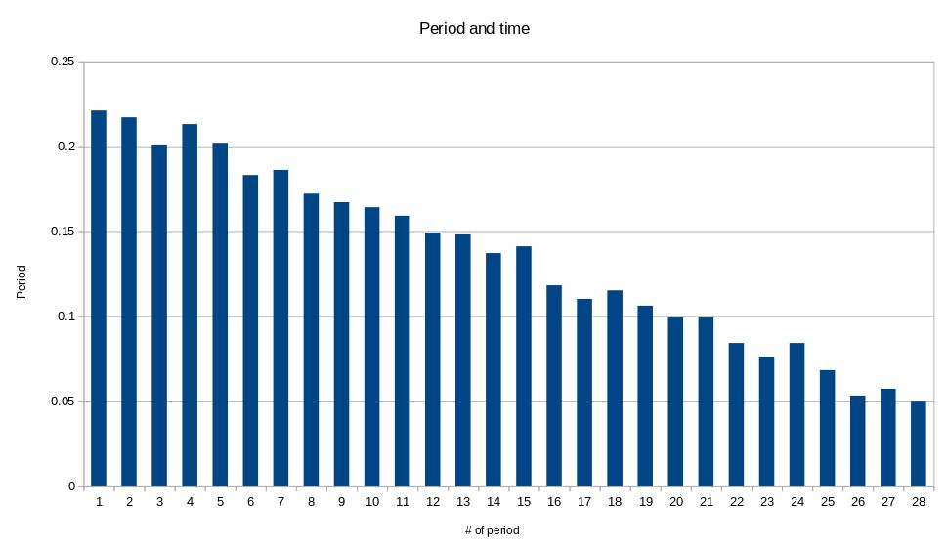
This looks very linear. However, there are some times where it looks less linear:
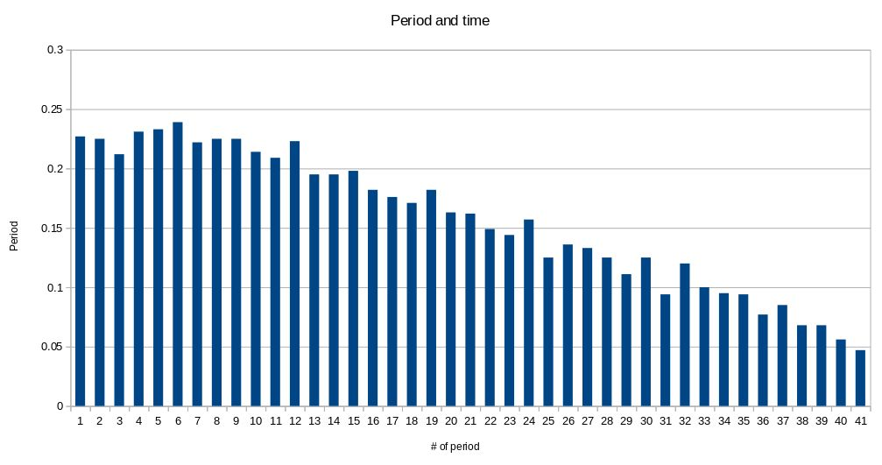
Here, it starts out relatively constant, before becoming linear later. I mostly noticed this on trials where I spun it very hard, so possibly this is a result of it spinning so much it can sustain itself somewhat, for a time, and so it doesn't follow the pattern. However, I didn't specifically test that, so it's possible thats completely unrelated.
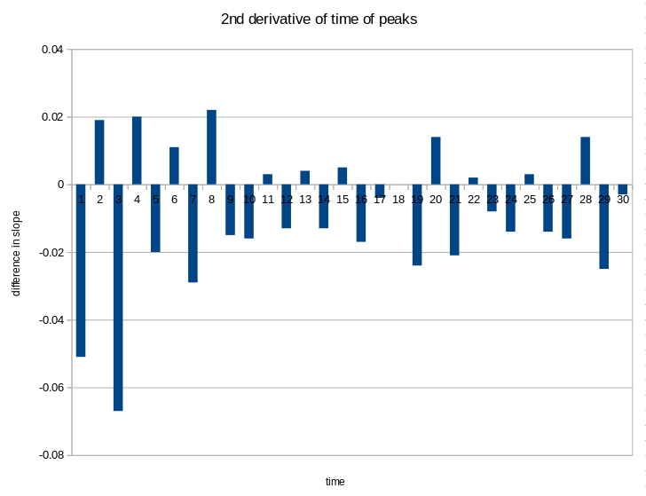
I tested the same object on various different surfaces. This produced the same looking function for the peaks, but changed the 2nd derivative. The 2nd derivative of any of these curves looks like this:
To me, this looks like random variation based on errors in measurement, centered around a non zero constant, which if we think that the original curve is quadratic, makes sense. When you average all these values, you get a number that is the slope of the 1st derivative. When you test the same object on various surfaces, the slope you get changes, which reflects the surfaces being better or worse at absorbing the energy of the object:
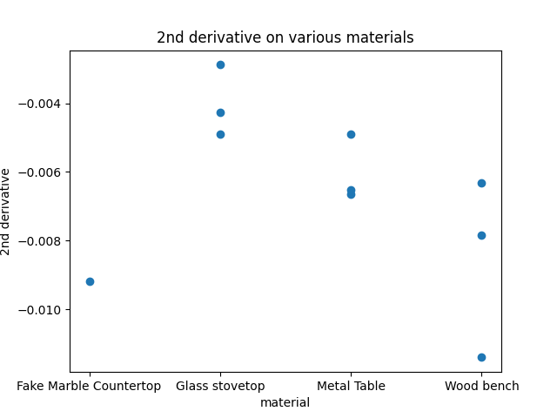
These values are all negative, so a larger slope means the material is absorbing less of the energy.
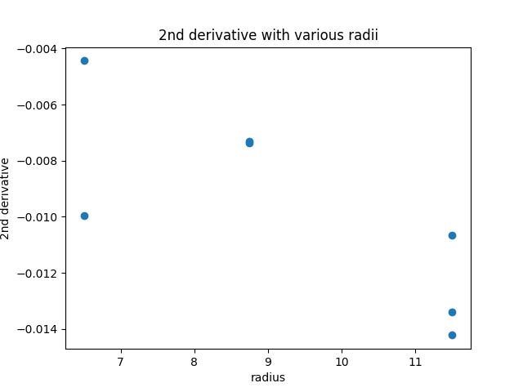
I also tested different radii of the same type of object. I did this with pot lids and with tape rolls with differing amounts of tape on them, but the audio samples for the pot lids are much harder to analyze, and so the data is unreliable. In most of them, I simply couldn't distinguish the peaks after a certain point. The graph of the radius and the 2nd derivative for the pans looks like this:

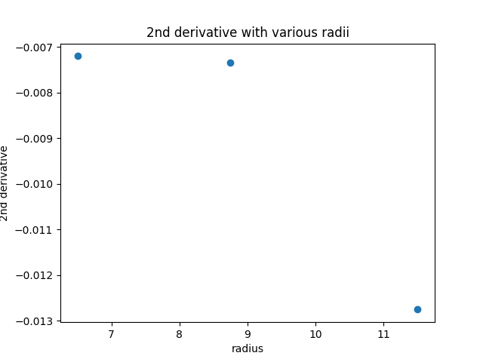
And looks like this when averaged:
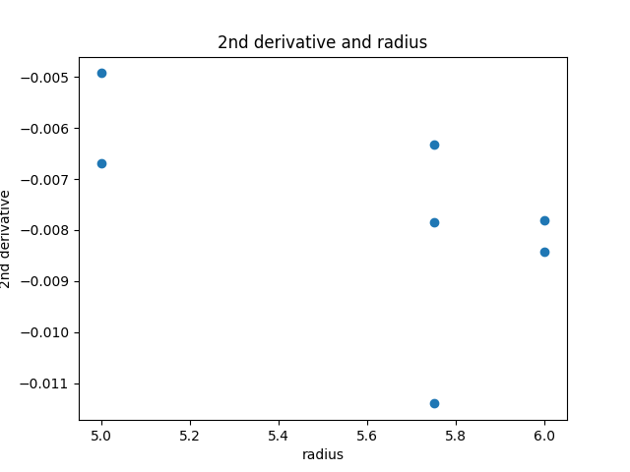
These results are unreliable, so I don't know what to make of this. When you repeat the same thing with the tape, which has much easier to resolve audio, it looks like this:

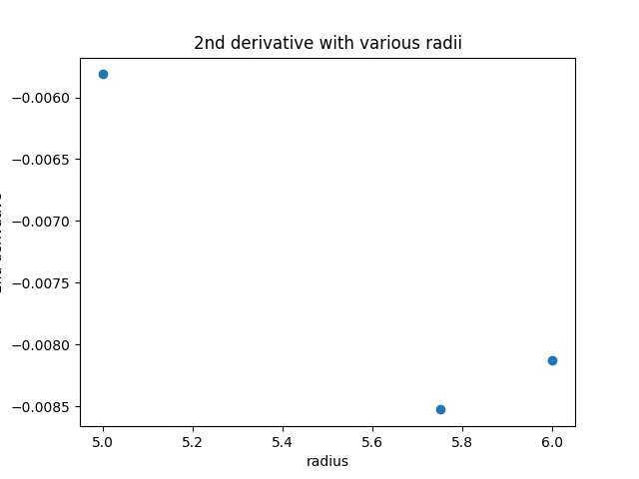
And when averaged looks like this:
Once again, I'm not really sure. Possibly for some reason, radius causes the 2nd derivative to decrease and then increase, maybe to do with the fact that I'm not increasing the force very much, perhaps. Possibly this is errors in my measurements. Possibly this is random variation caused by the amount of force I exerted. I don't have enough data to know, I think.
I think it's clear that the material the sound is on affects the 2nd derivative of the peaks in that sound, but it's less clear how the radius of the object affects these things. More trials would be needed to make that clear.

