**YAMAHA PERFORMANCE DAMPER**

A modern vehicle chassis is extremely rigid, realizing amazing performance and impact safety. However, during driving, even the slightest bump can cause a ripple effect of extremely small deformations and vibrations across the body. Despite the fact that these deformations are on the order of 50 to 100 micrometers (roughly the width of a human hair), they can be clearly felt by the passengers as unwanted vibration. The reason for this is not due to the amount of deformation, but the resulting oscillation.

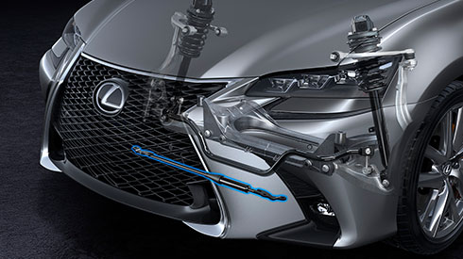

A good example is a giant tuning fork like the one pictured. If it is hit with a hammer, the metal forks vibrate, oscillating back and forth in the pattern shown on the waveform. However, if a damper is attached between the metal forks and it is struck again with a hammer, the metal forks very quickly ceases vibrating. The Yamaha Performance Damper utilizes this same principle to greatly reduce any vibration or oscillation propagating through the vehicle body due to input from the road surface.

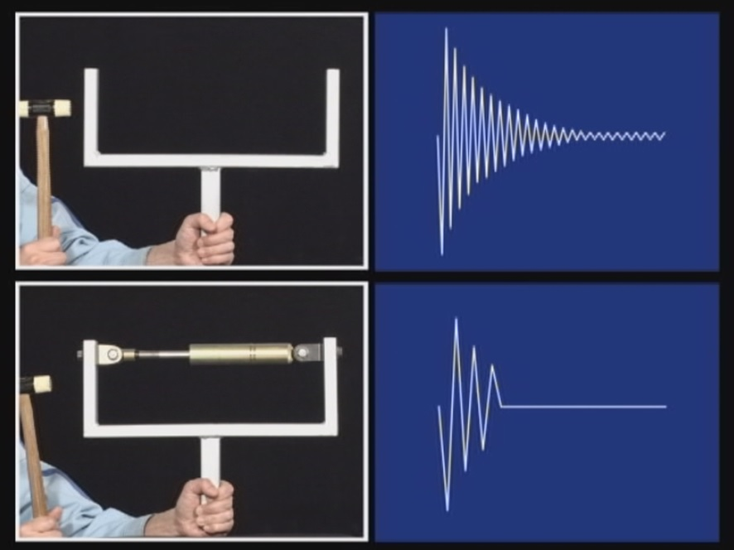

The Yamaha Performance Damper itself is constructed similarly to a standard shock absorber, like those used in the vehicle suspension. However, a standard shock absorber has a comparatively long stroke as it must operate throughout the entire travel distance of the suspension, which can be around 10 inches or 250 millimeters. The Yamaha Performance Damper on the other hand, has an extremely short stroke, in the region of 10 to 100 micrometers or 0.01 to 0.1 millimeters. As such, the Yamaha Performance Damper features a few unique design elements. The pressurized nitrogen gas at the end of the absorber creates a preload that presses the extension rod outwards. A spring that sits between the body of the damper and the piston valve creates a counter force that balances the preload created by the pressurized nitrogen gas. The piston valve itself features a unique design that generates very low speed damping force. This construction allows the damper to generate damping force for such miniscule fluctuations.

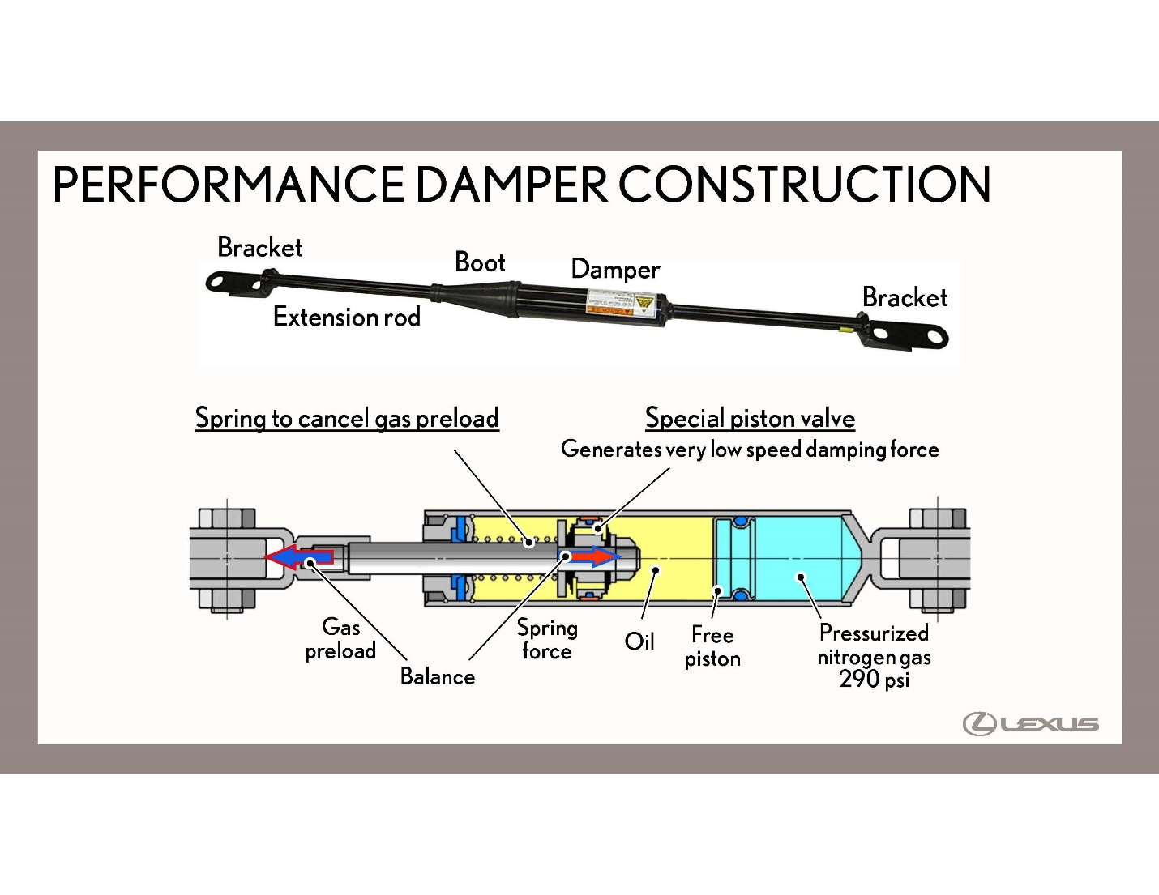

Usually a damper is installed both on the front and rear of the vehicle. The damper can actually be placed in a variety of locations at the front or rear, such as between the suspension towers, in the bumper reinforcement, mounted to the floor near the rear seat, or between the side members. The reason for this is that the entire body of the vehicle acts like a collection of interconnected spring elements, oscillating and vibrating. Wherever the damper is placed, it changes the oscillating condition of the entire vehicle due to the interconnected nature.

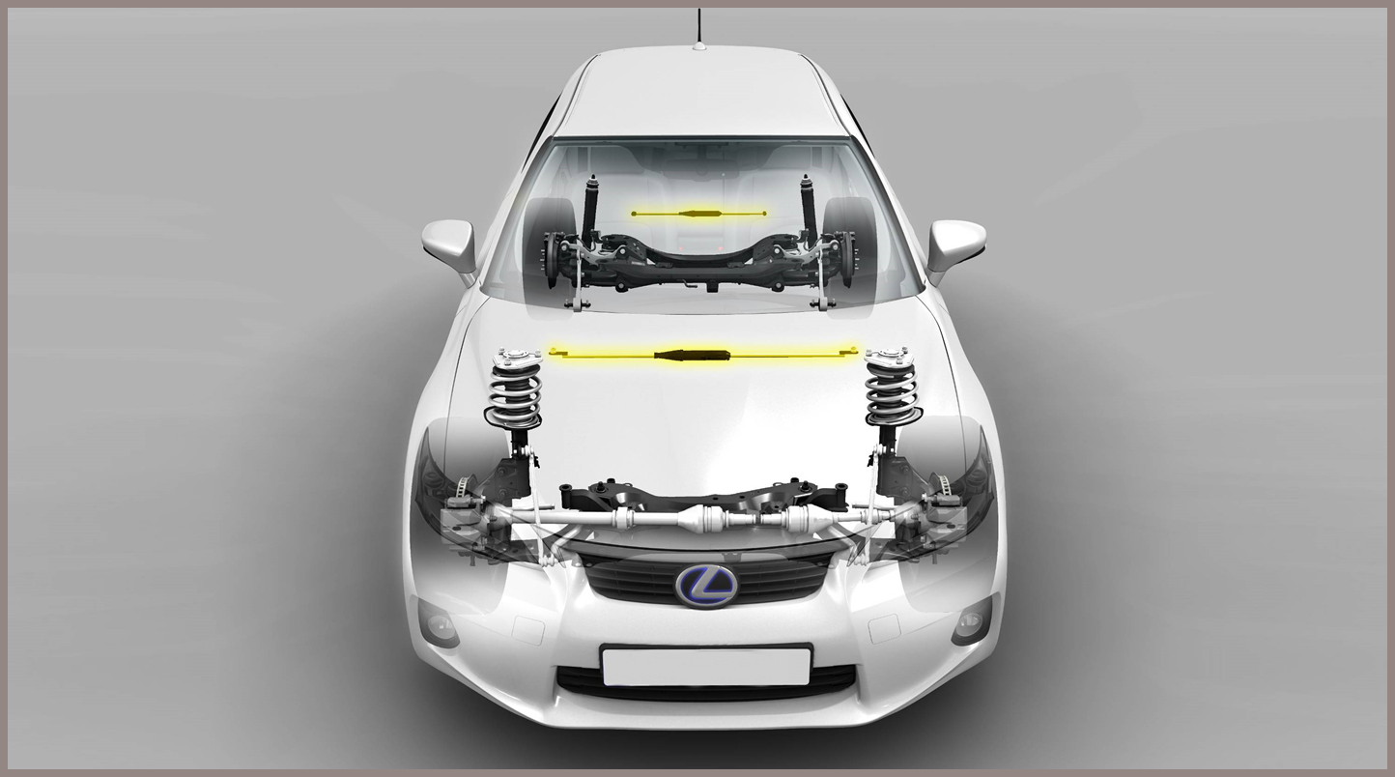

The result is, in short, “high-quality driving performance”. As you can see in the graph below, the dampers greatly reduce the effect on body deformation. Furthermore, the chassis settles much quicker, eliminating that unpleasant feeling of continuing motion after hitting a bump. This greatly reduces the amount oscillations occurring throughout the body. As a result, the “high-quality driving performance” doesn’t just apply to improved handling ability, but also contributes to greatly reduced noise, vibration and harshness. Even on vehicles with already notoriously high chassis rigidity, the addition of the Yamaha Performance Damper sees a noticeable increase in driving performance. This helps to contribute to a chassis that can perform like a sports car, yet ride like a Word-class luxury car as well.

