|  |  |  |  |  |  |
| --- | --- | --- | --- | --- | --- |
| AIUB | | **American International University- Bangladesh (AIUB)**  **Faculty of Engineering (EEE)** | | | |
|  | | |  |  |  |
| **Course Name:** | | | Microprocessor and Embedded System | **Course Code:** | EEE 4103 |
| **Semester:** | | | Spring 2023-2024 | **Sec:** | I |
| **Faculty:** | | | Ali Noor | | |
|  | | |  |  |  |
| **Capstone Project Title:** | | | Design, Simulation and Implementation of a Smart Dustbin system using Arduino Uno | | |
| **Project Group No.** | | | 7 | | |
|  | | |  |  |  |
|  | **Student ID:** | | | **Student Name:** | |
| **1.** | **20-42091-1** | | | **MD. Forhadul islam** | |
| **2.** | **20-42268-1** | | | **Nabila Chowdhury Joya** | |
| **3.** | **20-43589-1** | | | **Ananna Rashid Kumkum** | |
| **4.** |  | | |  | |
| **5.** |  | | |  | |
| **6.** |  | | |  | |
| **7.** |  | | |  | |
| **8.** |  | | |  | |

**Assessment Materials and Marks Allocation:**

|  |  |  |  |
| --- | --- | --- | --- |
| **Cos** | **Assessment Materials** | **POIs** | **Marks** |
| CO4 | Project report | P.d.1.C5 | **5** |

|  |  |  |  |  |  |  |  |
| --- | --- | --- | --- | --- | --- | --- | --- |
| COs-POIs | Excellent  [5] | Proficient  [4] | Good  [3] | Acceptable  [2] | Unacceptable  [1] | No Response  [0] | Secured Marks |
| **CO4**  **P.d.1.C5** | The outcome of project perfectly investigates the design of experiments for complex engineering  problem through  appropriate research. | The outcome of project displays impressive familiarity with good range of appropriate literature research. | The outcome of project displays familiarity with reasonably full range of literature; demonstrates an appropriate grounding and engagement with the literature | The outcome of project does not indicate familiarity with literature; has large gaps and shows little grounding of the capstone in the literature. No substantive engagement. | The outcome of project does  Minimally address research questions and fail to demonstrate its claims persuasively.  structure reflects a lack of organization. | No Response |  |
| **Comments** |  |  |  |  |  | Total marks (5) |  |

**Design, Simulation and Implementation of a Smart Dustbin system using Arduino Uno**

**1. Abstract**

The main purpose of the project is to design a smart dustbin which uses is much easier and time-saving than a normal dustbin and it will help in keeping our environment clean and eco-friendly [1]. As the present world is a world of technologies where all the technologies are modernizing to work smarter than one another Smart Dustbin System is also a product of that modernization. Nowadays technologies are getting smarter day by day, so to clean the environment we are designing a smart dustbin using Arduino. This smart dustbin system is built on the microcontroller-based system having ultrasonic sensors on the dustbin. If dustbin is not maintained, then these can cause an unhealthy environment and can cause pollution that affects our health. In this proposal, we have designed a smart dustbin using ARDUINO UNO, along with an ultrasonic sensor, servo motor, and battery jumper wire. After all hardware and software, connections the Smart Dustbin program will be run. The dustbin lid will open when someone comes near at some range then wait for a user to put the garbage and close it. For social it will help toward health and hygiene, and for business, we try to make it affordable to as many as possible so that people can take benefit from this. Also we added the fire alarm system into this smart dustbin. A fire alarm system is an electronic device designed to detect and alert individuals to the presence of fire, smoke, or other potentially hazardous conditions. It typically consists of a series of sensors, such as smoke detectors or heat sensors, that are connected to a central control panel. When a sensor detects a potential fire, it sends a signal to the control panel, which triggers an alarm or alerts the relevant authorities. Fire alarm systems are essential for ensuring the safety of individuals and property in both residential and commercial settings.

**2. Introduction**

2.1 Background of Study and Motivation

In every day’s work we use what we need and throw the wastes, which is a part of our regular life. Sometimes we experience bad smell and unhygienic situation through using the normal dustbins. For these kind of problems in our regular life we were highly inspire to made a dustbin that should have the best way to use and we got the idea of Smart Dustbin System.

2.2 Project Objectives

To make a better waste management which is hygienic, fire free, affordable and digital time saving technology.

2.3 A brief outline of the report

We will make a smart dustbin system where we will use ARDUINO UNO, along with ultrasonic sensor, servo motor, and battery jumper wire. After all hardware and software connection the Smart Dustbin program will run. Dustbin lid will open when someone comes near at some range than wait for user to put garbage and close it.

**3. Literature Review**

The project's major goal is to create a smart trash that can aid in maintaining a clean and environmentally friendly environment. Since technology is becoming increasingly intelligent, we are utilizing Arduino to develop a smart dustbin that will help clean the environment [1]. This intelligent trash can management system is based on a microcontroller-based setup with ultrasonic sensors on the trash can. If trash bins are not maintained, they might lead to pollution that is bad for our health and create an unhealthful atmosphere. In the suggested technique, a smart trash can made of an Arduino Uno, an ultrasonic sensor, a servo motor, and a battery jumper wire has been created.

Urbanization has dramatically risen in the modern world. There is an increase in garbage output at the same time. Waste management has been an important topic to think about. This paper presents an alternative strategy for achieving this goal cause [2]. This report's smart bin is constructed on the Arduino microcontroller platform. Ultrasonic sensor is connected to an Uno board. It will stop spilling over from roadside and neighborhood trash cans are a sensible idea. Real-time management is used for dustbins. Once the conventional trash cans are replaced with these smart ones on a big scale, dumpsters, the garbage may be rapidly and effectively controlled, preventing needless dumping of rubbish along the road.

Ignorance of the overflowing waste disposal issue has many detrimental effects on our society, including the attraction of disease-carrying vectors, the production of bad odors, and the breeding of mosquitoes. The goal of this project is to decrease the problem by constructing an Internet of Things-based smart trash can utilizing an Arduino Uno microcontroller [3]. The two goals of this study are design a prototype Iot-based smart dustbin equipped with an Arduino Uno, an ultrasonic sensor, a buzzer, and an ESP 8266 Wi-Fi module, and (ii) use a survey questionnaire to assess the effectiveness of the smart dustbin provided by the local restaurant authority. Arduino Uno, an ultrasonic sensor, an ESP 8266 Wi-Fi module, a buzzer, and a public trash can were chosen using a concept-screening matrix to construct an Iot-based smart trash can.

Most often, we meet overstuffed trash cans with waste pouring out of them in our daily lives. Neither our environment nor our growth benefit from situations like these. Due to the vast number of insects and mosquitoes that grow on the trash that has collected in this landfill, this issue causes a significant number of ailments. As a result, we created a project to prevent the trash can from becoming overfilled by giving it the ability to alert users when it needs to be cleaned [4]. The smart trash can management system in this project is based on a microcontroller and has ultrasonic sensors on each of the four trash cans to display the garbage's current condition on an LCD screen and a mobile device.

Garbage contributes to sickness, foul smells, and air pollution. Waste can originate from families and companies, which have many different sorts and forms, at any time and everywhere. Public knowledge of proper garbage disposal is frequently quite low, and when dustbins are few and very unclean, the open and close method is still manual, making it easy for hands to become infected with bacteria while handling the rubbish. This project attempts to start with a modest goal, namely installing smart trash cans for the campus environment and training students so that they are more motivated to dispose of trash properly [5]. The super-smart dustbin and mini-smart dustbin are two different variations of the smart dustbin system that is advised.

**4. Methodology and Modelling**

4.1 Introduction

The population rate in our country has increased rapidly and so it has increased garbage that created environmental issues. A dustbin is a container that collects garbage dust items that can be recyclable or non-recyclable, decompose, and non-decompose. But when a dustbin is full and no one is there to clean it, then the garbage is spilled out. Therefore, we have designed a smart dustbin using ARDUINO UNO, the ultrasonic sensor which will sense the item to be thrown in the dustbin and open the lid with the help of the motor. It is an IOT-based project that will bring a smart way of cleanliness. It is a decent gadget to make our life easier.

4.2 Working principle of the proposed project

The main objective of the project is to design a smart dustbin, which will help in keeping our environment clean and also eco-friendly. It will be applied to various types of waste. This will only open when required. It will bring drastic changes in tern of cleanliness with the help of technology. Our aim is also to make it cost-effective so that many numbers of people can get the benefit from this as well as it should be usable to anyone and helpful for them.

4.2.1 Process of Work

We are using Arduino for code execution, for sensing we used an ultrasonic sensor that will open its lid when someone or the object is near a distance range, then it will wait for a given time and after that, it will close automatically. The smart dustbin uses an Ultrasonic sensor HC-SR04 to detect objects in front. It then sends the signals to Arduino Uno. The Arduino understands the signal and sends a signal to the Servomotor which opens the flap on top of the dustbin.

After wiring and attaching all the devices and setting up the Smart Dustbin, we need to observe all the important setups whether they are well connected or something missed. After the connection is set up, we will upload the code in Arduino and give the power supply to the circuit. When the system is powered ON, Arduino keeps monitoring for any objects that come near the sensor at a given range or distance. When an Ultrasonic sensor detects any object for example like hand or others, Arduino auto calculates its distance. If it is less than a certain predefined value, then the lid will be closed. Again, if it is more than a certain predefined value, then also the lid will be closed. The lid will be only open for a short time if the object is in a certain range and then it will be automatically closed.

4.3 Description of the components

Required Software:

1. Arduino IDE

Required hardware:

1. Arduino Uno
2. Ultrasonic Sensor
3. A Basket
4. Jumper wires
5. Flame sensor
6. Buzzer
7. LED

4.4 Implementation

Wiring up the components: The build process is to make the necessary connections using long connecting wires as per the circuit diagram and securing these wires so that they don’t hang around. All the wires from both the components. Ultrasonic Sensor is connected to respective pins of Arduino. This finishing up the build process working or not?

Arduino Uno board consists of an ATmega328 P microcontroller, which is an important component of the UNO board. In this, other of the Smart Dustbin. In Arduino Code has been submitted, and with all hardware and software connections in Dustbin. We will run our dustbin, wait for its component to be present like a power supply, ultrasonic module, and servo motor, etc. The ultrasonic sensor echo pin and trigger pin is connected to pin digital pin D7 and D8. The +Vcc pin is connected to the +5V supply and the GND pin is connected to the ground pin of the Arduino Uno-board. The control (PWM) pin of the servo motor is connected to digital pin D9 of Arduino.

Ultrasonic Sensor: This sensor is used to locate the distance between the smart dustbin and the object that comes near it. The principle behind finding the distance of an obstacle is a sonar wave. It only detects obstacles when the Trigger pin receives a high pulse for a period of more than 10 us. When this sensor verifies the presence of an obstacle, it starts to send eight cycles of the ultrasonic burst, and then it waits for the reflected ultrasonic signal. The ultrasonic sensor module has two drums. One of the drums is used for transmitting the pulse ultrasonic and the second drums are for receiving the ultrasonic signal.

When ultrasonic detect or sense object, the echo pin of the module is set high. The waiting period of the reflected pulse is completely dependent upon the location of the obstacle. When the echo signal is obtained, we can calculate the distance by using the following formula:

Distance (in cm) = (duration / 2)

The controller keeps on monitoring the signal received from the ultrasonic module. When the ultrasonic module detects an obstacle, the controller checks if it crosses a threshold distance value set for opening the cap of a dustbin. A pull-up resistor is connected in a series of a switch as shown in the circuit diagram to solve the de-bouncing problem.

4.5 Test/Experimental setup

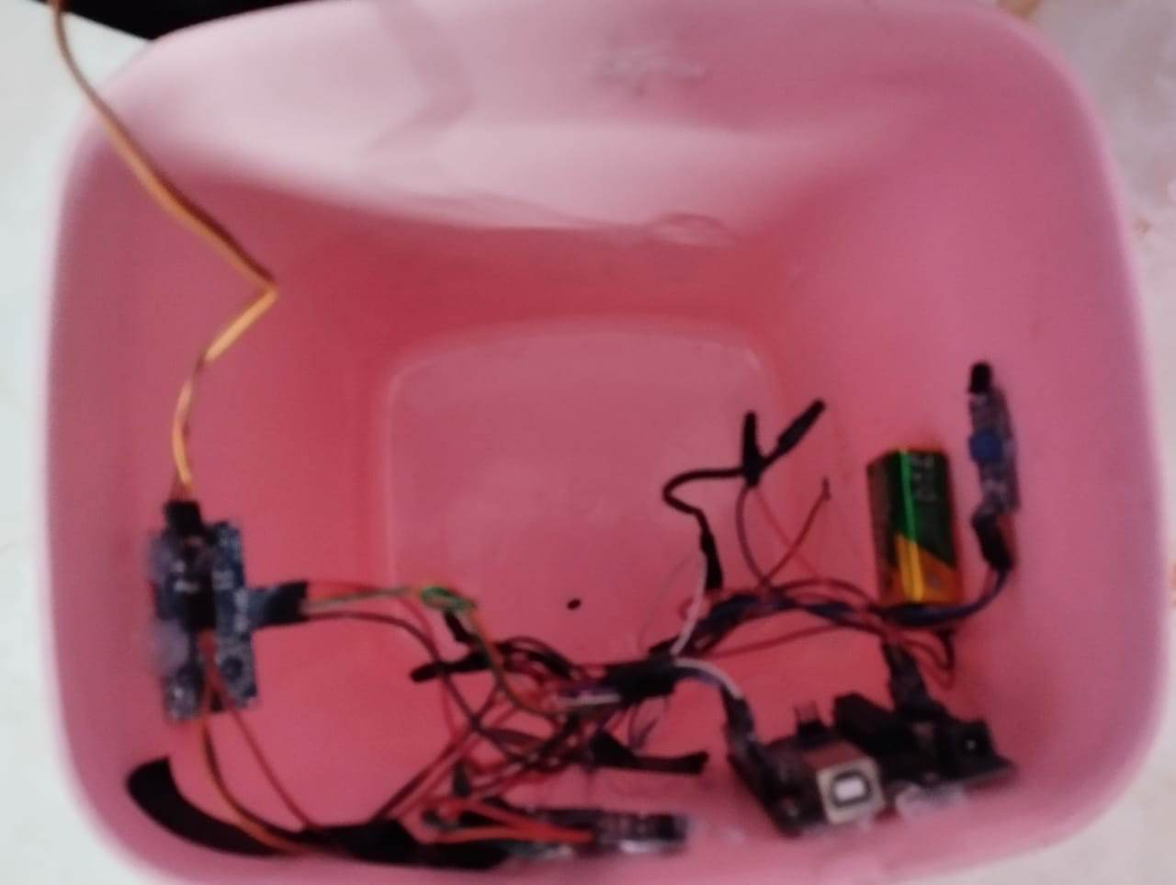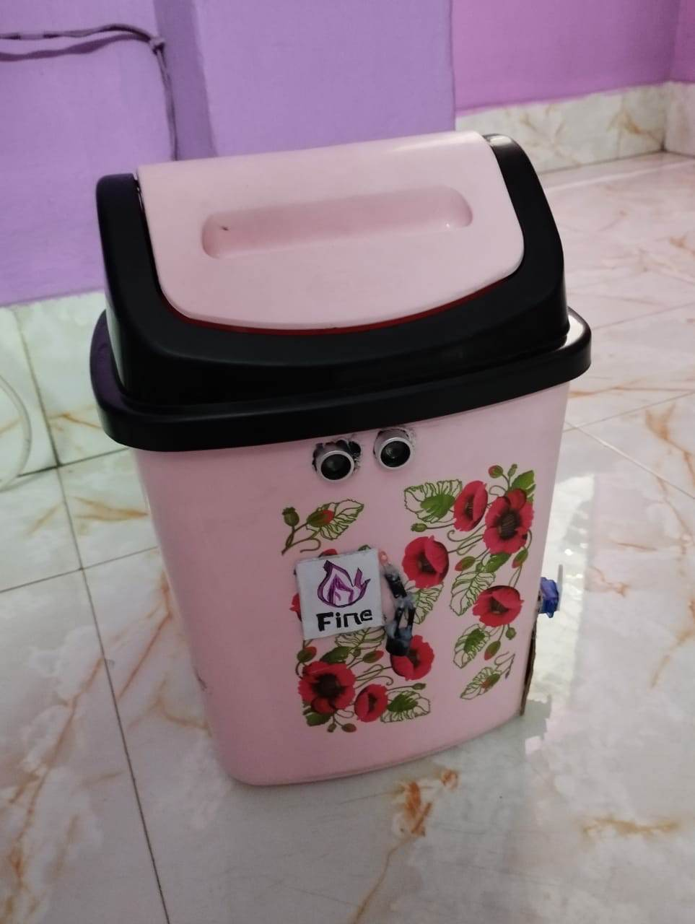

**5. Cost analysis**

**Our Price**

|  |  |  |  |
| --- | --- | --- | --- |
| **Product Name** | **Qty** | **Price** | **Subtotal (BDT** |
| Arduino UNO | 1 | 990.63 | 990.63 |
| Servo Motor SG91R | 1 | 290.66 | 290.66 |
| Sonar Sensor (HC-SR04) | 1 | 119.69 | 119.69 |
| Battery 9V | 1 | 54.45 | 54.45 |
| Male To Female Jumper Wire - Single | 10 | 3.19 | 31.9 |
| 9V Battery Connector (Barrel Jack) | 1 | 29.9 | 15.7 |
| Breadboard (400 Point) | 1 | 120.9 | 120.9 |
| Dustbin  Flame Sensor | 1  1 | 210  100 | 210  100 |
|  |  | **Grand Total** | **1933.93** |

Here, we can see the total price breakdown of our projects. The total cost of our project is 1833.93 taka and from many websites we saw that the price of an automatic dustbin cost more than 3000+ taka [6]. So, our project is having a lower cost than their project.

**6. Results and Discussion**

6.1 Simulation/Numerical analysis

Simulation Analysis

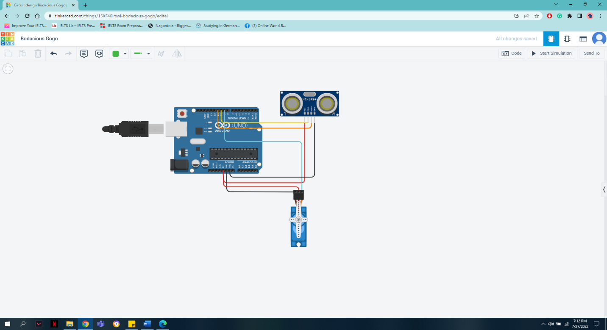

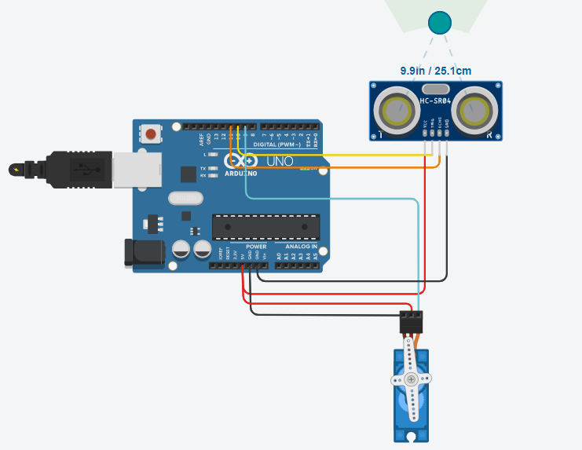

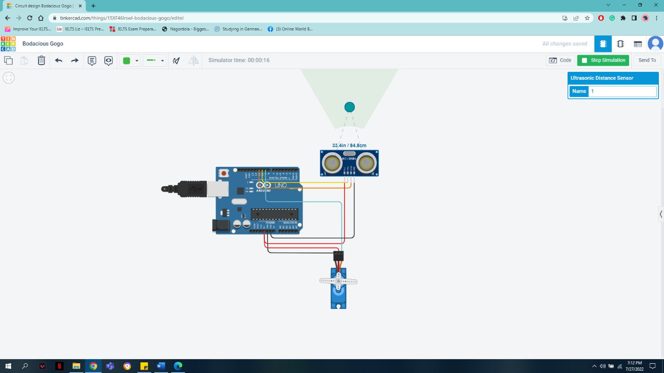

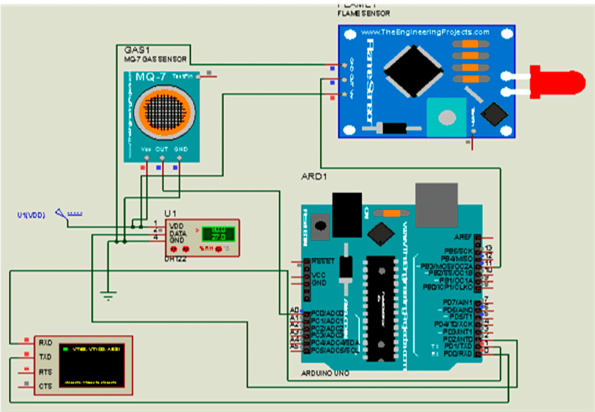

In the simulation, we have taken a sensor, Arduino Uno, servo motor, and wires. We have connected the trig and echo ports of the sensor with Arduino board 11 and 10 number ports. The ground and Vcc of the servo motor and sensor are connected with Arduino’s ground and Vcc port. Servo motor's main Signal port is connected with the Arduino’s 9 number port. After the component connection if we start the simulation, we can see when the object is in the range of 30 cm to the sensor it will remain at 0-degree position and if the object's range is greater than 30 cm then it will remain at 90 degrees.

6.2 Experimental results

In the experiment, we used Arduino Uno, servo motor, ultrasonic sensor, battery, and jumper wire. The sensor and servo motor are connected with the Arduino with the help jumper wire. Arduino and servo motor are connected with the trash can with the help of glue. The Servo motor will lift the lid of the trash can. As expected after the implantation of the experiment the lid of the trash can will open when an object will be in the range of 30 cm of the sensor and will close automatically after 3 seconds. When anyone unintentionally or intentionally

Throw the smoke or fire then the flame sensor automatically deleted the smoke the give us a warning and fire alarm also turn on.

6.3 Comparison between numerical and experimental results

The experimental and simulation both results give us our expected result. As expected, in the experiment the lid of the trash can will open when an object will be in the range of 30 cm of the sensor and will close automatically after 3 seconds. In the simulation, also servo motor will be at 0-degree position when the object is in the range of 30 cm to the sensor and if the object's range is greater than 30 cm then it will remain at 90 degrees.

6.4 Limitations in the project

1. If the object is big, the sensor cannot be able to identify it.

2. If the object is too close to the sensor, the sensor will not be able to detect it

3. If the cover dustbin is heavy then the servo motor will not able to lift it.

4. The lifting wire of the servo motor can shred if it is not strong enough to hold the dustbin cover.

5. If the warm object throw the bin then it is also detect as a fire .

**7. Conclusion and future endeavors**

This project will help to maintain a healthy and clean environment. This is a simple project made with the help of Arduino. In this project, the lid opens automatically to help with the disposal of trash. Also helps to maintain a healthy environment as well it doesn’t allow flies and other insects to enter the bin In the Future, we can also make it autonomous. Also, we develop it with a powerful sensor so that it can be used in bigger dustbins and can also detect the close object.

**8. References**

[1] Mamta Pandey, Anamika Gowala, Mrinal Jyoti Goswami, Chinmoy Saikia and Dr. Dibyajyoti Bora, “Smart Dustbin Using Arduino”, *International Journal of Scientific Research in Engineering and Management (IJSREM)*, Volume: 04, Issue: 08, August -2020.

[2] M.R. Sundarakumar, S. Arun kumar, S. Naveen, Kamal Kumar Ray, “Smart Dustbin-Garbage Monitoring System by Efficient Arduino Based”, *International Research Journal of Modernization in Engineering Technology and Science,* Volume:11, Issue:07, September 13.

[3] Bariya Amarbhai.M., Bariya Amarbhai.M., Ghodeswar Krunal.G, “Smart dustbin with automatic open/close cover”, *International Journal of Research and Advanced Development,* Volume 9, Issue 7, pp. 25-26, June 2022.

[4] Sohan Wagh*1, Shailesh Patil*2, Vikas Solanke*3, “Automatic Dustbin Using Arduino Nano”, *International Research Journal of Modernization in Engineering Technology and Science,* Volume:03, Issue:05, May-2021.

[5] Pavan Kumar Reddy chinthakunta, R Shiva Sai Rama Krishna, K. S. S. Naga Teja, S. Sunanda, “Smart Dustbin Using ARDUINO, Ultrasonic Sensor & Servo Motor”, *International Journal of Research and Advanced Development,* Volume 3, Issue 4, pp. 32-33, October 2019.

[6] <https://www.daraz.com.bd/products/2-12l-i161224631-s1093186797.html?spm=a2a0e.searchlist.list.5.60253d8etu0HaL&search=1>