

American International University-Bangladesh (AIUB)  
Department of Computer Science  
Faculty of Science &Technology (FST)  
Summer 22 23

Section: G  
Software Quality Assurance and Testing

Lookoid

A Report submitted By

|  |  |  |
| --- | --- | --- |
| SN | Student Name | Student ID |
| 1 | Shahidul Islam Ifte | 20-42088-1 |
| 2 | Md. Forhadul Islam | 20-42091-1 |
| 3 | Golam Kader Chowdhury | 20-42369-1 |
| 4 | Abdullah Al Noman | 18-39208-3 |

Under the supervision of

**FARZANA BENTE ALAM**

Faculty Designation: Lecturer, CS

Software Test Plan

for

<LOOKOID>

Version 1.0 approved

Prepared by <Shahidul Islam Ifte,

Md. Forhadul Islam,

Golam Kader Chowdhury,

Abdullah Al Noman >

< American International University-Bangladesh >

<26-4-2023>

**Checked By Industry Personnel**

Name: Muntasir Rahman Mahin

Designation: SQA Engineer

Company: Brain Station 23

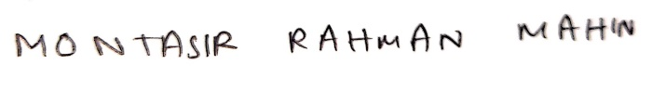

Sign:

Date: 26.04.23

Table of Contents

Revision History 4

1. TEST PLAN IDENTIFIER: RS-MTP01.3 4

2. REFERENCES 4

3. INTRODUCTION 4

Background to the Problem 4

Solution to the Problem 5

4. REQUEIREMNT SPECIFICATION 5

4.1 System Features 6

4.2 System Quality Attributes 7

4.3 System Interface 8

4.4 Project Requirements 9

5. FEATURES NOT TO BE TESTED 11

6. TESTING APPROACH 12

6.1 Testing Levels 12

6.2 Test Tools 13

6.3 Meetings 13

7. TEST CASES/TEST ITEMS 14

8. ITEM PASS/FAIL CRITERIA 39

9. TEST DELIVERABLES 40

10. STAFFING AND TRAINING NEEDS 41

11. RESPONSIBILITIES 41

12. TESTING SCHEDULE 41

13. PLANNING RISKS AND CONTINGENCIES 42

14. APROVALS 42

# Revision History

|  |  |  |  |
| --- | --- | --- | --- |
| Revision | Date | Updated by | Update Comments |
| 0.1 | 2023.04.19 | Shahidul Islam Ifte | First Draft |
| 0.2 | 2023.04.20 | Md. Forhadul Islam | Second Draft |
| 0.3 | 2023.04.21 | Golam Kader Chowdhury | Third Draft |
| 0.4 | 2023.04.23 | Shahidul Islam Ifte | Fourth Draft |
| 0.5 | 2023.04.24 | Golam Kader Chowdhury | Fifth Draft |
| 0.6 | 2023.04.25 | Shahidul Islam Ifte | Sixth draft |
| 0.7 | 2023.04.26 | Abdullah Al Noman | Seventh |
| 0.8 | 2023.04.27 | Md. Forhadul Islam | Eighth |

# TEST PLAN IDENTIFIER:RS-MTP01.3

# REFERENCES

* <https://www.lookoidbd.com>
* Software Engineering Course slides
* Software Quality and Testing Course slides
* Selenium Testing

# INTRODUCTION

## Background to the Problem

* Now a days in general all clothing companies are making themselves more available to their customers which is by creating their own websites. In Bangladesh due to a lack of opportunities, many artisans and craftspeople in these areas struggle to make ends meet. Like other companies

Lookoid an indie was founded to address this issue by providing a platform for rural artisans to showcase their skills and sell their products in urban markets. In addition to promoting local craftsmanship.

* The root causes of issues with an ecommerce site can vary widely and may include factors such as poor website design, technical problems, insufficient marketing, inadequate customer support, bad services, competition, and economic or industry trends. It is important to identify the root causes of any issues within a clothing site like “Lookoid” because they can impact the site's performance, reputation, and revenue.

## Solution to the Problem

* The activities of the customers and users are provided by our system. with the use of this system admin may handle things like customers information, order list, registrations, payment, address. we are making sure that customers data is secure. These are some solutions that are addressed:
  1. Optimize website performance: E-commerce websites need to be fast, user-friendly, and easily navigable to ensure that customers have a positive experience
  2. Ensure website security: Customers need to feel secure when making purchases online.
  3. Utilize marketing strategies: Businesses can utilize various marketing strategies, such as email marketing, social media marketing, and paid advertising, to increase website traffic and sales.
  4. Provide excellent customer service: Providing excellent customer service can help build customer loyalty and encourage repeat purchases.

Optimizing website performance and ensuring website security are essential for creating a positive user experience and building trust with customers. Utilizing marketing strategies and providing excellent customer service can help increase website traffic and sales, which aligns with the business objective of increasing revenue. And utilizing analytics tools can provide valuable insights into customer behavior and help businesses make data-driven decisions to improve website performance and meet business objectives.

* Our suggested web-based software’s primary function is to facilitate online shopping for customers by offering a convenient and user-friendly e-commerce platform for Lookoid's products. The website's main objective is to increase sales, expand the customer base, and improve the brand image of Lookoid. Lookoidbd.com's main function is to provide customers with an easy and secure way to browse, select, and purchase lookoid's products online, with a wide range of products available, secure payment options, and home delivery services.
* Existing studies presented in the problem area. What are the existing software solutions   
   are available to solve the aforementioned problem?

# REQUEIREMNT SPECIFICATION

## System Features

1. **Software feature**

Functional requirement

1.1 The user login into the software with their username and password.

1.2 If the login successful the main my-account page in this software will be displayed.

1.3 If the user forgets the username or password they can be reset password using their valid email address.

Priority level: High

Precondition: User have valid username and password.

Cross- references: None

**2. Admin**

Functional Requirements

   2.1 Monitoring user information by maintaining accurate database of all ID.

   2.3 Admin will able to see the payment status. If paid by any online platform

   2.4 Admin can assign new user without registrations like manager, Moderators, customer

**3. Account**

    Functional Requirements

   3.1 Payment can be complete by 2-way Cash on delivery and online payment

   3,2 The Payment slip can be gotten after place order and will be save into the user account

   3.3 All information will be showing the user account

  Priority level: High

  Precondition: Online Payment system must be pay using user ID.

**4 Search**

   Functional Requirements

1.User can search any product what he expecting

2. User can also filter the amount

 Priority level: Medium

 Precondition: None

## System Quality Attributes

* Numerous attributes can be used to describe quality. If a product is straightforward to use and includes the essential features, it is deemed to be of high quality. While Quality Assurance is intended to prevent flaws, Quality Control Activities are intended to find them in products and services. Preventing the display of flaws is the goal of assurance activities or attributes. Then, as shown, the following can be used to ensure the best quality for all of the company’s items in the statement.
* **Reliability:** Check the product’s dependability by determining whether it is strong enough to endure any circumstance. Additionally, the outcomes must consistently be accurate. How effectively a project functions in diverse working environments and conditions determines how reliable a product will be.
* **Maintainability:** It should be easy to maintain the product’s many versions. A current system’s code should be easy to add for development purposes and upgrade for new features and technologies as they become available. It should be affordable and easy to maintain. The system is easy to maintain, and making software modifications or fixing bugs is easy.
* **Usability:** The usability of this can be evaluated. The website should be easy to use. It ought to be easy to learn as well. The navigation needs to be simple. Usability can be used to evaluate this. It ought to be easy to learn as well. The navigation needs to be simple. In terms of input preparation, system operation, and output interpretation, the system must be easy to use. Make sure that the user interface standards or procedures utilized by our other regularly used systems are uniform. For novice or infrequent users, the system is straightforward to learn.
* **Portability:** Concerns about costs associated with porting, technical difficulties encountered while porting, and behavioral problems encountered during porting can all be measured.
* **Efficiency:** A key component of system quality and is determined by how long it takes a system to complete a given activity. The system should, for instance, utilize its CPU power, disk space, and memory to the fullest extent possible. The user’s performance will suffer and the system will be regarded inefficient if it uses up all of the resources. If a system is inefficient, it cannot be used in real-time applications.
* **Testability:** The system should be easy to test and spot errors in. If necessary, it ought to be easy to divide it into various components for testing.

## System Interface

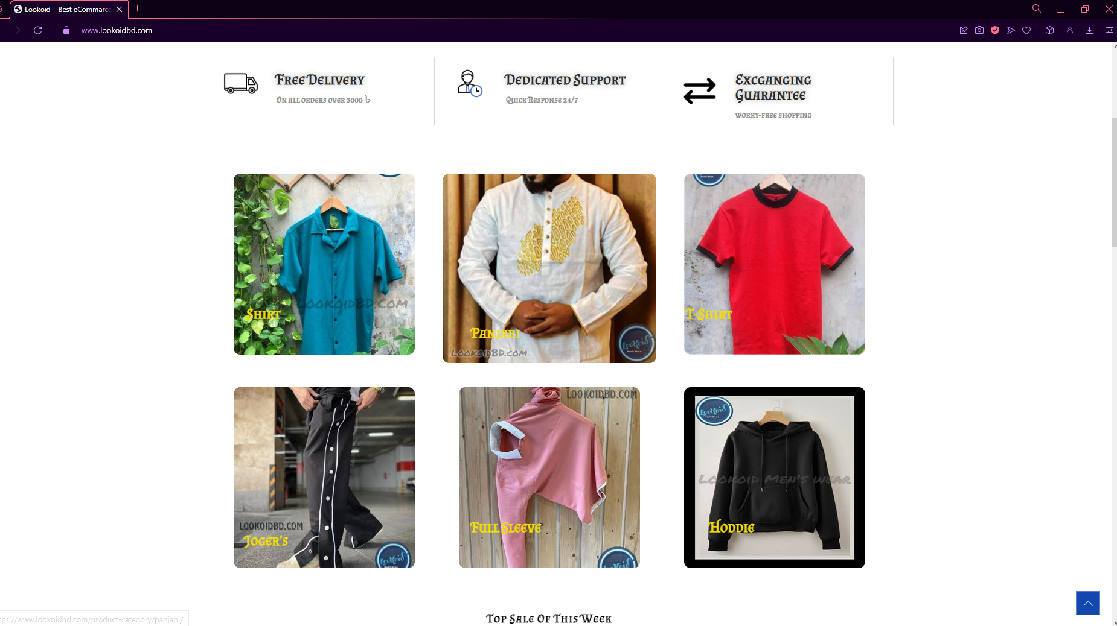

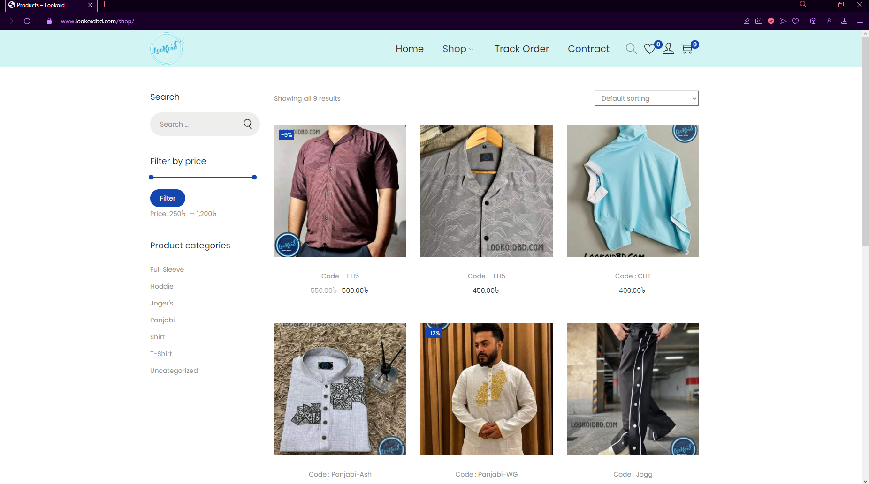

## Project Requirements

Project constraints are the general limitations of a project, including time, costs and risks. Understanding project constraints is important because they affect project performance.

**Time:** To finish our project we need 5.5 months or 440 working hours.

**Cost:** To build this project we need approximately 437360 bdt

**Resources:**

**Project Type : Organic**

**Coefficient < Effect Factor> :** 2.4 [P=1.05; T=0.38]

**Source Line of Code:** SLOC= 4000 Lines

**Persons Months, PM** = Coefficient < Effect Factor>*(SLOC/1000)P

=2.4*(3000/1000) 1.05

= 7.6

**Development Time**, **DM** = 2.50*(PM)T

= 2.50*(7.6) 0.38

= 5.4

= 5.5 months

= 5.5*10*8 working hours

= 440 working hours

**Required People**, **ST** = PM/DM

=7.6/ 5.5

=1.4

=2

**Developer Salary in 2 Months:**

Developer Salary per Working Hour = 400 bdt

Total Developer Salary = 400*440 BDT

=176000 BDT

**Requirements Analysis:**

Time needed = 10 days (8 working days)

= 8*8 Working hours

= 64 Working hours

Requirement Analysis Person's Hourly wage= 350 bdt

Total Requirement Analysis Expense = 350*64 bdt

= 22400 bdt

**Transportation Cost:**

Estimated Cost for transportation=8000 bdt

**Training and Hardware Expense:**

Estimated Cost for Training and Hardware =40000 bdt

**Rent Expenses:**

Rent per month= 8000 bdt

Total rent in 2 months = 2*8000 bdt

=16000 bdt

**Utilities Cost:**

Total utilities bill in 2 months =6000 bdt

**Maintenance (Till 6 months after delivery):**

Expense per hour = 500 bdt

Total Estimated Time needed for maintenance = 72 hours

Total Estimated maintenance cost =72*500 bdt

=36000 bdt

**Miscellaneous:**

Total Miscellaneous cost =8000 bdt Total

**Estimated Expense:**

Total Estimated cost = 176000+ 22400+ 8000+ 40000+ 16000+ 6000+ 36000+ 8000

= 312400 bdt

**Profit:**

40% of total estimated expense = 312400*40% bdt

=312400+124960

# Project Budget: (312400+124960) bdt = 437360 bdt

# FEATURES NOT TO BE TESTED

The following is a list of the areas that will not be specifically addressed. All testing in these areas will be indirect as a result of other testing efforts. For example:

* PC based spreadsheet analysis applications using Reassigned Sales data. Because these applications are completely under the control of the customer and are outside the scope of this project. The necessary data base format information will be provided to the customers to allow them to extract data. Testing of their applications is the responsibility of the application maintainer/developer.
* Each users ID & PASSWORD will not be tested as it’s confidential.
* Any kind of transactions will not be calculated.

# TESTING APPROACH

## Testing Levels

* The testing for the SMS project will consist of Unit, System/Integration (combined) and Acceptance test levels. It is hoped that there will be at least one full time independent test person for system/integration testing. However, with the budget constraints and timeline established; most testing will be done by the test manager with the development teams’ participation.
* UNIT Testing will be done by the developer and will be approved by the development team leader. Proof of unit testing (test case list, sample output, data printouts, defect information) must be provided by the programmer to the team leader before unit testing will be accepted and passed on to the test person. All unit test information will also be provided to the test person.
* SYSTEM/INTEGRATION Testing will be performed by the test manager and development team leader with assistance from the individual developers as required. No specific test tools are available for this project. Programs will enter into System/Integration test after all critical defects have been corrected. A program may have up to two Major defects as long as they do not impede testing of the program (I.E. there is a work around for the error).
* ACCEPTANCE Testing will be performed by the actual end users with the assistance of the test manager and development team leader. The acceptance test will be done in parallel with the existing manual ZIP/FAX process for a period of one month after completion of the System/Integration test process.

## Test Tools

The only test tools to be used are the standard AS/400 provided utilities and commands.

* The Program Development Manager (PDM) will be used as the source version configuration management tool in conjunction with the in-house check-in/check-out control utility. The check-in/out utility is part of each developer’s standard AS/400 access menu.
* The initial prototypes for the new screens will be developed using the AS/400 Screen Design Aid (SDA). The initial layout and general content of the screens will be shown to the sales administration staff prior to proceeding with testing and development of the screens.
* The ‘Selenium IDE’ – testing tool has been used to build test cased and test our website. Selenium IDE has been used because it supports automated testing. We will perform manual testing initially, and then we will perform automation testing. The most crucial tool for automation testing is Selenium. Selenium is an open-source, free framework for assessing web applications across a variety of platforms and browsers. Scripts for Selenium tests can be written in a variety of programming languages, including Java, C#, Python, and others.

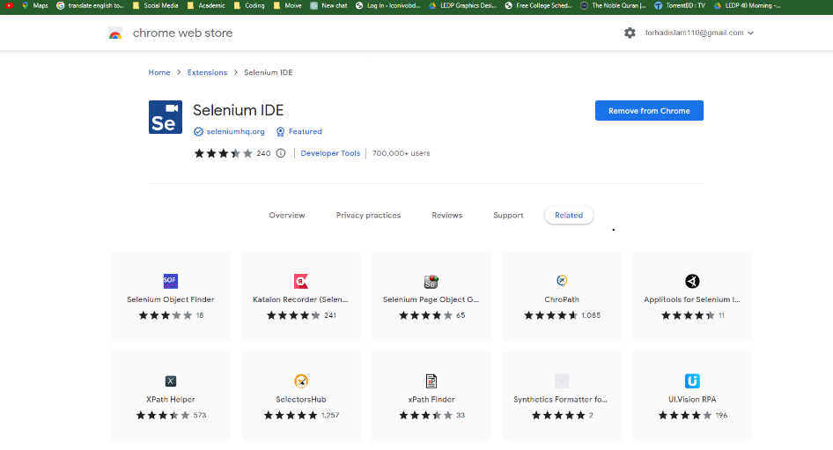

* Grant Chart (https://www.onlinegantt.com)

## Meetings

The test team will meet once in every week to evaluate progress to date and to identify error trends and problems as early as possible. The test team leader will meet with development and the project manager once every two weeks as well. These two meetings will be scheduled on different weeks. Additional meetings can be called as required for emergency situations.

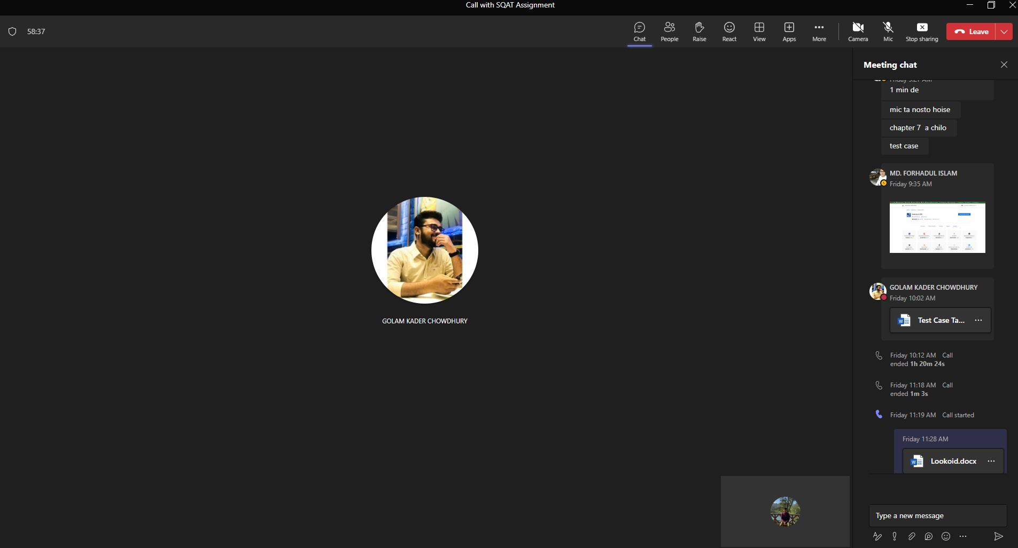

# TEST CASES/TEST ITEMS

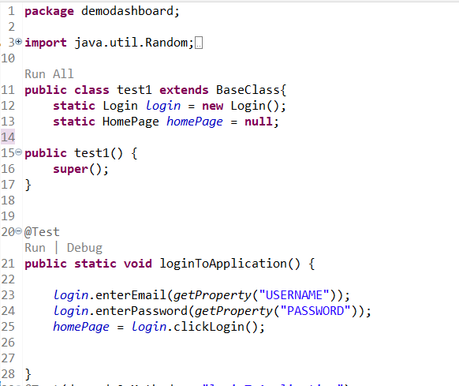

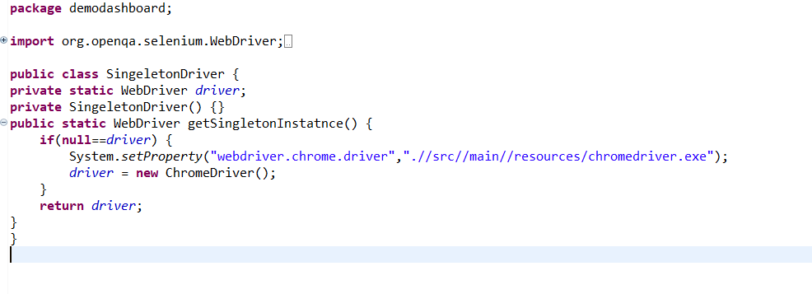

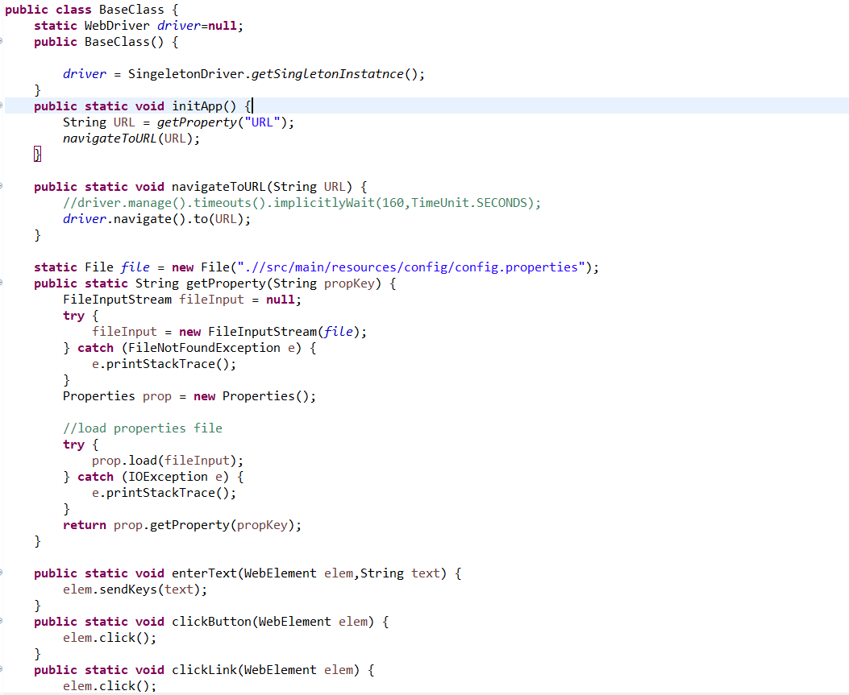

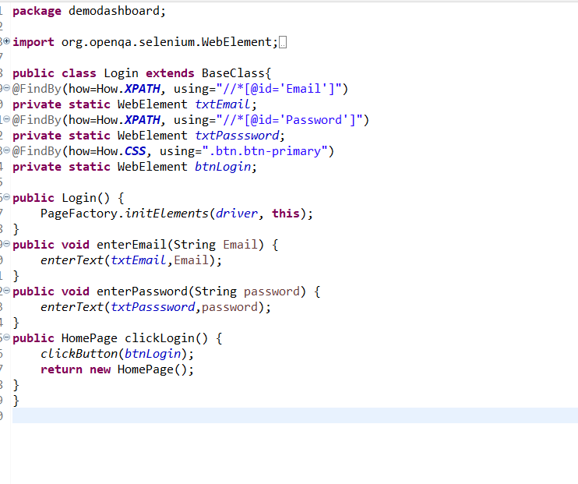

|  |  |  |  |  |  |
| --- | --- | --- | --- | --- | --- |
| Project Name: Lookoid | | | Test Designed by: Shahidul Islam Ifte | | |
| Test Case ID: FR_1 | | | Test Designed date: 19/4/2023 | | |
| Test Priority (Low, Medium, High): High | | | Test Executed by: Shahidul Islam Ifte | | |
| Module Name: Registration Session | | | Test Execution date: 19/4/2022 | | |
| Test Title: Successful Registration Check | | |  | | |
| Description: Test website’s Registration Page and storing username and password to the database. | | |  | | |
| Precondition (If any): Must land on account page from website homepage successfully. | | | | | |
| Test Steps | Test Data | Expected Results | | Actual Results | Status (Pass/Fail) |
| 1. Go to the website 2. Click on register 3. Enter E-mail 4. Enter password 5. Click “Register”   button | E-mail: iftespotify@gmail.com  Password: 6655779966  Confirm Password:  6655779966 | User should  register successfully  to the website | | As expected | Pass |
| Post Condition: User is registered with database and can be log in later. | | | | | |

|  |  |  |  |  |  |
| --- | --- | --- | --- | --- | --- |
| Project Name:  Lookoid | | | Test Designed by:  Shahidul Islam Ifte | | |
| Test Case ID: FR_2 | | | Test Designed date:  23/4/23 | | |
| Test Priority (Low, Medium, High):  Heavy | | | Test Executed by: Shahidul Islam Ifte | | |
| Module Name:  Log In session | | | Test Execution date: 19/4/2022 | | |
| Test Title:  Log in button check | | | | | |
| Description:  Verify login with valid username and password. Will land on user account page. | | | | | |
| Precondition:  User must have valid username & password. Will land on das3 | | | | | |
| Test Steps | Test Data | Expected Results | | Actual Results | Status (Pass/Fail) |
| 1. Go to website 2. Enter username 3. Enter password 4. Click “Log in” button | Username:  [iftespotify@gmail.com](mailto:iftespotify@gmail.com)  Password:  6655779966 | User should be able to access the website | | As expected | Paass |
| Post condition: User is validated with database & successfully login to account. The account session details are logged in the database. | | | | | |

|  |  |  |  |  |  |
| --- | --- | --- | --- | --- | --- |
| Project Name:  Lookoid | | | Test Designed by: Shahidul Islam Ifte | | |
| Test Case ID: FR_3 | | | Test Designed date:  23/4/23 | | |
| Test Priority (Low, Medium, High):  Medium | | | Test Executed by:  Shahidul Islam Ifte | | |
| Module Name:  Login Feature Session | | | Test Execution date:  23/4/23 | | |
| Test Title:  Login Forgot Password Feature Checking | | | | | |
| Description:  Checking forgot password option working properly or not | | | | | |
| Precondition:  Must be on the Login page. Username must be registered to database. | | | | | |
| Test Steps | Test Data | Expected Results | | Actual Results | Status (Pass/Fail) |
| 1. Go to the website 2. Go to login page 3. Click forgot password 4. Enter correct username 5. Click reset password | Username:  iftee or iftespotify@gmail.com | User should be able to reset password and get login info in email | | As expected | Pass |
| Post condition: User should get login information’s via email | | | | | |

|  |  |  |  |  |  |
| --- | --- | --- | --- | --- | --- |
| Project Name:  Lookoid | | | Test Designed by: Shahidul Islam Ifte | | |
| Test Case ID: FR_4 | | | Test Designed date:  23/4/23 | | |
| Test Priority (Low, Medium, High):  Medium | | | Test Executed by: Shahidul Islam Ifte | | |
| Module Name:  Registration input field validation 1.0 | | | Test Execution date:  23/4/23 | | |
| Test Title:  Registration’s E-mail Pattern Validation Checking | | | | | |
| Description:  Testing username field functionality as an e-mail’s pattern validation | | | | | |
| Precondition:  Must land on sign up page. | | | | | |
| Test Steps | Test Data | Expected Results | | Actual Results | Status (Pass/Fail) |
| 1. Go to the website’s signup page 2. Enter username 3. Enter password 4. Enter confirm password 5. Click register button | Username:  iftee  Password:  6655779966 | User should able register successfully to the website | | As expected | Pass |
| Post condition:  User can log in anytime using its username. | | | | | |

|  |  |  |  |  |  |
| --- | --- | --- | --- | --- | --- |
| Project Name:  Lookoid | | | Test Designed by: Shahidul Islam Ifte | | |
| Test Case ID: FR_5 | | | Test Designed date:  23/4/23 | | |
| Test Priority (Low, Medium, High):  High | | | Test Executed by: Shahidul Islam Ifte | | |
| Module Name:  Login Feature Session | | | Test Execution date:  23/4/23 | | |
| Test Title:  Login Forgot Password Feature Checking | | | | | |
| Description:  Checking forgot password option working properly or not | | | | | |
| Precondition:  Must be on the Login page. Username must be registered to database. | | | | | |
| Test Steps | Test Data | Expected Results | | Actual Results | Status (Pass/Fail) |
| 1. Go to the website 2. Go to login page 3. Click forgot password 4. Enter correct username 5. Click reset password | Username:  iftee or [iftespotify@gmail.com](mailto:iftespotify@gmail.com) | User should be able to reset password and get login info in email | | As expected | Pass |
| Post condition:  User should get login information’s via email | | | | | |

|  |  |  |  |  |  |
| --- | --- | --- | --- | --- | --- |
| Project Name:  Lookoid | | | Test Designed by: Shahidul Islam Ifte | | |
| Test Case ID: FR_6 | | | Test Designed date:  23/4/23 | | |
| Test Priority (Low, Medium, High):  Low | | | Test Executed by: Shahidul Islam Ifte | | |
| Module Name:  Home Tab | | | Test Execution date:  23/4/23 | | |
| Test Title:   Checking “Home” tab | | | | | |
| Description:  Checking if the tab working properly & jumps to Homepage | | | | | |
| Precondition:  Must be on the Login page. | | | | | |
| Test Steps | Test Data | Expected Results | | Actual Results | Status (Pass/Fail) |
| 1. Go to the website 2. Go to login page 3. Click menu button 4. Click “Home” tab | Username:  iftee or [iftespotify@gmail.com](mailto:iftespotify@gmail.com) | User should be able to access the site  and explore the page | | As expected | Pass |
| Post condition:  User should able to go from dashboard page to homepage | | | | | |

|  |  |  |  |  |  |
| --- | --- | --- | --- | --- | --- |
| Project Name:  Lookoid | | | Test Designed by: Shahidul Islam Ifte | | |
| Test Case ID: FR_7 | | | Test Designed date:  23/4/23 | | |
| Test Priority (Low, Medium, High):  Medium | | | Test Executed by: Shahidul Islam Ifte | | |
| Module Name:  Search bar validation | | | Test Execution date:  23/4/23 | | |
| Test Title:   Checking Search bar valid input | | | | | |
| Description:  Checking if invalid input in search bar shows product page result | | | | | |
| Precondition:  Must be logged in & be on homepage | | | | | |
| Test Steps | Test Data | Expected Results | | Actual Results | Status (Pass/Fail) |
| 1. Go to the website 2. Go to login page 3. Click menu button 4. Click “Home” tab | Input (Tag):  Shirt, Pant,  Panjabi, T-shirt | User should be able to see estimated product result | | As expected | Pass |
| Post condition:  Explore the product page. | | | | | |

|  |  |  |  |  |  |
| --- | --- | --- | --- | --- | --- |
| Project Name:  Lookoid | | | Test Designed by: Shahidul Islam Ifte | | |
| Test Case ID: FR_8 | | | Test Designed date:  23/4/23 | | |
| Test Priority (Low, Medium, High):  Medium | | | Test Executed by: Shahidul Islam Ifte | | |
| Module Name:  Search bar validation 1.0 | | | Test Execution date:  23/4/23 | | |
| Test Title:   Checking Search bar with invalid input | | | | | |
| Description:  Checking if valid input in search bar shows product page result | | | | | |
| Precondition:  Must be Logged in | | | | | |
| Test Steps | Test Data | Expected Results | | Actual Results | Status (Pass/Fail) |
| 1. Go to the website 2. Go to login page 3. Enter id & password 4. Go to the homeepage 5. Click menu button 6. Click “Home” tab | Input (Tag):  3,77,5,4 | Page will show random product | | Not as expected | Failed |
| Post condition:  User should able to go from dashboard page to homepage but with invalid search will show invalid or not as expected result | | | | | |

|  |  |  |  |  |  |
| --- | --- | --- | --- | --- | --- |
| Project Name:  Lookoid | | | Test Designed by: Shahidul Islam Ifte | | |
| Test Case ID: FR_9 | | | Test Designed date:  23/4/23 | | |
| Test Priority (Low, Medium, High):  High | | | Test Executed by: Shahidul Islam Ifte | | |
| Module Name:  Logout Session | | | Test Execution date:  23/4/23 | | |
| Test Title:   Logout Functionality | | | | | |
| Description: Checking the logout functionality working | | | | | |
| Precondition:  Must be on the Logged in | | | | | |
| Test Steps | Test Data | Expected Results | | Actual Results | Status (Pass/Fail) |
| 1. Go to the website 2. Go to login page 3. Enter id & password 4. Shows homepage 5. Click menu button 6. Click log-out button | Username:  iftee  Password:  6655779966 | User should be able logout successfully | | As expected | Pass |
| Post condition:  Goes back to the Log in page. | | | | | |

|  |  |  |  |  |  |
| --- | --- | --- | --- | --- | --- |
| Project Name: Lookoid | | | Test Designed by: MD. Forhadul  Islam | | |
| Test Case ID: FR_10 | | | Test Designed date: 28/4/2023 | | |
| Test Priority (Low, Medium, High): Medium | | | Test Executed by: MD. Forhadul  Islam | | |
| Module Name: Wishlist Check validations | | | Test Execution date: 28/4/2023 | | |
| Test Title: Wishlist button check field | | | | | |
| Description: Verify that the product is added to the wishlist when the wishlist button is clicked | | | | | |
| Precondition: The user is logged into the websites | | | | | |
| Test Steps | Test Data | Expected Results | | Actual Results | Status (Pass/Fail) |
| 1. Go to web site 2. Scroll down and see all of the product 3. If any of them you like then click the favorite options 4. Click the wishlist button | User login credentials, | After clicking the Contract button, the user should be able to download the contract file. | | Result as Expected | Pass |
| Post condition: The user can add or remove items from their wishlist without any issues | | | | | |

|  |  |  |  |  |  |
| --- | --- | --- | --- | --- | --- |
| Project Name: Lookoid | | | Test Designed by: MD. Forhadul  Islam | | |
| Test Case ID: FR_11 | | | Test Designed date: 28/4/2023 | | |
| Test Priority (Low, Medium, High): Medium | | | Test Executed by: MD. Forhadul Islam | | |
| Module Name: Contact Check validations | | | Test Execution date: 28/4/2023 | | |
| Test Title: Contact button check field | | | | | |
| Description: To Verify that the contract button allows the user to download the correct contract file. | | | | | |
| Precondition: The contact file is available | | | | | |
| Test Steps | Test Data | Expected Results | | Actual Results | Status (Pass/Fail) |
| 1. Go to web site 2. Click the contract button 3. Wait for the download to complete 4. Verify that the download file can be opened and read | Contract file available for download | After clicking the contract button the user should be able to download the contract information | | Result as Expected | Pass |
| Post condition: The download file can be opened and read without any issues | | | | | |

|  |  |  |  |  |  |
| --- | --- | --- | --- | --- | --- |
| Project Name: Lookoid | | | Test Designed by: MD. Forhadul  Islam | | |
| Test Case ID: FR_12 | | | Test Designed date: 28/4/2023 | | |
| Test Priority (Low, Medium, High): High | | | Test Executed by: MD. Forhadul  Islam | | |
| Module Name: Track order validations | | | Test Execution date: 28/4/2023 | | |
| Test Title: Tracking an order | | | | | |
| Description: To verify that the track order options page allows the user to track their order correctly. | | | | | |
| Precondition: logged into the website, place an order, order id is available, billing email is  available | | | | | |
| Test Steps | Test Data | Expected Results | | Actual Results | Status (Pass/Fail) |
| 1. Go to the track order options page 2. Enter the order Id 3. Enter the billing email 4. Click the track button | Order details  Tracking ID  Billig mail address | User should be able to enter their id and billing email,  After click track button the tracking information should be displayed | | Result as Expected | Fail |
| Post condition: The user can tract multiple order without any issues | | | | | |

|  |  |  |  |  |  |
| --- | --- | --- | --- | --- | --- |
| Project Name: Lookoid | | | Test Designed by: MD. Forhadul  Islam | | |
| Test Case ID: FR_13 | | | Test Designed date: 28/4/2023 | | |
| Test Priority (Low, Medium, High): High | | | Test Executed by: MD. Forhadul  Islam | | |
| Module Name: Cart validations | | | Test Execution date: 28/4/2023 | | |
| Test Title: Adding a product to the cart | | | | | |
| Description: To verify that the add to cart options page allows the user to add products to their cart  correctly. | | | | | |
| Precondition: User logged into the website, select an product | | | | | |
| Test Steps | Test Data | Expected Results | | Actual Results | Status (Pass/Fail) |
| 1. Go to the shop page 2. Select a product 3. Select product color, size and quantity 4. Click add to cart button | Product details, size, color and quantity | User should be able to select the quantity, color, size. User should be able to multiple items to their cart without any issues.  After clicking the cart button all item should be added to the user’s cart. | | Result as Expected | Pass |
| Post condition: The user cart has been updated to include the added item. User can view the added item on their cart | | | | | |

|  |  |  |  |  |  |
| --- | --- | --- | --- | --- | --- |
| Project Name: Lookoid | | | Test Designed by: MD. Forhadul  Islam | | |
| Test Case ID: FR_14 | | | Test Designed date: 29/4/2023 | | |
| Test Priority (Low, Medium, High): High | | | Test Executed by: MD. Forhadul  Islam | | |
| Module Name: Admin Add Product | | | Test Execution date: 29/4/2023 | | |
| Test Title: Upload a new Product | | | | | |
| Description: To verify that an admin can successfully add a new product to the website | | | | | |
| Precondition: The Admin is logged into the admin panel and has the necessary  permissions to add a new product. | | | | | |
| Test Steps | Test Data | Expected Results | | Actual Results | Status (Pass/Fail) |
| 1. Go to the admin panel 2. Click to the Add new product 3. Enter the required product information’s 4. Set Product category 5. Set the product stock level 6. Set product images, price, size 7. Click Publish button | Product name, descriptions  Product price, images | Admin should be able to add a new product without getting an error.  All product information should be save into the database correctly | | Result as Expected | Pass |
| Post condition: The admin can be updating the product information if it necessary | | | | | |

|  |  |  |  |  |  |
| --- | --- | --- | --- | --- | --- |
| Project Name: Lookoid | | | Test Designed by: MD. Forhadul  Islam | | |
| Test Case ID: FR_15 | | | Test Designed date: 29/4/2023 | | |
| Test Priority (Low, Medium, High): High | | | Test Executed by: MD. Forhadul  Islam | | |
| Module Name: Admin Remove Product | | | Test Execution date: 29/4/2023 | | |
| Test Title: Remove any Product | | | | | |
| Description: To verify that an admin can successfully Remove the product from the website | | | | | |
| Precondition: The Admin is logged into the admin panel and has the necessary  permissions to remove a product. | | | | | |
| Test Steps | Test Data | Expected Results | | Actual Results | Status (Pass/Fail) |
| 1. Go to the admin panel 2. Click to the Remove product 3. Select the product 4. Click the trash button 5. Confirm that the admin want to remove 6. Verify that the product is no longer display | Product name, ID | Admin should be able to remove product without getting an error. | | Result as Expected | Pass |
| Post condition: The admin can be updating the product information if it necessary | | | | | |

|  |  |  |  |  |  |
| --- | --- | --- | --- | --- | --- |
| Project Name: Lookoid | | | Test Designed by: Golam Kader | | |
| Test Case ID: FR_16 | | | Test Designed date: 25/04/2023 | | |
| Test Priority (Low, Medium, High): High | | | Test Executed by: Golam Kader | | |
| Module Name: Shop button | | | Test Execution date: 25/04/2023 | | |
| Test Title: Shop button check | | | | | |
| Description: Verify that shows the list of product category | | | | | |
| Precondition: User must have valid account and data connection. | | | | | |
| Test Steps | Test Data | Expected Results | | Actual Results | Status (Pass/Fail) |
| 1. Go to the website 2. Login 3. Click on Shop button | Shop button information | Show the list of product category | | As Expected | Pass |
| Post condition: User see the list of product category | | | | | |

|  |  |  |  |  |  |
| --- | --- | --- | --- | --- | --- |
| Project Name: Lookoid | | | Test Designed by: Golam Kader | | |
| Test Case ID: FR_17 | | | Test Designed date: 25/04/2023 | | |
| Test Priority (Low, Medium, High): Medium | | | Test Executed by: Golam Kader | | |
| Module Name: Shirt Button | | | Test Execution date: 25/04/2023 | | |
| Test Title: Shirt Button check | | | | | |
| Description: Verify that shows the list of Shirt | | | | | |
| Precondition: User must have login to the website and click shop then select shirt option. | | | | | |
| Test Steps | Test Data | Expected Results | | Actual Results | Status (Pass/Fail) |
| 1. Go to the website 2. Login 3. Click on Shop button 4. Select “Shirt” option | Shirt button information | Show the list of Shirt | | As Expected | Pass |
| Post condition: User see the list of Shirt | | | | | |

|  |  |  |  |  |  |
| --- | --- | --- | --- | --- | --- |
| Project Name: Lookoid | | | Test Designed by: Golam Kader | | |
| Test Case ID: FR_18 | | | Test Designed date: 25/04/2023 | | |
| Test Priority (Low, Medium, High): Medium | | | Test Executed by: Golam Kader | | |
| Module Name: Panjabi Button | | | Test Execution date: 25/04/2023 | | |
| Test Title: Panjabi Button check | | | | | |
| Description: Verify that shows the list of Panjabi | | | | | |
| Precondition: User must have login to the website and click shop then select Panjabi option. | | | | | |
| Test Steps | Test Data | Expected Results | | Actual Results | Status (Pass/Fail) |
| 1. Go to the website 2. Login 3. Click on Shop button 4. Select “Panjabi” option | Panjabi button information | Show the list of Panjabi | | As Expected | Pass |
| Post condition: User see the list of panjabi | | | | | |

|  |  |  |  |  |  |
| --- | --- | --- | --- | --- | --- |
| Project Name: Lookoid | | | Test Designed by: Golam Kader | | |
| Test Case ID: FR_19 | | | Test Designed date: 25/04/2023 | | |
| Test Priority (Low, Medium, High): Medium | | | Test Executed by: Golam Kader | | |
| Module Name: Full sleeve Button | | | Test Execution date: 25/04/2023 | | |
| Test Title: Full sleeve Button check | | | | | |
| Description: Verify that shows the list of Full sleeves | | | | | |
| Precondition: User must have login to the website and click shop then select Full sleeve option. | | | | | |
| Test Steps | Test Data | Expected Results | | Actual Results | Status (Pass/Fail) |
| 1. Go to the website 2. Login 3. Click on Shop button 4. Select “Full sleeve” option | Full sleeve button information | Show the list of Full sleeves | | As Expected | Pass |
| Post condition: User see the list of Full sleeves | | | | | |

|  |  |  |  |  |  |
| --- | --- | --- | --- | --- | --- |
| Project Name: Lookoid | | | Test Designed by: Golam Kader | | |
| Test Case ID: FR_20 | | | Test Designed date: 25/04/2023 | | |
| Test Priority (Low, Medium, High): Medium | | | Test Executed by: Golam Kader | | |
| Module Name: T-Shirt Button | | | Test Execution date: 25/04/2023 | | |
| Test Title: T-Shirt Button check | | | | | |
| Description: Verify that shows the list of T-Shirt | | | | | |
| Precondition: User must have login to the website and click shop then select T-Shirt option. | | | | | |
| Test Steps | Test Data | Expected Results | | Actual Results | Status (Pass/Fail) |
| 1. Go to the website 2. Login 3. Click on Shop button 4. Select “T-Shirt” option | T-Shirt button information | Show the list of T-Shirt | | As Expected | Pass |
| Post condition: User see the list of T-Shirt | | | | | |

|  |  |  |  |  |  |
| --- | --- | --- | --- | --- | --- |
| Project Name: Lookoid | | | Test Designed by: Golam Kader | | |
| Test Case ID: FR_21 | | | Test Designed date: 25/04/2023 | | |
| Test Priority (Low, Medium, High): Medium | | | Test Executed by: Golam Kader | | |
| Module Name: Hoodie Button | | | Test Execution date: 25/04/2023 | | |
| Test Title: Hoodie Button check | | | | | |
| Description: Verify that shows the list of Hoodie | | | | | |
| Precondition: User must have login to the website and click shop then select Hoodie option. | | | | | |
| Test Steps | Test Data | Expected Results | | Actual Results | Status (Pass/Fail) |
| 1. Go to the website 2. Login 3. Click on Shop button 4. Select “Hoodie” option | Hoodie button information | Show the list of Hoodie | | As Expected | Pass |
| Post condition: User see the list of Hoodie | | | | | |

|  |  |  |  |  |  |
| --- | --- | --- | --- | --- | --- |
| Project Name: Lookoid | | | Test Designed by: Golam Kader | | |
| Test Case ID: FR_22 | | | Test Designed date: 25/04/2023 | | |
| Test Priority (Low, Medium, High): Medium | | | Test Executed by: Golam Kader | | |
| Module Name: Hoodie Button | | | Test Execution date: 25/04/2023 | | |
| Test Title: Hoodie Button check | | | | | |
| Description: Verify that shows the list of Hoodie | | | | | |
| Precondition: User must have login to the website and click shop then select Hoodie option. | | | | | |
| Test Steps | Test Data | Expected Results | | Actual Results | Status (Pass/Fail) |
| 1. Go to the website 2. Login 3. Click on Shop button 4. Select “Hoodie” option | Hoodie button information | Show the list of Hoodie | | As Expected | Pass |
| Post condition: User see the list of Hoodie | | | | | |

|  |  |  |  |  |  |
| --- | --- | --- | --- | --- | --- |
| Project Name: Lookoid | | | Test Designed by: Golam Kader | | |
| Test Case ID: FR_23 | | | Test Designed date: 25/04/2023 | | |
| Test Priority (Low, Medium, High): Medium | | | Test Executed by: Golam Kader | | |
| Module Name: Jogger’s Button | | | Test Execution date: 25/04/2023 | | |
| Test Title: Jogger’s Button check | | | | | |
| Description: Verify that shows the list of Jogger’s | | | | | |
| Precondition: User must have login to the website and click shop then select Jogger’s option. | | | | | |
| Test Steps | Test Data | Expected Results | | Actual Results | Status (Pass/Fail) |
| 1. Go to the website 2. Login 3. Click on Shop button 4. Select “Jogger’s” option | Jogger’s button information | Show the list of Jogger’s | | As Expected | Pass |
| Post condition: User see the list of Jogger’s | | | | | |

|  |  |  |  |  |  |
| --- | --- | --- | --- | --- | --- |
| Project Name: Lookoid | | | Test Designed by: Golam Kader | | |
| Test Case ID: FR_24 | | | Test Designed date: 25/04/2023 | | |
| Test Priority (Low, Medium, High): Medium | | | Test Executed by: Golam Kader | | |
| Module Name: Check Order Validation | | | Test Execution date: 25/04/2023 | | |
| Test Title: Order button check field | | | | | |
| Description: Verify that shows the list of ordered product | | | | | |
| Precondition: The user logged into the website and place order | | | | | |
| Test Steps | Test Data | Expected Results | | Actual Results | Status (Pass/Fail) |
| 1. Go to the website 2. Login 3. Click on Order button | Ordered product information | Show the list of ordered product | | As Expected | Pass |
| Post condition: User see the list of ordered product | | | | | |

|  |  |  |  |  |  |
| --- | --- | --- | --- | --- | --- |
| Project Name: Lookoid | | | Test Designed by: Golam Kader | | |
| Test Case ID: FR_25 | | | Test Designed date: 25/04/2023 | | |
| Test Priority (Low, Medium, High): Medium | | | Test Executed by: Golam Kader | | |
| Module Name: Address Button | | | Test Execution date: 25/04/2023 | | |
| Test Title: Address button check field | | | | | |
| Description: Verify that shows the Billing address and shipping address | | | | | |
| Precondition: The user logged into the website and click address button | | | | | |
| Test Steps | Test Data | Expected Results | | Actual Results | Status (Pass/Fail) |
| 1. Go to the website 2. Login 3. Click on Address button | Billing address and shipping address information | Show the Billing address and shipping address | | As Expected | Pass |
| Post condition: User see the billing address and shipping address | | | | | |

|  |  |  |  |  |  |
| --- | --- | --- | --- | --- | --- |
| Project Name: Lookoid | | | Test Designed by: Golam Kader | | |
| Test Case ID: FR_26 | | | Test Designed date: 25/04/2023 | | |
| Test Priority (Low, Medium, High): Medium | | | Test Executed by: Golam Kader | | |
| Module Name: Account Details validation check | | | Test Execution date: 25/04/2023 | | |
| Test Title: Account Details button check field | | | | | |
| Description: Verify that shows the details about user | | | | | |
| Precondition: The user logged into the website and click address button | | | | | |
| Test Steps | Test Data | Expected Results | | Actual Results | Status (Pass/Fail) |
| 1. Go to the website 2. Login 3. Click on Account Details button | Account information | Show the details about user account | | As Expected | Pass |
| Post condition: User see the billing address and shipping address | | | | | |

|  |  |  |  |  |  |
| --- | --- | --- | --- | --- | --- |
| Project Name: Lookoid | | | Test Designed by: Golam Kader | | |
| Test Case ID: FR_27 | | | Test Designed date: 25/04/2023 | | |
| Test Priority (Low, Medium, High): Medium | | | Test Executed by: Golam Kader | | |
| Module Name: Logout Session | | | Test Execution date: 25/04/2023 | | |
| Test Title: Verify Logout | | | | | |
| Description: Test Logout session | | | | | |
| Precondition: The user logged into the website and click Logout button | | | | | |
| Test Steps | Test Data | Expected Results | | Actual Results | Status (Pass/Fail) |
| 1. Go to the website 2. Login 3. Click on Logout button | Logout | Logout from website | | As Expected | Pass |
| Post condition: User is validated with database and successfully logout | | | | | |

# TEM PASS/FAIL CRITERIA

The test process will be completed once the initial set of distributors have successfully sent in reassigned sales data for a period of one month and the new EDI data balances with the old ZIP/FAX data received in parallel. When the sales administration staff is satisfied that the data is correct the initial set of distributors will be set to active and all parallel stopped for those accounts.

`

# TEST DELIVERABLES

* Acceptance test plan
* System test plan
* Unit test plans
* Screen prototypes
* Defect/Incident reports and summaries
* Test logs and turnover reports

# STAFFING AND TRAINING NEEDS

It is preferred that there will be at least one (1) full time tester assigned to the project for the system/integration and acceptance testing phases of the project. This will require assignment of a person part time at the beginning of the project to participate in reviews etc... and approximately four months into the project they would be assigned full time. If a separate test person is not available the project manager/test manager will assume this role. In order to provide complete and proper testing the following areas need to be addressed in terms of training.

* The developers and tester(s) will need to be trained on the basic operations of the EDI interface. Prior to final acceptance of the project the operations staff will also require complete training on the EDI communications process.
* The sales administration staff will require training on the new screens and reports.

# RESPONSIBILITIES

|  |  |  |  |  |  |
| --- | --- | --- | --- | --- | --- |
|  | TM | PM | Dev Team | Test Team | Client |
| Acceptance test documentation & execution | X | X |  |  |  |
| System/Integration test documentation & execution | X | X |  |  | X |
| Unit test documentation & execution | X | X |  | X | X |
| System Design Reviews |  |  | X |  | X |
| Detail Design Reviews |  |  | X |  | X |
| Test procedures and rules | X | X |  | X |  |
| Screen & Report prototype reviews |  |  | X |  | X |
| Change Control and regression testing | X | X | X | X |  |

# TESTING SCHEDULE

Time has been allocated within the project plan for the following testing activities. The specific dates and times for each activity are defined in the project plan timeline. The persons required for each process are detailed in the project timeline and plan as well. Coordination of the personnel required for each task, test team, development team, management and customer will be handled by the project manager in conjunction with the development and test team leaders. Schedule must be done using any PM tool.

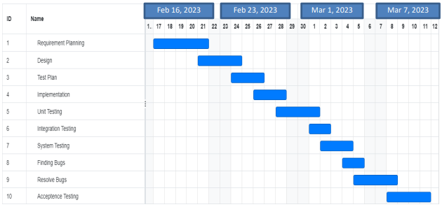

# PLANNING RISKS AND CONTINGENCIES

* Planning for risks and contingency is essential for producing good project results. It is mostly applied to uncommon situations in project risk management. Supplier issues, If the product supplier goes out of business or can't meet with customer’s needs, it can cause delays and lost sales. To mitigate this risk, have backup suppliers in place and establish strong relationships with them. Consider ordering a small test batch before committing to a large production run to ensure quality and reliability. As a result, it is crucial to follow these rules and act solely in the company’s best interests.

# APROVALS

|  |  |
| --- | --- |
| Project Sponsor- Md. Farhadul Islam | Approved |
| Development Management- Shahidul Islam Ifte | Approved |
| EDI Project Manager- Golam Kader | Approved |
| RS Test Manager- Shahidul Islam Ifte | Approved |
| RS development Team Manager- Md. Farhadul Islam | Approved |
| Reassigned Sales- Abdullah Al Noman | Approved |
| Order Entry EDI Team Manager- Golam Kader Chow | Approved |