
PUB CSE Fest-26 Programming Contest
Pundra University of Science & Technology
Department of Computer Science and Engineering
Problem Set
Problem | Title
Problem 1 | Welcome to CSE Fest-26
Problem 2 | Fest T-Shirts
Problem 3 | Fest ID Checker
Problem 4 | Lab Robot
Problem 5 | Fest Scoreboard
Problem 6 | Love Letter
Problem 7 | Rickshaw Ride
Problem 8 | Lucky Raffle
Problem 9 | Fest Treasure Hunt
Problem 10 | Fest Budget
This problem set has 10 problems. Read from standard input and write to standard output. Allowed languages: C, C++, Java, Python 3.
PROBLEM 1

Welcome to CSE Fest-26
The opening ceremony of PUB CSE Fest-26 starts in a few minutes, and the big screen in the contest hall needs a welcome message.
Write a program that prints the following two lines exactly as shown:
Welcome to PUB CSE Fest-26!
Code. Compete. Celebrate.
Uppercase and lowercase letters, spaces, the hyphen -, the exclamation mark ! and the full stops . must all match exactly. Do not print anything else.

Input
There is no input for this problem.

Constraints
There are no constraints, because the program reads no input.

Output
Print exactly two lines:
- Line 1: Welcome to PUB CSE Fest-26!
- Line 2: Code. Compete. Celebrate.

Sample Input
(no input)

Sample Output
Welcome to PUB CSE Fest-26!
Code. Compete. Celebrate.

Explanation
The program reads nothing and prints the two lines of the welcome message.
PROBLEM 2

Fest T-Shirts
PUB CSE Fest-26 is just around the corner! The organizing committee of PUB CSE has promised that everyone involved in the programming contest will get one fest T-shirt.
This year there are N teams, and every team has exactly 3 members. There are also V volunteers and J judges. Each contestant, volunteer and judge gets exactly one T-shirt.
The supplier does not sell single T-shirts. T-shirts come only in packs of K, and each pack costs C taka. The committee wants to buy the minimum number of packs so that there is at least one T-shirt for every person (leftover T-shirts are fine).
For each scenario, find the number of packs the committee must buy and the total cost in taka.

Input
The first line contains an integer T, the number of scenarios.
Each of the next T lines contains five space-separated integers N V J K C.

Constraints
- 1 ≤ T ≤ 10⁴
- 1 ≤ N ≤ 10⁹
- 0 ≤ V, J ≤ 10⁹
- 1 ≤ K ≤ 10⁹
- 1 ≤ C ≤ 10⁹

Output
For each scenario, print one line with two space-separated integers: the minimum number of packs and the total cost in taka.

Sample Input
3
2 3 2 5 120
10 0 0 7 450
1 1 1 5 1000

Sample Output
3 360
5 2250
1 1000

Explanation
- Scenario 1: 2 teams have 6 contestants. With 3 volunteers and 2 judges, 11 people need T-shirts. Two packs of 5 give only 10 T-shirts, so 3 packs are needed, costing 3 × 120 = 360 taka.
- Scenario 2: 10 teams have 30 contestants, and there are no volunteers or judges. Four packs of 7 give only 28 T-shirts, so 5 packs are needed, costing 5 × 450 = 2250 taka.
- Scenario 3: 3 + 1 + 1 = 5 people, and one pack of 5 is exactly enough.
PROBLEM 3

Fest ID Checker
Every contestant at PUB CSE Fest-26 wears an ID card. Some students typed their IDs carelessly in the registration form, so the volunteers at the entry desk need a program to check them.
A valid ID has the form CSE-YY-NNNN and follows all of these rules:
1. It is exactly 11 characters long.
2. The first three characters are CSE, in uppercase.
3. The 4th and the 7th characters are both a hyphen -.
4. YY (the 5th and 6th characters) are two digits, and together they form the batch year, which must be between 20 and 26 (inclusive).
5. NNNN (the 8th to 11th characters) are four digits, and they are not 0000.
Any ID that breaks at least one rule is invalid.

Input
The first line contains an integer T, the number of IDs.
Each of the next T lines contains one ID string S.

Constraints
- 1 ≤ T ≤ 1000
- 1 ≤ length of S ≤ 20
- S consists of printable ASCII characters and contains no spaces.

Output
For each ID, print VALID if it follows all the rules, otherwise print INVALID (in uppercase, exactly as shown). Print each answer on its own line.

Sample Input
6
CSE-26-1042
cse-26-1042
CSE-19-0420
CSE-24-0000
CSE-22-12345
CSE-20-0001

Sample Output
VALID
INVALID
INVALID
INVALID
INVALID
VALID

Explanation
- CSE-26-1042 follows all five rules.
- cse-26-1042 is invalid because CSE must be uppercase (rule 2).
- CSE-19-0420 is invalid because batch 19 is outside 20 to 26 (rule 4).
- CSE-24-0000 is invalid because the last four digits are 0000 (rule 5).
- CSE-22-12345 has 12 characters (rule 1).
- CSE-20-0001 is valid: batch 20 is allowed, and 0001 is not 0000.
PROBLEM 4

Lab Robot
During PUB CSE Fest-26, the robotics club lends the contest hall a small robot named Robu, which carries water bottles to the teams.
The contest lab is a grid of N rows and M columns. Rows are numbered 1 to N from top to bottom, and columns 1 to M from left to right. Each cell is one of:
- .: free floor
- #: a computer desk, which Robu cannot enter
- S: free floor where Robu starts (there is exactly one S)
Robu receives a string of K commands, one character each: U (up one row), D (down one row), L (left one column), R (right one column).
Robu executes the commands in order. If a command would move it outside the lab or into a desk, Robu ignores that command and stays where it is, then continues with the next command.
After all commands are done, report:
1. Robu's final position (row and column), and
2. how many different cells Robu has stood on, including the starting cell.
The picture below shows Robu's walk for Sample Input 0. A red bar with a ✕ inside Robu's cell marks a command that was ignored, because that move would leave the lab or enter a desk.
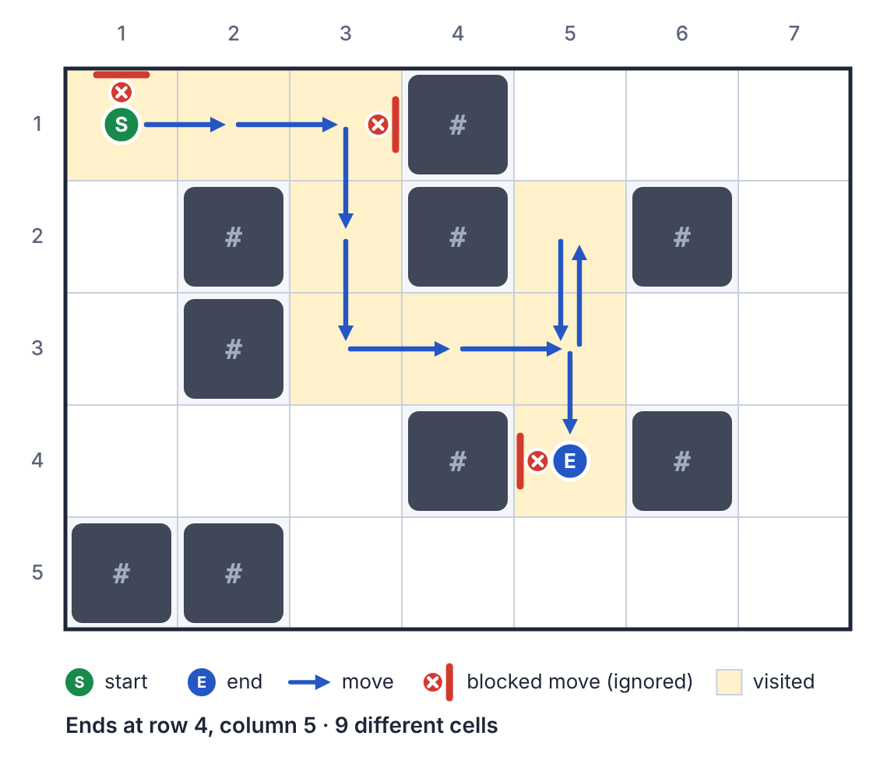
Robu's walk in Sample Input 0

Input
- The first line contains two integers N and M.
- Each of the next N lines contains a string of M characters describing one row of the lab, from row 1 to row N.
- The next line contains an integer K.
- The last line contains a string of K characters, the commands.

Constraints
- 1 ≤ N, M ≤ 100
- Each grid character is ., # or S, and there is exactly one S.
- 1 ≤ K ≤ 10⁵
- Each command is U, D, L or R.

Output
Print two lines:
- The first line contains two integers: Robu's final row and column.
- The second line contains one integer: the number of different cells Robu has stood on.

Sample Input
5 7
S..#...
.#.#.#.
.#.....
...#.#.
##.....
12
URRRDDRRUDDL

Sample Output
4 5
9

Explanation
Robu starts at (1, 1).
- U is ignored, because it would leave the lab.
- R R moves it to (1, 3). The next R is ignored, because (1, 4) is a desk.
- D D moves it to (3, 3), and R R to (3, 5).
- U moves it to (2, 5), and D D moves it back through (3, 5) to (4, 5).
- The final L is ignored, because (4, 4) is a desk.
Robu ends at row 4, column 5. The cells it stood on are (1,1), (1,2), (1,3), (2,3), (3,3), (3,4), (3,5), (2,5) and (4,5). That is 9 different cells; (3, 5) was visited twice but is counted once.
PROBLEM 5

Fest Scoreboard
Ten minutes before the end of PUB CSE Fest-26, the scoreboard screen crashed! Luckily, the judges still have the submission log. Help them rebuild the scoreboard.
There are T teams, numbered 1 to T, and P problems, labelled with the first P uppercase letters (A, B, C, ...). The log lists N submissions in the order they were judged. Each submission has the minute it was made, the team, the problem and the verdict, which is one of:
- AC: accepted
- WA (wrong answer), TLE (time limit exceeded), RE (runtime error): rejected
- CE: compile error
The scoreboard follows these ICPC rules:
1. A team solves a problem with its first AC on that problem. Every later submission by that team on that problem is ignored.
2. The penalty for a solved problem is the minute of that first AC, plus 20 minutes for every rejected submission (WA, TLE or RE) the team made on that problem before that AC.
3. A CE submission never adds penalty.
4. Rejected submissions on a problem that the team never solves add no penalty.
A team's total penalty is the sum of the penalties of the problems it solved.
The winner is the team that solved the most problems. If several teams solved the same number of problems, the one with the smaller total penalty wins. If they are still tied, the team with the smaller team number wins.
For every team, find the number of problems it solved and its total penalty, and then find the winner.

Input
- The first line contains three integers T, P and N.
- Each of the next N lines describes one submission with four values separated by spaces: the minute, the team number, the problem letter and the verdict.
The submissions are given in the order they were judged.

Constraints
- 1 ≤ T ≤ 100
- 1 ≤ P ≤ 26
- 0 ≤ N ≤ 10⁵
- 0 ≤ minute ≤ 300, and the minutes never decrease from one line to the next (several submissions can share the same minute)
- 1 ≤ team ≤ T
- The problem letter is one of the first P uppercase letters.
- The verdict is one of AC, WA, TLE, RE, CE.

Output
Print T + 1 lines:
- Line i (for i = 1 to T): two integers, the number of problems team i solved and its total penalty.
- The last line: the team number of the winner.

Sample Input
3 3 10
5 1 A WA
12 1 A AC
15 2 A CE
20 2 A AC
25 3 B WA
31 1 B TLE
40 1 A WA
45 2 C WA
52 2 C AC
58 1 B AC

Sample Output
2 110
2 92
0 0
2

Explanation
- Team 1: on problem A, one WA (minute 5) and then AC at minute 12, so 12 + 20 = 32. The WA at minute 40 comes after the AC, so it is ignored. On problem B, one TLE and then AC at minute 58, so 58 + 20 = 78. Team 1 solved 2 problems with penalty 32 + 78 = 110.
- Team 2: on problem A, the CE adds nothing and the AC is at minute 20, so 20. On problem C, one WA and then AC at minute 52, so 52 + 20 = 72. Team 2 solved 2 problems with penalty 20 + 72 = 92.
- Team 3: one WA on problem B but never solved it, so 0 problems and penalty 0.
Teams 1 and 2 both solved 2 problems, and team 2 has the smaller penalty (92 < 110), so the winner is team 2.
PROBLEM 6

Love Letter
Every evening during PUB CSE Fest-26, a shy student drops a secret love letter into the notice box of the CSE department. The whole department wants to know who the lucky one is, but every love letter is encrypted!
Each love letter is written as a string.
To encrypt a string, the student picks a secret key K (0 ≤ K ≤ 25) and replaces every English letter with the letter that comes K places later in the alphabet, going around from z back to a (and from Z back to A):
- Uppercase letters stay uppercase, and lowercase letters stay lowercase.
- Every other character (spaces, digits, punctuation) stays unchanged.
For example, with K = 3, a becomes d, x becomes a, C becomes F, and I love C++ <3 becomes L oryh F++ <3.
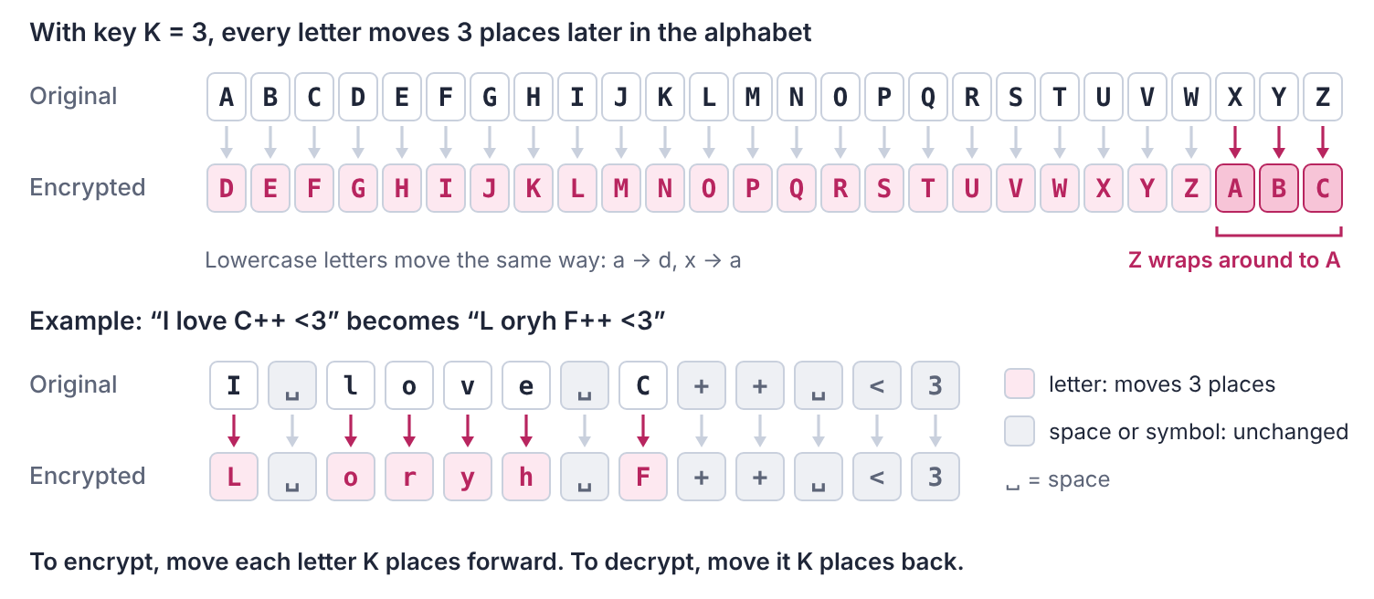
How a shift with K = 3 works
The key can be different for every string, and nobody knows it. But the student always signs off the same way: the last five characters of every original string are exactly Coder.
Decrypt every string and find out who the love letters are written to!

Input
The first line contains an integer T, the number of strings.
Each of the next T lines contains one encrypted string S.
Each string contains spaces, so read the whole line at once.

Constraints
- 1 ≤ T ≤ 100
- 5 ≤ length of S ≤ 1000
- S consists of printable ASCII characters. It does not start or end with a space, and it never has two spaces in a row.
- The original string ends with Coder.

Output
For each string, print the decrypted (original) string on its own line.

Sample Input
3
Pb ghduhvw F++, brx frpsloh pb khduw zlwkrxw d vlqjoh huuru. Brxuv iruhyhu, Frghu
Nokb Zidryx, iyeb sxnoxdkdsyx uoozc wi vspo sx ybnob <3 Vyfo, Mynob
Qnrdr zqd qdc, VZ hr z ozhm, ats vhsg xnt dudqx udqchbs hr ZB zfzhm! Xntq Bncdq

Sample Output
My dearest C++, you compile my heart without a single error. Yours forever, Coder
Dear Python, your indentation keeps my life in order <3 Love, Coder
Roses are red, WA is a pain, but with you every verdict is AC again! Your Coder

Explanation
The first string ends with Frghu. The original ends with Coder, and C → F is 3 places, so K = 3. Moving every letter 3 places back gives My dearest C++, you compile my heart ... Yours forever, Coder. Notice that C++, the comma and the full stop keep their symbols.
The second string ends with Mynob. C → M is 10 places, so K = 10.
The third string ends with Bncdq. C → B goes around the end of the alphabet: C, D, ..., Z, A, B is 25 places, so K = 25.
So the shy student's love letters were written to programming itself!
PROBLEM 7

Rickshaw Ride
The prize-giving ceremony of PUB CSE Fest-26 ends late in the evening, and N students need to get from the campus to Satmatha. A long line of rickshaws is waiting at the campus gate.
A rickshaw can carry one or two students, and the total weight of the students on it must not exceed X kilograms. The i-th student weighs wᵢ kilograms. Every student is light enough to ride alone (wᵢ ≤ X).
Every student must ride exactly one rickshaw. What is the minimum number of rickshaws needed to take all N students to Satmatha?

Input
The first line contains two space-separated integers N and X: the number of students and the weight limit of a rickshaw in kilograms.
The second line contains N space-separated integers: the weights of the students in kilograms, w₁, w₂, ..., wₙ.

Constraints
- 1 ≤ N ≤ 2 × 10⁵
- 1 ≤ X ≤ 10⁹
- 1 ≤ wᵢ ≤ X

Output
Print one integer: the minimum number of rickshaws needed.

Sample Input
6 150
50 90 60 100 75 80

Sample Output
4

Explanation
A rickshaw can carry at most 150 kg.
- The 100 kg student can share only with the 50 kg student, because 100 + 50 = 150 is allowed but 100 + 60 = 160 is too heavy.
- The 90 kg student can then share only with the 60 kg student (90 + 60 = 150).
- The 75 kg and 80 kg students cannot share (75 + 80 = 155 > 150), so each of them rides alone.
So 4 rickshaws are enough: {100, 50}, {90, 60}, {80} and {75}.
Three rickshaws are not enough. Six students in three rickshaws means every rickshaw carries two, but as shown above, 100 must ride with 50 and 90 must ride with 60, which leaves 75 and 80 together, and that is too heavy.
PROBLEM 8

Lucky Raffle
PUB CSE Fest-26 has a raffle draw! The raffle tickets are numbered from 1 to 1000000 (10⁶). The organizing committee loves mathematics, so they announced a simple rule:
A ticket wins a prize if its number is a prime number.
A prime number is an integer greater than 1 whose only positive divisors are 1 and itself. For example, 2, 3, 5, 7 and 11 are prime, but 1, 4, 9 and 15 are not.
Q students each bought one bundle of tickets. A bundle contains every ticket numbered from L to R, with both L and R included.
For every student, find how many winning tickets are in their bundle.

Input
The first line contains an integer Q, the number of students.
Each of the next Q lines contains two space-separated integers L and R: the first and the last ticket number in that student's bundle.

Constraints
- 1 ≤ Q ≤ 10⁵
- 1 ≤ L ≤ R ≤ 10⁶

Output
For each student, in the order of the input, print one line with the number of winning tickets in their bundle.

Sample Input
6
1 10
11 20
1 1
24 28
13 13
1 100

Sample Output
4
4
0
0
1
25

Explanation
- Student 1 has tickets 1 to 10. The primes are 2, 3, 5 and 7, so the answer is 4.
- Student 2 has tickets 11 to 20. The primes are 11, 13, 17 and 19, so the answer is 4. Ticket 11 counts, because both ends of a bundle are included.
- Student 3 has only ticket 1, and 1 is not prime, so the answer is 0.
- Student 4 has tickets 24 to 28. None of them is prime: 24 = 2 × 12, 25 = 5 × 5, 26 = 2 × 13, 27 = 3 × 9 and 28 = 2 × 14. The answer is 0.
- Student 5 has only ticket 13, which is prime, so the answer is 1.
- Student 6 has tickets 1 to 100, and there are 25 primes among them.
PROBLEM 9

Fest Treasure Hunt
PUB CSE Fest-26 ends with a campus treasure hunt!
The campus has N buildings, numbered from 1 to N. Building 1 is the main gate, where every team starts. There are M walkways. Each walkway joins two different buildings and can be walked in both directions. Some buildings may not be connected to the rest of the campus at all.
The organizers have hidden K clues: clue 1 is in building c₁, clue 2 is in building c₂, and so on. A team must collect the clues in order. It starts at the main gate, walks to the building of clue 1, then from there to the building of clue 2, and so on, until it reaches the building of clue K. On the way, a team may pass through any building any number of times.
Find the minimum total number of walkways a team must walk to collect all K clues in order. If some clue cannot be reached at all, print -1.
The picture below shows the campus of Sample Input 0 and one shortest way to collect its three clues.
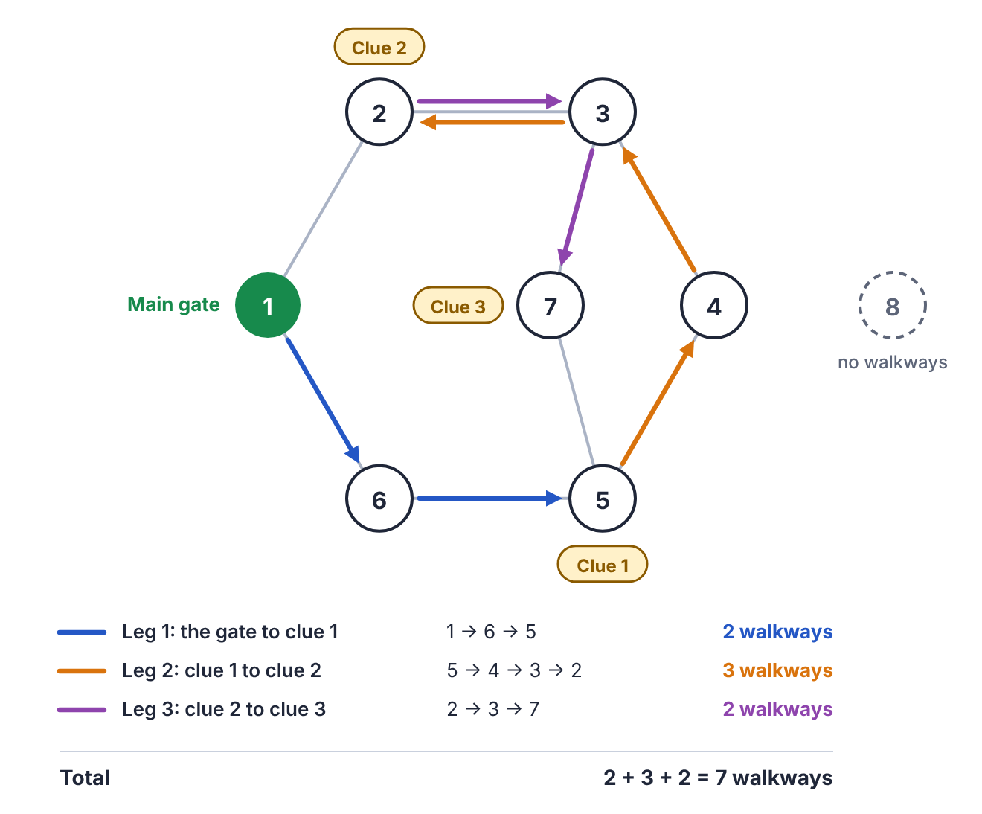
The campus of Sample Input 0

Input
The first line contains two space-separated integers N and M: the number of buildings and the number of walkways.
Each of the next M lines contains two space-separated integers u and v, meaning there is a walkway between building u and building v.
The next line contains an integer K, the number of clues.
The last line contains K space-separated integers c₁, c₂, ..., cₖ: the buildings of the clues, in the order they must be collected.

Constraints
- 2 ≤ N ≤ 10⁵
- 1 ≤ M ≤ 2 × 10⁵
- 1 ≤ u, v ≤ N and u ≠ v
- No two walkways join the same pair of buildings.
- 1 ≤ K ≤ 10
- 1 ≤ cᵢ ≤ N
- c₁ ≠ 1, and two consecutive clues are never in the same building.

Output
Print one integer: the minimum total number of walkways the team must walk, or -1 if some clue cannot be reached.

Sample Input
8 8
1 2
2 3
3 4
4 5
5 6
6 1
3 7
7 5
3
5 2 7

Sample Output
7

Explanation
The clues are in buildings 5, 2 and 7, in that order.
- Gate → clue 1: from building 1 to building 5, the shortest way is 1 → 6 → 5, which is 2 walkways. Going 1 → 2 → 3 → 4 → 5 would take 4.
- Clue 1 → clue 2: from building 5 to building 2 takes 3 walkways, for example 5 → 4 → 3 → 2. (5 → 6 → 1 → 2 and 5 → 7 → 3 → 2 are also 3.)
- Clue 2 → clue 3: from building 2 to building 7, the shortest way is 2 → 3 → 7, which is 2 walkways.
The total is 2 + 3 + 2 = 7.
Building 8 has no walkways, so nobody can reach it. No clue is there, so it does not matter in this sample, but if a clue were in building 8, the answer would be -1.
PROBLEM 10

Fest Budget
The organizing committee of PUB CSE Fest-26 has a budget of B taka for the fun activities of the fest.
Students have suggested N activities: a photo booth, a gaming zone, a quiz show, a cultural night, and many more. The i-th activity costs cᵢ taka and brings fᵢ fun points.
The committee may choose any group of activities, but:
- each activity can be chosen at most once, and
- the total cost of the chosen activities must not exceed B taka (spending less than B is fine).
What is the maximum total fun the committee can get? Choosing no activity at all gives 0 fun.

Input
The first line contains two space-separated integers N and B: the number of activities and the budget in taka.
Each of the next N lines contains two space-separated integers cᵢ and fᵢ: the cost and the fun of one activity.

Constraints
- 1 ≤ N ≤ 100
- 1 ≤ B ≤ 5 × 10⁴
- 1 ≤ cᵢ ≤ 10⁵ (an activity may cost more than the whole budget)
- 1 ≤ fᵢ ≤ 10⁹

Output
Print one integer: the maximum total fun within the budget.

Sample Input
5 10
6 30
5 24
5 23
1 3
12 100

Sample Output
47

Explanation
The budget is 10 taka. The activities are (cost, fun): (6, 30), (5, 24), (5, 23), (1, 3) and (12, 100).
- The last activity costs 12 taka, which is more than the whole budget, so it can never be chosen.
- Choosing the two activities that cost 5 taka spends exactly 10 taka and gives 24 + 23 = 47 fun. This is the best possible.
- Starting with the activity of cost 6 looks tempting, because it gives the most fun per taka (5 points per taka). But then only 4 taka are left, which buys only the activity of cost 1: 30 + 3 = 33 fun.
- The activity (5, 24) cannot be chosen twice, so 24 + 24 = 48 is not allowed.

