**Introduction to Figma**

**What is Figma?**

Figma is a cloud-based design tool used for creating user interfaces, web pages, and digital products collaboratively. It's widely used in the design industry due to its accessibility and real-time collaboration features.

**Why Use Figma?**

**Collaboration:** Figma allows multiple users to work on the same project simultaneously, fostering seamless collaboration among designers and stakeholders.

**Cloud-Based:** Since Figma is cloud-based, designs are accessible from any device with an internet connection, eliminating the need for manual file transfers.

**Real-Time Editing:** Changes made by one user are instantly visible to others, making it easy to work together and provide feedback in real-time.

**Prototyping:** Figma integrates design and prototyping, enabling designers to create interactive prototypes to showcase user flows and interactions.

**Version History**: Figma maintains a version history of your designs, allowing you to review and revert to previous iterations if needed.

**Overview of Figma's Interface and Workspace:**

**Canvas:**The central area where you create and arrange your designs. This is where frames, shapes, and text elements are placed.

**Frames:** Containers that hold your design elements. Frames can represent entire screens or specific sections of a design.

**Layers Panel:** Located on the left, it displays a hierarchical list of all layers in your design. This helps you manage and organize elements.

**Toolbar:** At the top, it contains tools for creating shapes, text, and other design elements. It also includes options for styling and arranging.

**Properties Panel:** On the right, it provides detailed control over selected elements. You can adjust properties like size, color, and text formatting here.

**Prototype Mode:** Allows you to create interactive prototypes by linking frames together and defining transitions.

**Comments and Collaboration:** Figma includes features for leaving comments on specific design elements, facilitating communication among team members.

**Play Button:** Found in the top-right corner, it allows you to preview your design in prototype mode to simulate user interactions.

**Travel App Design in Figma**

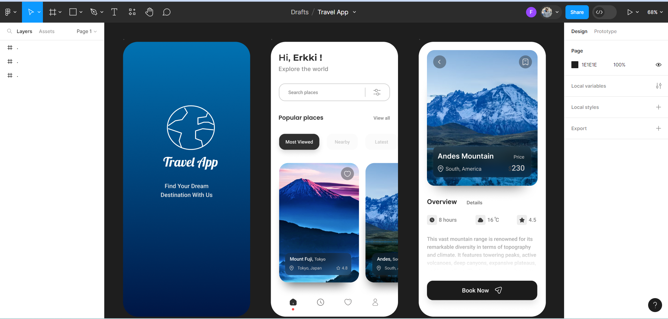

The Travel app design in Figma is a mobile application interface that aims to provide users with a seamless and visually appealing experience for planning and organizing their travel activities. It includes features such as destination search, itinerary planning, and real-time travel updates.

**Goals:**

**User-Centric Design:** The design prioritizes user needs, focusing on intuitive navigation and clear information presentation.

**Visual Appeal:** Aesthetically pleasing visuals and a cohesive color scheme create a positive and engaging user experience.

**Functionality:** The app integrates essential travel features, ensuring users can easily plan and manage their trips within the application.

**Implements:**

**Homepage:** The homepage features a visually striking hero image, encouraging users to explore destinations. Captures user attention and sets the tone for an inspiring travel experience.

Learning Note: Experiment with hero images to create a visually compelling entry point.

**Destination Search:** An intuitive search bar with auto complete suggestions. Enables users to quickly find and select their desired destinations.

Learning Note: Implementing effective search functionality is crucial for user convenience.

**Itinerary Planner:** A drag-and-drop itinerary planner with date and activity details. Empowers users to customize their travel plans easily.

Learning Note: Explore drag-and-drop functionality for interactive design elements.

**Real-Time Updates:** Push notifications for flight status, weather updates, and itinerary changes. Keeps users informed and enhances their travel experience.

Learning Note: Incorporate real-time features for dynamic user engagement.

**Solution and Motivation**: The Travel app design solution strives to create a user-friendly platform that not only assists in travel planning but also inspires users to embark on new adventures. The motivation behind this approach is to merge functionality with aesthetics, ensuring that users not only find the app useful but also enjoy the experience of using it.

By combining a visually appealing design with practical features, the Travel app aims to become a go-to tool for users looking to seamlessly plan and manage their travel journeys.

**Balancing Aesthetics and Functionality:** Continuously explore ways to create visually pleasing designs without compromising on functionality.

**User-Centric Design:** Prioritize user needs and preferences when making design decisions to enhance the overall user experience.

**Interactive Elements:** Experiment with interactive elements such as drag-and-drop to make the design more engaging and user-friendly.

**Real-Time Features:** Explore incorporating real-time updates or notifications to add a dynamic and responsive element to the app.