Forkcast — Project Briefing for Reference-Letter Writers
Prepared July 2026 · In support of the founder's EB-2 National Interest Waiver petition · seymurhh.github.io/forkcast-live
Thank you for considering a letter of support. This briefing explains what Forkcast is, the national problem it addresses, and its intended impacts, so you can assess the project and write from your own expertise. Please write only what you genuinely conclude — candid, specific letters carry the most weight.
What Forkcast is
Forkcast is an AI-powered nutrition platform for the meals Americans increasingly eat: restaurant meals. It tells a person what to order before they order — every nearby dish scored 0–100 against their own body and goals — then closes the loop: the order is placed in the app, the restaurant confirms it, the meal is logged automatically with the user's confirmation, and the user's personal targets recalibrate from their own measured results. A complete working product exists today (web application, live demo below), with native mobile apps in development.
Three design commitments distinguish it from existing diet apps: every nutrition number carries its source and an uncertainty range (restaurant-verified, restaurant-published, or clearly labeled AI estimate); restaurants themselves can review and correct their data through a public, versioned process; and sponsored placement can never influence a recommendation score. The aim is to be the trust layer for restaurant nutrition decisions.
The national problem it addresses
A record 58.5% of U.S. food spending now occurs away from home (USDA ERS, 2024) and roughly a third of adult calories come from restaurant food — yet the majority of U.S. restaurants are independents exempt from federal menu-labeling rules and publish no nutrition information at all. Where labels do exist, peer-reviewed evaluations find they change behavior by only ~24 calories per order. Meanwhile, per CDC surveillance, 40.3% of U.S. adults have obesity and 72% have elevated BMI, at an economic cost of roughly $173 billion per year for obesity alone and ~$334 billion for diet-related disease overall. In 2024, every U.S. state had adult obesity prevalence of 25% or higher.
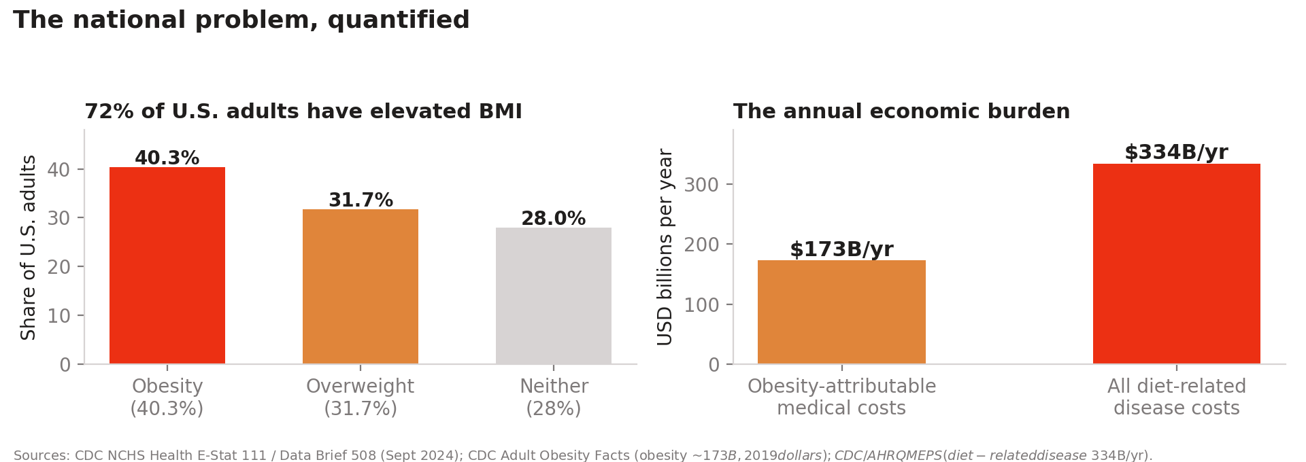
National scale: elevated BMI among U.S. adults and the annual economic burden (CDC NCHS 2024; CDC; AHRQ MEPS).
Three intended impacts
- 1. Health- and nutrition-aware dining. Decision support at the moment of ordering — where passive calorie labels demonstrably fail — with personalized breakdowns of calories, protein, carbohydrates, fat, fiber, and sodium against each user's own clinically derived targets, plus allergy and health-condition advisories on every dish. The pilot pre-registered six public outcome metrics (including a per-user diet-quality delta) before any measurement, so impact will be demonstrated, not asserted.
- 2. A scalable protocol aimed at the most-affected regions. The Boston pilot proves a reproducible market playbook — menu digitization, restaurant verification, measured outcomes — that then expands into the regions the CDC's 2024 prevalence maps identify as most affected (Midwest 35.9%, South 34.5%; nineteen jurisdictions at 35%+). Expansion works through partnerships with locally owned independent restaurants, giving small businesses free digitization and verification tools and a demand channel at a fraction of the 15–30% commissions delivery marketplaces charge.
- 3. AI applied to personal awareness. Large-language-model menu parsing (grounded against USDA federal nutrition data), computer-vision meal recognition with user correction, an AI nutrition coach with strict not-medical-advice boundaries, and adaptive calibration that learns each user's true energy expenditure from their own logs and weight trend — AI serving comprehension of one's own body, with uncertainty always disclosed.
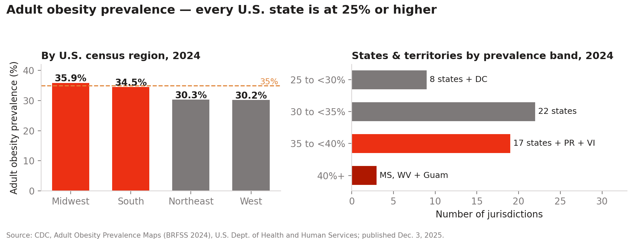
The expansion roadmap in federal data: adult obesity by census region and prevalence band, 2024 BRFSS (CDC, published Dec. 2025).
Current status and evidence
- Working product: full web application — discovery, personalized Fit Scores, ordering, restaurant order terminal, confirmed meal logging with provenance, adaptive calibration, AI coach — with a dated 2026 development record. Mobile apps (iOS/Android) are the next build phase.
- Real data integrations: nutrition quoted live from restaurant-published disclosures (e.g., Sweetgreen; The Halal Guys) alongside clearly labeled engine estimates for independents — the three-tier provenance model in action.
- Documented methods: a menu-collection protocol, published pilot metric definitions, a sourced market-research dossier, and business/financial plans whose figures are verified against primary sources.
- Evidence integrity: no claimed users, partners, revenue, or health outcomes that do not exist; demo states are labeled as demos throughout the product and its documents.
What a letter of support can address
Whatever falls within your own expertise and experience, for example: the significance of the public-health problem and of intervening at the point of ordering; the value of verified nutrition data for independent restaurants and their customers; the technical soundness or novelty of the approach (AI estimation with disclosed uncertainty, adaptive calibration, evidence-first measurement); the founder's capability as demonstrated by the working product; or the economic and small-business dimensions described above. Letters should be on letterhead where possible, state your credentials and relationship to the project (including if you have none beyond reviewing it), and be entirely in your own words.
Links and contact
- Live demo (web): https://seymurhh.github.io/forkcast-live/
- Impact & methodology page: https://seymurhh.github.io/forkcast-live/impact/
- Founder: Seymur Hasanov · shasanov@seas.harvard.edu
Primary sources cited: CDC Adult Obesity Prevalence Maps (2024 BRFSS; pub. Dec. 3, 2025) · CDC NCHS Health E-Stat 111 (2024) · CDC Adult Obesity Facts · AHRQ MEPS · USDA ERS Food Expenditure Series (2024) · peer-reviewed menu-labeling literature (Petimar et al.; Bleich et al.).

