EB-2 NATIONAL INTEREST WAIVER
Prong One Analysis — Substantial Merit and National Importance of the Proposed Endeavor
Prepared regarding: Forkcast (seymurhh.github.io/forkcast-live) — Boston pilot, pre-seed stage
Draft memorandum — for review by a licensed U.S. immigration attorney before use

I. Purpose, Scope, and Important Disclaimer
This memorandum was prepared by an AI assistant, not by a licensed attorney, and does not constitute legal advice. It is an analytical draft intended to help a qualified U.S. immigration attorney evaluate and, if appropriate, build out the "substantial merit and national importance" prong (Prong One) of an EB-2 National Interest Waiver (NIW) petition. It should not be filed with U.S. Citizenship and Immigration Services (USCIS) in this form, relied upon as a final legal position, or treated as a substitute for individualized advice from a licensed immigration attorney who has reviewed the petitioner's full record.
The analysis below is based solely on the public content of the website located at seymurhh.github.io/forkcast-live, reviewed on the date of this memorandum. It does not include a review of the petitioner's resume, prior work history, degrees, immigration history, or any non-public business records. It addresses Prong One of the three-prong framework established in Matter of Dhanasar only; Prongs Two (petitioner is well positioned to advance the endeavor) and Three (on balance, a waiver benefits the United States) require a separate, petitioner-specific evidentiary record and are outside the scope of this document.

II. Description of the Proposed Endeavor
Based on the reviewed website and additional information provided regarding the endeavor's technical scope, the proposed endeavor is Forkcast, an AI-powered nutrition platform whose purpose is broader than meal recommendation alone: its stated aim is to give consumers a complete, accurate picture of what they eat across every eating occasion — restaurant meals and home meals alike — in order to measurably improve dietary quality and reduce obesity prevalence at national scale. Restaurant meals are addressed through Forkcast's core differentiator: a pre-order, location-aware recommendation that helps a consumer choose a specific dish, at a specific nearby restaurant, before ordering, rather than logging what was already eaten. Home meals, which the after-the-fact logging category has never adequately captured, are addressed through a complementary computer-vision feature: a consumer photographs a home-cooked or home-prepared meal, and the platform's machine learning models estimate its nutritional composition and log it automatically against the consumer's personalized targets for calories, protein, fiber, sodium, and other tracked nutrients.
This combination is a deliberate design choice, not a contradiction of the platform's core thesis. As discussed in Section VIII.B below, independent research finds that after-the-fact logging alone is an insufficient, willpower-dependent mechanism when it is the primary tool a consumer relies on to make a food decision. Forkcast's architecture is built around leading with a pre-order, choice-architecture intervention for the restaurant-meal decision specifically, while using AI-driven photo logging as a secondary, low-friction data-capture layer for the home-meal occasions that pre-order recommendation cannot reach. Together, these two capture surfaces are intended to give the platform, and the consumer, a genuinely complete nutritional picture across an entire day rather than a partial one limited to restaurant meals — which is also what allows the platform to generate the kind of validated, ground-truth nutrition dataset described in Section IV.B below.
The endeavor is built on artificial intelligence and machine learning throughout, not only in the photo-logging feature: large language models are used to parse and structure menu data at scale (a necessary capability given that, as discussed below, no commercial database currently covers independent-restaurant nutrition), computer vision models estimate nutritional content from user-submitted meal photographs, and the platform's confidence-scored, source-labeled estimation engine (restaurant-published disclosure, restaurant-verified estimate, or AI-generated engine estimate) is designed to be retrieval-grounded against authoritative federal nutrition data such as USDA FoodData Central rather than relying on model outputs alone.
The endeavor is also explicitly designed for national, not merely local, scale. Because the platform is a cloud-based software product rather than a business requiring physical infrastructure to be rebuilt in each new city, its go-to-market plan (Section V.A) calls for sequential expansion across multiple dense urban markets beyond the initial Boston pilot, with the underlying AI menu-parsing and nutrition-estimation pipeline designed to onboard new restaurants and new metro areas without the linear increase in manual effort that would be required of a non-AI-driven, city-by-city data-collection approach. This scalability is directly relevant to the national-importance analysis in Section V: an endeavor whose core technology is built to scale nationally, and whose stated objective is a measurable reduction in obesity prevalence rather than a narrower commercial goal, presents a materially stronger national-importance case than a single-city recommendation app would.
The site describes three sequenced revenue lines: (1) a consumer subscription; (2) a restaurant "retail media" product charging independent and small-chain restaurants for featured placement of clearly labeled dishes; and (3) a business-to-business-to-consumer line built on payer and employer contracts for medical nutrition therapy, billed under existing CPT codes 97802–97804. The company states it is currently at the pre-seed stage, piloting in Boston, and is transparent that its restaurant catalog is demonstration data pending real restaurant partnerships.
The site further identifies what it frames as a structural, national-level gap: the FDA's mandatory menu-labeling rule applies only to restaurant chains with 20 or more locations, leaving the nutrition content of meals served by the large population of independent restaurants undisclosed in any commercial database. The endeavor's stated approach — building a verified, restaurant-confirmed nutrition dataset for independent restaurants, beginning in Boston and expanding to additional metro areas — is presented as a direct response to that regulatory and market gap.
Accuracy note: the photo-based home-meal logging feature, the specific macro-nutrient tracking (calorie, protein, fiber, sodium, etc.), and the underlying AI/ML/LLM technical architecture described in this section were provided as additional information beyond what the publicly reviewed website itself displayed. Before this description is used in a filed petition, it should be verified against actual current product documentation, and any AI/ML technical claims (e.g., which models are used, how computer-vision nutrition estimation is validated, what "retrieval-grounded" means in the platform's actual implementation) should be confirmed with the engineering team and, ideally, supported by technical documentation as a separate exhibit — Prong One credibility depends on every technical claim being both accurate and demonstrable, not merely descriptive.
A defining feature of the endeavor's consumer-facing design is AI-driven personalization that makes nutritional consequences legible to the individual user. Rather than presenting generic calorie counts, the platform computes each user's personal daily targets from clinically standard formulas (resting energy expenditure via the Mifflin-St Jeor equation, scaled by activity level and adjusted for the user's stated goal, with published safety floors), then expresses every dish and every day as a breakdown against those personal targets: calorie count, protein intake, carbohydrate intake, fat, fiber, sodium, and sugar, each shown both per dish and as a share of the user's own remaining daily budget. The platform further personalizes over time: an adaptive calibration feature back-calculates the user's observed energy expenditure from their own logged intake and weight trend and blends it into the target, so the recommendation engine reflects the individual's measured physiology rather than a population average. Allergy and self-reported condition flags (for example, sodium advisories for users reporting hypertension) attach to every dish view. The intended effect, consistent with the choice-architecture research discussed in Section VIII.B, is that a consumer is made aware of what they are about to eat and how it affects their body at the moment of decision, in units personalized to them.
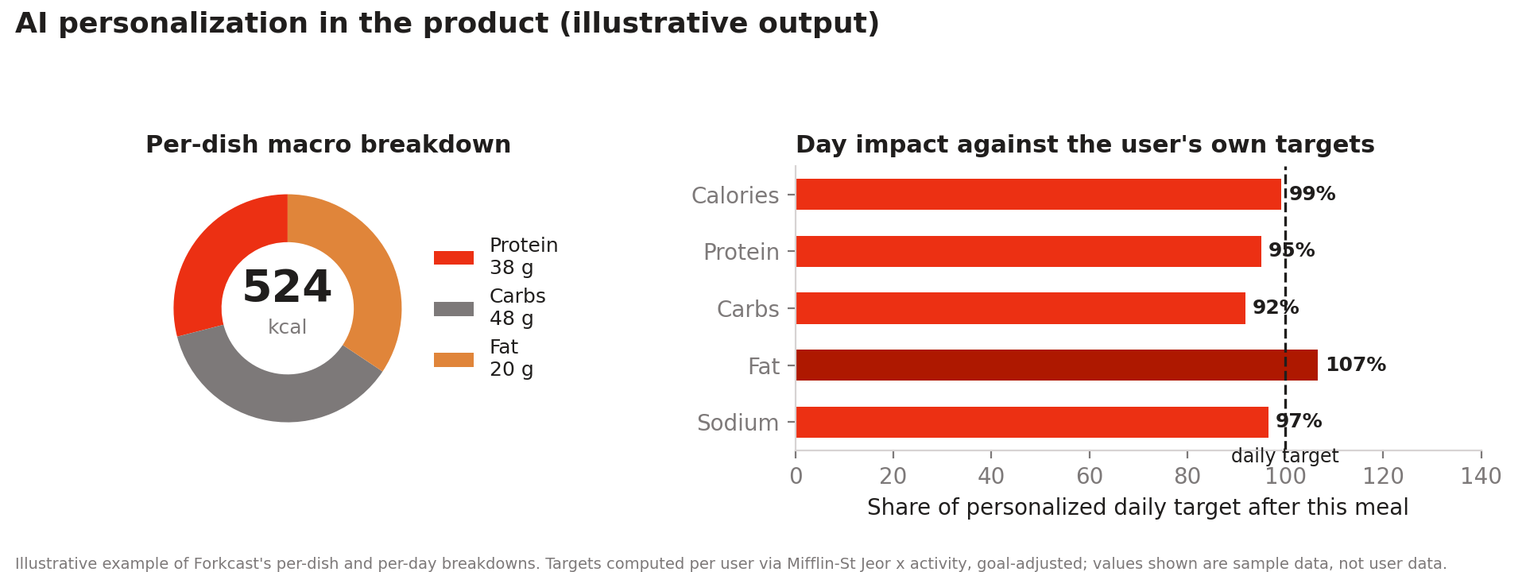
Figure 1. Illustrative product output: per-dish macronutrient breakdown (left) and the same meal expressed against the user's personalized daily targets (right). Sample data; targets are computed per user.

III. Legal Standard — Prong One
Under Matter of Dhanasar, 26 I&N Dec. 884 (AAO 2016), USCIS applies a three-prong framework to NIW petitions. The first prong asks whether the foreign national's proposed endeavor has both substantial merit and national importance:
- Substantial merit may be demonstrated in a wide range of areas, including business, entrepreneurship, science, technology, culture, health, or education. Substantial merit can be established even where the endeavor has not yet generated profit, provided the record shows the endeavor's intrinsic merit through such evidence as its potential significant economic impact, its scientific or technical value, or its contribution to an underserved need.
- National importance turns on the endeavor's potential prospective impact, not simply on the petitioner's own employment prospects or a narrow, self-interested benefit. Relevant considerations recognized in Dhanasar and subsequent AAO decisions include: whether the endeavor has broader implications beyond a particular employer or geographic area; whether it has significant potential to employ U.S. workers or otherwise offer substantial positive economic effects, particularly in an economically depressed region; whether it addresses a matter of national concern (e.g., public health, national security, environmental protection); and whether it stands to advance a critical field, sector, or technology of importance to the United States.
Note: national importance does not require the endeavor to operate nationwide from day one. AAO decisions applying Dhanasar have credited endeavors with a realistic, evidenced path to broader impact — which is directly relevant to a pilot-stage venture such as this one, provided the record substantiates that broader trajectory rather than merely asserting it.

IV. Substantial Merit Analysis

A. Business and Entrepreneurial Merit
The site presents a reasoned, evidence-referenced business case: a defined market problem (after-the-fact calorie logging with documented high abandonment), a stated point of differentiation (pre-order, location-aware recommendation instead of retrospective logging), a three-legged revenue model, and a named comparable transaction (the acquisition of Cal AI by MyFitnessPal in December 2025) offered as evidence that ventures in this category can achieve meaningful scale. This level of specificity — as opposed to a general business idea — supports an argument for substantial merit in the business/entrepreneurial sense contemplated by Dhanasar.

B. Technical and Data Merit
The site describes a structured methodology for building the underlying nutrition dataset: nutrition values are labeled by provenance (restaurant-published disclosure, restaurant-verified estimate, or engine estimate with a stated error band), and the "Impact & evidence" page pre-registers specific, falsifiable pilot metrics (pre-order decision rate, verified-menu coverage, correction turnaround, logged-meal accuracy, onboarding cost per restaurant, and diet-quality delta) before any pilot data has been collected. This kind of pre-registration — defining what will be measured, and how, before results exist — is a meaningful, attorney-usable evidentiary point: it distinguishes a rigorous, falsifiable methodology from an unsubstantiated marketing claim, and it directly supports substantial merit on technical/scientific grounds.
The endeavor's technical foundation is applied artificial intelligence and machine learning across several distinct problems, which is itself relevant to substantial merit as a technology endeavor under Dhanasar: large language models to parse and structure unstructured restaurant menu data at the scale needed to close the independent-restaurant nutrition gap described in Section V; computer vision models to estimate nutritional composition from consumer-submitted photographs of home meals; and a retrieval-grounded estimation architecture intended to tie AI-generated estimates back to authoritative federal nutrition data rather than allowing a model to generate figures without an underlying data source. If supportable with technical documentation (see the accuracy note above), this AI/ML/LLM architecture is a substantive, non-trivial technical undertaking distinguishable from a simple database or directory product, which strengthens the argument that this endeavor has substantial merit in the technology and scientific sense contemplated by Dhanasar, independent of its business merit.

C. Public Health Merit
The endeavor's stated objective is not merely convenience but a measurable reduction in obesity prevalence: by tying the endeavor to a documented federal public-health statistic (CDC: 72% of U.S. adults have elevated BMI) and a documented information gap in how consumers understand both restaurant and home meals, and by pre-registering a "diet-quality delta" metric intended to measure actual behavior change rather than mere engagement, the endeavor connects a commercial product to an explicit, measurable public-health objective rather than a purely commercial one. This is the kind of connection Dhanasar contemplates when it lists health as an area in which substantial merit may be shown, and it is strengthened by the endeavor's full-picture approach — capturing both restaurant and home meals — since a tool limited to restaurant meals alone would capture only a fraction of a consumer's actual nutritional intake and would be a correspondingly weaker vehicle for the obesity-reduction outcome the endeavor claims to pursue.

D. Corroboration from Federal Public-Health Surveillance (CDC)
The public-health merit described above is corroborated by the federal government's own surveillance data, which an adjudicator can verify directly against CDC publications. Per the CDC's National Center for Health Statistics (Health E-Stat 111 / Data Brief 508, September 2024), 40.3% of U.S. adults have obesity and a further 31.7% are overweight — approximately 72% of the adult population with elevated BMI. The CDC attributes roughly $173 billion per year in medical costs to obesity alone (2019 dollars), within an estimated $334 billion per year for diet-related disease overall.
The CDC's most recent Adult Obesity Prevalence Maps (2024 Behavioral Risk Factor Surveillance System data; published December 3, 2025) establish that the problem is universal across U.S. jurisdictions and severe in many: in 2024, every U.S. state and territory had an adult obesity prevalence of 25% or higher — at least one in four adults everywhere in the country; 19 jurisdictions (17 states plus Puerto Rico and the U.S. Virgin Islands) were at 35% or higher; and two states (Mississippi and West Virginia) plus Guam were at 40% or greater. The same surveillance shows a pronounced education gradient (37.6% prevalence among adults without a high-school diploma versus 27.3% among college graduates) and substantial disparities by race and ethnicity, underscoring that accessible, low-cost nutrition tools address an equity dimension as well as an aggregate one. Suggested citation: Centers for Disease Control and Prevention, Adult Obesity Prevalence Maps, U.S. Dept. of Health and Human Services; 2025.
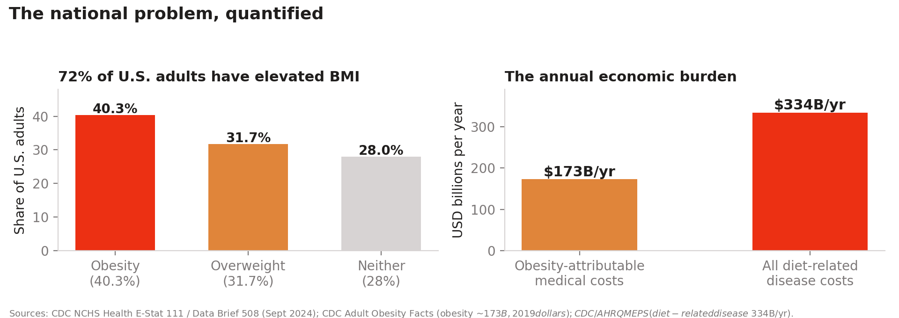
Figure 2. National scale of the problem the endeavor addresses. Left: distribution of elevated BMI among U.S. adults (CDC NCHS, 2024). Right: annual economic burden (CDC; AHRQ MEPS).

V. National Importance Analysis

A. Evidence Supporting National Importance
The table below maps specific evidentiary points drawn from the site to the national-importance factors recognized under Dhanasar.
Data Point | Source (as cited on the Forkcast site) | Relevance to Prong 1
58.5% of U.S. food spending is now away from home (a record share) | USDA Economic Research Service, Food Expenditure Series, 2023 | Establishes the national scale of the underlying problem
72% of U.S. adults have elevated BMI; ~186M adults | CDC, Adult Obesity Facts, 2024 | Ties the endeavor to a recognized federal public-health priority
2 in 3 diners underestimate restaurant-meal calories; 1 in 4 by 500+ kcal | USDA / NHANES, 2024 | Documents the specific information gap the endeavor targets
Mandatory chain menu labeling changes order choice by only ~24 calories on average | Peer-reviewed study, 2024 (as cited) | Shows the existing federal regulatory tool (FDA menu-labeling rule) is insufficient — supports "national importance" via an unaddressed structural gap
FDA menu-labeling rule applies only to chains with 20+ locations; independent restaurants are structurally excluded from any nutrition database | Site's stated market analysis | Central "national importance" argument: the endeavor addresses a regulatory and market gap left open by existing federal law, not a niche or purely local problem
TAM $11.1B/yr; SAM $3.3B/yr; modeled SOM $40–90M ARR at 5 years | Company market model, triangulated against CDC/USDA figures and the calorie-tracking market | Supports the economic-impact factor of national importance
Comparable company Cal AI reached ~15M downloads and $30M+ ARR in under two years before acquisition by MyFitnessPal (Dec. 2025) | Site's competitive analysis | Independent market validation that endeavors in this category can scale nationally and attract acquirer interest
Go-to-market plan: sequential expansion beyond the Boston pilot to additional dense urban markets, then a restaurant retail-media leg, then payer/employer B2B2C contracts on covered medical nutrition therapy (CPT 97802–97804) | Site's stated go-to-market plan | Demonstrates the endeavor is designed for national scale from inception, not a single-city venture

Geographic scalability directed at the most-affected regions. The endeavor's expansion strategy is not merely national in the abstract; it is targeted, using the CDC's own prevalence geography as the roadmap. The Boston pilot serves as the proving ground for the platform's reproducible market protocol — menu collection, restaurant verification, and pre-registered outcome measurement — after which expansion prioritizes the regions federal surveillance identifies as most affected: the Midwest (35.9% adult obesity prevalence in 2024, the highest of any census region) and the South (34.5%), including the nineteen jurisdictions at or above 35% prevalence and the three at or above 40% (Mississippi, West Virginia, and Guam). Because the platform's core mechanism is partnership with locally owned independent restaurants — providing them free menu-digitization and verification tools and a low-cost demand channel — each new market simultaneously delivers the consumer-facing intervention where obesity prevalence is highest and a small-business benefit to the local restaurant economy in those same communities. A cloud-delivered software platform whose AI menu pipeline onboards new metropolitan areas without linear manual cost, deliberately sequenced toward the highest-prevalence states, presents a national-importance profile that a single-city service could not.
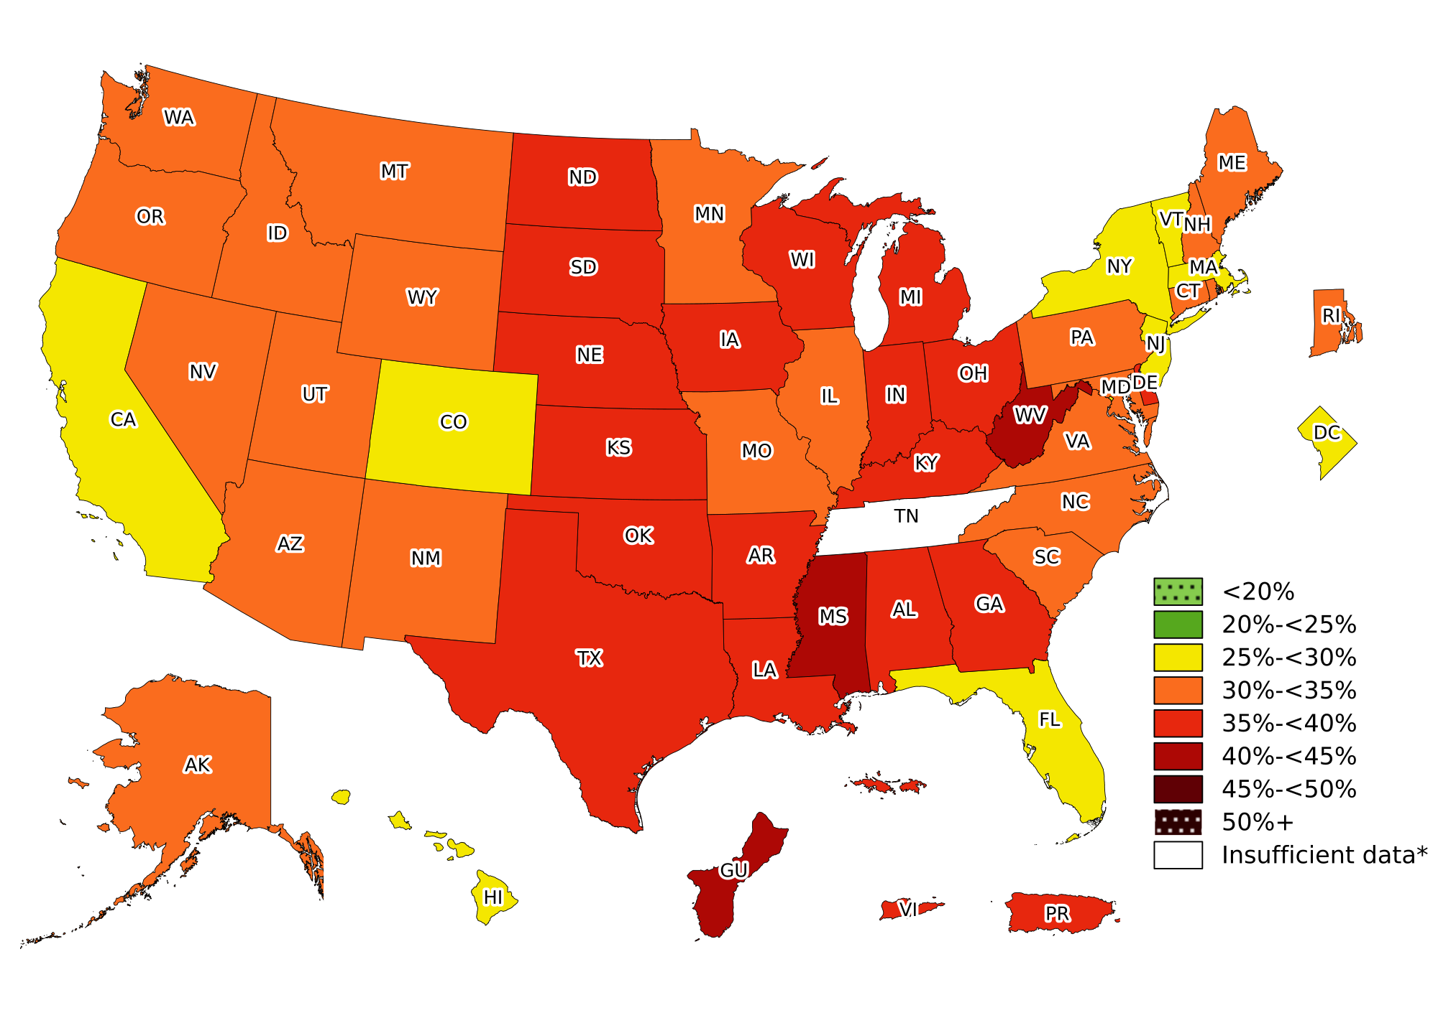
Figure 3. Official CDC map: self-reported adult obesity prevalence by state and territory, 2024 BRFSS. In 2024, at least 1 in 4 adults in every U.S. state and territory had obesity; 19 states had prevalence at or above 35%, and Mississippi, West Virginia, and Guam were at or above 40% (Tennessee: insufficient data). Source: Centers for Disease Control and Prevention, Adult Obesity Prevalence Maps, published December 3, 2025.
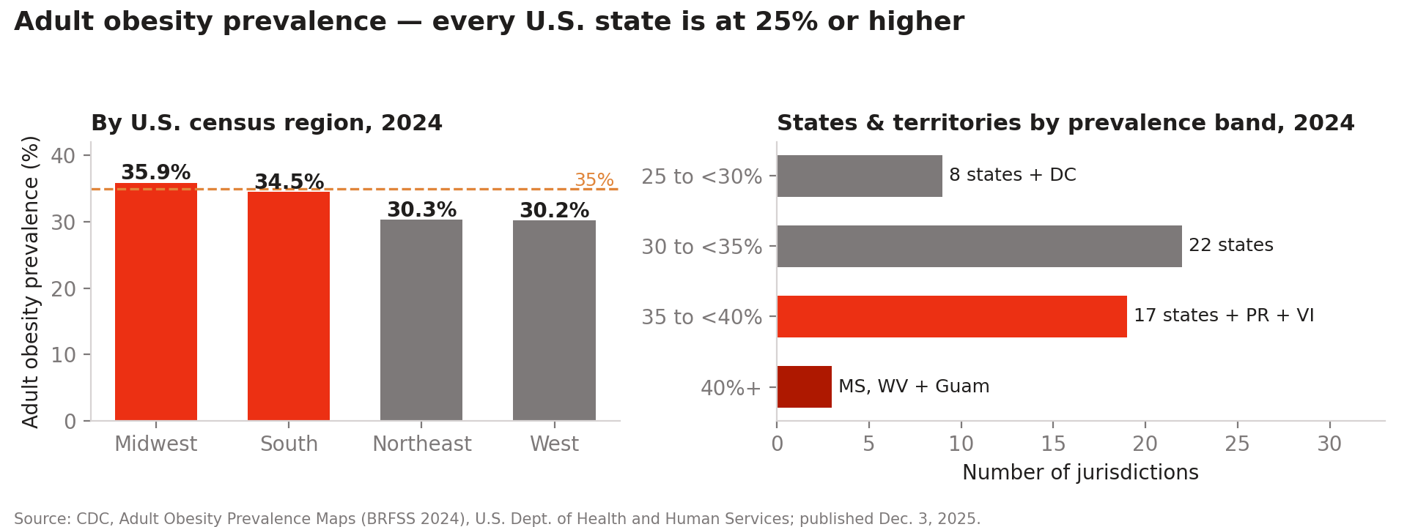
Figure 4. The expansion roadmap in federal data: adult obesity prevalence by census region and by prevalence band, 2024 BRFSS (CDC Adult Obesity Prevalence Maps, published Dec. 3, 2025).
The gap between where diets are decided and where existing policy operates completes the national-importance picture: a record 58.5% of U.S. food spending now occurs away from home and roughly a third of adult calories come from such food, while the primary existing federal intervention at that decision point — mandatory menu calorie labeling — changes behavior by only about 22–25 calories per transaction in peer-reviewed evaluations, and applies only to chains of twenty or more locations in any case. The endeavor operates precisely in this gap.
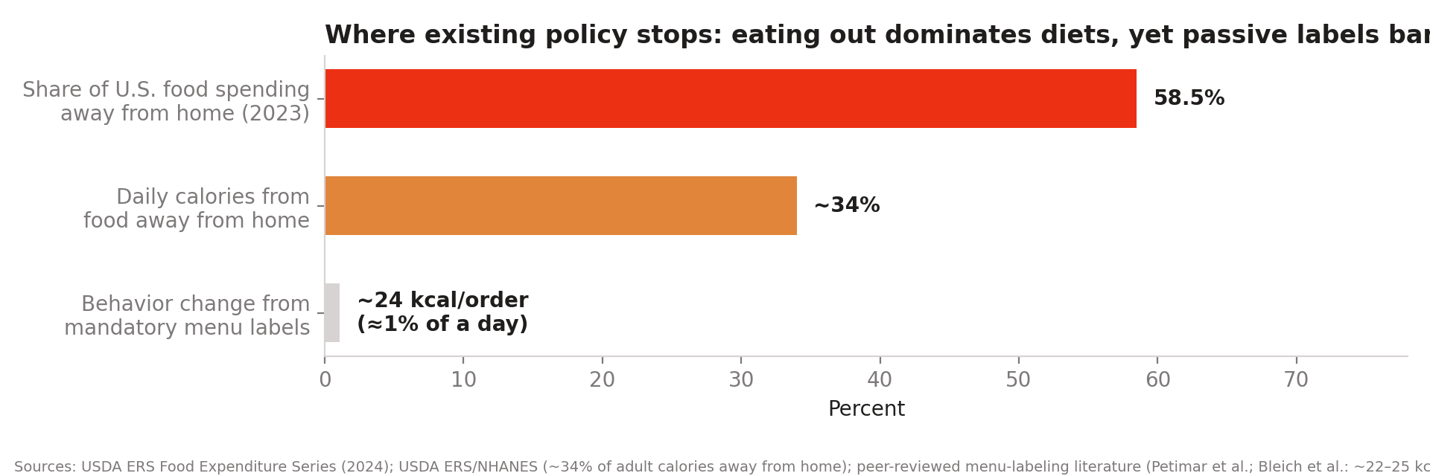
Figure 5. The intervention gap: the away-from-home channel dominates U.S. diets while the existing policy instrument produces a ~24 kcal/order effect (USDA ERS; peer-reviewed labeling literature).
Execution status — from demonstration to operating product. As of July 2026, the endeavor is no longer a demonstration: Forkcast operates as a deployed production web application at a public URL, with real user accounts stored in a cloud Postgres database under row-level security, cross-device synchronization of health profiles and meal logs, server-side AI services in live operation (photo-based meal estimation with user correction, description-grounded estimation, and a personalized nutrition coach), server-side membership entitlements, and hosted privacy, terms, and data-transparency policies written to the product's actual data practices. A structured developer handoff for iOS/Android applications (React Native, sharing the web product's verified nutrition engine) is complete and mobile development is underway. Each of these facts is verifiable by direct inspection of the running product and its dated commit history.
Projected employment and small-business impact. The endeavor's business plan (v2.1, July 2026) projects — and labels as projections from the planning model, not accomplishments — direct employment growing from 5 to 62 U.S. employees over five years across engineering, nutrition data operations, and market-launch teams sequenced toward the highest-prevalence regions identified above; and approximately 9,000 partner restaurants by Year 5, overwhelmingly independent small businesses. The small-business mechanism is concrete: federal menu-labeling obligations reach only chains with 20 or more locations, and laboratory nutrition analysis costs roughly $500–$1,000 per dish; the endeavor provides independent restaurants menu digitization, per-dish nutrition, verification tooling, and a public corrections ledger at no charge, earning a 6% fee only on orders it originates — against the 15–30% commissions charged by delivery marketplaces. The endeavor is thus job-creating for U.S. workers and revenue-protective for U.S. small businesses rather than displacing either.

B. Anticipated Adjudicative Concerns
A fair, balanced Prong One analysis must also anticipate how a USCIS adjudicator is likely to test this record. Two concerns stand out and should be addressed head-on in the petition rather than left for the adjudicator to raise in a Request for Evidence:
- Single-city pilot vs. national importance. The endeavor is currently confined to a Boston pilot. The petition should not rely on the pilot's existence alone; it should affirmatively argue — supported by the go-to-market plan already described on the site — that the endeavor is designed and evidenced as a scalable, multi-metro response to a nationwide structural gap (the FDA chain-only labeling threshold), not a local restaurant-recommendation app. National importance is assessed by the endeavor's prospective national or broader impact, not by its current geographic footprint.
- Commercial venture vs. national interest. Because Forkcast is a for-profit company with a clear monetization plan, the petition should explicitly address why a commercially viable endeavor also serves a broader public interest — for example, by emphasizing that closing the independent-restaurant nutrition-transparency gap is a public good regardless of who captures the associated commercial value, and by pointing to the CPT-billable medical nutrition therapy line as a direct connection to healthcare delivery, an area of recognized national concern.

VI. Independent Third-Party Corroboration — EY Industry Report (2022)
A 2022 Ernst & Young (EY) report, "How health care, retail and tech can work together to change how we eat," independently corroborates several elements of the Prong One analysis above. This report was authored by EY's Health, Consumer Products and Retail, and Food and Agriculture practice leaders, published years before the Forkcast site was reviewed, and makes no reference to Forkcast or any similarly positioned company. That independence is precisely what gives it evidentiary value here: it is a professional-services firm's own assessment of an industry-wide problem and an industry-wide solution direction, not a claim manufactured for this filing. It should be characterized to USCIS accurately as independent secondary market/industry analysis — not as a letter of support and not as a substitute for the personalized expert opinion letters recommended in Section VII below.

A. Independent Corroboration of the Underlying Public-Health Problem
- The average person makes more than 200 food-related decisions per day, a level of daily decision burden the report identifies as a root driver of poor nutrition outcomes (citing Wansink and Sobal, SAGE Journals, 2007) — independently corroborating the "decision fatigue" problem Forkcast's pre-order model targets.
- 73% of US adults are overweight or obese and nearly half have hypertension (American Psychological Association, 2021) — a second, independently sourced obesity statistic that corroborates the CDC figure already cited in Section V, strengthening the record through multiple independent sources rather than a single data point.
- The report states that more than 12% of the US population is food insecure, with documented links between food insecurity and obesity — useful context for the broader national scope of the problem, though the report itself notes (and this memorandum agrees) that Forkcast's paid-subscription pilot model is more directly aligned with the report's stated focus on "consumers who do not qualify for food assistance programs, but who may struggle to afford healthy food or maintain healthy eating habits" rather than the food-insecure population, which the report separately notes requires federal and state coordination.

B. Independent Corroboration of National Economic Scale
- The CDC-sourced figures cited in the EY report state that the cost of managing Type 2 diabetes in the US was $327 billion in 2017, and the total aggregate medical cost of adult obesity in the US was estimated at $260.6 billion in 2016 — concrete, federally sourced, national-scale dollar figures that substantially strengthen the economic-impact component of the national-importance argument in Section V, beyond the company's own TAM/SAM/SOM modeling.
- The report cites peer-reviewed and Health Affairs research finding that medically tailored meal delivery is associated with reduced emergency department visits and inpatient admissions among dually eligible Medicare/Medicaid beneficiaries — independent clinical evidence that nutrition-focused interventions of the general type Forkcast proposes can produce measurable, costly-care-reducing outcomes, which is directly relevant to the credibility of Forkcast's proposed B2B2C payer/employer revenue leg.

C. Independent Corroboration of the Specific Solution Category
This is the most significant point of alignment. Without reference to Forkcast, the EY report calls for exactly the category of product Forkcast has built: it states that "health technology companies can provide the connective tissue that links consumer engagement between payers or self-insured employers, health care professionals and food retailers," and it specifically envisions a single application allowing consumers to select meals and build shopping lists that meet personalized health goals within a budget, track food intake, share data with health care providers, and access nutrition advice and coaching — all in one place, rather than across three or more disconnected applications. That an independent, major professional-services firm identified this precise solution shape as a needed industry direction, in a report published years before this filing, is strong independent corroboration that Forkcast's proposed endeavor has substantial merit as a recognized, sector-important direction rather than an idiosyncratic business idea invented to support an immigration petition.
The report also independently proposes a "food-as-medicine" model in which payers and self-insured employers cover healthy food similarly to how they cover medication, including covering food "prescriptions" at restaurants based on income level or health risk — a model that maps closely onto Forkcast's stated third revenue leg, built on existing medical nutrition therapy CPT billing codes 97802–97804. Independent identification of this model by EY, separate from and prior to Forkcast's own articulation of it, supports the argument that this revenue leg reflects an industry-recognized direction rather than a speculative or invented mechanism.

D. A Risk the Report Itself Identifies (Useful for Credibility)
In the interest of the balanced analysis this memorandum has maintained throughout, it is worth noting that the EY report also flags an equity concern relevant to any national-scale digital nutrition tool: smartphone penetration is 90% or higher in US households earning above $50,000 annually, but falls below 80% in households earning below that threshold. A petition that cites this report as corroboration should not overlook this point; acknowledging it directly (for example, by noting Forkcast's initial focus on markets and price points where this access gap is smaller, or by flagging it as a known limitation to be addressed as the endeavor scales) will read as more credible to an adjudicator than a one-sided citation of only the favorable portions of the same source.
Source: EY, "How health care, retail and tech can work together to change how we eat," Ernst & Young LLP, 2022 (EY 2201-3947920). Recommended as a supporting exhibit; cite specific page numbers in the final petition once paginated against the version to be filed.

VII. Independent Corroboration — 2025 Joint Economic Report, U.S. Congress
Chapter 4 of the 2025 Joint Economic Report (Chairman's Views), "An Update on Obesity Trends," published March 3, 2025 by the Joint Economic Committee of the U.S. Congress, provides a materially stronger category of corroboration than the EY report discussed above: it is a primary federal legislative-branch document, not a private industry analysis. A word of accuracy is owed here, however — this chapter presents the Chairman's views (the document is captioned "Chairman's Views" and builds on a prior "Republican Response"), so it should be cited to USCIS as reflecting the views of the Committee's Chairman and majority, not as a unanimous or bipartisan Congressional finding. What is not partisan, and can be relied on directly, is the underlying data the chapter compiles and cites: CDC/NHANES prevalence data, Congressional Budget Office (CBO) cost estimates, and peer-reviewed research, all independently verifiable federal or peer-reviewed sources in their own right.

A. Stronger National-Scale Economic Evidence
- The chapter states that obesity is projected to result in between $8.2 and $9.1 trillion in excess U.S. medical expenditures over the following ten years — a substantially larger, and more recent, national economic figure than the $260.6B/$327B annual figures drawn from the EY report in Section VI, and one directly tied to federal fiscal policy analysis rather than industry commentary.
- Current NHANES data (August 2021–August 2023) puts the adult obesity rate at 40.3%, with severe (Class 3) obesity continuing to rise to 9.7% even as the headline rate has plateaued. The report projects the overall rate could exceed 50% by 2032 in its own best-case scenario.
- Class 3 (severe) obesity, while under a quarter of the obese population, accounts for more than 44% of total excess medical expenditures attributable to obesity — evidence that supports an argument for targeted, sustained intervention rather than treating the plateau in headline rates as a solved problem.
- The chapter documents active federal legislative engagement with this issue: the Treat and Reduce Obesity Act (H.R. 4818, 118th Congress) and a proposed (later suspended) CMS rule to expand Medicare/Medicaid coverage of anti-obesity medications, with CBO estimating a $35 billion nine-year fiscal cost to expand Medicare Part D coverage alone. This level of active, ongoing federal legislative and budgetary engagement is itself strong evidence that obesity, and by extension interventions addressing it, constitute a recognized matter of national importance within the meaning of Dhanasar — this is not this memorandum's characterization alone, but the U.S. Congress's own documented treatment of the issue.

B. Directly Addresses the GLP-1 Risk Flagged Previously — and Turns It Into Supporting Evidence
The prior version of this memorandum flagged, as an open question, that GLP-1 medications have meaningfully changed the weight-management landscape since the EY report's 2022 publication, and that this shift was not yet reflected in the record. This chapter — current as of March 2025 — directly addresses that gap, and its findings support rather than undermine the continued national importance of nutrition-focused, non-pharmaceutical interventions such as Forkcast's proposed endeavor:
- Adherence is low: in a Blue Cross Blue Shield study, only 42% of GLP-1 patients adhered to the recommended 12-week treatment guideline, and 30% discontinued within a month; broader research puts one-year adherence to anti-obesity medications at only around 40%. Weight lost is substantially regained after early discontinuation.
- Cost remains a significant barrier: monthly prices range from roughly $700 to over $1,000 even before newer lower-cost vial formulations ($400–$530/month); the majority of adults using these medications, including insured adults, report it is somewhat or very difficult to afford them.
- The chapter's own analysis concludes that, even under CBO's most optimistic assumptions for price declines and adherence, current federal proposals to expand medication coverage would not have a net positive fiscal impact within a ten-year window, and that behavioral and lifestyle-based approaches remain fiscally relevant alongside pharmaceutical ones.
Taken together, this is meaningful independent evidence — from a current, federal, non-company source — that pharmaceutical treatment alone is not resolving the underlying national problem, whether because a majority of users discontinue medication before achieving durable results, because cost prohibits access for a large population, or because the fiscal case for broad public coverage remains unfavorable. This directly supports, rather than weakens, the argument that non-pharmaceutical, nutrition-focused interventions retain substantial and growing national importance. Any final petition should cite this point specifically, since it preempts an adjudicator's likely question of whether GLP-1 medications have mooted the underlying problem.
Source: Joint Economic Committee (Chairman David Schweikert), "Chapter 4: An Update on Obesity Trends," in The 2025 Joint Economic Report of the Joint Economic Committee, Congress of the United States, on the 2025 Economic Report of the President (March 3, 2025), 119th Cong., 1st Sess. Recommended as a supporting exhibit — a primary federal legislative-branch document carries more weight with USCIS than industry commentary and should be positioned as the lead corroborating exhibit ahead of the EY report.

VIII. Independent Corroboration — McKinsey Global Institute (2014)
A discussion paper by the McKinsey Global Institute (MGI), "Overcoming obesity: An initial economic analysis," adds a third, independent category of corroboration. MGI is McKinsey & Company's self-funded research arm; the paper states explicitly that it was not commissioned by any company, government, or external organization, and that its academic advisory panel spanned more than a dozen independent university and public-health researchers. This paper's contribution to the record is different in kind from the EY and JEC sources above: rather than simply adding another economic figure, it provides independent behavioral-economics evidence for why the specific mechanism Forkcast has built — a pre-order recommendation delivered at the point of decision — should be expected to outperform the after-the-fact logging model used by incumbents such as MyFitnessPal.

A. Additional Independent Economic Scale (Global Context)
- MGI estimates the global economic impact of obesity at approximately $2.0 trillion annually, or 2.8% of global GDP — placing it on a similar scale to the global economic impact of smoking ($2.1 trillion) or of armed violence, war, and terrorism ($2.1 trillion). More than 2.1 billion people, close to 30% of the global population, are overweight or obese.
- In the United States specifically, MGI estimated obesity's annual economic impact at $663 billion (4.1% of GDP) — the second-largest human-generated economic burden identified in the U.S. after military/armed-conflict spending. This is a third independent economic figure, from a third independent source (following the CDC-sourced figures via EY and the CBO/CDC-sourced figures via the 2025 JEC report), further corroborating the scale of the problem this endeavor addresses.

B. Independent Validation of Forkcast's Specific Mechanism — the Strongest Point of Alignment in the Record
MGI's research explicitly examined why obesity interventions succeed or fail, and its central behavioral finding maps directly onto Forkcast's core product design choice. The report concludes that interventions relying on conscious mechanisms — education, information availability, and self-directed tracking or logging — are necessary but not sufficient, because they depend on individual willpower, which the report describes as "a notoriously limited resource." The report finds that traditional weight-management interventions (dietary counseling, logging-based programs, and even post-surgical weight loss) show weight regain of 30% to 70% of the original loss over time, precisely because they rely on sustained conscious effort after the point of decision has already passed.
By contrast, MGI finds that the highest-impact, most durable interventions are those that restructure the choice environment itself — shifting the default option available to a person at the actual moment of decision, rather than asking them to consciously resist temptation after the fact. This is the exact mechanism distinction between Forkcast's proposed endeavor and the dominant incumbent model it aims to displace: after-the-fact calorie logging (the MyFitnessPal model discussed in Section IV.A) is a conscious, willpower-dependent mechanism of precisely the type MGI's independent research finds insufficient on its own, while Forkcast's pre-order, location-aware recommendation is delivered at the point of the actual food decision — a choice-architecture intervention of the type MGI's independent research identifies as more durable and higher-impact. This is not a claim manufactured for this filing; it is an independent research institution's own behavioral-economics conclusion, published years before Forkcast existed, that happens to describe precisely the mechanism distinction Forkcast has built its product around.

C. Independent Support for a Multi-Sector, Portfolio-Based Model
MGI's research also concludes that no single intervention or single sector can meaningfully abate obesity on its own — effective impact requires a coordinated portfolio of interventions delivered across government, employers, health-care payors, retailers, and food-service providers. This independently corroborates both the EY report's call for health technology to serve as "connective tissue" across payers, providers, and food retailers (Section VI.C) and Forkcast's own three-legged model spanning consumer subscription, restaurant retail media, and payer/employer B2B2C contracts.

D. Caveats for Accurate Citation
Two accuracy points should guide use of this source. First, this is a 2014 discussion paper; its economic figures are now roughly a decade old and should be presented as historical/foundational corroboration of the problem's scale and mechanism, with the current, more recent JEC (2025) figures in Section VII carrying the primary weight for present-day national economic scale. Second, the paper's authors caution in their own preface that they did not independently verify all third-party research underlying each of the 74 cataloged interventions, and that the paper is an "initial contribution," not a settled consensus — this caveat should be carried into any petition citation rather than presenting MGI's figures as beyond dispute.
Source: Richard Dobbs, Corinne Sawers, Fraser Thompson, James Manyika, Jonathan Woetzel, Peter Child, Sorcha McKenna, and Angela Spatharou, "Overcoming Obesity: An Initial Economic Analysis," McKinsey Global Institute discussion paper (McKinsey & Company, 2014). Recommended as a supporting exhibit specifically for the behavioral-mechanism argument in Section VIII.B, which is likely the single most persuasive piece of independent corroboration in this record for why Forkcast's specific product design — not just the general problem it addresses — has substantial merit.

IX. Evidentiary Gaps in the Current Record and Recommendations
The site is unusually candid about its own stage of development — it explicitly labels itself a "demonstration prototype," states that no restaurant has authorized or partnered with Forkcast, and commits to reporting no user, revenue, or outcome data that has not actually been recorded. That candor is a genuine asset for credibility purposes, but it also means the current public record, standing alone, is not yet sufficient to support a filed Prong One argument. The table below sets out the specific gaps and recommended evidence to close them.
Gap in Current Record | Why It Matters for This Filing | Recommended Evidence to Obtain
Site is explicitly labeled a "demonstration prototype"; catalog is demo/placeholder data; no restaurant has authorized or partnered with Forkcast; no users, revenue, or outcomes have been recorded | USCIS adjudicators (and, on appeal, the AAO) scrutinize NIW filings for overstated claims. Prong 1 asks about the endeavor's merit and importance, not present traction — but the petition must describe the endeavor accurately or it risks a credibility finding that damages all three prongs | A clear, consistent description across the petition letter and exhibits: "proposed endeavor," "pilot-stage," "pre-seed." Do not let any exhibit imply live users or revenue that do not yet exist
Partially addressed: the EY industry report (Section VI) provides independent corroboration of the problem's scale and the solution category, but no press coverage, personalized expert letters, or grant awards exist yet | Dhanasar and subsequent AAO decisions give significant weight to independent corroboration over self-reported projections. Industry-level corroboration (EY) is a meaningful supplement but is not a substitute for evidence tied specifically to this petitioner and this endeavor | 1–2 letters from independent experts (public health / nutrition researchers, digital-health investors, or academic faculty) addressing the national significance of the problem and the plausibility of THIS endeavor specifically; pursue the SBIR/STTR application referenced on the site — a federal grant, even applied for, is persuasive
Market sizing and financial projections are self-modeled, not third-party audited | Self-generated TAM/SAM/SOM figures carry less evidentiary weight than independent market research | Cite independent third-party market reports (e.g., published calorie-tracking / digital-health market sizing) alongside the company's own model, and clearly label which figures are the company's own estimates
The petitioner's individual qualifications, degree(s), prior work, and specific role in building Forkcast are not addressed on the public site | Prong 1 only requires proof of the endeavor's merit and importance — but the overall I-140 also requires satisfying Prongs 2 (well positioned) and 3 (waiver benefits the U.S.) with petitioner-specific evidence | This memorandum addresses Prong 1 only. Prongs 2 and 3 require a separate evidentiary record: resume/CV, degrees, prior technical or entrepreneurial achievements, any IP, and a plan showing the petitioner personally (not just the company) is positioned to advance the endeavor

X. Suggested Framing for the Petition Letter (Draft Language for Attorney Review)
The following is a draft starting point only, to be revised, verified, and adopted or rejected at the attorney's discretion. Every factual assertion below must be independently verified against the actual, current state of the business before use — do not rely on this memorandum as a source of fact for the petition itself:
"Petitioner's proposed endeavor addresses a documented and structurally unaddressed gap in U.S. nutrition transparency: existing federal menu-labeling requirements apply only to restaurant chains with 20 or more locations, leaving the substantial majority of independent restaurants — where a record 58.5% of U.S. food spending now occurs — outside any commercial nutrition database. Petitioner's endeavor proposes to build a verified, restaurant-confirmed nutrition dataset and pre-order recommendation system beginning with a pilot in Boston, Massachusetts, with an evidenced plan to expand to additional dense urban markets nationally. Given that 72% of U.S. adults have elevated BMI (CDC, 2024), that obesity is projected to result in $8.2 to $9.1 trillion in excess U.S. medical expenditures over the next ten years (Joint Economic Committee, U.S. Congress, 2025, citing CBO and CDC data), and that existing after-the-fact tracking tools suffer 70–80% two-week abandonment, the endeavor's proposed shift to pre-order, location-aware guidance addresses a matter of substantial and growing national concern in public health, with a business model structured to sustain and scale that impact beyond any single employer or region. This direction is independently corroborated by industry and federal analysis alike: a 2022 Ernst & Young report, published without reference to Petitioner's endeavor, called specifically for health technology to serve as the 'connective tissue' linking consumers, payers, and food providers through a single integrated application — precisely the solution category Petitioner's endeavor occupies. Nor has the recent growth of anti-obesity medications displaced this need: current federal analysis shows only around 40% one-year adherence to these medications and persistent cost barriers, underscoring the continued national importance of non-pharmaceutical, nutrition-focused interventions such as Petitioner's endeavor. Independent behavioral-economics research from the McKinsey Global Institute further finds that interventions relying on conscious, willpower-dependent mechanisms such as after-the-fact food logging are insufficient on their own, and that higher-impact, more durable interventions instead restructure the choice environment at the actual point of decision — precisely the mechanism Petitioner's endeavor is designed around."

XI. Recommended Next Steps
- Retain a licensed U.S. immigration attorney experienced in EB-2 NIW entrepreneur petitions to review this memorandum, verify every factual claim against the actual current state of the business, and determine whether the record is ready to support a filing.
- Do not submit any petition describing user numbers, restaurant partnerships, revenue, or outcomes that have not actually occurred; the site's own "demonstration prototype" labeling must be mirrored accurately throughout the petition.
- Begin building the independent third-party evidentiary record identified in Section VI — particularly expert letters and any federal grant application (e.g., SBIR/STTR) — well before filing, as this evidence typically takes the longest to obtain.
- Prepare Prong Two (petitioner is well positioned to advance the endeavor) and Prong Three (waiver benefits the U.S. on balance) as separate work streams; a strong Prong One record does not, by itself, support approval.
- Reassess the national-importance argument once real pilot data exists — the pre-registered metrics on the site's "Impact & evidence" page will, once populated, meaningfully strengthen this record.
- Proactively address the GLP-1 medication trend in the petition rather than waiting for an adjudicator to raise it — Section VII.B above shows the current federal data supports, rather than undermines, the endeavor's continued relevance, but this argument should be made affirmatively rather than left unaddressed.
This document is an AI-assisted draft prepared for attorney review and does not constitute legal advice or an attorney-client communication.

